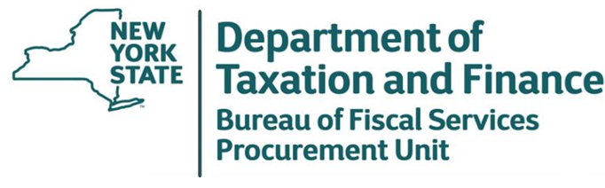

May 1, 2026

Request for Quote (RFQ) 25-474
R-Series Courses

Department Response to Bidder Questions

To All Potential Bidders:

Attached are the Department’s responses to bidder questions for the above referenced RFQ. Bidder responses to this RFQ are due May 11, 2026 by 2:00 PM ET.
# | RFQ Section | RFQ Page | Question | Response
1 | 2.6 | 5 | I just wanted to confirm that [Potential Bidder] expected that Exams would be given at each students’ “home” office and proctored by NY State Staff. Exams will be then sent to [Potential Bidder] staff for grading. | That is correct. If the Bidder is able to use State staff as proctors, then the State would designate a proctor at each assigned work location: Ray Brook, Syracuse, White Plains, Batavia, and Latham. The State could scan in or physically mail the completed exams, which are equally acceptable to the State.

