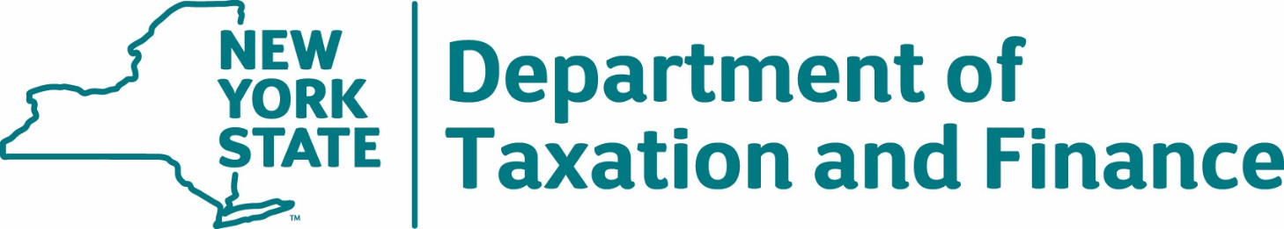

Request for Proposals
26-101
Telecommunications Expert Consultant

Exhibits

Table of Contents

Exhibit A – Preliminary Base Contract 3
Attachment 1 to C400759 – DTF-202, Tax Information Access and Non-Disclosure Agreement 32
Exhibit B - Contractor Sales Tax Certification Forms 34
Exhibit C – Minority and Women-Owned Business Enterprises – Equal Employment Opportunity Policy Statement 40
Exhibit D – State Consultant Services – Contractor’s Planned Employment – Form A 42
Exhibit E – Contractor’s Annual Employment Report – Form B 43
Exhibit F – New York State Office of the State Comptroller Substitute Form W-9 44
Exhibit G - Workforce Utilization Report 46
Exhibit H – Secrecy & Non-Disclosure List (to be submitted by Contractor to DTF) 47
Exhibit 1 – Special Franchise Property and Telecommunications Assessment Ceiling Property by Location 48
Exhibit 2 – NYS Department of Taxation & Finance (DTF) Pre-Authorization for Non-Employee Travel 52

Exhibit A – Preliminary Base Contract
THIS AGREEMENT is between the New York State Department of Taxation and Finance, located at Building 9, W.A. Harriman State Office Campus, Albany, New York 12227 (hereinafter, the “Department” or “DTF” or “State”) and [Contractor Name], with a principal place of business located at [Contractor Address] (hereinafter, the “Contractor”). The Department and the Contractor are together referred to herein as the “Parties”.
WHEREAS, the Department issued Request for Proposals (“RFP”) 26-101 on April 13, 2026, for the acquisition of telecommunications expert services relating to the utilization of fiber optic cable, coaxial cable, and associated property owned by SLIC Network Solutions, Inc. (“Litigant”) both in and outside of the public right-of-way throughout New York State (“Services”); and
WHEREAS, the Contractor timely submitted a responsive Proposal to provide the Services in accordance with the requirements set forth in RFP 26-101 and the Department has determined that the Contractor is responsible; and
WHEREAS, pursuant to Section 10. Proposal Evaluation of said RFP, the Contractor was determined to have provided the best value Proposal and has been determined capable of providing the required Services; and
WHEREAS, the Contractor is prepared to provide the Services according to the terms of the RFP and this Agreement.
NOW, THEREFORE, in consideration of the mutual covenants and conditions herein set forth, the Parties hereto agree as follows:

Article I. Definitions
The following terms when used herein shall have the specified meanings:
Agreement (also referred to as “Contract”) - This Contract C400759, which includes all documents identified in Article II. Entirety of Agreement.
Attorney General or AG - See RFP 26-101 at Appendix C, RFP Glossary.
Base Contract - See RFP 26-101 at Appendix C, RFP Glossary.
Commissioner - See RFP 26-101 at Appendix C, RFP Glossary.
Deficiency - Any failure by Contractor to meet requirements in providing the Services pursuant to this Agreement.

Department or DTF - See RFP 26-101 at Appendix C, RFP Glossary.
Dispute Resolution - The procedure set forth in Article X. for resolving disputes arising under this Agreement.
Material Breach - The failure to perform an obligation that Contractor is bound to perform under this Agreement which materially impacts the State or is so fundamental to the undertaking that Contractor’s failure to perform defeats the purpose of the Agreement.
Notice of Deficiency or NOD – A written notice which may be issued to the Contractor by the Department, in its sole discretion, to set forth a Deficiency.
Notice of Termination - The written notification issued to the Contractor by DTF following a Cure Period, if applicable, which sets forth the termination date of the Agreement.
OGS-BSC - The New York State Office of General Services, Business Services Center.
OSC - See RFP 26-101 at Appendix C, RFP Glossary.
Proposal (or Bid) - See RFP 26-101 at Appendix C, RFP Glossary.
Services - See RFP 26-101 at Appendix C, RFP Glossary.
Special Franchise Property - See RFP 26-101 at Appendix C, RFP Glossary.
State - See RFP 26-101 at Appendix C, RFP Glossary.

Subcontractor - See RFP 26-101 at Appendix C, RFP Glossary.

Tax Law - The New York State Tax Law.

Article II. Entirety of Agreement
This Contract C400759 shall consist of the documents listed below, which are fully incorporated by reference. In the event of a conflict between or among the provisions of the Contract, such conflict shall be resolved by reference to the documents in the order listed with Appendix A having precedence:
Appendix A attached to the RFP, “Standard Clauses for New York State Contracts,” dated June 2023;
Attachment 1 to C400759, DTF-202, “Tax Information Access and Non-Disclosure Agreement,” dated 06/2019, attached hereto;
Any written amendments and/or changes to the Agreement agreed to by the Parties and approved, where necessary, by the Attorney General and the Office of the State Comptroller;
Base Contract;
Any Amendments and Clarifications to RFP 26-101, including Questions and Answers issued by the State, as follows: [List by Title and/or Date];
RFP 26-101 (including all attachments to the RFP, but excluding Appendix A);
Contractor’s Proposal Clarifications, as follows: [List by Title and/or Date]; and
Contractor’s Proposal, excluding Contractor’s Proposal Clarifications.

Article III. Contractor Responsibilities
The Contractor has, by submitting its Proposal, agreed to all mandatory RFP Requirements and to provide all Services as set forth in the RFP, and all are incorporated herein by reference. In addition to the Contractor’s responsibilities set forth elsewhere in this Agreement, the Contractor shall: Prepare an appraisal report (trial ready) for the Litigant’s Special Franchise Property and testify in court at trial, if necessary.
- Provide all Services as set forth herein and in RFP 26-101 and the Contractor’s Proposal in response to RFP 26-101.
- Comply with the Department’s Secrecy requirements.
- Not disclose any data or other information/materials provided by the Department to any other individual or entity except as expressly provided by law. The data provided, while in the custody of the Contractor, must be kept confidential, and the Contractor must take all reasonable and prudent steps to ensure the data is fully protected and secured.
- Pay, at its sole expense, all applicable permits, licenses, tariffs, tolls and fees and give all notices and comply with all federal, state and local laws, ordinances, rules and regulations of any governmental entity in conjunction with the performance of obligations under the contract.
- Maintain insurance as required in RFP 26-101 and as set forth in this Agreement.

Article IV. Department Responsibilities
In addition to the Department’s responsibilities set forth elsewhere in this Agreement, the Department shall:
- Make diligent efforts to provide the Contractor with direction, assistance, procedures, and contact persons necessary to perform in accordance with this Agreement.
- Cooperate with the Contractor to utilize, where necessary, informal dispute resolution as well as the formal Dispute Resolution process to facilitate the timely resolution of any disputes and technical problems that arise during the term of this Agreement.
- Provide the Contractor with access, as necessary, to DTF staff who are committed to providing the business information needed by the Contractor to perform Services under this Agreement.
- Be responsible for the performance of its employees and agents.
- Advise the Contractor of the security rules, procedures, and regulations that the Department may from time to time establish with respect to the Department’s premises, property, records, and data.
- Compensate the Contractor for Services appropriately rendered and invoiced, in accordance with the terms set forth herein under Article VI. Fees and Payment.

Article V. Contract Term
The Department will award one (1) Contract to the successful Bidder. The Contract will become valid and effective only upon its approval by both the Attorney General (“AG”) and the Office of the State Comptroller (“OSC”). Upon receiving the last such approval, the Contract term will commence and shall terminate upon completion and receipt of all required documents and other required services, including testimony, and upon the conclusion of the pending tax certiorari proceedings; or in three (3) years, whichever is later.

Article VI. Fees and Payment
All fees and payments shall be in accordance with RFP 26-101 Section 7. Financial Requirements and Attachment 17 – Financial Response Form, submitted by the Contractor in response to the RFP, both of which are incorporated in their entirety herein by reference.
- Electronic Payment
Payment for invoices submitted by the Contractor will only be rendered electronically and in accordance with ordinary State procedures and practices. Contractor shall comply with the State Comptroller’s procedures to authorize electronic payments and acknowledges that Contractor will not receive payment on any invoices submitted under this Agreement if it does not comply with the State Comptroller’s electronic payment procedures. The Commissioner, in his/her sole discretion, may authorize payment by paper check, if specifically requested by the Contractor in advance, due to extenuating and documented circumstances necessitating payment by paper check.
In order to receive payment, Contractor must complete and update, as appropriate, its Vendor Record through the online Vendor Self-Service Portal with the applicable Automated Clearing House (“ACH”) information (e.g., bank routing number, bank account number, account type) into which the Contractor wants payment deposited. It is the Contractor’s responsibility to access the self-service portal, follow instructions provided there, and accurately supply the required information to set up electronic payments. Contractor must input the required ACH information and not permit the payment type to default to payment by paper check. In addition to inputting the appropriate ACH information in the State Comptroller’s Vendor Record system, the Contractor must also advise DTF in writing of the ACH payment information (bank account location) into which it wants payment remitted for this Agreement. The Vendor Self-Service Portal can be found at https://esupplier.sfs.ny.gov/psp/fscm/SUPPLIER. Contractors requiring assistance with accessing or using the self-service portal should contact the NYS Statewide Financial System (“SFS”) by e-mail at helpdesk@sfs.ny.gov, or by telephone at (855) 233-8363.
- Properly Submitted Invoices
Payment will be made only upon submission of proper invoices by the Contractor, and in accordance with Article 11-A of New York State Finance Law.
Required Information on properly submitted invoices:
- Vendor name;
- Name of NYS Agency that ordered the goods or services;
- Description of goods or services requesting payment for (may be in narrative or code values format);
- Quantity of goods, property, or services delivered or rendered;
- Amount requested; and
- Purchase order (“PO”) number, if applicable, as provided by ordering agency.
It is preferred that an invoice also contain the following information:
- NYS Vendor ID number;
- Invoice Date;
- Unique invoice number;
- Payment terms being offered, if other than Net 30; and
- Any other information or substantiating documentation the agency may reasonably require.
All invoices and payments therefor are subject to the State’s acceptance of the Services for which billing is being made.
Submission:
Preferred Method:
Submit invoices through the SFS Vendor Portal. (Note: Do not email or send a paper copy, in addition to submitting an invoice via the SFS Vendor Portal.)
Alternate Method:
Email invoices to the OGS-BSC at: accountspayable@ogs.ny.gov including the invoice number and the name of the agency being billed in the subject field. (Note: Do not send a paper copy, in addition to the electronic invoice.)
OR
Mail invoices to OGS-BSC at the following U.S. postal address:
New York State Department of Taxation and Finance
c/o NYS OGS Business Services Center
1220 Washington Ave, Building 5, 5th Floor
Albany, NY 12226-1900

Article VII. Tax Secrecy and Confidentiality
RFP 26-101 sets forth mandatory requirements relating to tax secrecy and confidentiality covering, among other things, the required Tax Information Access and Non-Disclosure Agreement (“DTF-202”) form, secrecy training requirements of Contractor personnel, and recordkeeping requirements for DTF-202 forms and training completion records, as well as destruction requirements for confidential tax records at the conclusion of the contract. All are incorporated herein in their entirety by reference thereto. The following contains additional information about Tax Secrecy and provisions with which the Contractor must comply.
- New York State Tax Law and Internal Revenue Code Tax Secrecy Provisions
The various secrecy provisions of the Tax Law (e.g., Tax Law §§ 487, 697(e) and 1825) prohibit independent contractors from disclosing tax information in any manner and provide for misdemeanor prosecution for violations. The secrecy provisions of the Internal Revenue Code (26 USC § 6103) provide for felony prosecution for unauthorized disclosure of Federal tax information in the possession of the Department.
All other information about the Department's operations not covered by the preceding provisions of law must be kept confidential as if it were so covered. Contractor representatives must comply with the administrative procedures enforcing these rules.
The Contractor, all staff members and Subcontractors shall agree to view, access, and use only that information relevant and necessary to provide Services to the State under the Agreement; and to subscribe to the provisions of §§ 73 and 74 of the Public Officers Law.
- Tax Secrecy - Required Forms
The Contractor will require each employee and/or Subcontractor assigned to this Agreement to sign form DTF-202 form as set forth in Attachment 1 to C400759. The Department reserves the right to require the Contractor to have its employees (and any Subcontractor employees, if applicable) who, in the course of providing Services in connection with this Agreement may view or access tax secret information, sign DTF-202 forms and/or complete the Department’s Annual Security Awareness Training on the Department’s website at https://www.tax.ny.gov/about/procure. In that event, Contractor will create and maintain records of such course completion for each such employee, including recording their names, titles and date(s) of completion of the annual training and provide same to DTF upon request. The Contractor will send all completed original DTF-202 forms to the Department at the address provided on the DTF-202 form.
- Breach of Confidentiality
The Contractor agrees to maintain as confidential all information which is disclosed by or on behalf of the Department to the Contractor verbally, electronically, visually, or in written or other tangible form which is either identified as or should be reasonably understood to be confidential or proprietary, including confidential and/or proprietary information and materials of third parties rightfully in the Department’s possession (“Confidential Information”). Contractor agrees to comply with all requirements the Department may impose related to access, use, disclosure, audit, and return or destruction of such Confidential Information. Contractor shall use Confidential Information solely for the purpose of carrying out its obligations to, or on behalf of, the Department as set forth in this Agreement, and for no other purpose. Contractor shall maintain all such information in confidence for the sole and exclusive benefit of the Department and shall not use same for any purpose whatsoever other than rendering Services to the Department. The Contractor shall be fully liable for damages for disclosing Confidential Information.
The requirement of confidentiality under this Agreement applies to Contractor, its Subcontractors, and employees and agents of Contractor and its Subcontractors. Contractor, its Subcontractors, employees, and agents shall protect Confidential Information obtained in the course of providing Services to the Department, and not use it to obtain benefits, financial or otherwise, for themselves or anyone else. Contractor will use its best efforts to ensure that such persons adhere to the confidentiality requirements set forth herein. Use and disclosure of Confidential Information by employees and agents to the extent necessary to carry out the terms and purposes of this Agreement is permitted.
- Information Security Breach and Notification Act
The Contractor agrees to be responsible for the State’s obligation to comply with provisions of Section 208 of the State Technology Law, commonly known as the Information Security Breach and Notification Act (the “ISBNA” or “Act”), and any future amendments thereto, to the extent an information security breach occurs as a result of the acts or omissions of the Contractor, including being responsible to pay all costs associated with and/or incurred because of the breach. The Contractor shall comply with all obligations imposed by the Act on the State with respect to any breach of “private information” (as defined in the Act) used, received, handled, processed, uploaded, stored, or maintained by the Contractor on behalf of the State under this Agreement (“Department Information”). In the event of a “breach of the security of the system” (as defined by the Act), the Contractor shall immediately notify the Department upon the Contractor’s discovery or receipt of notification of such breach. Such notice to the Department shall be made by contacting the Information Security Office by email to: ISO.Mail@tax.ny.gov. The Contractor shall immediately commence an investigation, in cooperation with the Department, to determine the scope of the breach and to restore the security of the system. To the extent the Department determines that further notifications are required to be sent out pursuant to the Act, the Contractor shall be responsible for providing such notifications to all required recipients including, in accordance with New York State policy NYS-P03-002, non-New York State residents whose private information is reasonably believed to have been exposed as a result of the breach. All costs associated with providing breach notifications shall be borne by the Contractor. It is expressly agreed that the Contractor shall be obligated to receive authorization from the Department prior to making additional notifications hereunder to any individuals, the State Office of Information Technology Services, the Department of State’s Division of Consumer Protection, the Attorney General’s Office or any consumer reporting agencies of a breach of the security of the system, or concerning making any determination to delay notifications due to law enforcement investigations. The Contractor agrees that the Department shall have final approval over the form, content, mode of transmission, and timing of any notice to be provided concerning a breach of the security of State Information. Nothing contained herein shall be interpreted as reducing or altering the Contractor’s own obligations under section 899-aa of the General Business Law if such breach also involves other private information unrelated to this Agreement.
- Ownership and Return of the State’s Data
The State retains sole ownership and intellectual property rights in and to all information, data, databases, data compilations, reports, charts, graphs, diagrams, or other information provided or made accessible by the State to the Contractor, or created by the Contractor pursuant to the Agreement (“State Data”) except for Contractor’s prior proprietary, trademarked or patented materials, even if utilized for this project. The State shall not have any residual rights to said materials beyond this Agreement. The Contractor shall not copy or use State Data except to carry out contracted work under the terms herein, and shall not transfer nor display such records to any other party not involved in the performance of this Agreement. The Contractor does not have the right to retain State Data.
The Contractor must, during the term of the Agreement (including any extensions and/or transition or disengagement), provide the State with access to any State Data maintained by the Contractor. The Contractor must, in accordance with applicable law and the instructions of the State, exercise due care for the protection of such data, and maintain appropriate data integrity safeguards against the deletion or alteration of State Data.
Upon completion of the work hereunder Contractor will destroy or return, at the State’s discretion, all State Data and records in its possession or control. Promptly after the termination or expiration of the Agreement, the Contractor shall, at no cost to the State, perform the following actions, as directed by the State, regarding State Data: (i) transmit it to the State or its designee(s) in a format that is easily usable by the State or its designee(s) and does not contain any proprietary software or other materials of Contractor or third parties; (ii) destroy the State Data and any copies, extracts, descriptions, and summaries thereof contained in the Contractor’s records or systems; and (iii) provide the State with a written certification of such return and/or destruction executed, under penalty of perjury, by an Officer of the Contractor.

Article VIII. Reserved Rights
In addition to such other rights as allowed under this Agreement, the Department reserves the right to request a copy of Federal Form I-9, Employment Eligibility Verification, for each individual assigned to work at the Department under this Contract, if the Contractor is legally obligated to obtain and retain such Form I-9. The social security number of the employee, if listed on Form I-9, shall be redacted from the form.

Article IX. Performance and Remedies
If it is determined that the Contractor is in breach of any terms or conditions set forth in this Contract, the Department reserves the right to take any action it deems appropriate, at its sole discretion, including but not limited to contract termination or the withholding of payment until such breach is remedied to the Department’s satisfaction. The taking of any such action shall not give rise to any cause of action against the Department for any kind of damages, loss of profits, expenses, or other remuneration of any kind.

Article X. Dispute Resolution
In the event of a dispute arising from this Agreement, the State shall continue to be able to use the Contractor and obtain Services under the terms and conditions herein while the dispute is resolved. The Contractor and the Department agree that it is important to expeditiously resolve any disputes arising under the Agreement.
The first step of Dispute Resolution will be through informal conference between the State and the Contractor. The party initiating the Dispute Resolution process shall notify the other party in writing and set forth the issues for resolution and provide all necessary documentation. The Parties shall review each other’s position and attempt to reach a resolution. Unresolved disputes will be resolved by the Commissioner of Taxation and Finance, or his/her designee, whose decision is final and binding. During this period, all work required hereunder shall continue to be performed If the Contractor pursues any legal or equitable remedy outside this Dispute Resolution process, the Contractor shall continue to perform work in accordance with the Agreement and the direction of DTF until such proceedings may be concluded and will continue to be paid in accordance with the Agreement, less any amounts attributable to the dispute. Disputes that go to litigation must be pursued in a court of competent jurisdiction within the State of New York, with venue in Albany County. New York law (without regard to its conflicts of law jurisprudence) will govern the dispute. Nothing in this paragraph shall diminish the State’s right to terminate the Agreement.

Article XI. Termination
A. Termination for Cause (Material Breach)
In the event of a Material Breach, the State reserves the right, in its sole discretion, to terminate this Agreement in whole or in part, or to terminate the Contractor’s Services with respect to a specific matter or matters, immediately upon providing written notice to the Contractor.
Such termination shall not give rise to any cause of action against the State for damages, breach of contract, loss of profits, expenses, or other remuneration of any kind. The Contractor shall be fully liable for the State’s damages resulting from any Material Breach, and shall be responsible, without limitation, for all additional costs the State incurs should the State terminate the Agreement due to such a breach. Without limiting the foregoing, this includes the State’s recovery of costs incurred by the State in engaging a new contractor.
Material Breach includes, but is not limited to, the following:
- Significant or repeated failure of Contractor to comply with its obligations under the Agreement.
- Failure of Contractor to maintain the confidentiality of information and/or security of State Data, and/or taxpayer data or tax administration policies and procedures provided to it in connection with its performance of this Agreement.
- Failure of Contractor to cooperate fully with the Department, its agents, OSC and/or the AG, to the extent required in connection with performance of this Agreement.
- Failure of Contractor to remain a responsible Contractor consistent with applicable New York State Law, regulations and/or policy.
- A finding that the certification filed by the Contractor in accordance with Section 5-a of the Tax Law was intentionally false or misleading or intentionally incomplete.
- A finding that the certification filed by the Contractor in accordance with Procurement Lobbying law was intentionally false or misleading or intentionally incomplete.
- Contractor’s breach of any warranty or representation under the Agreement, which remains uncured.
If it is subsequently determined for any reason that Contractor was not in Material Breach or that the Contractor’s failure to perform or make progress in performance was due to causes beyond the control and without the fault or negligence of the Contractor, the Department will have the option to allow the Contractor to resume performance under the Agreement without an increase in cost.
In the event of Termination for Cause by the State, Contractor shall be liable for the State’s damages resulting from such Material Breach.
B. Termination for Convenience
The State may terminate this Agreement in whole, or in part, for convenience upon 30 days’ prior written notice to Contractor without penalty or other early termination charges due. This provision should not be understood as waiving the State’s right to terminate the Agreement for cause, or to require the Contractor to stop work immediately, but is supplementary to those provisions.
C. Notice of Termination; Cooperation
In the event of termination of the Agreement by the State, the Department will issue a written Notice of Termination. Except as otherwise provided, where any notice is required to be provided by a party, such notice will be delivered in accordance with Article XX. P. Notices. The Parties agree to cooperate in a manner to effectuate an orderly termination of the Agreement, and to comply with all disengagement and data sanitization requirements set forth in RFP 26-101 and herein.

Article XII. Continuing Administrative Requirements
A. Vendor Responsibility
General Responsibility
The Contractor shall at all times during the Contract term remain responsible. The Contractor agrees, if requested by the Commissioner of Taxation and Finance, or their designee, to present evidence of its continuing legal authority to do business in New York State, integrity, experience, ability, prior performance and organizational and financial capacity.
Suspension of Work
The Commissioner or their designee, at their sole discretion, reserves the right to suspend any or all activities under this Agreement at any time, when they discover information that calls into question the responsibility of the Contractor. In the event of such suspension, the Contractor will be given written notice outlining the particulars of such suspension. Upon issuance of such notice, the Contractor must comply with the terms of the suspension order. Contract activity may resume at such time as the Commissioner or their designee issues a written notice authorizing resumption of performance under the Agreement.
Termination
Upon written notice to the Contractor, and a reasonable opportunity to be heard with appropriate DTF officials, or staff, the Contract may be terminated by the Department at the Contractor’s expense where the Contractor is determined by the Commissioner or their designee to be non-responsible. In such event, the Commissioner or their designee may complete the contractual requirements in any manner they may deem advisable and pursue available legal or equitable remedies for breach.
B. Sales and Compensating Use Tax
Section 5-a of the Tax Law, as amended, effective April 26, 2006, requires certain contractors awarded state contracts for commodities, services and technology valued at more than $100,000 to certify, to the Department, that they are registered to collect New York State and local sales and compensating use taxes. The law applies to contracts where the total amount of such contractors’ sales delivered into New York State are in excess of $300,000 for the four quarterly periods immediately preceding the quarterly period in which the certification is made, and with respect to any affiliates and subcontractors whose sales delivered into New York State exceeded $300,000 for the four quarterly periods immediately preceding the quarterly period in which the certification is made.
This law also imposes upon certain contractors the obligation to certify whether or not the contractor, its affiliates, and its subcontractors are required to register to collect state sales and compensating use taxes and contractors must certify to the Department that each affiliate and Subcontractor exceeding the $300,000 sales threshold referenced above is registered with the Department to collect New York State and local sales and compensating use taxes. The law prohibits the State Comptroller, or other approving agency, from approving a contract awarded to a contractor meeting the registration requirements but who has not registered in accordance with the law.

C. Procurement Lobbying
State Finance Law §§ 139-j and 139-k impose certain restrictions on communications between a Governmental Entity and an Offerer/Bidder during the procurement process. An Offerer/Bidder is restricted from making contacts during the restricted period to other than designated staff unless it is a contact that is included among certain statutory exceptions set forth in State Finance Law § 139-j(3)(a).
If this Agreement is renewed or amended, Contractor shall be subject to the Procurement Lobbying requirements set forth herein and shall submit such updated Procurement Lobbying forms, as required by the State.

D. Contractor Consultant Law
In 2006, the Civil Service and State Finance Laws were amended to require information about Contractor employees for Contractors working on State agency service and consulting contracts be provided to the State, the Office of the State Comptroller (OSC), the Division of the Budget (DOB) and the Department of Civil Service (CS). To meet these requirements, the Contractor will assist in the completion of State Consultant Services - Contractor’s Planned Employment – Form A, attached to the RFP as Exhibit D.
In addition, for each year a consulting services contract is in effect, contracting agencies must require contractors to report annually regarding the above described employment information including work performed by subcontractors. The Contractor must properly complete a copy of Contractor’s Annual Employment Report – Form B, attached to RFP as Exhibit E, and provide it to the contracting agency, the Office of the State Comptroller (OSC) and the Department of Civil Service (CS). Form B captures historical information, detailing actual employment information for the most recently concluded State fiscal year (April 1 – March 31). Form B will be due no later than May 15 of each year.
Form B shall be provided to OSC and CS as set forth in the Guide to Financial Operations; the Guide may be found online at:
http://www.osc.state.ny.us/agencies/guide/MyWebHelp/Content/XI/18/C.htm.
Form B shall be provided to the State as follows:
By mail: New York State Department of Taxation and Finance
Office of Budget and Management Analysis
Procurement Services Unit
W. A. Harriman State Office Building Campus
Albany, NY 12227
By e-mail: BFS.Contracts@tax.ny.gov
Fax: (518) 435-8413
For purposes of this section, the following terms have the specified meanings:
- “Employment Category” means the specific occupation(s), as listed in the O*NET occupational classification system, which best describes the employees providing services under this contract; and
(Note: The O*NET database is available through the U.S. Department of Labor’s Employment and Training Administration at http://online.onetcenter.org to find a list of occupations.)
- “Consulting Services Contract” includes any contract entered into by a State agency for analysis, evaluation, research, training, data processing, computer programming, engineering, environmental, health and mental health services, accounting, auditing, paralegal, legal, or similar services.

Article XIII. Participation by Minority and Women-Owned Business Enterprises: Requirements and Procedures
- General Provisions

1. The Department of Taxation and Finance (“Department”) is required to implement the provisions of New York State Executive Law Article 15-A and Parts 140-145 of Title 5 of the New York Codes of Rules and Regulations (“NYCRR”) for all State contracts, as defined therein, with a value (1) in excess of $25,000 for labor, services, equipment, materials, or any combination of the foregoing or (2) in excess of $100,000 for real property renovations and construction.

2. The contractor to the subject contract (the “Contractor” and the “Contract,” respectively) agrees, in addition to any other nondiscrimination provision of the Contract and at no additional cost to the Department, to fully comply and cooperate with the Department in the implementation of New York State Executive Law Article 15-A and the regulations promulgated thereunder. These requirements include equal employment opportunities for minority group members and women (“EEO”) and contracting opportunities for New York State-certified minority and women-owned business enterprises (“MWBEs”). The Contractor’s demonstration of “good faith efforts” pursuant to 5 NYCRR § 142.8 shall be a part of these requirements. These provisions shall be deemed supplementary to, and not in lieu of, the nondiscrimination provisions required by New York State Executive Law Article 15 (the “Human Rights Law”) and other applicable federal, state, and local laws.

- Contract Goals
For purposes of this Contract, the Department hereby establishes an overall goal of 0% percent for MWBE participation, 0% percent for New York State-certified minority-owned business enterprise (“MBE”) participation and 0% percent for New York State-certified women-owned business enterprise (“WBE”) participation (collectively, “MWBE Contract Goals”) based on the current availability of MBEs and WBEs.
- Equal Employment Opportunity (“EEO”)

1. The provisions of Article 15-A of the Executive Law and the rules and regulations promulgated thereunder pertaining to equal employment opportunities for minority group members and women shall apply to the Contract.
2. In performing the Contract, the Contractor shall:
a. Ensure that each contractor and subcontractor performing work on the Contract shall undertake or continue existing EEO programs to ensure that minority group members and women are afforded equal employment opportunities without discrimination because of race, creed, color, national origin, sex, age, disability or marital status. For these purposes, EEO shall apply in the areas of recruitment, employment, job assignment, promotion, upgrading, demotion, transfer, layoff, or termination and rates of pay or other forms of compensation.
b. The Contractor shall submit an EEO policy statement to the Department within seventy-two (72) hours after the date of the notice by the Department to award the Contract to the Contractor.
c. If the Contractor, or any of its subcontractors, does not have an existing EEO policy statement, the Department may require the Contractor or subcontractor to adopt a model statement (see Exhibit C - Minority and Women-Owned Business Enterprises – Equal Employment Opportunity Policy Statement).
d. The Contractor’s EEO policy statement shall include the following language:
i. The Contractor will not discriminate against any employee or applicant for employment because of race, creed, color, national origin, sex, age, disability, or marital status, will undertake or continue existing EEO programs to ensure that minority group members and women are afforded equal employment opportunities without discrimination, and shall make and document its conscientious and active efforts to employ and utilize minority group members and women in its work force.

ii. The Contractor shall state in all solicitations or advertisements for employees that, in the performance of the contract, all qualified applicants will be afforded equal employment opportunities without discrimination because of race, creed, color, national origin, sex, age, disability or marital status.

iii. The Contractor shall request each employment agency, labor union, or authorized representative of workers with which it has a collective bargaining or other agreement or understanding, to furnish a written statement that such employment agency, labor union, or representative will not discriminate on the basis of race, creed, color, national origin, sex age, disability or marital status and that such union or representative will affirmatively cooperate in the implementation of the Contractor's obligations herein.

iv. The Contractor will include the provisions of Subdivisions (i) through (iii) of this Subsection d and Paragraph “5” of this Section C, which provides for relevant provisions of the Human Rights Law, in every subcontract in such a manner that the requirements of the subdivisions will be binding upon each subcontractor as to work in connection with the Contract.

- Staffing Plan (see RFP Attachment 3)
To ensure compliance with this Section, the Contractor shall submit a staffing plan to document the composition of the proposed workforce to be utilized in the performance of the Contract by the specified categories listed, including ethnic background, gender, and Federal occupational categories. The Contractor shall complete the staffing plan form and submit it as part of their bid or proposal or within a reasonable time, as directed by the Department.
- Exhibit G – Workforce Utilization Report (See RFP Exhibit G)

a. The Contractor shall submit a Workforce Utilization Report and shall require each of its subcontractors to submit a Workforce Utilization Report, in such form as shall be required by the Department on a quarterly basis during the term of the Contract.

b. Separate forms shall be completed by the Contractor and any subcontractors.
- The Contractor shall comply with the provisions of the Human Rights Law, and all other State and Federal statutory and constitutional non-discrimination provisions. The Contractor and its subcontractors shall not discriminate against any employee or applicant for employment because of race, creed (religion), color, sex, national origin, sexual orientation, military status, age, disability, predisposing genetic characteristic, marital status or domestic violence victim status, and shall also follow the requirements of the Human Rights Law with regard to non-discrimination on the basis of prior criminal conviction and prior arrest.

Article XIV. Participation Opportunities for New York State Certified Service-Disabled Veteran-Owned Businesses
Article 3 of the New York State Veterans’ Services Law provides for more meaningful participation in public procurement by certified Service-Disabled Veteran-Owned Businesses (“SDVOBs”), thereby further integrating such businesses into New York State’s economy. The Department of Taxation and Finance recognizes the need to promote the employment of service-disabled veterans and to ensure that certified service-disabled veteran-owned businesses have opportunities for maximum feasible participation in the performance of the contracts.
In recognition of the service and sacrifices made by service-disabled veterans and in recognition of their economic activity in doing business in New York State, Bidders/Contractors are strongly encouraged and expected to consider SDVOBs in the fulfillment of the requirements of the Department of Taxation and Finance contracts. Such participation may be as subcontractors or suppliers, as protégés, or in other partnering or supporting roles.
For purposes of this procurement, the Department conducted a comprehensive search and determined that the Contract does not offer sufficient opportunities to set specific goals for participation by SDVOBs as subcontractors, service providers, and suppliers to Contractor. Nevertheless, Bidder/Contractor is encouraged to make good faith efforts to promote and assist in the participation of SDVOBs on the Contract for the provision of services and materials. The directory of New York State Certified SDVOBs can be viewed at: https://ogs.ny.gov/veterans/
Bidder/Contractor is encouraged to contact the Office of General Services’ Division of Service-Disabled Veteran’s Business Development at 518-474-2015 or VeteransDevelopment@ogs.ny.gov to discuss methods of maximizing participation by SDVOBs on the Contract.

Article XV. Indemnification Provisions
- Indemnification
Contractor shall be fully liable for the actions of its agents, employees, partners or Subcontractors and shall fully indemnify, defend and save harmless the Department and its officers, commissioners, employees, representatives, and agents from all suits, actions, damages and costs of every name and description including relating to personal injury and damage to real or personal tangible property caused by any intentional act or negligence of Contractor, its agents, employees, partners or Subcontractors, without limitation, provided, however, that the Contractor shall not indemnify to the extent any claim, loss or damage arising hereunder is solely due to the negligence or willful misconduct of the Department.

The State shall give Contractor: (i) prompt written notice of any action, claim or threat of suit, or other suit for which Contractor is required to indemnify the State, (ii) the opportunity to take over, settle or defend such action, claim or suit at Contractor’s sole expense, and (iii) assistance in the defense of any such action, claim or suit at the expense of Contractor. The Contractor agrees to cooperate fully with the Attorney General in the defense of such action. Notwithstanding the foregoing, the State reserves the right to join such action, at its sole expense, if it determines there is an issue involving a significant public interest.

In the event that any action or proceeding at law or in equity is commenced against the State arising out of a claim for death, personal injury or damage to real or personal tangible property caused by an intentional or willful act, or negligence of Contractor, its agents, employees, or partners, which shall arise from or result directly or indirectly from the Services performed under this Agreement, and Contractor is of the opinion that the allegations in such action in whole or in part are not covered by the indemnification and defense provisions set forth in the Agreement, Contractor shall immediately notify the Department and the New York State Office of the Attorney General in writing and shall specify to what extent Contractor believes it is obligated to defend and indemnify under the terms and conditions of the Agreement and to what extent it is not so obligated to defend and indemnify. Contractor shall in such event attempt to secure a continuance to permit the State to appear and defend its interests in cooperation with Contractor, as is appropriate, including any jurisdictional defenses the State may have. In the event of a dispute regarding the defense, the Contractor and the Attorney General shall try to reach an amicable resolution, but the Attorney General shall have the final determination on such matters.
- Indemnification Relating to Infringement
Contractor shall fully indemnify, defend and save harmless the Department, its officers, employees, and agents or subcontractors without monetary limitation from and against any and all losses, liabilities, judgments, damages, awards and costs (including legal fees and expenses), arising out of or related to any claim of, or action for, infringement of a United States Letter Patent, or of any copyright, trademark, trade secret or other third party intellectual property rights in each case to the extent caused by any product or Services provided by Contractor hereunder, without limitation, provided that such claim arises out of any product or Services as supplied by the Contractor, and not out of any modification of the product or Services made by the Department or by someone other than the Contractor at the direction of the State without Contractor’s approval. DTF shall give the Contractor: (i) prompt written notice of any action, claim or threat of infringement suit, or other suit, promptness of which shall be established by the Department upon the furnishing of written notice and verified receipt, (ii) the opportunity to take over, settle or defend such action, claim or suit at the Contractor’s sole expense, and (iii) assistance in the defense of any such action at the expense of the Contractor. Where a dispute or claim arises relative to a real or anticipated infringement, the Department may require the Contractor, at its sole expense, to submit such information and documentation, including formal patent attorney opinions, as the Department shall require. Notwithstanding the foregoing, the State reserves the right to join such action, at its sole expense when it determines there is an issue involving a significant public interest.
In the event that any action at law or equity is commenced against the State arising out of a claim that the Department’s use of the product or Services infringes any patent, copyright, trademark, trade secret, or proprietary right, the Contractor will indemnify the State for any expense due to such claim and will cooperate with the Department and the Attorney General in the defense of that claim. If the Contractor is of the opinion that the allegations in such action in whole or in part are not covered by the indemnification and defense provisions set forth in the Agreement, Contractor shall immediately notify the Department and the New York State Office of the Attorney General in writing and shall specify to what extent the Contractor believes it is obligated to defend and indemnify under the terms and conditions of the Agreement and to what extent it is not so obligated to defend and indemnify. Contractor shall in such event protect the interests of the Department and seek to secure a continuance to permit the Department to appear and defend its interest in cooperation with Contractor, as is appropriate, including any jurisdictional defenses the State may have.

Article XVI. Force Majeure
Neither party shall be responsible to the other for a delay resulting from its failure to perform if neither the fault nor negligence of the Department or the Contractor, their officers, employees or agents contributed to such delay and the delay is due directly to: acts of God, wars, acts of public enemies, strikes, fire or floods, pandemic, or other similar causes beyond the control of either party, or for any of the foregoing which affects subcontractors or suppliers and no alternate source of supply is available. In such event, the aggrieved party shall notify the other party, by certified or registered United States mail return receipt requested, facsimile transmission, personal delivery, expedited delivery service, or email of the delay or potential delay and the cause(s) thereof either (a) within ten calendar days after the cause which creates or will create the delay first arose if the aggrieved party could reasonably foresee that a delay could occur by reason thereof, or (b) if the delay is not reasonably foreseeable, within five calendar days after the date the aggrieved party first had reason to believe that a delay could result. The foregoing shall constitute the aggrieved party’s sole remedy or excuse with respect to such delay. In the event performance is suspended or delayed in whole or in part, by reason of any of the aforesaid causes or occurrences and proper notification is given to the other party, any performance so suspended or delayed shall be performed by the aggrieved party at no increased cost, promptly after such disabilities have ceased to exist unless it is determined in the sole discretion of the Department that the delay will significantly impair the value of the Agreement to the Department. In the event of such determination, the Department may immediately terminate the Agreement with written notice.

Article XVII. Ethics Provisions
- Public Officers Law /Former State Employees
The Contractor shall comply will all applicable requirements of Public Officers Law Sections 73 and 74, the Procurement Lobbying Reform Act of 2005, and other New York State statutes, rules and regulations establishing ethical standards for the conduct of business with New York State. Failure to comply with those provisions may result in termination of the Agreement and/or other civil or criminal proceedings as required by law.
Contractor, and any Subcontractors, may hire former DTF employees. However, former employees of DTF may neither appear nor practice before DTF, nor receive compensation for services rendered on a matter before DTF, for a period of two years following their separation from DTF service. In addition, former DTF employees are subject to a “lifetime bar” prohibiting them from appearing before DTF or receiving compensation for services regarding any transaction in which they had personally participated or which was under their active consideration during their tenure with DTF.

- Ethics Requirements
The Contractor and its Subcontractors shall not engage any person who is, or has been at any time, in the employ of the State to perform services in violation of the provisions of New York Public Officers Law, other laws applicable to the service of State employees, and the rules, regulations, opinions, guidelines or policies promulgated or issued by the New York State Commission on Ethics and Lobbying in Government (the “NYS Ethics Commission”), or its predecessors or successors (collectively, the “Ethics Requirements”). The Contractor certifies that all its employees and those of its Subcontractors who are former employees of the State and who are assigned to perform services under this Contract shall be assigned in accordance with all Ethics Requirements. During the Term of the Agreement, no person who is employed by the Contractor or its Subcontractors and who is disqualified from providing services under this Contract pursuant to any Ethics Requirements may share in any net revenues of the Contractor or its Subcontractors derived from this Contract. The Contractor shall identify and provide the State with notice of those employees of the Contractor and its Subcontractors who are former employees of the State that will be assigned to perform Services under this Contract, and make sure that such employees comply with all applicable laws and prohibitions. The State may request that the Contractor provide it with whatever information the State deems appropriate about each such person’s engagement, work cooperatively with the State to solicit advice from the NYS Ethics Commission and, if deemed appropriate by the State, instruct any such person to seek the opinion of the Ethics Commission. The State shall have the right to withdraw or withhold approval of any Subcontractor if utilizing such Subcontractor for any work performed hereunder would be in conflict with any of the Ethics Requirements. The State shall have the right to terminate this Contract at any time if any work performed hereunder conflicts with any of the Ethics Requirements.

Article XVIII. No Conflict of Interest (Contractor & Subcontractors)
- The Contractor has provided a form (Attachment 12 to the RFP, Vendor Assurance of No Conflict of Interest or Detrimental Effect), signed by an authorized executive or legal representative attesting that the Contractor’s performance of the Services does not and will not create a conflict of interest with, nor position the Contractor to breach any other contract currently in force with the State of New York, and that the Contractor will not act in any manner that is detrimental to any State project on which the Contractor is rendering services.
- The Contractor hereby reaffirms the attestations made in its proposal and covenants and represents that there is and shall be no actual or potential conflict of interest that could prevent the Contractor’s satisfactory or ethical performance of duties required to be performed pursuant to the terms of this Agreement. The Contractor shall have a duty to notify DTF immediately of any actual or potential conflicts of interest.
- In conjunction with any Subcontract under this Agreement, the Contractor shall obtain and deliver to DTF, prior to entering into a Subcontract, a Vendor Assurance of No Conflict of Interest or Detrimental Effect form, signed by an authorized executive or legal representative of the Subcontractor. The Contractor shall also require in any subcontracting agreement that the Subcontractor, in conjunction with any further subcontracting agreement, obtain and deliver to DTF a signed and completed Vendor Assurance of No Conflict of Interest or Detrimental Effect form for each of its Subcontractors prior to entering into a subcontract.
DTF and the Contractor recognize that conflicts may occur in the future because the Contractor may have existing, or establish new, relationships. The State will review the nature of any relationship and reserves the right to terminate this Agreement for any reason, or for cause, if, in the judgment of the State, a real or potential conflict of interest cannot be cured.

Article XIX. Insurance
The Contractor is required to provide proof of Workers’ Compensation and Disability Insurance as set forth in RFP 26-101 at Section 8.2.9 Workers’ Compensation and Disability Benefits Certifications, which requirements are incorporated herein in their entirety by reference. The Contractor shall also procure, at its sole cost and expense, insurance as set forth below, and provide proof of compliance with all requirements of this section.
During the term of the Agreement, the Contractor shall maintain in force, at its sole cost and expense policies of insurance as set forth below. All insurance shall be written by companies licensed or authorized by the New York State Department of Financial Services (NYSDFS) to issue insurance in the State of New York and that have an A.M. Best Company rating of “A-,” Class “VII” or better. If, during the term of a policy, the carrier’s A.M. Best rating falls below “A-,” Class “VII,” the insurance must be replaced, on or before the renewal date of the policy, with an insurer licensed or authorized by the NYSDFS to issue insurance in the state of New York and rated at least “A-,” Class “VII” in the most recently published Best’s Insurance Report.
The Contractor shall deliver to the State evidence of the insurance required by this section in a form acceptable to the Department. Policies must be written in accordance with the requirements of the paragraphs below, as applicable. Acceptance and/or approval by the State does not, and shall not be construed to, relieve the Contractor of any obligations, responsibilities or liabilities under this Agreement. The Contractor shall not take any action, or fail to take any action, that would suspend or invalidate any of the insurance coverages during the term of this Agreement.
General Conditions
- Conditions Applicable to Insurance. Unless otherwise agreed to by the Parties in writing, all policies of insurance required by this section shall comply with the following:
- Coverage Types and Policy Limits. The types of coverage and policy limits required from the Contractor are specified below in Paragraph B-Insurance Coverage/Limits.
- Policy Forms. Except as otherwise specifically provided herein, or agreed to in writing by the Department, all policies of insurance required by this section shall be written on an occurrence basis.
- Certificate of Insurance/Notices. The Contractor shall provide the Department with a Certificate or Certificates of Insurance, in a form satisfactory to the Department (i.e., an ACORD certificate), within twenty (20) business days of tentative award, or at the request of the Department, but in all events prior to commencement of Services under the Agreement, and thereafter, within thirty (30) days after renewal or within three (3) business days of a request from the Department therefor. Certificates shall reference the Agreement number and shall name the People of the State of New York, New York State Department of Taxation and Finance, Procurement Services, Building 9, W.A. Harriman State Office Campus, Albany, NY 12227, and their officers agents and employees as the certificate holders. The certificates shall be signed by an authorized representative of the referenced insurance carriers.
Policies shall be written to include the requirements for notice of cancellation contained in the New York State Insurance Law. The Contractor shall provide DTF with a copy of any written notice of cancellation or non-renewal received from an insurer along with proof of replacement coverage that complies with the requirements of this section within ten (10) business days of Contractor’s receipt. Only original documents (an ACORD form and any endorsements and other attachments) or electronic versions of the same that can be directly traced back to the insurer, agent or broker via email distribution or similar means will be accepted.
The Contractor is requested to refrain from submitting entire insurance policies, unless specifically requested by the Department. If an entire insurance policy is submitted but not requested, DTF shall not be obligated to review and shall not be chargeable with knowledge of its contents. In addition, submission of an entire insurance policy not requested by the Department does not constitute proof of compliance with the insurance requirements and does not discharge Contractor from submitting the requested insurance documentation.
- Primary Coverage. All insurance policies shall provide that the required coverage shall be primary and non-contributory to other insurance available to the People of the State of New York, the New York State Department of Taxation and Finance, and their officers, agents, and employees. Any other insurance maintained by the People of the State of New York, the New York State Department of Taxation and Finance, and their officers, agents, and employees, shall be in excess of and shall not contribute with the Contractor’s insurance.
- Breach for Lack of Proof of Coverage. The term of this Agreement shall not commence if the coverage provisions and limits of the policies provided by the Contractor do not meet the provisions of this section or proof of compliance is not provided to the Department. In addition, the failure to comply with this section at any time during the term of any Agreement shall be considered a breach of the terms of the Agreement and shall allow the Department to avail itself of all remedies available under the Agreement or at law or in equity, except that the State shall not procure insurance and seek reimbursement from the Contractor.
- Self-Insured Retention/Deductibles. Certificates of Insurance must indicate the applicable deductibles/self-insured retentions for each listed policy. Deductibles or self-insured retentions above $100,000.00 are subject to approval from the State. Such approval shall not be unreasonably withheld, conditioned or delayed. The Contractor shall be solely responsible for all claim expenses and loss payments with the deductibles or self-insured retentions. Contractor must provide evidence of the financial capacity to support any self-insurance program, along with a description of that program.
- Subcontractors. Prior to the commencement of any work by a Subcontractor, the Contractor shall require such Subcontractor to procure policies of insurance as required by this section and maintain the same in force during the term of any work performed by that Subcontractor.
- Waiver of Subrogation. For the Commercial General Liability Insurance and Comprehensive Business Automobile Liability Insurance required below, the Contractor shall cause to be included in each of its policies a waiver of the insurer’s right to recovery or subrogation against the People of the State of New York, the New York State Department of Taxation and Finance, and their officers, agents, and employees. A Waiver of Subrogation Endorsement evidencing such coverage shall be provided to the State within three (3) days of request.
- Additional Insured. For the Commercial General Liability Insurance and Comprehensive Business Automobile Liability Insurance required below, the Contractor shall cause to be included of each of its policies ISO form CG 20 10 11 85 (or a form or forms that provide equivalent coverage) naming as additional insureds: The People of the State of New York, the New York State Department of Taxation and Finance, and their officers, agents, and employees. An Additional Insured Endorsement evidencing such coverage should be provided to the State within twenty (20) business days of tentative award and within three (3) days of request.
- Insurance Coverage/Limits. The Contractor shall, at its own expense, obtain and maintain in full force and effect during the term of this Agreement, the following insurance with limits not less than those described below, or as required by law, whichever is greater (limits may be provided through a combination of primary and umbrella/excess policies):
- Commercial General Liability Insurance (“CGL”) covering the liability of the Contractor for bodily injury, property damage, and personal/advertising injury arising from all work and operations under this Agreement. The limits under such policy shall not be less than the following:
- Each Occurrence Limit – $1,000,000
- General Aggregate Limit – $2,000,000
- Products/Completed Operations Limit – $2,000,000
- Personal Advertising Injury Limit – $1,000,000
- Damage to Rented Premises Limit – $50,000
- Medical Expenses Limit– $5,000
Coverage shall include, but not be limited to, the following:
- Premises liability;
- Independent contractors;
- Blanket contractual liability, including tort liability of another assumed in a contract;
- Defense and/or indemnification obligations, including obligations assumed under this Agreement;
- Cross liability for additional insureds;
- Products/Completed Operations for a term of no less than three years commencing upon acceptance of the work;
- Explosion, collapse, and underground hazards;
- Contractor means and methods; and
- Liability resulting from Section 240 or Section 241 of the New York State Labor Law.
The following ISO forms must be endorsed to the Policy:
- CG 00 01 01 96 or an equivalent – Commercial General Liability Coverage Form; and
CG 20 10 11 85 or an equivalent – Additional Insured-Owner, Lessees or Contractors (Form B).
The CGL policy, and any umbrella/excess policies used to meet the “Each Occurrence Limit” specified above, must be endorsed to be primary with respect to the coverage afforded the Additional Insureds, and such policy/policies shall be primary to, and non-contributing with, any other insurance maintained by the State of New York and the Department. Any other insurance maintained by the State of New York and the Department shall be excess of and shall not contribute with the Contractor’s or Subcontractor’s insurance, regardless of the “Other Insurance” clause contained in any party’s policy of insurance.
- Comprehensive Business Automobile Liability Insurance (“Auto”) covering liability arising out of any automobile used in connection with performance under this Agreement, including owned, leased, hired and non-owned automobiles bearing or, under the circumstances under which they are being used, required by the Motor Vehicles Laws of the State of New York to bear, license plates. Such policy shall have a combined single limit for Bodily Injury and Property Damage of at least $1,000,000 each accident. The limits may be provided through a combination of primary and umbrella liability policies.
In the event that the Contractor does not own, lease or hire any automobiles used in connection with performance under this Agreement, the Contractor does not need to obtain Comprehensive Business Automobile Liability Insurance, but must attest to the fact that the Contractor does not own, lease or hire any automobiles used in connection with performance under this Agreement on a form provided by the State. If, however, during the term of this Agreement, the Contractor acquires, leases or hires any automobiles that will be used in connection with performance under this Agreement, the Contractor must obtain Comprehensive Business Automobile Liability Insurance that meets all of the requirements of this section and provide proof of such coverage to the State within ten (10) days following the date the coverage is bound.
- Professional Liability (Errors and Omissions)
The Contractor and any Subcontractor retained by the Contractor to work on the Contract shall procure and maintain during and for a period of three (3) years after completion of this Contract, Professional Liability Insurance in the amount of $1,000,000 issued to and covering damage for liability imposed on the Contractor by this Agreement or law arising out of any negligent act, error, or omission in the rending of or failure to render professional services required by this Agreement. The professional liability insurance may be issued on a claims-made policy form, in which case the Contractor shall purchase, at its sole expense, extended Discovery Clause coverage of up to three (3) years after work is completed if coverage is cancelled or not renewed.
- Umbrella and Excess Liability
When the limits of the policies procured by the Contractor are insufficient to meet the limits specified, the Contractor shall procure and maintain additional limits via Umbrella and/or Excess Liability policies. The limits of these policies, in combination with those of the primary policies, may be used to satisfy the requirements; provided, however, that the total amount of insurance coverage is at least equal to the requirements set forth above. Such policies shall provide coverage at least as broad as the primary. If Umbrella and/or Excess policies are procured to meet policy limits, the Contractor shall provide the State with a Schedule setting forth the insurance policies under the Umbrella and/or Excess Liability policies.
- Tail Coverage
If any of the required insurance is on a claims made basis and does not include an extended reporting period of at least 24 months, Contractor shall maintain either tail coverage or continuous claims made liability coverage, provided the effective date of the continuous claims made coverage is on or before the effective date of this Agreement, and extend for a minimum of 24 months following the Contractors’ completion and the Department’s acceptance of all Services required under this Agreement.

Article XX. General Terms and Conditions
A. Americans with Disabilities Act
The Contractor’s and Subcontractor’s operations sites must be in compliance with applicable building codes and the Americans with Disabilities Act.
B. Appendix A
The Contractor has read and agrees to Appendix A (Standard Clauses For New York State Contracts), dated June 2023, which is incorporated as part of the Agreement without revision.
C. Assignment of Rights and Duties
The Contractor may not assign the Agreement except in accordance with Section 138 of the State Finance Law and Appendix A. The State may assign this Agreement to any New York State agency provided that the assignee agrees in writing to be bound by the terms and conditions of this Agreement. The State agrees to provide the Contractor 30 days’ prior written notice of any such assignment.
D. Authorized Representatives
The following individuals are authorized representatives of the Parties and by signing documents do bind their respective party:
On behalf of the State:

-Commissioner
-Executive Deputy Commissioner
-Chief Financial Officer
-Director, Procurement Services

On behalf of the Contractor:
___[To be provided]___
____________________
____________________

E. Continuity of the Agreement
The terms and conditions of this Agreement shall remain in full force and effect for the term of this Agreement and the Contractor agrees to provide all Services for such term, regardless of any reorganizations, consolidations or mergers to which the Contractor is, or may become, a party.
Notwithstanding the foregoing, Appendix A, Standard Clauses for NYS Contracts; Article VII. Tax Secrecy and Confidentiality; Article XV, Indemnification Provisions; and subsection I. of this Article XX. General Terms and Conditions, Evidence/Litigation Support, shall survive the expiration or termination of this Agreement. Any insurance requirements set forth herein shall survive six months beyond the termination of this Agreement, or longer, as otherwise prescribed in Article XIX. Insurance of this Agreement.
F. Cooperation with Department, State and/or Federal Investigations
The Contractor must cooperate fully with any investigation conducted by the State or its designee acting on its behalf, including but not limited to, the Inspector General's Office, the Office of Internal Affairs, the New York State Police or any local, state or federal law enforcement agency. If the State determines it necessary to investigate relative to a possible or actual (1) crime, or (2) breach of confidentiality or security, in either case related to the Services provided under this Agreement, Contractor and any Subcontractors shall cooperate fully with the State's efforts to investigate. Upon written notification from the State, Contractor and any Subcontractors shall make their employees and all relevant records, including personnel records and employee photographs, available to investigators. The Contractor must allow the State to interview Contractor's employees and/or agents on matters related to the Agreement during normal business hours. Contractor representatives may be disallowed from being present when the State determines (at its sole discretion) that such presence would present a potential conflict or impede an investigation or review. The Contractor shall provide immediate and unrestricted access to the State to all records deemed necessary by the State for the conduct of an investigation or review. In criminal investigations, an out of state Contractor or out of state Subcontractor performing any of the Services, must accept a subpoena served upon one of its New York State branches/offices or the Secretary of State designated for this purpose. Additionally, the Contractor must refer, to the Department’s Office of Internal Affairs, any information indicating there is reasonable cause to believe that any of its employees or third-party servicers might have engaged in fraud or other criminal misconduct in the administration of the Agreement.
G. Cooperation with Third Parties
The Contractor shall fully cooperate with all persons engaged in performing services for the Department, whether or not related to this Agreement, including, without limitation, Department officers and employees and third-parties engaged by the State.
H. Dual Employment Provision
The Contractor shall implement and administer a "dual employment policy" under the Code of Ethics in Government Act. The Contractor will not knowingly or recklessly employ a State employee in the provision of the Services under this Agreement. Further, if the Contractor discovers that an employee is also an employee of the State, the Contractor shall immediately notify the Department and take appropriate action to remove such employee from the provision of Services under this Agreement. The Contractor agrees that all the Contractor’s personnel, whether permanent or temporary, involved in providing Services pursuant to this Agreement shall be required to sign a document at the time of employment attesting that they are not employed by the State.
I. Evidence/Litigation Support
During the term of this Agreement (including extensions and transition periods, if applicable) and for a reasonable time thereafter, the Contractor shall cooperate with any request by the State to provide an affidavit or equivalent document (and supporting testimony to the extent reasonably necessary) to assist the Department in the matter or to establish the accuracy, trustworthiness, authenticity or admissibility, in any administrative or judicial proceeding involving the Department, of any procedures utilized by the Contractor, and any records generated by the Contractor in connection with the Services provided under this Agreement, subject to any right of the Contractor to make a claim to the presiding officer in any administrative or judicial proceeding that such records are privileged. The provisions of this section shall survive the termination or expiration of this Agreement.
J. Extension of Use
The terms and conditions of this Agreement may be extended to any other New York State agency, political subdivision, governmental jurisdiction or other authorized entity, through the use of a formally executed agreement between the Contractor and the state agency, political subdivision, governmental jurisdiction, or other authorized entity, subject to review and approval of the Office of the New York State Attorney General and the Office of the New York State Comptroller, if applicable. New York State reserves the right to negotiate pricing discounts based on any increased volume generated by such extensions.
K. Freedom of Information Law
The Department is an agency of the State of New York and is subject to said State’s Freedom of Information Law (FOIL). The Department shall have no liability to Contractor, nor to anyone else, for its good faith compliance with New York State Law, including providing information in response to a FOIL request.
L. Funding
In accordance with Section 41 of the State Finance Law, the State shall have no liability under this Agreement to the Contractor or to anyone else beyond funds appropriated and available for this Agreement. Accordingly, this Agreement will be performed only as long as the New York State legislature appropriates funds and the Governor allocates such funds to the State. Failure of New York State to enact a timely Budget may result in the State being unable to reimburse the Contractor for Services provided in the new fiscal year. All work approved and accepted by the State will subsequently be reimbursed when the Budget has been signed into law.
M. Governing Law and Venue
This Agreement shall be governed by and construed in accordance with the laws of the State of New York without giving effect to its principles of conflict of laws. Venue must be laid in a court of competent jurisdiction in New York State in Albany County.
N. Independent Contractor
It is understood and agreed that the legal status of the Contractor, its agents, officers and employees under this Agreement is that of an Independent Contractor and in no manner shall they be deemed employees of the Department, and therefore are not entitled to any of the benefits associated with such employment. The Contactor agrees, during the term of this Agreement to maintain at the Contractor's expense those benefits to which its employees would otherwise be entitled by law, including health benefits, and all necessary insurance, including workers’ compensation, disability and unemployment insurance, and to provide the State with certification of such insurance upon request. The Contractor remains responsible for all applicable federal, state and local taxes, and all FICA contributions.
O. Mergers, Acquisitions or Consolidation
In the event of any merger, acquisition, or consolidation involving the Contractor which affects this Agreement, the Contractor agrees to transfer all responsibilities for the performance of this Agreement to the successor entity with the approval of the State, which approval will not be unreasonably withheld.
P. Notices
All notices provided hereunder shall be in writing and transmitted either:
Via certified or registered United States mail, return receipt requested;
By facsimile transmission;
By personal delivery;
By expedited delivery service; or
By e-mail.
Unless otherwise provided herein, such notices shall be addressed to the individuals designated below or to others as the Parties may from time to time designate:
Notices to the Department from the Contractor:

Amber Alexander
Director, Procurement Services
New York State Department of Taxation and Finance
Office of Budget and Management Analysis
W.A. Harriman Campus
Albany, NY 12227

E-mail: BFS.Contracts@tax.ny.gov
Notices to the Contractor from the Department:
___[To be provided]___
____________________
____________________

Any such notice shall be deemed to have been given either at the time of personal delivery or, in the case of expedited delivery service or certified or registered United States mail, as of the date of first attempted delivery at the address provided herein or in the case of facsimile transmission or e-mail, upon completed transmission.
The Parties may, from time to time, specify any new or different address in the United States as the address for purpose of receiving notice under this Agreement by giving fifteen (15) days written notice. The Parties agree to mutually designate individuals as their respective representatives for the purposes of receiving notices under this Agreement. Additional individuals may be designated in writing by the Parties for purposes of implementation and administration/billing, resolving issues and problems and/or for Dispute Resolution.
Q. Payment Records
The Contractor must maintain adequate records as prescribed by the Department to substantiate all claims for payment and must make those records available in New York State for examination and copying.
R. Pending Litigation
The Contractor shall notify the Department of any pending litigation, regulatory action or commencement of legal or regulatory actions which may have a material adverse impact on the ability of the Contractor to perform Services under this Agreement. Such notification shall be in writing and addressed to the Department’s Director of Procurement.
S. Publicity
Neither the Contractor nor any of its officers, directors, employees, affiliates, agents or Subcontractors shall, at any time, during or after termination of this Agreement, make any statement to the press or issue any material for publication through any media of communication bearing on the Services performed or data collected under this Agreement without the prior written approval of the Department.
Neither party grants the other the right to use any of its trademarks, trade names, logos, seals, or other designations, whether in any promotion, publication, or otherwise, without the other party's prior written consent.
T. Required Approvals
This Agreement and any amendments will not be effective or binding upon the Parties until approved by both the Office of the New York State Attorney General and the Office of the New York State Comptroller.
U. Severability
If any term or provision of this Agreement shall be found to be illegal or unenforceable, then, notwithstanding such provision, the remainder of this Agreement shall remain in full force and effect, and such term or provision shall be deemed null and void. In addition, if any provision of this Agreement, for any reason, is declared to be unenforceable, the Parties shall make a reasonable effort to substitute an enforceable provision that, to the maximum extent possible in accordance with applicable law, preserves the original intentions and economic positions of the Parties.
V. Tax Liabilities
All outstanding tax liabilities due to the State of New York from the Contractor, or the Contractor's partners, agents and Subcontractors engaged in providing services under this Agreement, other than tax liabilities being contested by any such entity, must be satisfied prior to the execution of this Agreement, or a payment schedule arranged for their speedy satisfaction.
W. Unauthorized Use of Information
The Contractor, its officers, employees, Subcontractors, or agents shall not use information, confidential or otherwise, obtained in the course of providing the Services to the State, to obtain benefits, financial or otherwise, for themselves or anyone else. Neither can the Contractor or its officers, employees, Subcontractors, or agents use or disclose such information to cause embarrassment or injury to others.
X. Waiver of Breach
No waiver of breach or failure to exercise any option, right, or privilege under the terms of this Agreement or any order on any occasion or occasions shall be construed to be a waiver of the same or any other option, right, or privilege on any other occasion. All waivers must be in writing and a waiver of one provision does not constitute a waiver of any other provision. The failure to act or a delay in acting shall not constitute a waiver of any right or remedy.

[The Remainder of this Page is Intentionally Left Blank]

IN WITNESS WHEREOF, the Parties hereto have executed this Agreement, effective upon the date of OSC approval as indicated below.
In addition to the acceptance of this Agreement, the Department’s and Contractor’s signatures on this page also certify that originals of this signature page will be attached to all other originals of this Agreement.
[Contractor] New York State Department of Taxation and Finance

_________________________________ ___________________________________
Signature Signature

_________________________________ ___________________________________
Print Name Print Name
_________________________________ ___________________________________
Title Title
_________________________________ ___________________________________
Date Date

CORPORATE ACKNOWLEDGEMENT
STATE OF }
} SS.:
COUNTY OF }

On the day of in the year 2026, before me personally appeared , known to me to be the person who executed the foregoing instrument, who, acknowledged to me that they maintain an office at , and further that they are the ______________ of _______ , the corporation described in foregoing instrument; that, by authority of the Board of Directors of the corporation they are authorized to execute the foregoing instrument on behalf of the corporation for purposes set forth therein; and that, pursuant to that authority, they executed the foregoing instrument in the name of and on behalf of the corporation as the act and deed of the corporation.

_______________________________________________
Notary Public

_______________________________ _______________________________
Attorney General Office of the State Comptroller

Attachment 1 to C400759 – DTF-202, Tax Information Access and Non-Disclosure Agreement
This form is available at the NYS Department of Taxation and Finance website:
https://www.tax.ny.gov/pdf/current_forms/misc/dtf202_fill_in.pdf
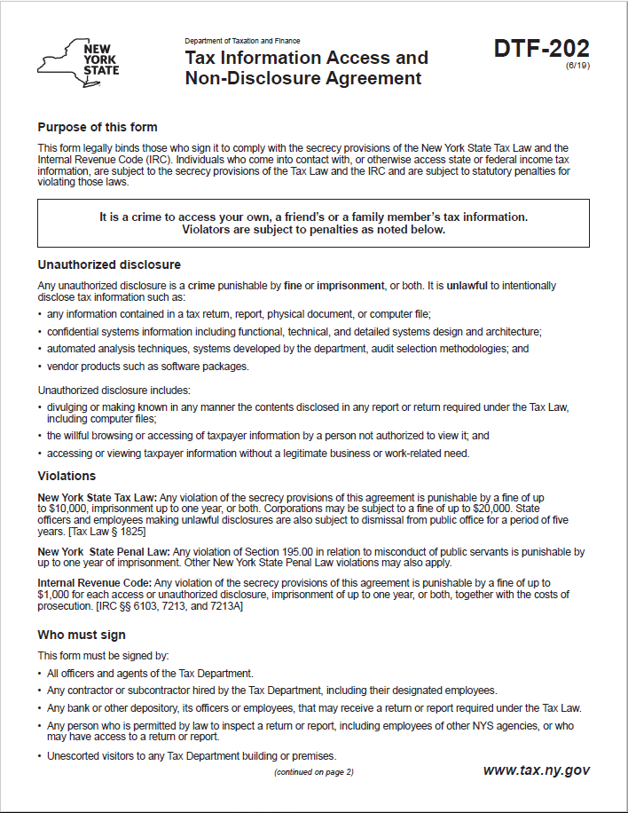
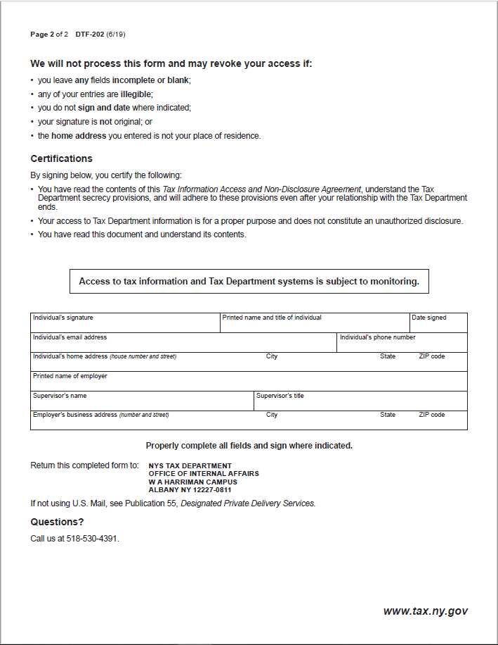

Exhibit B - Contractor Sales Tax Certification Forms
Note: These forms are available at the NYS Department of Taxation and Finance website:
ST-220-TD: https://www.tax.ny.gov/pdf/current_forms/st/st220td_fill_in.pdf
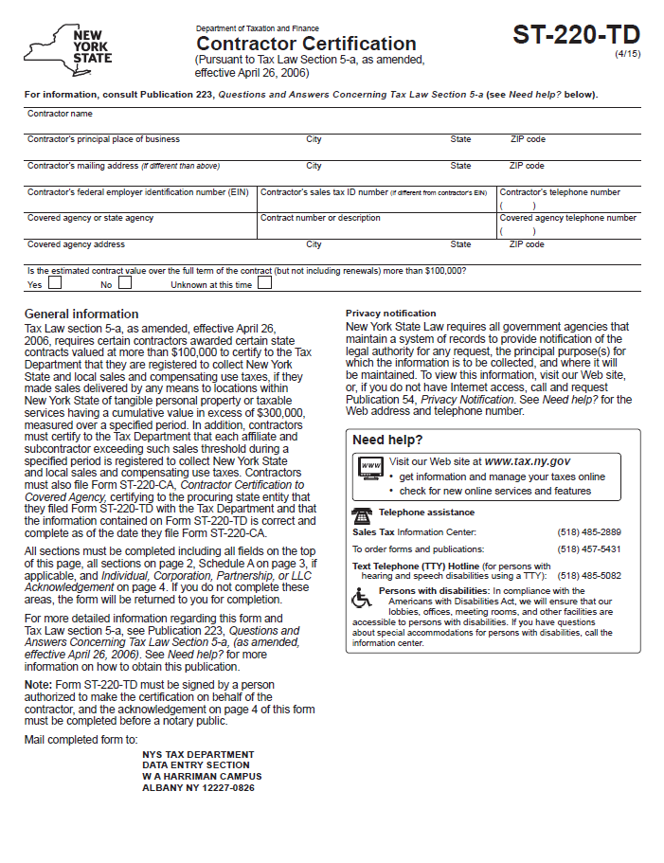
ST-220-CA: https://www.tax.ny.gov/pdf/current_forms/st/st220ca_fill_in.pdf

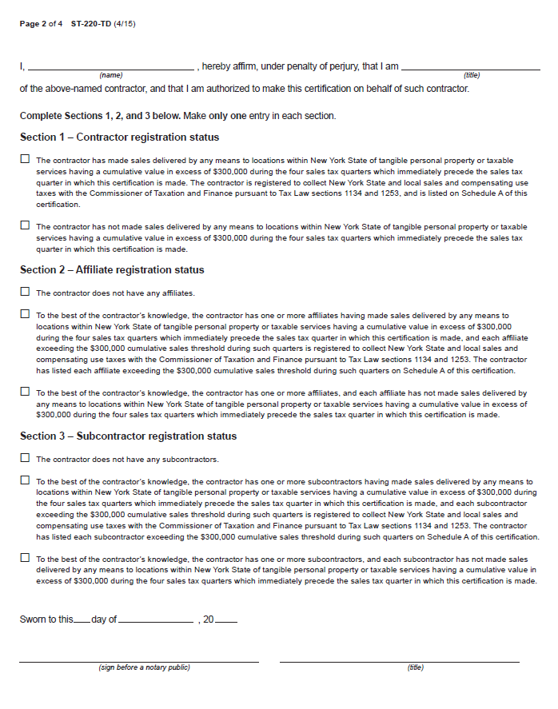
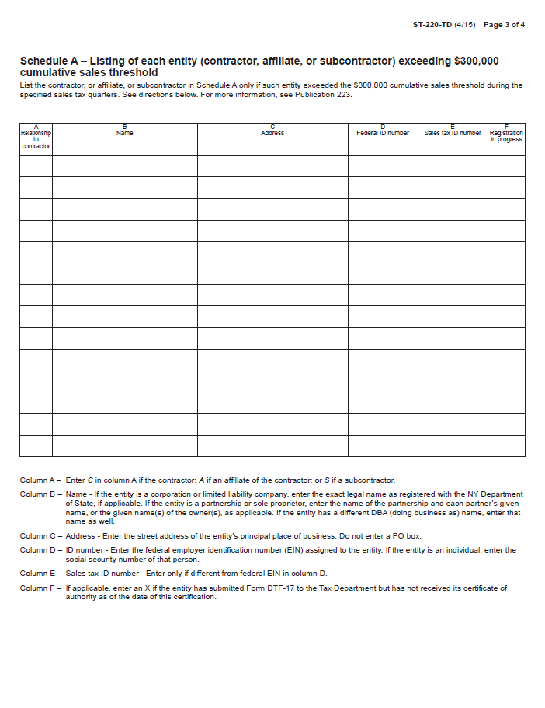
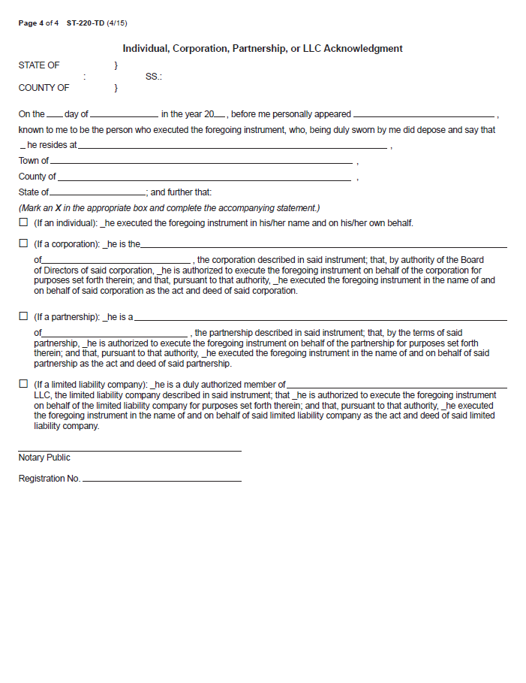
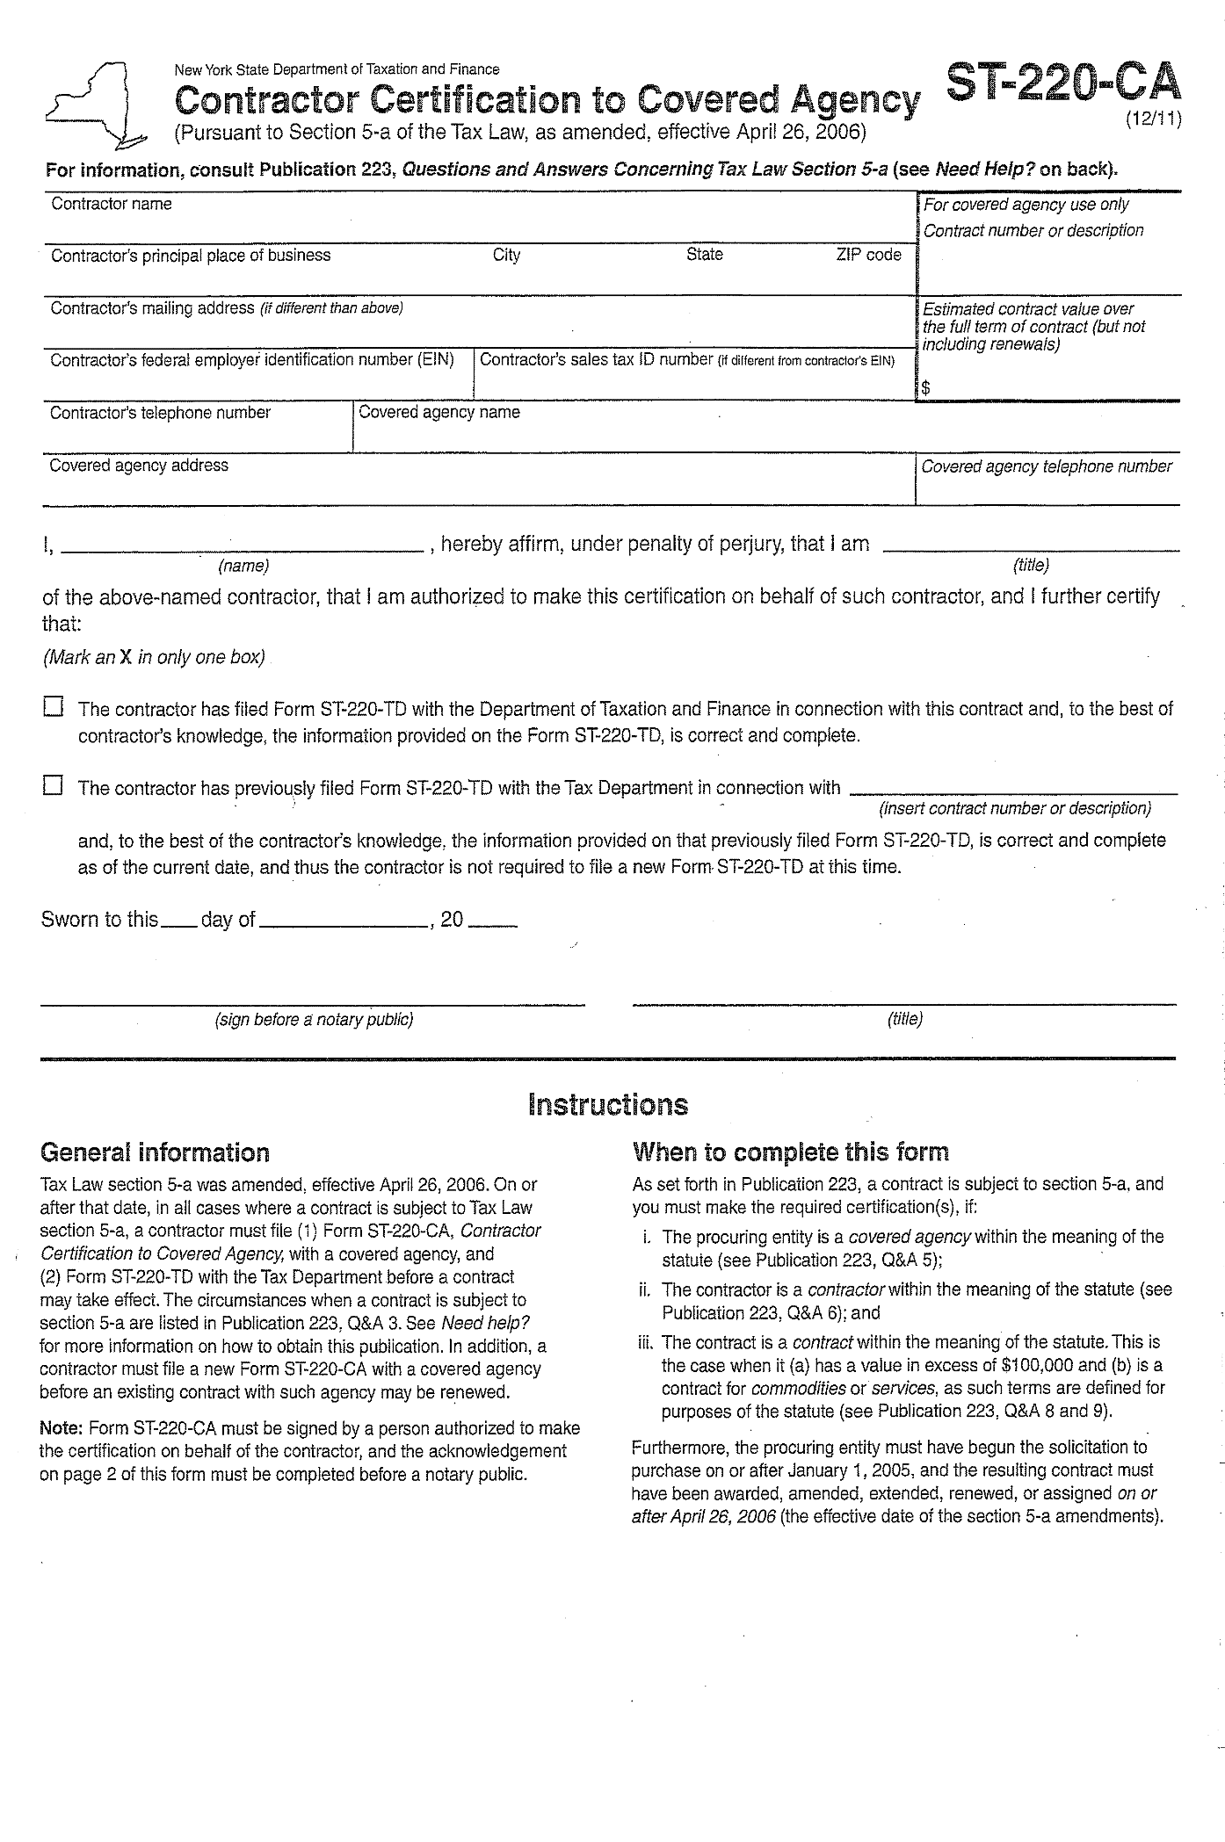

Exhibit C – Minority and Women-Owned Business Enterprises – Equal Employment Opportunity Policy Statement
M/WBE AND EEO POLICY STATEMENT
I, _________________________, the (awardee/contractor)____________________ agree to adopt the following policies with respect to the project being developed or services rendered at __________________________________________________________________________________
M/WBE

EEO

This organization will and will cause its contractors and subcontractors to take good faith actions to achieve the M/WBE contract participations goals set by the State for that area in which the State-funded project is located, by taking the following steps:
- Actively and affirmatively solicit bids for contracts and subcontracts from qualified State certified MBEs or WBEs, including solicitations to M/WBE contractor associations.
- Request a list of State-certified M/WBEs from AGENCY and solicit bids from them directly.
- Ensure that plans, specifications, request for proposals and other documents used to secure bids will be made available in sufficient time for review by prospective M/WBEs.
- Where feasible, divide the work into smaller portions to enhanced participations by M/WBEs and encourage the formation of joint venture and other partnerships among M/WBE contractors to enhance their participation.
- Document and maintain records of bid solicitation, including those to M/WBEs and the results thereof. Contractor will also maintain records of actions that its subcontractors have taken toward meeting M/WBE contract participation goals.
- Ensure that progress payments to M/WBEs are made on a timely basis so that undue financial hardship is avoided, and that bonding and other credit requirements are waived or appropriate alternatives developed to encourage M/WBE participation.

  - This organization will not discriminate against any employee or applicant for employment because of race, creed, color, national origin, sex, age, disability or marital status, will undertake or continue existing programs of affirmative action to ensure that minority group members are afforded equal employment opportunities without discrimination, and shall make and document its conscientious and active efforts to employ and utilize minority group members and women in its work force on state contracts.
  - This organization shall state in all solicitation or advertisements for employees that in the performance of the State contract all qualified applicants will be afforded equal employment opportunities without discrimination because of race, creed, color, national origin, sex disability or marital status.
  - At the request of the contracting agency, this organization shall request each employment agency, labor union, or authorized representative will not discriminate on the basis of race, creed, color, national origin, sex, age, disability or marital status and that such union or representative will affirmatively cooperate in the implementation of this organizations’ obligations herein.
  - Contractor shall comply with the provisions of the Human Rights Law, all other State and Federal statutory and constitutional non-discrimination provisions. Contractor and subcontractors shall not discriminate against any employee or applicant for employment because of race, creed (religion), color, sex, national origin, sexual orientation, marital status or domestic violence victim status, and shall also follow the requirements of the Human Rights Law with regard to non-discrimination on the basis of prior criminal conviction and prior arrest.

- This organization will include the provisions of sections (a) through (d) of this agreement in every subcontract in such a manner that the requirements of the subdivisions will be binding upon each subcontractor as to work in connection with the State contract.

Agreed to this _______ day of ____________________, 2___________
By __________________________________________
Print: _____________________________________ Title: _____________________________
Minority Business Enterprise Liaison
_________________________________is designated as the Minority Business Enterprise Liaison
(Name of Designated Liaison)
responsible for administering the Minority and Women-Owned Business Enterprises- Equal Employment Opportunity (M/WBE-EEO) program.

M/WBE Contract Goals
________% Minority Business Enterprise Participation
________% Women’s Business Enterprise Participation

EEO Contract Goals
________% Minority Labor Force Participation
________%Female Labor Force Participation

____________________________________________
(Authorized Representative)
Title: ________________________________________
Date: ________________________________________

Exhibit D – State Consultant Services – Contractor’s Planned Employment – Form A
New York State Consultant Services
Contractor's Planned Employment
From Contract Start Date Through the End of the Contract Term
State Agency Name: NYS Department of Taxation and Finance
State Agency Department ID: 3850000 |  |  |  |  |  | Agency Business Unit: TAX01
Contractor Name: |  |  |  |  |  | Contract Number:
Contract Start Date: / / |  |  |  | Contract End Date: / /
Employment Category |  |  | Number of Employees |  | Number of hours to be worked |  |  | Amount Payable Under the Contract
Total this page |  |  | 0 |  | 0 |  |  | $ 0.00
 | Grand Total
Name of person who prepared this report:
Title: |  |  |  |  |  |  | Phone #:
Preparer's Signature:
Date Prepared: / /
(Use additional pages, if necessary) |  |  |  |  |  |  |  | Page of

Exhibit E – Contractor’s Annual Employment Report – Form B
New York State Consultant Services
Contractor’s Annual Employment Report
Report Period: April 1, to March 31,
Contracting State Agency Name: NYS Department of Taxation and Finance
Contract Number: |  |  |  |  |  | Agency Business Unit: TAX01
Contract Term: / / to / / |  |  |  |  |  | Agency Department ID: 3850000
Contractor Name:
Contractor Address:
Description of Services Being Provided:

Scope of Contract (Choose one that best fits):
Analysis Evaluation Research Training
Data Processing Computer Programming Other IT consulting
Engineering Architect Services Surveying Environmental Services
Health Services Mental Health Services
Accounting Auditing Paralegal Legal Other Consulting
Employment Category |  |  | Number of Employees |  | Number of  Hours Worked |  |  | Amount Payable Under the Contract
Total this page |  |  | 0 |  | 0 |  |  | $ 0.00
 | Grand Total
Name of person who prepared this report:
Title: |  |  |  |  |  |  | Phone #:
Preparer's Signature:
Date Prepared: / /
(Use additional pages, if necessary) |  |  |  |  |  |  |  | Page of

Exhibit F – New York State Office of the State Comptroller Substitute Form W-9
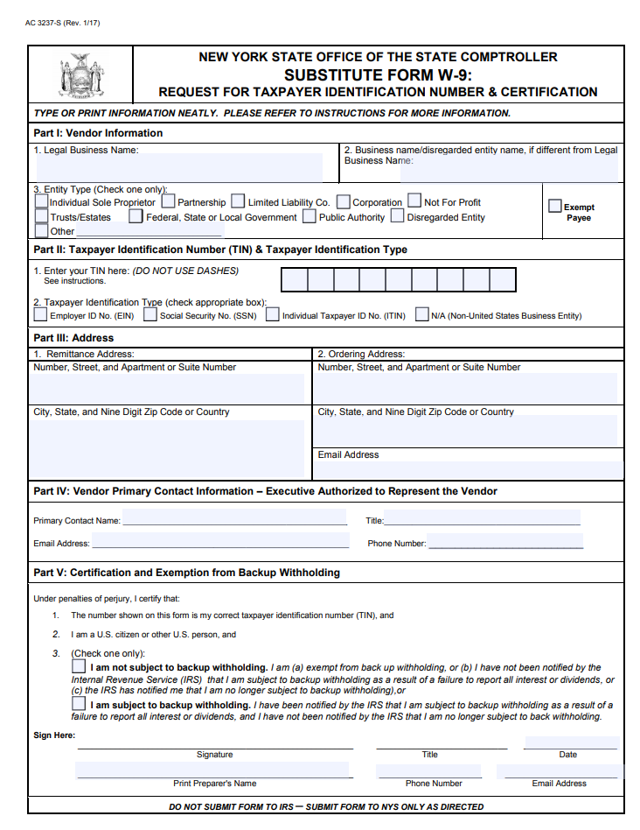
Note: This form is available at the NYS Office of State Comptroller website: https://www.osc.state.ny.us/vendors/forms/ac3237s_fe.pdf
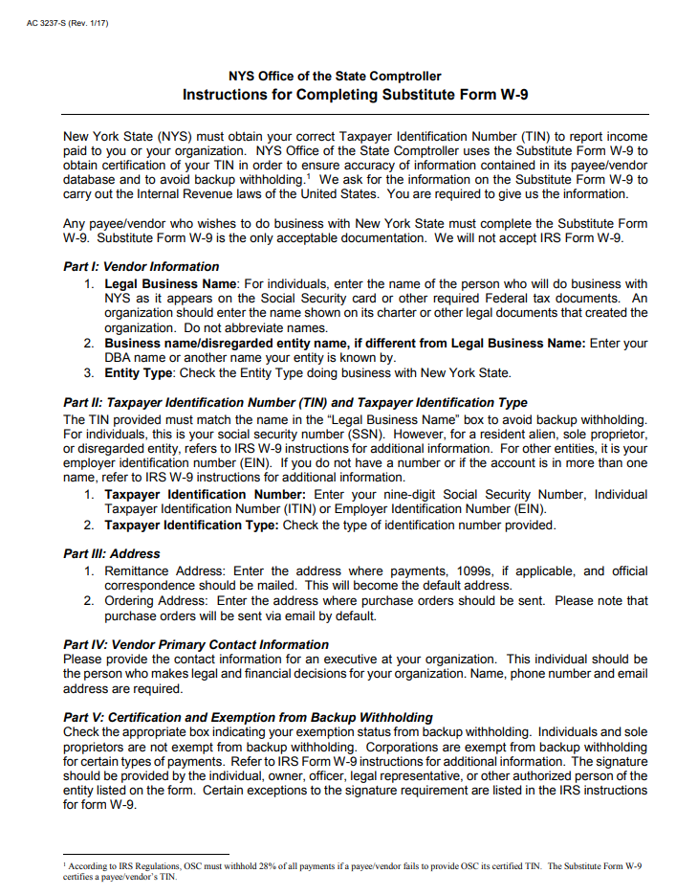

Exhibit G - Workforce Utilization Report
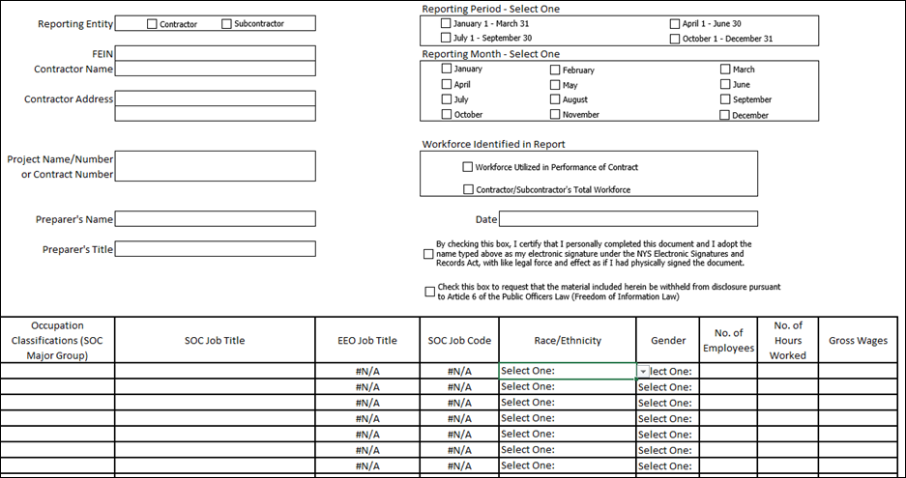
Note: An Excel file of this form will be provided to the Contractor after contract execution.

Exhibit H – Secrecy & Non-Disclosure List (to be submitted by Contractor to DTF)

SECTION A
Contract #: |  |  | Contractor Name:
Date:
The Contractor shall submit this Secrecy & Non-Disclosure List to DTF within 30 days of Contract execution and update this List every six (6) months to reflect any changes to the individuals assigned to perform work under the Contract or who may access confidential or tax information throughout the Contract term.

SECTION B
Listing of Employees/Agents of Contractor/Subcontractor Performing Work Under the Contract
*Do not abbreviate any entries. Duplicate form as needed.
 |  |  |  | Page: |  | of
Full Name of Individual |  | Employer Full Name |  | Job Title
Complete & send to NYS Tax Department, Office of Risk Management at tax.dl.irscomplianceunit@tax.ny.gov

Exhibit 1 – Special Franchise Property and Telecommunications Assessment Ceiling Property by Location
SLIC Network Solutions, Inc.
Locations marked with ^ include Nicholville Telephone Company
All years 2021 and 2022 challenge TAC assessments only
Year(s) at issue | Location by Town  (and/or village) | Property Type
2022, 2023, 2024, 2025 | Altona | Special Franchise and TAC
2024, 2025 | Argyle | Special Franchise and TAC
2025 | Ausable | Special Franchise
2025 | Ballston | Special Franchise
2020, 2021, 2022, 2023, 2024, 2025 | Bangor | Special Franchise and TAC
2023, 2024, 2025 | Beekmantown | Special Franchise and TAC
2020, 2021, 2022, 2023, 2024, 2025 | Bellmont | Special Franchise and TAC
2024, 2025 | Bombay | Special Franchise and TAC
2020, 2021, 2022, 2023, 2024, 2025 | Brandon | Special Franchise and TAC
2020, 2021, 2022, 2023, 2024, 2025 | Brasher ^ | Special Franchise and TAC
2020 | Brushton (village) | TAC
2024, 2025 | Cambridge | Special Franchise and TAC
2020, 2021, 2022, 2023, 2024, 2025 | Canton | Special Franchise and TAC
2020, 2021, 2022, 2023, 2024, 2025 | Canton (village) | Special Franchise and TAC
2023, 2024, 2025 | Chateaugay | Special Franchise and TAC
2021, 2022, 2023, 2024, 2025 | Chester | Special Franchise and TAC
2023, 2024, 2025 | Chesterfield | Special Franchise and TAC
2020, 2021, 2022, 2023, 2024, 2025 | Clare | Special Franchise and TAC
2020, 2021, 2022, 2023, 2024, 2025 | Clifton | Special Franchise and TAC
2023, 2024, 2025 | Colton | Special Franchise and TAC
2020, 2021, 2022 | Colton | TAC
2024, 2025 | Constable | Special Franchise and TAC
2024, 2025 | Crown Point | Special Franchise and TAC
2020, 2021, 2022, 2023, 2024, 2025 | Dannemora | Special Franchise and TAC
2020, 2021, 2022, 2023, 2024, 2025 | Dannemora (village) | Special Franchise and TAC
2020, 2021, 2022, 2023, 2024, 2025 | De Peyster | Special Franchise and TAC
2025 | Diana | TAC
2020, 2021, 2022, 2023, 2024, 2025 | Dickinson | Special Franchise and TAC
2021, 2022, 2023, 2024, 2025 | Dresden | Special Franchise and TAC
2023, 2024, 2025 | Duane | Special Franchise and TAC
2024, 2025 | Easton | Special Franchise and TAC
2021, 2022, 2023, 2024, 2025 | Elizabethtown | Special Franchise and TAC
2020, 2021, 2022, 2023, 2024, 2025 | Ellenburg | Special Franchise and TAC
2023, 2024, 2025 | Essex | Special Franchise and TAC
2020, 2021, 2022, 2023, 2024, 2025 | Fine | Special Franchise and TAC
2024, 2025 | Fort Ann | Special Franchise and TAC
2024, 2025 | Fort Covington | Special Franchise and TAC
2024, 2025 | Fort Edward | Special Franchise and TAC
2024, 2025 | Granville | Special Franchise and TAC
2024, 2025 | Greenwich | Special Franchise and TAC
2024, 2025 | Hague | TAC
2023, 2024, 2025 | Hampton | Special Franchise and TAC
2020 | Harrietstown | Special Franchise and TAC
2024, 2025 | Hartford | Special Franchise and TAC
2024, 2025 | Hebron | Special Franchise and TAC
2020, 2021, 2022, 2023, 2024, 2025 | Hopkinton ^ | Special Franchise and TAC
2023, 2025 | Johnsburg | Special Franchise
2021, 2022, 2023, 2024 | Johnsburg | TAC
2020, 2021, 2022, 2023, 2024, 2025 | Keene | Special Franchise and TAC
2023, 2024, 2025 | Lake George | Special Franchise and TAC
2025 | Lake George (village) | TAC
2020, 2021, 2022, 2023, 2024, 2025 | Lawrence ^ | Special Franchise and TAC
2021, 2022, 2023, 2024, 2025 | Lewis | Special Franchise and TAC
2020, 2021, 2022, 2023, 2024, 2025 | Lisbon | Special Franchise and TAC
2023, 2024, 2025 | Long Lake | Special Franchise
2020, 2021, 2022, 2023 | Long Lake | TAC
2020, 2021, 2022, 2023, 2024, 2025 | Louisville | Special Franchise and TAC
2020, 2021, 2022, 2023, 2024, 2025 | Madrid | Special Franchise and TAC
2020, 2021, 2022, 2023, 2024, 2025 | Malone | Special Franchise and TAC
2020, 2021, 2022, 2023, 2024, 2025 | Malone (village) | Special Franchise and TAC
2020, 2021, 2022, 2023, 2024, 2025 | Massena | Special Franchise and TAC
2020, 2021, 2022, 2023, 2024, 2025 | Massena (village) | Special Franchise and TAC
2020, 2021, 2022, 2023, 2024, 2025 | Minerva | Special Franchise and TAC
2020, 2021, 2022, 2023, 2024, 2025 | Moira | Special Franchise and TAC
2024, 2025 | Mooers | Special Franchise and TAC
2024, 2025 | Moriah | Special Franchise and TAC
2020, 2021, 2022, 2023, 2024, 2025 | Newcomb | Special Franchise and TAC
2020, 2021, 2022, 2023, 2024, 2025 | Norfolk | Special Franchise and TAC
2020, 2024, 2025 | North Elba | Special Franchise and TAC
2021, 2022 | North Elba | TAC
2020, 2021, 2022, 2023, 2024, 2025 | North Hudson | Special Franchise and TAC
2023, 2024, 2025 | Norwood | Special Franchise and TAC
2023, 2024, 2025 | Ogdensburg (city) | Special Franchise
2020, 2021, 2022, 2023 | Ogdensburg (city) | TAC
2020, 2021, 2022, 2023, 2024, 2025 | Oswegatchie | Special Franchise and TAC
2020, 2021, 2022, 2023, 2024, 2025 | Parishville | Special Franchise and TAC
2025 | Peru | Special Franchise
2020, 2021, 2022, 2023, 2024, 2025 | Piercefield | Special Franchise and TAC
2020, 2021, 2022, 2023, 2024, 2025 | Pierrepont | Special Franchise and TAC
2024, 2025 | Plattsburgh | Special Franchise and TAC
2020, 2021, 2022, 2023, 2024, 2025 | Potsdam | Special Franchise and TAC
2020, 2021, 2022, 2023, 2024, 2025 | Potsdam (village) | Special Franchise and TAC
2021, 2022, 2023, 2024, 2025 | Putnam | Special Franchise and TAC
2020, 2021, 2022, 2023, 2024, 2025 | Russell | Special Franchise and TAC
2024, 2025 | Salem | Special Franchise and TAC
2024, 2025 | Santa Clara | TAC
2020, 2021, 2022, 2023, 2024, 2025 | Saranac | Special Franchise and TAC
2020, 2021, 2022, 2023, 2024, 2025 | Saranac Lake (village) | Special Franchise and TAC
2024, 2025 | Schaghticoke | Special Franchise
2020, 2021, 2022, 2023, 2024, 2025 | Schroon | Special Franchise and TAC
2025 | Sherrill (city) | TAC
2020 | St. Armand | Special Franchise and TAC
2020, 2021, 2022, 2023, 2024, 2025 | Stockholm ^ | Special Franchise and TAC
2021, 2022, 2023, 2024, 2025 | Stony Creek | Special Franchise and TAC
2021, 2022, 2023, 2024, 2025 | Thurman | Special Franchise and TAC
2023, 2024, 2025 | Ticonderoga | Special Franchise and TAC
2020, 2021, 2022, 2023, 2024, 2025 | Tupper Lake | Special Franchise and TAC
2020, 2021, 2022, 2023, 2024, 2025 | Tupper Lake (village) | Special Franchise and TAC
2025 | Vernon | TAC
2020, 2021, 2022, 2023, 2024, 2025 | Waddington | Special Franchise and TAC
2020, 2021, 2022, 2023, 2024, 2025 | Waddington (village) | Special Franchise and TAC
2021, 2022, 2023, 2024, 2025 | Warrensburg | Special Franchise and TAC
2020, 2023, 2024, 2025 | Waverly | Special Franchise and TAC
2022 | Waverly | TAC
2024, 2025 | Westville | Special Franchise and TAC
2021, 2022, 2023, 2024, 2025 | Whitehall | Special Franchise and TAC
2024, 2025 | Whitehall (village) | Special Franchise and TAC
2021, 2022, 2023, 2024, 2025 | Willsboro | Special Franchise and TAC

Exhibit 2 – NYS Department of Taxation & Finance (DTF) Pre-Authorization for Non-Employee Travel
Travel Justification:
Traveler Information
Traveler Name
Company name & Contract # (if applicable)
Starting Location (city/state)
Destination Location (city/state)
Travel Dates
Expense Descriptions
LODGING
Lodging (Number of nights)
Lodging GSA Rates | $
LODGING TOTAL | $
MEALS
Meals GSA Rates | $
MEALS TOTAL | $
TRANSPORTATION
Transportation Type: Train | $
Transportation Type: Airplane | $
Transportation Type: Vehicle Rental | $
Transportation Type: Other | $
Transportation Type: Personal Vehicle Mileage | $
TRANSPORTATION TOTAL | $
INCIDENTALS
Parking Estimated Amount | $
Gas (Vehicle rentals) Estimated Amount | $
Tolls Estimated Amount | $
Taxi, Uber, Lyft, etc. | $
INCIDENTALS TOTAL | $
TOTAL ESTIMATE | $
Before submitting this form, per the Office of the State Comptroller (OSC) Travel Manual (https://www.osc.ny.gov/state-agencies/travel), please ensure the following:
- All authorized travel is in the best interest of the State
- All expenses are actual, reasonable and necessary
- The most economical method of travel is secured
Contractor Signature
DTF Program Signature
DTF Bureau of Fiscal Services Signature

NYS Department of Taxation & Finance (DTF) Non-Employee Travel Forms and Information
Before submitting "Pre-Authorization for Non-Employee Travel" form, please ensure the following per the Office of the State Comptroller (OSC) Travel Manual (https://www.osc.ny.gov/state-agencies/travel):
• All authorized travel is in the best interest of the State
• All expenses are actual, reasonable and necessary
• The most economical method of travel is secured
Type of Expense | Expense Description | Links | Forms
LODGING
Receipted Method: | Lodging receipt required and must be more than 35 miles from home or office location. Lodging reimbursed by US Government Services Administration (GSA) rates + sales tax. NYS contractors are not guaranteed but can request the government rate. | https://www.gsa.gov/travel/plan-book/per-diem-rates
Unreceipted Method | No lodging receipt required (stay with family or friends) and must be more than 35 miles from home or office location. No lodging reimbursement for this method, but NYS contractors will receive meal reimbursements.
MEALS
Lodging in hotel | Overnight Meal Per Diem (If lodging in hotel) - Meals reimbursed pursuant to GSA per diem rates if lodging overnight and have a hotel receipt. No meal receipts required. | https://www.gsa.gov/travel/plan-book/per-diem-rates
Staying overnight with family or friends | Unreceipted Overnight Meal Per Diem if staying overnight with family or friends. Reimbursed pursuant to OSC Travel Manual Rates (see chart below).
TRANSPORTATION |  |  | Statement of Incidental and Transportation Expenses: https://www.osc.ny.gov/files/state-agencies/resources/pdf/agency-form-ac3259s-fe.pdf
Personal Vehicle Mileage | Reimbursed by OSC mileage rates. Gas and other incidental costs are included in the mileage rates and are not reimbursable. | https://www.osc.ny.gov/state-agencies/gfo/chapter-xiii/xiii4c-travel-mileage-rates | Statement of Automobile Travel: https://www.osc.ny.gov/files/state-agencies/2017-11/agency-form-ac160s-fe.pdf
Rental Vehicle | Rental vehicle cost is reimbursable - additional add ons/fees are not. NYS contractors are not entitled to the rates in the NYS vehicle rental contract.
Taxi, Uber, Lyft, etc. | Reimbursable with receipt and must be most efficient mode of transportation.
Airfare | Reimbursable with prior approval from DTF. Business class tickets are not reimbursable.
Train | Reimbursable with prior approval from DTF. Business class tickets are not reimbursable.
INCIDENTAL |  |  | Statement of Incidental and Transportation Expenses: https://www.osc.ny.gov/files/state-agencies/resources/pdf/agency-form-ac3259s-fe.pdf
Gas | Only reimbursable in rental vehicle with a receipt.
Tolls | Reimbursable with receipt/statement.
Parking | Reimbursable with receipt.

Unreceipted Meal Per Diem Rates
