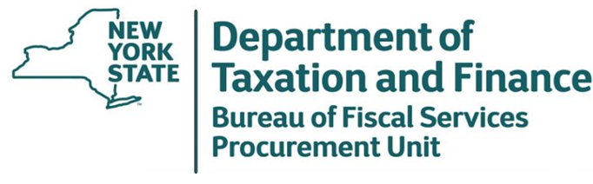

May 8, 2026

Request for Proposals (RFP) 26-100
Real Property Appraisal Services – Special Franchise Properties and Telecommunications Assessment Ceiling Properties

Responses to First Round Bidder Questions

To All Potential Bidders:
Attached are the Department’s Responses to Bidder Questions received for the above referenced RFP.

Table 1: RFP 26-100 DTF Responses to First Round of Questions and Answers
# | RFP Reference |  | Question | Answer
# | Section | Page | Question | Answer
1 | RFP Section 2. Scope of Services  2.1 Review Cost Data | 11 | How should assets funded by third parties (Contributions in Aid of Construction, or CIAC) be treated in the valuation, should they be included in the RCNLD analysis, or treated differently? | The Department applies the cost approach in valuing utility companies. Accordingly, utility companies are required to report their property inventory at original cost, regardless of which party incurred those costs. The identity of the payer is not considered relevant for valuation purposes.
2 | RFP Section 2. Scope of Services  2.1 Review Cost Data | 11 | Can the Department provide an indication of the scale and structure of the original cost data to be provided, including approximate total dollar value, number of asset records, and how the data is organized and distributed by municipality? | The original cost data is provided by account number, municipality, install year, and whether the property is located on the public or private right-of-way. From 2024 inventory filing, there was about $21,000,000 original cost in the Highway (both taxable and non-taxable accounts) and about $58,000,00 original cost Mass Property in Private (both taxable and non-taxable) for about 2,300 asset records.
3 | RFP Section 2. Scope of Services  2.1 Review Cost Data | 11 | Will the original cost data provided by the Department be available at the individual asset detail, or will it be provided in aggregated property account groupings? If aggregated, can the Department clarify the typical level of grouping (e.g., by account, vintage year, or asset class), and whether supporting detail sufficient for depreciation, obsolescence, and net salvage analysis will be available? | The original cost data will be provided in aggregated property account groupings.  The Department can specify municipality / account number / Vintage year / cost incurred by, and obsolescence requests submitted by the company.
4 | RFP Section 2. Scope of Services  2.1 Review Cost Data | 11 | Will the Department provide supporting records such as Continuing Property Records (CPRs), GIS data, network maps, or engineering diagrams in addition to the original cost data? | This information will not be provided by the Department.
5 | RFP Section 2. Scope of Services  2.1 Review Cost Data | 11 | Will the Department’s original cost data identify the municipality associated with each cost record or account grouping, such that the property can be directly valued by assessing unit? | Yes, the original cost data will identify the municipality associated with each cost record and/or account grouping.
6 | RFP Section 2. Scope of Services  2.8 Milestones | 13-14 | Are “intangible values” expected to be included in the appraised value conclusions, and what specific items or components are considered “intangible values” for purposes of this assignment? | The intangible value is expected to be included in the appraised value conclusion. The intangible value deems to be the usage of the public right-of-way and is valued at five percent of the RCNLD of the tangible physical property. Five percent of the RCNLD of physical property has historically been considered a reasonable estimate of the intangible value. The calculation of the intangible value of the special franchise is outlined in the Procedures of the Office of Real Property Tax Services and has been accepted by the courts in the past.  The Procedures can be found at https://www.tax.ny.gov/research/property/legal/procedures/index.htm.
7 | RFP Section 2. Scope of Services  2.9 Subcontracting – Civil Engineer | 14-15 | Has the Department received inquiries from NYS-certified MWBE civil engineering firms regarding participation in this engagement, and can the Department identify any such firms? | The Department has not received inquiries from NYS-certified MWBE civil engineering firms regarding participation in this engagement. Bidders are encouraged to review the NYS Certified MWBE Directory at https://ny.newnycontracts.com/FrontEnd/searchcertifieddirectory.asp and reach out to potential subcontractors.  To assist in outreach, the Department has included an Excel Spreadsheet listing 137 MWBE certified businesses in civil engineering classifications from the NYS certified MWBE directory as of 05/07/2026.  In a recent contract for similar services, a certified MWBE firm BVF Engineering, Inc. was identified as a subcontractor.

