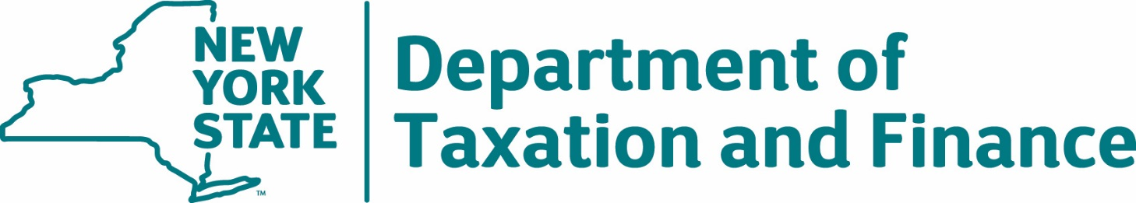

Request for Proposals
23-101
Cigarette Tax Stamps Manufacturing Solution

Exhibits

Table of Contents
Exhibit A – Preliminary Base Contract 3
Article I. Definitions 3
Article II. Entirety of Agreement 4
Article III. Contractor Responsibilities 5
Article IV. Department Responsibilities 6
Article V. Contract Term 7
Article VI. Fees and Payment 7
Article VII. Tax Secrecy and Confidentiality 8
Article VIII. Reserved Rights 10
Article IX. Testing and Acceptance of Stamps after Contract Award 10
Article X. Notice of Deficiency/Cover; Other Remedies; Dispute Resolution 10
Article XI. Continuing Administrative Requirements 12
Article XII. Participation By Minority And Women-Owned Business Enterprises: Requirements and Procedures 12
Article XIII. Participation Opportunities for New York State Certified Service-Disabled Veteran-Owned Businesses 15
Article XIV. Termination 15
Article XV. Indemnification and Limitation of Liability 17
Article XVI. Ethics Provisions 20
Article XVII. No Conflict of Interest (Contractor & Subcontractors) 21
Article XVIII. Insurance 21
Article XIX. Contractor and Subcontractors 25
Article XX. General Terms and Conditions 27
Exhibit B – Contractor Sales Tax Certification Forms 34
Exhibit C – New York State Office of the State Comptroller Substitute Form W-9 40
Exhibit D – Minority and Women-Owned Business Enterprises – Equal Employment Opportunity Policy Statement 42
Exhibit E – Workforce Utilization Report 44

Exhibit A – Preliminary Base Contract
THIS AGREEMENT is between the New York State Department of Taxation and Finance, located at Building 9, W.A. Harriman State Office Campus, Albany, New York 12227 (hereinafter, the “Department” or “DTF” or the “State”), New York City Department of Finance, located at 55 Maiden Lane, 32nd Floor, New York, NY 10038 (hereinafter, the “City”), and [insert Contractor Name], with principal place of business located at [insert Contractor’s address] (hereinafter, the “Contractor”). The Department, City and Contractor are collectively referred to as the “Parties.”
WHEREAS, the Department issued Request for Proposals (RFP) 23-101 on [insert issued date], for a Cigarette Tax Stamps Manufacturing Solution (“Solution”); and
WHEREAS, the Contractor timely submitted a responsive Proposal to provide the Solution in accordance with the requirements set forth in RFP 23-101 and the Department has determined that the Contractor is responsible; and
WHEREAS, pursuant to Section 9., Proposal Evaluation of said RFP, the Contractor was determined to have provided the best value Proposal and has been determined capable of providing the required Solution; and
WHEREAS, the Contractor is prepared to undertake performance of the manufacture and delivery of a Solution according to the terms of the RFP and this Agreement.
NOW, THEREFORE, in consideration of the mutual covenants and conditions herein set forth, the Parties agree as follows:

Article I. Definitions
The following terms when used herein shall have the specified meanings:
Agreement (also referred to as “Contract”) – This Contract C400753, which includes all documents identified in Article II. Entirety of Agreement.
Attorney General or AG - See RFP 23-101 at Appendix C, RFP Glossary.
Base Contract - See RFP 23-101 at Appendix C, RFP Glossary.
City - See RFP 23-101 at Appendix C, RFP Glossary.
Commissioner - See RFP 23-101 at Appendix C, RFP Glossary.
Contractor - [successful Bidder’s name to be inserted here].
Cure Period - The period of time during which Contractor may have the opportunity to cure a Deficiency or a Material Breach, as set forth in the applicable Notice of Deficiency issued by the Department.
Deficiency - Any failure by Contractor to meet requirements in providing the Solution pursuant to this Agreement.

Department or DTF - See RFP 23-101 at Appendix C, RFP Glossary.
Disaster Recovery Plan - See RFP 23-101 at Appendix C, RFP Glossary.
Dispute Resolution - The procedure set forth in Article X.C for resolving disputes arising under this Agreement.
Initial Order - See RFP 23-101 at Appendix C, RFP Glossary.
Material Breach - The failure to perform an obligation that Contractor is bound to perform under this Agreement which materially impacts the State or is so fundamental to the undertaking that Contractor’s failure to perform defeats the purpose of the Agreement.
Notice of Deficiency or NOD - A written notice which may be issued to the Contractor by the Department, in its sole discretion, to set forth a Deficiency.
Notice of Termination - The written notification issued to the Contractor by DTF following a Cure Period, if applicable, which sets forth the termination date of the Agreement.
OGS-BSC - The New York State Office of General Services, Business Services Center.
OSC – See RFP 23-101 at Appendix C, RFP Glossary.
Proposal (or Bid) - See RFP 23-101 at Appendix C, RFP Glossary.
Services - See RFP 23-101 at Appendix C, RFP Glossary.
Solution - Solution includes, but is not limited to, the Cigarette Excise and Prepaid Sales Taxes Stamps and Services which will satisfy all of the requirements of the RFP.

Stamp(s) - See RFP 23-101 at Appendix C, RFP Glossary.

Subcontractor - See RFP 23-101 at Appendix C, RFP Glossary.

Tax Law - The New York State Tax Law.

Article II. Entirety of Agreement
This Contract C400753 shall consist of the documents listed below, which are fully incorporated by reference. In the event of a conflict between or among the provisions of the Contract, such conflict shall be resolved by reference to the documents in the order listed with Appendix A having precedence:
Appendix A to the RFP, “Standard Clauses for New York State Contracts,” dated June 2023;
Attachment 17 to the RFP – DTF-202, “Tax Information Access and Non-Disclosure Agreement,” dated 06/2019 (“DTF-202”);
Attachment 18 to the RFP– City of New York – Department of Finance - Agreement to Adhere to the Secrecy and Confidentiality Provisions of the New York City Administrative Code, New York State Tax Law and the Internal Revenue Code;
Attachment 19 to the RFP - New York City Tax Affirmation;
Any written amendments and/or changes to the Agreement agreed to by the Parties and approved, where necessary, by the Attorney General and the Office of the State Comptroller;
Base Contract;
Any Amendments and Clarifications to RFP 23-101, including Questions and Answers issued by DTF, as follows: [List by Title and/or Date];
RFP 23-101 (including attachments to the RFP, but excluding Appendix A, Attachment 17, Attachment 18, and Attachment 19 thereto);
Contractor’s Proposal Clarifications, as follows: [List by Title and/or Date]; and
Contractor’s Proposal (excluding Contractor’s Proposal Clarifications).

Article III. Contractor Responsibilities
In addition to the Contractor responsibilities set forth elsewhere in the RFP and this Agreement, the Contractor shall:
- Provide the Solution and associated Services as set forth herein, in RFP 23-101, and the Contractor’s Proposal in response to said RFP;

- Comply with the Secrecy requirements set forth in Article VII;

- Warrant and affirm that the terms of this Agreement do not violate any contract or agreement to which the Contractor is a party and that Contractor’s other contractual obligations will not adversely influence its performance under this Agreement;
- Maintain insurance as set forth in RFP 23-101 and this Agreement;
- Maintain accurate records;
- Accept Department oversight, and keep the Department informed of any problems encountered in providing the Services;
- Pay, at its sole expense, all applicable permits, licenses, tariffs, tolls and fees and give all notices and comply with all Federal, State, and local laws, ordinances, rules and regulations of any governmental entity in conjunction with the performance of obligations under the Agreement;

- Ensure Subcontractor (if any) compliance with all responsibilities under this Agreement, as applicable;

- Not disclose any data provided by the Department to any other individual or entity except as expressly provided by law. The data provided, while in the custody of the Contractor, must be kept confidential, and the Contractor must take all reasonable and prudent steps to ensure the data is fully protected and secured;
- Make good faith efforts to follow any recommendations made by the Department regarding the performance of the Agreement;
- Comply and cooperate with all testing and acceptance criteria set forth in RFP 23-101, section 1.4;

- Immediately notify the Department of any instance of employee or Subcontractor discipline or termination(s) related to misconduct in the performance of the Services required in this Agreement;

- Accept sole and complete responsibility for the timely and satisfactory performance of all activities required under this Agreement;

- Cooperate with the Department to utilize, where necessary, the Dispute Resolution process to ensure the timely resolution of disputes and technical problems that arise during the term of this Agreement;

- Respond within twenty-four (24) hours (unless such period is extended in writing by the Department because the nature of the issue requires additional time) to any DTF request to provide Services under this Agreement; and

- Continuously provide the qualified and experienced personnel and levels of effort required to provide the Solution and Services in accordance with all requirements as set forth herein and in RFP 23-101, and the Contractor’s Proposal in response to said RFP.

Article IV. Department Responsibilities
In addition to the Department’s responsibilities set forth elsewhere in the RFP and this Agreement, the Department shall:
- Oversee the Solution provided by Contractor and make reasonable recommendations regarding the performance of such Services;
- Make diligent efforts to provide the Contractor with direction, assistance, procedures, and contact persons necessary to perform in accordance with the requirements herein;
- Promptly designate the appropriate contacts following the date of commencement of this Agreement;
- Cooperate with the Contractor to utilize, where necessary, informal dispute resolution as well as the formal dispute resolution process to facilitate the timely resolution of any disputes that arise;
- Provide access to DTF staff, as necessary, to provide the Contractor the business information needed to perform Services under this Agreement;
- Be responsible for the performance of its employees and agents; and
- Advise the Contractor of the security rules, procedures, and regulations that DTF may from time to time establish with respect to DTF’s premises, property, records, and data.

Article V. Contract Term
The term of the Agreement shall be for a five-year period and will commence and become valid and binding between the Parties only upon its approval by both the New York State Attorney General (AG) and the Office of the State Comptroller (OSC).
This Contract may be renewed or modified only upon agreement of the Parties. Such renewal or modification shall be accomplished through written amendment and may require the approval of the New York State Attorney General and the Office of the State Comptroller.

Article VI. Fees and Payment
All fees and payments shall be in accordance with Section 6. Financial Requirements of RFP 23-101, which is incorporated in its entirety herein by reference, and Contractor’s financial proposal, Attachment 20 - Financial Response Form.
- Electronic Payment
Payment for invoices submitted by the Contractor will only be rendered electronically and in accordance with ordinary State procedures and practices. Contractor shall comply with the State Comptroller’s procedures to authorize electronic payments and acknowledges that Contractor will not receive payment on any invoices submitted under this Agreement if it does not comply with the State Comptroller’s electronic payment procedures. The Commissioner, in his/her sole discretion, may authorize payment by paper check, if specifically requested by the Contractor in advance, due to extenuating and documented circumstances necessitating payment by paper check.
In order to receive payment, Contractor must complete and update, as appropriate, its Vendor Record through the online Vendor Self-Service Portal with the applicable Automated Clearing House (ACH) information (e.g., bank routing number, bank account number, account type) into which the Contractor wants payment deposited. It is the Contractor’s responsibility to access the self-service portal, follow instructions provided there, and accurately supply the required information to set up electronic payments. Contractor must input the required ACH information and not permit the payment type to default to payment by paper check. In addition to inputting the appropriate ACH information in the State Comptroller’s Vendor Record system, the Contractor must also advise DTF in writing of the ACH payment information (bank account location) into which it wants payment remitted for this Agreement. The Vendor Self-Service Portal can be found at https://esupplier.sfs.ny.gov/psp/fscm/SUPPLIER. Contractors requiring assistance with accessing or using the self-service portal should contact the NYS Statewide Financial System (SFS) by e-mail at helpdesk@sfs.ny.gov, or by telephone at (855) 233-8363.
- Properly Submitted Invoices
Payment will be made only upon submission of proper invoices by the Contractor, and in accordance with Article 11-A of New York State Finance Law.
Required Information on properly submitted invoices:
- Vendor name;
- Name of NYS Agency that ordered the goods or services;
- Description of goods or services requesting payment for (may be in narrative or code values format);
- Quantity of goods, property, or services delivered or rendered;
- Amount requested; and
- Purchase order (PO) number, if applicable, as provided by ordering agency
It is preferred that an invoice also contain the following information:
- NYS Vendor ID number;
- Invoice Date;
- Unique invoice number;
- Payment terms being offered, if other than Net 30; and
- Any other information or substantiating documentation the agency may reasonably require.
All invoices and payments therefor are subject to the State’s acceptance of the Services for which billing is being made.
Submission:
Preferred Method:
Submit invoices through the SFS Vendor Portal. (Note: Do not email or send a paper copy, in addition to submitting an invoice via the SFS Vendor Portal.)
Alternate Method:
Email invoices to the OGS-BSC at: accountspayable@ogs.ny.gov including the invoice number and the name of the agency being billed in the subject field. (Note: Do not send a paper copy, in addition to the electronic invoice.)
OR
Mail invoices to OGS-BSC at the following U.S. postal address:
New York State Department of Taxation and Finance
c/o NYS OGS Business Services Center
1220 Washington Ave, Building 5, 5th Floor
Albany, NY 12226-1900

Article VII. Tax Secrecy and Confidentiality
RFP 23-101 sets forth mandatory requirements relating to tax secrecy and confidentiality covering, among other things, the required Tax Information Access and Non-Disclosure Agreement form and City of New York secrecy and confidentiality provisions. All are incorporated herein in their entirety by reference thereto. The following contains additional information about Tax Secrecy and provisions with which the Contractor must comply.

- New York State Tax Law and Federal (Internal Revenue Code) Tax Secrecy Provisions
The various secrecy provisions of the Tax Law (e.g., Tax Law §§ 487, 697(e) and 1825) prohibit independent contractors from disclosing tax information in any manner and provide for misdemeanor prosecution for violations. The secrecy provisions of the Internal Revenue Code (26 USC § 6103) provide for felony prosecution for unauthorized disclosure of Federal tax information in the possession of the Department.
All other information about the Department's operations not covered by the preceding provisions of law must be kept confidential as if it were so covered. Contractor representatives must comply with the administrative procedures enforcing these rules. The Contractor, all staff members and Subcontractors shall agree to view, access, and use only that information relevant and necessary to provide Services to the State under the Agreement; and to subscribe to the provisions of §§ 73 and 74 of the Public Officers Law.
- Tax Secrecy: NYS DTF-202 Form and New York City Secrecy Form
The RFP contains Secrecy Requirements for the Contractor (and any Subcontractor, if applicable), with respect to acknowledging and maintaining the secrecy of confidential tax information. As part of its Proposal, the Contractor has had an individual authorized to bind the Contractor execute on behalf of the Contractor both a: (1) Tax Information Access and Non-Disclosure Agreement (DTF-202 – Attachment 17 to the RFP) and a (2) City of New York Department of Finance Agreement to Adhere to the Secrecy and Confidentiality Provisions of the New York City Administrative Code, New York State Tax Law and the Internal Revenue Code Secrecy Provisions, Attachment 18 to the RFP.
The Department reserves the right to require the Contractor to have its employees (and any Subcontractor employees, if applicable) who, in the course of providing Services in connection with this Agreement may view or access tax secret information, sign additional DTF-202 forms and/or complete the Department’s Annual Access and Disclosure Training on DTF’s website at https://www.tax.ny.gov/about/procure. This includes any employees who enter upon Department/City premises in the course of providing Services hereunder. In that event, the Contractor will create and maintain records of such course completion for each such employee, including recording their names, titles and date(s) of completion of the annual training and provide same to DTF upon request. The Contractor will send any additional completed original DTF-202 forms to the Department at the address provided on the DTF-202 form.
- Breach of Confidentiality
The Contractor, through its employees and agents, may have access to tax secret and other confidential and/or proprietary information and materials of the State and tax secret and other confidential and/or proprietary information and materials of third parties rightfully in the State’s possession (“Confidential Information”). Contractor shall maintain all such information in confidence for the sole and exclusive benefit of the State and shall not use same for any purpose whatsoever other than rendering Services to the State.
Contractor acknowledges that any unauthorized use or disclosure of Confidential Information may cause irreparable damage to the State. If an unauthorized use or disclosure occurs, the Contractor shall, at its expense, take such commercially reasonable steps as are necessary to recover Confidential Information and to prevent its subsequent unauthorized use or dissemination, including availing itself of actions for seizure and injunctive relief. If the Contractor fails to take these steps in a timely and adequate manner, the State may take them at the expense of the Contractor.
The Contractor shall be fully liable for breach of the confidentiality provisions of this Agreement in an amount not to exceed the amount allowed by applicable Federal or New York State law (including any damages construed as incidental, consequential or indirect damages).

Article VIII. Reserved Rights
In addition to its other rights as allowed under this Agreement, the Department/City reserves the following rights:
- To add additional unique Stamps and/or Stamp types due to changes in legislative or administrative requirements, or for any other reason, during the term of the Agreement through the Change Control process and/or through Contract Amendment, subject to the approval of OSC and the AG, as appropriate.
2. To send its officers and/or employees into the offices and plants of the Contractor for inspection of the facilities and operations provided for the performance of any work under this Agreement. On the basis of such inspection, specific measures may be required in cases where the Contractor is found to be non-compliant with Contract safeguards. Such determination shall be made at the sole discretion of the Department.
3. To negotiate mutually acceptable modifications throughout the term of this Agreement.
4. To terminate the Agreement if the Contractor does not resolve a conflict of interest to the State’s satisfaction.
5. To require or conduct testing on any Stamps supplied by the Contractor under the Agreement as and when any issue may arise concerning whether the Stamps fully conform to requirements.

Article IX. Testing and Acceptance of Stamps after Contract Award
Testing and acceptance of Contractor’s Stamps shall be in accordance with Section 1.4. Testing and Acceptance of Contractor’s Stamps after Contract Award of RFP 23-101, which is incorporated in its entirety herein by reference.

Article X. Notice of Deficiency/Cover; Other Remedies; Dispute Resolution
- Notice of Deficiency/Cover–Substitute Services

Contractor agrees to comply with all requirements for providing the Solution as set forth in RFP 23-101 and this Agreement. If DTF determines that Contractor is deficient in meeting any requirements, the Department may email a Notice of Deficiency (“NOD”) to Contractor informing Contractor of the Deficiency and requesting it be cured within a time period to be specified by DTF (the “Cure Period”). The Department may, but is not required to, provide the Contractor with a corrective action plan outlining steps to be taken to cure the Deficiency.

If a Deficiency is not resolved to the Department’s satisfaction within the Cure Period set by the Department in the NOD, the Department may email a second NOD to the Contractor, or seek cover as set forth in RFP 23-101 at Section 2. Scope of Services, 2.9. Cover/Substitute Services and/or pursue any other remedies available to it.

- Other Remedies

The remedies set forth above are not exclusive. In addition to them, and other legal remedies available to it, the Department/City may retain from amounts otherwise payable to Contractor such money as may be necessary to satisfy any claim for damages or reimbursements the Department/City may have against Contractor.
Additionally, the Parties recognize that the value of the Stamps is not limited to the cost to produce or reproduce the Stamps and the Department/City may recover damages from the Contractor for any expenses incurred if any Stamps are lost, stolen, or tampered with prior to delivery and acceptance of delivery by the Department. These expenses include, but are not limited to, redesign and manufacturing of the Stamps and the costs associated with additional enforcement procedures and actions that may need to be undertaken by the Department/City to counteract the effects of any such lost or stolen Stamps that are, or could be, used in the market.
The Department also retains the right to, at its sole discretion, terminate the Agreement. The taking of such action shall not give rise to any cause of action against the Department/City for any kind of damages, loss of profits, or other remuneration of any kind.
- Dispute Resolution

In the event of a dispute arising from this Agreement, the State shall continue to be able to use the Contractor and obtain Services under the terms and conditions herein while the dispute is resolved. The Contractor and the Department agree that it is important to expeditiously resolve any disputes regarding the performance of Services, or otherwise arising under the Agreement.

The first step of Dispute Resolution will be through informal conference between DTF and the Contractor. The party initiating the process shall notify the other party in writing and set forth the issues for resolution and provide all necessary documentation. The Parties shall review each other’s position and attempt to reach a resolution. Unresolved disputes will be resolved formally by the Commissioner of Taxation and Finance, or his/her designee, whose decision is final and binding. During this period, all work required hereunder shall continue to be performed. If the Contractor pursues any legal remedy outside this process, the Contractor will continue to perform work in accordance with the Agreement and the direction of the Department until such proceedings may be concluded and the Contractor will continue to be paid, less an amount determined by the Department to be attributable to the disputed work.
Nothing in this paragraph shall diminish the State’s right to terminate the Agreement.

Article XI. Continuing Administrative Requirements
A. Vendor Responsibility
1. General Responsibility
The Contractor shall at all times during the Contract term remain responsible. The Contractor agrees, if requested by the Commissioner of Taxation and Finance or his or her designee, to present evidence of its continuing legal authority to do business in New York State, integrity, experience, ability, prior performance and organizational and financial capacity.
2. Suspension of Work (for Non-Responsibility)
The Commissioner or his or her designee, in his or her sole discretion, reserves the right to suspend any or all activities under this Contract, at any time, when he or she discovers information that calls into question the responsibility of the Contractor. In the event of such suspension, the Contractor will be given written notice outlining the particulars of such suspension. Upon issuance of such notice, the Contractor must comply with the terms of the suspension order. Contract activity may resume at such time as the Commissioner or his or her designee issues a written notice authorizing resumption of performance under the Contract.
3. Termination (for Non-Responsibility)
Upon written notice to the Contractor, and a reasonable opportunity to be heard with appropriate DTF officials or staff, the Contract may be terminated by the Commissioner or his or her designee at the Contractor’s expense where the Contractor is determined by the Commissioner or his or her designee to be non-responsible. In such event, the Commissioner or his or her designee may complete the contractual requirements in any manner he or she may deem advisable and pursue available legal or equitable remedies for breach.
B. Sales and Compensating Use Tax
The Contractor shall comply with all documentation requirements of Section 5-a of the Tax Law, as set forth at RFP 23-101 at Section 7. Administrative Requirements, 7.2. Administrative Contract Conditions, 7.2.16. Sales and Compensating Use Tax Documentation, which is incorporated in its entirety herein by reference.
C. Procurement Lobbying
If this Agreement is renewed or amended, Contractor shall be subject to the Procurement Lobbying requirements set forth in RFP 23-101 and shall submit updated Procurement Lobbying forms as are required by the Department.

Article XII. Participation By Minority And Women-Owned Business Enterprises: Requirements and Procedures
- General Provisions

1. The Department of Taxation and Finance (“Department”) is required to implement the provisions of New York State Executive Law Article 15-A and Parts 140-145 of Title 5 of the New York Codes of Rules and Regulations (“NYCRR”) for all State contracts, as defined therein, with a value (1) in excess of $25,000 for labor, services, equipment, materials, or any combination of the foregoing or (2) in excess of $100,000 for real property renovations and construction.

2. The contractor to the subject contract (the “Contractor” and the “Contract,” respectively) agrees, in addition to any other nondiscrimination provision of the Contract and at no additional cost to the Department, to fully comply and cooperate with the Department in the implementation of New York State Executive Law Article 15-A and the regulations promulgated thereunder. These requirements include equal employment opportunities for minority group members and women (“EEO”) and contracting opportunities for New York State-certified minority and women-owned business enterprises (“MWBEs”). The Contractor’s demonstration of “good faith efforts” pursuant to 5 NYCRR § 142.8 shall be a part of these requirements. These provisions shall be deemed supplementary to, and not in lieu of, the nondiscrimination provisions required by New York State Executive Law Article 15 (the “Human Rights Law”) and other applicable federal, state, and local laws.

- Contract Goals
For purposes of this Contract, the Department hereby establishes an overall goal of 0% percent for MWBE participation, 0% percent for New York State-certified minority-owned business enterprise (“MBE”) participation and 0% percent for New York State-certified women-owned business enterprise (“WBE”) participation (collectively, “MWBE Contract Goals”) based on the current availability of MBEs and WBEs.
- Equal Employment Opportunity (“EEO”)

1. The provisions of Article 15-A of the Executive Law and the rules and regulations promulgated thereunder pertaining to equal employment opportunities for minority group members and women shall apply to the Contract.
2. In performing the Contract, the Contractor shall:
a. Ensure that each contractor and subcontractor performing work on the Contract shall undertake or continue existing EEO programs to ensure that minority group members and women are afforded equal employment opportunities without discrimination because of race, creed, color, national origin, sex, age, disability or marital status. For these purposes, EEO shall apply in the areas of recruitment, employment, job assignment, promotion, upgrading, demotion, transfer, layoff, or termination and rates of pay or other forms of compensation.
b. The Contractor shall submit an EEO policy statement to the Department within seventy-two (72) hours after the date of the notice by the Department to award the Contract to the Contractor.
c. If the Contractor, or any of its subcontractors, does not have an existing EEO policy statement, the Department may require the Contractor or subcontractor to adopt a model statement (see Exhibit D - Minority and Women-Owned Business Enterprises – Equal Employment Opportunity Policy Statement).
d. The Contractor’s EEO policy statement shall include the following language:
i. The Contractor will not discriminate against any employee or applicant for employment because of race, creed, color, national origin, sex, age, disability, or marital status, will undertake or continue existing EEO programs to ensure that minority group members and women are afforded equal employment opportunities without discrimination, and shall make and document its conscientious and active efforts to employ and utilize minority group members and women in its work force.

ii. The Contractor shall state in all solicitations or advertisements for employees that, in the performance of the contract, all qualified applicants will be afforded equal employment opportunities without discrimination because of race, creed, color, national origin, sex, age, disability or marital status.

iii. The Contractor shall request each employment agency, labor union, or authorized representative of workers with which it has a collective bargaining or other agreement or understanding, to furnish a written statement that such employment agency, labor union, or representative will not discriminate on the basis of race, creed, color, national origin, sex age, disability or marital status and that such union or representative will affirmatively cooperate in the implementation of the Contractor's obligations herein.

iv. The Contractor will include the provisions of Subdivisions (i) through (iii) of this Subsection d and Paragraph “5” of this Section C, which provides for relevant provisions of the Human Rights Law, in every subcontract in such a manner that the requirements of the subdivisions will be binding upon each subcontractor as to work in connection with the Contract.

- Staffing Plan (see RFP Attachment 3)
To ensure compliance with this Section, the Contractor shall submit a staffing plan to document the composition of the proposed workforce to be utilized in the performance of the Contract by the specified categories listed, including ethnic background, gender, and Federal occupational categories. The Contractor shall complete the staffing plan form and submit it as part of their bid or proposal or within a reasonable time, as directed by the Department.
- Exhibit E – Workforce Utilization Report (See RFP Exhibit E)

a. The Contractor shall submit a Workforce Utilization Report and shall require each of its subcontractors to submit a Workforce Utilization Report, in such form as shall be required by the Department on a quarterly basis during the term of the Contract.

b. Separate forms shall be completed by the Contractor and any subcontractors.

- The Contractor shall comply with the provisions of the Human Rights Law, and all other State and Federal statutory and constitutional non-discrimination provisions. The Contractor and its subcontractors shall not discriminate against any employee or applicant for employment because of race, creed (religion), color, sex, national origin, sexual orientation, military status, age, disability, predisposing genetic characteristic, marital status or domestic violence victim status, and shall also follow the requirements of the Human Rights Law with regard to non-discrimination on the basis of prior criminal conviction and prior arrest.

Article XIII. Participation Opportunities for New York State Certified Service-Disabled Veteran-Owned Businesses
Article 3 of the New York State Veterans’ Services Law provides for more meaningful participation in public procurement by certified Service-Disabled Veteran-Owned Businesses (“SDVOBs”), thereby further integrating such businesses into New York State’s economy. The Department of Taxation and Finance recognizes the need to promote the employment of service-disabled veterans and to ensure that certified service-disabled veteran-owned businesses have opportunities for maximum feasible participation in the performance of the contracts.
In recognition of the service and sacrifices made by service-disabled veterans and in recognition of their economic activity in doing business in New York State, Bidders/Contractors are strongly encouraged and expected to consider SDVOBs in the fulfillment of the requirements of the Department of Taxation and Finance contracts. Such participation may be as subcontractors or suppliers, as protégés, or in other partnering or supporting roles.
For purposes of this procurement, the Department conducted a comprehensive search and determined that the Contract does not offer sufficient opportunities to set specific goals for participation by SDVOBs as subcontractors, service providers, and suppliers to Contractor. Nevertheless, Bidder/Contractor is encouraged to make good faith efforts to promote and assist in the participation of SDVOBs on the Contract for the provision of services and materials. The directory of New York State Certified SDVOBs can be viewed at: https://ogs.ny.gov/veterans/
Bidder/Contractor is encouraged to contact the Office of General Services’ Division of Service-Disabled Veteran’s Business Development at 518-474-2015 or VeteransDevelopment@ogs.ny.gov to discuss methods of maximizing participation by SDVOBs on the Contract.

Article XIV. Termination
- Termination for Cause
In the event of a Material Breach or if DTF deems the Contractor’s performance unsatisfactory at any time during the term of this Agreement, DTF reserves the right, in its sole discretion, to terminate this Agreement in whole or in part, or to terminate the Contractor’s Services with respect to a specific matter or matters, immediately upon written notice to the Contractor. In its sole discretion, the Department may elect not to allow a Cure Period for such failure and, in such event, DTF will issue a Notice of Termination.
Such termination shall not give rise to any cause of action against DTF/City for damages, breach of contract, loss of profits, expenses, or other remuneration of any kind. Except as set forth in Limitation of Liability at Article XV. C., the Contractor shall be fully liable for DTF’s/City’s damages resulting from any Material Breach, and shall be responsible, without limitation, for all additional costs DTF/City incurs should DTF terminate the Agreement due to such a breach. Without limiting the foregoing, this includes DTF’s/City’s recovery of costs incurred by the Department in engaging a new contractor.
In addition, the Department reserves the right to terminate the Agreement immediately, upon written notice, if the Contractor fails to perform its obligations as set forth in Article VII (Tax Secrecy and Confidentiality).
- Material Breach includes, but is not limited to, the following:

- Failure of Contractor to provide a Solution as defined in the Scope of Services and Technical Requirements of RFP 23-101, including but not limited to, the failure of the Solution to receive DTF’s acceptance during testing;
- Failure of Contractor to implement Disaster Recovery, Fail Safe or Business Continuity services, within a reasonable period of time, in the event a disaster or material business interruption occurs;
- Failure of Contractor to correct an infringement of an Intellectual Property right, and such failure materially impairs Contractor’s ability to perform in accordance with the terms of this Agreement; or
- Breach of a material term or condition of any subcontract by Contractor if such breach materially impairs Contractor’s performance under this Agreement with the reasonable likelihood that a Material Breach will occur.

- The following Material Breaches are ones for which no Cure Period will be provided:

- Failure of Contractor to cooperate fully with the Department/City and/or their agents and/or OSC;
- Failure of Contractor to remain a responsible Contractor consistent with applicable New York State Law, regulations and/or Executive policy;
- Failure of the Contractor to maintain financial stability as determined by the Department;
- Contractor is or becomes insolvent or a party to any bankruptcy or receivership proceeding, or any similar action affecting the affairs or property of Contractor;
- Failure of Contractor to maintain the confidentiality of tax information, including tax administration policies and procedures, as set forth in the Agreement. However, isolated acts of individual employees do not constitute a Material Breach, unless Contractor has failed to adequately inform such individuals of the Department’s confidentiality and security requirements as set forth in the Agreement;
- A finding that the certification filed by the Contractor in accordance with Section 5-a of the Tax Law was intentionally false or intentionally incomplete;
- A finding that the certification filed by the Contractor in accordance with Procurement Lobbying Laws was intentionally false or intentionally incomplete;
- A finding that the information filed by the Contractor in accordance with the requirements for Vendor Responsibility is incomplete, untrue or inaccurate or that the Contractor has failed to comply with the Vendor Responsibility provisions of the Agreement;
- Failure of Contractor to maintain vendor responsibility substantially similar to, or superior to, its status as of the execution of this Agreement; or
- Contractor fails to submit and/or use such MWBE Utilization Plan, if applicable.

- Declaration of Material Breach

The Department, in its sole discretion, may declare a Material Breach of the Agreement in the event that the Contractor fails to materially meet any of the requirements set forth in the RFP or Agreement.
- Notices of Deficiency (NODs); Cure Periods

- In the event of circumstances which constitute a failure of performance and a Material Breach of the Agreement, DTF, in its sole discretion, may furnish a NOD to the Contractor providing for an immediately commencing Cure Period, as set forth in such NOD. The duration of such Cure Period shall be reasonable in length. The Department may, at its discretion, extend the Cure Period by providing subsequent written notice to the Contractor.

b) Contractor shall continue to perform the Services throughout the Cure Period. No later than ten (10) business days after expiration of the Cure Period, the Department shall provide written notification to the Contractor of the Department’s decision to: (1) extend the Cure Period; (2) confirm that the Department agrees that the Contractor has cured the Deficiency/Deficiencies noted by the Department, or 3) issue a Notice of Termination. If the Department issues a Notice of Termination, it shall specify the termination date.
In the event of Termination for Cause, Contractor shall be liable for the Department’s/City’s direct damages resulting from such Material Breach.
- Termination for Convenience
The Department may terminate this Agreement in whole or in part, or terminate the Services with respect to a specific matter or matters, for convenience, upon 30 days’ prior written notice to the Contractor without penalty or other early termination charges due. This provision should not be understood as waiving the Department’s right to terminate the Agreement for Cause, or to require the Contractor to stop work immediately for unsatisfactory performance, but is supplementary to those provisions.
- Notice of Termination; Cooperation
In the event DTF terminates the Agreement, the Department will issue a written Notice of Termination addressed to the person, and in a manner, provided for in the Notices section of this Agreement. The Parties agree to cooperate in a manner to effect an orderly termination of the Agreement. In the event of termination for any reason, the Contractor will be compensated for all Services, not in dispute, performed up to the date of termination.

Article XV. Indemnification and Limitation of Liability
A. Indemnification

Contractor shall be fully liable, without limitation, for the actions of its agents, employees, partners or Subcontractors and shall fully defend, indemnify and hold harmless DTF/City and their officers, commissioners, employees, representatives, and agents from all suits, actions, damages and costs of every name and description relating to personal injury and damage to real or personal tangible property as a result of any intentional act or negligence of Contractor, its agents, employees, partners or Subcontractors, without limitation, provided, however, that the Contractor shall not indemnify to the extent any claim, loss or damage arising hereunder is solely due to the negligence or willful misconduct of the DTF/City.
DTF shall give Contractor: (i) prompt written notice of any action, claim or threat of suit, or other suit for which Contractor is required to indemnify DTF/City, (ii) the opportunity to take over, settle or defend such action, claim or suit at Contractor’s sole expense, and (iii) assistance in the defense of any such action, claim or suit at the expense of Contractor. The Contractor agrees to cooperate fully with the Attorney General in the defense of such action. Notwithstanding the foregoing, the State reserves the right to join such action, at its sole expense, if it determines there is an issue involving a significant public interest.

In the event that any action or proceeding at law or in equity is commenced against the arising out of a claim for death, personal injury or damage to real or personal tangible property caused by an intentional or willful act, or negligence of Contractor, its agents, employees, or partners, which shall arise from or result directly or indirectly from the Services performed under this Agreement, and Contractor is of the opinion that the allegations in such action in whole or in part are not covered by the indemnification and defense provisions set forth in the Agreement, Contractor shall immediately notify the Department and the New York State Office of the Attorney General in writing and shall specify to what extent Contractor believes it is obligated to defend and indemnify under the terms and conditions of the Agreement and to what extent it is not so obligated to defend and indemnify. Contractor shall in such event attempt to secure a continuance to permit the State to appear and defend its interests in cooperation with Contractor, as is appropriate, including any jurisdictional defenses the State may have. In the event of a dispute regarding the defense, the Contractor and the Attorney General shall try to reach an amicable resolution, but the Attorney General shall have the final determination on such matters.

B. Indemnification Relating to Infringement

The Contractor will defend, indemnify and hold the State and its officers, commissioners, employees, representatives, and agents harmless from and against any and all damages, expenses (including reasonable attorneys’ fees), claims, judgments, liabilities and costs in any action for infringement of a patent, copyright, trademark, trade secret or other proprietary right provided: (i) such claim arises solely out of the Services, Solution, product(s), deliverable(s) (or part(s) thereof), as supplied by the Contractor, and not out of any modification to the Services, Solution, product(s), deliverable(s) (or part(s) thereof), made by the State or by someone other than the Contractor at the direction of the State without Contractor’s approval, and (ii) the State gives Contractor prompt written notice of any such action, claim, suit, or threat of suit alleging infringement.

The State shall give Contractor the opportunity to take over, settle or defend such action, claim or suit at Contractor’s sole expense, and the State will provide assistance in the defense of any such action, claim or suit at the expense of Contractor.

Where a dispute or claim arises relative to a real or anticipated infringement, DTF may require the Contractor, at its sole expense, to submit such information and documentation, including formal patent attorney opinions, as the State shall require. Notwithstanding the foregoing, the State reserves the right to join such action, at its sole expense, when it determines there is an issue involving a significant public interest.

If any claim is brought against the State for the unauthorized use of such Services, Solution, product(s), deliverable(s) (or part(s) thereof), the Contractor will indemnify the State for any expense due to such claim and will cooperate with the State and the Attorney General in the defense of that claim.

- Limitation of Liability
Except as otherwise provided in this Agreement, and as set forth in the Indemnification and Indemnification Relating to Infringement paragraphs above, the limit of liability shall be as follows:

    - Contractor’s liability for any claim, loss or liability arising out of, or connected with Contractor’s Services, Solution, product(s) or deliverable(s) (or part(s) thereof) under the Agreement or performance of this Agreement, and whether based upon default, or other liability such as breach of contract, warranty, negligence, misrepresentation or otherwise, shall in no case exceed four million dollars ($4,000,000); however, such dollar limitation shall not apply to damages resulting from Contractor's (i) willful, malicious, or intentional misconduct, (ii) intentional tortious conduct, or (iii) gross negligence.

    - In the event of termination of the Agreement, the State will not be liable for damages, loss of profits, expenses, specific performance or remuneration for future performance of any kind.

NOTWITHSTANDING THE FOREGOING, CONTRACTOR REMAINS LIABLE, WITHOUT MONETARY LIMITATION, FOR DIRECT DAMAGES FOR PERSONAL INJURY, DEATH OR DAMAGE TO REAL PROPERTY OR TANGIBLE PERSONAL PROPERTY OR INTELLECTUAL PROPERTY ATTRIBUTABLE TO THE NEGLIGENCE OR OTHER TORT OF CONTRACTOR, ITS OFFICERS, EMPLOYEES OR AGENTS.
D. Force Majeure
Neither the State nor the Contractor shall be responsible to the other for a delay resulting from its failure to perform if neither the fault nor negligence of the State or the Contractor, its officers, employees or agents contributed to such delay and the delay is due directly to acts of God, wars, acts of public enemies, strikes, fire or floods, or other similar causes beyond the control of either party, or for any of the foregoing which affects Subcontractors or suppliers and no alternate source of supply is available to the Contractor. In such event, the aggrieved party shall notify the other party, by certified or registered mail, of the delay or potential delay and the cause(s) thereof either (a) within ten calendar days after the cause which creates or will create the delay first arose if the aggrieved party could reasonably foresee that a delay could occur by reason thereof, or (b) if the delay is not reasonably foreseeable, within five calendar days after the date the aggrieved party first had reason to believe that a delay could result. The foregoing shall constitute the aggrieved party’s sole remedy or excuse with respect to such delay. In the event performance is suspended or delayed in whole or in part, by reason of any of the aforesaid causes or occurrences and proper notification is given to the other party, any performance so suspended or delayed shall be performed by the Contractor at no increased cost, promptly after such disabilities have ceased to exist unless it is determined in the sole discretion of the Department that the delay will significantly impair the value of the Agreement to the State. In the event of such determination, the Department may immediately terminate the Agreement with written notice.

Article XVI. Ethics Provisions
      - Public Officers Law/Former State Employees

The Contractor shall subscribe to and comply with all applicable requirements of Public Officers Law Sections 73 and 74, the Procurement Lobbying Reform Act of 2005, and other New York State statutes, rules, and regulations establishing ethical standards for the conduct of business with New York State. Failure to comply with those provisions may result in termination of the Agreement and/or other civil or criminal proceedings as required by law.

The Contractor, and any Subcontractors, may hire former DTF employees. However, former employees of DTF may neither appear nor practice before DTF, nor receive compensation for services rendered on a matter before DTF, for a period of two years following their separation from DTF service. In addition, former DTF employees are subject to a “lifetime bar” from appearing before DTF or receiving compensation for services regarding any transaction in which they personally participated or which was under their active consideration during their tenure with DTF.

      - Ethics Requirements
The Contractor and its Subcontractors shall not engage any person who is, or has been at any time, in the employ of the State to perform services in violation of the provisions of New York Public Officers Law, other laws applicable to the service of State employees, and the rules, regulations, opinions, guidelines or policies promulgated or issued by the New York State Commission on Ethics and Lobbying in Government (the “NYS Ethics Commission”), or its predecessors or successors (collectively, the “Ethics Requirements”). The Contractor certifies that all of its employees and those of its Subcontractors who are former employees of the State and who are assigned to perform services under this Contract shall be assigned in accordance with all Ethics Requirements. During the Term of the Agreement, no person who is employed by the Contractor or its Subcontractors and who is disqualified from providing services under this Contract pursuant to any Ethics Requirements may share in any net revenues of the Contractor or its Subcontractors derived from this Contract. The Contractor shall identify and provide the State with notice of those employees of the Contractor and its Subcontractors who are former employees of the State that will be assigned to perform services under this Contract, and make sure that such employees comply with all applicable laws and prohibitions. The State may request that the Contractor provide it with whatever information the State deems appropriate about each such person’s engagement, work cooperatively with the State to solicit advice from the NYS Ethics Commission and, if deemed appropriate by the State, instruct any such person to seek the opinion of the NYS Ethics Commission. The State shall have the right to withdraw or withhold approval of any Subcontractor if utilizing such Subcontractor for any work performed hereunder would be in conflict with any of the Ethics Requirements. The State shall have the right to terminate this Contract at any time if any work performed hereunder conflicts with any of the Ethics Requirements.

Article XVII. No Conflict of Interest (Contractor & Subcontractors)
- The Contractor has provided a form (Attachment 12 to the RFP, Vendor Assurance of No Conflict of Interest or Detrimental Effect), signed by an authorized executive or legal representative attesting that the Contractor’s performance of the Services does not and will not create a conflict of interest with, nor position the Contractor to breach any other contract currently in force with the State of New York, and that the Contractor will not act in any manner that is detrimental to any State project on which the Contractor is rendering services.
- The Contractor hereby reaffirms the attestations made in its proposal and covenants and represents that there is and shall be no actual or potential conflict of interest that could prevent the Contractor’s satisfactory or ethical performance of duties required to be performed pursuant to the terms of this Agreement. The Contractor shall have a duty to notify DTF immediately of any actual or potential conflicts of interest.
- In conjunction with any Subcontract under this Agreement, the Contractor shall obtain and deliver to DTF, prior to entering into a Subcontract, a Vendor Assurance of No Conflict of Interest or Detrimental Effect form, signed by an authorized executive or legal representative of the Subcontractor. The Contractor shall also require in any subcontracting agreement that the Subcontractor, in conjunction with any further subcontracting agreement, obtain and deliver to DTF a signed and completed Vendor Assurance of No Conflict of Interest or Detrimental Effect form for each of its Subcontractors prior to entering into a subcontract.
- DTF and the Contractor recognize that conflicts may occur in the future because the Contractor may have existing, or establish new, relationships. The State will review the nature of any relationship and reserves the right to terminate this Agreement for any reason, or for cause, if, in the judgment of the State, a real or potential conflict of interest cannot be cured.

Article XVIII. Insurance
The Contractor is required to provide proof of Workers’ Compensation and Disability Insurance as set forth in RFP 23-101 at Section 7. Administrative Requirements, 7.2. Administrative Contract Conditions, 7.2.9. Required Insurance Coverages/ Workers’ Compensation and Disability Benefits Certifications, which requirements are incorporated herein in their entirety by reference. The Contractor shall also procure, at its sole cost and expense, insurance as set forth below, and provide proof of compliance with all requirements of this section.
During the term of the Agreement, the Contractor shall maintain in force, at its sole cost and expense policies of insurance as set forth below. All insurance shall be written by companies licensed or authorized by the New York State Department of Financial Services (NYSDFS) to issue insurance in the State of New York and that have an A.M. Best Company rating of “A-,” Class “VII” or better. If, during the term of a policy, the carrier’s A.M. Best rating falls below “A-,” Class “VII,” the insurance must be replaced, on or before the renewal date of the policy, with an insurer licensed or authorized by the NYSDFS to issue insurance in the state of New York and rated at least “A-,” Class “VII” in the most recently published Best’s Insurance Report.
The Contractor shall deliver to the State evidence of the insurance required by this section in a form acceptable to the Department. Policies must be written in accordance with the requirements of the paragraphs below, as applicable. Acceptance and/or approval by the State does not, and shall not be construed to, relieve the Contractor of any obligations, responsibilities or liabilities under this Agreement. The Contractor shall not take any action, or fail to take any action, that would suspend or invalidate any of the insurance coverages during the term of this Agreement.
General Conditions
- Conditions Applicable to Insurance. Unless otherwise agreed to by the Parties in writing, all policies of insurance required by this section shall comply with the following:

- Coverage Types and Policy Limits. The types of coverage and policy limits required from the Contractor are specified below in Paragraph B - Insurance Coverage/Limits.

- Policy Forms. Except as otherwise specifically provided herein, or agreed to in writing by the Department, all policies of insurance required by this section shall be written on an occurrence basis.

- Certificate of Insurance/Notices. The Contractor should provide the Department with a Certificate or Certificates of Insurance, in a form satisfactory to the Department (i.e., an ACORD certificate), within twenty (20) business days of tentative award, or at the request of the Department, but in all events prior to commencement of Services under the Agreement, and thereafter, within thirty (30) days after renewal or within three (3) business days of a request from the Department therefor. Certificates shall reference the Agreement number and shall name the People of the State of New York, New York State Department of Taxation and Finance, Procurement Services, Building 9, W.A. Harriman State Office Campus, Albany, NY 12227, the City of New York Department of Finance (55 Maiden Lane, 32nd Floor New York, NY 10038), and their officers, agents and employees as the certificate holders. The certificates shall be signed by an authorized representative of the referenced insurance carriers.
Policies shall be written to include the requirements for notice of cancellation contained in the New York State Insurance Law. The Contractor shall provide DTF with a copy of any written notice of cancellation or non-renewal received from an insurer along with proof of replacement coverage that complies with the requirements of this section within ten (10) business days of Contractor’s receipt. Only original documents (an ACORD form and any endorsements and other attachments) or electronic versions of the same that can be directly traced back to the insurer, agent or broker via e-mail distribution or similar means will be accepted.
The Contractor is requested to refrain from submitting entire insurance policies, unless specifically requested by the Department. If an entire insurance policy is submitted but not requested, DTF shall not be obligated to review and shall not be chargeable with knowledge of its contents. In addition, submission of an entire insurance policy not requested by DTF does not constitute proof of compliance with the insurance requirements and does not discharge Contractor from submitting the requested insurance documentation.
- Primary Coverage. All insurance policies shall provide that the required coverage shall be primary and non-contributory to other insurance available to the People of the State of New York, the New York State Department of Taxation and Finance, the City of New York Department of Finance, and their officers, agents, and employees. Any other insurance maintained by the People of the State of New York, the New York State Department of Taxation and Finance, the City of New York Department of Finance and their officers, agents, and employees, shall be in excess of and shall not contribute with the Contractor’s insurance.

- Breach for Lack of Proof of Coverage. The term of this Agreement shall not commence if the coverage provisions and limits of the policies provided by the Contractor do not meet the provisions of this section or proof of compliance is not provided to the Department. In addition, the failure to comply with this section at any time during the term of any Agreement shall be considered a breach of the terms of the Agreement and shall allow the Department to avail itself of all remedies available under the Agreement or at law or in equity, except that the State shall not procure insurance and seek reimbursement from the Contractor.

- Self-Insured Retention/Deductibles. Certificates of Insurance must indicate the applicable deductibles/self-insured retentions for each listed policy. Deductibles or self-insured retentions above $100,000.00 are subject to approval from the State. Such approval shall not be unreasonably withheld, conditioned or delayed. The Contractor shall be solely responsible for all claim expenses and loss payments with the deductibles or self-insured retentions.

- Subcontractors. Prior to the commencement of any work by a Subcontractor, the Contractor shall require such Subcontractor to procure policies of insurance as required by this section and maintain the same in force during the term of any work performed by that Subcontractor.

- Waiver of Subrogation. For the Commercial General Liability and Comprehensive Business Automobile Liability Insurances required below, the Contractor shall cause to be included in each of its policies a waiver of the insurer’s right to recovery or subrogation against the People of the State of New York, the New York State Department of Taxation and Finance, the City of New York Department of Finance, and their officers, agents, and employees. A Waiver of Subrogation Endorsement evidencing such coverage shall be provided to the State within three (3) days of request.

- Additional Insured. For the Commercial General Liability and Comprehensive Business Automobile Liability Insurances required below, the Contractor shall cause to be included of each of its policies ISO form CG 20 10 11 85 (or a form or forms that provide equivalent coverage) naming as additional insureds: The People of the State of New York, the New York State Department of Taxation and Finance, the City of New York Department of Finance, and their officers, agents, and employees. An Additional Insured Endorsement evidencing such coverage should be provided to the State within twenty (20) business days of tentative award and within three (3) days of request.

- Insurance Coverage/Limits. The Contractor shall, at its own expense, obtain and maintain in full force and effect during the term of this Agreement, the following insurance with limits not less than those described below, or as required by law, whichever is greater (limits may be provided through a combination of primary and umbrella/excess policies):

- Commercial General Liability Insurance (“CGL”) covering the liability of the Contractor for bodily injury, property damage, and personal/advertising injury arising from all work and operations under this Agreement. The limits under such policy shall not be less than the following:

- Each Occurrence Limit –$1,000,000
- General Aggregate Limit – $2,000,000
- Products/Completed Operations Limit – $2,000,000
- Personal Advertising Injury Limit – $1,000,000
- Damage to Rented Premises Limit – $50,000
- Medical Expenses Limit– $5,000

Coverage shall include, but not be limited to, the following:
- Premises liability;
- Independent contractors;
- Blanket contractual liability, including tort liability of another assumed in a contract;
- Defense and/or indemnification obligations, including obligations assumed under this Agreement;
- Cross liability for additional insureds;
- Products/Completed Operations for a term of no less than three years commencing upon acceptance of the work;
- Explosion, collapse, and underground hazards;
- Contractor means and methods; and
- Liability resulting from Section 240 or Section 241 of the New York State Labor Law.

The following ISO forms must be endorsed to the Policy:
- CG 00 01 01 96 or an equivalent – Commercial General Liability Coverage Form; and
- CG 20 10 11 85 or an equivalent – Additional Insured-Owner, Lessees or Contractors (Form B).

The CGL policy, and any umbrella/excess policies used to meet the “Each Occurrence Limit” specified above, must be endorsed to be primary with respect to the coverage afforded the Additional Insureds, and such policy/policies shall be primary to, and non-contributing with, any other insurance maintained by the State of New York and the Department or the City of New York Department of Finance. Any other insurance maintained by the State of New York, the Department and the City shall be excess of and shall not contribute with the Contractor’s or Subcontractor’s insurance, regardless of the “Other Insurance” clause contained in any party’s policy of insurance.
- Comprehensive Business Automobile Liability Insurance (“Auto”) covering liability arising out of any automobile used in connection with performance under this Agreement, including owned, leased, hired and non-owned automobiles bearing or, under the circumstances under which they are being used, required by the Motor Vehicles Laws of the State of New York to bear, license plates. Such policy shall have a combined single limit for Bodily Injury and Property Damage of at least $2,000,000 each accident. The limits may be provided through a combination of primary and umbrella liability policies.
In the event that the Contractor does not own, lease or hire any automobiles used in connection with performance under this Agreement, the Contractor does not need to obtain Comprehensive Business Automobile Liability Insurance, but must attest to the fact that the Contractor does not own, lease or hire any automobiles used in connection with performance under this Agreement on a form provided by the State. If, however, during the term of this Agreement, the Contractor acquires, leases or hires any automobiles that will be used in connection with performance under this Agreement, the Contractor must obtain Comprehensive Business Automobile Liability Insurance that meets all of the requirements of this section and provide proof of such coverage to the State within ten (10) days following the date the coverage is bound.
- Umbrella and Excess Liability
When the limits of the CGL, Auto and/or Employers Liability policies procured by the Contractor are insufficient to meet the limits specified, the Contractor shall procure and maintain additional limits via Commercial Umbrella and/or Excess Liability policies. The limits of these policies, in combination with those of the primary policies, may be used to satisfy the requirements; provided, however, that the total amount of insurance coverage is at least equal to the requirements set forth above. Such policies shall follow the same form as the primary. If Umbrella and/or Excess policies are procured to meet policy limits, the Contractor shall provide the State with a Schedule setting forth the insurance policies under the Umbrella and/or Excess policies.
Any insurance maintained by the State of New York, the Department, the City of New York Department of Finance or any additional insured shall be considered excess of and shall not contribute with any other insurance procured and maintained by the Contractor including primary, umbrella and excess liability regardless of the other insurance clause contained in any party’s policies.

Article XIX. Contractor and Subcontractors
      - Contractor
The Contractor is acting as the prime Contractor under this Agreement and agrees not to subcontract any of its Services, unless indicated in its proposal, without the prior written approval of the State. Approval shall not be unreasonably withheld upon written request to subcontract. Any such approval does not relieve Contractor of its ultimate responsibility for all Services performed under the Agreement. The Contractor shall be:
- Responsible for, and liable to, the State for performing in accordance with this Agreement. Contractor shall not in any way be relieved of any financial, programmatic or service responsibility under the Agreement by its agreement with any Subcontractor or by the State’s approval of such an agreement with a Subcontractor.
- Responsible for supervising the work of its Subcontractors performing any Services under the Agreement consistent with industry standards applicable to such work.
- As fully responsible for the acts and omissions of its Subcontractors and Subcontractor employees as it is for acts and omissions of its own employees and agents.
- Responsible for payment of all Subcontractors and suppliers engaged by or through the Contractor in performance of this Agreement.
      - Subcontractors
Except as otherwise prohibited in RFP 23-101, Contractor may arrange for a portion(s) of its responsibilities under this Agreement to be subcontracted out to qualified, responsible Subcontractors, subject to the approval of the State. If the Contractor determines to subcontract a portion of the Services, the Subcontractors must be clearly identified and the nature and extent of their involvement in and/or proposed performance under this Agreement must be fully explained by the Contractor to the State. As part of this explanation, the Subcontractor must submit to DTF a completed Vendor Assurance of No Conflict of Interest or Detrimental Effect form.
The State reserves the right to reject any proposed Subcontractor, assignee or supplier for bona fide business reasons, which may include, but are not limited to:
- that the proposed Subcontractor is on the Department of Labor’s list of companies with which New York State cannot do business;
- the State determines that the Subcontractor is not qualified; or
- unsatisfactory contract performance or service has been previously provided by such Subcontractor.
All subcontracts shall be in writing and shall contain provisions, which are functionally identical to, and consistent with, the provisions of this Agreement including, but not limited to:
- That the work performed by the Subcontractor must be in accordance with the terms of the Agreement including, but not limited to, Appendix A and RFP 23-101, Cigarette Tax Stamps Manufacturing Solution;
- That Subcontractor shall comply with the provisions of section 5-a of the Tax Law and all Secrecy and confidentiality provisions;
- That all subcontracts between the Contractor and Subcontractor to perform Services in connection with this Agreement shall expressly name the State, through the DTF, and the City of New York Department of Finance as the sole intended third party beneficiaries of such subcontract;
- That nothing contained in such subcontract shall impair the rights of the State or City;
- That nothing contained herein shall create any contractual relation between any Subcontractor and the State or City;
- That Subcontractor shall maintain all records with respect to work performed under the Subcontract in the same manner as required of the Contractor; and
- That the State shall have the same authority to audit the records of all Subcontractors as it does those of the Contractor.
DTF reserves the right to review and approve or reject any subcontract, as well as any amendment to said subcontract(s), and this right shall not make the State a party to any subcontract or create any right, claim, or interest in the Subcontractor or proposed Subcontractor against the State.
DTF reserves the right, at any time during the term of the Agreement, to (1) request and be provided with a copy of the written subcontract between the Contractor and Subcontractors and (2) to verify that the written subcontract is in compliance with all the provisions of this Section and any subcontract provisions contained in this Agreement.
The Contractor shall give DTF immediate notice in writing of the initiation of any legal action or suit which relates in any way to any subcontract with Subcontractor or which may affect the performance of the Contractor’s duties under the Agreement. Any subcontract shall not relieve the Contractor in any way of any responsibility, duty and/or obligation of the Agreement.
If at any time during the performance of this Agreement total compensation to a Subcontractor exceeds or is expected to exceed $100,000, that Subcontractor shall be required to submit and certify a Vendor Responsibility Questionnaire and the Contractor will be responsible for obtaining compliance by the Subcontractor with this requirement.

Article XX. General Terms and Conditions
- Americans with Disabilities Act
The Contractor’s and Subcontractor’s operations sites must be in compliance with applicable building codes and the Americans with Disabilities Act.
- Appendix A
The Contractor has read and agrees to Appendix A (Standard Clauses For New York State Contracts) dated June 2023, which is incorporated as part of the Agreement without revision.
- Assignment of Rights and Duties
The Contractor may not assign the Agreement except in accordance with Section 138 of the State Finance Law and Appendix A. The State may assign this Agreement to any New York State agency provided that the assignee agrees in writing to be bound by the terms and conditions of this Agreement. The State agrees to provide the Contractor 30 days’ prior written notice of any such assignment.
- Authorized Representatives
The following individuals are authorized representatives of the Parties and by signing documents do bind their respective party:
On behalf of the Department:
-Commissioner
-Executive Deputy Commissioner
-Chief Financial Officer
-Director, Procurement Services

On behalf of the City:
-Commissioner
-Deputy Commissioner
-Agency Chief Contracting Officer

On behalf of the Contractor:
___[To be provided]___
____________________
____________________
- Continuity of the Agreement
The terms and conditions of this Agreement shall remain in full force and effect for the term of this Agreement and the Contractor agrees to provide all Services for such term, regardless of any reorganizations, consolidations or mergers to which the Contractor is, or may become, a party.
Notwithstanding the foregoing, Appendix A, Standard Clauses for NYS Contracts; Article VII. Tax Secrecy and Confidentiality; Article XV. Indemnification and Limitation of Liability; and subsection J. of this Article XX. General Terms and Conditions, Evidence and Litigation Support, shall survive the expiration or termination of this Agreement. Any insurance requirements set forth herein shall survive six months beyond the termination of this Agreement, or longer, as otherwise prescribed in Article XVIII. Insurance of this Agreement.
- Cooperation with Department, State and/or Federal Investigations
The Contractor must cooperate fully with any investigation conducted by the State or its designee acting on its behalf, including but not limited to, the Inspector General's Office, the Office of Internal Affairs, the New York State Police or any local, state or federal law enforcement agency. If the State determines it necessary to investigate relative to a possible or actual (1) crime, or (2) breach of confidentiality or security, in either case related to the Services provided under this Agreement, Contractor and any Subcontractors shall cooperate fully with the State's efforts to investigate. Upon written notification from the State, Contractor and any Subcontractors shall make their employees and all relevant records, including personnel records and employee photographs, available to investigators. The Contractor must allow the State to interview Contractor's employees and/or agents on matters related to the Agreement during normal business hours. Contractor representatives may be disallowed from being present when the State determines (at its sole discretion) that such presence would present a potential conflict or impede an investigation or review. The Contractor shall provide immediate and unrestricted access to the State to all records deemed necessary by the State for the conduct of an investigation. In criminal investigations, an out of state Contractor or out of state Subcontractor performing any of the Services, must accept a subpoena served upon one of its New York State branches/offices or the Secretary of State designated for this purpose. Additionally, the Contractor must refer to the Department’s Office of Internal Affairs any information indicating there is reasonable cause to believe that any of its employees or third-party servicers might have engaged in fraud or other criminal misconduct in the administration of the Agreement.
- Cooperation with Stamping Agents, Equipment Manufacturers, and Third Parties
The Contractor shall work with and fully cooperate with the stamping agents and stamping machine manufacturers to ensure proper application of the Stamps. The Contractor shall also cooperate with all persons engaged in performing services for the Department, whether or not related to this Agreement, including, without limitation, State and City officers and employees and third-party vendors engaged by the Department.

- Evidence/Litigation Support
During the term of this Agreement (including extensions and transition periods, if applicable) and for a reasonable time thereafter, the Contractor shall cooperate with any request by the State/City to provide an affidavit or equivalent document (and supporting testimony as necessary) to assist the Department/City in the matter or to establish the accuracy, trustworthiness, authenticity or admissibility, in any administrative or judicial proceeding involving the Department/City, of any procedures utilized by the Contractor, and any records generated by the Contractor in connection with the Services provided under this Agreement, subject to any right of the Contractor to make a claim to the presiding officer in any administrative or judicial proceeding that such records are privileged. The provisions of this section shall survive the termination or expiration of this Agreement. These duties are supplemental to, and not in lieu of, the requirements of RFP 23-101 at Section 4.6. Laboratory Testing and Witness Testimony.
- Extension of Use
The terms and conditions of this Agreement may be extended to any other New York State agency, political subdivision, governmental jurisdiction or other authorized entity, through the use of a formally executed agreement between the Contractor and the state agency, political subdivision, governmental jurisdiction, or other authorized entity, subject to review and approval of the Office of the New York State Attorney General and the Office of the New York State Comptroller, if applicable. New York State reserves the right to negotiate pricing discounts based on any increased volume generated by such extensions.
- Freedom of Information Law
The Department is an agency of the State of New York and is subject to said State’s Freedom of Information Law (FOIL). The Department shall have no liability to Contractor, nor to anyone else, for its good faith compliance with New York State Law, including providing information in response to a FOIL request.
- Funding
In accordance with Section 41 of the State Finance Law, the State shall have no liability under this Agreement to the Contractor or to anyone else beyond funds appropriated and available for this Agreement. Accordingly, this Agreement will be performed only as long as the New York State legislature appropriates funds and the Governor allocates such funds to the State. Failure of New York State to enact a timely Budget may result in the State being unable to reimburse the Contractor for Services provided in the new fiscal year. All work approved and accepted by the State will subsequently be reimbursed when the Budget has been signed into law.
- Governing Law and Venue
This Agreement shall be governed by and construed in accordance with the laws of the State of New York without giving effect to its principles of conflict of laws. Venue must be laid in a court of competent jurisdiction in New York State in Albany County.
- Independent Contractor
The legal status of the Contractor, its agents, officers and employees under this Agreement is that of an Independent Contractor and in no manner shall they be deemed employees of the Department, and therefore are not entitled to any of the benefits associated with such employment. The Contactor agrees, during the term of this Agreement to maintain at the Contractor's expense those benefits to which its employees would otherwise be entitled by law, including health benefits, and all necessary insurance, including workers’ compensation, disability and unemployment insurance, and to provide the State with certification of such insurance upon request. The Contractor remains responsible for all applicable federal, state and local taxes, and all FICA contributions.
- Mergers, Acquisitions or Consolidation
In the event of any merger, acquisition, or consolidation involving the Contractor which affects this Agreement, the Contractor agrees to transfer all responsibilities for the performance of this Agreement to the successor entity with the approval of the Department, which approval will not be unreasonably withheld.
- Notices
All notices provided hereunder shall be in writing and transmitted either:

  - Via certified or registered United States mail, return receipt requested;
  - By facsimile transmission;
  - By personal delivery;
  - By expedited delivery service; or
  - By e-mail.

Unless otherwise provided herein, such notices shall be addressed to the individuals designated below or to others as the Parties may from time to time designate:
Notices to the Department from the Contractor:

Ms. Amber Alexander
Director, Procurement Services
New York State Department of Taxation and Finance
Office of Budget and Management Analysis
W.A. Harriman Campus
Albany, NY 12227

E-mail: BFS.Contracts@tax.ny.gov

Notices to the Contractor from the Department:
___[To be provided]___
____________________
____________________

Any such notice shall be deemed to have been given either at the time of personal delivery or, in the case of expedited delivery service or certified or registered United States mail, as of the date of first attempted delivery at the address provided herein, or in the case of facsimile transmission or e-mail, upon completed transmission.

The Parties may, from time to time, specify any new or different address in the United States as the address for purpose of receiving notice under this Agreement by giving fifteen (15) days written notice. The Parties agree to mutually designate individuals as their respective representatives for the purposes of receiving notices under this Agreement. Additional individuals may be designated in writing by the Parties for purposes of implementation and administration/billing, resolving issues and problems and/or for Dispute Resolution.
- Payment Records
The Contractor must maintain adequate records as prescribed by the Department to substantiate all claims for payment and must make those records available in New York State for examination and copying.
- Pending Litigation
The Contractor shall notify the Department of any pending litigation, regulatory action or commencement of legal or regulatory actions which may have a material adverse impact on the ability of the Contractor to perform Services under this Agreement. Such notification shall be in writing, and addressed to the Department’s Director of Procurement.
- Publicity
Neither the Contractor nor any of its officers, directors, employees, affiliates, agents or Subcontractors shall, at any time, during or after termination of this Agreement, make any statement to the press or issue any material for publication through any media of communication bearing on the Services performed or data collected under this Agreement without the prior written approval of the Department.
Neither party grants the other the right to use any of its trademarks, trade names, logos, seals, or other designations, whether in any promotion, publication, or otherwise, without the other party's prior written consent.
- Required Approvals
This Agreement and any amendments will not be effective or binding upon the Parties until executed by the Contractor, the Department and the City, and approved by both the Office of the New York State Attorney General and the Office of the New York State Comptroller.
- Severability
If any term or provision of this Agreement shall be found to be illegal or unenforceable, then, notwithstanding such provision, the remainder of this Agreement shall remain in full force and effect, and such term or provision shall be deemed null and void. In addition, if any provision of this Agreement, for any reason, is declared to be unenforceable, the Parties shall make a reasonable effort to substitute an enforceable provision that, to the maximum extent possible in accordance with applicable law, preserves the original intentions and economic positions of the Parties.
- Tax Liabilities
All outstanding tax liabilities due to the State of New York from the Contractor, or the Contractor's partners, agents and Subcontractors engaged in providing services under this Agreement, other than tax liabilities being contested by any such entity, must be satisfied prior to the execution of this Agreement, or a payment schedule arranged for their speedy satisfaction.
- Unauthorized Use of Information
The Contractor, its officers, employees, Subcontractors, or agents shall not use information, confidential or otherwise, obtained in the course of providing the Services to the State, to obtain benefits, financial or otherwise, for themselves or anyone else. Neither can the Contractor or its officers, employees, Subcontractors, or agents use or disclose such information to cause embarrassment or injury to others.
- Waiver of Breach
No waiver of breach or failure to exercise any option, right, or privilege under the terms of this Agreement or any order on any occasion or occasions shall be construed to be a waiver of the same or any other option, right, or privilege on any other occasion. All waivers must be in writing and a waiver of one provision does not constitute a waiver of any other provision. The failure to act or a delay in acting shall not constitute a waiver of any right or remedy.

[Remainder of Page Intentionally Left Blank]
IN WITNESS WHEREOF, the Parties hereto have executed this Agreement, effective upon the date of OSC approval as indicated below.
In addition to the acceptance of this Agreement, the Department’s and Contractor’s signatures on this page also certify that originals of this signature page will be attached to all other originals of this Agreement.

NEW YORK CITY DEPARTMENT OF FINANCE NEW YORK STATE DEPARTMENT OF TAXATION AND FINANCE

__________________________________ ________________________________
Signature Signature
__________________________________ ________________________________
Print Name & Title Print Name & Title
__________________________________ ________________________________
Date Date

[CONTRACTOR NAME]
___________________________________
Signature

___________________________________
Print Name & Title
___________________________________
Date

CORPORATE ACKNOWLEDGEMENT
STATE OF }
} SS.:
COUNTY OF }

On the day of in the year 2024, before me personally appeared , known to me to be the person who executed the foregoing instrument, who, acknowledged to me that they maintain an office at , and further that they are the _________ of __ , the corporation described in foregoing instrument; that, by authority of the Board of Directors of the corporation they are authorized to execute the foregoing instrument on behalf of the corporation for purposes set forth therein; and that, pursuant to that authority, they executed the foregoing instrument in the name of and on behalf of the corporation as the act and deed of the corporation.

_______________________________________________
Notary Public
_______________________________ _______________________________
Attorney General Office of the State Comptroller

Exhibit B – Contractor Sales Tax Certification Forms
These forms are available at the NYS Department of Taxation and Finance website:
ST-220-TD: https://www.tax.ny.gov/pdf/current_forms/st/st220td_fill_in.pdf
ST-220-CA: https://www.tax.ny.gov/pdf/current_forms/st/st220ca_fill_in.pdf
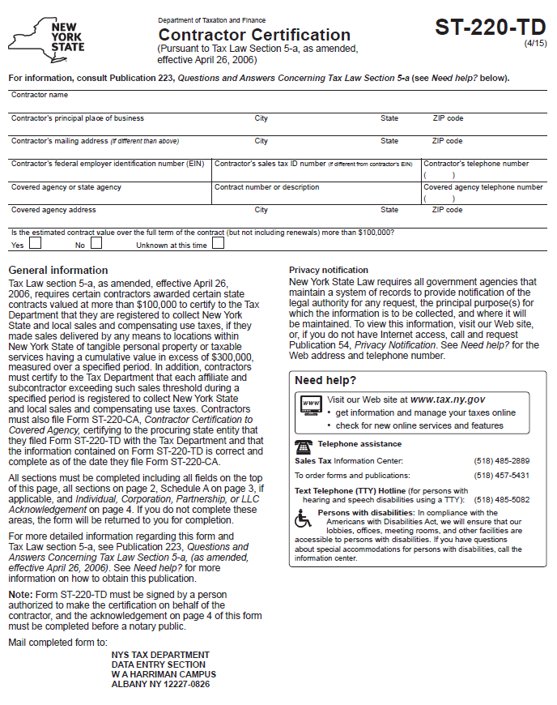
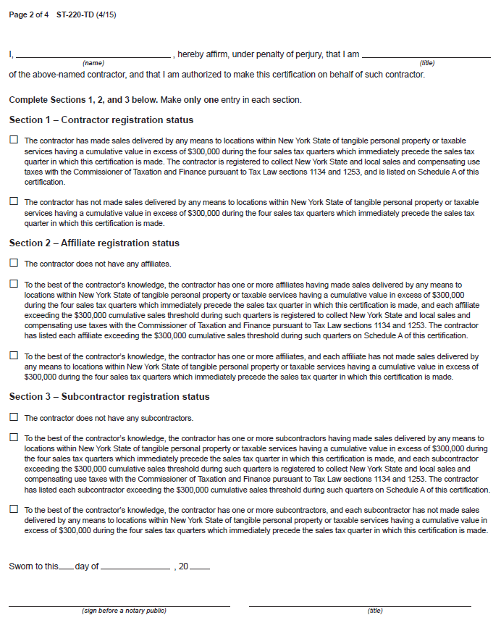

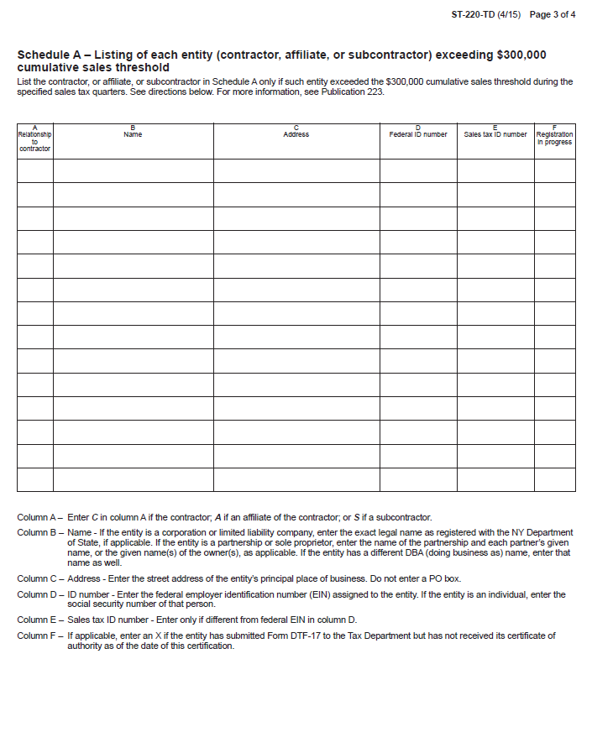
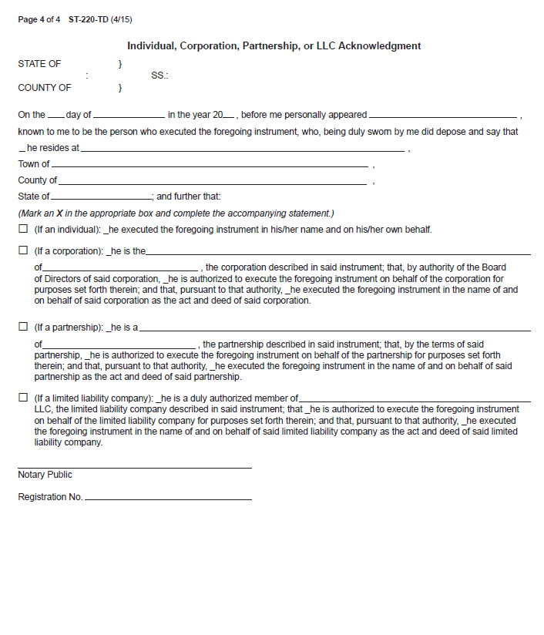

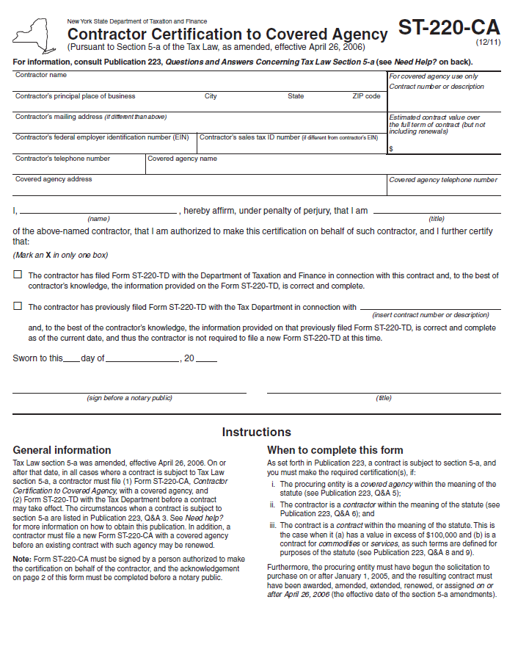
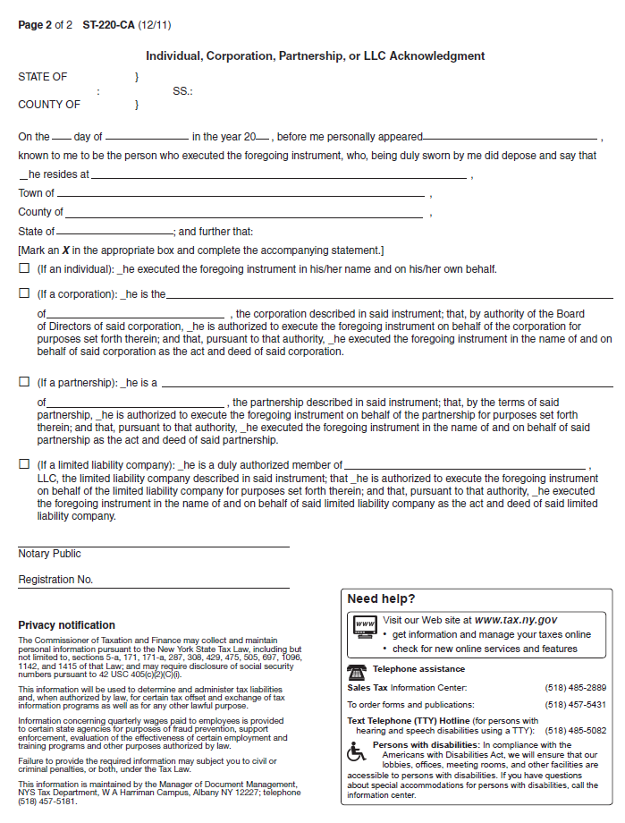

Exhibit C – New York State Office of the State Comptroller Substitute Form W-9
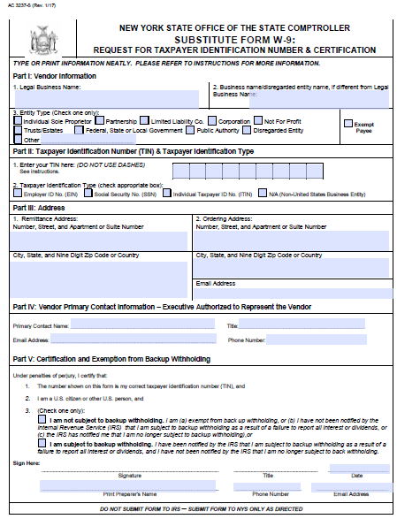
Note: This form is available at the NYS Office of State Comptroller website: https://www.osc.state.ny.us/vendors/forms/ac3237s_fe.pdf

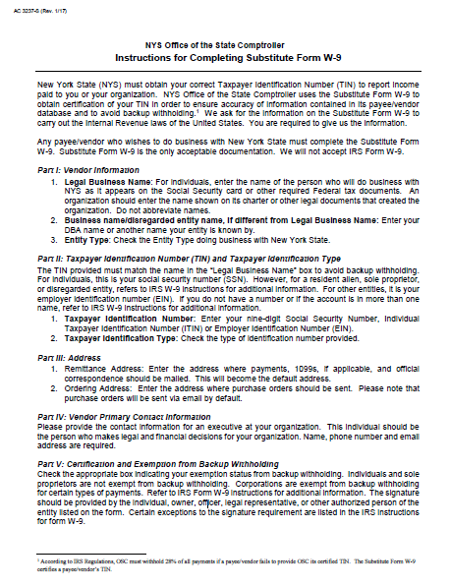

Exhibit D – Minority and Women-Owned Business Enterprises – Equal Employment Opportunity Policy Statement
I, _________________________, the (awardee/contractor) ____________________ agree to adopt the following policies with respect to the project being developed or services rendered at
____________________________________________________________________________.
M/WBE

EEO

This organization will and will cause its contractors and subcontractors to take good faith actions to achieve the M/WBE contract participations goals set by the State for that area in which the State-funded project is located, by taking the following steps:

- Actively and affirmatively solicit bids for contracts and subcontracts from qualified State certified MBEs or WBEs, including solicitations to M/WBE contractor associations.

- Request a list of State-certified M/WBEs from AGENCY and solicit bids from them directly.

- Ensure that plans, specifications, request for proposals and other documents used to secure bids will be made available in sufficient time for review by prospective M/WBEs.

- Where feasible, divide the work into smaller portions to enhanced participations by M/WBEs and encourage the formation of joint venture and other partnerships among M/WBE contractors to enhance their participation.

- Document and maintain records of bid solicitation, including those to M/WBEs and the results thereof. Contractor will also maintain records of actions that its subcontractors have taken toward meeting M/WBE contract participation goals.

- Ensure that progress payments to M/WBEs are made on a timely basis so that undue financial hardship is avoided, and that bonding and other credit requirements are waived or appropriate alternatives developed to encourage M/WBE participation.

a. This organization will not discriminate against any employee or applicant for employment because of race, creed, color, national origin, sex, age, disability or marital status, will undertake or continue existing programs of affirmative action to ensure that minority group members are afforded equal employment opportunities without discrimination, and shall make and document its conscientious and active efforts to employ and utilize minority group members and women in its work force on state contracts.

b. This organization shall state in all solicitation or advertisements for employees that in the performance of the State contract all qualified applicants will be afforded equal employment opportunities without discrimination because of race, creed, color, national origin, sex disability or marital status.

c. At the request of the contracting agency, this organization shall request each employment agency, labor union, or authorized representative will not discriminate on the basis of race, creed, color, national origin, sex, age, disability or marital status and that such union or representative will affirmatively cooperate in the implementation of this organizations’ obligations herein.

d. Contractor shall comply with the provisions of the Human Rights Law, all other State and Federal statutory and constitutional non-discrimination provisions. Contractor and subcontractors shall not discriminate against any employee or applicant for employment because of race, creed (religion), color, sex, national origin, sexual orientation, marital status or domestic violence victim status, and shall also follow the requirements of the Human Rights Law with regard to non-discrimination on the basis of prior criminal conviction and prior arrest.

- This organization will include the provisions of sections (a) through (d) of this agreement in every subcontract in such a manner that the requirements of the subdivisions will be binding upon each subcontractor as to work in connection with the State. contract.

Agreed to this _____ day of ___________________, 20____
By (signature) _______________________________________
Print: __________________________________ Title:__________________________________

_________________________________is designated as the Minority Business Enterprise Liaison (Name of Designated Liaison)
responsible for administering the Minority and Women-Owned Business Enterprises- Equal
Employment Opportunity (M/WBE-EEO) program.

M/WBE Contract Goals

________% Minority and Women’s Business Enterprise Participation

________% Minority Business Enterprise Participation

________% Women’s Business Enterprise Participation

____________________________________________
(Authorized Representative)

Title: ________________________________________

Date: ____________________________________

Exhibit E – Workforce Utilization Report

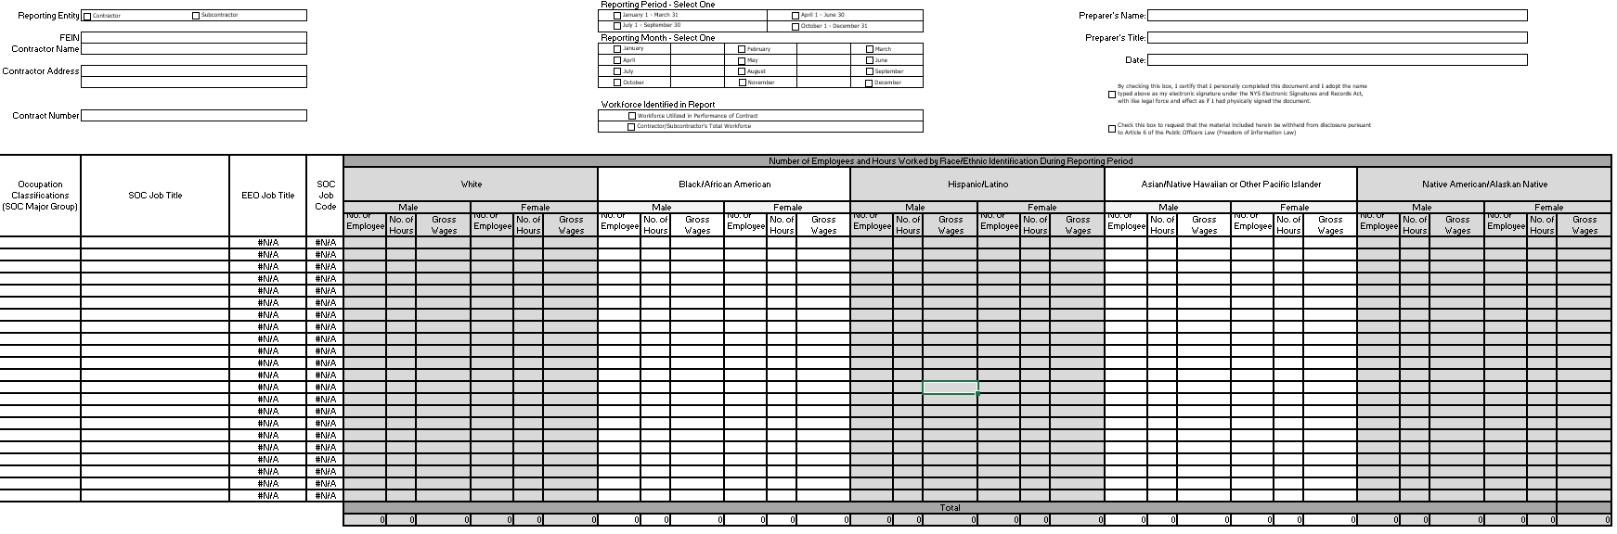
Note: An Excel file of this form will be provided to the Contractor after contract execution.

