New York State Department of Taxation and Finance
WA Harriman Campus, Building 9, Room 234
Albany, NY 12227
Mini-Bid # RFP 22-102
Data Sanitization Services

Contract Category: PROJECT BASED INFORMATION TECHNOLOGY CONSULTING SERVICES
Group: 73600 Award Number: 22772
FIXED-PRICE DELIVERABLE BASED IT CONSULTING SERVICES ONLY
LOT #1
DESIGNATED CONTACTS
Primary Contacts: Yafei Cao  Courtney Goyer  E-mail address: BFS.Contracts@tax.ny.gov  Yafei.Cao@tax.ny.gov  Courtney.Goyer@tax.ny.gov | Secondary Contact: Todd Murray  E-mail address: Todd.Murray@tax.ny.gov
Bidders are advised that the Procurement Lobbying Law/Restricted Period is in effect.

New York State (“NYS”) Finance Law § 139-j(6)(b) requires that the Department of Taxation and Finance (“Department” or “DTF” ) seek written affirmation from all Offerers as to the Offerer’s understanding of, and agreement to comply with, the DTF procedures relating to permissible contacts during a Government Procurement. Information related to the Procurement Lobbying Law and DTF guidelines can be found on the Department’s website at: http://www.tax.ny.gov/about/procure.

All inquiries concerning this solicitation must be addressed to one of the above designated contacts.

Contract Term, Extensions and No Cost Change Requests/Enhancements
The term of the resulting Agreement will start from contract approval, anticipated by 7/15/2022, and continue till 8/31/2022 or the completion of the Project, whichever is earlier. DTF anticipates the Project should complete within three (3) weeks from commencement.

NO COST Change Request: The Project scope may be changed without a price increase. Written approval is required from both the Contractor and DTF regarding the no cost change order.
Tentative Start Date 7/15/2022 through 8/31/2022

MWBE Goals
0%

Best Value Award Methodology
An award will be made to the Contractor who offers the Best Value solution.
Evaluation Weights:

Technical: 60% Financial/Cost: 40%
The total price quoted/negotiated will be a fixed-price for the term of the resulting Agreement. Prices will remain firm for the entire Project duration.

Mini-Bid Proposal Validity
All bidder responses to this Mini-Bid must remain open and valid for at least 60 days from the Mini-Bid opening date, unless the time for awarding the resulting Agreement is extended by mutual consent of DTF and the Contractor. A Contractor’s Mini-Bid response shall continue to remain an effective offer, firm and irrevocable, subsequent to such 60 day period until either tentative award of the Agreement by DTF is made or withdrawal of the Contractor Submission in writing by the Contractor.

Introduction
The New York State Department of Taxation and Finance (DTF) is seeking a Contractor to validate the sanitization of data stored on media assets and equipment in accordance with the requirements of Internal Revenue Service Publication 1075, Tax Information Security Guidelines for Federal, State and Local Agencies and the standards of National Institute of Standards and Technology (NIST).

This Mini-Bid is being distributed to the Contractors awarded under Lot #1 to acquire Project Based Information Technology (IT) Consulting Services for New York State Department of Taxation and Finance, an Authorized User of OGS Centralized Contract Award 22772 on a fixed-price basis.
- The purpose of this Mini-Bid is to obtain Proposals for Data Sanitization Services as detailed in this document and the attachments.
- Responses will only be accepted from Contractors listed under Award #22772, Lot # 1
- Responses which include pricing in excess of the maximum “Not-To-Exceed” price on the Contractor’s price list will be found non-responsive.
- Responses which include titles/descriptions not listed in a Contractor’s Appendix D will be found non-responsive.

DTF Reserved Rights
DTF reserves the following rights:
- Reject any or all Contractor Submissions received in response to the Mini-Bid.
- Withdraw the Mini-Bid at any time, in Authorized User’s sole discretion.
- Make an award under the Mini-Bid in whole or in part.
- Disqualify any Contractor whose conduct and/or Contractor Submission fails to conform to the requirements of the Mini-Bid.
- Seek clarifications and revisions of Contractor Submission(s).
- Prior to the Submission opening, amend the Mini-Bid specifications to correct errors or oversights, or to supply additional information, as it becomes available.
- Prior to the Submission opening, direct Contractor to submit Contractor Submission modifications addressing subsequent Mini-Bid amendments.
- Eliminate any mandatory, non-material specifications that cannot be complied with by all of the prospective Contractors.
- Waive any requirements that are not material.
- The Authorized User may utilize any and all ideas submitted in the Mini-Bids received.
- Adopt all or any part of a Contractor’s Submission in selecting the optimum solution.
- Negotiate with the Contractor(s) responding to this Mini-Bid within the Mini-Bid requirements to serve the best interests of the State. This includes requesting clarifications of any or all Contractors’ Submissions.
- All Contractor Submissions and accompanying documentation shall become the property of the Authorized User and shall not be returned.
- Require clarification at any time during the Mini-Bid process and/or require correction of arithmetic or other apparent errors for the purpose of assuring a full and complete understanding of a Contractor’s Submission and/or to determine a Contractor’s compliance with the requirements of the Mini-Bid.
- Exclude any price lists that do not fall within the scope of the Mini-Bid.
- Upon discovery of non-material completeness or conformance issues with a Contractor’s Submission, contact the Contractor to attempt to cure the issue prior to completion of the evaluation of the Contractor’s Submission.
- Consider late or non-conforming bids as offers in the event compliant bids are not received.
- OGS reserves the right to post information about Authorized User Contract usage of Centralized Contracts.

Schedule of Events
Event | Date | Time
Mini-Bid Release | June 10, 2022
Bidder Questions Due | June 22, 2022 | 2:00 PM EST
DTF Responses to Bidder Questions | June 29, 2022
Proposal Due Date | July 6, 2022 | 2:00 PM EST
Anticipated Notification of Award | July 13, 2022
Please note: DTF will not accept any proposals received after 2:00 PM EST on July 6, 2022, except for circumstances identified in DTF Reserved Rights, Item Q above.

Question and Answer Period
Prospective bidders will have one opportunity to submit written questions and requests for clarification regarding this RFP. All questions regarding this RFP must be submitted by emailing BFS.Contracts@tax.ny.gov and be received by the date and time specified in the Schedule of Events.

format and Delivery of Proposals
All proposals must be submitted via email to BFS.Contracts@tax.ny.gov by the date and time specified in the Schedule of Events. Originally signed documents may be provided in Adobe Acrobat pdf format.
All proposals must be organized and submitted in two parts: (1) Volume 1: Technical and Administrative Proposal and (2) Volume 2: Financial Proposal, each of which will be evaluated separately.
Data Sanitization Services Project Description

1. Project Overview
The New York State Department of Taxation and Finance (DTF) is seeking a Contractor to validate the sanitization of data stored on media assets and equipment in accordance with the requirements of Internal Revenue Service Publication 1075, Tax Information Security Guidelines for Federal, State and Local Agencies and the standards of National Institute of Standards and Technology (NIST).
Currently DTF sensitive information is located in the network, servers and storage systems of Performant, a third-party vendor. The contract for services between DTF and Performant is soon to expire. DTF and Performant are currently in the process of disengagement. DTF information must be purged in accordance with the Publication 1075 requirements and NIST standards.
Performant’s servers, storage and backup systems were configured as a single backup set specifically for Federal Tax Information. The servers and one storage system contain data of other Performant’s clients that need to remain on these systems until their end of life. Therefore, Performant will sanitize the DTF data by using the “clear” and “destroy” method in two separate stages. With respect to the backup systems, Performant will delete Amazon Web Services (AWS) encrypted backup.
DTF needs Contractor to validate that the purge or CLEAR sanitization process was appropriately performed so that DTF tax data on all Performant’s systems and servers are sanitized in accordance with the disengagement plan agreed upon between Performant and DTF.
DTF anticipates to work with up to two (2) consultants to complete this project, with the assistance from Contractor’s project management staff as necessary.

2. Contractor Responsibilities
- Contractor will perform the tasks described in the sections below.
- Contactor will designate a Contractor Project Manager who will be the focal point for all Contractor communications relative to this Project.
- Unless otherwise directed by the DTF Chief Information Security Officer (DTF CISO), services will be provided during normal DTF business hours, 8:30a.m.-5:15p.m. Eastern Time (ET), Monday through Friday, excluding NYS State holidays.
- Services specified in this Project Description document and changes as agreed-upon between DTF and Contractor (Services) can be provided remotely.
- Any changes of the anticipated time frames will be subject to DTF prior approval.

3. Services Description
The Contractor personnel will work together with DTF CISO to observe the sanitization process and to validate that all DTF information has been completely sanitized from Performant’s systems.
Activities:
Contractor consultant(s) will perform the following activities/tasks, at a minimum:
- Observe and document Performant’s clearing of data on Media Assets and Equipment.
- Validate whether Performant appropriately cleared data stored on server assets in accordance with the disengagement plan.
- Advise if screenshots of the sanitization process support validation that data has been purged from the servers.

Item# | Item Description
1. | Observe and document with photos or video:  - VM environment clear  - Printer file share clear (for subcontractor)  Document:  - AWS Glacier (Back-up assets) are deleted
2. | Provide Verification Documentation:  - Physical destruction of workstations (laptops and desktops)  - Clear (deletion) of Voice Over Internet Protocol (VOIP) audio files
3. | Issue close-out report:  - Executive Summary  - Scope and Objective  - Approach / Method of Sanitization / Purge  - Equipment  - Servers and Backup  - Documentation  - Photos / Snapshots  - Results of Sanitization / Purge Observation
Description of Procedures:
Prior to initiating the clear process, Performant will take pictures of information on the consoles which will include volumes and the serial numbers on the storage arrays.
DTF CISO and Contractor consultant(s) will observe this sanitization process and document the observation as necessary for validation purposes, across the following system components / layers:
- VMWare
  - The virtual server assets will be purged by being cleared and/or destroyed. The server assets listed above are virtual with VMware; therefore, the “vmkfstools” command is used to initialize the virtual disk (-w|--writezeros). This method will clear the virtual disk by writing zeros over all its data at the ESX Host level. The VMDK will then be destroyed from the VMWare cluster.
- Storage Array
  - The clear process will be performed at the VMware level which sits on top of the storage array.
  - No sanitization will be performed at the storage array level.
  - Storage array drives are an SED (Self Encrypted Drive).
- Backup Systems
  - Encrypted backups will be deleted from AWS environment.
- Printing Servers
  - The virtual server assets will be purged by being cleared and destroyed. The server assets listed above are virtual with VMware. Therefore, the “vmkfstools” command is used to initialize the virtual disk (-w|--writezeros). This method will clear the virtual disk by writing zeros over all its data at the ESX Host level. The VMDK will then be destroyed from the VMWare cluster.
  - NOTE:
    - Performant’s printing is handled by Microdynamics Group (MDG), a subcontractor.
    - Sanitization Method: MDG environment is similar to Performant. Therefore, they are following the same procedure as Performant (CLEAR and DESTROY).
    - Performant will provide all documentation to DTF CISO to confirm whether the sanitization process was successfully performed in accordance with MDG’s disengagement plan and may consult with the Contractor for validation purposes.
Deliverables:
Close-out Report
Completion Criteria:
These tasks will be considered completed when performed as described and accepted by DTF CISO. Contractor will have fulfilled its obligations when the close-out report is accepted by DTF CISO.
Anticipated Timeframes:
  - DTF anticipates a contract will be executed by 7/15/2022.
  - DTF will schedule the dates for sanitization as soon as possible upon execution of a contract.
  - DTF anticipates the project should complete within three (3) weeks from commencement.
  - Contractor’s final close-out report must be delivered to DTF CISO no later than two weeks from date of completion of data sanitization process.

4. DTF Responsibilities
DTF CISO
After a contract is executed, DTF CISO will be the focal point for all DTF communications relative to this project. DTF CISO's responsibilities include, but are not limited to, the following:
- Serve as the interface between Contractor and DTF.
- Manage DTF personnel and responsibilities for this project.
- Attend scheduled project meetings.
- Obtain and provide information, data, documents, decisions and approvals within timeframes agreed to by DTF CISO and Contractor Project Manager.
- Schedule and secure attendance of all required DTF personnel as required for interviews, meetings and work sessions. Consolidate and reconcile feedback from DTF representatives when appropriate and/or necessary.
- Resolve deviations from the estimated schedule, which may be caused by DTF.
- Help resolve project issues and escalate issues within DTF as necessary.
- Work with Contractor Project Manager to administer project changes as necessary.
Office Space and Other Facilities
DTF will provide appropriate meeting rooms, office space, office supplies, furniture, telephone, clerical assistance, machine time and other facilities for Contractor project team while working on DTF premises. These facilities shall be provided as determined by DTF CISO. Contractor project team members shall observe DTF work rules.

5. Data File Content and Security
DTF is responsible for the actual content of any data file, selection and implementation of controls on its access and use, and security of stored data, to the extent and subject to the requirements by the applicable laws and DTF procedures. Any DTF data provided to Contractor by DTF in furtherance of Contractor’s Services is considered Confidential Information.

6. Additional Terms and Conditions
- New York State and Federal Tax Secrecy Provisions
The various secrecy provisions of the Tax Law (e.g., Tax Law §§ 487, 697(e) and 1825) prohibit independent contractors from disclosing tax information in any manner and provide for misdemeanor prosecution for violations. The secrecy provisions of the Internal Revenue Code (26 USC § 6103) provide for felony prosecution for unauthorized disclosure of Federal tax information in the possession of the Department.
All other information about the Department's operations not covered by the preceding provisions of law must be kept confidential as if it were so covered. Contractor representatives must comply with the administrative procedures enforcing these rules.
The Contractor, all staff members and Subcontractors agree to view, access, and use only that information relevant and necessary to provide Services to the State under the Agreement; and to subscribe to the provisions of §§ 73 and 74 of the Public Officers Law.
- Tax Secrecy - Required Forms
The Contractor acknowledges and agrees that it has read, will comply with, and will require each employee and/or Subcontractor performing services under this Agreement and/or coming on to DTF premises to review and execute the DTF-202, Tax Information Access and Non-Disclosure Agreement form (Attachment 2) and provide completed originals to the Department.

7. Debriefing
Contractors will be notified in writing and, within fifteen (15) calendar days of such notification, may request the opportunity for a debriefing session. Such sessions will be limited to discussions of evaluation results as they apply to the contractor receiving the debriefing.

8. Dispute Resolution Procedure
In the event of a dispute arising from this bid or the resulting Agreement, the first step of dispute resolution will be through informal conference between parties. The party initiating the process shall notify the other party in writing and set forth the issues for resolution and provide all necessary documentation. The parties shall review each other’s position and attempt to reach a resolution. Unresolved disputes will be resolved formally by the DTF commissioner, or his/her designee, whose decision is final and binding. During this period, all work required hereunder shall continue to be performed. If the Contractor pursues any legal remedy outside this process, the Contractor will continue to perform work in accordance with the contract and the direction of DTF until such proceedings may be concluded and the Contractor will continue to be paid, less an amount determined by the State to be attributable to the disputed work. Disputes that go to litigation must be pursued in a court of competent jurisdiction within the State of New York, and must be venued in Albany County, NY. New York law (without regard to conflicts of law provisions) will govern the dispute. Nothing in this paragraph shall diminish the DTF’s right to terminate the contract.

9. DTF Bid Protest Procedure
The procedures for handling protests of bid awards are set forth in Appendix 1 - Bid Protest Policy.

10. Technical Submission Requirements
Bidders will be evaluated and scored on the experience of the firm and the proposed consultant(s) . The bidder should:
- Describe its relevant experience of the firm (via Attachment A – Firm Experience Response Form); and
- Describe the relevant experience of the proposed consultant(s) and provide their resumes (via Attachment B – Consultant Experience Response Form).

11. Financial submission Requirements
The cost for the Services will not exceed the amount proposed by the bidder. The cost will include all bidder’s costs, including travel and living expenses. Responses which include pricing in excess of the “maximum Not-To-Exceed price” shall be rejected by DTF.

The bidder should provide consultant title(s), consultant name(s), estimated hours, and fully loaded hourly rate(s) to substantiate the proposed cost.

DTF anticipates to work with up to two (2) consultants to complete this project, with the assistance from Contractor’s project management staff as necessary.

The bidder must submit Attachment 6 – Financial Response Form.

12. Tie-breaking
In the event that more than one Bidder receives the same final score, the Department will use the following tie breaking mechanisms, in the order listed, to determine final ranking:
- The Bidder’s Financial Score
- Consultant Experience Score

CONTRACTOR RESPONSE

Contractor: When the Authorized User provides for electronic submission, please convert this executed document to PDF, attach this PDF with the Contractor’s full submission, and e-mail before the Mini-Bid Deadline.

The Contractor Submission must be fully and properly executed by an authorized person. By signing you certify your express authority to sign on behalf of yourself, your company, or other entity and full knowledge and acceptance of this Mini-Bid (including any Questions/Answers or addendums), the OGS Centralized Contract and that all information provided is complete, true and accurate.
(Where Procurement Lobbying Law is applicable by the Authorized User, by signing, Contractor affirms that it understands and agrees to comply with the Authorized User’s procedures relative to permissible contacts. Information may be accessed at: Procurement Lobbying: http://www.ogs.ny.gov/aboutOgs/regulations/defaultAdvisoryCouncil.html)
The Authorized User will not be held liable for any cost incurred by the Contractor for work performed in the preparation of a response to this Mini-Bid or for any work performed prior to the formal execution of an Authorized User Agreement. Responses to the Mini-Bid must be received as specified in Schedule of Events. Contractor assumes all risks for timely, properly submitted deliveries of this Mini-Bid response. A Contractor is strongly encouraged to arrange for delivery of Mini-Bid responses prior to the date of the bid opening. LATE MINI-BID RESPONSES may be rejected. The received time of Mini-Bid responses will be determined by the clock at the Authorized User’s location.

Contractor’s Federal Tax Identification Number  (Do Not Use Social Security Number) | Contractor’s NYS Vendor Identification Number
Legal Business Name of Company Responding (must match the OGS Centralized Contract):

D/B/A – Doing Business As (if applicable):

OGS Centralized Contract Number:

Contractor’s Signature: |  | Printed or Typed Name:
Title: |  | Date:
- CONTRACTOR DECLINES TO RESPOND TO THE MINI-BID for the following reasons:
- Insurance Affirmation: All insurance forms as per Lot requirements, have been provided to OGS and are up to date.
- Additional Incentives

The information in this document defines the Authorized User’s Project and its scope. The Contractor is to return technical, administrative, and financial submissions based on the above information. The Contractor’s response to this Mini-Bid should address all elements included within the Mini-Bid, following the order listed in this document. No extraneous elements or enhancements are to be included.

INDIVIDUAL, CORPORATION, PARTNERSHIP, OR LLC ACKNOWLEDGMENT

STATE OF }
} SS.:
COUNTY OF }

On the ______day of ____________________ in the year 20 __, before me personally appeared ____________________, known to me to be the person who executed the foregoing instrument, who, being duly sworn by me did depose and say that _ maintains an office at ________________, and further that:
[Check One]
☐ | If an individual): __ executed the foregoing instrument in his/her name and on his/her own behalf.
☐ | If a corporation): __ is the _____________________ of ____________________, the corporation described in said instrument; that, by authority of the Board of Directors of said corporation, __ is authorized to execute the foregoing instrument on behalf of the corporation for purposes set forth therein; and that, pursuant to that authority, __ executed the foregoing instrument in the name of and on behalf of said corporation as the act and deed of said corporation.
☐ | If a partnership): __ is the _____________________ of ____________________, the partnership described in said instrument; that, by the terms of said partnership, _he is authorized to execute the foregoing instrument on behalf of the partnership for purposes set forth therein; and that, pursuant to that authority, _he executed the foregoing instrument in the name of and on behalf of said partnership as the act and deed of said partnership.
☐ | If a limited liability company): __ is a duly authorized member of _________________ LLC, the limited liability company described in said instrument; that _he is authorized to execute the foregoing instrument on behalf of the limited liability company for purposes set forth therein; and that, pursuant to that authority, _he executed the foregoing instrument in the name of and on behalf of said limited liability company as the act and deed of said limited liability company.
________________________________________________
Notary Public
Registration No.

Attachment A – Firm Experience Response Form
Bidders will be evaluated and scored on the experience of the firm. The Bidder should describe its relevant experience of the firm.
Expand fields and attach additional sheets as necessary.
Describe:

Attachment B – Consultant Experience Response Form
Bidders will be evaluated and scored on the experience of the proposed consultant(s) to work for this data sanitization services project. The Bidder should describe the relevant experience of the proposed consultant(s) and provide their resumes. DTF anticipates to work with up to two (2) consultants to complete this project, with the assistance from Contractor’s project management staff as necessary.
Expand fields and attach additional sheets as necessary.
Consultant #1 Name
Describe this consultant’s role in the data sanitization services project, his/her relevant experience, and provide detailed information on similar project(s) he/she has worked on. Attach resume:

Consultant #2 Name (if applicable)
Describe this consultant’s role in the data sanitization services project, his/her relevant experience and provide detailed information on similar project(s) he/she has worked on. Attach resume:

Attachment 1 – Bidder’s Checklist
Volume One: Technical and Administrative Proposal
☐ | Attachment 1 – Bidder’s Checklist
☐ | Attachment A – Firm Experience Response Form
☐ | Attachment B – Consultant Experience Response Form
☐ | Attachment 2 – DTF-202, Tax Information Access and Non-Disclosure Agreement
☐ | Attachment 3 – Offerer Understanding of, and Compliance with, Procurement Lobbying Guidelines
☐ | Attachment 4 – Offerer Disclosure of Prior Non-Responsibility Determinations
☐ | Attachment 5 – Offerer’s Certification of Compliance with State Finance Law 139-k (5)
Volume Two: Financial Proposal
☐ Attachment 6 – Financial Response Form

Attachment 2 – DTF-202, Tax Information Access and Non-Disclosure Agreement

This form is available at the NYS Department of Taxation and Finance website:
https://www.tax.ny.gov/pdf/current_forms/misc/dtf202_fill_in.pdf

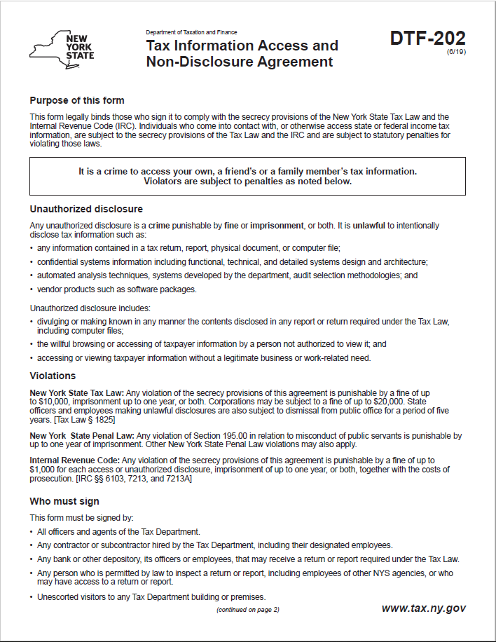
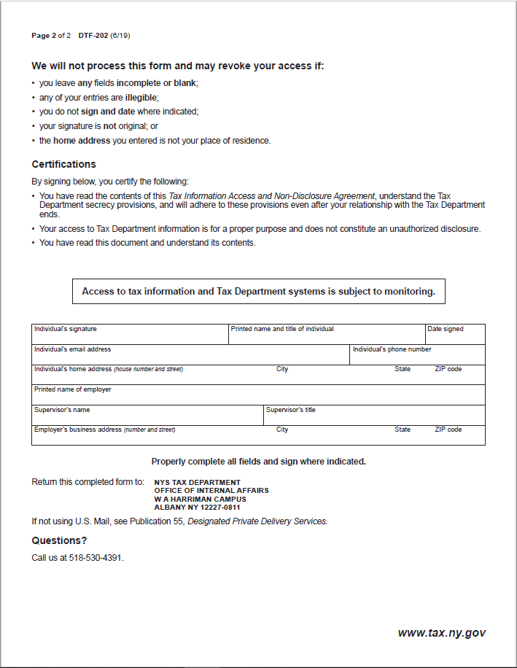

Attachment 3 – Offerer Understanding of, and Compliance with, Procurement Lobbying Guidelines
New York State Finance Law 139-j(6)(b) requires the DTF seek written affirmation from all Offerers as to the Offerer’s understanding of, and agreement to comply with, the DTF procedures relating to permissible contacts during a Government Procurement pursuant to subdivision three of this section.

Procurement Description, Contract or Bid Number:
RFP 22-102 Data Sanitization Services

Offerer Name: _________________________________________________________
Offerer Address: _______________________________________________________
Telephone Number: ____________________________________________________
E-mail Address: ________________________________________________________

Offerer affirms it has read, understands and agrees to comply with the guidelines of the New York State Department of Taxation and Finance relative to permissible contacts as required by the State Finance Law 139-j(3) and 139-j(6)(b).

By (signature): _________________________________________________________
Name (please print): ____________________________________________________
Title (please print): _____________________________________________________
Date: _____________________________________

Attachment 4 – Offerer Disclosure of Prior Non-Responsibility Determinations

New York State Finance Law §139-k(2) obligates a Governmental Entity to obtain specific information regarding prior non-responsibility determinations with respect to State Finance Law §139-j. This information must be collected in addition to the information that is separately obtained pursuant to State Finance Law §163(9). In accordance with State Finance Law §139-k, an Offerer must be asked to disclose whether there has been a finding of non-responsibility made within the previous four years by any Governmental Entity due to: (a) a violation of State Finance Law §139-j or (b) the intentional provision of false or incomplete information to a Governmental Entity. The terms “Offerer” and “Governmental Entity” are defined in State Finance Law § 139-k(1). State Finance Law §139-j sets forth detailed requirements about the restrictions on Contacts during the procurement process. A violation of State Finance Law §139-j includes, but is not limited to, an impermissible Contact during the restricted period (for example, contacting a person or entity other than the designated contact person, when such contact does not fall within one of the exemptions).
As part of its responsibility determination, State Finance Law §139-k(3) mandates consideration of whether an Offerer fails to timely disclose accurate or complete information regarding the above non-responsibility determination. In accordance with law, no Procurement Contract shall be awarded to any Offerer that fails to timely disclose accurate or complete information under this section, unless a finding is made that the award of the Procurement Contract to the Offerer is necessary to protect public property or public health safety, and that the Offerer is the only source capable of supplying the required Article of Procurement within the necessary timeframe. See State Finance Law §§139-j (10)(b) and 139-k(3).
A Governmental Entity must include a disclosure request regarding prior non-responsibility determinations in accordance with State Finance Law §139-k in its solicitation of proposals or bid documents or specifications or contract documents, as applicable, for Procurement Contracts. The attached form is to be completed and submitted by the individual or entity seeking to enter into a Procurement Contract. It shall be submitted to the Governmental Entity conducting the Governmental Procurement.

Offerer Disclosure of Prior Non-Responsibility Determinations
Procurement Description, Contract or Bid Number:
RFP 22-102 Data Sanitization Services

Offerer Name: ________________________________________________________________
Offerer Address: ______________________________________________________________ ____________________________________________________________________________
Telephone Number: __________________________________________________________
E-mail Address: _______________________________________________________________
Name and Title of Person Submitting This Form: _____________________________________ _____________________________________
- Has any New York State agency or authority made a finding of non-responsibility regarding the Offerer in the last four years? (Please circle):
No Yes
If yes, please answer the following questions:
- Was the basis for the finding of the Offerer’s non-responsibility due to a violation of State Finance Law 139-j? (Please circle):
No Yes
- Was the basis for the finding of the Offerer’s non-responsibility due to the intentional provision of false or incomplete information to a Governmental Entity? (Please circle):
No Yes
- If you responded “Yes” to Questions 1, 2 or 3, please provide details regarding the finding of non-responsibility below:
Government Entity: _________________________________________________
Date of Finding of Non-responsibility: ____________________________________

Facts Underlying Finding of Non-Responsibility (Add additional pages as necessary):
___________________________________________________________________________________________________________________________________________________________________________________________________________________________
- Has any New York State agency or authority terminated a Procurement Contract with the Offerer due to the intentional provision of false or incomplete information? (Please circle):

No Yes
- If you responded “Yes” to the above question, please provide details regarding the termination below:

Government Entity: _________________________________________________________
Date of Finding of Non-Responsibility:__________________________________________
Facts Underlying Finding of Non-Responsibility (Add additional pages as necessary):
_______________________________________________________________________________________________________________________________________________________________________________________________________________________________________
Offerer certifies that all information provided to the DTF with respect to State Finance Law 139-k is complete, true and accurate.
By (Signature): _________________________________________________
Name (Please print): __________________________________________
Date: __________________________

Attachment 5 – Offerer’s Certification of Compliance with State Finance Law 139-k (5)
New York State Finance Law 139-k(5) requires that every Procurement Contract award subject to the provisions of State Finance Law 139-k or 139-j shall contain a certification by the Offerer that all information provided to the procuring Government Entity with respect to State Finance Law 139-k is complete, true and accurate.

Offerer Certification
I certify that all information provided to the DTF with respect to State Finance Law 139-k is complete, true and accurate.

By: (signature) _________________________________________
Date: ____________________________________________
Procurement Description, Contract or Bid Number:
RFP 22-102 Data Sanitization Services

Name (Please print): __________________________________________________________
Title: ______________________________________________________________________
Offerer Name: ______________________________________________________________
Offerer Address: _____________________________________________________________
_____________________________________________________________
Telephone Number: ______________________________________________
E-mail Address: __________________________________________________

Attachment 6 – Financial Response Form
The cost for the Services will not exceed the amount proposed by the bidder. The cost will include all bidder’s costs, including travel and living expenses. Responses which include pricing in excess of the “maximum Not-To-Exceed price” shall be rejected by DTF. DTF anticipates to work with up to two (2) consultants to complete this project, with the assistance from Contractor’s project management staff as necessary.

Bidder-Proposed Cost: $ _____________

Please provide title(s), name(s), estimated hours, and fully loaded hourly rate(s) of consultant(s), and project management staff if applicable, to substantiate the cost proposed above.

Title | Name | Estimated  Hours | Fully Loaded Hourly Rate

Appendix 1 – Bid Protest Policy
DTF Protest Procedure
Section 1 Applicability
Section 2 Definitions
Section 3 General Protest Guidelines
Section 4 Protest Procedure
Section 5 Appeal process
Section 1: Applicability
These guidelines set forth the procedure to be utilized when an Interested Party challenges a Contract Award by the New York State Department of Taxation and Finance. The guidelines shall apply to all Contract Awards made by the Department and approved by the New York State Office of the State Comptroller, including bid Solicitations, Sole Source procurements, Single Source procurements, and Emergency procurements.
Section 2: Definitions
- "Contract Award" is a written determination from DTF to an Offeror indicating that the DTF has selected a particular Offeror under the procurement process.
- “DTF” or “Department” means the New York State Department of Taxation and Finance.
- "Emergency" means an urgent and unexpected requirement where health and public safety or the conservation of public resources is at risk (see New York State Finance Law, Section 163.1.b).
- "Interested Party" means a participant in the procurement process and those whose participation in the procurement process has been foreclosed by the actions of the DTF and have suffered harm as a result of the manner in which the procurement was conducted.
- “Offeror” means the entity submitting an offer to DTF.
- "OSC" means the New York State Office of the State Comptroller.
- "Protest" means a written challenge by an Interested Party of a Contract Award that is subject to the approval of OSC.
- “Protesting Party” means an Interested Party who has filed a Protest.
- "Single Source" means a procurement in which, although two or more offerors can supply the required commodities or services, DTF, upon written findings setting forth the material and substantial reasons therefor, awards the contract to one offeror over the other (see New York State Finance Law, Section 163.1.h).
- "Sole Source" means a procurement in which only one offeror is capable of supplying the required commodities or services (see New York State Finance Law, Section 163.1.g).
- “Solicitation” means a document issued by DTF, requesting a response to a procurement need, including an Invitation for Bids, a Request for Proposals, or another written method seeking a bid or proposal for a specified purpose.
- "Successful Bidder" means the bidder or offeror whose bid or proposal has been selected for Contract Award by DTF.
Section 3: General Protest Guidelines

  - Any Interested Party will be given the opportunity to participate in the protest procedure.
A Protest submitted to DTF must be in writing and must contain specific factual and legal allegations setting forth the basis on which the Protesting Party challenges the Contract Award by DTF. A Protest must include:
- a statement of all legal and/or factual grounds for disagreement with a DTF procurement determination;
- a description of all remedies or relief requested; and
- copies of all applicable supporting documentation.
  - DTF may, at its sole discretion, waive any deadline or requirement set forth in these guidelines, or consider any materials submitted beyond the time periods set forth in these guidelines.
  - Where DTF deems appropriate, DTF may require the Protesting Party, DTF staff involved in the procurement, the Successful Bidder, or any other Interested Party, to address and/or submit further information with respect to additional issues raised by any DTF review of the procurement.
  - Nothing herein shall preclude DTF from obtaining information relevant to the procurement from any other source, as it may deem appropriate.
Section 4: Protest Procedure

  - Any Interested Party may file, by mail or electronic mail, a Protest with the DTF Director of Procurement. The following statement must be clearly and prominently displayed on the envelope or package or header of electronic transmittal: “Bid Protest of DTF Solicitation (Reference Number)” when being submitted in regards to a Solicitation and “Protest of DTF Contract Award (Reference Number)” when being submitted in regards to a contract being entered into on a non-competitive basis.
  - Timing of Protest submission:
- Concerning Errors, Omissions or Prejudice in the Bid Specifications, Requirements or Documents - Protests which concern the drafting of bid specifications must be received by DTF at least ten business days before the date set in the Solicitation for receipt of bids. If the date set in the Solicitation for receipt of bids is less than ten business days from the date of issue, Protests concerning the specifications must be received by DTF at least 48 hours before the time designated for receipt of bids.
- Concerning Proposed Contract Award - Protests concerning a pending Contract Award must be received within ten business days after the notice of Contract Award or five business days after receiving a debriefing.
  - The DTF Director of Procurement may summarily deny a Protest that fails to contain specific factual or legal allegations, or where the Protest raises only issues of law that have already been decided by the courts or by the OSC Bureau of Contracts.
  - An Interested Party may file only one Protest with respect to a specific Solicitation.
  - The DTF Director of Procurement shall issue a written determination addressing all issues raised by the Protest, as well as any relevant issues raised by his/her review of the procurement or contract. The determination shall make findings of fact and conclusions of law on any issues in dispute. All participants in the Protest and the Successful Bidder shall be provided a copy of the determination. The determination shall be made part of the procurement record.
Section 5: Appeal Process

  - The protest determination of DTF shall be deemed a final and conclusive agency determination unless a written notice of appeal is received no more than five business days after the date the written Protest decision is sent to the Offeror. Such notice of appeal must be filed in writing at the address set forth below:
Chief Financial Officer
New York State Department of Taxation and Finance
Reference: Bid Protest of DTF Solicitation (provide procurement reference number) (or, Protest of DTF Contract Award [Reference Number])
Building 9 W.A. Harriman Campus
Albany, NY 12227
  - The Chief Financial Officer shall review and make a final written determination on all appeals within ten business days of the date the Appeal is received. A protest appeal may not introduce new facts or legal allegations unless responding to issues newly raised as a result of the written protest determination.
Section 6: OSC Appeal Process

  - An Interested Party must file an appeal of the Department’s determination of a Protest with the OSC Bureau of Contracts within ten business days of receiving DTF’s final written determination on appeal.
  - In its appeal, the Interested Party shall set forth the basis on which it challenges DTF’s protest determination. The Interested Party shall also include, as an exhibit to its appeal, a copy of the initial bid Protest submitted to the Department and the determination of such bid Protest issued by DTF.
The appeal must be in writing and a copy must be delivered to DTF and the Successful Bidder (unless the Successful Bidder is the appealing party in which case a copy of the appeal must be delivered to the original Protesting Party), and any other party that participated in the Protest conducted by DTF.
The appeal must be filed with:
Bureau Director at bidprotests@osc.state.ny.us
or
Bureau of Contracts
New York State Office of the State Comptroller
110 State Street, 11th Floor
Albany, NY 12236

July 2020

