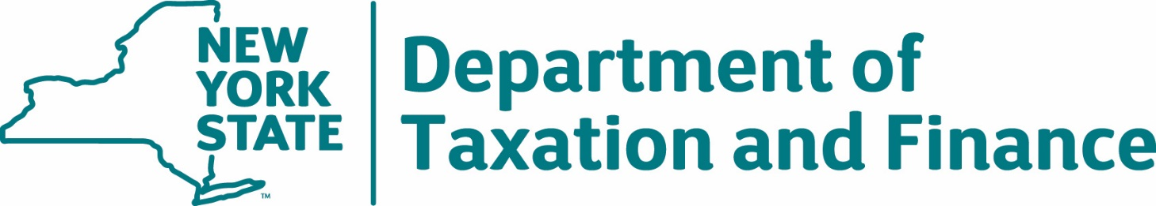

Request for Proposals
22-100
Economic Impact of
New York State Tax Incentive Programs

Appendices

Table of Contents

Appendix A – Standard Clauses for New York State Contracts 3
Appendix B – Bid Protest Policy 10
Appendix C – RFP Glossary 13

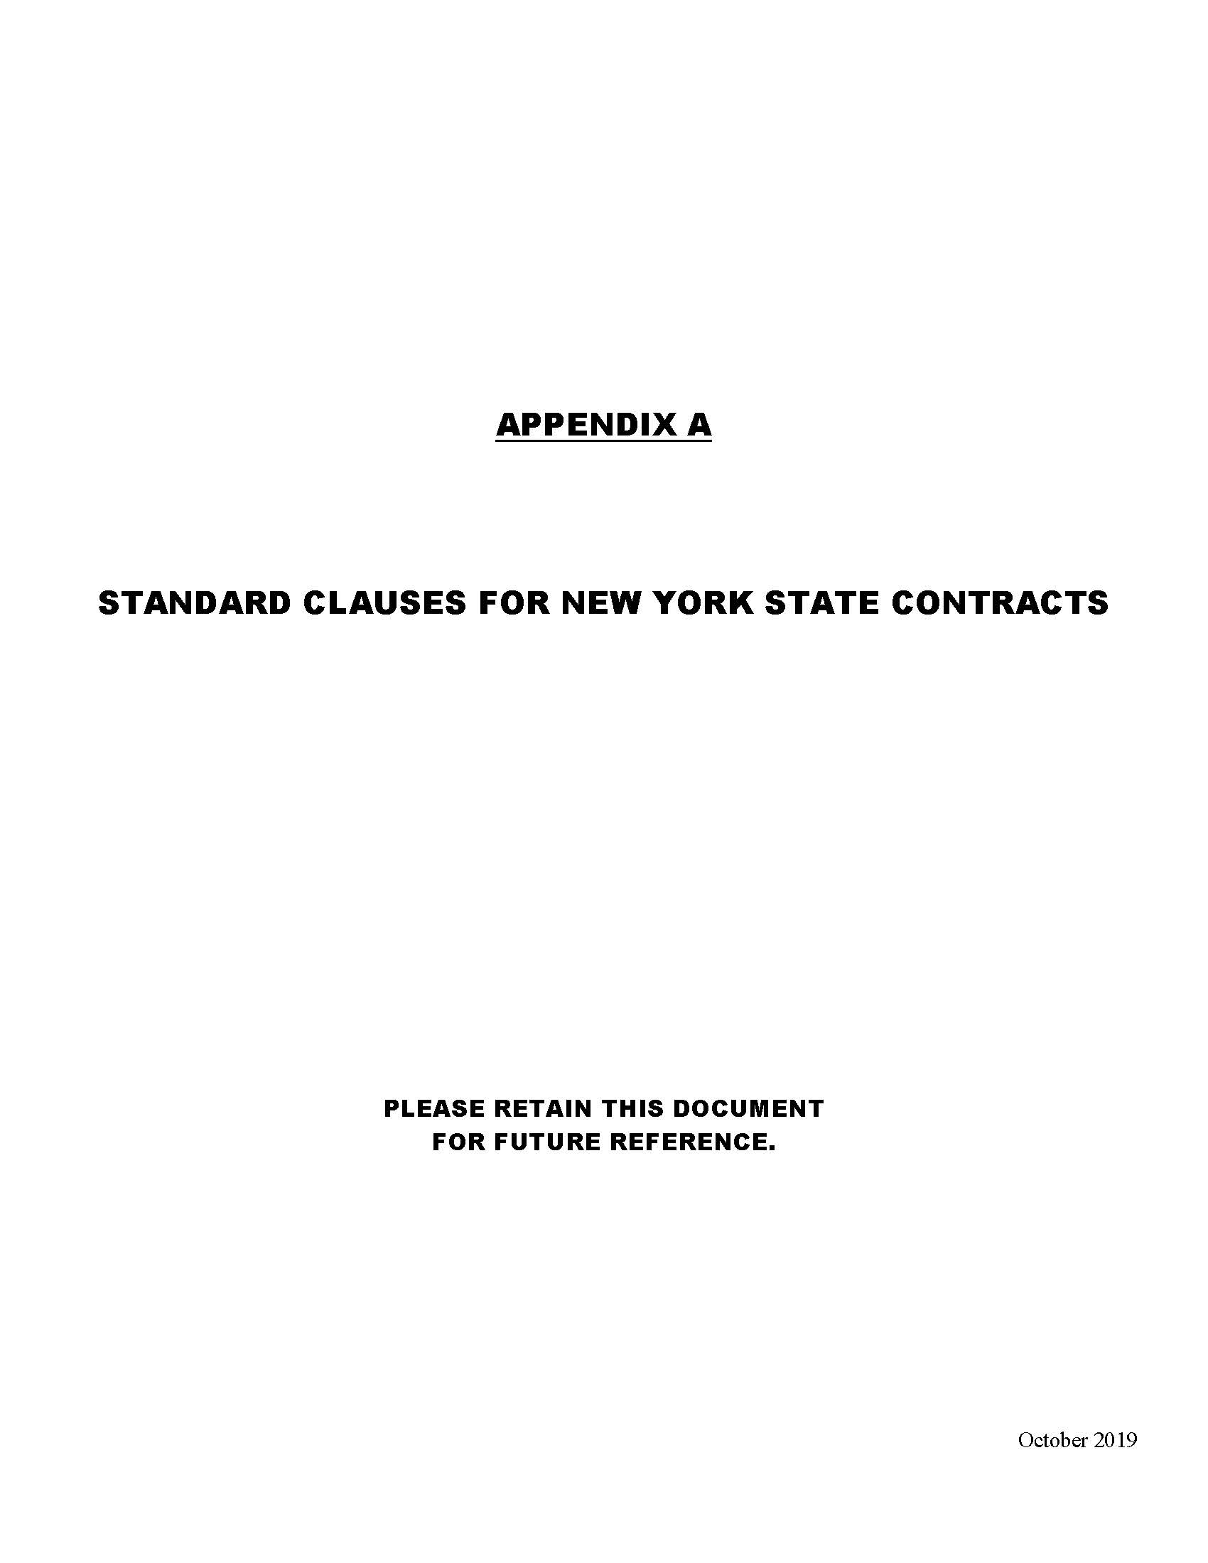
Appendix A – Standard Clauses for New York State Contracts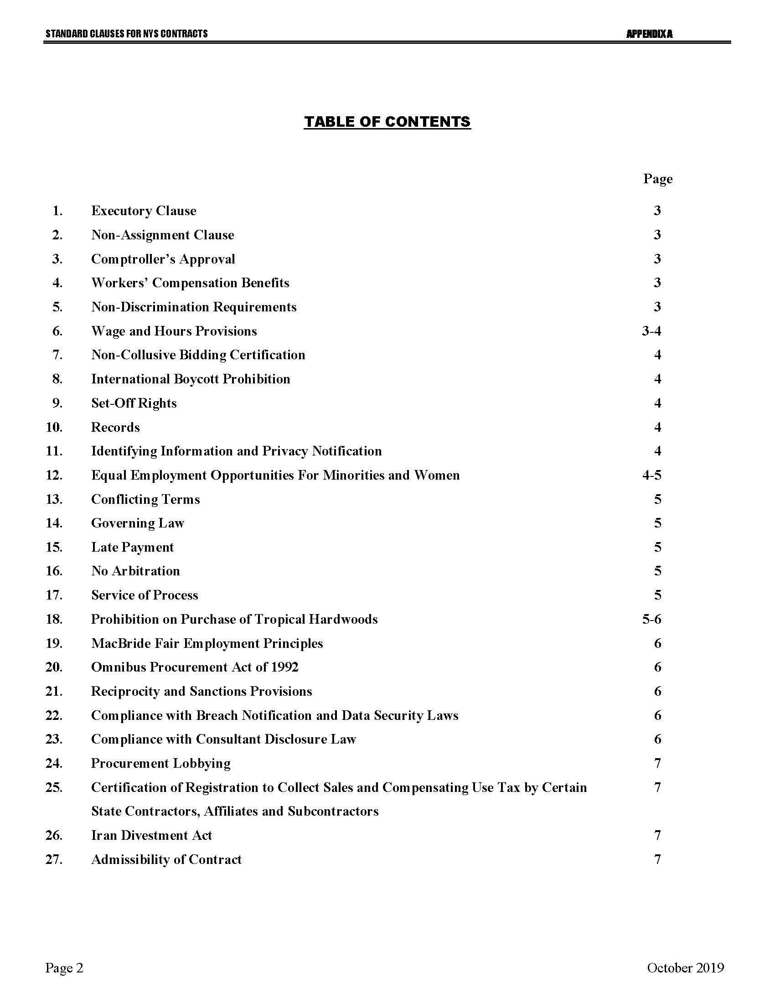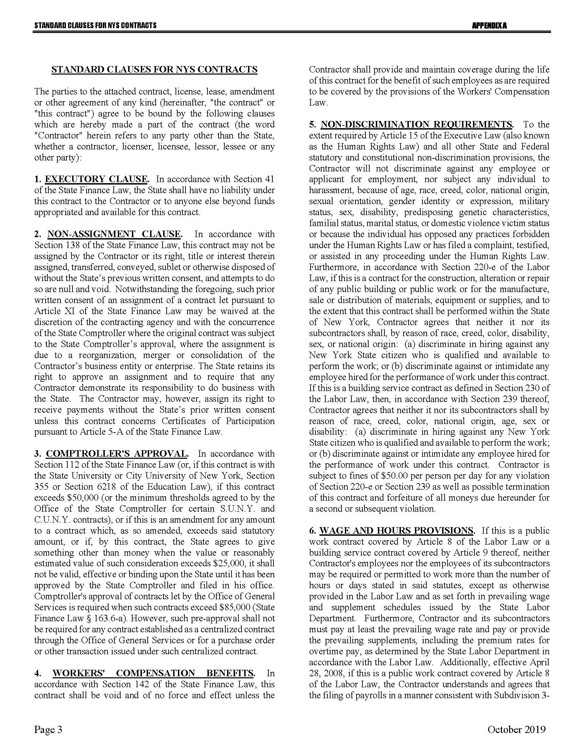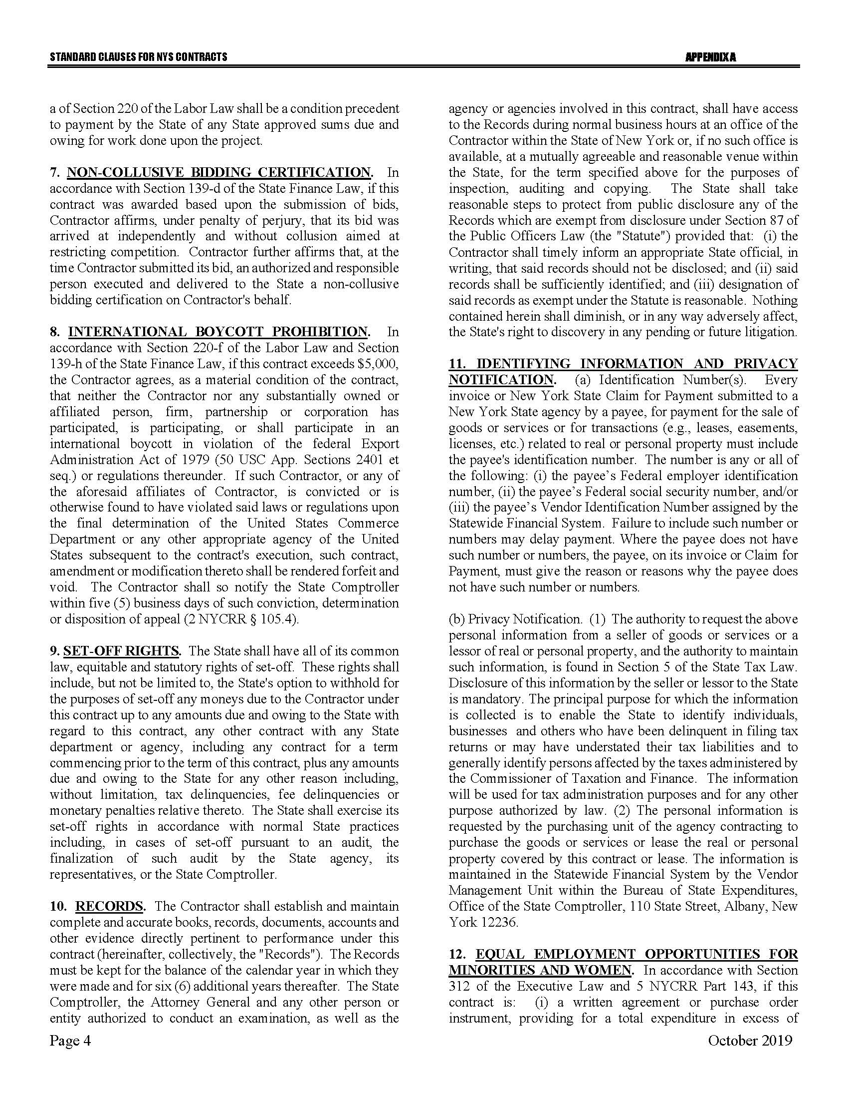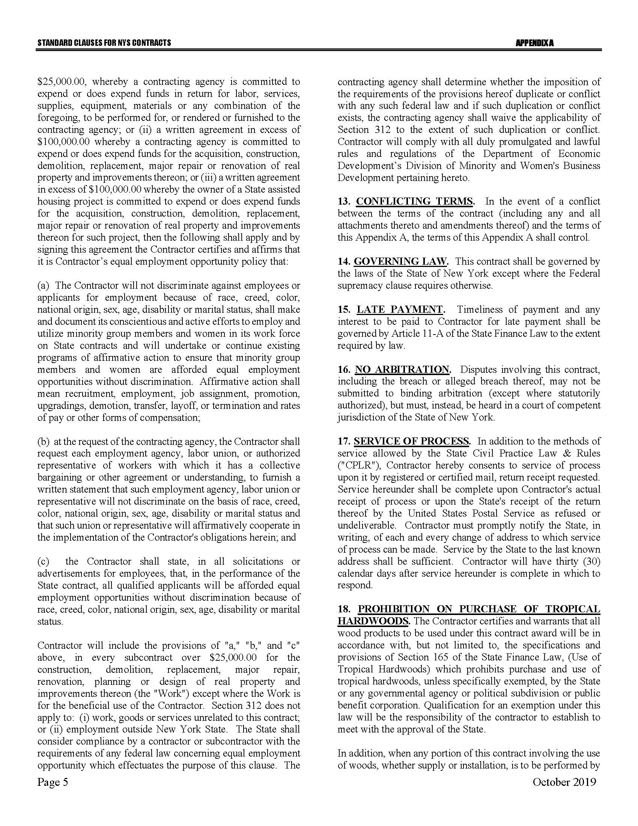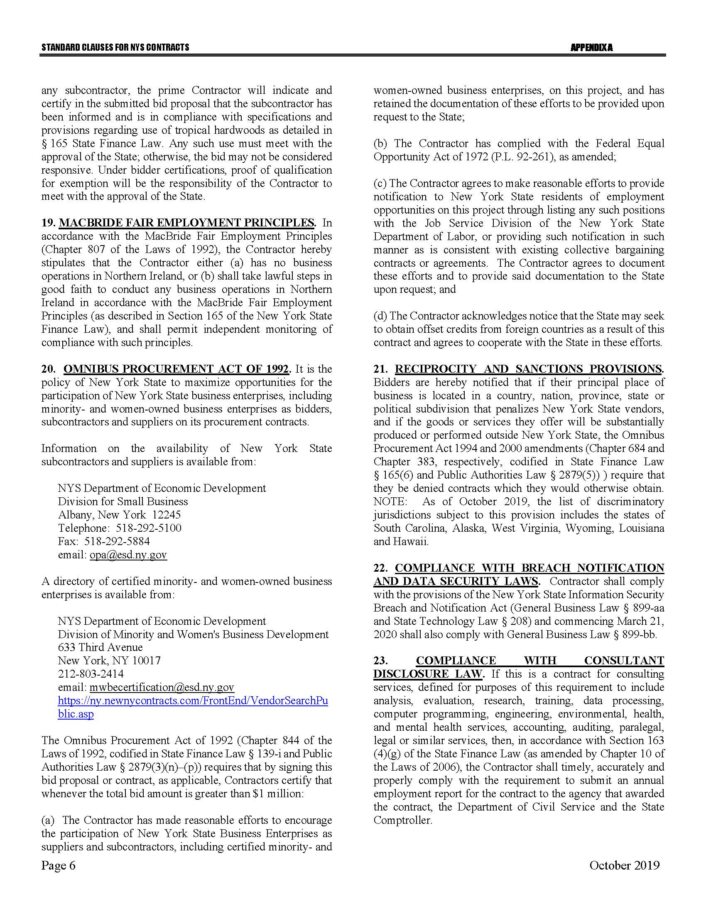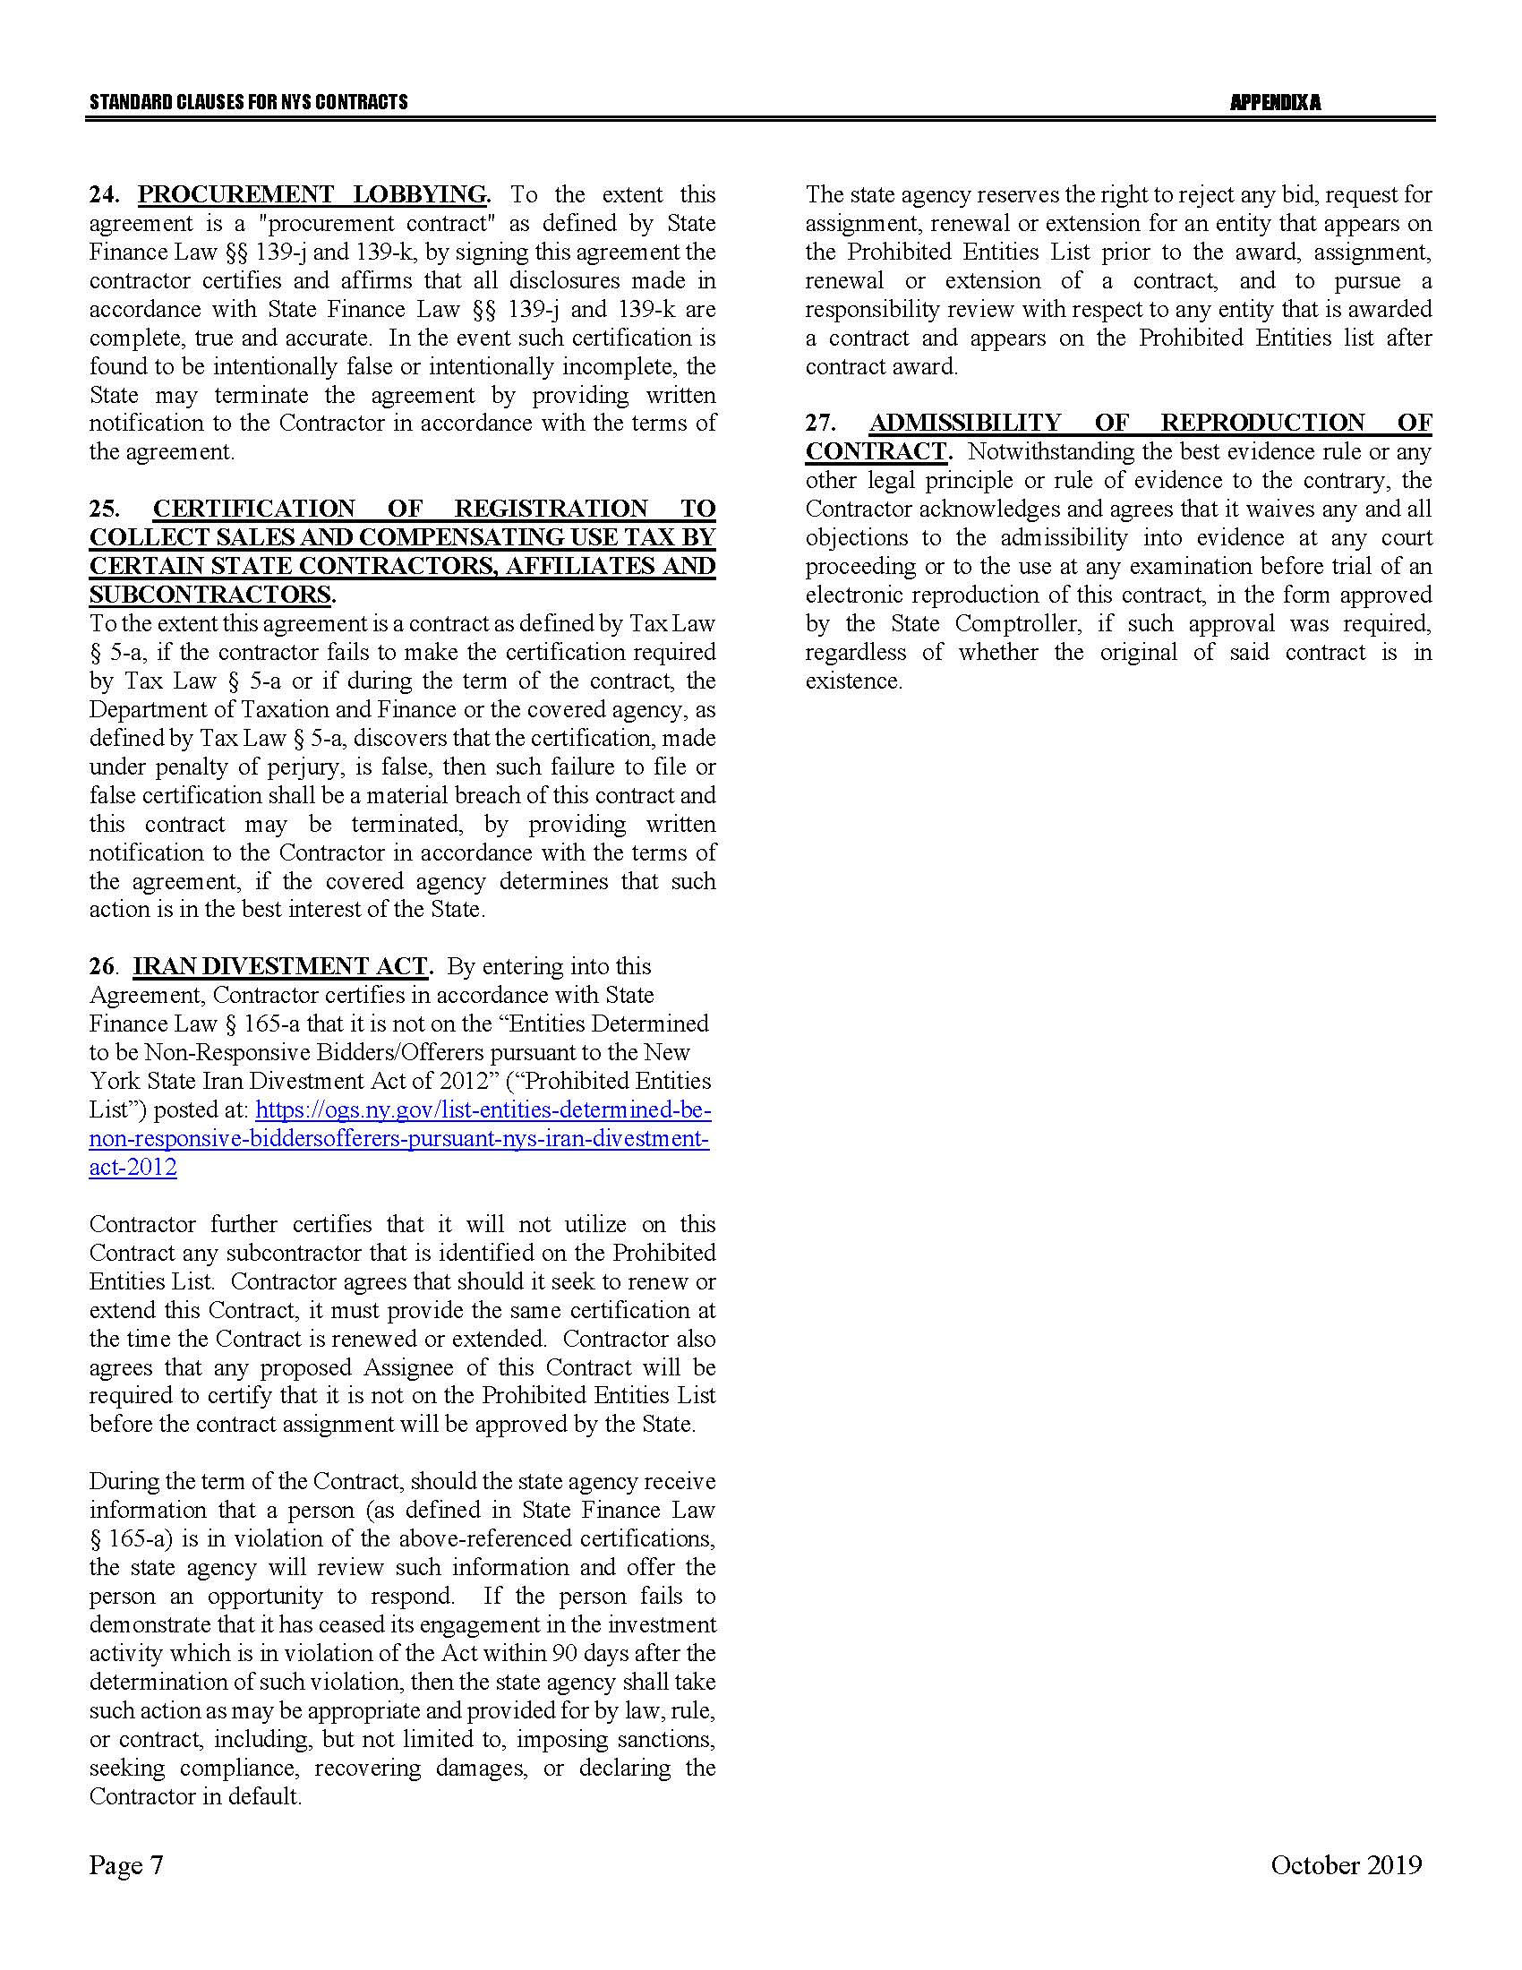

Appendix B – Bid Protest Policy
DTF Protest Procedure
Section 1 Applicability
Section 2 Definitions
Section 3 General Protest Guidelines
Section 4 Protest Procedure
Section 5 Appeal process
Section 1: Applicability
These guidelines set forth the procedure to be utilized when an Interested Party challenges a Contract Award by the New York State Department of Taxation and Finance. The guidelines shall apply to all Contract Awards made by the Department and approved by the New York State Office of the State Comptroller, including bid Solicitations, Sole Source procurements, Single Source procurements, and Emergency procurements.
Section 2: Definitions
- "Contract Award" is a written determination from DTF to an Offeror indicating that the DTF has selected a particular Offeror under the procurement process.
- “DTF” or “Department” means the New York State Department of Taxation and Finance.
- "Emergency" means an urgent and unexpected requirement where health and public safety or the conservation of public resources is at risk (see New York State Finance Law, Section 163.1.b).
- "Interested Party" means a participant in the procurement process and those whose participation in the procurement process has been foreclosed by the actions of the DTF and have suffered harm as a result of the manner in which the procurement was conducted.
- “Offeror” means the entity submitting an offer to DTF.
- "OSC" means the New York State Office of the State Comptroller.
- "Protest" means a written challenge by an Interested Party of a Contract Award that is subject to the approval of OSC.
- “Protesting Party” means an Interested Party who has filed a Protest.
- "Single Source" means a procurement in which, although two or more offerors can supply the required commodities or services, DTF, upon written findings setting forth the material and substantial reasons therefor, awards the contract to one offeror over the other (see New York State Finance Law, Section 163.1.h).
- "Sole Source" means a procurement in which only one offeror is capable of supplying the required commodities or services (see New York State Finance Law, Section 163.1.g).
- “Solicitation” means a document issued by DTF, requesting a response to a procurement need, including an Invitation for Bids, a Request for Proposals, or another written method seeking a bid or proposal for a specified purpose.
- "Successful Bidder" means the bidder or offeror whose bid or proposal has been selected for Contract Award by DTF.
Section 3: General Protest Guidelines

  - Any Interested Party will be given the opportunity to participate in the protest procedure.
A Protest submitted to DTF must be in writing and must contain specific factual and legal allegations setting forth the basis on which the Protesting Party challenges the Contract Award by DTF. A Protest must include:
- a statement of all legal and/or factual grounds for disagreement with a DTF procurement determination;
- a description of all remedies or relief requested; and
- copies of all applicable supporting documentation.
  - DTF may, at its sole discretion, waive any deadline or requirement set forth in these guidelines, or consider any materials submitted beyond the time periods set forth in these guidelines.
  - Where DTF deems appropriate, DTF may require the Protesting Party, DTF staff involved in the procurement, the Successful Bidder, or any other Interested Party, to address and/or submit further information with respect to additional issues raised by any DTF review of the procurement.
  - Nothing herein shall preclude DTF from obtaining information relevant to the procurement from any other source, as it may deem appropriate.
Section 4: Protest Procedure

  - Any Interested Party may file, by mail or electronic mail, a Protest with the DTF Director of Procurement. The following statement must be clearly and prominently displayed on the envelope or package or header of electronic transmittal: “Bid Protest of DTF Solicitation (Reference Number)” when being submitted in regards to a Solicitation and “Protest of DTF Contract Award (Reference Number)” when being submitted in regards to a contract being entered into on a non-competitive basis.
  - Timing of Protest submission:
- Concerning Errors, Omissions or Prejudice in the Bid Specifications, Requirements or Documents - Protests which concern the drafting of bid specifications must be received by DTF at least ten business days before the date set in the Solicitation for receipt of bids. If the date set in the Solicitation for receipt of bids is less than ten business days from the date of issue, Protests concerning the specifications must be received by DTF at least 48 hours before the time designated for receipt of bids.
- Concerning Proposed Contract Award - Protests concerning a pending Contract Award must be received within ten business days after the notice of Contract Award or five business days after receiving a debriefing.
  - The DTF Director of Procurement may summarily deny a Protest that fails to contain specific factual or legal allegations, or where the Protest raises only issues of law that have already been decided by the courts or by the OSC Bureau of Contracts.
  - An Interested Party may file only one Protest with respect to a specific Solicitation.
  - The DTF Director of Procurement shall issue a written determination addressing all issues raised by the Protest, as well as any relevant issues raised by his/her review of the procurement or contract. The determination shall make findings of fact and conclusions of law on any issues in dispute. All participants in the Protest and the Successful Bidder shall be provided a copy of the determination. The determination shall be made part of the procurement record.
Section 5: Appeal Process

  - The protest determination of DTF shall be deemed a final and conclusive agency determination unless a written notice of appeal is received no more than five business days after the date the written Protest decision is sent to the Offeror. Such notice of appeal must be filed in writing at the address set forth below:
Chief Financial Officer
New York State Department of Taxation and Finance
Reference: Bid Protest of DTF Solicitation (provide procurement reference number) (or, Protest of DTF Contract Award [Reference Number])
Building 9 W.A. Harriman Campus
Albany, NY 12227
  - The Chief Financial Officer shall review and make a final written determination on all appeals within ten business days of the date the Appeal is received. A protest appeal may not introduce new facts or legal allegations unless responding to issues newly raised as a result of the written protest determination.
Section 6: OSC Appeal Process

  - An Interested Party must file an appeal of the Department’s determination of a Protest with the OSC Bureau of Contracts within ten business days of receiving DTF’s final written determination on appeal.
  - In its appeal, the Interested Party shall set forth the basis on which it challenges DTF’s protest determination. The Interested Party shall also include, as an exhibit to its appeal, a copy of the initial bid Protest submitted to the Department and the determination of such bid Protest issued by DTF.
The appeal must be in writing and a copy must be delivered to DTF and the Successful Bidder (unless the Successful Bidder is the appealing party in which case a copy of the appeal must be delivered to the original Protesting Party), and any other party that participated in the Protest conducted by DTF.
The appeal must be filed with:
Bureau Director at bidprotests@osc.state.ny.us
or
Bureau of Contracts
New York State Office of the State Comptroller
110 State Street, 11th Floor
Albany, NY 12236

July 2020

Appendix C – RFP Glossary
Term | Definition
Agreement (also referred to as “Contract”) | Contract C400744, which includes all documents identified in the Base Contract at Article II., Entirety of Agreement, which results from the award of this Request for Proposals.
Attorney General (AG) | Attorney General of the State of New York, or their designee.
Base Contract | That portion of the Agreement preceding the signatures of the parties.
Bidder/Offerer | An entity submitting a Proposal or Bid in response to this RFP.
Commissioner | The Commissioner of the New York State Department of Taxation and Finance, or their designee.
Comptroller (OSC) | The New York State Office of the State Comptroller, or their designee.
Contractor | A Bidder to whom a contract is awarded as a result of this RFP.
Department (DTF) | The New York State Department of Taxation and Finance.
Proposal or Bid | The response submitted by a Bidder to the Department’s RFP 22-100, Economic Impact of New York State Tax Incentive Programs
Request for Proposals (RFP) | This solicitation document used by the Department to procure services where factors, in addition to cost, are considered and weighted to award the Contract using a “best value” standard as defined in State Finance Law.
Responsible Bidder | A Bidder that is determined to have financial and organizational capacity, legal authority, satisfactory previous performance, skill, judgment and integrity, and that is found to be competent, reliable and experienced, as determined by the Department. For purposes of being deemed responsible, a Bidder must also be determined to be in compliance with Sections 139-j and 139-k of the State Finance Law relative to restrictions on contacts during the procurement process and disclosure of contacts and prior findings of non-responsibility under these statutes.
Services | All functions required to be performed by Contractor in accordance with RFP 22-100, and the Agreement, to study the Economic Impact of New York State Tax Incentive Programs (also referred to as “the Engagement”).
Subcontractor | Any individual who is not an employee of the Contractor, or other legal entity (including but not limited to sole proprietor, partnership, limited liability company, firm or corporation) who is engaged or assigned by the Contractor or any other Subcontractor to perform a portion of the Contractor’s obligations under the Agreement.

