Request for Proposals
21-100
Consulting Services for the New York State Secure Choice Savings Program

Exhibits

Table of Contents
Exhibit A – Preliminary Base Contract 3
Article I. Definitions 3
Article II. Entirety of Agreement 4
Article III. Contractor Responsibilities 5
Article IV. State Responsibilities 8
Article V. Agreement Term 8
Article VI. Fees and Payment 8
Article VII. Tax Secrecy and Confidentiality Provisions 10
Article VIII. Confidentiality 11
Article IX. Information Security Breach and Notification 12
Article X. Ownership; Return of Data: Rights in Work Product 13
Article XI. Workmanship Warranty 15
Article XII. Training and Certification Warranty 15
Article XIII. Reserved Rights 15
Article XIV. Compliance with Requirements: Performance Monitoring; Deficiencies 16
Article XV. Ethics Provisions 17
Article XVI. No Conflict of Interest (Contractor & Subcontractors) 18
Article XVII. Continuing Administrative Requirements 19
Article XVIII. Participation By Minority And Women-Owned Business Enterprises: Requirements And Procedures 21
Article XIX. Termination 25
Article XX. Indemnification and Limitation of Liability 27
Article XXI. Contractor and Subcontractors 30
Article XXII. Insurance 32
Article XXIII. General Terms and Conditions 37
Attachment 1 to C400716 – DTF-202, Tax Information Access and Non-Disclosure Agreement 44
Exhibit B – SOW for Market Analysis and Feasibility Study Services 46
Exhibit C – SOW for General Consulting and Program Design Services 49
Exhibit D – Bi-Weekly Contractor Timesheet 52
Exhibit E – New York State Office of the State Comptroller Substitute Form W-9 53
Exhibit F – MWBE Contractor Compliance and Payment Quarterly Report 55
Exhibit G – Minority and Women-Owned Business Enterprises – Equal Employment Opportunity Policy Statement 57
Exhibit H – Contractor Sales Tax Certification Forms 59
Exhibit I – State Consultant Services – Contractor’s Planned Employment – Form A 65
Exhibit J – Contractor’s Annual Employment Report – Form B 66
Exhibit K – Workforce Utilization Report 67
Exhibit L – Request For Waiver Form 68
Exhibit 1 – NYS General Business Law Article 43 70

Exhibit A – Preliminary Base Contract
THIS AGREEMENT is between the State of New York, acting by and through the New York Secure Choice Savings Program Board (hereinafter, the “Board” or the “State”), and [Contractor Name], with a principal place of business located at [Contractor Address] (hereinafter, the “Contractor”). The Board and the Contractor are together referred to herein as the “Parties.” The New York State Department of Taxation and Finance, located at Building 9, W.A. Harriman State Office Campus, Albany, New York 12227 (hereinafter, the “Department” or “DTF”), acting at the direction of, and as staff to, the Board, is compiling, publishing and administering RFP 21-100 (“Consulting Services for the New York State Secure Choice Savings Program”) and the resulting contract [Contract C400716].
WHEREAS, New York State enacted legislation (Article 43 of the NYS General Business Law) establishing the New York State Secure Choice Savings Program (“Program”) in the form of a voluntary IRA payroll deduction to promote retirement savings for private-sector Employees in a convenient, low-cost, and portable manner; and
WHEREAS, the Department published Request for Proposals (RFP) 21-100 on [insert date], seeking proposals from qualified entities to provide market and feasibility analysis, general consulting, and program design services (“Secure Choice Program Consulting Services” or the “Services”) for the purposes of development, implementation and general administration of the Program; and
WHEREAS, the Contractor timely submitted a responsive Proposal to provide the Services set forth in RFP RFP 21-100 and the State has determined the Contractor is responsible; and
WHEREAS, pursuant to Section 10. Proposal Evaluation of said RFP, the Contractor was determined to have provided the best value Proposal and has been determined capable of providing the Services; and
WHEREAS, the Contractor is prepared to undertake performance of the Services per the terms of the RFP and this Agreement;
NOW, THEREFORE, in consideration of the mutual covenants and conditions herein set forth, the Parties agree as follows:

Article I. Definitions
The following terms when used herein shall have the specified meanings:
Agreement – See RFP 21-100 at Appendix C, RFP Glossary.
Attorney General or AG – See RFP 21-100 at Appendix C, RFP Glossary.
Base Contract – See RFP 21-100 at Appendix C, RFP Glossary.
Board – See RFP 21-100 at Appendix C, RFP Glossary.
Commissioner – See RFP 21-100 at Appendix C, RFP Glossary.
Comptroller (OSC) – See RFP 21-100 at Appendix C, RFP Glossary.
Contractor – [successful Bidder’s name to be inserted here].
Cure Period – the period of time during which Contractor may have the opportunity to cure a Deficiency or a Material Breach, as set forth in the applicable Notice of Deficiency issued by the Department.
Deficiency – any failure by Contractor to meet requirements in providing the Services pursuant to this Agreement.

Department (DTF) – See RFP 21-100 at Appendix C, RFP Glossary.
Dispute Resolution – the procedure set forth in Article XIV for resolving disputes arising under this Agreement.
Employee – See RFP 21-100, at Appendix C, RFP Glossary.
Enrollee – Any Employee who is enrolled in the Program.
IRA – See RFP 21-100, at Appendix C, RFP Glossary.
Material Breach – the failure to perform an obligation that Contractor is bound to perform under this Agreement which significantly impacts the State or is so fundamental to the Agreement that Contractor’s failure to perform defeats its purpose.
Notice of Deficiency or NOD – a written notice which may be issued by the State in its sole discretion to set forth a Deficiency.
OGS-BSC – the New York State Office of General Services, Business Services Center.
Participating Employer – See RFP 21-100, at Appendix C, RFP Glossary.
Payroll Deduction IRA – See RFP 21-100, at Appendix C, RFP Glossary.
Program – See RFP 21-100 at Appendix C, RFP Glossary.
Proposal (or Bid) – See RFP 21-100 at Appendix C, RFP Glossary.
Services – See RFP 21-100 at Appendix C, RFP Glossary.
Subcontractor – See RFP 21-100 at Appendix C, RFP Glossary.

Article II. Entirety of Agreement
The entire Agreement shall consist of the documents listed below. Conflicts between these documents shall be resolved in the following order of precedence:
Appendix A of the RFP, “Standard Clauses for New York State Contracts,” dated October 2019;
Attachment 1 to C400716, DTF-202, “Tax Information Access and Non-Disclosure Agreement,” dated 06/2019, attached to this Base Contract;
Any written amendments to the Agreement agreed to by the Parties and approved, where necessary, by the Attorney General and the Office of the State Comptroller;
Base Contract;
All Amendments and Clarifications to RFP 21-100, including Questions and Answers issued by the State, as follows: [List by Title and/or Date];
RFP 21-100 (including all attachments to the RFP, but excluding Appendix A);
Contractor’s Proposal Clarifications, as follows: [List by Title and/or Date]; and
Contractor’s Proposal, excluding Contractor’s Proposal Clarifications.

Article III. Contractor Responsibilities
In addition to the Contractor’s responsibilities set forth elsewhere in the RFP and this Agreement, the Contractor shall:
- Act as a fiduciary to the Program under the standards promulgated by the U. S. Securities and Exchange Commission (SEC) applicable to investment advisors;
- Provide and perform all Services as set forth herein, in RFP 21-100, and in the Contractor’s Proposal in response to said RFP;
- Upon request, develop proposed Statements of Work (SOWs) setting forth the specific tasks to be undertaken in a workplan that includes an estimate of hours necessary to complete the work and a not to exceed cost for the work (see, e.g., samples/templates of the SOWs attached as Exhibit B and Exhibit C to RFP 21-100);
- Require all Staff (Contractor’s and Subcontractor’s, if any) providing Services to complete bi-weekly timesheets which include: (1) the Contract and SOW number (e.g., Contract C400XXX-SOW 01, Contract C400XXX-SOW 02), (2) the name of the Consultant performing the Services, (3) the Consultant’s job title, (4) the date the Services were performed, (5) a description of the work performed by the Consultant sufficient to convey the scope and status of the task(s) undertaken, and (6) the hours worked by such person on the task(s). This information is required to be submitted to the Department Project Manager bi-weekly in the format set forth in Bi-Weekly Contractor Timesheet, Exhibit D to the RFP. (Note: This requirement to submit the bi-weekly timesheets to the Department Project Manager is in addition to the requirement to submit same (along with the invoice) to the Business Services Center, which is referenced in RFP 21-100 at Section 7. Financial Requirements);
- Warrant and affirm that the terms of this Agreement do not violate any contract or agreement to which the Contractor is a party and that Contractor’s other contractual obligations will not adversely influence its performance under this Agreement;
- Comply with the Secrecy requirements set forth in Article VII., Tax Secrecy and Confidentiality Provisions;
- Adhere to the Department’s security rules, procedures, regulations, and any other work rules that the State may from time to time establish for State employees and contractors with respect to the State’s premises, property, records, and data in the State’s care and custody;
- Ensure that Contractor team members observe the State work rules while working on Department premises;
- Require all staff assigned to provide the Services required in this Agreement, including Subcontractors, to execute the DTF-202 and complete the Annual Access and Disclosure Training accessible from the Department’s website;

- Maintain insurance as set forth in RFP 21-100 and this Agreement;
- Maintain accurate records;
- Accept State oversight, and keep the Department informed of any problems encountered in providing the Services;
- Ensure Subcontractor compliance with all responsibilities under this Agreement, as applicable;
- Meet Minority and Women-Owned Business Enterprise (MWBE) goals as outlined in Article XVIII., Participation By Minority And Women-Owned Business Enterprises: Requirements And Procedures, of this Agreement;
- Pay, at Contractor’s sole expense, all applicable permits, licenses, tariffs, tolls, and fees and give all notices and comply with all federal, state, and local laws, ordinances, rules, and regulations of any governmental entity in conjunction with the performance of obligations under the Agreement;
- Not disclose data provided by the State to any other individual or entity except as expressly provided by law. The data provided, while in the custody of the Contractor, must be kept confidential, and the Contractor must take all reasonable and prudent steps to ensure the data is fully protected and secured;
- Make good faith efforts to follow any recommendations made by the State regarding the performance of the Agreement;
- Immediately notify the State of any instance of employee discipline or termination(s) related to misconduct in the performance of the Services required in this Agreement; and

- Accept sole and complete responsibility for the timely accomplishment of all activities required under this Agreement, including:
- Identify an Engagement Partner who will be responsible for directing work to be performed under the Agreement;

- Identify a Project Manager who will be responsible for overseeing and coordinating work to be performed under this Agreement. The State will appoint a Department Project Manager to work with the Contractor’s Project Manager. The Department’s Project Manager and the Contractor’s Project Manager will hold meetings in such form and at the time, place and frequency specified by the Department’s Project Manager;

- Provide for normal day-to-day communications through the Contractor’s Project Manager, who shall be responsible for maintaining the level of liaison and cooperation with the State necessary for proper performance of all contractual responsibilities. Upon request, the Contractor's Project Manager will be expected to communicate through, and meet with, the person so designated by the State. The purposes of such communications or meetings include, but are not limited to, resolving issues, and ensuring all project objectives are met and Services and Work Product(s) are timely provided;

- Staff the project with personnel assigned to the positions identified in the Contractor’s Proposal to deliver the Services. Personnel assigned to the positions identified in the Contractor’s Proposal are considered to be essential to this project. The Contractor shall not transfer or replace personnel unless such transfer or replacement is at the State’s request or due to a bona fide promotion, illness, family leave, disability, termination of employment, or other circumstances beyond the Contractor’s reasonable control. Prior to any permitted transfer of personnel to another position, the Contractor should provide the State with at least (30) thirty days’ notice of such transfer. No staffing decisions regarding the addition or removal of Contractor staff from the project will be made without the State’s prior consent and written approval. Any substitution of personnel shall be made only after consultation with and the written consent of the Department’s Project Manager and after written documentation of the circumstances requiring the changes has been provided to the State. The State shall respond to any such substitution requests in a reasonable and timely manner in order to avoid delays to the project schedule. Replacement staff must be of equal or superior qualifications as the previously assigned personnel. The State reserves the right to review the resumes, interview, and perform reference checks on proposed substitute personnel. If the Contractor reassigns an employee to another project without the written consent of the State, at a minimum, and reserving all rights to seek further damages, all previous charges for that individual's time will be credited back to the State;

- Replace any employee whose continued presence would be detrimental to the success of the project, for work related causes, with an employee of equal or better qualifications. The Department’s Project Manager will exercise exclusive judgment in this matter and will make such a request in writing to the Contractor’s Project Manager;

- Notify the State in writing of any changes in the person(s) designated to bind the Contractor;

- Ensure that all contacts by Contractor personnel with other external organizations, to fulfill the objectives of this Agreement, are cleared in advance with, and coordinated by, the Department’s Project Manager. The State will fulfill this role promptly, so as not to impede the Contractor’s timely performance hereunder;

- Notify the Department within twenty-four (24) hours of each problem that threatens the successful completion of the project, including a recommendation for resolution whenever possible;

- Agree that no aspect of Contractor performance under this Agreement will be contingent upon State personnel or the availability of Department resources with the exception of: a) all proposed actions of the Contractor specifically identified in this Agreement as requiring State acquisition, approval, policy decisions, or policy approvals; or b) the normal cooperation which can be expected in such a contractual relationship. Such actions by the State will not be unreasonably delayed;

- Cooperate with any other agent of the State or contractor who may be engaged by the State to carry out responsibilities associated with this Agreement and immediately, in consultation with DTF, take action to accommodate and implement changes mandated by the State due to changes in policies, guidelines, rules, regulations, statutes or judicial interpretations; and

- Recognize and agree that any and all work performed outside the scope of this Agreement shall be deemed by the State to be gratuitous and not subject to charge by the Contractor.

Article IV. State Responsibilities
In addition to responsibilities set forth elsewhere in the RFP and this Agreement, the State shall:
- Make diligent efforts to provide the Contractor with the direction, assistance, procedures and contact persons necessary to perform the Services in accordance with the requirements contained herein and in RFP 21-100;
- Provide access to DTF staff, as necessary, to provide the Contractor the business information needed to perform the Services;
- Be responsible for the performance of Department employees and agents;
- Advise the Contractor of the security rules, procedures, regulations, and work rules that the State may from time to time establish for Department employees and the Contractor’s employees with respect to the Department’s premises, property, records, and data in the Department’s care and custody;
- Provide appropriate meeting rooms, office space, office supplies, furniture, telephone, machine time, and other facilities for the Contractor and its employees, agents, and team members while working on Department premises. Those facilities shall be provided as determined by the DTF Project Manager;
- Use its best efforts to ensure that any reasonable deficiencies identified by the Contractor are handled expeditiously; and
- Cooperate with the Contractor to utilize, where necessary, informal Dispute Resolution as well as the formal Dispute Resolution process to facilitate the timely resolution of disputes that arise.

Article V. Agreement Term
This Agreement will only be valid and effective to bind the Parties upon its approval by both the Attorney General (AG) and the Office of the State Comptroller (OSC). The term of the Agreement will commence upon the date of such last approval and continue for a three-year period thereafter. The State reserves the right to extend the term of the Agreement, subject to the approval of the AG and OSC, for up to two (2) additional one-year terms.

Article VI. Fees and Payment
- Fees and Payments
All fees and payments shall be in accordance with RFP 21-100 Section 7, Financial Requirements and Attachment 18, Financial Response Form, submitted by the Contractor in response to the RFP, both of which are incorporated in their entirety herein by reference. Total payment under this Agreement shall not exceed [tbd].
Payment will be made only for Services billed by Contractor on invoices which are accepted by the State.
- Electronic Payment
Payment for invoices submitted by the Contractor will only be rendered electronically and in accordance with ordinary State procedures and practices. Contractor shall comply with the State Comptroller’s procedures to authorize electronic payments and acknowledges that Contractor will not receive payment on any invoices submitted under this Agreement if it does not comply with the State Comptroller’s electronic payment procedures. The Commissioner, in his/her sole discretion, may authorize payment by paper check, if specifically requested by the Contractor in advance, due to extenuating and documented circumstances necessitating payment by paper check.
In order to receive payment, Contractor must complete and update, as appropriate, its Vendor Record through the online Vendor Self-Service Portal with the applicable Automated Clearing House (ACH) information (e.g., bank routing number, bank account number, account type) into which the Contractor wants payment deposited. It is the Contractor’s responsibility to access the self-service portal, follow instructions provided there, and accurately supply the required information to set up electronic payments. Contractor must input the required ACH information and not permit the payment type to default to payment by paper check. In addition to inputting the appropriate ACH information in the State Comptroller’s Vendor Record system, the Contractor must also advise DTF in writing of the ACH payment information (bank account location) into which it wants payment remitted for this Agreement. The Vendor Self-Service Portal can be found at https://esupplier.sfs.ny.gov/psp/fscm/SUPPLIER. Contractors requiring assistance with accessing or using the self-service portal should contact the NYS Statewide Financial System (SFS) by e-mail at helpdesk@sfs.ny.gov, or by telephone at (855) 233-8363.
- Properly Submitted Invoices
Payment will be made only upon submission of proper invoices by the Contractor, and in accordance with Article 11-A of New York State Finance Law.
Required Information on properly submitted invoices:
- Contractor's SFS Vendor Number;
- Invoice or account number;
- Name of NYS Agency to which goods or services related to the invoice were provided;
- A valid NYS Purchase Order (PO) Number and Contract number associated with the invoice; and
- Line item details that match the corresponding PO line item.
All invoices and payments therefor are subject to the State’s acceptance of the Services for which billing is being made.
Submission:
Preferred Method:
Submit invoices through the SFS Vendor Portal. (Note: Do not email or send a paper copy, in addition to submitting an invoice via the SFS Vendor Portal.)
Alternate Method:
Email invoices to the OGS-BSC at: accountspayable@ogs.ny.gov including the invoice number and the name of the agency being billed in the subject field. (Note: Do not send a paper copy, in addition to the electronic invoice.)
OR
Mail invoices to OGS-BSC at the following U.S. postal address:
New York State Department of Taxation and Finance
c/o NYS OGS Business Services Center
1220 Washington Ave, Building 5, 5th Floor
Albany, NY 12226-1900

Article VII. Tax Secrecy and Confidentiality Provisions
- New York State Tax Law and Internal Revenue Code Tax Secrecy Provisions
The various secrecy provisions of the Tax Law (e.g., Tax Law § 697 (e) and 1825) prohibit independent contractors from disclosing tax information in any manner and provide for misdemeanor prosecution for violations. The secrecy provisions of the Internal Revenue Code (e.g., 26 U.S.C. at §§ 6103, 7213, 7213A, and 7431) provide for felony prosecution for unauthorized disclosure of Federal tax information (FTI) in the possession of the Department. All other information about the Department's tax administration operations not covered by the preceding provisions of law must be kept confidential as if it were so covered. Contractor representatives must comply with all tax secrecy provisions and DTF’s administrative procedures for enforcing these rules.
All persons who enter DTF premises and who have or may have access to confidential tax information, including Contractors, and all Subcontractor(s) (if applicable), and the respective employees and agents of each, must adhere to the tax secrecy and confidentiality provisions of the Tax Law and the Internal Revenue Code and not engage in any unauthorized accesses, use, or disclosures of any confidential information.
- Tax Secrecy -- Required Forms / Training
Contractor must have a representative authorized to bind the organization complete and submit to DTF with the executed Agreement a signed Tax Information Access and Non-Disclosure Agreement (“DTF-202 Form”), attached hereto as Attachment 1 to C400716.
Contractor must require each employee, agent, Subcontractor and any other person who performs work under the Contract, or who enters onto DTF premises, even if not directly involved in providing services or accessing tax information (Contractor Personnel), to sign the DTF-202 Form. Contractor must collect all original, completed, signed forms and send them to the address provided on the DTF-202 Form. This requirement is ongoing and new DTF-202s must be signed and provided to DTF as and when new Contractor Personnel are engaged for the Contract.
DTF reserves the right to require Contractor Personnel to take online training in tax secrecy. If requested by DTF, Contractor must have Contractor Personnel complete the Access and Disclosure Training for Non-DTF Employees, accessible via the Department’s website by navigating to https://www.tax.ny.gov/about/procure (-->Information -->Disclosure Requirements) and clicking on the link to “DTF Annual Access and Disclosure Training,” Individuals must sign and date an acknowledgement (last page of the Contractor Training Materials) setting forth their date(s) of completion. In the event training is required, Contractor and Subcontractor(s) shall maintain records of their respective employees’ completion of such training. Upon DTF's request, the Contractor will provide DTF with a list of Contractor Personnel that have, according to the Contractor's and Subcontractor's records, completed the DTF Training. The list to be provided by Contractor will include each employee's full name, identify his/her employer, provide his/her job description or title, and set forth the date(s) of the employee's completion of the DTF training.

Article VIII. Confidentiality
A. Definition of Confidential Information
As used in this Article and elsewhere in this Agreement, the term “Confidential Information” shall mean any and all information which is disclosed by the State to Contractor verbally, electronically, visually, or in written or other tangible form which is either identified or should be reasonably understood to be confidential or proprietary.
Confidential Information shall include, but not be limited to:
- State or federal tax information subject to tax secrecy, as described in Article VII., Tax Secrecy and Confidentiality Provisions.
- Personal information about individuals, e.g., home addresses, home telephone numbers, social security numbers, payroll information, account numbers, health status.
- Computer codes or other electronic or non-electronic information, the disclosure of which could jeopardize the security of the State’s computer systems.
- Any other material designated as being “Confidential.”
Confidential Information shall not include any information that: (i) Contractor independently develops; (ii) Contractor lawfully obtains from a third party under no obligation of confidentiality; or (iii) information that becomes available to the public without an obligation or breach of confidentiality and other than as a result of Contractor’s act or omission.
B. Treatment of Confidential Information
Contractor shall use Confidential Information solely for the purpose of carrying out its obligations to, or on behalf of, the State as set forth in this Agreement, and for no other purpose. Contractor shall maintain all such information in confidence for the sole and exclusive benefit of the State, and shall not use same for any purpose whatsoever other than rendering Services to the State. Contractor shall execute, and shall cause its employees, Subcontractors and agents having access to such confidential information of the State, to execute confidentiality agreements in such form as the State may reasonably request.
In connection with the Services to be provided, the Contractor, on its own behalf, and on behalf of its employees, directors, officers and Subcontractors agrees to preserve the confidentiality of any and all Confidential Information viewed, accessed, or developed under the Agreement, and agrees:
(a) To view, access and use only the Confidential Information relevant and necessary to provide Services to the State under the Agreement;
(b) To preserve the confidentiality of the Confidential Information;
(c) To prevent disclosure of the Confidential Information to any person other than to State staff;
(d) To abide by all State confidentiality policies and procedures;
(e) That all reports and other materials, preliminary, final and otherwise, prepared for or relating to Services described herein shall be treated at all times as Confidential Information by the Contractor;
(f) That all Confidential Information shall remain the property of the State; and
(g) That all Confidential Information shall be returned or destroyed in accordance with the requirements of RFP 21-100 and this Agreement.
C.

- Breach of Confidentiality Provisions
Contractor acknowledges that any unauthorized use or disclosure of Confidential Information may cause irreparable damage to the State. If an unauthorized use or disclosure occurs, the Contractor shall, at its expense, take such commercially reasonable steps that are necessary to recover the Confidential Information and to prevent its subsequent unauthorized use or dissemination, including availing itself of actions for seizure and injunctive relief. If the Contractor fails to take these steps in a timely and adequate manner, the State may take them at the expense of the Contractor.

Article IX. Information Security Breach and Notification
Contractor expressly agrees to comply with the provisions of the State Technology Law § 208 (the "Law") and any future amendments thereto, as applied to any computerized "private information" (as defined in the Law) received, handled, processed, uploaded, or maintained by the Contractor on behalf of the Department under this Agreement (hereinafter, the "Department Information"). In the event of a "breach of the security of the system" (as defined by the Law), the Contractor shall promptly notify the Department upon discovery or notification of such breach. Such notice to the Department shall be provided by contacting the Department's Information Security Office by email to: ISO.Mail@tax.ny.gov and phone call to the DTF Information Security Office at 518-898-0749. The Contractor shall promptly commence an investigation, in cooperation with the Department, to determine the scope of the breach and to restore the security of the system. Upon completion of the Contractor's investigation, the Contractor shall promptly notify DTF of the results.
If the Department determines that notifications are required to be sent out pursuant to the Law, the Contractor shall be responsible for providing such notifications to all required recipients including, in accordance with New York State policy, non-New York State residents whose private information is reasonably believed to have been exposed as a result of the breach, and all costs associated with providing such notices shall be borne by the Contractor. It is expressly agreed that the Contractor shall be obligated to receive authorization from the Department prior to making any notifications to any individuals, the State Office of Information Technology Services, the Department of State – Division of Consumer Protection, the Attorney General's Office or any consumer reporting agencies concerning a breach of the security of the system, or prior to making any determination whether or not to delay notifications due to law enforcement investigations. The Contractor agrees that the Department shall have final approval over the form, content, mode of transmission, and timing of any notice to be provided concerning a breach of the security of the Department Information. Nothing contained herein shall be interpreted as reducing or altering Contractor's own information security breach notification obligations under General Business Law § 899-aa.

Article X. Ownership; Return of Data: Rights in Work Product
- State Data
Any property or material furnished or provided by the State to the Contractor hereunder is and will remain the property of the State; the State retains sole ownership and intellectual property rights in and to all information, data, databases, data compilations, reports, charts, graphs, diagrams, or other information provided or made accessible by the State to the Contractor (“State Data”). The Contractor shall not copy or use State Data except to carry out contracted work under the terms herein, and shall not transfer nor display such records to any other party not involved in the performance of this Agreement. The Contractor does not have the right to retain State Data. The Contractor must, during the term of the Agreement (including any extensions and/or transition or disengagement), provide the State with access to any State Data maintained by the Contractor and, in accordance with applicable law and the instructions of the State, exercise due care for the protection of State Data, and maintain appropriate data integrity safeguards against the deletion or alteration of State Data. Upon the completion of the work hereunder, Contractor will destroy or return, at the State’s direction, all State Data and records in its possession or control. Promptly after the termination or expiration of the Agreement, the Contractor shall, at no cost to the State, perform the following actions as directed by the State, regarding State Data: (i) transmit it to the State or its designee(s) in a format that is easily usable by the State or its designee(s) and does not contain any proprietary materials of Contractor or third parties; (ii) destroy the State Data and any copies, extracts, descriptions, and summaries thereof contained in the Contractor’s records or systems; and (iii) provide the State with a written certification of such return and/or destruction of the State Data executed by a principal or Officer of the Contractor.
- Title and Legal Interest in Work Product
Unless otherwise specified in the Agreement, all materials developed pursuant to the terms of the Agreement without limitation, including materials developed as a result of contractually required documentation, or change orders, and all other Agreement Work Product(s) of whatever description, developed or prepared for the State by the Contractor under the Agreement, whether or not the Agreement is completed, are the property of the State and all title and interest therein shall vest in the State, with the exclusion of works that are derivative of Contractor Intellectual Property. Any property or material furnished or provided by the State to the Contractor hereunder is and will remain the property of the State.
- Definitions; Rights and Ownership of Work Product
1. Definitions
As used in this Agreement, the following terms have the meanings set forth below:
(i) “Contractor Intellectual Property” means any intellectual property owned by Contractor and developed independently from the Services;
(ii) “Third Party Intellectual Property” means any intellectual property owned by parties other than the State or Contractor.
(iii) “Work Product” means every invention, discovery, work of authorship, trade secret or other tangible or intangible item and all intellectual property rights therein that Contractor is required to deliver to pursuant to the Agreement.
2. Original Works
All Work Product created by Contractor pursuant to the Agreement, including derivative works and compilations, and whether or not such Work Product is considered a work made for hire or an employment to invent, shall be the exclusive property of the State. The Board and Contractor agree that such original works of authorship are “work made for hire” of which the State is the author within the meaning of the United States Copyright Act. If for any reason the original Work Product created pursuant to the Agreement is not “work made for hire,” Contractor hereby irrevocably assigns to the State any and all of its rights, title, and interest in all original Work Product created pursuant to the Agreement, whether arising from copyright, patent, trademark, trade secret, or any other state or federal intellectual property law or doctrine. Upon DTF’s or the Board’s reasonable request(s), Contractor shall execute such further documents and instruments necessary to fully vest such rights in the State. Contractor forever waives any and all rights relating to original Work Product created pursuant to the Agreement, including without limitation, any and all rights arising under 17 USC §106A or any other rights of identification of authorship or rights of approval, restriction or limitation on use or subsequent modifications.
In the event that Work Product created by Contractor under this Agreement is a derivative work based on Contractor Intellectual Property, or is a compilation that includes Contractor Intellectual Property, Contractor hereby grants to State an irrevocable, non-exclusive, perpetual, royalty-free license to use, reproduce, prepare derivative works based upon, distribute copies of, perform and display the pre-existing elements of the Contractor Intellectual Property employed in the Work Product, and to authorize others to do the same on the State’s behalf.
In the event that Work Product created by Contractor under this Agreement is a derivative work based on Third Party Intellectual Property, or is a compilation that includes Third Party Intellectual Property, Contractor shall secure on the State’s behalf and in the name of the State an irrevocable, non-exclusive, perpetual, royalty-free license to use, reproduce, prepare derivative works based upon, distribute copies of, perform and display the pre-existing elements of the Third Party Intellectual Property employed in the Work Product, and to authorize others to do the same on the State’s behalf.
3. Contractor Intellectual Property
In the event that Work Product is Contractor Intellectual Property, Contractor hereby grants to the State an irrevocable, non-exclusive, perpetual, royalty-free license to use, reproduce, prepare derivative works based upon, distribute copies of, perform and display the Contractor Intellectual Property, and to authorize others to do the same on the State’s behalf.
4. Third Party Works
In the event that Work Product is Third Party Intellectual Property, Contractor shall secure on the State’s behalf and in the name of the State, an irrevocable, non-exclusive, perpetual, royalty-free license to use, reproduce, prepare derivative works based upon, distribute copies of, perform and display the Third Party Intellectual Property, and to authorize others to do the same on the State’s behalf.

Article XI. Workmanship Warranty
The Contractor warrants and represents that all Services provided by the Contractor and its Subcontractors under the Agreement will be performed in a professional and workmanlike manner, in accordance with the highest applicable industry standards. Contractor warrants each of the Contractor’s employees and agents assigned to perform Services under this Agreement have the proper skills, training and background (core competencies) so as to be able to perform the Services in a competent and professional manner. For purposes of the Agreement, “highest applicable industry standards” shall be defined as the degree of care, skill, efficiency, and diligence that a prudent person possessing technical expertise in the subject area and acting in a like capacity would exercise in similar circumstances. The Department will notify Contractor of any Services warranty deficiencies within ninety (90) calendar days from performance of the Services that gave rise to the warranty claim.

Article XII. Training and Certification Warranty
The Contractor warrants and represents that all staff assigned to the State’s work in performing this Agreement will be kept current in training and any applicable certifications. Any fees or charges incurred by the Contractor to obtain and maintain such training and certificates shall be the responsibility of the Contractor and will not be billed to the State.

Article XIII. Reserved Rights
In addition to its other rights under this Agreement, the State reserves the following rights:
- To require the removal of any Contractor staff assigned to this project for work-related cause upon written notification to the Contractor. Such notification shall set forth the reasons for the request for removal. In such event, the Contractor shall promptly provide a substitution;
- To request a copy of Federal Form I-9, Employment Eligibility Verification, for each individual assigned to work under this Agreement, if the Contractor/Subcontractor is so legally obligated to obtain and retain such Form I-9. The social security number of the employee, if listed on Form I-9, shall be redacted from the form;
- In the State’s sole discretion, to allow extra time for the delivery of a Service or Work Product, without waiver of, or prejudice to, any of its rights;
- To terminate the Agreement should the Contractor not cooperate with a State investigation. This includes, but is not limited to, not providing immediate and unrestricted access to personnel and records relating to the Agreement;
- To terminate the Agreement if the Contractor does not resolve a conflict of interest to the State’s satisfaction; and
- To negotiate mutually acceptable modifications throughout the term of this Agreement.

Article XIV. Compliance with Requirements: Performance Monitoring; Deficiencies
By the submission of its Proposal, Contractor has agreed to comply with all requirements for providing the Services as set forth in RFP 21-100 and this Agreement. Performance monitoring, reviews and/or audits will be conducted by the State to determine the Contractor’s compliance with the requirements. The following sets out the process and terms that will govern, in the event of performance deficiencies.
  - Performance Monitoring
The Contractor’s performance will be assessed by the State according to the achievement of Contractor's contractual obligations in a timely and professional manner, as set forth herein. The State will utilize progress reports and periodic meetings to ensure that the Services are provided and the Agreement is carried out on a timely basis and results in effective recommendations and Work Products.
  - Notice of Deficiency/Corrective Action/Fee Retention/ Remedies
If the State determines that the Contractor is deficient in meeting any requirement, the State may e-mail a Notice of Deficiency (“NOD”) to Contractor informing the Contractor of the Deficiency and requiring it be cured. The State may, but is not required to, provide the Contractor with a Corrective Action Plan (“CAP”) outlining steps to be taken to cure the Deficiency.
If a Deficiency is not resolved within the timeframe set by the State in the NOD, the State may e-mail a second NOD to the Contractor and, at its option, the State may withhold up to 30% of any amount invoiced by Contractor for work performed under the Agreement until such time as the Deficiency is rectified to the State’s satisfaction and the State accepts the performance. If the Deficiency is rectified within a time period satisfactory to the State, which period may be extended at the State’s sole discretion, then the State shall pay over to the Contractor the withheld amount(s). If, however, the Deficiency is not satisfactorily cured by the Contractor, the State will retain the withheld amounts and may also pursue all other available remedies.
  - Reimbursements
If the Contractor’s Deficiency results from Contractor reassignment of staff to another project without the written consent of the State, at a minimum, and reserving all rights to seek further damages, all previous charges for that individual's time will be credited back to the State.
  - Cover and Substitute Services
If Contractor’s failure to meet the requirements of the RFP or this Agreement threatens timely Program implementation or results in the Program being materially interrupted, then DTF will be entitled to immediately seek and obtain cover, i.e., substitute Services, at Contractor’s expense until Contractor’s failure has been cured. The Contractor will not be paid for the Services affected by the performance failure if substitute Services must be performed by a third party or by the Department, or if the Department must pay any additional costs for substitute Services.
  - Other Remedies
The remedies set forth above are not exclusive. In addition to them, and other legal remedies available to it, the State may retain from amounts otherwise payable to Contractor such money as may be necessary to satisfy any claim for damages or reimbursements the State may have against Contractor.
The State also retains the right to, at its sole discretion, terminate the Agreement. The taking of such action shall not give rise to any cause of action against the State for any kind of damages, loss of profits, or other remuneration of any kind.
  - Dispute Resolution
In the event of a dispute arising from this Agreement, the State shall continue to be able to use the Contractor and obtain Services under the terms and conditions herein while the dispute is resolved. The Contractor and the State agree that it is important to expeditiously resolve any disputes regarding the performance of Services, or otherwise arising under the Agreement.

The first step of Dispute Resolution will be through informal conference between the State and the Contractor. The party initiating the process shall notify the other party in writing and set forth the issues for resolution and provide all necessary documentation. The Parties shall review each other’s position and attempt to reach a resolution. Unresolved disputes will be resolved formally by the Chairman of the Board, or his/her designee, whose decision is final and binding. During this period, all work required hereunder shall continue to be performed. If the Contractor pursues any legal remedy outside this process, the Contractor will continue to perform work in accordance with the Agreement and the direction of the State until such proceedings may be concluded and the Contractor will continue to be paid, less an amount determined by the State to be attributable to the disputed work.
Disputes that go to litigation must be pursued in a court of competent jurisdiction within the State of New York, and must be venued in Albany County, NY. New York law (without regard to conflicts of law provisions) will govern the dispute. Nothing in this paragraph shall diminish the State’s right to terminate the Agreement.

Article XV. Ethics Provisions
      - Public Officers Law/Former State Employees

The Contractor shall subscribe to and comply with all applicable requirements of Public Officers Law Sections 73 and 74, the Procurement Lobbying Reform Act of 2005, and other New York State statutes, rules, and regulations establishing ethical standards for the conduct of business with New York State. Failure to comply with those provisions may result in termination of the Agreement and/or other civil or criminal proceedings as required by law.

The Contractor, and any Subcontractors, may hire former DTF employees. However, former employees of DTF may neither appear nor practice before DTF, nor receive compensation for services rendered on a matter before DTF, for a period of two years following their separation from DTF service. In addition, former DTF employees are subject to a “lifetime bar” from appearing before DTF or receiving compensation for services regarding any transaction in which they personally participated or which was under their active consideration during their tenure with DTF.

B. Ethics Requirements
The Contractor and its Subcontractors shall not engage any person who is, or has been at any time, in the employ of the State to perform services in violation of the provisions of New York Public Officers Law, other laws applicable to the service of State employees, and the rules, regulations, opinions, guidelines or policies promulgated or issued by the New York State Joint Commission on Public Ethics, or its predecessors (collectively, the “Ethics Requirements”). The Contractor certifies that all its employees and those of its Subcontractors who are former employees of the State and who are assigned to perform Services under this Contract shall be assigned in accordance with all Ethics Requirements. During the Agreement term, no person who is employed by the Contractor or its Subcontractors and who is disqualified from providing Services under this Contract pursuant to any Ethics Requirements may share in any net revenues of the Contractor or its Subcontractors derived from this Contract. The Contractor shall identify and provide the State with notice of those employees of the Contractor and its Subcontractors who are former employees of the State that will be assigned to perform Services under this Contract, and make sure that such employees comply with all applicable laws and prohibitions. The State may request that the Contractor provide it with whatever information the State deems appropriate about each such person’s engagement, work cooperatively with the State to solicit advice from the New York State Joint Commission on Public Ethics and, if deemed appropriate by the State, instruct any such person to seek the opinion of the New York State Joint Commission on Public Ethics. The State shall have the right to withdraw or withhold approval of any Subcontractor if utilizing such Subcontractor for any work performed hereunder would be in conflict with any of the Ethics Requirements. The State shall have the right to terminate this Contract at any time if any work performed hereunder is in conflict with any of the Ethics Requirements.

Article XVI. No Conflict of Interest (Contractor & Subcontractors)
- The Contractor has provided a form (Attachment 15 to the RFP, Vendor Assurance of No Conflict of Interest or Detrimental Effect), signed by an authorized executive or legal representative attesting that the Contractor’s performance of the Services does not and will not create a conflict of interest with, nor position the Contractor to breach any other contract currently in force with the State of New York, and that the Contractor will not act in any manner that is detrimental to any State project on which the Contractor is rendering services.
- The Contractor hereby reaffirms the attestations made in its Proposal and covenants and represents that there is and shall be no actual or potential conflict of interest that could prevent the Contractor’s satisfactory or ethical performance of duties required to be performed pursuant to the terms of this Agreement. The Contractor shall have a duty to notify DTF immediately of any actual or potential conflicts of interest.
- In conjunction with any subcontract under this Agreement, the Contractor shall obtain and deliver to DTF, prior to entering into a subcontract, a Vendor Assurance of No Conflict of Interest or Detrimental Effect form, signed by an authorized executive or legal representative of the Subcontractor. The Contractor shall also require in any subcontracting agreement that its Subcontractor, in conjunction with any further subcontracting agreement, obtain and deliver to DTF a signed and completed Vendor Assurance of No Conflict of Interest or Detrimental Effect form signed by any Subcontractors it may engage prior to entering into a subcontract.
DTF and the Contractor recognize that conflicts may occur in the future because the Contractor may have existing, or establish new, relationships. The State will review the nature of any relationship and reserves the right to terminate this Agreement for any reason or for cause if, in the judgment of the State, a real or potential conflict of interest cannot be cured.

Article XVII. Continuing Administrative Requirements
A. Vendor Responsibility
1. General Responsibility
The Contractor shall at all times during the Contract term remain responsible. The Contractor agrees, if requested by the Board or Commissioner, to present evidence of its continuing legal authority to do business in New York State, integrity, experience, ability, prior performance and organizational and financial capacity.
- Suspension of Work
The Board or Commissioner, at their sole discretion, reserves the right to suspend any or all activities under this Contract, at any time, when they discover information that calls into question the responsibility of the Contractor. In the event of such suspension, the Contractor will be given written notice outlining the particulars of such suspension. Upon issuance of such notice, the Contractor must comply with the terms of the suspension order. Contract activity may resume at such time as the Board or Commissioner issues a written notice authorizing resumption of performance under the Contract.
- Termination
Upon written notice to the Contractor, and a reasonable opportunity to be heard with appropriate Board or DTF officials, or staff, the Contract may be terminated by the Board or Commissioner at the Contractor’s expense where the Contractor is determined by the Board or Commissioner to be non-responsible. In such event, the Board or Commissioner may complete the contractual requirements in any manner they may deem advisable and pursue available legal or equitable remedies for breach.
B. Sales and Compensating Use Tax
Section 5-a of the Tax Law, as amended, effective April 26, 2006, requires certain contractors awarded state contracts for commodities, services and technology valued at more than $100,000 to certify, to the Department, that they are registered to collect New York State and local sales and compensating use taxes. The law applies to contracts where the total amount of such contractors’ sales delivered into New York State are in excess of $300,000 for the four quarterly periods immediately preceding the quarterly period in which the certification is made, and with respect to any affiliates and subcontractors whose sales delivered into New York State exceeded $300,000 for the four quarterly periods immediately preceding the quarterly period in which the certification is made.

This law also imposes upon certain contractors the obligation to certify whether or not the contractor, its affiliates, and its subcontractors are required to register to collect state sales and compensating use taxes and contractors must certify to the Department that each affiliate and Subcontractor exceeding the $300,000 sales threshold referenced above is registered with the Department to collect New York State and local sales and compensating use taxes. The law prohibits the State Comptroller, or other approving agency, from approving a contract awarded to a contractor meeting the registration requirements but who has not registered in accordance with the law.
C. Procurement Lobbying
Pursuant to State Finance Law §§139-j and 139-k, there are certain restrictions on communications between a Governmental Entity and an Offerer/Bidder during the procurement process. An Offerer/Bidder is restricted from making contacts during the restricted period to other than designated staff unless it is a contact that is included among certain statutory exceptions set forth in State Finance Law § 139-j(3)(a).
If this Agreement is renewed or amended, Contractor shall be subject to the Procurement Lobbying requirements set forth herein and shall submit such updated Procurement Lobbying forms, as required by the State.
D. Contractor Consultant Law
In 2006, the Civil Service and State Finance Laws were amended to require information about Contractor employees for Contractors working on State agency service and consulting contracts be provided to the State, the Office of the State Comptroller (OSC), the Division of the Budget (DOB) and the Department of Civil Service (CS). To meet these requirements, the Contractor will assist in the completion of State Consultant Services - Contractor’s Planned Employment – Form A, attached to the RFP as Exhibit I.
In addition, for each year a consulting services contract is in effect, contracting agencies must require contractors to report annually regarding the above described employment information including work performed by subcontractors. The Contractor must properly complete a copy of Contractor’s Annual Employment Report – Form B, attached to RFP as Exhibit J, and provide it to the contracting agency, the Office of the State Comptroller (OSC) and the Department of Civil Service (CS). Form B captures historical information, detailing actual employment information for the most recently concluded State fiscal year (April 1 – March 31). Form B will be due no later than May 15 of each year.
Form B shall be provided to OSC and CS as set forth in the Guide to Financial Operations; the Guide may be found online at:
http://www.osc.state.ny.us/agencies/guide/MyWebHelp/Content/XI/18/C.htm.
Form B shall be provided to the State as follows:
By mail: New York State Department of Taxation and Finance
Office of Budget and Management Analysis
Procurement Services Unit
W. A. Harriman State Office Building Campus
Albany, NY 12227
By e-mail: BFS.Contracts@tax.ny.gov
Fax: (518) 435-8413
For purposes of this section, the following terms have the specified meanings:
- “Employment Category” means the specific occupation(s), as listed in the O*NET occupational classification system, which best describes the employees providing services under this contract; and
(Note: The O*NET database is available through the U.S. Department of Labor’s Employment and Training Administration at http://online.onetcenter.org to find a list of occupations.)
- “Consulting Services Contract” includes any contract entered into by a State agency for analysis, evaluation, research, training, data processing, computer programming, engineering, environmental, health and mental health services, accounting, auditing, paralegal, legal, or similar services.

Article XVIII. Participation By Minority And Women-Owned Business Enterprises: Requirements And Procedures
- General Provisions
- The Department of Taxation and Finance (“Department”) is required to implement the provisions of New York State Executive Law Article 15-A and Parts 140-145 of Title 5 of the New York Codes, Rules and Regulations (“NYCRR”) for all State contracts, as defined therein, with a value (1) in excess of $25,000 for labor, services, equipment, materials, or any combination of the foregoing or (2) in excess of $100,000 for real property renovations and construction.
- The contractor to the subject contract (the “Contractor” and the “Contract,” respectively) agrees, in addition to any other nondiscrimination provision of the Contract and at no additional cost to the Department, to fully comply and cooperate with the Department in the implementation of New York State Executive Law Article 15-A and the regulations promulgated thereunder. These requirements include equal employment opportunities for minority group members and women (“EEO”) and contracting opportunities for New York State-certified minority and women-owned business enterprises (“MWBEs”). The Contractor’s demonstration of “good faith efforts” pursuant to 5 NYCRR § 142.8 shall be a part of these requirements. These provisions shall be deemed supplementary to, and not in lieu of, the nondiscrimination provisions required by New York State Executive Law Article 15 (the “Human Rights Law”) and other applicable federal, state, and local laws.
- Failure to comply with all the requirements herein may result in a finding of non-responsiveness, non-responsibility and/or a breach of contract, leading to the assessment of liquidated damages pursuant to Section vii of this Article and such other remedies that are available to the Department pursuant to the Contract and applicable law.
- Contract Goals
- For purposes of this Contract, the Department hereby establishes an overall goal of 30% percent for MWBE participation, 17% percent for New York State-certified minority-owned business enterprise (“MBE”) participation and 13% percent for New York State-certified women-owned business enterprise (“WBE”) participation (collectively, “MWBE Contract Goals”) based on the current availability of MBEs and WBEs.
- For purposes of providing meaningful participation by MWBEs on the Contract and achieving the MWBE Contract Goals established in Section ii-A hereof, the Contractor should reference the directory of MWBEs at the following internet address: https://ny.newnycontracts.com.
Additionally, the Contractor is encouraged to contact the Division of Minority and Women’s Business Development at (212) 803-2414 to discuss additional methods of maximizing participation by MWBEs on the Contract.
- The Contractor understands that only sums paid to MWBEs for the performance of a commercially useful function, as that term is defined in 5 NYCRR § 140.1, may be applied towards the achievement of the applicable MWBE participation goal. The portion of a contract with an MWBE serving as a broker that shall be deemed to represent the commercially useful function performed by the MWBE shall be 25% of the total value of the contract.
- The Contractor must document “good faith efforts,” pursuant to 5 NYCRR § 142.8, to provide meaningful participation by MWBEs as subcontractors and suppliers in the performance of the Contract. Such documentation shall include, but not necessarily be limited to:
- Evidence of outreach to MWBEs;
- Any responses by MWBEs to the Contractor’s outreach;
- Copies of advertisements for participation by MWBEs in appropriate general circulation, trade, and minority or women-oriented publications;
- The dates of attendance at any pre-bid, pre-award, or other meetings, if any, scheduled by the Department with MWBEs; and,
- Information describing specific steps undertaken by the Contractor to reasonably structure the Contract scope of work to maximize opportunities for MWBE participation.

- Equal Employment Opportunity (“EEO”)
        - The provisions of Article 15-A of the Executive Law and the rules and regulations promulgated thereunder pertaining to equal employment opportunities for minority group members and women shall apply to the Contract.
        - In performing the Contract, the Contractor shall:
- Ensure that each contractor and subcontractor performing work on the Contract shall undertake or continue existing EEO programs to ensure that minority group members and women are afforded equal employment opportunities without discrimination because of race, creed, color, national origin, sex, age, disability or marital status. For these purposes, EEO shall apply in the areas of recruitment, employment, job assignment, promotion, upgrading, demotion, transfer, layoff, or termination and rates of pay or other forms of compensation.
- The Contractor shall submit an EEO policy statement to the Department within seventy-two (72) hours after the date of the notice by the Department to award the Contract to the Contractor.
- If the Contractor, or any of its subcontractors, does not have an existing EEO policy statement, the Department may require the Contractor or subcontractor to adopt a model statement (see RFP Exhibit G, Minority and Women-Owned Business Enterprises - Equal Employment Opportunity Policy Statement).
- The Contractor’s EEO policy statement shall include the following language:
- The Contractor will not discriminate against any employee or applicant for employment because of race, creed, color, national origin, sex, age, disability, or marital status, will undertake or continue existing EEO programs to ensure that minority group members and women are afforded equal employment opportunities without discrimination, and shall make and document its conscientious and active efforts to employ and utilize minority group members and women in its work force.
- The Contractor shall state in all solicitations or advertisements for employees that, in the performance of the contract, all qualified applicants will be afforded equal employment opportunities without discrimination because of race, creed, color, national origin, sex, age, disability or marital status.
- The Contractor shall request each employment agency, labor union, or authorized representative of workers with which it has a collective bargaining or other agreement or understanding, to furnish a written statement that such employment agency, labor union, or representative will not discriminate on the basis of race, creed, color, national origin, sex, age, disability or marital status and that such union or representative will affirmatively cooperate in the implementation of the Contractor's obligations herein.
- The Contractor will include the provisions of Subdivisions (a) through (c) of this Subsection 4 and Paragraph “E” of this Section iii, which provides for relevant provisions of the Human Rights Law, in every subcontract in such a manner that the requirements of the subdivisions will be binding upon each subcontractor as to work in connection with the Contract.

        - Staffing Plan (see RFP Attachment 5)
To ensure compliance with this Section, the Contractor shall submit a staffing plan to document the composition of the proposed workforce to be utilized in the performance of the Contract by the specified categories listed, including ethnic background, gender, and Federal occupational categories. The Contractor shall complete the staffing plan form and submit it as part of their bid or proposal or within a reasonable time, as directed by the Department.
        - Workforce Utilization Report (see RFP Exhibit K)
- The Contractor shall submit a Workforce Utilization Report, and shall require each of its subcontractors to submit a Workforce Utilization Report, in such form as shall be required by the Department on a quarterly basis during the term of the Contract.
- Separate forms shall be completed by the Contractor and any subcontractors.
- Pursuant to Executive Order #162, contractors and subcontractors are also required to report the gross wages paid to each of their employees for the work performed by such employees on the contract on a quarterly basis.
        - The Contractor shall comply with the provisions of the Human Rights Law, and all other State and Federal statutory and constitutional non-discrimination provisions. The Contractor and its subcontractors shall not discriminate against any employee or applicant for employment because of race, creed (religion), color, sex, national origin, sexual orientation, military status, age, disability, predisposing genetic characteristic, marital status or domestic violence victim status, and shall also follow the requirements of the Human Rights Law with regard to non-discrimination on the basis of prior criminal conviction and prior arrest.
- MWBE Utilization Plan (see RFP Attachment 4)
- The Contractor represents and warrants that the Contractor has submitted an MWBE Utilization Plan, or shall submit an MWBE Utilization Plan at such time as shall be required by the Department, through the New York State Contract System (“NYSCS”), which can be viewed at https://ny.newnycontracts.com, provided, however, that the Contractor may arrange to provide such evidence via a non-electronic method to the Department, either prior to, or at the time of, the execution of the Agreement.
- The Contractor agrees to adhere to such MWBE Utilization Plan in the performance of the Contract.
- The Contractor further agrees that failure to submit and/or adhere to such MWBE Utilization Plan shall constitute a Material Breach of the terms of the Agreement. Upon the occurrence of such a Material Breach, the Department shall be entitled to any remedy provided herein, including but not limited to, a finding that the Contractor is non-responsive.
- Waivers
- If the Contractor, after making good faith efforts, is unable to achieve the MWBE Contract Goals stated herein, the Contractor may submit a request for a waiver through the NYSCS, or a non-electronic method provided by the Department. Such waiver request must be supported by evidence of the Contractor’s good faith efforts to achieve the maximum feasible MWBE participation towards the applicable MWBE Contract Goals. If the documentation included with the waiver request is complete, the Department shall evaluate the request and issue a written notice of approval or denial within twenty (20) business days of receipt.
- If the Department, upon review of the MWBE Utilization Plan, quarterly MWBE Contractor Compliance Reports described in Section vi, or any other relevant information, determines that the Contractor is failing or refusing to comply with the MWBE Contract Goals, and no waiver has been issued in regards to such non-compliance, the Department may issue a Notice of Deficiency (NOD) to the Contractor. The Contractor must respond to the NOD within seven (7) business days of receipt. Such response may include a request for partial or total waiver of MWBE Contract Goals.
- MWBE Contractor Compliance and Payment Quarterly Report (see RFP Exhibit F)
The Contractor is required to submit a quarterly MWBE Contractor Compliance Report through the NYSCS, provided, however, that the Contractor may arrange to provide such report via a non-electronic method to the Department by the 10th day following the end of each quarter during the term of the Contract.
- Liquidated Damages - MWBE Participation
- Where the Department determines that the Contractor is not in compliance with the requirements of this Article XVIII, and the Contractor refuses to comply with such requirements, or if the Contractor is found to have willfully and intentionally failed to comply with the MWBE participation goals, the Contractor shall be obligated to pay to the Department liquidated damages.
- Such liquidated damages shall be calculated as an amount equaling the difference between:
- All sums identified for payment to MWBEs had the Contractor achieved the contractual MWBE goals; and
- All sums actually paid to MWBEs for work performed or materials supplied under the Contract.
- In the event a determination has been made which requires the payment of liquidated damages and such identified sums have not been withheld by the Department, the Contractor shall pay such liquidated damages to the Department within sixty (60) days after they are assessed. Provided, however, that if the Contractor has filed a complaint with the Director of the Division of Minority and Women’s Business Development pursuant to 5 NYCRR § 142.12, liquidated damages shall be payable only in the event of a determination adverse to the Contractor following the complaint process.

Article XIX. Termination
- Termination for Cause
In the event of a Material Breach or if the State deems the Contractor’s performance unsatisfactory at any time during the term of this Agreement, the State reserves the right, in its sole discretion, to terminate this Agreement in whole or in part, or to terminate the Contractor’s Services with respect to a specific matter or matters, immediately upon written notice to the Contractor.
Such termination shall not give rise to any cause of action against the State for damages, breach of contract, loss of profits, expenses, or other remuneration of any kind. Except as set forth in Limitation of Liability at Article XX C., the Contractor shall be fully liable for the State’s damages resulting from any Material Breach, and shall be responsible, without limitation, for all additional costs the State incurs should the State terminate the Agreement due to such a breach. Without limiting the foregoing, this includes the State’s recovery of costs incurred by the State in engaging a new contractor or completing the Services “in-house.”
Material Breach includes, but is not limited to, the following:

- Significant and/or repeated failure of the Contractor to comply with its obligations under the Agreement.

- Breach of a material term or condition of any subcontract by the Contractor or the Subcontractor, if such breach materially impairs the Contractor's performance under this Agreement.

- Breach of the Contractor’s fiduciary duty under the Agreement.

- Failure of the Contractor to maintain the confidentiality of information and/or the security of data owned by the State, taxpayer data, or tax administration policies and procedures as set forth in the Agreement.

- Failure of the Contractor to correct an infringement of an Intellectual Property right, when such failure materially impairs the Contractor's ability to perform in accordance with the terms of this Agreement.

- Significant and/or repeated failure of the Contractor to continue to provide all required Services during an extension or transition period following expiration, or termination of this Agreement.

- Failure of the Contractor to cooperate fully with the State, its agents, OSC and/or the AG, to the extent required under this Agreement.

- Failure of Contractor to remain a responsible contractor consistent with applicable New York State Law, regulations and/or policy.

- A finding that the certification filed by the Contractor in accordance with Section 5-a of the Tax Law was intentionally false or intentionally incomplete.

- A finding that the certification filed by the Contractor in accordance with Procurement Lobbying Law was intentionally false or intentionally incomplete.

- A finding that the information filed by the Contractor in accordance with the requirements for Vendor Responsibility is incomplete, untrue or inaccurate or that the Contractor has failed to comply with the Vendor Responsibility provisions of the Agreement.
- Failure of Contractor to maintain vendor responsibility substantially similar to, or superior to, its status as of the execution of this Agreement.
- Contractor’s breach of any warranty or representation under the Agreement, which remains uncured.
- Failure of Contractor to cooperate fully with the Board, DTF or their designee(s) during reviews or audits conducted in connection with the Services.
If it is subsequently determined for any reason that the Contractor was not in Material Breach, or that the Contractor’s failure to perform or make progress in performance was due to causes beyond the control and without the fault or negligence of the Contractor, the State will have the option, at its sole discretion, to either deem the Termination for Cause to have been issued hereunder as a Termination for Convenience or to allow the Contractor to resume performance under the Agreement without an increase in cost.
- Termination for Convenience

The State may terminate this Agreement in whole or in part, or terminate the Services with respect to a specific matter or matters, for convenience upon 30 days’ prior written notice to the Contractor without penalty or other early termination charges due. This provision should not be understood as waiving the Department’s right to terminate the Agreement for cause, or to require the Contractor to stop work immediately for unsatisfactory performance, but is supplementary to those provisions.
- Notice of Termination; Cooperation
In the event of termination of the Agreement by the State, the Department will issue a written notice of termination addressed to the person and in a manner provided for in the Notices section of the Agreement. The Parties agree to cooperate in a manner to effect an orderly termination of the Agreement. In the event of termination for any reason, the Contractor will be reimbursed for all Services, not in dispute, performed up to the date of termination.
- Contractor’s Tender Upon Termination
Upon receiving a notice of termination of this Agreement, Contractor shall immediately cease all activities under this Agreement, unless the State expressly directs otherwise in such notice of termination. Upon termination of this Agreement, Contractor shall deliver to the Department’s Project Manager all Work Product, documents, information, works-in-progress, and other property that are or would be deliverables had the Agreement been completed. Upon request from the Department‘s Project Manager, Contractor shall surrender to anyone the Department’s Project Manager designates, all documents, research or objects or other tangible things needed to complete the Services.

Article XX. Indemnification and Limitation of Liability
A. Indemnification
Contractor shall be liable for the actions of its agents, employees, partners or Subcontractors and shall fully defend, indemnify and hold harmless the State and its officers, commissioners, employees, representatives, and agents from all suits, actions, damages and costs of every name and description relating to personal injury and damage to real or personal tangible property caused by any intentional act or negligence of Contractor, its agents, employees, partners or Subcontractors, which shall arise from or result directly or indirectly from this Agreement, without limitation; provided, however, that the Contractor shall not indemnify to the extent any claim, loss or damage arising hereunder is solely due to the negligent act, failure to act, gross negligence or willful misconduct of the State.

The State shall give Contractor: (i) prompt written notice of any action, claim or threat of suit, or other suit for which Contractor is required to indemnify the State, (ii) the opportunity to take over, settle or defend such action, claim or suit at Contractor’s sole expense, and (iii) assistance in the defense of any such action, claim or suit at the expense of Contractor. The Contractor agrees to cooperate fully with the Attorney General in the defense of such action. Notwithstanding the foregoing, the State reserves the right to join such action, at its sole expense, if it determines there is an issue involving a significant public interest.

In the event that any action or proceeding at law or in equity is commenced against the State arising out of a claim for death, personal injury or damage to real or personal tangible property caused by an intentional or willful act, gross negligence, or negligence of Contractor, its agents, employees, partners or Subcontractors, which shall arise from or result directly or indirectly from the Work Products supplied or Services performed under this Agreement, and Contractor is of the opinion that the allegations in such action in whole or in part are not covered by the indemnification and defense provisions set forth in the Agreement, Contractor shall immediately notify the Department and the New York State Office of the Attorney General in writing and shall specify to what extent Contractor believes it is obligated to defend and indemnify under the terms and conditions of the Agreement and to what extent it is not so obligated to defend and indemnify. Contractor shall in such event attempt to secure a continuance to permit the State to appear and defend its interests in cooperation with Contractor, as is appropriate, including any jurisdictional defenses the State may have. In the event of a dispute regarding the defense, the Contractor and the Attorney General shall try to reach an amicable resolution, but the Attorney General shall have the final determination on such matters.
- Indemnification Relating to Infringement

The Contractor will defend, indemnify and hold the State and its officers, commissioners, employees, representatives, and agents harmless from and against any and all damages, expenses (including reasonable attorneys’ fees), claims, judgments, liabilities and costs in any action for infringement of a patent, copyright, trademark, trade secret or other proprietary right provided: (i) such claim arises solely out of the Services, Work Product, product(s), deliverable(s) (or part(s) thereof), as supplied by the Contractor, and not out of any modification to the Services, Work Product, product(s), deliverable(s) (or part(s) thereof), made by the State or by someone other than the Contractor at the direction of the State without Contractor’s approval, and (ii) the State gives Contractor prompt written notice of any such action, claim, suit, or threat of suit alleging infringement.

The State shall give Contractor the opportunity to take over, settle or defend such action, claim or suit at Contractor’s sole expense, and the State will provide assistance in the defense of any such action, claim or suit at the expense of Contractor.

Such indemnity shall be applicable in the event of claims, judgments, liabilities and/or costs that may be finally assessed against the State in any action for infringement of a patent, or of any copyright, trademark, trade secret or other third party proprietary right except to the extent such claims, judgments, liabilities and/or costs arise solely from the State’s negligent act, failure to act, gross negligence or willful misconduct.

Where a dispute or claim arises relative to a real or anticipated infringement, the State may require the Contractor, at its sole expense, to submit such information and documentation, including formal patent attorney opinions, as the State shall require. Notwithstanding the foregoing, the State reserves the right to join such action, at its sole expense, when it determines there is an issue involving a significant public interest.

If any claim is brought against the State for the unauthorized use of such Services, Work Product, product(s), deliverable(s) (or part(s) thereof), the Contractor will indemnify the State for any expense due to such claim and will cooperate with the State and the Attorney General in the defense of that claim.

If use of any Contractor provided Services, Work Product, product(s), deliverable(s) (or part(s) thereof), shall be enjoined for any reason, or if the Contractor believes that such Services, Work Product, product(s), deliverable(s) (or part(s) thereof) may be enjoined, Contractor shall have the right, at its own expense and sole discretion to take action in the following order of precedence: (i) to procure for the State the right to continue using such Services, Work Product, product(s), deliverable(s) (or part(s) thereof), as applicable; (ii) to modify the Services, Work Product, product(s), deliverable(s) (or part(s) thereof) so that usage becomes non-infringing, and is of at least equal quality and performance; (iii) to replace said Services, Work Product, product(s) or deliverable(s) (or part(s) thereof), as applicable, with non-infringing Services, Work Product, product(s) or deliverable(s) of at least equal quality and performance; or (iv) if none of the foregoing is commercially reasonable, then the State agrees to return the Work Product, product(s) or deliverable(s) (or part(s) thereof) and Contractor shall provide monetary compensation to the State for its inability to continue to use the affected Services, Work Product, product(s) or deliverable(s) (or part(s) thereof).
In the event that any action or proceeding at law or in equity is commenced against the State arising out of a claim that the State’s use of the Services, Work Product, product(s) or deliverable(s) (or part(s) thereof) under the Agreement infringes any patent, copyright, trademark, trade secret or proprietary right, and Contractor is of the opinion that the allegations in such action in whole or in part are not covered by the indemnification and defense provisions set forth in the Agreement, Contractor shall immediately notify the State and the New York State Office of the Attorney General in writing and shall specify to what extent Contractor believes it is obligated to defend and indemnify under the terms and conditions of the Agreement and to what extent it is not so obligated to defend and indemnify. Contractor shall in such event protect the interests of the State and seek to secure a continuance to permit the State to appear and defend its interests in cooperation with Contractor, as is appropriate, including any jurisdictional defenses the State may have. This constitutes the State’s sole and exclusive remedy for infringement of a patent, copyright, trademark, trade secret or other proprietary right.
- Limitation of Liability
Except as set forth in the Indemnification and Indemnification Relating to Infringement paragraphs above, or otherwise expressly provided herein, the limit of liability shall be as follows:
1. Contractor’s liability for any claim, loss or liability arising out of, or connected with Contractor’s Services, Work Product, product(s) or deliverable(s) (or part(s) thereof) under the Agreement or performance of this Agreement, and whether based upon default, or other liability such as breach of contract, warranty, negligence, misrepresentation or otherwise, shall in no case exceed direct damages in an amount equal to the greater of (a) two times the amount disbursed by the State to the Contractor, or (b) two million dollars ($2,000,000); however, such dollar limitation shall not apply to damages resulting from Contractor's (i) willful, malicious, or intentional misconduct, (ii) intentional tortious conduct, or (iii) gross negligence.
2. In the event of termination of the Agreement, the State will not be liable for damages, loss of profits, expenses, specific performance or remuneration for future performance of any kind.
3. Neither the Contractor nor the State shall be liable for any consequential, indirect or special damages of any kind which may result directly or indirectly in connection with the performance of this Agreement, including, without limitation, damages resulting from loss of use or loss of profit by the State, the Contractor, or others.
NOTWITHSTANDING THE FOREGOING, CONTRACTOR REMAINS LIABLE WITHOUT MONETARY LIMITATION, FOR DIRECT DAMAGES FOR PERSONAL INJURY, DEATH OR DAMAGE TO REAL PROPERTY OR TANGIBLE PERSONAL PROPERTY OR INTELLECTUAL PROPERTY ATTRIBUTABLE TO THE NEGLIGENCE OR OTHER TORT OF CONTRACTOR, ITS OFFICERS, EMPLOYEES OR AGENTS.
- Force Majeure
Neither the State nor the Contractor shall be responsible to the other for a delay resulting from its failure to perform if neither the fault nor negligence of the State or the Contractor, it officers, employees or agents contributed to such delay and the delay is due directly to acts of God, wars, acts of public enemies, strikes, fire or floods, or other similar causes beyond the control of either party, or for any of the foregoing which affects Subcontractors or suppliers and no alternate source of supply is available to the Contractor. In such event, the aggrieved party shall notify the other party, by certified or registered mail, of the delay or potential delay and the cause(s) thereof either (a) within ten calendar days after the cause which creates or will create the delay first arose if the aggrieved party could reasonably foresee that a delay could occur by reason thereof, or (b) if the delay is not reasonably foreseeable, within five calendar days after the date the aggrieved party first had reason to believe that a delay could result. The foregoing shall constitute the aggrieved party’s sole remedy or excuse with respect to such delay. In the event performance is suspended or delayed in whole or in part, by reason of any of the aforesaid causes or occurrences and proper notification is given to the other party, any performance so suspended or delayed shall be performed by the Contractor at no increased cost, promptly after such disabilities have ceased to exist unless it is determined in the sole discretion of the Department that the delay will significantly impair the value of the Agreement to the State. In the event of such determination, the Department may immediately terminate the Agreement with written notice.

Article XXI. Contractor and Subcontractors
A. Contractor
The Contractor is acting as the prime Contractor under this Agreement and agrees not to subcontract any of its Services, unless indicated in its Proposal, without the prior written approval of the State. Approval shall not be unreasonably withheld upon written request to subcontract. Any such approval does not relieve Contractor of its ultimate responsibility for all Services performed under the Agreement. The Contractor shall be:
  - Responsible for, and liable to, the State for performing in accordance with this Agreement. Contractor shall not in any way be relieved of any financial, programmatic or service responsibility under the Agreement by its agreement with any Subcontractor or by the State’s approval of such an agreement with a Subcontractor.
  - Responsible for supervising the work of its Subcontractors performing any Services under the Agreement consistent with industry standards applicable to such work.
  - As fully responsible for the acts and omissions of its Subcontractors and employees as it is for acts and omissions of its own employees and agents.
  - Responsible for payment of all Subcontractors and suppliers engaged by or through the Contractor in performance of this Agreement.
B. Subcontractors
Contractor may arrange for a portion(s) of its responsibilities under this Agreement to be subcontracted to qualified, responsible Subcontractors, subject to the approval of the State. A Subcontractor is any firm or person who is not a full-time employee of the Contractor, engaged or assigned to perform work under the Agreement (see RFP 21-100 at Appendix C, RFP Glossary). If the Contractor determines to subcontract a portion of the Services, the Subcontractors must be clearly identified and the nature and extent of their involvement in and/or proposed performance under this Agreement must be fully explained by the Contractor to the State. As part of this explanation, the Subcontractor must submit to DTF a completed Vendor Assurance of No Conflict of Interest or Detrimental Effect form (Attachment 15 to RFP 21-100).

The State reserves the right to reject any proposed Subcontractor, assignee or supplier for bona fide business reasons, which may include, but are not limited to: that the proposed Subcontractor is on the Department of Labor’s list of companies with which New York State cannot do business; the State determines that the Subcontractor is not qualified; or unsatisfactory contract performance or service has been previously provided by such Subcontractor.
All subcontracts shall be in writing and shall contain provisions, which are functionally identical to, and consistent with, the provisions of this Agreement including, but not limited to:

- That the work performed by the Subcontractor must be in accordance with the terms of the Agreement including, but not limited to, Appendix A and RFP 21-100, Consulting Services for the New York State Secure Choice Savings Program;
- That Subcontractor shall comply with the provisions of section 5-a of the Tax Law and all Secrecy provisions;
- That all subcontracts between the Contractor and Subcontractor to perform services in connection with this Agreement shall expressly name the State, through the Board and DTF, as the sole intended third party beneficiaries of such subcontract;
- That nothing contained in such subcontract shall impair the rights of the State;
- That nothing contained herein shall create any contractual relation between any Subcontractor and the State;
- That Subcontractor shall maintain all records with respect to work performed under the Subcontract in the same manner as required of the Contractor; and
- That the State shall have the same authority to audit the records of all Subcontractors as it does those of the Contractor.
DTF reserves the right to review and approve or reject any subcontract, as well as any amendment to said subcontract(s), and this right shall not make the State a party to any subcontract or create any right, claim, or interest in the Subcontractor or proposed Subcontractor against the State.
DTF reserves the right, at any time during the term of the Agreement, to (1) request and be provided with a copy of the written subcontract between the Contractor and Subcontractors and (2) to verify that the written subcontract is in compliance with all the provisions of this Section and any subcontract provisions contained in this Agreement.
The Contractor shall give DTF immediate notice in writing of the initiation of any legal action or suit which relates in any way to any subcontract with Subcontractor or which may affect the performance of the Contractor’s duties under the Agreement. Any subcontract shall not relieve the Contractor in any way of any responsibility, duty and/or obligation of the Agreement.
If at any time during the performance of this Agreement total compensation to a Subcontractor exceeds or is expected to exceed $100,000, that Subcontractor shall be required to submit and certify a Vendor Responsibility Questionnaire.

Article XXII. Insurance
The Contractor shall procure, at its sole cost and expense, insurance as set forth below.
The Contractor shall provide proof of compliance with the requirements of this section, as follows:
- Proof of Workers’ Compensation and Disability Benefits Insurance should be provided at the time of bid submission;
- Proof of all other insurance shall be provided within twenty (20) business days of tentative award, or at request of the State, but in all events prior to commencement of Services under the Agreement; and
- After award, the Contractor shall be required to provide proof of all insurance within three (3) days of request or as otherwise required in this section.

During the term of the Agreement, the Contractor shall maintain in force, at its sole cost and expense policies of insurance as set forth below. All insurance shall be written by companies licensed or authorized by the New York State Department of Financial Services (NYSDFS) to issue insurance in the State of New York and that have an A.M. Best Company rating of “A-,” Class “VII” or better. If, during the term of a policy, the carrier’s A.M. Best rating falls below “A-,” Class “VII,” the insurance must be replaced, on or before the renewal date of the policy, with an insurer licensed or authorized by the NYSDFS to issue insurance in the state of New York and rated at least “A-“ Class “VII” in the most recently published Best’s Insurance Report.
The Contractor shall deliver to the State evidence of the insurance required by this section in a form acceptable to the Department. Policies should be written in accordance with the requirements of the paragraphs below, as applicable. Acceptance and/or approval by the State does not, and shall not be construed to, relieve the Contractor of any obligations, responsibilities or liabilities under this Agreement.
The Contractor shall not take any action, or fail to take any action, that would suspend or invalidate any of the insurance coverages during the term of this Agreement.
General Conditions
- Conditions Applicable to Insurance. Unless otherwise agreed, all policies of insurance required by this section shall comply with the following:

- Coverage Types and Policy Limits. If at any time during the term of the Agreement, the Contractor performs work at more than one location, the required policies shall contain an endorsement to the effect that the aggregate limit in the policies shall apply separately to each location where work is performed by the Contractor. The types of coverage and policy limits required from the Contractor are specified below in Paragraph B-Insurance Coverage/Limits.

- Policy Forms. Except as otherwise specifically provided herein, or agreed to in writing by the Department, all policies of insurance required by this section shall be written on an occurrence basis.

- Certificate of Insurance/Notices. The Contractor shall provide the Department with a Certificate or Certificates of Insurance, in a form satisfactory to the Department (i.e., an ACORD certificate), within twenty (20) business days of tentative award, or at the request of the Department, but in all events prior to commencement of Services under the Agreement, and thereafter, within thirty (30) days after renewal or within three (3) business days of a request from the Department therefor. Certificates shall reference the Agreement number and shall name as the certificate holder the People of the State of New York, the New York Secure Choice Savings Program Board, the New York State Department of Taxation and Finance, and any entity authorized by the Agreement, law or regulation to use any Services or Work Products under this Agreement and their officers, agents, and employees, at address: Procurement Services, Building 9, W.A. Harriman State Office Campus, Albany, NY 12227.
Policies shall be written to include the requirements for notice of cancellation contained in the New York State Insurance Law. The Contractor shall provide the Department with a copy of any written notice of cancellation or non-renewal received from an insurer along with proof of replacement coverage that complies with the requirements of this section within ten (10) business days of Contractor’s receipt.
Certificates of Insurance shall:
- Disclose any deductible, self-insured retention, aggregate limit or exclusion to the policy that materially changes the coverage required by this Agreement;
- Refer to this Agreement by the contract number assigned to it;
- Be signed by an authorized representative of the referenced insurance carriers; and
- Contain the following language in the Description of Operations/Locations/Vehicles section: The People of the State of New York, the New York Secure Choice Savings Program Board, the New York State Department of Taxation and Finance, and any entity authorized by the Agreement, law or regulation to use any Services or Work Products under this Agreement and their officers, agents, and employees are included as an additional insureds on endorsement CG 20 10 11 85 (or endorsements that provide equivalent coverage).
- Provide General Liability coverage on Commercial General Liability Coverage Form CG 00 01 12 07 (or a form that provides equivalent coverage). Insurance is primary and non-contributory to other insurance available to the People of the State of New York, the New York Secure Choice Savings Program Board, the New York State Department of Taxation and Finance and any entity authorized by the Agreement, law or regulation to use any Services or Work Products under this Agreement and their officers, agents, and employees.

Only original documents (an ACORD form and any endorsements and other attachments) or electronic versions of the same that can be directly traced back to the insurer, agent or broker via e-mail distribution or similar means will be accepted.
The Department has not requested the Contractor to submit copies of their entire insurance policies. Generally, the Department only requests specific documentation regarding proof of insurance coverage, such as an ACORD form and endorsements. The Contractor is requested to refrain from submitting entire insurance policies, unless specifically requested by the Department. If an entire insurance policy is submitted but not requested, the Department shall not be obligated to review and shall not be chargeable with knowledge of its contents. In addition, submission of an entire insurance policy not requested by the Department does not constitute proof of compliance with the insurance requirements and does not discharge Contractor from submitting the requested insurance documentation.
- Primary Coverage. All insurance policies shall provide that the required coverage shall be primary and non-contributory to other insurance available to the People of the State of New York, the New York Secure Choice Savings Program Board, the New York State Department of Taxation and Finance, and any entity authorized by the Agreement, law or regulation to use any Services or Work Products under this Agreement and their officers, agents, and employees. Any other insurance maintained by the People of the State of New York, the New York Secure Choice Savings Program Board, the New York State Department of Taxation and Finance, and any entity authorized by this Agreement, law or regulation to use any Services or Work Products under this Agreement and their officers, agents, and employees shall be in excess of and shall not contribute with the Contractor’s insurance regardless of any “Other Insurance” clause that may be contained in a policy of insurance.

- Breach for Lack of Proof of Coverage. The term of this Agreement shall not commence if the coverage provisions and limits of the policies provided by the Contractor do not meet the provisions of this section or proof of compliance is not provided to the Department. In addition, the failure to comply with this section at any time during the term of any Agreement shall be considered a breach of the terms of the Agreement and shall allow the Department to avail itself of all remedies available under the Agreement or at law or in equity, except that the State shall not procure insurance and seek reimbursement from the Contractor.

- Self-Insured Retention/Deductibles. Certificates of Insurance must indicate the applicable deductibles for each listed policy. Deductibles above $100,000.00 are subject to approval from the State. Such approval shall not be unreasonably withheld, conditioned or delayed. If the Contractor is self-insured for any of the required coverages, the Contractor will be required to provide information about its self-coverage. The Contractor shall be solely responsible for all claim expenses and loss payments required to be made on account of deductibles or self-insured retentions.
- Subcontractors. Prior to the commencement of any work by a Subcontractor, the Contractor shall require such Subcontractor to procure policies of insurance as required by this section and maintain the same in force during the term of any work performed by that Subcontractor.
- Waiver of Subrogation. The Contractor shall cause to be included in each of its policies a waiver of the insurer’s right to recovery or subrogation against the People of the State of New York, the New York Secure Choice Savings Program Board, the New York State Department of Taxation and Finance, and any entity authorized by the Agreement, law or regulation to use any Services or Work Products under this Agreement and their officers, agents, and employees. A Waiver of Subrogation Endorsement evidencing such coverage shall be provided to the State within three (3) days of request.

- Additional Insured. The Contractor shall cause to be included of each of its policies language naming as additional insureds: The People of the State of New York, the New York Secure Choice Savings Program Board, the New York State Department of Taxation and Finance, and any entity authorized by the Agreement, law or regulation to use any Services or Work Products under this Agreement and their officers, agents, and employees. An Additional Insured Endorsement evidencing such coverage shall be provided to the State within twenty (20) business days of tentative award and within three (3) days of request.

- Insurance Coverage/Limits. Unless otherwise agreed, the Contractor shall, at its own expense, obtain and maintain in full force and effect during the term of this Agreement, the following insurance with limits not less than those described below, or as required by law, whichever is greater (limits may be provided through a combination of primary and umbrella/excess policies):

- Commercial General Liability Insurance (“CGL”) covering the liability of the Contractor for bodily injury, property damage, and personal/advertising injury arising from all work and operations under this Agreement. The limits under such policy shall not be less than the following:
- Each Occurrence Limit –$1,000,000
- General Aggregate Limit – $2,000,000
- Products/Completed Operations Limit – $2,000,000
- Personal Advertising Injury Limit – $1,000,000
- Damage to Rented Premises Limit – $50,000
- Medical Expenses Limit– $5,000

Coverage shall include, but not be limited to, the following:
- Premises liability;
- Independent contractors;
- Blanket contractual liability, including tort liability of another assumed in a contract;
- Defense and/or indemnification obligations, including obligations assumed under this Agreement;
- Cross liability for additional insureds;
- Products/Completed Operations for a term of no less than three years commencing upon acceptance of the work;
- Contractor means and methods; and
- Liability resulting from Section 240 or Section 241 of the New York State Labor Law.
The following ISO forms must be endorsed to the Policy:
- CG 00 01 12 07 or an equivalent – Commercial General Liability Coverage Form; and
- CG 20 10 11 85 or an equivalent – Additional Insured-Owner, Lessees or Contractors (Form B).
- Comprehensive Business Automobile Liability Insurance (“Auto”) covering liability arising out of any automobile used in connection with performance under this Agreement, including owned, leased, hired and non-owned automobiles bearing or, under the circumstances under which they are being used, required by the Motor Vehicles Laws of the State of New York to bear, license plates. Such policy shall have a combined single limit for Bodily Injury and Property Damage of at least $2,000,000.00 each accident.
In the event that the Contractor does not own, lease or hire any automobiles used in connection with performance under this Agreement, the Contractor does not need to obtain Comprehensive Business Automobile Liability Insurance, but must attest to the fact that the Contractor does not own, lease or hire any automobiles used in connection with performance under this Agreement on a form provided by the State. If, however, during the term of this Agreement, the Contractor acquires, leases or hires any automobiles that will be used in connection with performance under this Agreement, the Contractor must obtain Comprehensive Business Automobile Liability Insurance that meets all of the requirements of this section and provide proof of such coverage to the State within ten (10) days following the date the coverage is bound.
- Professional Liability (Errors and Omissions)
The Contractor and any Subcontractor retained by the Contractor to work on the Contract shall procure and maintain during and for a period of three (3) years after completion of this Contract, Professional Liability Insurance in the amount of $1,000,000 issued to and covering damage for liability imposed on the Contractor by this Agreement or law arising out of any negligent act, error, or omission in the rending of or failure to render professional services required by this Agreement. The professional liability insurance may be issued on a claims-made policy form, in which case the Contractor shall purchase, at its sole expense, extended Discovery Clause coverage of up to three (3) years after work is completed if coverage is cancelled or not renewed.
- Umbrella and Excess Liability
When the limits of the policies procured by the Contractor are insufficient to meet the limits specified, the Contractor shall procure and maintain additional limits via Umbrella and/or Excess Liability policies. The limits of these policies, in combination with those of the primary policies, may be used to satisfy the requirements; provided, however, that the total amount of insurance coverage is at least equal to the requirements set forth above. Such policies shall follow the same form as the primary. If Umbrella and/or Excess policies are procured to meet policy limits, the Contractor shall provide the State with a Schedule setting forth the insurance policies under the Umbrella and/or Excess Liability policies.
- Fiduciary Liability
Fiduciary Liability insurance covering breaches in fiduciary duties related to the Services or fiduciary responsibility to be provided under this Agreement in an amount not less than $2,000,000 per occurrence. Annual aggregate limit shall not be less than $4,000,000. Coverage may be on a claims-made basis provided that either: (i) an extended reporting period of not less than 24 months shall be included in the Professional Liability insurance coverage; or (ii) the Contractor shall provide Tail Coverage as stated below.
- Tail Coverage
If any of the required insurance is on a claims made basis and does not include an extended reporting period of at least 24 months, Contractor shall maintain either tail coverage or continuous claims made liability coverage, provided the effective date of the continuous claims made coverage is on or before the effective date of this Agreement, and extend for a minimum of 24 months following the Contractors’s completion and the Board’s acceptance of all Services required under this Agreement.

Article XXIII. General Terms and Conditions
      - Americans with Disabilities Act
The Contractor’s and Subcontractor’s processing and/or operations sites must be in compliance with applicable building codes and the Americans with Disabilities Act.
      - Appendix A
The Contractor has read and agrees to Appendix A (Standard Clauses For New York State Contracts), dated October 2019, which is incorporated as part of the Agreement without revision.
      - Assignment of Rights and Duties
The Contractor may not assign the Agreement except in accordance with Section 138 of the State Finance Law and Appendix A. The State may assign this Agreement to any New York State agency provided that the assignee agrees in writing to be bound by the terms and conditions of this Agreement. The State agrees to provide the Contractor 30 day prior written notice of any such assignment.
      - Authorized Representatives
The following individuals are authorized representatives of the Parties and by signing documents do bind their respective party:
On behalf of the State:

-Chair of the Board
-Commissioner
-Executive Deputy Commissioner
-Chief Financial Officer
-Director, Procurement Services

On behalf of the Contractor:
___[To be provided]___
____________________
____________________

      - Continuity of the Agreement
The terms and conditions of this Agreement shall remain in full force and effect for the term of this Agreement and the Contractor agrees to provide all Services for such term, regardless of any reorganizations, consolidations or mergers to which the Contractor is, or may become, a party.
Notwithstanding the foregoing, Appendix A, Standard Clauses For NYS Contracts; Article VII, Tax Secrecy and Confidentiality Provisions; Article XX, Indemnification and Limitation of Liability; and subsection I. of this Article XXIII, General Terms and Conditions, Evidence and Litigation Support, shall survive the expiration or termination of this Agreement. Any insurance requirements set forth herein shall survive six months beyond the termination of this Agreement, or longer, as otherwise prescribed in Article XXII, Insurance of this Agreement.
      - Cooperation with Department, State and/or Federal Investigations
The Contractor must cooperate fully with any investigation conducted by the State or its designee acting on its behalf, including but not limited to, the Inspector General's Office, the Office of Internal Affairs, the New York State Police or any local, state or federal law enforcement agency. If the State determines it necessary to investigate relative to a possible or actual (1) crime, or (2) breach of confidentiality or security, in either case related to the Services provided under this Agreement, Contractor and its Subcontractors shall cooperate fully with the State's efforts to investigate. Upon written notification from the State, Contractor and its Subcontractors shall make their employees and all relevant records, including personnel records and employee photographs, available to investigators. The Contractor must allow the State to interview Contractor's employees and/or agents on matters related to the Agreement during normal business hours. Contractor representatives may be disallowed from being present when the State determines (at its sole discretion) that such presence would present a potential conflict or impede an investigation . The Contractor shall provide immediate and unrestricted access to the State to all records deemed necessary by the State for the conduct of an investigation. In criminal investigations, an out of state Contractor or out of state Subcontractor performing any of the Services, must accept a subpoena served upon one of its New York State branches/offices or the Secretary of State designated for this purpose. Additionally, the Contractor must refer, to the Department’s Office of Internal Affairs, any information indicating there is reasonable cause to believe that any of its employees or third-party servicers might have engaged in fraud or other criminal misconduct in the administration of the Agreement.

      - Cooperation with Third Parties
The Contractor shall cooperate with all persons engaged in performing services for the Board or Department, whether or not related to this Agreement, including, without limitation, Department officers and employees and third-parties engaged by the State.
      - Dual Employment Provision
The Contractor shall implement and administer a "dual employment policy" under the Code of Ethics in Government Act. The Contractor will not knowingly or recklessly employ a State employee in the provision of the Services under this Agreement. Further, if the Contractor discovers that an employee is also an employee of the State, the Contractor shall immediately notify the Department and take appropriate action to remove such employee from the provision of Services under this Agreement. The Contractor agrees that all the Contractor’s personnel, whether permanent or temporary, involved in providing Services pursuant to this Agreement shall be required to sign a document at the time of employment attesting that they are not employed by the State.
      - Evidence/Litigation Support
During the term of this Agreement (including extensions and transition periods, if applicable) and for a reasonable time thereafter, the Contractor shall cooperate with any request by the the State to provide an affidavit or equivalent document (and supporting testimony to the extent reasonably necessary) to assist the Board or Department in the matter or to establish the accuracy, trustworthiness, authenticity or admissibility, in any administrative or judicial proceeding involving the Board or Department, of any procedures utilized by the Contractor, and any records generated by the Contractor in connection with the Services provided under this Agreement, subject to any right of the Contractor to make a claim to the presiding officer in any administrative or judicial proceeding that such records are confidential and/or privileged. The provisions of this section shall survive the termination or expiration of this Agreement.
      - Extension of Use
The terms and conditions of this Agreement may be extended to any other New York State agency, political subdivision, governmental jurisdiction or other authorized entity, through the use of a formally executed agreement between the Contractor and the state agency, political subdivision, governmental jurisdiction, or other authorized entity, subject to review and approval of the Office of the New York State Attorney General and the Office of the New York State Comptroller, if applicable. New York State reserves the right to negotiate pricing discounts based on any increased volume generated by such extensions.
      - Funding
In accordance with Section 41 of the State Finance Law, the State shall have no liability under this Agreement to the Contractor or to anyone else beyond funds appropriated and available for this Agreement. Accordingly, this Agreement will be performed only as long as the New York State legislature appropriates funds and the Governor allocates such funds to the State. Failure of New York State to enact a timely Budget may result in the State being unable to reimburse the Contractor for Services provided in the new fiscal year. All work approved and accepted by the State will subsequently be reimbursed when the Budget has been signed into law.
      - Governing Law and Venue
This Agreement shall be governed by and construed in accordance with the laws of the State of New York without giving effect to its principles of conflict of laws. Venue must be laid in a court of competent jurisdiction in New York State in Albany County.
      - Independent Contractor
It is understood and agreed that the legal status of the Contractor, its agents, officers and employees under this Agreement is that of an Independent Contractor and in no manner shall they be deemed employees of the Department, and therefore are not entitled to any of the benefits associated with such employment. The Contactor agrees, during the term of this Agreement to maintain at the Contractor's expense those benefits to which its employees would otherwise be entitled by law, including health benefits, and all necessary insurance, including workers’ compensation, disability and unemployment insurance, and to provide the State with certification of such insurance upon request. The Contractor remains responsible for all applicable federal, state and local taxes, and all FICA contributions.
      - Mergers, Acquisitions or Consolidation
In the event of any merger, acquisition, or consolidation involving the Contractor which affects this Agreement, the Contractor agrees to transfer all responsibilities for the performance of this Agreement to the successor entity with the approval of the State, which approval will not be unreasonably withheld.
      - Notices
All notices provided hereunder shall be in writing and transmitted either:

  - Via certified or registered United States mail, return receipt requested;
  - By facsimile transmission;
  - By personal delivery;
  - By expedited delivery service; or
  - By e-mail.

Unless otherwise provided herein, such notices shall be addressed to the individuals designated below or to others as the Parties may from time to time designate:
Notices to the Board/Department from the Contractor:

Ms. Amber Alexander
Director, Procurement Services
New York State Department of Taxation and Finance
Office of Budget and Management Analysis
W.A. Harriman Campus
Albany, NY 12227

E-mail: BFS.Contracts@tax.ny.gov

Notices to the Contractor from the Board/Department:
___[To be provided]___
____________________
____________________

Any such notice shall be deemed to have been given either at the time of personal delivery or, in the case of expedited delivery service or certified or registered United States mail, as of the date of first attempted delivery at the address provided herein or in the case of facsimile transmission or e-mail, upon completed transmission.

The Parties may, from time to time, specify any new or different address in the United States as the address for purpose of receiving notice under this Agreement by giving fifteen (15) days written notice. The Parties agree to mutually designate individuals as their respective representatives for the purposes of receiving notices under this Agreement. Additional individuals may be designated in writing by the Parties for purposes of implementation and administration/billing, resolving issues and problems and/or for Dispute Resolution.

      - Payment Records
The Contractor must maintain adequate records as prescribed by the Department to substantiate all claims for payment and must make those records available in New York State for examination and copying.
      - Pending Litigation
The Contractor shall notify the Department of any pending litigation, regulatory action or commencement of legal or regulatory actions which may have a material adverse impact on the ability of the Contractor to perform Services under this Agreement. Such notification shall be in writing, and directed to the Department’s Director of Procurement.
      - Publicity
Neither the Contractor nor any of its officers, directors, employees, affiliates, agents or subcontractors shall, at any time, during or after termination of this Agreement, make any statement to the press or issue any material for publication through any media of communication bearing on the Services performed or data collected under this Agreement without the prior written approval of the Department.
Neither party grants the other the right to use any of its trademarks, trade names, logos, seals, or other designations, whether in any promotion, publication, or otherwise, without the other party's prior written consent.
      - Required Approvals
This Agreement and any amendments will not be effective until approved by the Board, the Office of the New York State Attorney General, and the Office of the New York State Comptroller.
      - Severability
If any term or provision of this Agreement shall be found to be illegal or unenforceable, then, notwithstanding such provision, the remainder of this Agreement shall remain in full force and effect, and such term or provision shall be deemed null and void. In addition, if any provision of this Agreement, for any reason, is declared to be unenforceable, the Parties shall make a reasonable effort to substitute an enforceable provision that, to the maximum extent possible in accordance with applicable law, preserves the original intentions and economic positions of the Parties.

      - Tax Liabilities
All outstanding tax liabilities due to the State of New York from the Contractor, or the Contractor's partners, agents and Subcontractors engaged in providing services under this Agreement, other than tax liabilities being contested by any such entity, must be satisfied prior to the execution of this Agreement, or a payment schedule arranged for their speedy satisfaction.
      - Time is of the Essence
Contractor agrees that time is of the essence under this Agreement.
      - Unauthorized Use of Information
The Contractor, its officers, employees, Subcontractors, or agents shall not use information, confidential or otherwise, obtained in the course of providing the Services to the State, to obtain benefits, financial or otherwise, for themselves or anyone else. Neither can the Contractor or its officers, employees, Subcontractors, or agents use or disclose such information to cause embarrassment or injury to others.
      - Waiver of Breach
No waiver of breach or failure to exercise any option, right, or privilege under the terms of this Agreement or any order on any occasion or occasions shall be construed to be a waiver of the same or any other option, right, or privilege on any other occasion. All waivers must be in writing and a waiver of one provision does not constitute a waiver of any other provision. The failure to act or a delay in acting shall not constitute a waiver of any right or remedy.
[Remainder of Page Intentionally Left Blank]
IN WITNESS WHEREOF, the Parties hereto have executed this Agreement, effective upon the date of OSC approval as indicated below.
In addition to the acceptance of this Agreement, the Board’s and Contractor signatures on this page also certify that originals of this signature page will be attached to all other originals of this Agreement.

[Contractor Name] New York Secure Choice Savings Program Board

____________________________________ __________________________________________
Signature Signature

____________________________________ __________________________________________
Print Name Print Name
___________________________________ __________________________________________
Title Title
___________________________________ __________________________________________
Date Date

State of
County of _______ ss:

On this _________ day of __________, 202_, before me personally came ________________, to me known and known to me to be the person who executed the above instrument, who, being duly sworn by me, did depose and state that they are a ______________________[insert title/affiliation] of ___________________________[insert name of Contracting entity], the Contractor, and that they executed the foregoing instrument in the name of the of ________________________________[insert name of Contracting entity], and that they had authority to sign same, and they did duly acknowledge to me that they executed the same as the act and deed of said Contractor for the uses and purposes mentioned therein.

________________________________
Notary Public

___________________________________ __________________________________________
Attorney General Office of the State Comptroller

Attachment 1 to C400716 – DTF-202, Tax Information Access and Non-Disclosure Agreement
These forms are available at the NYS Department of Taxation and Finance website:
https://www.tax.ny.gov/pdf/current_forms/misc/dtf202_fill_in.pdf
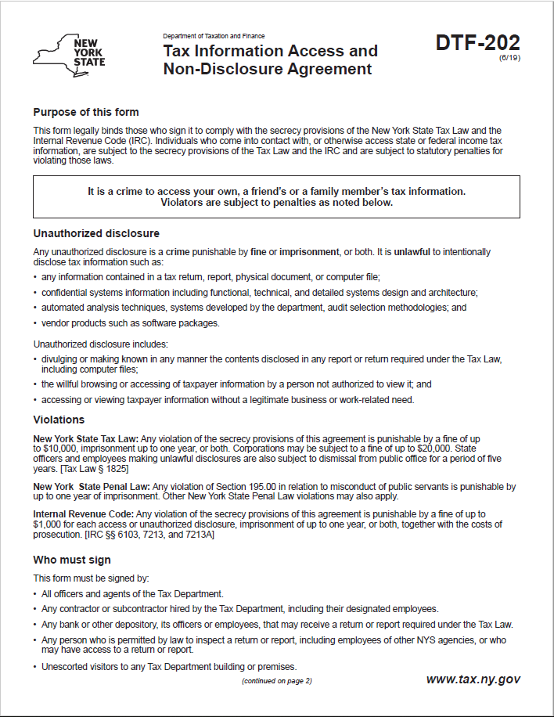
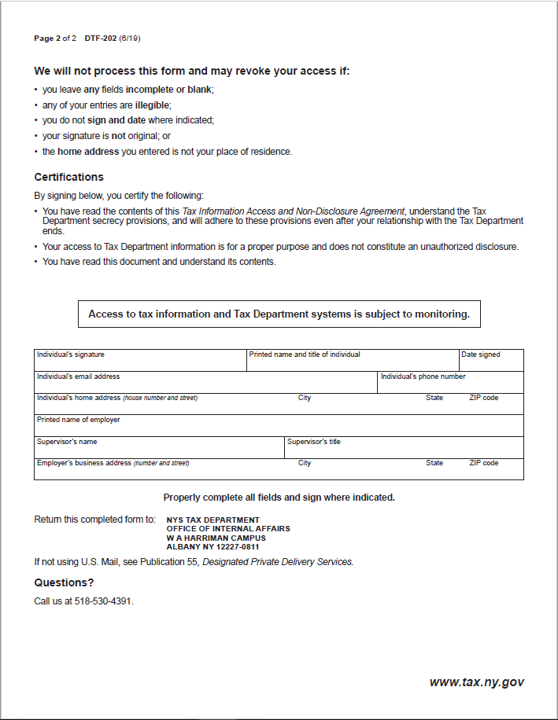

Exhibit B – SOW for Market Analysis and Feasibility Study Services
This Statement of Work (the “SOW”) is provided in connection with Request for Proposals 21-100 “Consulting Services for the New York State Secure Choice Savings Program” (the “RFP”) and resulting Contract C000XXX (the “Contract”), dated <Contract Date>, between <Insert Contractor Full Name> (“<Insert Contractor Abbreviation>”) and the New York Secure Choice Savings Program Board (“the Board”), as approved by the New York State Attorney General (“AG”) and the Office of the New York State Comptroller (“OSC”). The Contractor shall, as requested by the Board, provide ongoing and comprehensive consulting services within the scope of the engagement. This SOW sets forth in more detail the scope of work for Market Analysis and Feasibility Study Services that <Insert Contractor Abbreviation> will perform for the Board under the Contract, with the Contractor coordinating and providing its work product to the Board and the New York State Department of Taxation and Finance (“DTF”), acting at the direction of, and as staff to, the Board.
- State Staff:
Engagement Manager: Christopher Curtis

- Consultant Staff:
Engagement Partner: <Insert Name>
Project Manager: <Insert Name>
Senior Analyst: <Insert Name>
Analyst: <Insert Name>
<Insert Name>
- SOW Term: TBD

- Project Overview: New York State enacted the Act (Article 43 of the NYS General Business Law) establishing the Board and the Program in the form of an automatic enrollment Payroll Deduction IRA to promote retirement savings for Employees in a convenient, low-cost, and portable manner. The Program’s general administration, operation and governance will be administered by the Board with assistance from DTF for development and implementation.
Contractor will conduct market analysis and survey potential Program participants to assess Program financial feasibility and collect pertinent information to assist in Program design, implementation, and participation. Market Analysis and Feasibility Study results will estimate start-up costs associated with creating the Program and onboarding Participating Employers and Enrollees. This analysis will also provide an estimate of the operating costs associated with the Program (e.g., servicing accounts and managing investments).
Among other things, analysis of potential Program participants should be undertaken to facilitate:
- projecting the number of Program participants and participation rates;
- estimating continued participation rates;
- estimating contribution rates;
- identification of relevant demographic characteristics of the potential Enrollees (including, but not limited to: gender, age, race, education, work industry, and income); and
- predicting transactional costs associated with the Program.

- Project Scope/Deliverables:
- Conduct a Market Analysis and Feasibility Study that includes:
  - An executive summary of findings and conclusions; and
  - Description of the methodology, data sources, assumptions, results, conclusions and recommendations.
- Provide a financial model that simulates various outcomes based on relevant variables including, but not limited to, Enrollee participation rates, contribution rates, auto-escalation options, and start-up and operating costs.
- Undertake other tasks as assigned by the Board.

- Contractor Roles and Responsibilities:
- Contractor will submit a project plan including a summary of project objectives and deliverables, critical tasks/milestones, and the chronological steps to be taken to complete deliverables.
- Contractor will perform project administration and coordination of tasks to complete project deliverables.
- Contractor will submit to the State one or more drafts of the written deliverables for review, input, and acceptance.
- Contractor will submit progress reports to the State on a monthly basis, or more frequently as determined by the State, identifying any schedule changes and addressing overall project status by deliverable.

- Project Plan/Timeline: A project plan/timeline for this engagement is presented below:
<Proposed plan/timeline to be provided by Contractor with consultation from the State>

- Project Hours and Fees:
The following table represents the estimate of resources and hours to perform the work described herein. Hours specified below for each resource shall not be exceeded without the State’s written approval.
Hourly rates specified below are as set-forth in Attachment 18 – Financial Response Form to the RFP and exclude travel expenses. Travel expenses will be reimbursed in accordance with guidelines established by the OSC (See Office of the State Comptroller Travel Manual, available at http://www.osc.state.ny.us/agencies/travel/manual.pdf) when such travel has been authorized in advance.

Contract Title | Number of Hours | Hourly Rate | Total Cost
Engagement Partner |  | $ | $
Project Manager |  | $ | $
Senior Analyst |  | $ | $
Analyst |  | $ | $

Estimated Travel Expenses | $

- Executive Law Article 15-A Requirements: For purposes of this SOW, the State establishes an overall goal of [XX%] MWBE participation, [XX%] for New York State-certified minority-owned business enterprise (“MBE”) participation and [XX%] for New York State-certified women-owned business enterprise (“WBE”) participation (collectively, “MWBE Contract Goals”) based on the current availability of MBEs and WBEs. Contractor agrees to make good faith efforts to meet these goals or apply for a full or partial waiver.

AGREED AND ACCEPTED: AGREED AND ACCEPTED:

<CONTRACTOR> <STATE>

By: By:

Name: Name:

Title: Title:

Date: Date:

Exhibit C – SOW for General Consulting and Program Design Services
This Statement of Work (the “SOW”) is provided in connection with Request for Proposals 21-100 “Consulting Services for the New York State Secure Choice Savings Program” (the “RFP”) and resulting Contract C000XXX (the “Contract”), dated <Contract Date>, between <Insert Contractor Full Name> (“<Insert Contractor Abbreviation>”) and the New York Secure Choice Savings Program Board (“the Board”), as approved by the New York State Attorney General (“AG”) and the Office of the New York State Comptroller (“OSC”). The Contractor shall, as requested by the Board, provide ongoing and comprehensive services within the scope of the engagement. This SOW sets forth in more detail the scope of work for General Consulting and Program Design Services that <Insert Contractor Abbreviation> will perform for the Board under the Contract, with the Contractor coordinating and providing its work product to the Board and the New York State Department of Taxation and Finance (“DTF”), acting at the direction of, and as staff to, the Board.
- State Staff:
Engagement Manager: Christopher Curtis

- Consultant Staff:
Engagement Partner: <Insert Name>
Project Manager: <Insert Name>
Senior Analyst: <Insert Name>
Analyst: <Insert Name>
<Insert Name>
- SOW Term: TBD

- Project Overview: New York State enacted the Act (Article 43 of the NYS General Business Law) establishing the Board and the Program in the form of an automatic enrollment Payroll Deduction IRA to promote retirement savings for Employees in a convenient, low-cost, and portable manner. The Program’s general administration, operation and governance will be administered by the Board with assistance from DTF for development and implementation.
The results of the Market Analysis and Feasibility Study may be used to make Program design recommendations for administrative and recordkeeping guidelines, processing of payroll deductions, investing contributions, communicating with all Program participants, and providing any additional recommendations as requested by the Board. Contractor will assist with drafting and evaluating an RFP for a third-party administrator(s) to provide administrative recordkeeping and investment management services for the Program, provide recommendations to the Board regarding selection of a third-party administrator(s) and assist in the contract negotiations with the selected third-party administrator(s).

- Project Scope/Deliverables:
- Develop project timeline for issuing a third-party administrator RFP.
- Lead the drafting of the third-party administrator RFP.
- Recommend Program design elements including, but not limited to:
  - Type of entity best positioned to administer the Program (e.g., Should Program administrator and investment manager be distinct entities?);
  - Processes for on-boarding Participating Employers;
  - Processes for selection of contribution level and investment options by Enrollees;
  - How to effectively communicate information about Program participation, benefits, options, and disclosures to all Program participants; and
  - Providing best practices for establishing a secure website.
- Lead the drafting of the investment policy as required by GBL § 1305; assist the Board in all public hearings.
- Identifying investment options, including a default investment option for Enrollees who fail to make an election.
- Provide Board presentations on a variety of topics, including as to any aspects of the Contractor’s work with respect to the Program.
- Undertake other tasks as assigned by the Board.

- Contractor Roles and Responsibilities:
- Contractor will submit a project plan including a summary of project objectives and deliverables, critical tasks/milestones, and the chronological steps to be taken to complete deliverables.
- Contractor will provide project administration and coordination of tasks to complete project deliverables.
- Contractor will submit to the State one or more drafts of the written deliverables for review, input, and acceptance.
- Contractor will submit progress reports to the State on a monthly basis, or more frequently if requested by the State, identifying any schedule changes and addressing overall project status by deliverable.

- Project Plan/Timeline: A project plan/timeline for this engagement is presented below:
<Proposed plan/timeline to be provided by Contractor with consultation from the State>

- Project Hours and Fees:
The following table represents the estimate of resources and hours to perform the work described herein. Hours specified below for each resource shall not be exceeded without the State’s written approval.
Hourly rates specified below are as set-forth in Attachment 18 – Financial Response Form to the RFP and exclude travel expenses. Travel expenses will be reimbursed in accordance with guidelines established by the OSC (See Office of the State Comptroller Travel Manual, available at http://www.osc.state.ny.us/agencies/travel/manual.pdf) when such travel has been authorized in advance.

Contract Title | Number of Hours | Hourly Rate | Total Cost
Engagement Partner |  | $ | $
Project Manager |  | $ | $
Senior Analyst |  | $ | $
Analyst |  | $ | $

Estimated Travel Expenses | $
- Executive Law Article 15-A Requirements: For purposes of this SOW, the State establishes an overall goal of [XX%] MWBE participation, [XX%] for New York State-certified minority-owned business enterprise (“MBE”) participation and [XX%] for New York State-certified women-owned business enterprise (“WBE”) participation (collectively, “MWBE Contract Goals”) based on the current availability of MBEs and WBEs. <Contractor> agrees to make good faith efforts to meet these goals or apply for a full or partial waiver.

AGREED AND ACCEPTED: AGREED AND ACCEPTED:
<CONTRACTOR> <STATE>

By: By:

Name: Name:

Title: Title:

Date: Date:

Exhibit D – Bi-Weekly Contractor Timesheet

Exhibit E – New York State Office of the State Comptroller Substitute Form W-9
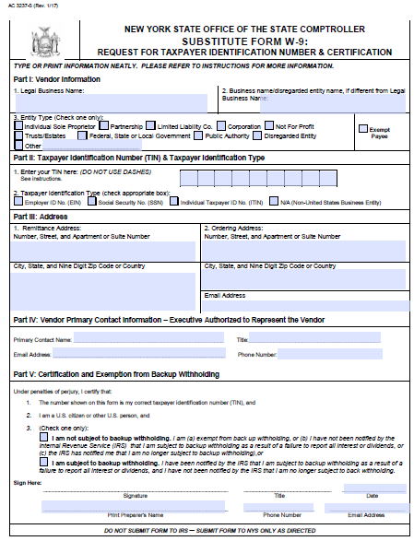
Note: This form is available at the NYS Office of State Comptroller website: https://www.osc.state.ny.us/vendors/forms/ac3237s_fe.pdf

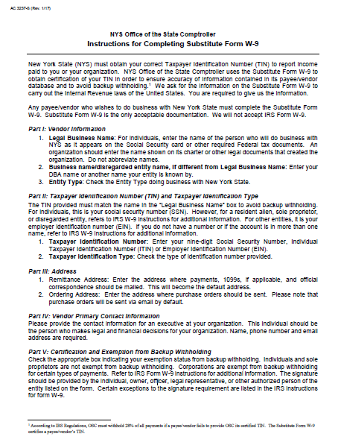

Exhibit F - MWBE Contractor Compliance and Payment Quarterly Report
Is this a final report? Check One
Yes _____ No______

of
NYS AGENCY Contract No. ___________________ Project No. _____________________
The following information indicates the payment amounts made by the grantee/contractor to the NYS Certified M/WBE subcontractor on this project.
Contractors Name and Address |  | Federal ID# |  | Goals/$ Amt.  MBE ____%= __________  WBE____%=___________ |  |  | Contract Type ___________________________  Paid to Contractor This Quarter_____________  Total Paid to Contractor To Date ____________
 |  | Project Completion Date |  | Work Location |  |  | Reporting Period:  ___ 1st Quarter (4/1-6/30) ____ 3rd Quarter (10/1-12/31)  ___ 2nd Quarter (7/1-9/30) ____ 4th Quarter (1/1-3/31)
M/WBE Subcontractor/Vendor | Product Code* | Work Status This Report | Total Subcontractor Contract Amount |  |  | Payments this Quarter |  | Previous Payments |  | Total Payment Made to Date
 |  |  | MBE |  | WBE | MBE | WBE | MBE | WBE | MBE | WBE
Name:  FED ID# |  | ___Active  ___Inactive  ___Complete
Name:  FED ID# |  | ___Active  ___Inactive  ___Complete
Name:  FED ID# |  | ___Active  ___Inactive  ___Complete
Name:  FED ID# |  | ___Active  ___Inactive  ___Complete
Total
The payments as shown made are in compliance with contract documents for the above referenced project.
*See Reverse Side for Product Codes
Date_________ Name________________________ Title ____________________ Signature______________________

PRODUCT KEY CODE
A = Agriculture/ Landscaping (e.g., all forms of landscaping services)
B = Mining (e.g., geological investigations)
C = Construction
C15 = Building Construction – General Contractors
C16 = Heavy Construction (e.g., highway, pipe laying)
C17 = Special Trade Contractors (e.g., plumbing, heating, electrical, carpentry)
D = Manufacturing
E = Transportation, Communication and Sanitary Services (e.g., delivery services, warehousing, broadcasting and cable systems)
F/G = Wholesale/Retail Goods (e.g. hospital supplies and equipment, food stores, computer stores, office supplies
G52 = Construction Materials (e.g., lumber, paint, law supplies)
H = Financial, Insurance and Real Estate Services
I = Services
I73 = Business Services (e.g., copying, advertising, secretarial, janitorial, rental services of equipment, computer programming, security services)
I81 = Legal Services
I82 = Education Services (e.g., AIDS education, automobile safety, tutoring, public speaking)
I83 = Social Services (Counselors, vocational training, child care)
I87 = Engineering, architectural, accounting, research, management and related services

Exhibit G – Minority and Women-Owned Business Enterprises – Equal Employment Opportunity Policy Statement
M/WBE AND EEO POLICY STATEMENT
I, _________________________, the (awardee/contractor)____________________ agree to adopt the following policies with respect to the project being developed or services rendered at __________________________________________________________________________________
M/WBE

EEO

This organization will and will cause its contractors and subcontractors to take good faith actions to achieve the M/WBE contract participations goals set by the State for that area in which the State-funded project is located, by taking the following steps:
- Actively and affirmatively solicit bids for contracts and subcontracts from qualified State certified MBEs or WBEs, including solicitations to M/WBE contractor associations.
- Request a list of State-certified M/WBEs from AGENCY and solicit bids from them directly.
- Ensure that plans, specifications, request for proposals and other documents used to secure bids will be made available in sufficient time for review by prospective M/WBEs.
- Where feasible, divide the work into smaller portions to enhanced participations by M/WBEs and encourage the formation of joint venture and other partnerships among M/WBE contractors to enhance their participation.
- Document and maintain records of bid solicitation, including those to M/WBEs and the results thereof. Contractor will also maintain records of actions that its subcontractors have taken toward meeting M/WBE contract participation goals.
- Ensure that progress payments to M/WBEs are made on a timely basis so that undue financial hardship is avoided, and that bonding and other credit requirements are waived or appropriate alternatives developed to encourage M/WBE participation.

  - This organization will not discriminate against any employee or applicant for employment because of race, creed, color, national origin, sex, age, disability or marital status, will undertake or continue existing programs of affirmative action to ensure that minority group members are afforded equal employment opportunities without discrimination, and shall make and document its conscientious and active efforts to employ and utilize minority group members and women in its work force on state contracts.
  - This organization shall state in all solicitation or advertisements for employees that in the performance of the State contract all qualified applicants will be afforded equal employment opportunities without discrimination because of race, creed, color, national origin, sex disability or marital status.
  - At the request of the contracting agency, this organization shall request each employment agency, labor union, or authorized representative will not discriminate on the basis of race, creed, color, national origin, sex, age, disability or marital status and that such union or representative will affirmatively cooperate in the implementation of this organizations’ obligations herein.
  - Contractor shall comply with the provisions of the Human Rights Law, all other State and Federal statutory and constitutional non-discrimination provisions. Contractor and subcontractors shall not discriminate against any employee or applicant for employment because of race, creed (religion), color, sex, national origin, sexual orientation, marital status or domestic violence victim status, and shall also follow the requirements of the Human Rights Law with regard to non-discrimination on the basis of prior criminal conviction and prior arrest.

- This organization will include the provisions of sections (a) through (d) of this agreement in every subcontract in such a manner that the requirements of the subdivisions will be binding upon each subcontractor as to work in connection with the State contract.

Agreed to this _______ day of ____________________, 2___________
By __________________________________________
Print: _____________________________________ Title: _____________________________
Minority Business Enterprise Liaison
_________________________________is designated as the Minority Business Enterprise Liaison
(Name of Designated Liaison)
responsible for administering the Minority and Women-Owned Business Enterprises- Equal Employment
Opportunity (M/WBE-EEO) program.
M/WBE Contract Goals
________% Minority Business Enterprise Participation
________% Women’s Business Enterprise Participation

EEO Contract Goals
________% Minority Labor Force Participation
________%Female Labor Force Participation

____________________________________________
(Authorized Representative)
Title: ________________________________________
Date: ________________________________________

Exhibit H – Contractor Sales Tax Certification Forms
These forms are available at the NYS Department of Taxation and Finance website:
ST-220-TD: https://www.tax.ny.gov/pdf/current_forms/st/st220td_fill_in.pdf
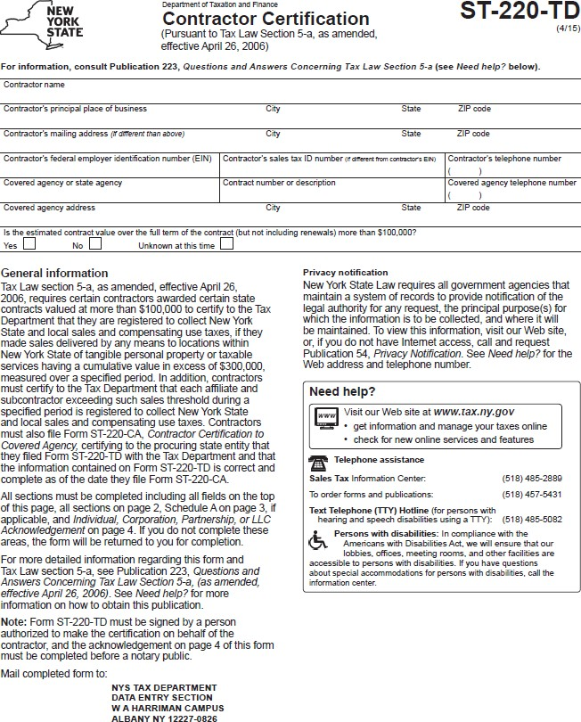
ST-220-CA: https://www.tax.ny.gov/pdf/current_forms/st/st220ca_fill_in.pdf

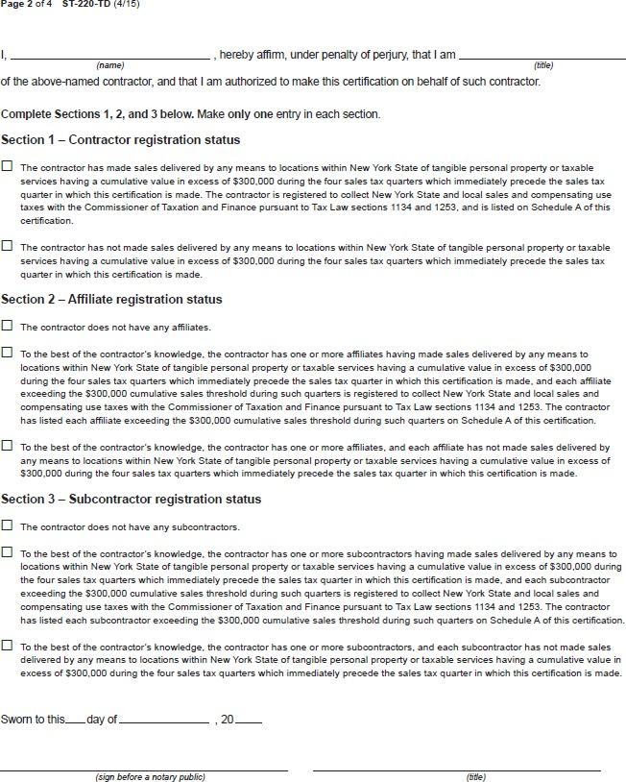

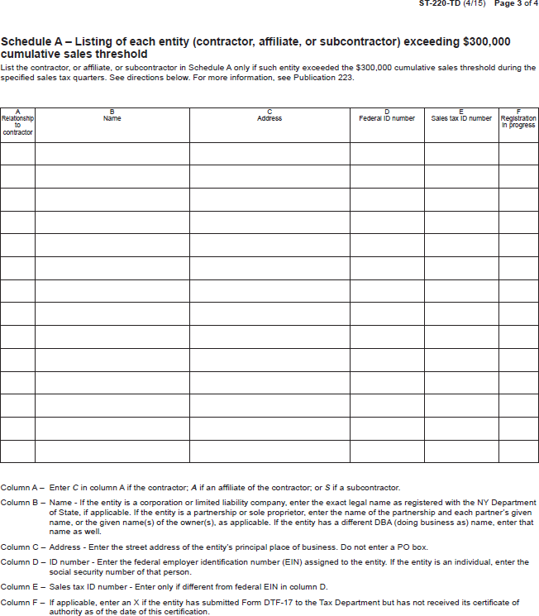

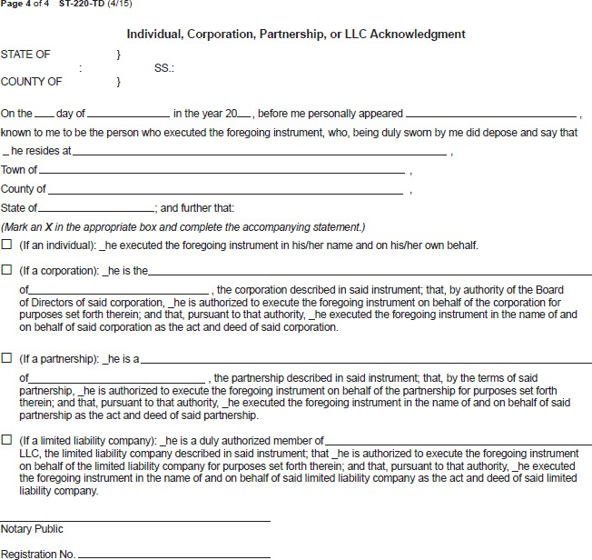

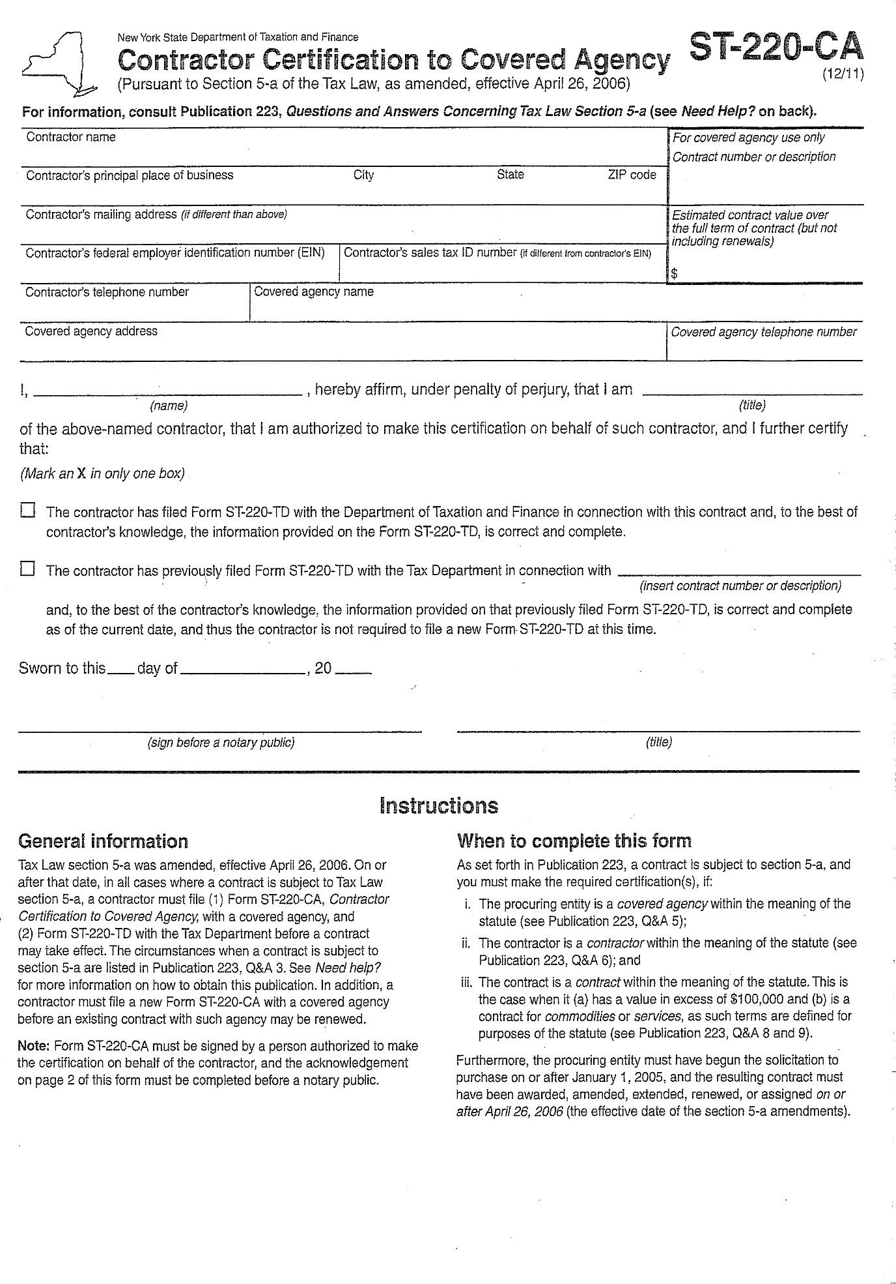

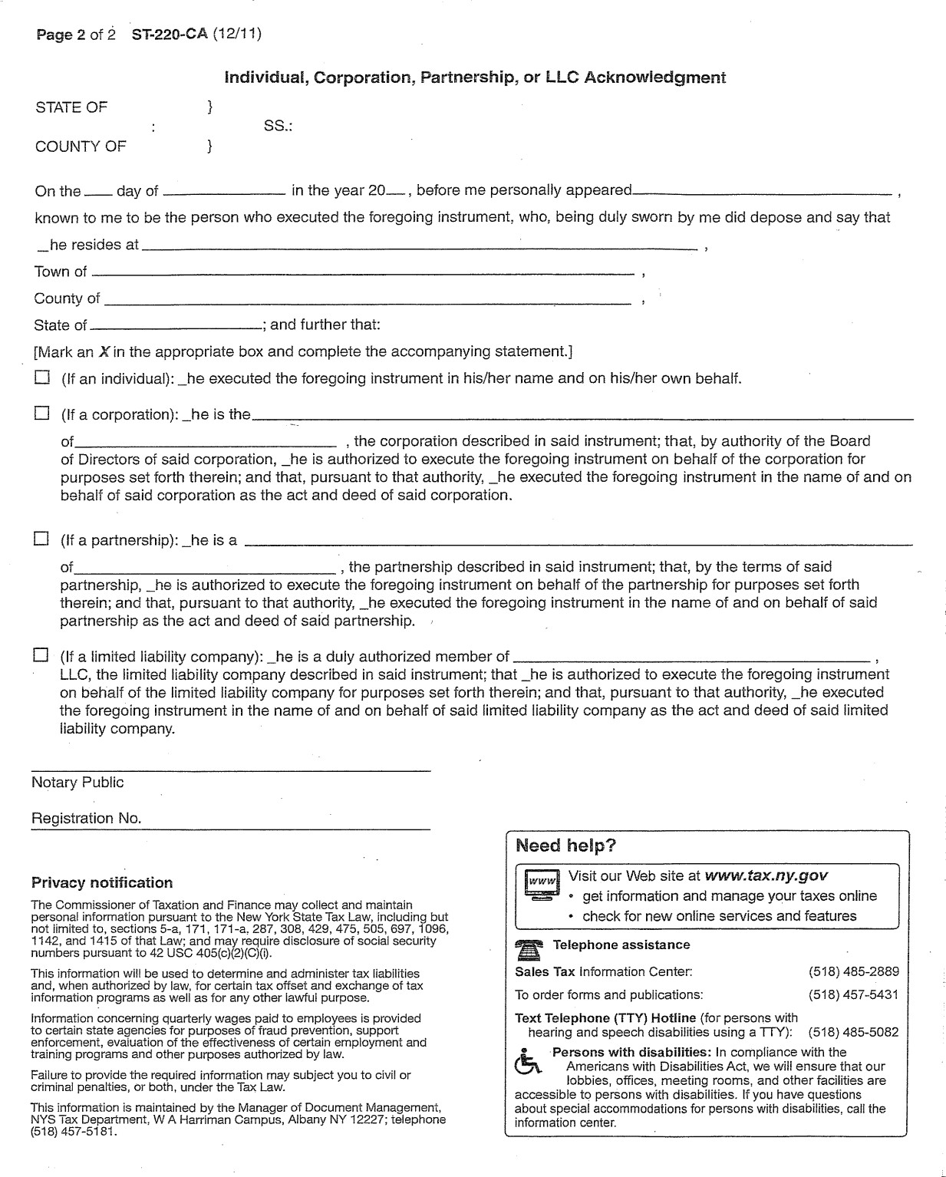

Exhibit I – State Consultant Services – Contractor’s Planned Employment – Form A
New York State Consultant Services
Contractor's Planned Employment
From Contract Start Date Through the End of the Contract Term
State Agency Name: NYS Department of Taxation and Finance
State Agency Department ID: 3850000 |  |  |  |  |  | Agency Business Unit: TAX01
Contractor Name: |  |  |  |  |  | Contract Number:
Contract Start Date: / / |  |  |  | Contract End Date: / /
Employment Category |  |  | Number of Employees |  | Number of hours to be worked |  |  | Amount Payable Under the Contract
Total this page |  |  | 0 |  | 0 |  |  | $ 0.00
 | Grand Total
Name of person who prepared this report:
Title: |  |  |  |  |  |  | Phone #:
Preparer's Signature:
Date Prepared: / /
(Use additional pages, if necessary) |  |  |  |  |  |  |  | Page of

Exhibit J – Contractor’s Annual Employment Report – Form B
New York State Consultant Services
Contractor’s Annual Employment Report
Report Period: April 1, to March 31,
Contracting State Agency Name: NYS Department of Taxation and Finance
Contract Number: |  |  |  |  |  | Agency Business Unit: TAX01
Contract Term: / / to / / |  |  |  |  |  | Agency Department ID: 3850000
Contractor Name:
Contractor Address:
Description of Services Being Provided:

Scope of Contract (Choose one that best fits):
Analysis Evaluation Research Training
Data Processing Computer Programming Other IT consulting
Engineering Architect Services Surveying Environmental Services
Health Services Mental Health Services
Accounting Auditing Paralegal Legal Other Consulting
Employment Category |  |  | Number of Employees |  | Number of  Hours Worked |  |  | Amount Payable Under the Contract
Total this page |  |  | 0 |  | 0 |  |  | $ 0.00
 | Grand Total
Name of person who prepared this report:
Title: |  |  |  |  |  |  | Phone #:
Preparer's Signature:
Date Prepared: / /
(Use additional pages, if necessary) |  |  |  |  |  |  |  | Page of

Exhibit K – Workforce Utilization Report

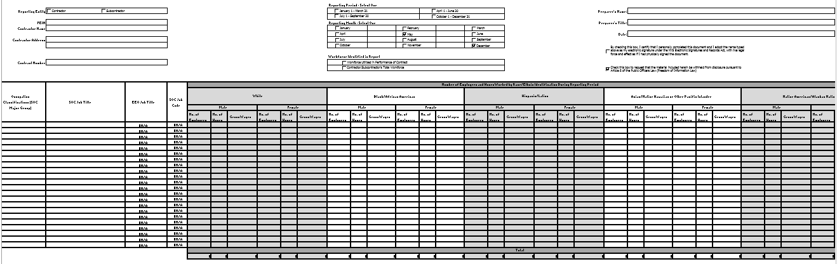
Note: An Excel file of this form will be provided to the Contractor after contract execution.

Exhibit L – Request For Waiver Form
INSTRUCTIONS: SEE PAGE 2 OF THIS ATTACHMENT FOR REQUIREMENTS AND DOCUMENT SUBMISSION INSTRUCTIONS
Offeror/Contractor Name: | Federal Identification No.:
Address: | Solicitation/Contract No.:
City, State, Zip Code: | M/WBE Goals: MBE % WBE %
By submitting this form and the required information, the officer or/contractor certifies that every Good Faith Effort has been taken to promote M/WBE participation pursuant to the M/WBE requirements set forth under the contract.
Contractor is requesting a (check applicable):
PREPARED BY (Signature) Date:

SUBMISSION OF THIS FORM CONSTITUTES THE OFFEROR/CONTRACTOR’S ACKNOWLEDGEMENT AND AGREEMENT TO COMPLY WITH THE M/WBE REQUIREMENTS SET FORTH UNDER NYS EXECUTIVE LAW, ARTICLE 15-A AND 5 NYCRR PART 143. FAILURE TO SUBMIT COMPLETE AND ACCURATE INFORMATION MAY RESULT IN A FINDING OF NONCOMPLIANCE AND/OR TERMINATION OF THE CONTRACT.
Name and Title of Preparer (Printed or Typed): | Telephone Number: | Email Address:
Submit with the bid or proposal or if submitting after award submit to: | ***** FOR DMWBD USE ONLY *****
 | REVIEWED BY: | DATE:
Waiver Granted: □ Yes □ No MBE: □ WBE: □
- Total Waiver □ Partial Waiver
- ESD Certification Waiver □ * Conditional
- Notice of Deficiency Issued
*Comments:

REQUIREMENTS AND DOCUMENT SUBMISSION INSTRUCTIONS
When completing the Request for Waiver Form please check all boxes that apply. To be considered, the Request for Waiver Form must be accompanied by documentation for items 1 – 11, as listed below. If box # 3 has been checked above, please see item 11. Copies of the following information and all relevant supporting documentation must be submitted along with the request:
- A statement setting forth your basis for requesting a partial or total waiver.
- The names of general circulation, trade association, and M/WBE-oriented publications in which you solicited certified MWBEs for the purposes of complying with your participation goals related to this contract.
- A list identifying the date(s) that all solicitations for certified M/WBE participation were published in any of the above publications.
- A list of all certified MWBEs appearing in the NYS Directory of Certified Firms that were solicited for purposes of complying with your certified M/WBE participation levels.
- Copies of notices, dates of contact, letters, and other correspondence as proof that solicitations were made in writing and copies of such solicitations, or a sample copy of the solicitation if an identical solicitation was made to all certified MWBEs.
- Provide copies of responses to your solicitations received by you from certified MWBEs.
- Provide a description of any contract documents, plans, or specifications made available to certified MWBEs for purposes of soliciting their bids and the date and manner in which these documents were made available.
- Provide documentation of any negotiations between you, the Offeror/Contractor, and the MWBEs undertaken for purposes of complying with the certified M/WBE participation goals.
- Provide any other information you deem relevant which may help us in evaluating your request for a waiver.
- Provide the name, title, address, telephone number, and e-mail address of offeror/contractor’s representative authorized to discuss and negotiate this waiver request.
- Copy of notice of application receipt issued by Empire State Development (ESD).
Note: Unless a Total Waiver has been granted, the Offeror/Contractor will be required to submit all reports and documents pursuant to the provisions set forth in the Contract, as deem appropriate by DTF, to determine M/WBE compliance.

Exhibit 1 – NYS General Business Law Article 43
New York State Secure Choice Savings Program
General Business
ARTICLE 43
NEW YORK STATE SECURE CHOICE SAVINGS PROGRAM

Section

1300. Definitions.

1301. Program established.
1302. Composition of the board. 1303. Fiduciary duty.
1304. Duties of the board. 1305. Risk management.
1306. Financial organizations.

1307. Investment options.

1308. Benefits.

1309. Employer and employee informational materials and disclosure forms. 1310. Program implementation and enrollment.
1311. Payments.

1312. Duty and liability of the state.

1313. Duty and liability of participating employers. 1314. Audit and reports.
1315. Delayed implementation.

1316. Regulations.

General Business

§ 1300. Definitions. All terms shall have the same meaning as when used in a comparable context in the Internal Revenue Code. As used in this article, the following terms shall have the following meanings:

- "Board" shall mean the New York secure choice savings program board established under this article.

- "Superintendent" shall mean the superintendent of the department of financial services.

2-a. "Commissioner" shall mean the commissioner of taxation and finance. 2-b. "Comptroller" shall mean the comptroller of the state.
- "Employee" shall mean any individual who is eighteen years of age or older, who is employed by an employer, and who earned wages working for an employer in New York state during a calendar year.

- "Employer" shall mean a person or entity engaged in a business, industry, profession, trade, or other enterprise in New York state, whether for profit or not for profit, that (i) has at all times during the previous calendar year employed at least ten employees in the state, (ii) has been in business at least two years, and (iii) has not offered a qualified retirement plan, including, but not limited to, a plan qualified under sections 401(a), 401(k), 403(a), 403(b), 408(k), 408(p) or 457(b) of the Internal Revenue Code of 1986 in the preceding two years.

- "Enrollee" shall mean any employee who is enrolled in the program.

- "Internal Revenue Code" shall mean the Internal Revenue Code of 1986, or any successor law, in effect for the calendar year.

- "IRA" shall mean a Roth IRA (individual retirement account).

- "Participating employer" shall mean an employer that facilitates access to the program's payroll deduction IRA as provided for by this article for its employees who are enrollees in the program.

- "Payroll deduction IRA" shall mean an arrangement by which a participating employer facilitates access for enrollees to remit payroll deduction contributions to the program.

- "Program" shall mean the New York state secure choice savings program.

- "Wages" means any compensation within the meaning of section 219(f)(1) of the Internal Revenue Code that is received by an enrollee from a participating employer during the calendar year.

§ 1301. Program established. There is hereby established a retirement savings program in the form of an automatic enrollment payroll deduction IRA, known as the New York state secure choice savings program. The general administration and responsibility for the proper operation of the program shall be administered by the board for the purpose of promoting greater retirement savings for private-sector employees in a convenient, low-cost, and portable manner. The board may delegate such authority and responsibility for the development and implementation of the program to the department of taxation and finance as the board deems proper.

§ 1302. Composition of the board. There is hereby created the New York state secure choice savings program board.

- The board shall consist of the following seven members:

- the commissioner, or his or her designee, who shall serve as chair;

- the state comptroller, or his or her designee;

- the superintendent, or his or her designee;

- two public representatives with expertise in retirement savings plan administration or investment, or both, one of whom shall be appointed by the speaker of the assembly and one of whom shall be appointed by the temporary president of the senate;

- a representative of participating employers, appointed by the governor; and

- a representative of enrollees, appointed by the governor.

- Members of the board shall serve without compensation but may be reimbursed for necessary travel expenses incurred in connection with their board duties from funds appropriated for the purpose.

- The initial appointments shall be as follows: the public representatives for four years; the representative of participating employers for three years; and the

representative of enrollees for three years. Thereafter, all the governor's appointees shall be for terms of four years.

- A vacancy in the term of an appointed board member shall be filled for the balance of the unexpired term in the same manner as the original appointment.

§ 1303. Fiduciary duty. The board, the individual members of the board, the trustees, any other agents appointed or engaged by the board, and all persons serving as program staff shall discharge their duties with respect to the program solely in the interest of the program's enrollees and beneficiaries as follows:

- for the exclusive purposes of providing benefits to enrollees and beneficiaries and defraying reasonable expenses of administering the program;

- by investing with the care, skill, prudence, and diligence under the prevailing circumstances that a prudent person acting in a like capacity and familiar with those matters would use in the conduct of an enterprise of a like character and with like aims; and

- by using any contributions paid by employees and employers remitting employees' own contributions into the fund exclusively for the purpose of paying benefits to the enrollees of the program, for the cost of administration of the program, and for investments made for the benefit of the program.

§ 1304. Duties of the board. In addition to the other duties and responsibilities stated in this article, the board shall, itself or through the use of appropriate financial organizations as managers:

- Cause the program to be designed, established and operated in a manner that:

- accords with best practices for retirement savings vehicles;

- maximizes participation, savings, and sound investment practices including considering the use of automatic enrollment as allowed under federal law;

- maximizes simplicity, including ease of administration for participating employers and enrollees;

- provides an efficient product to enrollees by pooling investment funds;

- ensures the portability of benefits; and

- provides for the deaccumulation of enrollee assets in a manner that provides a financial benefit in retirement.

- Explore and establish or authorize investment options, subject to this article, that offer enrollees returns on contributions and the conversion of individual retirement savings account balances to secure retirement income without incurring debt or liabilities to the state.

- Establish or authorize the process by which interest, investment earnings, and investment losses are allocated to individual program accounts on a pro rata basis and are computed at the interest rate on the balance of an individual's account.

- Make and enter into contracts necessary for the administration of the program and fund, including, but not limited to, retaining and contracting with investment managers, financial organizations, other financial and service providers, consultants, actuaries, counsel, auditors, third-party administrators, and other professionals as necessary.

- Conduct a periodic review of the performance of any financial organizations, including, but not limited to, a review of returns, fees, and customer service. A copy of reviews shall be posted to the program's Internet website.

- Cause moneys in the program to be held and invested as pooled investments or otherwise, with a view to achieving cost savings through efficiencies and economies of scale.

- Evaluate and establish or authorize the process for:

- an enrollee to contribute a portion of his or her wages to the program via payroll deduction; and

- the enrollment of participating employers in the program.

- The board may contract with financial organizations and third-party administrators with the capability to receive and process employee information and contributions for payroll deduction IRA or similar arrangements.

- Evaluate and establish or authorize the process for enrollment including the process by which an employee may opt not to participate in the program, select a contribution level, select an investment option, and terminate participation in the program.

- Evaluate, or cause to be evaluated, the need for, and procure as needed, insurance against any and all loss in connection with the property, assets, or activities of the program, and indemnify as needed each member of the board from personal loss or liability resulting from a member's action or inaction as a member of the board.

- Make provisions for the payment of administrative costs and expenses for the creation, management, and operation of the program. Subject to appropriation, the state may pay administrative costs associated with the creation and management of the program until sufficient assets are available in the program for that purpose. Thereafter, all administrative costs of the program, including repayment of any start- up funds provided by the state, shall be paid only out of moneys on deposit therein. However, private funds or federal funding received in order to implement the program until it is self-sustaining shall not be repaid unless those funds were offered contingent upon the promise of such repayment. The board shall keep its annual administrative expenses as low as possible.

- Allocate administrative fees to individual retirement accounts in the program on a pro rata basis.

- Set or authorize minimum and maximum contribution levels in accordance with limits established for IRAs by the Internal Revenue Code.

- Facilitate education and outreach to employers and employees.

- Facilitate compliance by the program with all applicable requirements for the program under the Internal Revenue Code, including tax qualification requirements or any other applicable legal, financial reporting and accounting requirements.

- Carry out the duties and obligations of the program in an effective, efficient, and low-cost manner.

- Exercise any and all other powers reasonably necessary for the effectuation of the purposes, objectives, and provisions of this article.

- Determine or authorize withdrawal provisions, such as economic hardships, portability and leakage.

- Determine employee rights and enforcement of penalties.

- Delegate such authority and responsibility for the development and implementation of the program to the department of taxation and finance as the board deems proper.

§ 1305. Risk management. The board shall annually prepare, or cause to be prepared, and adopt a written statement of investment policy that includes a risk management and oversight program. This investment policy shall prohibit the board and the program from borrowing for investment purposes. The risk management and oversight program shall be designed to ensure that an effective risk management system is in place to monitor the risk levels of the program, to ensure that the risks taken are prudent and properly managed, to provide an integrated process for overall risk management, and to assess investment returns as well as risk to determine if the risks taken are adequately compensated compared to applicable performance benchmarks and standards. The board shall consider the statement of investment policy and any changes in the investment policy at a public hearing.

§ 1306. Financial organizations. 1. The board shall engage, after an open bid process, a financial organization or organizations to invest assets of the program. In selecting the financial organization or organizations, the board shall take into consideration and give weight to the financial organization's fees and charges in order to reduce the program's administrative expenses.

- The financial organizations shall comply with applicable federal and state laws, rules, and regulations, as well as rules, policies, and guidelines promulgated by the board with respect to the program, including, but not limited to, the investment policy.

- The financial organization or organizations shall provide such reports as the board deems necessary for the board to oversee each financial organization's performance and the performance of the program.

§ 1307. Investment options. 1. The board shall establish or authorize a default investment option for enrollees who fail to elect an investment option. In making such determination, the board shall consider the cost, risk profile, benefit level and ease of enrollment. The board may change the default option if the board determines that such change is in the best interests of the enrollees.

2. The board may establish or authorize any additional investment options that the board deems appropriate including but not limited to:

- a conservative principal protection fund;

- a growth fund;

- a secure return fund whose primary objective is the preservation of the safety of principal and the provision of a stable and low-risk rate of return; if the board elects to establish a secure return fund, the board may procure any insurance, annuity, or other

product to insure the value of enrollees' accounts and guarantee a rate of return; the cost of such funding mechanism shall be paid out of the fund; under no circumstances shall the board, program, fund, the state, or any participating employer assume any liability for investment or actuarial risk; the board shall determine whether to establish or authorize such investment options based upon an analysis of their cost, risk profile, benefit level, feasibility, and ease of implementation;

- an annuity fund;

- a growth and income fund; or

- a life cycle fund with a target date based upon factors determined by the board.

§ 1308. Benefits. Interest, investment earnings, and investment losses shall be allocated to individual program accounts as authorized by the board pursuant to this article. An individual's retirement savings benefit under the program shall be an amount equal to the balance in the individual's program account on the date the retirement savings benefit becomes payable. The state shall have no liability for the payment of any benefit to any enrollee in the program.

§ 1309. Employer and employee informational materials and disclosure forms. 1.
Prior to the opening of the program for enrollment, the board shall design and disseminate, or cause to be designed and disseminated, to all employers employer informational materials and employee informational materials, which shall include background information on the program, and necessary disclosures as required by law for employees.

- The employee informational materials shall be made available in English, Spanish, Haitian Creole, Chinese, Korean, Russian, Arabic, and any other language the board deems necessary.

- The employee informational materials shall include a disclosure form. The disclosure form shall explain, but not be limited to, all of the following:

- the benefits and risks associated with making contributions to the program;

- the process for making contributions to the program;

- how to opt out of the program;

- the process by which an employee can participate in the program with a level of employee contributions other than three percent;

- that they are not required to participate or contribute more than three percent;

- the process for withdrawal of retirement savings;

- the process for selecting beneficiaries of their retirement savings;

- how to obtain additional information about the program;

- that employees seeking financial advice should contact financial advisors, that participating employers are not in a position to provide financial advice, and that participating employers are not liable for decisions employees make pursuant to this article;

- information on how to access any available financial literacy programs;

- that the program fund is not guaranteed by the state; and

- that they can opt out after they have been enrolled.

- The employee informational materials shall also include a form for an employee to note his or her decision to opt out of participation in the program or elect to participate with a level of employee contributions other than three percent.

- Participating employers shall supply the employee informational materials to existing employees at least one month prior to the participating employers' facilitation of access to the program. Participating employers shall supply the employee informational materials to new employees at the time of hiring and new employees may opt out of participation in the program.

§ 1310. Program implementation and enrollment. Except as otherwise provided in this article, the program shall be implemented, and enrollment of employees shall begin no later than December thirty-first, two thousand twenty-one. The provisions of this section shall be in force after the board opens the program for enrollment.

- (a) Each participating employer shall have a payroll deposit retirement savings arrangement to allow each employee to participate in the program at most nine months after the board opens the program for enrollment.

(b) Participating employers shall automatically enroll in the program each of their employees who has not opted out of participation in the program using the form described in this article and shall provide payroll deduction retirement savings

arrangements for such employees and deposit, on behalf of such employees, these funds into the program.

- Enrollees shall have the ability to select a contribution level into the program. This level may be expressed as a percentage of wages or as a dollar amount up to the deductible amount for the enrollee's taxable year under section 219(b)(1)(A) of the Internal Revenue Code. Enrollees may change their contribution level at any time, subject to rules promulgated by the board. If an enrollee fails to select a contribution level using the form described in this article, then he or she shall contribute three percent of his or her wages to the program, provided that such contributions shall not cause the enrollee's total contributions to IRAs for the year to exceed the deductible amount for the enrollee's taxable year under section 219(b)(1)(A) of the Internal Revenue Code. The deduction of contributions from an employee's wages shall not begin until the thirtieth day after such employee has been enrolled in the program.

- Enrollees may select an investment option offered under the program. Enrollees may change their investment option at any time, subject to rules promulgated by the board. In the event that an enrollee fails to select an investment option, that enrollee shall be placed in the investment option selected or authorized by the board as the default under this article.

- Following initial implementation of the program pursuant to this section, at least once every year, the program shall designate an open enrollment period during which employees who previously opted out of the program may enroll in the program.

- An employee who opts out of the program and who subsequently wants to participate may only enroll during the program's designated open enrollment period or if permitted by the program at an earlier time.

- Employers shall retain the option at all times to set up any type of employer- sponsored retirement plan.

- An enrollee may terminate his or her enrollment in the program at any time in a manner prescribed by the board.

- (a) The board shall establish or authorize a website regarding the secure choice savings program.

(b) The board shall establish and maintain or authorize the establishment and maintenance of a secure website wherein enrollees may log in and acquire information regarding contributions and investment income allocated to, withdrawals from, and balances in their program accounts for the reporting period. Such website must also

include information for the enrollees regarding other options available to the employee and how they can transfer their accounts to other programs should they wish to do so. Such website may include any other information regarding the program as the board may determine.

- A person or entity engaged in a business, industry, profession, trade, or other enterprise in New York state, whether for profit or not for profit, that offers a qualified retirement plan, including, but not limited to, a plan qualified under sections 401(a), 401(k), 403(a), 403(b), 408(k), 408(p) or 457(b) of the Internal Revenue Code of 1986 shall not terminate such plan for the purposes of participating in the program.

§ 1311. Payments. Employee contributions deducted by the participating employer through payroll deduction shall be remitted by the participating employer to the program using one or more payroll deduction IRAs established or authorized by the board under this article, either:

- on or before the last day of the month following the month in which the compensation otherwise would have been payable to the employee in cash; or

- before such later deadline prescribed by the board for making such payments, but not later than the due date for the deposit of tax required to be deducted and withheld relating to collection of income tax at source on wages or for the deposit of tax required to be paid under the unemployment insurance system for the payroll period to which such payments relate.

§ 1312. Duty and liability of the state. 1. The state shall have no duty or liability to any party for the payment of any retirement savings benefits accrued by any enrollee under the program. Any financial liability for the payment of retirement savings benefits in excess of funds available under the program shall be borne solely by the entities with whom the board contracts to provide insurance to protect the value of the program.

2. No state board, commission, or agency, or any officer, employee, or member thereof is liable for any loss or deficiency resulting from particular investments selected under this article, except for any liability that arises out of a breach of fiduciary duty.

§ 1313. Duty and liability of participating employers. 1. Participating employers shall not have any liability for an employee's decision regarding whether to participate in, or opt out of, the program or for the investment decisions of the board or of any enrollee.

2. A participating employer is not establishing or maintaining the program's payroll deduction IRA. A participating employer shall not be a fiduciary, or considered to be a fiduciary, over the program. A participating employer shall not bear responsibility for the administration, investment, or investment performance of the program. A participating employer shall not be liable with regard to investment returns, program design, and benefits paid to program participants.

§ 1314. Audit and reports. 1. The board shall annually submit:

- an audited financial report, prepared in accordance with generally accepted accounting principles, on the operations of the program during each calendar year by July first of the following year to the governor, the commissioner, the speaker of the assembly, the temporary president of the senate, the chair of the assembly ways and means committee, the chair of the senate finance committee, the chair of the assembly labor committee, the chair of the senate labor committee; and

- a report prepared or authorized by the board, which shall include, but is not limited to, a summary of the benefits provided by the program, including the number of enrollees in the program, the percentage and amounts of investment options and rates of return, and such other information that is relevant to make a full, fair, and effective disclosure of the operations of the program. The annual report shall be made by an independent certified public accountant and shall include, but is not limited to, direct and indirect costs attributable to the use of outside consultants, independent contractors, and any other persons who are not state employees for the administration of the program.

2. In addition to any other statements or reports required by law, the board shall provide or cause to be provided periodic reports at least annually to enrollees, reporting contributions and investment income allocated to, withdrawals from, and balances in their program accounts for the reporting period. Such reports may include any other information regarding the program as the board may determine.

§ 1315. Delayed implementation. The board may delay the implementation of the program an additional twelve months beyond the date established in section thirteen hundred ten of this article if the board determines that further delay is necessary to address legal, financial or other programmatic concerns impacting the viability of the program. The board shall provide reasonable notice of such delay to the governor, the commissioner, the speaker of the assembly, the temporary president of the senate, the chair of the assembly ways and means committee, the chair of the senate finance committee, the chair of the assembly labor committee, and the chair of the senate labor committee.

§ 1316. Regulations. The commissioner may issue such rules and regulations as he or she deems necessary to implement the terms of this article.

