INVITATION FOR BIDS
BID DUE DATE: March 4th at 2 PM EST | TITLE: TMT – 6 Highway Use Tax Sticker & TMT – 40 Automotive Fuel Carrier Sticker |  |  |  | IFB #: 23-201
CONTRACT PERIOD: This is a one-time purchase
The bid must be fully and properly executed by an authorized person. By signing you certify your express authority to sign on behalf of yourself, your company, or other entity and full knowledge and acceptance of this INVITATION FOR BIDS, Appendix A (Standard Clauses For New York State Contracts) and all other appendices, attachments and exhibits and that all information provided is complete, true and accurate. By signing, Bidder also affirms that it understands and agrees to comply with the Department of Taxation and Finance (“DTF”) procedures relative to permissible contacts as required by State Finance Law §139-j (3) and §139-j (6) (b). Information may be found at: http://www.tax.ny.gov/about/procure.
Bidder’s Federal Tax Identification Number:  (Do Not Use Social Security Number) |  |  | NYS Vendor Identification Number:  (See “New York State Vendor File Registration” clause)
If applicable, place an “x” in the appropriate box (check all that apply): |  | ☐NYS Small Business *  _____ # of Employees | ☐NYS Certified Minority Owned Business | ☐NYS Certified Women Owned Business
Legal Business Name of Company Bidding:

D/B/A - Doing Business As (if applicable):

Street, City, State, Zip, County:

If you are not bidding, place an “x” in the box and return this page only.
☐WE ARE UNABLE TO BID NOW BECAUSE:

Printed or Typed Name: |  |  | Title:
Bidder’s Signature: |  |  | Date:
* Note: A “New York State Small Business” is defined as a company that is a resident to New York State, independently owned and operated, with 100 or fewer employees, and not dominant in its field. There is no certification process to be considered a New York State Small Business.
- 1. GENERAL INFORMATION

IMPORTANT NOTICE TO POTENTIAL BIDDERS: Receipt of these bid documents does not indicate that the Department of Taxation and Finance has pre-determined your company's qualifications to receive a contract award. Such determination will be made after the bid opening and will be based on our evaluation of your bid submission compared to the specific requirements and qualifications contained in these bid documents.

  - NOTICE TO BIDDERS – BID SUBMISSION
Through this Invitation for Bids (“IFB”), the New York State Department of Taxation and Finance (“DTF” or “Department”) is seeking competitive bids from qualified firms (the “Offerer” or the “Bidder”) to produce and supply TMT – 6 Highway Use Tax Stickers & TMT – 40 Automotive Fuel Carrier Stickers in accordance with the detailed specifications outlined in this IFB 23-201.
    - Prepare and submit your bid in accordance with this IFB and Attachment 1, Bidder’s Checklist. This IFB and Attachment 1 outlines the terms and conditions, and all applicable information required for submission of a bid.
    - Include ten (10) uncolored samples of proposed decals. Failure to submit samples of the proposed stock may result in rejection of the bid.
    - The bidder should submit with its bid the manufacturer’s detailed specifications, circulars and all necessary data on the product to be furnished including proper application procedures.
    - Bids must be received by the date and time specified in the Schedule of Events. Bids must have a label on the outside of the package or shipping container that states "BID ENCLOSED" and record the IFB Number (23-201) and Bid Opening Date on the envelope containing the sealed bid. Failure to complete all information on the bid envelope may necessitate the premature opening of the bid which may compromise its confidentiality. An improperly submitted bid resulting in a LATE BID may not be considered. E-mail and fax bid submissions are not acceptable and will be considered non-responsive.

Bids are to be mailed to:
Attn: Amber Alexander, Director, Procurement Services
Procurement Services Unit
New York State Department of Taxation and Finance
W. A. Harriman State Office Building Campus
Albany, NY 12227

Please note: Deliveries by delivery services (e.g. UPS, FedEx, etc.) and/or requiring a signature of receipt should be addressed to the Department’s W.A. Harriman Campus address; however, the delivery service provider must be instructed to deliver the bid documents to the following address:
90 Cohoes Avenue
Green Island, New York 12183

  - SCHEDULE OF EVENTS

February 9, 2024 | Issuance of IFB
February 1692024 | Deadline for Submission of Written Questions
February 26, 2024 | Department Response to Bidder Questions Posted
March 4, 2024  by 2 PM EST | Deadline for Submission of Bids
March 5, 2024 | Anticipated Bid Opening
March 6, 2024 | Anticipated Notification of Intent to Award
May 15, 2024 | Anticipated Date of Independent Testing Phase Commencement
June 14, 2024 | Anticipated Date of Independent Testing Phase Completion
July 15, 2024 | Anticipated Delivery of Completed Order

  - QUESTIONS/INQUIRIES

Prospective bidders should note that all clarifications and exceptions including those relating to the terms and conditions of the IFB are to be resolved prior to the submission of a bid. Bidders entering into a Contract with the State are expected to comply with all the terms and conditions contained herein.

Prospective bidders have the opportunity to submit written questions and requests for clarifications regarding this IFB. All questions regarding this IFB must be submitted by e-mail and received by the date specified on the Schedule of Events. Bidders are cautioned to read this document thoroughly to become familiar with all aspects of the bid. Questions should cite the specific bid section and page number and the bidder should indicate the name, address, telephone number and e-mail address of the individual submitting questions.

All inquiries concerning this bid solicitation must be addressed to the following Designated Contacts and issuing office:

DESIGNATED CONTACTS: Katherine Cavanaugh, Contract Management Specialist 1
Gabrielle Lansburg, Contract Management Specialist 2
John Blanch, Purchasing Manager
Amber Alexander, Director, Procurement Services
Phone No: (518) 530-4484
bfs.contracts@tax.ny.gov

Contacting someone else may result in disqualification of the Bidder’s bid – please refer to PROCUREMENT LOBBYING LAW (section 1.15) for more information.

The Department will respond, in writing, to all substantive questions by the date specified in the Schedule of Events. All amendments, clarifications, bidder questions with the Department’s responses and any announcements related to this bid will be posted on the Department’s Procurement Opportunity website at:
https://www.tax.ny.gov/about/procure/current-bid-opportunities.htm.

It is the responsibility of the bidder to check the website for any amendments, clarifications or updates. All applicable amendment information must be incorporated into the bidder’s proposal. Failure to include this information in your proposal may result in the bidder’s proposal being deemed non-responsive.

IT IS INCUMBENT ON THE PROSPECTIVE BIDDER TO NOTIFY THE DESIGNATED CONTACT(S) OF ANY TERM, CONDITION, ETC. THAT PRECLUDES THE VENDOR FROM SUBMITTING A BID.

Any request by a bidder regarding changes in any part of the Contract must be made in writing to the Designated Contact(s) noted above, prior to the Questions Deadline noted in the above Schedule of Events.

  - SCOPE

This is a one-time purchase to procure a total of 2,000,000 TMT-6 Highway Use Tax (HUT) Stickers and 25,000 TMT-40 Automotive Fuel Carrier (AFC) Stickers.
Note: Over runs-under runs will not be accepted.
See Exhibit B, Specifications and Exhibit C, Draft HUT and AFC Decal IMAGE for detailed specifications.

  - BIDDER’S MINIMUM QUALIFICATIONS

Have successfully produced like items for a period of at least one year using the proposed stock. Determination of “like items” is at the sole discretion of the Department. Bidder’s must provide proof of meeting this minimum qualification using Attachment 15 – Qualifying Response Form.

  - MANDATORY PRODUCT REQUIREMENTS

Products must:
- Conform to the specifications outlined in Exhibit B, Specifications.
  - INDEPENDENT LABORATORY TESTING

The awarded Contractor will be required to submit samples of the Highway Use Tax (HUT) and Automotive Fuel Carrier (AFC) decals to an independent lab facility to be tested according to Exhibit B, Specifications and this Section 1.7., Independent Laboratory Testing. Samples must be actual press prints of the production decal.

The independent laboratory must test for compliance with each of the following sticker specifications: adhesion, fading, application at different temperatures, complete and easy removal of the liner from the sticker without sticking or tearing, and performance of any tamper-evident feature. Laboratory testing must be conducted at the Contractor’s expense, and such testing must also simulate three (3) years’ worth of exposure to all climactic conditions prevalent in the Northeastern United States for AFC and HUT. A copy of the test results, with a plain-language synopsis of such results, must be provided to DTF directly from the independent testing laboratory.

In the event that the independent laboratory test indicates that stickers do not strictly comply with all specifications (viz., “defective”), the Contractor will be afforded one opportunity to resolve the issue and must, upon written notification from DTF, provide conforming replacement stickers as expeditiously as possible, but in no event later than thirty (30) days from receipt of written notice of defects. A copy of the subsequent round of testing results, with a plain-language synopsis of such results, must again be provided to DTF directly from the independent testing laboratory. Contractor must also submit a Material Safety Data Sheet (MSDS) relative to the chemicals used in the production of the documents.

Contractor’s delay or failure to provide DTF with independent laboratory testing as required shall constitute a material breach of contract.

Testing results must be supplied to the Department within thirty (30) days of commencement of the testing phase, but no later than June 14, 2024. If the Contractor is unable to provide decals that pass the independent laboratory testing after being afforded the one opportunity to produce replacement stickers, the Department reserves the right to terminate the contract in accordance with Section 1.19., Termination and move-on to the next lowest cost responsible Bidder. The Department will not have any liability to the Contractor in the event it terminates the contract for failure of the decals to pass the Independent Laboratory Testing a second time.

  - DELIVERY

Guaranteed Delivery shall be indicated on Attachment 14, Bidders Financial Response Form and shall be expressed in number of calendar days required to make delivery after completion of successful testing. Delivery is required within a maximum of 30 calendar days after the decals have passed all testing and Department has approved full production.

If shipment will not be made within the Guaranteed Delivery date stated on the Bidders Financial Response Form, the Contractor is required to notify DTF in writing at least two weeks prior to the latest date of the original delivery obligation. This notification must include the reasons for the delay and the latest date the items will be shipped. Should the delay be not acceptable to DTF, appropriate Contract default proceedings will be initiated. Failure to supply timely written notification of delay may be cause for default proceedings.

All correspondence for the aforementioned shall be directed to:

Attn: Amber Alexander, Director, Procurement Services
Procurement Services Unit
New York State Department of Taxation and Finance
W. A. Harriman State Office Building Campus
Albany, NY 12227

Deliveries will be accepted only at the DTF Printing Facility, 90 Cohoes Avenue, Green Island, NY 12183 between the hours of 8:30 A.M. and 2:00 P.M. Monday through Friday except on New York State and legal holidays.

Contractor is to notify the DTF Registrations, Accounting and Support Bureau (RASB) Edward.Oberting@tax.ny.gov at least 48 hours in advance of an anticipated delivery. The purchase order number assigned must be on all invoices, packing slips and bill of lading.
  - NON-COLLUSIVE BIDDING CERTIFICATION

(Reference: State Finance Law Section 139-d and Appendix A, Clause 7)

By submission of this bid, each bidder and each person signing on behalf of any bidder certifies, and in the case of a joint bid each party thereto certifies as to its own organization, under penalty of perjury, that to the best of its knowledge and belief:

(1) The prices in this bid have been arrived at independently without collusion, consultation, communication, or agreement, for the purpose of restricting competition, as to any matter relating to such prices with any other bidder or with any competitor;
(2) Unless otherwise required by law, the prices which have been quoted in this bid have not been knowingly disclosed by the bidder and will not knowingly be disclosed by the bidder prior to opening, directly or indirectly, to any other bidder or to any competitor; and
(3) No attempt has been made or will be made by the bidder to induce any other person, partnership or corporation to submit or not submit a bid for the purpose of restricting competition.

  - APPENDIX A

Appendix A, Standard Clauses for NYS Contracts, dated June 2023 attached hereto, is hereby expressly made a part of this Bid Document as fully as if set forth at length herein and without revision. Please retain this document for future reference.

  - DEBRIEFING SESSIONS

Bidders will be notified in writing and, within fifteen (15) calendar days of such notification, may request the opportunity for a debriefing session. Such sessions will be limited to discussions of evaluation results as they apply to the Bidder receiving the debriefing.

  - CONFLICT OF TERMS AND CONDITIONS

Conflicts between documents shall be resolved in the following order of precedence:

- Appendix A
- This Invitation for Bid including all Exhibits and Attachments
- Contractor’s Bid

  - TAX LIABILITIES

All outstanding Tax Liabilities, due to the State of New York from the awarded Contractor, or Contractor’s partners, agents and subcontractors engaged in providing services under this Agreement, other than tax liabilities being contested by any such party, must be satisfied prior to the execution of this Agreement, or a payment schedule arranged for their satisfaction.

  - PROPOSAL SECURITY

Each Bidder’s Proposal will be held in strict confidence by Department staff and will not be disclosed except to the Office of the Attorney General and the Office of the State Comptroller as may be necessary to obtain approvals of those agencies for the final Contract and except as required by law.
Public inspection of the bids is regulated by the Freedom of Information Law (Article 6 of the New York State Public Officers Law (“Public Officers Law”)). The Bids are presumptively available for public inspection. If this would be unacceptable to a Bidder, the Bidder should apply to the Department for trade secret protection for those portions of the bid which the Bidder believes would qualify for such exemption under the Public Officer’s Law.
Section 74 of the Public Officers Law contains the code of ethics which sets forth that no officer or employee of a State agency should disclose confidential information that they acquire during the course of their official duties. This code controls the confidentiality of a Bidder’s Proposal unless the Department grants a petition for records access in accordance with the Freedom of Information Law.
Bidders should be advised that the confidentiality of their Proposals is founded upon statute, as described above. A nondisclosure agreement, whether prescribed by the Department or the Bidder, would not alter the rights and responsibilities of either party under the Freedom of Information Law. A Bidder should not propose a nondisclosure agreement for Department employees, for that would be legally ineffective to alter any legal responsibility under the Freedom of Information Law or the code of ethics.
The provisions of the Freedom of Information Law will also govern the confidentiality of any and all products or services supplied by the successful Bidder.

  - PROCUREMENT LOBBYING LAW

    - SUMMARY OF POLICY AND PROHIBITIONS ON PROCUREMENT LOBBYING

Pursuant to State Finance Law §§139-j and 139-k, this solicitation includes and imposes certain restrictions on communications between the DTF and an Offerer/bidder during the procurement process. An Offerer/bidder is restricted from making contacts from the earliest notice of intent to solicit offers/bids through final award and approval of the Procurement Contract by the DTF and, if applicable, the Office of the State Comptroller (“restricted period”) to other than the Designated Contact(s) unless it is a contact that is included among certain statutory exceptions set forth in State Finance Law §139-j (3) (a). Designated Contact(s), as of the date hereof, is identified above. The DTF employees are also required to obtain certain information when contacted during the restricted period and make a determination of the responsibility of the Offerer/bidder pursuant to these two statutes. Certain findings of non-responsibility can result in rejection for Contract award and in the event of two findings within a four-year period, the Offerer/bidder is debarred from obtaining governmental Procurement Contracts. Information related to the Procurement Lobbying Law and DTF guidelines can be found on the DTF’s Procurement website at: https://www.tax.ny.gov/about/procure/ .

    - AFFIRMATION OF UNDERSTANDING OF, AND COMPLIANCE WITH PROCUREMENT LOBBYING GUIDELINES

New York State Finance Law 139-j(6)(b) requires that the DTF seek written affirmation from all Offerers as to the Offerer’s understanding of and agreement to comply with the DTF procedures relating to permissible contacts during a Government Procurement. Information related to the Procurement Lobbying Law and DTF guidelines can be found on the Department’s Procurement website at: https://www.tax.ny.gov/about/procure/ Attachment 2: Offerer Understanding of, and Compliance with, Procurement Lobbying Guideline is to be completed and submitted with this bid.

    - PROCUREMENT LOBBYING ACT OFFERER DISCLOSURE OF PRIOR NON-RESPONSIBILITITY DETERMINATIONS

New York State Finance Law §139-k(2) obligates a Governmental Entity to obtain specific information regarding prior non-responsibility determinations with respect to State Finance Law §139-j. This information must be collected in addition to the information that is separately obtained pursuant to State Finance Law §163(9). In accordance with State Finance Law §139-k, an Offerer must be asked to disclose whether there has been a finding of non-responsibility made within the previous four (4) years by any Governmental Entity due to: (a) a violation of State Finance Law §139-j or (b) the intentional provision of false or incomplete information to a Governmental Entity. The terms “Offerer” and “Governmental Entity” are defined in State Finance Law § 139-k(1). State Finance Law §139-j sets forth detailed requirements about the restrictions on Contacts during the procurement process. A violation of State Finance Law §139-j includes, but is not limited to, an impermissible Contact during the restricted period (for example, contacting a person or entity other than the designated contact person, when such contact does not fall within one of the exemptions).

As part of its responsibility determination, State Finance Law §139-k(3) mandates consideration of whether an Offerer fails to timely disclose accurate or complete information regarding the above non-responsibility determination. In accordance with law, no Procurement Contract shall be awarded to any Offerer that fails to timely disclose accurate or complete information under this section, unless a finding is made that the award of the Procurement Contract to the Offerer is necessary to protect public property or public health safety, and that the Offerer is the only source capable of supplying the required Article of Procurement within the necessary timeframe. See State Finance Law §§139-j (10)(b) and 139-k(3).

A Governmental Entity must include a disclosure request regarding prior non-responsibility determinations in accordance with State Finance Law §139-k in its solicitation of proposals or bid documents or specifications or Contract documents, as applicable, for procurement contracts. Attachment 3: Offerer Disclosure of prior Non-Responsibility Determination is to be completed and submitted with this bid.

    - OFFERER’S CERTIFICATION OF COMPLIANCE WITH STATE FINANCE LAW 139-k(5)

New York State Finance Law 139-k(5) requires that every Procurement Contract award subject to the provisions of State Finance Law 139-k or 139-j shall contain a certification by the Offerer that all information provided to the procuring Government Entity with respect to State Finance Law 139-k is complete, true and accurate. Attachment 4: Offerer Certification of Compliance with State Finance Law 139-k(5) is to be completed and submitted with this bid.

    - PROCUREMENT LOBBYING TERMINATION

DTF reserves the right to terminate this Contract in the event it is found that the certification filed by the Offerer/bidder in accordance with New York State Finance Law §139-k was intentionally false or intentionally incomplete. Upon such finding, The DTF may exercise its termination right by providing written notification to the Offerer/bidder in accordance with the written notification terms of this Contract.

  - METHOD OF AWARD

The Contract Award will be made to the Bidder who successfully meets all the Mandatory Requirements and provides the lowest overall cost. Award shall be made by grand total for all items to one Bidder.

In the event of a tie, the Department will use the lowest cost bid for the TMT – 6 Highway Use Tax Stickers as the tie breaking mechanism. In the event the cost is the same for the TMT – 6 Highway Use Tax Stickers, the Department will use the earliest bid receive date.

The Bidder selected for Contract Award will be required to supply documents for testing in accordance with the Mandatory Requirements, Section 1.7, Testing.

  - PRICE

Price shall include all customs duties and charges and be net, F.O.B. New York State Dept. of Taxation and Finance, 90 Cohoes Ave., Green Island, NY 12183 including unloading on the dock.

Prices are to be provided by the Bidder on Attachment 14, Bidder’s Financial Response Form. A Bidder’s failure to provide a complete pricing response will result in the Bidder’s proposal being deemed non-responsive. Bidders must provide all pricing information requested on Attachment 14 and should not modify or change the Attachment. Any pricing information or add-on costs that do not conform to the presentation allowed on Attachment 14 cannot be evaluated, will be disregarded as extraneous, and cannot be charged to the Department after award of a Contract.

Prices or discounts quoted are to be firm for the entire period of the contract. Price escalation or discount reduction will not be allowed and is specifically excluded from the terms and conditions of the Invitation for Bid, its specifications and subsequent contract award.
Prices quoted shall be good for 120 days from date of bid submission indicated on the IFB cover page.

The Bidder must complete Attachment 14, Bidder’s Financial Response Form, to affirm understanding of, and agreement to comply with, the Mandatory financial provisions of this IFB. Bidders must only use this form to present their pricing, and Bidders must not modify or change the form. All costs associated with the Mandatory Requirements of this IFB must be incorporated into the Bidder’s financial response.

  - PAYMENTS

    - ELECTRONIC PAYMENT

Payment for invoices submitted by the Contractor shall only be rendered electronically unless payment by paper check is expressly authorized by the Commissioner, at the Commissioner’s sole discretion, due to extenuating circumstances. Such electronic payment shall be made in accordance with ordinary State procedures and practices. The Contractor shall comply with the State Comptroller’s procedures to authorize electronic payments. Authorization forms are available at the State Comptroller’s website at www.osc.state.ny.us/epay/index.htm, by email at helpdesk@sfs.ny.gov , or by telephone at (855)-233-8363. The Contractor acknowledges that it will not receive payment on any invoices submitted under this Contract if it does not comply with the State Comptroller’s electronic procedures, except where the Commissioner has expressly authorized payment by paper check as set forth above.

    - PROPERLY SUBMITTED INVOICES
Payment will be made only upon submission of proper invoices by the Contractor, and in accordance with Article 11-A of New York State Finance Law.

Required Information on properly submitted invoices:
- Contractor's Name and SFS Vendor Number.
- Name of NYS Agency to which goods or services related to the invoice were provided.
- Description of goods or services requesting payment for.
- Quantity of goods, property, or services delivered or rendered.
- Amount Requested.
- A valid NYS Purchase Order (PO) Number and/or Contract number associated with the invoice.
- Line item details that match the corresponding PO line item.
All invoices and payments therefore are subject to the State’s review, approval, and acceptance of the product for which billing is being made.
    - INVOICE SUBMISSION

Preferred Method: Submit invoices through the SFS Vendor Portal. (Note: Do not email or send a paper copy, in addition to submitting an invoice via the SFS Vendor Portal.)
- Alternate method:
Email invoices to the OGS-BSC at: accountspayable@ogs.ny.gov including the invoice number and the name of the agency being billed in the subject field. (Note: Do not send a paper copy, in addition to the electronic invoice.)

OR

Mail invoices to OGS-BSC at the following U.S. postal address:

New York State Department of Taxation and Finance
c/o NYS OGS Business Services Center
1220 Washington Avenue
Building 5, 5th Floor
Albany, NY 12226-1900

  - TERMINATION

    - TERMINATION FOR CONVENIENCE
DTF may terminate the Contract, in whole or in part, without penalty or other termination charges due, upon thirty (30) calendar days’ written notice to the Contractor.

    - TERMINATION FOR CAUSE
DTF reserves the right to terminate the Contract for cause at any time upon written notice to the awarded Contractor. If the Contractor materially fails to perform its obligations under the Contract and does not, within thirty (30) calendar days after receiving written notice from DTF describing the alleged material failure in reasonable detail, cure the material failure, then DTF may terminate the Contract, in whole or in part, and pursue its available remedies.

- ADMINISTRATIVE REQUIREMENTS
  - PUBLIC ANNOUNCEMENTS
Public announcements or news releases relating to this IFB or the resulting Contract shall not be made by any Bidder or its agent without the prior approval of the Department. All requests for public announcements should be directed to one of the designated contacts specified herein. Such requests for approval shall not be considered until an executed Contract is in place.
  - PARTICIPATION BY MINORITY AND WOMEN-OWNED BUSINESS ENTERPRISES: REQUIREMENTS AND PROCEDURES
    - GENERAL PROVISIONS
      - The Department of Taxation and Finance (“Department”) is required to implement the provisions of New York State Executive Law Article 15-A and Parts 140-145 of Title 5 of the New York Codes, Rules and Regulations (“NYCRR”) for all State contracts, as defined therein, with a value (1) in excess of $25,000 for labor, services, equipment, materials, or any combination of the foregoing or (2) in excess of $100,000 for real property renovations and construction.
      - The Contractor to the subject Contract (the “Contractor” and the “Contract,” respectively) agrees, in addition to any other nondiscrimination provision of the Contract and at no additional cost to the Department, to fully comply and cooperate with the Department in the implementation of New York State Executive Law Article 15-A and the regulations promulgated thereunder. These requirements include equal employment opportunities for minority group members and women (“EEO”) and contracting opportunities for New York State-certified minority and women-owned business enterprises (“MWBEs”). The Contractor’s demonstration of “good faith efforts” pursuant to 5 NYCRR § 142.8 shall be a part of these requirements. These provisions shall be deemed supplementary to, and not in lieu of, the nondiscrimination provisions required by New York State Executive Law Article 15 (the “Human Rights Law”) and other applicable federal, state, and local laws.
    - CONTRACT GOALS

      - For purposes of this Contract, the Department hereby establishes an overall goal of 0% for MWBE participation, 0% for New York State-certified minority-owned business enterprise (“MBE”) participation and 0% for New York State-certified women-owned business enterprise (“WBE”) participation (collectively, “MWBE Contract Goals”) based on the current availability of MBEs and WBEs.

    - EQUAL EMPLOYMENT OPPORTUNITY (“EEO”)

      - The provisions of Article 15-A of the Executive Law and the rules and regulations promulgated thereunder pertaining to equal employment opportunities for minority group members and women shall apply to the Contract.
      - In performing the Contract, the Contractor shall:
        - Ensure that each Contractor and subcontractor performing work on the Contract shall undertake or continue existing EEO programs to ensure that minority group members and women are afforded equal employment opportunities without discrimination because of race, creed, color, national origin, sex, age, disability or marital status. For these purposes, EEO shall apply in the areas of recruitment, employment, job assignment, promotion, upgrading, demotion, transfer, layoff, or termination and rates of pay or other forms of compensation.
        - The Contractor shall submit an EEO policy statement to the Department within seventy-two (72) hours after the date of the notice by the Department to award the Contract to the Contractor.
        - If the Contractor, or any of its subcontractors, does not have an existing EEO policy statement, the Department may require the Contractor or subcontractor to adopt a model statement (see Attachment 5 – Equal Employment Opportunity Policy Statement).
        - The Contractor’s EEO policy statement shall include the following language:
- The Contractor will not discriminate against any employee or applicant for employment because of race, creed, color, national origin, sex, age, disability, or marital status, will undertake or continue existing EEO programs to ensure that minority group members and women are afforded equal employment opportunities without discrimination, and shall make and document its conscientious and active efforts to employ and utilize minority group members and women in its work force.
- The Contractor shall state in all solicitations or advertisements for employees that, in the performance of the Contract, all qualified applicants will be afforded equal employment opportunities without discrimination because of race, creed, color, national origin, sex, age, disability or marital status.
- The Contractor shall request each employment agency, labor union, or authorized representative of workers with which it has a collective bargaining or other agreement or understanding, to furnish a written statement that such employment agency, labor union, or representative will not discriminate on the basis of race, creed, color, national origin, sex age, disability or marital status and that such union or representative will affirmatively cooperate in the implementation of the Contractor's obligations herein.
- The Contractor will include the provisions of all Subdivisions of this Subsection 2.2.3.2.4. and Subsection 2.2.3.5., which provides for relevant provisions of the Human Rights Law, in every subcontract in such a manner that the requirements of the subdivisions will be binding upon each subcontractor as to work in connection with the Contract.

      - STAFFING PLAN – ATTACHMENT 6
To ensure compliance with this Section, the Contractor shall submit a staffing plan to document the composition of the proposed workforce to be utilized in the performance of the Contract by the specified categories listed, including ethnic background, gender, and Federal occupational categories. The Contractor shall complete the staffing plan form and submit it as part of their bid or proposal or within a reasonable time, as directed by the Department.

      - WORKFORCE UTILIZATION REPORT – EXHIBIT A
        - The Contractor shall submit a Workforce Utilization Report and shall require each of its subcontractors to submit a Workforce Utilization Report, in such form as shall be required by the Department on a QUARTERLY basis during the term of the Contract.
        - Separate forms shall be completed by the Contractor and any subcontractors.
        - Pursuant to Executive Order #162, Contractors and subcontractors are also required to report the gross wages paid to each of their employees for the work performed by such employees on the Contract on a quarterly basis.
      - The Contractor shall comply with the provisions of the Human Rights Law, and all other State and Federal statutory and constitutional non-discrimination provisions. The Contractor and its subcontractors shall not discriminate against any employee or applicant for employment because of race, creed (religion), color, sex, national origin, sexual orientation, military status, age, disability, predisposing genetic characteristic, marital status or domestic violence victim status, and shall also follow the requirements of the Human Rights Law with regard to non-discrimination on the basis of prior criminal conviction and prior arrest.

  - PARTICIPATION OPPORTUNITIES FOR NEW YORK STATE CERTIFIED SERIVCE-DISABLED VETERAN-OWNED BUSINESSES

Article 17-B of the New York State Executive Law provides for more meaningful participation in public procurement by certified Service-Disabled Veteran-Owned Businesses (“SDVOBs”), thereby further integrating such businesses into New York State’s economy. The Department of Taxation and Finance recognizes the need to promote the employment of service-disabled veterans and to ensure that certified service-disabled veteran-owned businesses have opportunities for maximum feasible participation in the performance of The Department of Taxation and Finance contracts.

In recognition of the service and sacrifices made by service-disabled veterans and in recognition of their economic activity in doing business in New York State, Bidders/Contractors are strongly encouraged and expected to consider SDVOBs in the fulfillment of the requirements of the Contract. Such participation may be as subcontractors or suppliers, as protégés, or in other partnering or supporting roles.

For purposes of this procurement, The Department of Taxation and Finance conducted a comprehensive search and determined that the Contract does not offer sufficient opportunities to set specific goals for participation by SDVOBs as subcontractors, service providers, and suppliers to Contractor. Nevertheless, Bidder/Contractor is encouraged to make good faith efforts to promote and assist in the participation of SDVOBs on the Contract for the provision of services and materials. The directory of New York State Certified SDVOBs can be viewed at: https://ogs.ny.gov/veterans/ .

Bidder/Contractor is encouraged to contact the Office of General Services’ Division of Service-Disabled Veteran’s Business Development at 518-474-2015 or VeteransDevelopment@ogs.ny.gov to discuss methods of maximizing participation by SDVOBs on the Contract.

  - PERMISSION TO INVESTIGATE

In the event that the Department determines it necessary to investigate evidence relative to a possible or actual 1) crime, or 2) breach of confidentiality or security, the awarded Contractor shall cooperate fully with the Department, to the extent permitted by law, to investigate and identify the responsible individuals. Contractor shall, to the extent permitted by law, make their employees and all relevant records, including personnel records and employee photographs, available to Department investigators upon request by the Department’s Office of Risk Management. The Department may exclusively interview Contractor’s employees and/or agents in connection with an investigation during normal business hours.

  - WORKERS’ COMPENSATION AND DISABILITY BENEFITS CERTIFICATIONS

Sections 57 and 220 of the New York State Workers’ Compensation Law (WCL) provide that the State shall not enter into any contract unless proof of workers’ compensation and disability benefits insurance coverage is produced. Prior to entering into a contract with the State, Successful Proposers will be required to verify for the State, on forms authorized by the New York State Workers’ Compensation Board, the fact that they are properly insured or are otherwise in compliance with the insurance provisions of the WCL. The forms to be used to show compliance with the WCL are listed below. Any questions relating to either workers’ compensation or disability benefits coverage should be directed to the State of New York Workers’ Compensation Board, Bureau of Compliance at (518) 486-6307. Failure to provide verification of either of these types of insurance coverage by the time contracts are ready to be executed will be grounds for disqualification of an otherwise successful Proposal.

Proof of Workers’ Compensation Coverage:

Upon notification of award, the successful Bidder will be requested to submit ONE of the following forms as Workers’ Compensation documentation:
- Form C-105.2 – Certificate of Workers’ Compensation Insurance issued by private insurance carrier (or Form U-26.3 issued by the State Insurance Fund); or
- Form SI-12 – Certificate of Workers’ Compensation Self-Insurance (or Form GSI-105.2 Certificate of Participation in Workers’ Compensation Group Self-Insurance); or
- Form CE-200 – Certificate of Attestation of Exemption from New York State Workers’ Compensation and/or Disability Benefits Coverage.

Proof of Disability Benefits Coverage:

Upon notification of award, the successful Bidder will be requested to submit ONE of the following forms as Workers’ Compensation documentation:
- Form DB-120.1 – Certificate of Disability Benefits Insurance; or
- Form DB-155 – Certificate of Disability Benefits Self-Insurance; or
- Form CE-200—Certificate of Attestation of Exemption from New York State Workers’ Compensation and/or Disability Benefits Coverage.
Further information is available at the Workers’ Compensation Board’s website, which can be accessed at: http://www.wcb.ny.gov .

Please note that although these forms are not required as part of the bid submissions, the State encourages Bidders to include them with their bid submissions to expedite Contract execution if the Bidder is awarded the Contract. Note also that only the forms listed above are acceptable; ACCORD forms cannot be accepted.

  - NYS STANDARD VENDOR RESPONSIBILITY QUESTIONNAIRE

Article XI §163(a)(ii) of the State Finance Law states that “Commodities contracts shall be awarded on the basis of lowest price to a responsive and responsible offerer.”

Upon identification of the Bidder with the lowest price, the Bidders’ Vendor Responsibility will be analyzed to ensure that the Bidder is responsible.

In the event that a Bidder is found to be not responsible, the Bidder may be disqualified.

For bids equal to or exceeding $100,000, Bidders must complete a Vendor Responsibility Questionnaire. Bidders are invited to file the required Vendor Responsibility Questionnaire online via the OSC New York State VendRep system or may choose to complete and submit a paper questionnaire. To enroll and use the New York State VendRep system, see the VendRep system instructions available at: www.osc.state.ny.us/vendrep or go directly to the VendRep system online at: https://onlineservices.osc.state.ny.us/Enrollment/login?0. For direct VendRep System user assistance, the OSC Help Desk may be reached at (866) 370-4672 or (518) 408-4672 or by email at ciohelpdesk@osc.state.ny.us . Bidders opting to file a paper questionnaire can obtain the appropriate questionnaire from the VendRep website at www.osc.state.ny.us/vendrep or may contact one of the Department’s designated contacts.

If a Vendor Responsibility Questionnaire has been filed online and has not been certified within the last six months, the Bidder must either update/recertify the online questionnaire or submit a new paper Vendor Responsibility Questionnaire.

Bidders filing paper questionnaires must submit a copy of the completed questionnaire with its bid proposal. Bidders must complete and submit Attachment 7, Vendor Responsibility Response Form.

Upon notification of award, the Contractor will be required to update/recertify the online questionnaire.

  - NEW YORK STATE VENDOR FILE REGISTRATION

Prior to being awarded a contract pursuant to this Solicitation, the Bidder(s) must be registered in the New York State Vendor File (Vendor File) administered by the Office of the State Comptroller (OSC). This is a central registry for all vendors who do business with New York State Agencies and the registration must be initiated by a State Agency. Following the initial registration, a unique New York State ten-digit vendor identification number (Vendor ID) will be assigned to your company and Vendor IDs will be assigned to each of your authorized subcontractors (if any) for usage on all future transactions with New York State. Additionally, the Vendor File enables vendors to use the Vendor Self-Service application to manage certain vendor information in one central location for all transactions related to the State of New York.

If the Bidder is already registered in the Vendor File, the Bidder must enter its ten-digit Vendor ID number on the first page of this IFB.

If the Bidder is not currently registered in the Vendor File, the Bidder must request assignment of a Vendor ID number from DTF. Complete the OSC Substitute W-9 Form (available at http://www.osc.state.ny.us/vendors/forms/ac3237s_fe.pdf), and submit the form to DTF preferably in advance of bidding. Please send this document to the Designated Contact in the solicitation. DTF will initiate the vendor registration process for all Bidders. Once the process is initiated, registrants will receive an e-mail identifying their unique ten-digit Vendor ID and instructions on how to enroll in the online Vendor Self-Service application. For more information on the Vendor File please visit the following web site:
http://www.osc.state.ny.us/vendor_management/

  - REQUEST FOR EXEMPTION FROM DISCLOSURE

The bids are presumptively available for public inspection. If this would be unacceptable to Bidders, they should apply to the Department for trade secret protection of their bid.

In applying for trade secret protection, it would be unacceptable to indiscriminately categorize the entire proposal as such. The Bidder should point out those sections of the proposal that are trade secrets and explain the reasons therefore. The Bidder may wish to review with its legal counsel Restatement of Torts, Section 757, comment b, and the cases under the Federal Freedom of Information Act, 5 USC Section 522, as well as the Freedom of Information Law (FOIL). The Department will review applications and grant trade secret protection, if appropriate.

To obtain trade secret protections, the Bidder must submit with its response, a letter specifically identifying the page number, line or other appropriate designation of the information that is trade secret and explain in detail why such information is a trade secret and would be exempt from disclosure.

  - ENCOURAGING USE OF NEW YORK STATE BUSINESSES IN CONTRACT PERFORMANCE

New York State businesses have a substantial presence in State contracts and strongly contribute to the economies of the State and nation. In recognition of their economic activity and leadership in doing business in New York State, Bidders for this Contract for commodities are strongly encouraged and expected to consider New York State businesses in the fulfillment of the Requirements of the Contract. Such partnering may be as suppliers, protégés or other supporting roles.

Each Bidder must complete and submit Attachment 8, Encouraging Use of New York State Businesses in Contract Performance.

  - ETHICS COMPLIANCE
All Bidders/contractors and their employees must comply with Public Officers Law §§ 73 and 74 to the extent applicable, Chapter 1 of the Laws of 2005, the Procurement Lobbying Reform Act, and other State statutes, rules, regulations, and executive orders establishing ethical standards for the conduct of business with New York State. In signing the Bid, the Bidder certifies full compliance with those provisions for any present or future dealings, transactions, sales, contracts, services, offers, relationships, etc., involving New York State and/or its employees. Failure to comply with those provisions may result in disqualification from the Bidding process, termination of contracts, and/or other civil or criminal proceedings as required by law.

  - DISPUTE RESOLUTION

In the event of a dispute arising from this Agreement, the Department shall continue to be able to use the product(s) under the terms and conditions herein while the dispute is resolved. The awarded Contractor and the Department agree that it is important to resolve any disputes regarding the performance of services, or otherwise arising under the Agreement, expeditiously.

The first step of Dispute Resolution will be through conference between the Department and the Contractor. The party initiating the process shall notify the other party in writing and set forth the issues for resolution and provide all necessary documentation. The parties shall review each other’s position and attempt to reach a resolution. Unresolved disputes will be resolved by the Commissioner, or his/her designee, whose decision is final and binding. During this period all work required hereunder shall continue to be performed. If the Contractor pursues any legal remedy outside this process, the Bidder/Contractor will continue to perform work in accordance with the Agreement and the direction of the Department until such proceedings may be concluded and Contractor will continue to be paid, less an amount determined by the State to be attributable to the disputed work. Disputes that go to litigation must be pursued in a court of competent jurisdiction within the State of New York. New York law (without regard to conflicts of law provisions) will govern the dispute. Nothing in this paragraph shall diminish the State’s right to terminate the Agreement.

  - NO CONFLICT OF INTEREST (CONTRACTOR & SUBCONTRACTOR)

The Bidder has provided a form (Attachment 9, Vendor Assurance of No Conflict of Interest or Detrimental Effect), signed by an authorized executive or legal representative attesting that the Contractor’s performance of the services does not and will not create a conflict of interest with, nor position the Contractor to breach any other contract currently in force with the State of New York, that the Contractor will not act in any manner that is detrimental to any State project on which the Contractor is rendering services.

The awarded Contractor hereby reaffirms the attestations made in its proposal and covenants and represents that there is and shall be no actual or potential conflict of interest that could prevent the Contractor’s satisfactory or ethical performance of duties required to be performed pursuant to the terms of this Agreement. The Contractor shall have a duty to notify DTF immediately of any actual or potential conflicts of interest.

In conjunction with any subcontract under this Agreement, the awarded Contractor shall obtain and deliver to DTF, prior to entering into a subcontract, a Vendor Assurance of No Conflict of Interest or Detrimental Effect form, signed by an authorized executive or legal representative of the Subcontractor. The Contractor shall also require in any subcontracting agreement that the Subcontractor, in conjunction with any further subcontracting agreement, obtain and deliver to DTF a signed and completed Vendor Assurance of No Conflict of Interest or Detrimental Effect form for each of its Subcontractors prior to entering into a subcontract.

DTF and the awarded Contractor recognize that conflicts may occur in the future because the Contractor may have existing, or establish new, relationships. DTF will review the nature of any relationship and reserves the right to terminate this Agreement for any reason, or for cause, if, in the judgment of DTF, a real or potential conflict of interest cannot be cured.

  - EXECUTIVE ORDER NO. 177 CERTIFICATION

In accordance with Executive Order No. 177, the Bidder must certify that it does not have institutional policies or practices that fail to address the harassment and discrimination of individuals on the basis of their age, race, creed, color, national origin, sex, sexual orientation, gender identity, disability, marital status, military status, or other protected status under the Human Rights Law.

The Bidder is responsible for reading, signing and submitting Attachment 10, EO-177 Certification.

  - CONTRACTOR AND SUBCONTRACTOR

    - CONTRACTOR

The awarded Contractor is acting as the prime Contractor under this Agreement and agrees not to subcontract any of its services, unless as indicated in its proposal, without the prior written of approval of DTF. Approval shall not be unreasonably withheld upon written request to subcontract. Any such approval does not relieve Contractor of its ultimate responsibility for all services performed under the Agreement. The Contractor shall be:

- Responsible for, and liable to, the Department for performing in accordance with this Agreement. Contractor shall not in any way be relieved of any financial, programmatic or service responsibility under the Agreement by its agreement with any Subcontractor or by the Department’s approval of such an agreement with a Subcontractor.
- Responsible for supervising the work of its Subcontractors performing any Services under the Agreement consistent with industry standards applicable to such work.
- As fully responsible for the acts and omissions of its Subcontractors and employees as it is for acts and omissions of its own employees and agents.
- Responsible for payment of all Subcontractors and suppliers engaged by or through the Contractor in performance of this Agreement.

    - SUBCONTRACTING

Subcontracting is not allowed under this Contract.

  - TAX LAW § 5-A

For bids equal to or exceeding $100,000, pursuant to Tax Law Section 5-a, the awarded Contractor will be required to complete and sign, under penalty of perjury, Attachment 11, Contractor Sales Tax Certification Forms ST-220-CA and ST-220-TD. The awarded Contractor must also submit a copy of the Certificate of Authority, if available, for itself, any affiliates, and any subcontractors required to register to collect state sales and compensating use tax. If Certificates of Authority are unavailable, the Contractor, affiliate, subcontractor or affiliate of subcontractor must represent that it is registered and that it has conferment of such status with the Department.

Attachment 11, Contractor Sales Tax Certification Forms provides the Contractor Certification Forms and Instructions for completing the forms. ST-220-TD must be filed with and returned directly to the Department address provided on the form. Unless the information upon which the ST-220-TD is based changes, this form only needs to be filed once with the Department. If the information changes for the Contractor, its affiliate(s), or its subcontractor(s), a new form ST-220-TD must be filed with the Department. Completion of the form at the time of bid submission is not required; however, Form ST-220-TD must be filed and returned to the Department upon notification of Contract award.

Form ST-220-CA must be provided to the Department’s Office of Budget and Management Analysis upon notification of contract award certifying that the Contractor filed ST-220-TD. Proposed Contractors should complete and return the certification form within two business days of request.

Failure to make either of these filings may render a Bidder non-responsive and non-responsible. Bidders shall take the necessary steps to provide properly certified forms within a timely manner to ensure compliance with the law.

Vendors may call the Department at 1-518-485-2889 for any and all questions relating to Section 5-a of the Tax Law and relating to a company’s registration status with the Department. For additional information and frequently asked questions, please refer to the Department’s website: http://www.tax.ny.gov .

  - SEXUAL HARASSMENT PREVENTION CERTIFICATION

State Finance Law §139-l requires bidders on state procurements to certify that they have a written policy addressing sexual harassment prevention in the workplace and provide annual sexual harassment training to all its employees and that such policy, at a minimum, meets the requirements of section two hundred one-g of the labor law.
The Bidder must complete and submit Attachment 12, Sexual Harassment Prevention Certification.

  - EXECUTIVE ORDER NO. 16 CERTFICATION

In accordance with Executive Order No. 16, the Bidder must certify that it does not conduct any commercial activity in Russia or transact business with the Russian Government or with commercial entities headquartered in Russia or with their principal place of business in Russia in the form of contracting, sales, purchasing, investment, or any business partnership.
The Bidder must complete and submit the Attachment – EO-16 Certification.

- RESERVED RIGHTS

The Department of Taxation and Finance reserves the right to exercise the following:

- Change any of the scheduled dates herein.
- Prior to the bid opening, amend IFB specifications after their release to correct errors or oversights, or to supply additional information as it becomes available and so notify all Bidders.
- Withdraw the IFB, at its sole discretion.
- Eliminate a mandatory requirement when all Bidders cannot meet such requirement.
- Evaluate, accept and/or reject any and all proposals, in whole or in part, and to waive technicalities, irregularities, and omissions if, in the Department’s judgment, the best interests of the Department will be served. In the event compliant bids are not received, the Department reserves the right to consider late or non-conforming bids as offers.
- Require the Bidder to demonstrate, to the satisfaction of the Department, any information presented as a part of their proposal.
- Determine a tie breaking mechanism for award of the contract, to be set prior bid opening, to serve the best interests of the State.
- Disqualify any Bidder whose conduct and/or proposal fails to conform to the requirements of the IFB.
- Prior to the bid opening, direct Bidders to submit proposal modifications addressing subsequent IFB Amendments.
- Require clarification at any time during the procurement process and/or require correction of arithmetic or other apparent errors for the purpose of assuring a full and complete understanding of an offerer’s proposal and/or to determine an offerer’s compliance with the requirements of the solicitation.
- Use proposal information obtained through the Department’s investigation of a Bidder’s qualifications, experience, ability or financial standing, and any material or information submitted by the Bidder in response to the Department’s request for clarifying information, in the course of evaluation and selection under this IFB.
- Negotiate with the successful Bidder within the scope of the IFB to serve the best interests of the State.
- Conduct contract negotiations with the next lowest cost responsible Bidder should the Department be unsuccessful in negotiating an Agreement with the selected Bidder.
- Utilize any and all ideas submitted in the proposals received.
- Make an award under the IFB, in whole or in part.
- Seek clarifications and revisions of proposals.

Appendix A – Standard Clauses for New York State Contracts
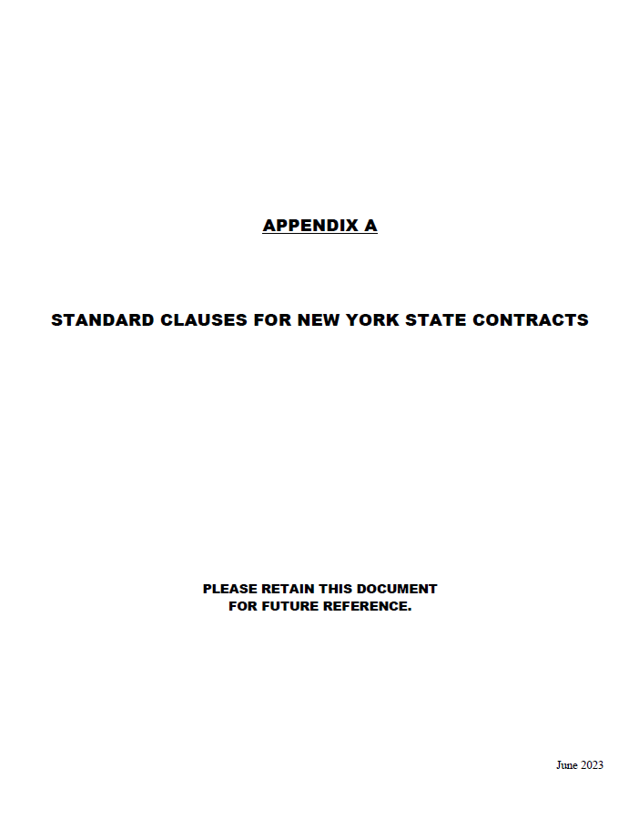
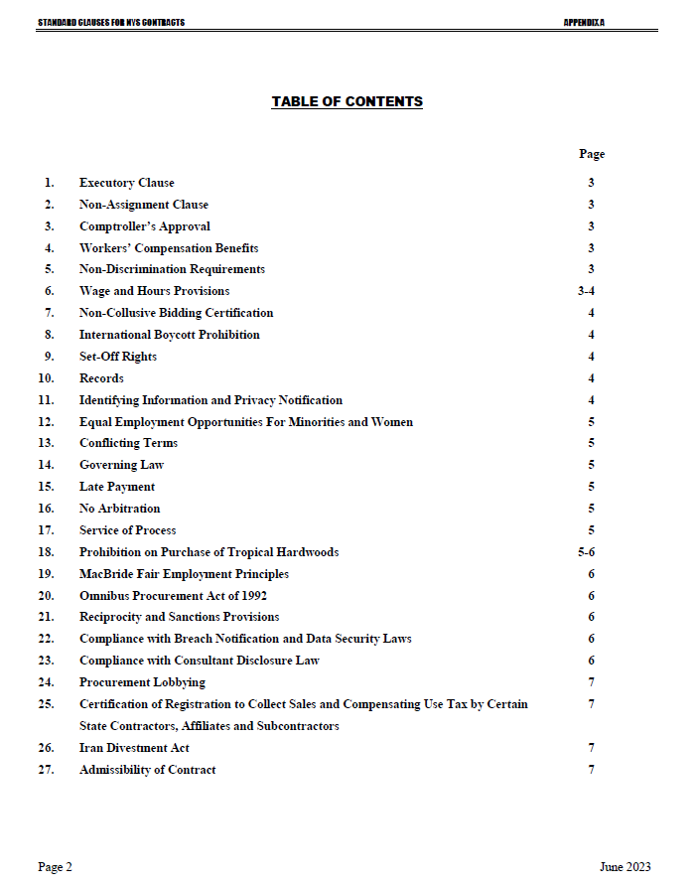

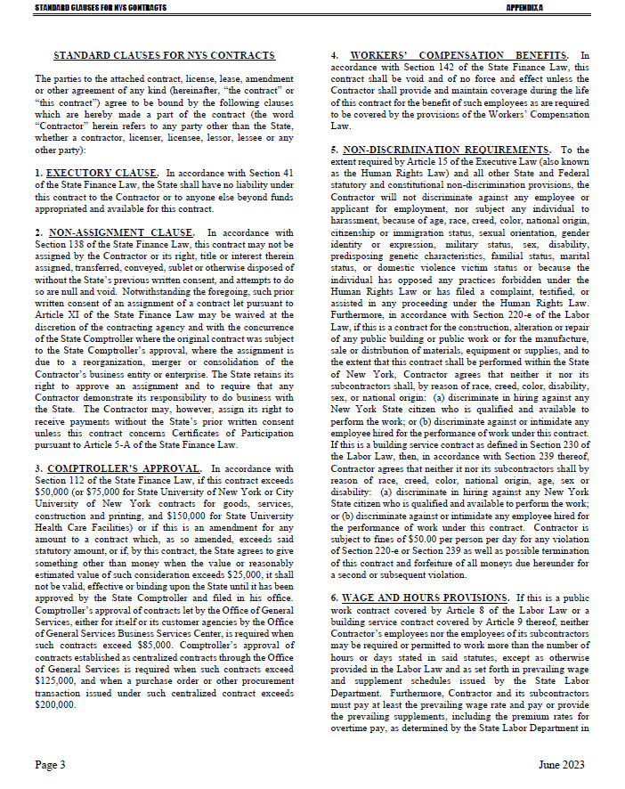

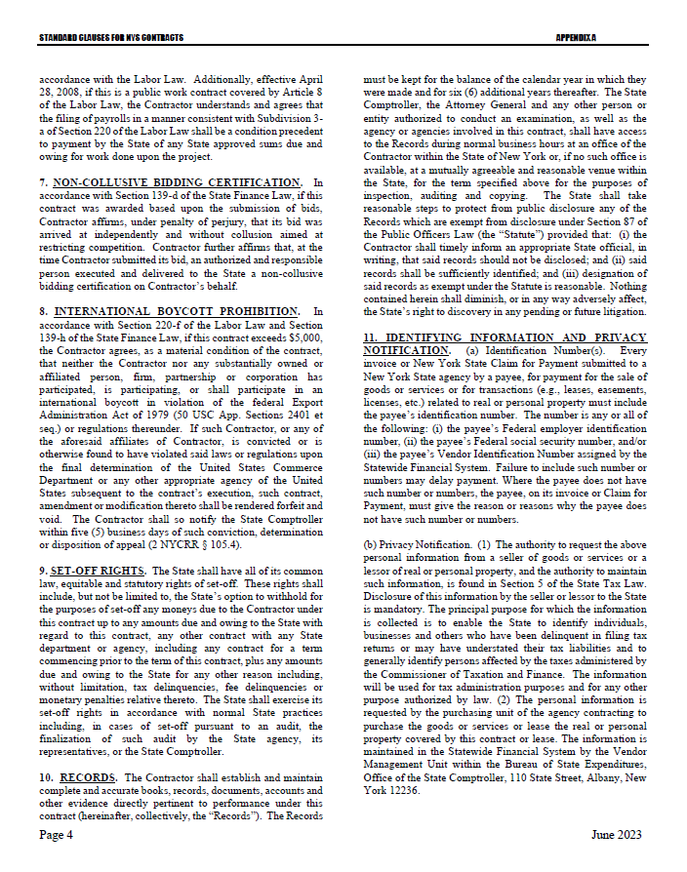

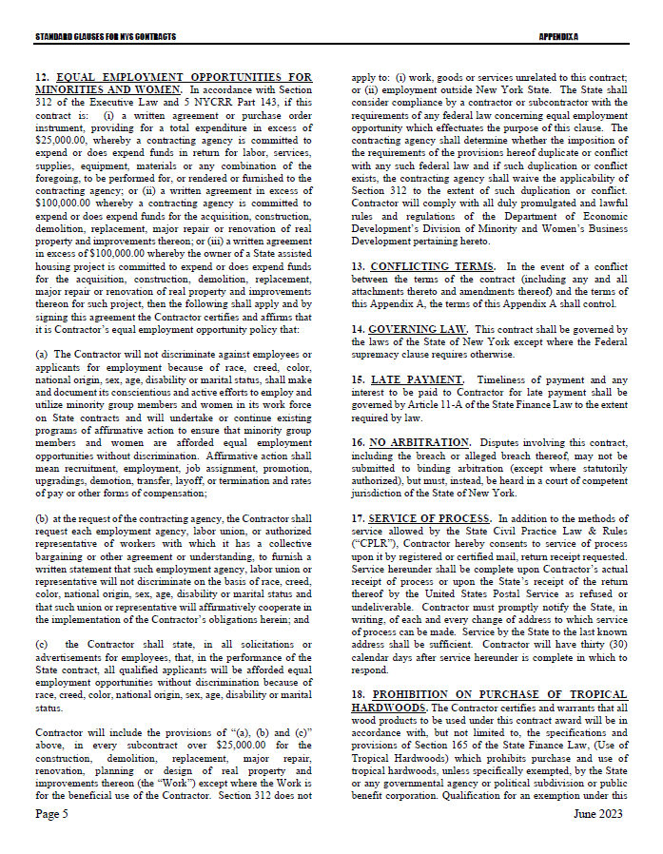

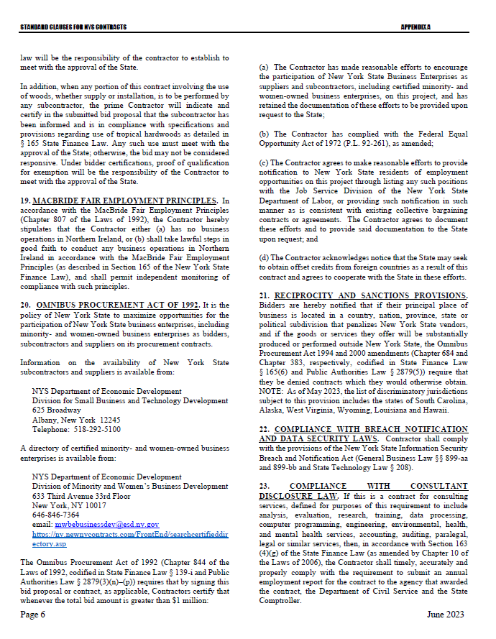

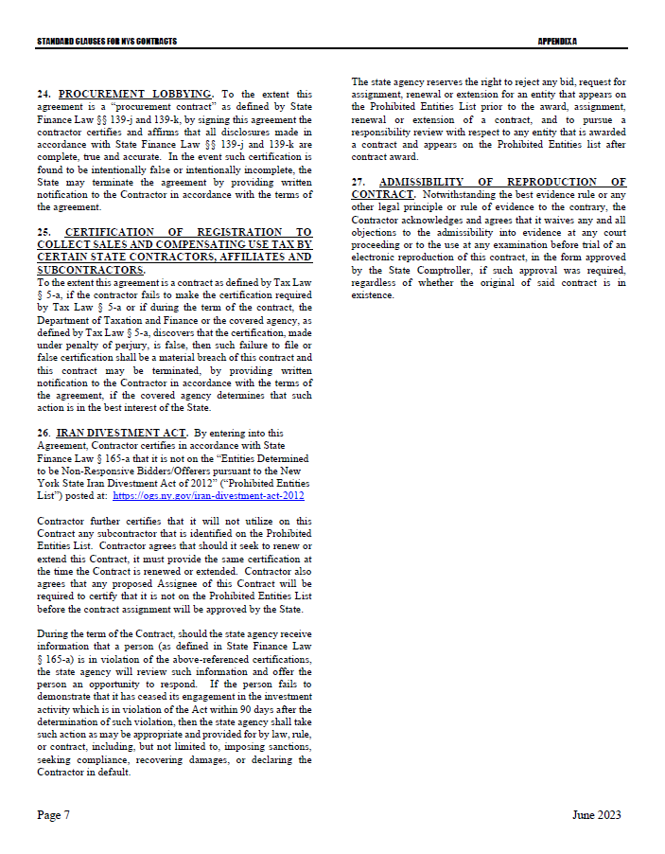

Appendix B – Bid Protest Policy
It is the policy of the Department of Taxation and Finance contracting program (hereafter “DTF”) to provide all Bidders with an opportunity to administratively resolve complaints or inquiries related to bid solicitations or pending contract awards. DTF encourages Bidders to seek resolution of complaints concerning the contract award process through consultation with the program. All such matters will be accorded impartial and timely consideration.
Informal Complaints/Protests
It is strongly recommended that staff encourage, be receptive to and resolve issues, inquiries, questions and complaints on an informal basis, whenever possible. Information provided informally by any interested party should be fully reviewed by Program Team Leaders, the contract administrator of the Contract Management Unit and/or the Director, Procurement Services Unit, Office of Budget and Management Analysis. In addition, matters that are perceived to contain, or are potentially confidential or trade secret information should be shared with the Chief Financial Officer of the Office of Budget and Management Analysis for possible direction. Staff should document the subject matter and results of informal inquiries. As appropriate, DTF responses to the inquirer should indicate the existence of a formal protest policy available to them should the informal process fail to resolve the matter.
In addition to informal inquiries, Bidders may also file formal written protests according to the procedures specified below. Final agency determinations or recommendations for award generally may only be reconsidered in the context of a formal written protest.
Formal Written Protests
Any potential Bidder who believes that there are errors or omissions in the procurement process, or that the Bidder has been aggrieved in the drafting or issuance of a bid solicitation or pending contract award, may present to a formal complaint to DTF and request administrative relief concerning such action (“formal protest”).
Submission of Bid or Award Protests
Deadline for Submission
  - Concerning Errors, Omissions or Prejudice in the Bid Specifications or Documents - Formal protests which concern the drafting of bid specifications must be received by DTF at least twenty (20) business days before the date set in the solicitation for receipt of bids. If the date set in the solicitation for receipt of bids is less than twenty (20) business days from the date of issue, formal protests concerning the specifications must be received by DTF at least seventy-two (72) hours before the time designated for receipt of bids.
  - Concerning Proposed Contract Award - Formal protests concerning a pending contract award must be received within five (5) business days after the protesting party (“protester”) knows or should have known of the facts which form the basis of the protest, and, where State Finance Law § 112 approval is required, prior to final approval of the recommendation by the State Comptroller.

Transmittal
A formal protest must be submitted in writing to DTF, by ground mail, or, where permitted in the solicitation, facsimile or e-mail transmission. The following statement must be clearly and prominently displayed on the envelope or package or header of electronic or facsimile transmittal: “Bid Protest of DTF Solicitation (Reference Number).”
Contents
A formal protest must include:
    - a statement of all legal and/or factual grounds for disagreement with a specification or a procurement determination;
    - a description of all remedies or relief requested; and
    - copies of all applicable supporting documentation.
Protests should be delivered to the Contact named in the RFP.
Review and Final Determination
Copies of all protests will be provided to the Director, Procurement Services Unit, Office of Budget and Management Analysis and appropriate program staff.
Protests shall be resolved through written correspondence, however, either the protester or DTF may request a meeting to discuss a formal protest, at which time the participants may present their concerns. Where further formal resolution is required, the Director, Procurement Services Unit, Office of Budget and Management Analysis may designate an alternate (“designee”) to determine and undertake the initial resolution or settlement of any protest.
The Program staff in conjunction with Contract Management Unit staff will conduct a review of the records involved in the protest, consult with the Director, Procurement services Unit, Office of Budget and Management Analysis, and provide a memorandum to the Chief Financial Officer of the Office of Budget and Management Analysis summarizing the results of the review and recommendation. The Chief Financial Officer of the Office of Budget and Management Analysis will evaluate the recommendation, the material presented by the protester, and, if necessary, consult with appropriate senior level program staff, Counsel, and the Executive Deputy Commissioner, and prepare a written response to the protest.
A copy of the decision, stating the reason(s) upon which it is based shall be sent to the protester or its agent within thirty (30) business days of receipt of the protest, except that upon notice to the protester such period may be extended. The protest determination should be recorded and included in the Procurement Record, or otherwise forwarded to OSC upon issue. The decision of the Chief Financial Officer of the Office of Budget and Management Analysis will be final.
Reservation of Rights and Responsibilities of DTF
DTF reserves the right to waive or extend the time requirements for protest submissions, decisions and appeals herein prescribed when, in its sole judgment, circumstances so warrant to serve the best interests of the State and DTF.
If DTF determines that there are compelling circumstances, including the need to proceed immediately with contract award in the best interest of the State, then these protest procedures may be suspended, and such determination shall be documented in the procurement record.
DTF will consider all information relevant to the protest, and may, at its discretion, suspend, modify, or cancel the protested procurement action including solicitation of bids or withdraw the recommendation of contract award prior to issuance of a formal protest decision.
If a formal bid protest is received by DTF, a final determination on the protest must be made prior to OSC approval of the award under State Finance Law § 112. However, during the pendency of the protest, bid evaluation by DTF and subsequent OSC review of the recommended award may continue to progress at the discretion of the Chief Financial Officer of the Office of Budget and Management Analysis.
If a formal protest is received prior to a determination by DTF on a recommended award, notice of receipt of the protest must be given in the procurement record forwarded to OSC. If a final protest determination has been reached prior to transmittal to OSC, a copy of the final determination should be included in the Procurement Record and forwarded with the recommendation for award.
If a final protest determination is made after the transmittal of a bid package to OSC but prior to OSC approval under State Finance Law § 112, a copy of the final DTF determination shall be forwarded to OSC when issued, along with a letter either: a) confirming the original DTF recommendation for award and supporting the request for final State Finance Law § 112 approval, b) modifying the proposed award recommendation in part and supporting a request for final State Finance Law § 112 approval as modified; or c) withdrawing the original award recommendation.
All records related to formal Bidder protests and appeals shall be retained for at least one (1) year following resolution of the protest. All other records concerning the procurement shall be retained according to the statutory requirements for records retention.

Exhibit A – Workforce Employment Utilization

The Workforce Employment Utilization, Exhibit A, is published as a separate file and can be found at: https://www.tax.ny.gov/about/procure.

Exhibit B - Specifications
ITEM: TMT-6 Highway Use Tax (HUT) Stickers – Pressure Sensitive Stickers.
QUANTITY: 2,000,000
SIZE: 4-1/2” X 3”, with adhesive on back, plus split on back or bend and peel tab. This shall allow for the easy and complete removal of the backing liner without damaging the printed film.
STOCK: Avery Fasson 2M VOID PET WH TC/S8015A/50#SCK or FLEXcon TAMPERmark PM 200 white void ll polyester or equal.
There shall be incorporated in each sticker a security feature that if an attempt is made to remove the sticker from the vehicle, the sticker will void.
ADHESIVE: Application will be made to the metal exterior of large trucks in accordance with the manufacturer’s application instructions. The adhesive must cover the entire back of the sticker.
Each sticker must carry a specially formulated pressure sensitive adhesive which requires no water, solvent, wetting agent or other activation means except pressure.
Stickers must remain affixed to the metal exterior of a truck subjected to frequent chemical pressure washes for a period of thirty-six (36) months from the time of application and be able to withstand temperatures between –20° Fahrenheit and 200° Fahrenheit. The stickers will be stored in a heated/air-conditioned warehouse for up to forty-eight (48) months before application to a vehicle. The adhesive must withstand both the storage and the usage period and conditions without degrading or failing to properly adhere.
Stickers must be “tamper-evident” and must reveal evidence of tampering or removal on unaided visual inspection, in order to defeat any attempt to re-apply a sticker to another vehicle. Stickers must clearly indicate any attempt made to remove the sticker, whether by mechanical means, or with the aid of other substances such as solvents or chemicals, with the result of the sticker either tearing, distorting, defacing, or being visibly destroyed and unable to be reused to an extent that is satisfactory to DTF. This “tamper-evident” feature need not be limited to adhesive alone but may also be built into the ink and/or the base material.
NOTE: The stickers must sufficiently bond to the metal exterior of a truck but must be able to be manually removed from these metal parts without causing damage to the metal part or paint. When a sticker is removed from the metal exterior of the vehicle, the sticker MUST self-destruct or in some way distort substantially enough to prevent the sticker from being reused.
NOTE WELL: Bidders must provide manufacturer’s product data sheet, including application instructions for proper adhesion and ten (10) uncolored samples with their bid.
PRESSWORK: Text and sequential numbering on front of stickers and on the back of the liner text will print in fade resistant black ink.
The background of the sticker will print 4 ¼ in. x 2 ¾ in. (this will allow for a 1/8” white border around the edge of the sticker) with Pantone 2593C (purple) sun inks or comparable. Screening or flood coating is not acceptable.
LAMINATE: After presswork is complete stickers must be laminated with a 1 mil clear poly laminate. Stickers must be guaranteed to hold up to outdoor year-round elements for a minimum of three years without fading or cracking.
COPY: Camera-ready copy will be provided. Instructions for applying the sticker will print on the back of the liner.
METHOD OF APPLICATION:
The method of application shall be as follows:
- Remove protective paper from adhesive side of the sticker.
- Position sticker, then squeegee firmly until tightly affixed to surface.
PRODUCTION SAMPLES: Before the order is approved by the Department for full production, the Contractor is required to supply 200 production samples for testing in accordance with Section 1.7. of the IFB to an independent laboratory. The Contractor must also supply the Tax Department with 20 production samples via overnight delivery of. As stated in Section 1.7. of the IFB, the production samples will be tested for adhesion, fading, application at different temperatures, complete and easy removal of the liner from the sticker without sticking or tearing, and performance of any tamper-evident feature. Once the Department receives the testing synopsis from the independent laboratory and has determined they are acceptable, the order will be approved for full production.
NUMBERING AND PACKING: TMT-6 six (6) digit number for the first million then one (1) alpha character with five (5) digit number for the remainder of the order as follows:
2,000,000
000000 thru 999999
A00000 thru A99999
B00000 thru B99999
C00000 thru C99999
D00000 thru D99999
E00000 thru E99999
F00000 thru F99999
G00000 thru G99999
L00000 thru L99999
M00000 thru M99999
N00000 thru N99999
There will be no skips or errors accepted in the numbering sequence. Serial numbers are to be printed in the colors as specified. The serial numbers must be legible and clearly defined and measure 1/2” + 1/16” wide x 1” to 1-1/4” high. Packing: Stickers are to be packed in suitable boxes, 500 per box. Not more than 30 boxes to each carton to facilitate handling and shipping. The contractor shall insure that the stickers are packed so that they will not adhere to one another. Each box shall contain a label which shall show the quantity of stickers contained therein and the highest and lowest serial number thereof. After packing each box, it is to be sealed with gummed paper tape. Cartons must be marked on outside ends with form no., quantity and number sequence contained within. Cartons must be palletized on reusable pallets with the highest number sequence at the bottom so that the lower sticker numbers may be removed first.

ITEM: TMT-40 Automotive Fuel Carrier (AFC) - Pressure Sensitive Stickers.
QUANTITY: 25,000
SIZE: 4-1/2” X 3”, with adhesive on back, plus split on back or bend and peel tab. This shall allow for the easy and complete removal of the backing liner without damaging the printed film.
STOCK: Avery Fasson 2M VOID PET WH TC/S8015A/50#SCK or FLEXcon TAMPERmark PM 200 white void ll polyester or equal.
There shall be incorporated in each sticker a security feature that if an attempt is made to remove the sticker from the vehicle, the sticker will void.
ADHESIVE: Application will be made to the metal exterior of large trucks in accordance with the manufacturer’s application instructions. The adhesive must cover the entire back of the sticker.
Each sticker must carry a specially formulated pressure sensitive adhesive which requires no water, solvent, wetting agent or other activation means except pressure.
Stickers must remain affixed to the metal exterior of a truck subjected to frequent chemical pressure washes for a period of thirty-six (36) months from the time of application and be able to withstand temperatures between –20° Fahrenheit and 200° Fahrenheit. The stickers will be stored in a heated/air-conditioned warehouse for up to forty-eight (48) months before application to a vehicle. The adhesive must withstand both the storage and the usage period and conditions without degrading or failing to properly adhere.
Stickers must be “tamper-evident” and must reveal evidence of tampering or removal on unaided visual inspection, in order to defeat any attempt to re-apply a sticker to another vehicle. Stickers must clearly indicate any attempt made to remove the sticker, whether by mechanical means, or with the aid of other substances such as solvents or chemicals, with the result of the sticker either tearing, distorting, defacing, or being visibly destroyed and unable to be reused to an extent that is satisfactory to DTF. This “tamper-evident” feature need not be limited to adhesive alone but may also be built into the ink and/or the base material.
NOTE: The stickers must sufficiently bond to the metal exterior of a truck but must be able to be manually removed from these metal parts without causing damage to the metal part or paint. When a sticker is removed from the metal exterior of the vehicle, the sticker MUST self-destruct or in some way distort substantially enough to prevent the sticker from being reused.
NOTE WELL: Bidders must provide manufacturer’s product data sheet, including application instructions for proper adhesion and ten (10) uncolored samples with their bid.
PRESSWORK: Text and sequential numbering on front of stickers and on the back of the liner text will print in fade resistant black ink.
The background of the sticker will print 4 ¼ in. x 2 ¾ in. (this will allow for a 1/8 “white border around the edge of the sticker) with Pantone 109c (yellow) sun inks or comparable. Screening or flood coating is not acceptable.
LAMINATE: After presswork is complete stickers must be laminated with a 1 mil clear poly laminate. Stickers must be guaranteed to hold up to outdoor year-round elements for a minimum of three years without fading or cracking.
COPY: Camera-ready copy will be provided. Instructions for applying the sticker will print on the back of the liner.
METHOD OF APPLICATION:
The method of application shall be as follows:
- Remove protective paper from adhesive side of the sticker.
- Position sticker, then squeegee firmly until tightly affixed to surface.
PRODUCTION SAMPLES: Before the order is approved by the Department for full production, the Contractor is required to supply 200 production samples for testing in accordance with Section 1.7. of the IFB to an independent laboratory. The Contractor must also supply the Tax Department with 20 production samples via overnight delivery of. As stated in Section 1.7. of the IFB, the production samples will be tested for adhesion, fading, application at different temperatures, complete and easy removal of the liner from the sticker without sticking or tearing, and performance of any tamper-evident feature. Once the Department receives the testing synopsis from the independent laboratory and has determined they are acceptable, the order will be approved for full production.
NUMBERING AND PACKING: TMT-40 one (1) alpha character with five (5) digit number for the remainder of the order as follows:
25,000
Y00000 thru Y24999
There will be no skips or errors accepted in the numbering sequence. Serial numbers are to be printed in the colors as specified. The serial numbers must be legible and clearly defined and measure 1/2” + 1/16” wide x 1” to 1-1/4” high. Packing: Stickers are to be packed in suitable boxes, 500 per box. Not more than 30 boxes to each carton to facilitate handling in shipping. The contractor shall insure that the stickers are packed so that they will not adhere to one another. Each box shall contain a label which shall show the quantity of stickers contained therein and the highest and lowest serial number thereof. After packing each box, it is to be sealed with gummed paper tape. Cartons must be marked on outside ends with form no., quantity and number sequence contained within. Cartons must be palletized on reusable pallets with the highest number sequence at the bottom so that the lower sticker numbers may be removed first.

Specifications applicable to both TMT – 6 Highway Use Tax Sticker & TMT – 40 Automotive Fuel Carrier Sticker:
MANUFACTURER:
An easily removable, opaque slip sheet containing text instructions for application must be placed over the adhesive to protect the sticker until it is ready for use. The slip sheet must remain affixed to the adhesive until it is intentionally and manually removed. The slip sheet itself must be split either horizontally or vertically for easy removal. The cut must not come through and damage the sticker or be apparent on the sticker face.
All stickers:
• The color on the face of the sticker must not fade for a period of thirty-six (36) months for AFC and HUT after the sticker has been applied and exposed to climactic conditions prevalent in the Northeastern United States, or exposed to chemical pressure washes;
• Stacks must not have a “lean” in them;
• Stickers must strictly conform to specifications stated herein;
• Serial numbers MUST be sequential.
PRODUCTION CONTROL: The manufacturer must observe precautions within their plant and organization to protect the State against unlawful production of the stickers. The manufacturer shall guard against loss of stickers both during the process of manufacture as well as during storage.
INSPECTION: The State reserves the right to send representatives to the contractor’s plant to inspect all phases of production and packing of the decals. The contractor shall notify the Tax Department four days in advance of each operation.
PROOFS: Ten (10) sets of colored proofs for HUT stickers and ten (10) sets of colored proofs for AFC stickers are required no later than 10 working days after receipt of order.
DELIVERY: Full delivery must arrive at the Tax Department no later than thirty (30) calendar days after the Department receives independent lab testing results and approves full production. Partial shipments will be accepted. The contractor must notify Edward Oberting 518-451-8913 within 24 hours prior to arrival of any shipment to the Tax Department. Shipments will not be accepted after 3:00 p.m. Monday thru Friday nor on any NYS Holiday. In the event that the product does not meet requirements and are denied by the Tax Department, the bidder must fulfill delivery no later than July 15, 2024.
PERFORMANCE BOND: The contractor may be required to furnish a performance bond in the amount of 10% of the total amount of the contract, which will protect the State from being damaged because of late deliveries. No additional costs will be allowed for providing this bond, if requested.
If the delivery exceeds the specified delivery date, the contractor will pay 1% of the contract price for each working day late until 10 working days have elapsed, when total amount of performance bond will be forfeited.
LATENT DEFECTS: Should latent defects be discovered after delivery has been accepted, and at any time during the 36-month guarantee period, the State reserves the right to, require the Contractor replace the decals at their sole expense, or cancel the contract, and surcharge the contractor for any expense to the State incurred by the cancellation of the contract and procurement of the satisfactory material. Fading of color, text numbering, loss of adhesive properties, “blocking” of stickers, etc., prior to the expiration of longevity period shall be considered by the State as sufficient reason to apply the provisions of the “Latent Defects” clause.

Exhibit C – Draft HUT and AFC Decal IMAGE
TMT-6 Highway Use Tax (HUT) Front:

TMT-6 Highway Use Tax (HUT) Back:
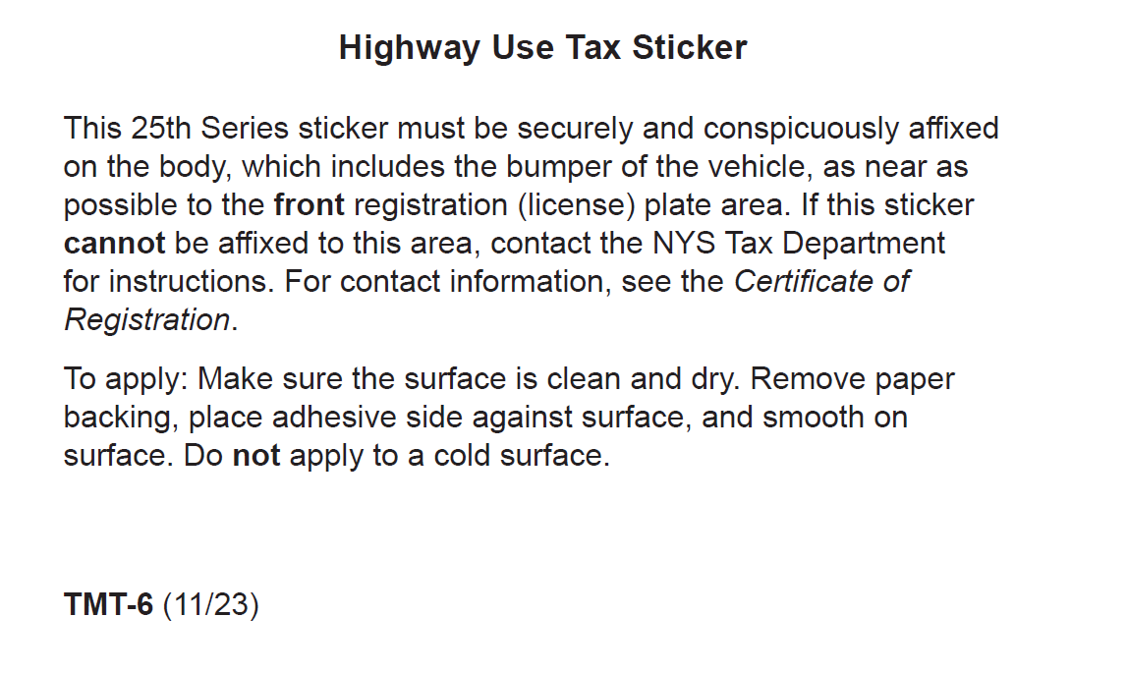
TMT-40 Automotive Fuel Tax Carrier (AFC) Front: 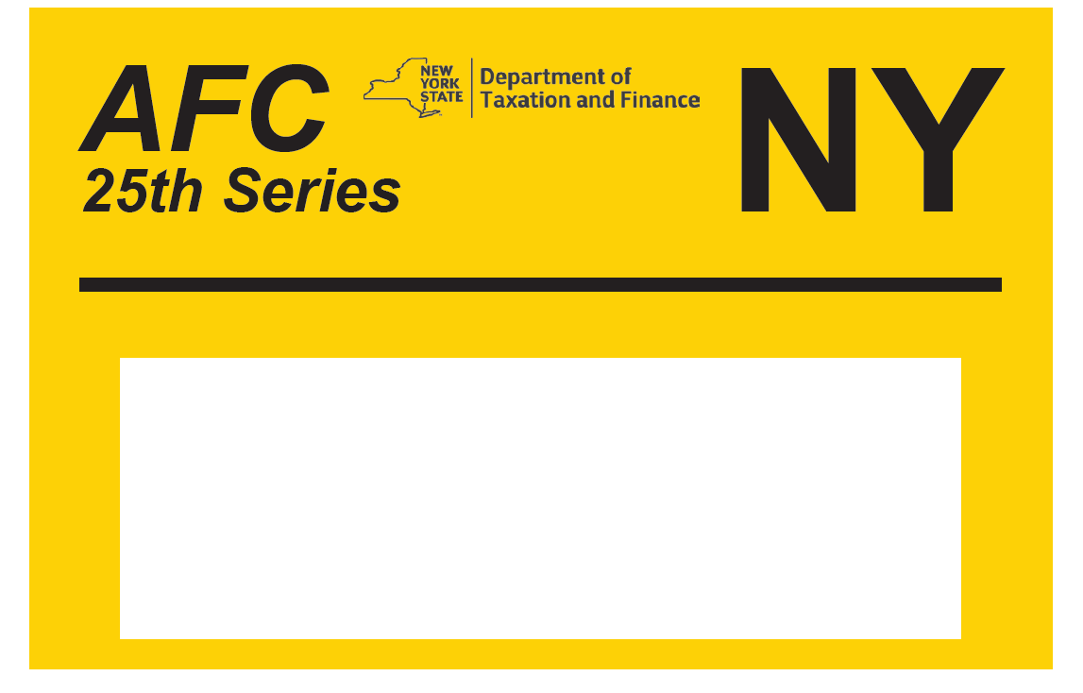

TMT-40 Automotive Fuel Tax Carrier (AFC) Back:
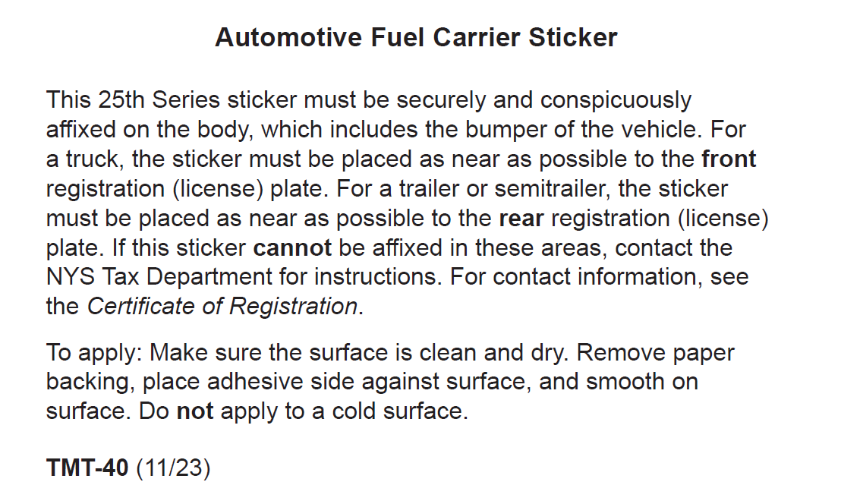

Attachment 1 – Bidder’s Checklist

Bids must be submitted in an 8-1/2” x 11” 3-ring binder, with the following Attachments in the order presented: Two original signed copies of all are required.

Cover Page (page 1 of this IFB) completed with all requested information
Attachment 1 – Bidder’s Checklist showing all provided items checked
Attachment 2 – Offerer Understanding of, and Compliance with, Procurement Lobbying Guidelines
Attachment 3 – Offerer Disclosure of Prior Non-Responsibility Determination
Attachment 4 – Offerer Certification of Compliance with State Finance Law 139-k(5)
Attachment 5 – Minority and Women-Owned Business Enterprises - Equal Employment Opportunity Policy Statement
Attachment 6 – EEO Staffing Plan
Attachment 8 – Encouraging Use of New York State Businesses in Contract Performance
Attachment 9 – Vendor Assurance of No Conflict of Interest or Detrimental Effect
Attachment 10 – EO-177 Certification
Attachment 12 – Sexual Harassment Prevention Certification
Attachment 13 – Executive Order No 16
Attachment 14 – Bidder’s Financial Response Form
Attachment 15 – Qualifying Response Form
Ten (10) Uncolored Stock Samples Including Application Instructions and Manufacturer Data Sheet

NOTE: Attachments 7 and 11 are not to be provided with the bid. These Attachments will be completed upon notification of award for contracts equal to or exceeding $100,000.

Attachment 7 – Vendor Responsibility Response Form (plus hard copy of the Vendor Responsibility Questionnaire if not submitting electronically via the OSC VendRep portal).
Attachment 11 – Contractor Sales Tax Certification Forms

Do not include any additional information or Attachments that attempt to change and/or conflict with the Terms and Conditions of this IFB. Including any such additional information or Attachments may result in the bid being determined non-responsive and disqualified.

Attachment 2 – Offerer Understanding of, and Compliance with, Procurement Lobbying Guidelines
New York State Finance Law 139-j(6)(b) requires the DTF seek written affirmation from all Offerers as to the Offerer’s understanding of, and agreement to comply, with the DTF procedures relating to permissible contacts during a Government Procurement pursuant to subdivision three of this section.

Procurement Description, Contract or Bid Number:
__________________________________________________________________________________________________________________________________________________________________________________________________________________________________________
Offerer Name: _______________________________________________________
Offerer Address: ______________________________________________________
Telephone Number: ___________________________________________________
E-mail Address: _____________________________________________________

Offerer affirms it has read, understands and agrees to comply with the Guidelines of the New York State Department of Taxation and Finance relative to permissible contacts as required by the State Finance Law 139-j(3) and 139-j(6)(b).

By (signature): ___________________________________________________________
Name (Please print): ______________________________________________________
Title (Please print): _______________________________________________________
Date: ___________________________

Attachment 3 - Offerer Disclosure of Prior Non-Responsibility Determinations

New York State Finance Law §139-k(2) obligates a Governmental Entity to obtain specific information regarding prior non-responsibility determinations with respect to State Finance Law §139-j. This information must be collected in addition to the information that is separately obtained pursuant to State Finance Law §163(9). In accordance with State Finance Law §139-k, an Offerer must be asked to disclose whether there has been a finding of non-responsibility made within the previous four (4) years by any Governmental Entity due to: (a) a violation of State Finance Law §139-j or (b) the intentional provision of false or incomplete information to a Governmental Entity. The terms “Offerer” and “Governmental Entity” are defined in State Finance Law § 139-k(1). State Finance Law §139-j sets forth detailed requirements about the restrictions on contacts during the procurement process. A violation of State Finance Law §139-j includes, but is not limited to, an impermissible contact during the restricted period (for example, contacting a person or entity other than the designated contact person, when such contact does not fall within one of the exemptions).
As part of its responsibility determination, State Finance Law §139-k(3) mandates consideration of whether an Offerer fails to timely disclose accurate or complete information regarding the above non-responsibility determination. In accordance with State Finance Law, no Procurement Contract shall be awarded to any Offerer that fails to timely disclose accurate or complete information under this section, unless a finding is made that the award of the Procurement Contract to the Offerer is necessary to protect public property or public health safety, and that the Offerer is the only source capable of supplying the required article of procurement within the necessary timeframe. See State Finance Law §§139-j (10)(b) and 139-k(3).
A Governmental Entity must include a disclosure request regarding prior non-responsibility determinations in accordance with State Finance Law §139-k in its solicitation of proposals or bid documents or specifications or contract documents, as applicable, for procurement contracts. The attached form is to be completed and submitted by the individual or entity seeking to enter into a Procurement Contract. It shall be submitted to the Governmental Entity conducting the Governmental Procurement.

Offerer Disclosure of Prior Non-Responsibility Determinations
Procurement Description, Contract or Bid Number:
____________________________________________________________________________

Offerer Name: ______________________________________________________________________
Offerer Address: ________________________________________________________________ ____ ___________________________________________________________________________________
Telephone Number: _______________________________________________________________
E-mail Address: _____________________________________________________________________
Name and Title of Person Submitting this Form: ___________________________________________ ___________________________________________
- Has any New York State agency or authority made a finding of non-responsibility regarding the Offerer in the last four (4) years? (Please circle):
No Yes
If you responded “Yes” to Question 1, please answer the following questions:
- Was the basis for the finding of the Offerer’s non-responsibility due to a violation of State Finance Law 139-j? (Please circle):
No Yes
- Was the basis for the finding of the Offerer’s non-responsibility due to the intentional provision of false or incomplete information to a Governmental Entity? (Please circle):
No Yes
- If you responded “Yes” to Questions 1, 2 or 3, please provide details regarding the finding of non-responsibility below:
Government Entity: ____________________________________________________
Date of Finding of Non-responsibility: ______________________________________
Facts Underlying Finding of Non-Responsibility (Add additional pages as necessary):
___________________________________________________________________________________________________________________________________________________________________________________________________________________________
- Has any New York State agency or authority terminated a procurement contract with the Offerer due to the intentional provision of false or incomplete information? (Please circle):

No Yes
If you responded “Yes” to Question 5, please provide details regarding the termination below:
Government Entity: _________________________________________________________________
Date of Finding of Non-Responsibility: __________________________________________________
Facts Underlying Finding of Non-Responsibility (Add additional pages as necessary):
______________________________________________________________________________________________________________________________________________________________________________________________________________________________________________________
Offerer certifies that all information provided to the DTF with respect to State Finance Law 139-k is complete, true and accurate.
Offerer’s Signature: _________________________________________________
Offerer’s Name (Please print): __________________________________________
Date: _______________________________________

Attachment 4 – Offerer Certification of Compliance with State Finance Law 139-k(5)
New York State Finance Law 139-k(5) requires that every Procurement Contract Award subject to the provisions of State Finance Law 139-k or 139-j shall contain a certification by the Offerer that all information provided to the procuring Government Entity with respect to State Finance Law 139-k is complete, true and accurate.

Offerer Certification
I certify that all information provided to the DTF with respect to State Finance Law 139-k is complete, true and accurate.
Offerer’s Signature: ________________________________________
Date: ____________________________________________________
Procurement Description, Contract or Bid Number: _________________________________________
Name (Please print): ___________________________________________________________________
Title: ______________________________________________________________________________
Offerer Name: ______________________________________________________________________
Offerer Address: _____________________________________________________________________
_____________________________________________________________________
Telephone Number: ____________________________________

E-mail Address: _____________________________________

Attachment 5 – Minority and Women-Owned Business Enterprises – Equal Employment Opportunity Policy Statement
I, _________________________, the (awardee/contractor) ____________________ agree to adopt the following policies with respect to the project being developed or services rendered at

__________________________________________________________________________________
M/WBE

EEO

This organization will and will cause its contractors and subcontractors to take good faith actions to achieve the M/WBE contract participations goals set by the State for that area in which the State-funded project is located, by taking the following steps:
- Actively and affirmatively solicit bids for contracts and subcontracts from qualified State certified MBEs or WBEs, including solicitations to M/WBE contractor associations.
- Request a list of State-certified M/WBEs from AGENCY and solicit bids from them directly.
- Ensure that plans, specifications, request for proposals and other documents used to secure bids will be made available in sufficient time for review by prospective M/WBEs.
- Where feasible, divide the work into smaller portions to enhanced participations by M/WBEs and encourage the formation of joint venture and other partnerships among M/WBE contractors to enhance their participation.
- Document and maintain records of bid solicitation, including those to M/WBEs and the results thereof. Contractor will also maintain records of actions that its subcontractors have taken toward meeting M/WBE contract participation goals.
- Ensure that progress payments to M/WBEs are made on a timely basis so that undue financial hardship is avoided, and that bonding and other credit requirements are waived or appropriate alternatives developed to encourage M/WBE participation.

a. This organization will not discriminate against any employee or applicant for employment because of race, creed, color, national origin, sex, age, disability or marital status, will undertake or continue existing programs of affirmative action to ensure that minority group members are afforded equal employment opportunities without discrimination, and shall make and document its conscientious and active efforts to employ and utilize minority group members and women in its work force on state contracts.
b. This organization shall state in all solicitation or advertisements for employees that in the performance of the State contract all qualified applicants will be afforded equal employment opportunities without discrimination because of race, creed, color, national origin, sex disability or marital status.
c. At the request of the contracting agency, this organization shall request each employment agency, labor union, or authorized representative will not discriminate on the basis of race, creed, color, national origin, sex, age, disability or marital status and that such union or representative will affirmatively cooperate in the implementation of this organizations’ obligations herein.
- Contractor shall comply with the provisions of the Human Rights Law, all other State and Federal statutory and constitutional non-discrimination provisions. Contractor and subcontractors shall not discriminate against any employee or applicant for employment because of race, creed (religion), color, sex, national origin, sexual orientation, marital status or domestic violence victim status, and shall also follow the requirements of the Human Rights Law with regard to non-discrimination on the basis of prior criminal conviction and prior arrest.

- This organization will include the provisions of sections (a) through (d) of this agreement in every subcontract in such a manner that the requirements of the subdivisions will be binding upon each subcontractor as to work in connection with the State contract.

Agreed to this _______ day of ____________________, 2___________

By __________________________________________

Print: _____________________________________ Title: _____________________________

_________________________________is designated as the Minority Business Enterprise Liaison
(Name of Designated Liaison)

responsible for administering the Minority and Women-Owned Business Enterprises- Equal Employment
Opportunity (M/WBE-EEO) program.

M/WBE Contract Goals

________% Minority and Women’s Business Enterprise Participation
________% Minority Business Enterprise Participation
________% Women’s Business Enterprise Participation

____________________________________________
(Authorized Representative)

Title: ________________________________________

Date: ________________________________________

Attachment 6 – EEO Staffing Plan

Submit with Bid or Proposal (Instructions attached)
Solicitation No.: | Reporting Entity: | Report includes Contractor’s/Subcontractor’s:  □ Work force to be utilized on this contract  □ Total work force
Offeror’s Name: |  | □ Offeror  □ Subcontractor  Subcontractor’s name________________
Offeror’s Address:
Enter the total number of employees for each classification in each of the EEO-Job Categories identified
EEO-Job Category | Total Work force | Work force by Gender |  | Work force by  Race/Ethnic Identification
 |  | Total  Male  (M) | Total  Female  (F) | White  (M) (F) |  | Black  (M) (F) |  | Hispanic  (M) (F) |  | Asian  (M) (F) |  | Native American  (M) (F) |  | Disabled  (M) (F) |  | Veteran  (M) (F)
Officials/Administrators
Professionals
Technicians
Sales Workers
Office/Clerical
Craft Workers
Laborers
Service Workers
Temporary /Apprentices
Totals

PREPARED BY (Signature): | TELEPHONE NO.:  EMAIL ADDRESS: |  | DATE:
NAME AND TITLE OF PREPARER (Print or Type): |  | Submit completed with bid or proposal M/WBE 101 (Rev 11/08)

General instructions: All Offerors and each subcontractor identified in the bid or proposal must complete an EEO Staffing Plan (M/WBE 101) and submit it as part of the bid or proposal package. Where the work force to be utilized in the performance of the State contract can be separated out from the contractor’s and/or subcontractor’s total work force, the Offeror shall complete this form only for the anticipated work force to be utilized on the State contract. Where the work force to be utilized in the performance of the State contract cannot be separated out from the contractor’s and/or subcontractor’s total work force, the Offeror shall complete this form for the contractor’s and/or subcontractor’s total work force.

Instructions for completing:
- Enter the Solicitation number that this report applies to along with the name and address of the Offeror.
- Check off the appropriate box to indicate if the Offeror completing the report is the contractor or a subcontractor.
- Check off the appropriate box to indicate work force to be utilized on the contract or the Offerors’ total work force.
- Enter the total work force by EEO job category.
- Break down the anticipated total work force by gender and enter under the heading ‘Work force by Gender’
- Break down the anticipated total work force by race/ethnic identification and enter under the heading ‘Work force by Race/Ethnic Identification’. Contact the OM/WBE Permissible contact(s) for the solicitation if you have any questions.
- Enter information on disabled or veterans included in the anticipated work force under the appropriate headings.
- Enter the name, title, phone number and email address for the person completing the form. Sign and date the form in the designated boxes.

RACE/ETHNIC IDENTIFICATION
Race/ethnic designations as used by the Equal Employment Opportunity Commission do not denote scientific definitions of anthropological origins. For the purposes of this form, an employee may be included in the group to which he or she appears to belong, identifies with, or is regarded in the community as belonging. However, no person should be counted in more than one race/ethnic group. The race/ethnic categories for this survey are:
- WHITE (Not of Hispanic origin) All persons having origins in any of the original peoples of Europe, North Africa, or the Middle East.
- BLACK a person, not of Hispanic origin, who has origins in any of the black racial groups of the original peoples of Africa.
- HISPANIC a person of Mexican, Puerto Rican, Cuban, Central or South American or other Spanish culture or origin, regardless of race.
- ASIAN & PACIFIC a person having origins in any of the original peoples of the Far East, Southeast Asia, the Indian subcontinent or the Pacific Islands.
IISLANDER
- NATIVE INDIAN (NATIVE a person having origins in any of the original peoples of North America, and who maintains cultural identification through tribal
AMERICAN/ ALASKAN NATIVE) affiliation or community recognition.
OTHER CATEGORIES
- DISABLED INDIVIDUAL any person who: - has a physical or mental impairment that substantially limits one or more major life activity(ies)
- has a record of such an impairment; or
- is regarded as having such an impairment.
- VIETNAM ERA VETERAN a veteran who served at any time between and including January 1, 1963 and May 7, 1975.
- GENDER Male or Female

Attachment 7 – Vendor Responsibility Response Form

Bidder’s Name: ______________________________________________

Bidders must complete a Vendor Responsibility Questionnaire in response to this IFB. Bidders are invited to file the required Vendor Responsibility Questionnaire online via the OSC New York State VendRep System or may choose to complete and submit a paper questionnaire. To enroll in and use the New York State VendRep System, see the VendRep System instructions available at www.osc.state.ny.us/vendrep or go directly to the VendRep System online at https://onlineservices.osc.state.ny.us/Enrollment/login?3. For direct VendRep System user assistance, the OSC Help Desk may be reached at 866-370-4672 or 518-408-4672 or by e-mail at itservicedesk@osc.ny.gov. Bidders opting to file a paper questionnaire can obtain the appropriate questionnaire from the VendRep website at www.osc.state.ny.us/vendrep or may contact one of the Department’s designated contacts.
Please check one of the following:
A Vendor Responsibility Questionnaire has been filed online and has been certified/updated within the last six months.
A Vendor Responsibility Questionnaire is attached to this bid proposal.
NOTE: If a Vendor Responsibility Questionnaire has been filed online and has not been certified within the last six months, the Bidder must either update/recertify the online questionnaire or submit a new paper Vendor Responsibility Questionnaire. Upon notification of award, the Contractor will be required to update/recertify the online questionnaire.

Attachment 8 – Encouraging Use of New York State Businesses in Contract Performance
New York State businesses have a substantial presence in State contracts and strongly contribute to the economies of the State and nation. In recognition of their economic activity and leadership in doing business in New York State, Bidders/proposers for this contract for commodities, services or technology are strongly encouraged and expected to consider New York State businesses in the fulfillment of the requirements of the Contract. Such partnering may be as subcontractors, suppliers, protégés or other supporting roles.
Bidders/proposers need to be aware that all authorized users of this Contract will be strongly encouraged to the maximum extent practical and consistent with legal requirements, to use responsible and responsive New York State businesses in purchasing commodities that are of equal quality and functionality and in utilizing services and technology. Furthermore, Bidders/proposers are reminded that they must continue to utilize small, minority- and women-owned businesses, consistent with current State law.
Utilizing New York State businesses in State contracts will help create more private sector jobs, rebuild New York’s infrastructure and maximize economic activity to the mutual benefit of the Contractor and its New York State business partners. New York State businesses will promote the Contractor’s optimal performance under the Contract, thereby fully benefitting the public-sector programs that are supported by associated procurements.
Public procurements can drive and improve the State’s economic engine through promotion of the use of New York businesses by its Contractors. The State therefore expects Bidders/proposers to provide maximum assistance to New York businesses in their use of the Contract. The potential participation by all kinds of New York businesses will deliver great value to the State and its taxpayers.
Bidders/proposers can demonstrate their commitment to the use of New York State businesses by responding to the question below:
Will New York State Businesses be used in the performance of this contract? Yes No
If “Yes,” identify New York State businesses that will be used and attach identifying information.

By (signature): ________________________________________
Name (Please print): ___________________________________
Title (Please print): ____________________________________
Date: ___________________________

Attachment 9 – Vendor Assurance of No Conflict of Interest or Detrimental Effect
The Bidder offering to provide services pursuant to this IFB attests that its performance of the services outlined does not and will not create a conflict of interest with, nor position the Bidder to breach, any other contract currently in force with the State of New York.
Furthermore, the Bidder attests that it will not act in any manner that is detrimental to any State project on which the Bidder is rendering services. Specifically, the Bidder attests that:
- The fulfillment of obligations by the Bidder, as proposed in the response, does not violate any existing contract or agreement between the Bidder and the State;
- The fulfillment of obligations by the Bidder, as proposed in the response, does not and will not create any conflict of interest, or perception thereof, with any current role or responsibility that the Bidder has with regard to any existing contract or agreement between the Bidder and the State;
- The fulfillment of obligations by the Bidder, as proposed in the response, does not and will not compromise the Bidder’s ability to carry out its obligations under any existing contract between the Bidder and the State;
- The fulfillment of any other contractual obligations that the Bidder has with the State will not affect or influence its ability to perform under any contract with the State resulting from this solicitation;
- During the negotiation and execution of any contract resulting from this solicitation, the Bidder will not knowingly take any action or make any decision which creates a potential for conflict of interest or might cause a detrimental impact to the State as a whole including, but not limited to, any action or decision to divert resources from one State project to another;
- In fulfilling obligations under each of its State contracts, including any contract which results from this solicitation, the Bidder will act in accordance with the terms of each of its State contracts and will not knowingly take any action or make any decision which might cause a detrimental impact to the State as a whole including, but not limited to, any action or decision to divert resources from one State project to another;
- No former officer or employee of the State who is now employed by the Bidder, nor any former officer or employee of the Bidder who is now employed by the State, has played a role with regard to the administration of this contract procurement in a manner that may violate section 73(8)(a) of the State Ethics Law; and
- The Bidder has not and shall not offer to any employee, member or director of the State any gift, whether in the form of money, service, loan, travel, entertainment, hospitality, thing or promise, or in any other form, under circumstances in which it could reasonably be inferred that the gift was intended to influence said employee, member or director, or could reasonably be expected to influence said employee, member or director, in the performance of the official duty of said employee, member or director or was intended as a reward for any official action on the part of said employee, member or director.
The Bidder should note that the State recognizes that conflicts may occur in the future because a Bidder may have existing or new relationships. The State will review the nature of any such new relationship and reserves the right to terminate the contract for cause if, in its judgment, a real or potential conflict of interest cannot be cured.

By (signature): ____________________________________________________
Name (please print): ______________________________________________
Title (please print): _______________________________________________
Date: _____________________________________

This form must be signed by an authorized executive or legal representative.

Attachment 10 - EO 177 Certification

The New York State Human Rights Law, Article 15 of the Executive Law, prohibits discrimination and harassment based on age, race, creed, color, national origin, sex, pregnancy or pregnancy-related conditions, sexual orientation, gender identity, disability, marital status, familial status, domestic violence victim status, prior arrest or conviction record, military status or predisposing genetic characteristics.

The Human Rights Law may also require reasonable accommodation for persons with disabilities and pregnancy-related conditions. A reasonable accommodation is an adjustment to a job or work environment that enables a person with a disability to perform the essential functions of a job in a reasonable manner. The Human Rights Law may also require reasonable accommodation in employment on the basis of Sabbath observance or religious practices.
Generally, the Human Rights Law applies to:

- all employers of four or more people, employment agencies, labor organizations and apprenticeship training programs in all instances of discrimination or harassment;
- employers with fewer than four employees in all cases involving sexual harassment; and,
- any employer of domestic workers in cases involving sexual harassment or harassment based on gender, race, religion or national origin.

In accordance with Executive Order No. 177, the Bidder hereby certifies that it does not have institutional policies or practices that fail to address the harassment and discrimination of individuals on the basis of their age, race, creed, color, national origin, sex, sexual orientation, gender identity, disability, marital status, military status, or other protected status under the Human Rights Law.
Executive Order No. 177 and this certification do not affect institutional policies or practices that are protected by existing law, including but not limited to the First Amendment of the United States Constitution, Article 1, Section 3 of the New York State Constitution, and Section 296(11) of the New York State Human Rights Law.

Contractor:

By (signature): ____________________________________

Name (Please Print): _______________________________

Title: ____________________________________________

Date: ____________________
This form must be signed by an authorized executive or legal representative.

Attachment 11 - Contractor Sales Tax Certification Forms

Contractor Certification (ST-220-TD)
https://www.tax.ny.gov/pdf/current_forms/st/st220td_fill_in.pdf

Contractor Certification to Covered Agency (ST-220-CA)
https://www.tax.ny.gov/pdf/current_forms/st/st220ca_fill_in.pdf

For Frequently Asked Questions Tax Law Section 5-a, please review the following:
https://www.tax.ny.gov/pdf/publications/sales/pub223.pdf?_ga=1.182183655.1161750456.1470166341

Attachment 12 - Sexual Harassment Prevention Certification
State Finance Law §139-l requires bidders on state procurements to certify that they have a written policy addressing sexual harassment prevention in the workplace and provide annual sexual harassment training to all its employees and that such policy, at a minimum, meets the requirements of section two hundred one-g of the labor law.
By submission of this bid, each bidder and each person signing on behalf of any bidder certifies, and in the case of a joint bid each party thereto certifies its own organization, under penalty of perjury, that the bidder has and has implemented a written policy addressing sexual harassment prevention in the workplace and provides annual sexual harassment prevention training to all of its employees. Such policy shall, at a minimum, meet the requirements of section two hundred one-g of the labor law.
The Bidder’s signature below certifies its compliance with State Finance Law §139-I.

Bidder: __________________________________________

By (signature): ____________________________________

Name (Please Print): _______________________________

Title: ____________________________________________

Date: ____________________

This form must be signed by an authorized executive or legal representative.

If the bidder cannot make the above certification, the bidder must provide a statement with their bid detailing the reasons therefor:

Attachment 13 - EO 16 Certification
Executive Order No. 16 provides that “all Affected State Entities are directed to refrain from entering into any new contract or renewing any existing contract with an entity conducting business operations in Russia.” The complete text of Executive Order No. 16 can be found here.
The Executive Order remains in effect while sanctions imposed by the federal government are in effect. Accordingly, vendors who may be excluded from award because of current business operations in Russia are nevertheless encouraged to respond to solicitations to preserve their contracting opportunities in case the sanctions are lifted during a solicitation or even after award in the case of some solicitations.
As defined in Executive Order No. 16, an “entity conducting business operations in Russia” means an institution or company, wherever located, conducting any commercial activity in Russia or transacting business with the Russian Government or with commercial entities headquartered in Russia or with their principal place of business in Russia in the form of contracting, sales, purchasing, investment, or any business partnership.
Is Vendor an entity conducting business operations in Russia, as defined above? Please answer by checking one of the following boxes:
☐ 1. No, Vendor does not conduct business operations in Russia within the meaning of Executive Order No. 16.
☐ 2.a. Yes, Vendor conducts business operations in Russia within the meaning of Executive Order No. 16 but has taken steps to wind down business operations in Russia or is in the process of winding down business operations in Russia. (Please provide a detailed description of the wind down process and a schedule for completion.)
☐ 2.b. Yes, Vendor conducts business operations in Russia within the meaning of Executive Order No. 16 but only to the extent necessary to provide vital health and safety services within Russia or to comply with federal law, regulations, executive orders, or directives. (Please provide a detailed description of the services being provided or the relevant laws, regulations, etc.)
☐ 3. Yes, Vendor conducts business operations in Russia within the meaning of Executive Order No. 16.
The undersigned certifies under penalties of perjury that they are knowledgeable about the Vendor’s business and operations and that the answer provided herein is true to the best of their knowledge and belief.
Vendor Name:
By (signature):
Name:
Title:
Date:

Attachment 14 – Bidder’s Financial Response Form

Bidder Name:

Proposed Stock:
Manufacturer of Proposed Stock:

Will this item be printed by the company named on the front page of this bid?
City and State of Plant where Stickers will be produced:

Item 1: TMT- 6 Highway Use Tax Stickers
Quantity |  | Price bid Per M |  | Total Item 1 cost
2,000,000 |  | $ |  | $
Item 2: TMT-40 Automotive Fuel Carrier Stickers
Quantity |  | Price bid Per M |  | Total Item 2 cost
25,000 |  | $ |  | $
Total Cost Bid for all Items
Total Cost Bid for all Items | $
Attachment 14 – Bidder’s Financial Response Form cont’d
Independent Lab Testing – number of calendar days from date of order to sending the production samples to the lab for testing:
Independent Lab Testing – number of calendar days for the lab to complete their testing and send results:
Guaranteed Delivery - number of calendar days after completion of successful testing to delivering the product:

Attachment 15 – Qualifying Response Form

Bidder Name:
In accordance with Section 1.5. Bidder’s Minimum Qualifications, Bidder’s must have successfully produced like items for a period of at least one year using the proposed stock.

REFERENCE CONTRACT #1
Client Name
Client Address
Client Contact Person | Name:
 | Title:
 | Telephone #:
 | Email Address:
Stock used for item produced (please also submit sample of item if able).
Number of Years producing item for this Client:

REFERENCE CONTRACT #2 (if needed to meet the one-year requirement)
Client Name
Client Address
Client Contact Person | Name:
 | Title:
 | Telephone #:
 | Email Address:
Stock used for Item produced (please also submit sample of item if able).
Number of Years producing item for this Client:

Bidders are advised to verify that their proposed stock(s) meet bid specifications before submitting their bid. Proposed stocks that are not at least equal to the reference(s) in the specifications will result in rejection of the bid. If bidding on other than the referenced brand, bid MUST show proposed brand and mill. In addition, a manufacturer's product data sheet, including application instructions and ten (10) samples of the proposed brand must be submitted with the bid. Failure to comply with this requirement may result in rejection of the bid.
The Bidder must provide all pricing information requested on this Attachment 14 and must not modify or change the Attachment. Any pricing information or add-on costs that do not conform to the presentation allowed on this Attachment 14 cannot be evaluated, will be disregarded as extraneous, and cannot be charged to the Department after award of a Contract.

