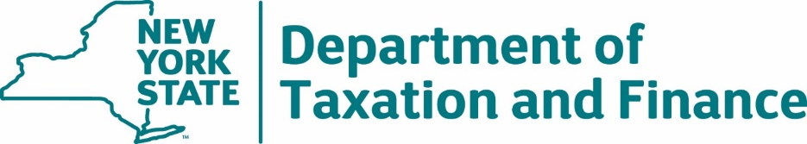

INVITATION FOR BIDS NO. 22-201

SOLICITED BY THE
NEW YORK STATE DEPARTMENT OF TAXATION AND FINANCE

FOR

NATIONAL CHANGE OF ADDRESS AND NIXIE MAIL PROCESSING SERVICES

ISSUE DATE: May 24, 2023

BID DUE DATE: July 12, 2023, at 2:00 PM EST

Designated Contacts:
Kevin Brownell
Yafei Cao
Amber Alexander
Voice: (518) 530-4484
E-Mail: BFS.Contracts@tax.ny.gov

Table of Contents

1. Introduction 4
1.1 Overview 4
1.2 Schedule of Events 4
1.3 Minimum Bidder Qualification 4
1.4 IFB Key Points 4
1.5 Glossary of Terms 7
2. Scope of Work 9
3. Qualifying Requirements 9
3.1. NCOA/NIXIE Processing License 9
3.2. Prior Experience 10
4. Mandatory Service Requirements 10
4.1. Bidder Attestation 10
4.2. Connectivity 10
4.3. Record Processing 11
4.4. Disengagement and Data Sanitization 11
4.5. Insurance 12
5. Testing 17
6. Price 17
7. Method of Award 18
8. Bid Submission 18
8.1 Bid Content and Organization 18
8.2 Instructions for Bid Submission 19
9. Administrative Requirements 20
9.1 Administrative Proposal Conditions 20
9.2 Administrative Contract Conditions 23
Appendix A – Standard Clauses for New York State Contracts 33
Appendix B – Bid Protest Policy 40
Exhibit A – Preliminary Base Contract 44
Exhibit B – New York State Office of the State Comptroller Substitute Form W-9 69
Exhibit C – Workforce Utilization Report 71
Exhibit D – Vendor Responsibility Response Form 72
Exhibit E – Contractor Sales Tax Certification Forms 73
Exhibit 1 – NCOA Outgoing File Layout 79
Exhibit 2 – NCOA Incoming File Layout 81
Attachment 1 – Bidder’s Checklist 98
Attachment 2 – Offerer Understanding of, and Compliance with, Procurement Lobbying Guidelines 99
Attachment 3 – Minority and Women-Owned Business Enterprises – Equal Employment Opportunity Policy Statement 100
Attachment 4 – Staffing Plan 102
Attachment 5 – Designation of Prime Contact Response Form 104
Attachment 6 – Non-Collusive Bidding Certification 105
Attachment 7 – Offerer Disclosure of Prior Non-Responsibility Determinations 106
Attachment 8 – Offerer Certification of Compliance with State Finance Law 139-k(5) 108
Attachment 9 – Public Officers Law Form 109
Attachment 10 – Public Officers Law – Post Employment Restrictions 110
Attachment 11 – Encouraging Use of New York State Businesses in Contract Performance 111
Attachment 12 – Vendor Assurance of No Conflict of Interest or Detrimental Effect 112
Attachment 13 – EO 177 Certification 113
Attachment 14 – Sexual Harassment Prevention Certification 114
Attachment 15 – EO 16 Certification 115
Attachment A – Qualifying Requirements Response Form 116
Attachment B – Bidder Attestation Response Form 118
Attachment C – Mandatory Service Requirements Response Form 119
Attachment D – Financial Response Form 120

- Introduction

1.1 Overview
The New York State Department of Taxation and Finance (“DTF” or “Department”) is seeking competitive bids from qualified firms to obtain a Full Service Provider, licensed by the United States Postal Service (USPS), to provide National Change of Address (NCOA) and NIXIE mail processing services in accordance with USPS regulations pertaining to First Class Mail on the inventory of taxpayer addresses in order to obtain reduced postal rates, in accordance with the detailed specifications outlined in this document.

1.2 Schedule of Events
The table below outlines the schedule for important action dates.

May 24, 2023 | Issuance of IFB
June 14, 2023 | Deadline for Filing Offerer Understanding of, and Compliance with, Procurement Lobbying Guidelines (IFB Attachment 2)
June 14, 2023 | Deadline for Submission of Written Questions
June 28, 2023 | Department Response to Bidder Questions Posted
July 12, 2023  by 2:00 PM EST | Bids Due
August 2, 2023 | File Testing Begins
August 9, 2023 | Anticipated Notification of Intent to Award
September 8, 2023 | Deadline for Contract Signature
October 13, 2023 | Anticipated Date for Contract Approval

1.3 Minimum Bidder Qualification
The following qualification is a pre-requisite to be considered a qualified Bidder for purposes of responding to this solicitation.
The Bidder must be a Full Service Provider with a current license in good standing, issued by the United States Postal Service to NCOA contractors.

1.4 IFB Key Points
A. Procurement Lobbying – Offerer Understanding of, and Compliance with, Procurement Lobbying Guidelines
New York State (“NYS”) Finance Law § 139-j(6)(b) requires that the Department seek written affirmation from all Offerers as to the Offerer’s understanding of, and agreement to comply with, the DTF procedures relating to permissible contacts during a Government Procurement. Information related to the Procurement Lobbying Law and DTF guidelines can be found on the Department’s website at: http://www.tax.ny.gov/about/procure.
All inquiries concerning this solicitation must be addressed to one of the following designated contacts:
DESIGNATED CONTACTS FOR INQUIRIES AND SUBMISSIONS
NYS Department of Taxation and Finance
Bureau of Fiscal Services, Procurement Unit
Designated Contacts:
Kevin Brownell
Yafei Cao
Amber Alexander
IFB-related questions and inquiries must be submitted via electronic mail at BFS.Contracts@tax.ny.gov or via Fax to (518) 435 - 8413. No other method of inquiries will be accepted.
Administrative issues pertaining to sending/receiving email through the designated mailbox may be reported to one of the designated contacts listed above at (518) 530 - 4484.
Procurement Website:
https://www.tax.ny.gov/about/procure/current-bid-opportunities.htm

Contacting individuals other than the designated contacts listed above may result in the disqualification of the Bidder’s Proposal – please refer to the Procurement Lobbying Law and the guidelines posted on the Department’s procurement website at: http://www.tax.ny.gov/about/procure, and additional requirements in Section 9. Administrative Requirements.
Offerers are requested to sign and submit Attachment 2 - Offerer Understanding of, and Compliance with, Procurement Lobbying Guidelines by the date and time specified in the Schedule of Events. This may be submitted in conjunction with Bidder questions.
B. Bidder Questions/Inquiries
Prospective Bidders have one opportunity to submit written questions and requests for clarification regarding this IFB. All questions regarding this IFB must be submitted via e-mail (preferred) or fax and be received by the date and time specified in the Schedule of Events. Questions should reference the relevant page and section of the IFB and must be directed to the designated contacts identified herein.
E-mail: BFS.Contracts@tax.ny.gov
Fax: (518) 435-8413
Questions submitted by Bidders should be in a word document in the following format:
# | IFB Section | IFB Page # | Vendor Name | Question
1
2
All clarifications and exceptions, including those relating to the terms and conditions of the IFB, are to be resolved prior to the submission of a Bid by utilizing the questions and answers period. Also, during the questions and answers period, Bidders should bring forward terms and conditions in the IFB and Exhibit A – Preliminary Base Contract that would prohibit a Bidder from bidding. All objections, proposed changes, and/or additions to the terms and conditions (Bidder-Proposed Change(s)) relating to Preliminary Base Contract language in Exhibit A must be submitted with the Bid. The Bidder entering into an Agreement with the State is expected to comply with all the terms and conditions contained herein.
C. IFB Amendments/Announcements
All amendments, clarifications and any announcements related to this IFB will be posted on the Department’s Procurement website at: http://www.tax.ny.gov/about/procure.
It is the responsibility of the Bidder to check the website for any amendments, clarifications or updates. All applicable amendment information must be incorporated into the Bidder’s Bid. Failure to include this information in your Bid may result in the Bidder’s Bid being deemed non-responsive.
D. Response to Bidder Questions and Requests for Clarification
The Department will provide a written response to all substantive questions and requests for clarification. Responses to Bidder questions and requests for clarifications will be posted on the Department’s Procurement website at: http://www.tax.ny.gov/about/procure.
E. Submission of Bids
The Bidder must submit their Bid as instructed in Section 8. Bid Submission.
F. Contract Signing
The Bidder must agree to sign a Contract within thirty (30) days of Notification of Intent to Award. If the Bidder fails to do so, the Department reserves the right to begin negotiations with the next highest ranked Bidder.
The Preliminary Base Contract is attached hereto as Exhibit A. Bidders should review Exhibit A and must be willing to enter into an Agreement substantially in accordance with the terms of Exhibit A.
Bidders may propose language amending Exhibit A that does not materially change the requirements of the IFB. All objections, proposed changes, and/or additions to the terms and conditions (“Bidder-Proposed Changes”) of Exhibit A must be identified in the Bidder’s Bid. Therefore, if there are specific terms a Bidder wishes to be considered for inclusion in the final Contract, they must be submitted with the Bid in accordance with Section 9.2.17 Bidder-Proposed Changes to Preliminary Base Contract Terms.
Note: The Department is under no obligation to include in the final Agreement any Bidder-Proposed Changes, or to negotiate from, any Bidder-supplied documents. The Department reserves the right to require a Bidder to withdraw any and all such proposed terms or documents or parts thereof, as necessary.
G. Contract Term
The Department will award one (1) Contract to the successful Bidder. The Contract will become valid and effective only upon its approval by both the Attorney General (AG) and the Office of the State Comptroller (OSC). Upon receiving the last such approval, the Contract term will commence and thereafter continue for a period of five (5) years.
This Contract may be renewed or modified only upon agreement of the Parties. Such renewal or modification shall be accomplished through written amendment and may require the approval of the New York State Attorney General and the Office of the State Comptroller.

1.5 Glossary of Terms
Term | Definition
Attorney General (AG) | Attorney General of the State of New York, or their designee.
Proposal or Bid | The response submitted by a Bidder to the Department’s IFB 22-201, National Change of Address and NIXIE Mail Processing Services.
Bidder/Offerer | An entity submitting a Proposal or Bid in response to this IFB.
Base Contract | That portion of the Agreement preceding the signatures of the parties.
Business Day | A weekday (Monday-Friday) that is not a holiday designated by the New York State Office of Employee Relations.
Commissioner | The Commissioner of the New York State Department of Taxation and Finance, or their designee.
Comptroller (OSC) | The New York State Office of the State Comptroller, or their designee.
Contract (or Agreement) | Contract C400750 awarded as a result of this IFB.
Contractor | A Bidder to whom a Contract is awarded as a result of this IFB.
Department (DTF) | The New York State Department of Taxation and Finance.
Full Service Provider | One of the licensing categories of NCOA^{Link}. Full Service Providers receive 48 months of Change of Address (COA) data on a weekly basis from the USPS.
Invitation for Bids (IFB) | The National Change of Address and NIXIE Mail Processing Services Invitation for Bids #22-201 issued by the Department on May 24, 2023, including all appendices, exhibits, and attachments contained therein, and any written clarifications or amendments thereto made by DTF.
NCOA^{Link} | An address correction service provided to mailers (such as DTF) through companies licensed by the USPS. Updated change-of-address information for the entire country is provided on a regular basis to the licensees by the USPS. The licensees match mailing lists submitted to them by mailers against the computerized information. If a match is made, NCOA^{Link} can correct the address before it is printed.
NCOA^{Link} Processing | One of the approved Move Update methods for First-Class Mail and all Standard Mail where contractors licensed by the United States Postal Service (USPS) match customer files via the National Change of Address Linkage System (NCOA^{Link}).
NIXIE Processing | A process that examines the records that NCOA^{Link} Processing determines to be deliverable and identifies those that almost match. A footnote or notes indicate why records do not pass match criteria. The customer then decides whether or not to mail to these addresses. The NIXIE option must be run concurrently with NCOA^{Link} Processing.
Record | A name and address constitute a record regardless of the number of lines. If the same name and address is repeated in the customer’s files, each entity will count as one record.
Responsible Bidder | A Bidder that is determined to have financial and organizational capacity, legal authority, satisfactory previous performance, skill, judgment and integrity, and that is found to be competent, reliable and experienced, as determined by the Department. For purposes of being deemed responsible, a Bidder must also be determined to be in compliance with Sections 139-j and 139-k of the State Finance Law relative to restrictions on contacts during the procurement process and disclosure of contacts and prior findings of non-responsibility under these statutes.
State or New York State | Any New York State agency, board, bureau, commission, division, tribunal or other governmental entity.
Subcontractor | Any individual who is not an employee of the Contractor, or other legal entity (including but not limited to sole proprietor, partnership, limited liability company, firm or corporation) who is hired or contractually engaged by the Contractor.
- Scope of Work

The New York State Department of Taxation and Finance is responsible for collecting tax revenue and providing associated services in support of government services in New York State. The Department is also required to produce and manage large volumes of mailings to taxpayers. As such, the Department requires the most accurate address data available.
The objective of this IFB is to enter into a Contract with one successful Bidder to provide the NCOA and NIXIE mail processing services as described herein. In order to meet postal service requirements and qualify to receive reduced postal rates, DTF must contract with only qualified, USPS licensed firms performing NCOA and NIXIE mail processing services. These postal requirements are in accordance with current USPS Domestic Mail Manual Regulations pertaining to First Class Mail, Section 233.3.5 Move Update Standard.
The Move Update Standard is a means of reducing the number of mail pieces in a mailing that require forwarding or return by periodic matching of a mailer’s address Records with customer-filed change-of-address orders received and maintained by the Postal Service. Currently, mailers who claim presorted or automation rates for First-Class Mail must demonstrate that they have updated their mailing list within 95 days before the mailing date.
The Postal Service offers several pre-approved methods. Mailers must use one of the pre-approved methods to meet the Move Update standard. DTF seeks a Full Service Provider that utilizes the National Change of Address Linkage System (NCOA^{Link}).

- Qualifying Requirements
Only qualified Bidders should submit a Proposal in response to this IFB. A qualified Bidder is defined as one that meets all of the Qualifying Requirements below. Failure to provide complete and detailed information may result in the Bidder’s Proposal being deemed non-responsive and removed from further consideration. Entities not meeting these Qualifying Requirements should not submit a Proposal.

3.1. NCOA/NIXIE Processing License
The Bidder must be a Full Service Provider with a current license in good standing, issued by the United States Postal Service to NCOA Contractors. Bidder must utilize the NCOA^{Link}. Throughout the term of the Contract resulting from this IFB, the Bidder must continue to maintain its status as a NCOA^{Link} Full Service Provider licensed by the USPS, to provide National Change of Address processing services in accordance with current USPS Domestic Mail Manual Regulations pertaining to First Class Mail, Section 233.3.5 Move Update Standard USPS Postal Regulations, and as they may be amended from time to time. The Bidder must immediately notify the Department about any change in the status of their NCOA^{Link} license issued by the USPS.
Proposal Response Requirement:
The Bidder must provide sufficient evidence of the status of their current license issued by the USPS. Use Attachment A – Qualifying Requirements Response Form, attach documents as needed.

3.2. Prior Experience
The Bidder must have experience providing NCOA and NIXIE mail processing services for a minimum of two (2) years within the past three (3) years immediately prior to Bid due date. Such experience must have included the use of electronic data exchange for the transfer of data. The Bidder must demonstrate its experience in the use of electronic data exchange for the transfer of data consisting of fifteen million (15,000,000) or more Records, with a maximum turnaround time of ten (10) Business Days (twelve (12) to fourteen (14) calendar days plus holidays) from Contractor receipt of Outgoing File to the contracting agency receipt of Incoming File.
Proposal Response Requirement:
The Bidder must submit the information of one (1) reference contract demonstrating it meets the Qualifying Requirement 3.2. The Bidder must complete and submit Attachment A – Qualifying Requirements Response Form, providing all information requested therein for demonstrating the required qualifications. The information provided will be verified by the Department.
The Bidder may submit the information of a second reference contract that meets the Qualifying Requirement 3.2 as an alternate reference in the event that the primary reference contract does not demonstrate the required experiential qualifications or the reference fails to respond to DTF outreach.
NOTE: The Bidder is solely responsible for providing contact information of clients that are readily available to be contacted by DTF and will respond to questions.
- Mandatory Service Requirements
This section of the IFB provides mandatory service requirements and instructions to Bidders regarding information that is to be included in the Proposal.

4.1. Bidder Attestation
The Bidder is required to submit Attachment B - Bidder Attestation Response Form, attesting it has read, understands, and agrees to comply with, all requirements and to provide the Services as specified in this IFB, including Section 2. Scope of Work, Section 3. Qualifying Requirements, Section 4. Mandatory Service Requirements, and Section 5. Testing.

4.2. Connectivity
The Contractor must supply electronic data file exchange over the internet, to and from the State, using secure protocols acceptable to the State.
The Contractor must adhere to the State’s acceptable protocols for internet file exchanges.
The State has approved the use of the following secure file transfer protocols, which are listed in order of preference. Encryption algorithms must comply with current FIPS 140.x guidelines.
    - HTTPS (browser or compatible clients pickup and drop off at Department servers only, port 443) The encryption algorithm must be Transport Layer Security (TLS) 1.2 or better.
    - SFTP (SSH/FTP) using minimum 2048-bit key based authentication (port 22)
Additionally, the State also supports the use of PGP “Pretty Good Privacy” or the open source equivalent GPG “Gnu Privacy Guard” with encryption key exchange. Periodic testing is required to ensure that the encryption and version of software used by the Contractor is always compatible with Department software. This connection will need to meet all State and industry standard security measures, including using standard TCP Ports.
Proposal Response Requirement:
The Bidder must complete and submit Attachment C – Mandatory Service Requirements Response Form.

4.3. Record Processing
Currently, DTF’s file of business taxpayer addresses (Business File) contains approximately twenty-two million (22,000,000) Records; DTF’s file of Individual taxpayer addresses (Individual File) contains approximately thirty-six million (36,000,000) Records. Based on historical data, it is expected the number of Records on the Business File will increase by approximately 5% per year while the number of Records on the Individual File will increase by approximately 2.5% per year.
DTF expects to produce one Business File and one Individual File monthly.
For each file that DTF sends to the Contractor:
1. The Contractor will process each Record for NCOA and NIXIE Address matches to the USPS-supplied Database using USPS certifiable standards. This will include Individual Moves, Family Moves, and Business Moves.
2. The Contractor will send back to DTF the same number of files, each with the same amount of Records per file, in the same order as the extract files sent to the Contractor. Records will be written in a fixed record length of 514 characters. The Contractor must follow the DTF file format (See Exhibit 1 - NCOA Outgoing File Layout and Exhibit 2 - NCOA Incoming File Layout).
3. Contractor processing will be completed within ten (10) Business Days (twelve (12) to fourteen (14) calendar days plus holidays) from Contractor receipt of Outgoing File to DTF Receipt of Incoming File.
4. The Contractor and DTF technicians shall work together to resolve any technical issues that may disrupt the electronic data file exchange.
Specifications are per the current USPS mandates. These file formats will remain fixed length records, with fixed length fields, and with no usage of packed fields. File formats (see Exhibit 1 and Exhibit 2), are subject to change as per USPS-mandated changes, or DTF technical considerations. Such change will be handled by following the change control process at no additional cost to DTF.

4.4. Disengagement and Data Sanitization
The Contractor will work with the Department to draft a complete detailed disengagement plan at the start of the Contract. The disengagement plan may be subject to change, if necessary, as agreed or requested by the Department. The Department will prescribe the disengagement process to be followed during the disengagement.
Disengagement requirements to be provided for in the disengagement plan are to include the following. Contractor must promptly:
- destroy or return to the Department, as directed, all paper records, including, but not limited to, work papers, photocopies, computer printouts, and transcripts. Where destruction is required, records must be destroyed by shredding or disintegrating. Paper records should be shredded to 5/16-inch width or smaller strips;
- make sure to remove all Department data from the Contractor’s systems. Storage devices such as hard disk drives, thumb drives, and other magnetic media such as tapes, diskettes, and CDs/DVDs must be properly sanitized via a PURGE or DESTROY method to prevent unauthorized disclosure of Department and taxpayer-specific or identifying data;
- make sure to remove all Department data from the Contractor’s system, including both on-site and off-site backup copies, in accordance with applicable laws and regulations; and
- comply with all record destruction policies in accordance with the Office of Information Technology Services Policy for Sanitization/Secure Disposal in NYS-S13-003 found here:
https://its.ny.gov/system/files/documents/2022/10/nys-s13-003_sanitization_secure_disposal_standard.pdf
The Contractor must provide to the Department a record of the media sanitization or disposal and maintain a record of the destruction for a period of one year from the date of last destruction. This record is to contain:
- the date and time of the sanitization or disposal;
- a description of the data;
- a description of the media;
- the method of sanitization or disposal (clear/purge/physical destruction);
- the name of the Contractor;
- If a Subcontractor was used to handle the destruction, provide the name and contact information of the Subcontractor;
- Contractor contact name for information regarding the sanitization or disposal activity; and
- the name and title of the Contractor’s officer, such as the company Chief Information Officer, Information Security Officer, or Privacy Officer, responsible for sanitization or disposal of media. This officer must sign and send the record via US Mail or email to the appropriate person designated according to the disengagement plan. Said document must be notarized and executed under penalty of perjury, affirming the Contractor has complied with the terms and conditions for record destruction and sanitization requirements during the disengagement that are prescribed by the Department.

4.5. Insurance
Unless otherwise agreed to by the Parties in writing, the Contractor shall comply with and procure, at its sole cost and expense, all insurance requirements of the State as set forth below.
The Contractor shall provide proof of compliance with the requirements of this section, as follows:
- Proof of Workers’ Compensation Insurance and Disability Benefits Insurance, should be provided within a reasonable period after notification of tentative award;
- Proof of all other insurance shall be provided within twenty (20) Business Days of notification of tentative award, or at the request of the State, but in all events prior to commencement of Services under the Agreement; and
- After award, the Contractor shall be required to provide proof of all insurance within three (3) days of request or as otherwise required in this section.
During the term of the Agreement, the Contractor shall maintain in force, at its sole cost and expense policies of insurance as set forth below. All insurance shall be written by companies licensed or authorized by the New York State Department of Financial Services (NYSDFS) to issue insurance in the State of New York and that have an A.M. Best Company rating of “A-,” Class “VII” or better. If, during the term of a policy, the carrier’s A.M. Best rating falls below “A-,” Class “VII,” the insurance must be replaced, on or before the renewal date of the policy, with an insurer licensed or authorized by the NYSDFS to issue insurance in the state of New York and rated at least “A-” Class “VII” in the most recently published Best’s Insurance Report.
The Contractor shall deliver to the State evidence of the insurance required by this section in a form acceptable to the Department. Unless otherwise agrees to by the Parties in writing, policies should be written in accordance with the requirements of the paragraphs below, as applicable. Acceptance and/or approval by the State does not, and shall not be construed to, relieve the Contractor of any obligations, responsibilities or liabilities under the Contract.
The Contractor shall not take any action, or fail to take any action, that would suspend or invalidate any of the insurance coverages during the term of the Contract.
4.5.1. General Insurance
- Conditions Applicable to Insurance. Unless otherwise agreed to by the Parties in writing, all policies of insurance required by this section shall comply with the following:

- Coverage Types and Policy Limits. If at any time during the term of the Contract, the Contractor performs work at more than one location, the required policies shall contain an endorsement to the effect that the aggregate limit in the policies shall apply separately to each location where work is performed by the Contractor. The types of coverage and policy limits required from the Contractor are specified below in Paragraph B-Insurance Coverage/Limits.

- Policy Forms. Except as otherwise specifically provided herein, or agreed to in writing by the Department, all policies of insurance required by this section shall be written on an occurrence basis.

- Certificate of Insurance/Notices. The Contractor shall provide the Department with a Certificate or Certificates of Insurance, in a form satisfactory to the Department (i.e., an ACORD certificate), within twenty (20) Business Days of tentative award, or at the request of the Department, but in all events prior to commencement of Services under the Contract, and thereafter, within thirty (30) days after renewal or within three (3) days of a request from the Department therefor. Certificates shall reference the Contract number and shall name as the certificate holder the People of the State of New York, and the New York State Department of Taxation and Finance, and their officers, agents, and employees, at address: Procurement Services, Building 9, W.A. Harriman State Office Campus, Albany, NY 12227.

Policies shall be written to include the requirements for notice of cancellation contained in the New York State Insurance Law. The Contractor shall provide the Department with a copy of any written notice of cancellation or non-renewal received from an insurer along with proof of replacement coverage that complies with the requirements of this section within ten (10) Business Days of Contractor’s receipt.
Certificates of Insurance shall:
- Disclose any deductible, self-insured retention, aggregate limit or exclusion to the policy that materially changes the coverage required by the Contract;
- Refer to the Contract by the contract number assigned to it;
- Be signed by an authorized representative of the referenced insurance carriers;
- Contain the following language in the Description of Operations/Locations/Vehicles section: The People of the State of New York, the New York State Department of Taxation and Finance, and their officers, agents, and employees are included as an additional insureds on endorsement CG 20 10 11 85 (or endorsements that provide equivalent coverage).
- Provide General Liability coverage on Commercial General Liability Coverage Form CG 00 01 12 07 (or a form that provides equivalent coverage). Insurance is primary and non-contributory to other insurance available to the People of the State of New York, the New York State Department of Taxation and Finance and their officers, agents, and employees; and
- Provide that a waiver of subrogation is granted in favor of all Additional Insureds listed above.

Only original documents (an ACORD form and any endorsements and other attachments) or electronic versions of the same that can be directly traced back to the insurer, agent or broker via e-mail distribution or similar means will be accepted.
Policies Not Requested- The Department has not requested the Contractor to submit copies of their entire insurance policies. Generally, the Department only requests specific documentation regarding proof of insurance coverage, such as an ACORD form and endorsements. The Contractor is requested to refrain from submitting entire insurance policies, unless specifically requested by the Department. If an entire insurance policy is submitted but not requested, the Department shall not be obligated to review and shall not be chargeable with knowledge of its contents. In addition, submission of an entire insurance policy not requested by the Department does not constitute proof of compliance with the insurance requirements and does not discharge Contractor from submitting the requested insurance documentation.
- Primary Coverage. All insurance policies shall provide that the required coverage shall be primary and non-contributory to other insurance available to the People of the State of New York, the New York State Department of Taxation and Finance, and their officers, agents, and employees. Any other insurance maintained by the People of the State of New York, the New York State Department of Taxation and Finance, and their officers, agents, and employees shall be in excess of and shall not contribute with the Contractor’s insurance regardless of any “Other Insurance” clause that may be contained in a policy of insurance.

- Breach for Lack of Proof of Coverage. The term of the Contract shall not commence if the coverage provisions and limits of the policies provided by the Contractor do not meet the provisions of this section or proof of compliance is not provided to the Department. In addition, the failure to comply with this section at any time during the term of any Contract shall be considered a breach of the terms of the Contract and shall allow the Department to avail itself of all remedies available under the Contract or at law or in equity, except that the State shall not procure insurance and seek reimbursement from the Contractor.

- Self-Insured Retention/Deductibles. Certificates of Insurance must indicate the applicable deductibles for each listed policy. Deductibles above $100,000 are subject to approval from the State. Such approval shall not be unreasonably withheld, conditioned or delayed. If the Contractor is self-insured for any of the required coverages, the Contractor will be required to provide information about its self-coverage. The Contractor shall be solely responsible for all claim expenses and loss payments required to be made on account of deductibles or self-insured retentions.
- Waiver of Subrogation. The Contractor shall cause to be included in each of its policies a waiver of the insurer’s right to recovery or subrogation against the People of the State of New York, the New York State Department of Taxation and Finance, and their officers, agents, and employees. A Waiver of Subrogation Endorsement evidencing such coverage shall be provided to the State within three (3) days of request.

- Additional Insured. The Contractor shall cause to be included of each of its policies language naming as additional insureds: The People of the State of New York, the New York State Department of Taxation and Finance, and their officers, agents, and employees. An Additional Insured Endorsement evidencing such coverage shall be provided to the State within thirty (30) Business Days of tentative award and within three (3) days of request.

- Insurance Coverage/Limits. Unless otherwise agreed to by the Parties in writing, the Contractor shall, at its own expense, obtain and maintain in full force and effect during the term of this Contract, the following insurance with limits not less than those described below, or as required by law, whichever is greater (limits may be provided through a combination of primary and umbrella/excess policies):

- Commercial General Liability Insurance (“CGL”) covering the liability of the Contractor for bodily injury, property damage, and personal/advertising injury arising from all work and operations under the Contract. The limits under such policy shall not be less than the following:
- Each Occurrence Limit –$1,000,000
- General Aggregate Limit – $2,000,000
- Products/Completed Operations Limit – $2,000,000
- Personal Advertising Injury Limit – $1,000,000
- Damage to Rented Premises Limit – $50,000
- Medical Expenses Limit– $5,000

Coverage shall include, but not be limited to, the following:
- Premises liability;
- Independent contractors/subcontractors;
- Blanket contractual liability, including tort liability of another assumed in a contract;
- Defense and/or indemnification obligations, including obligations assumed under the Contract;
- Cross liability for additional insureds;
- Products/Completed Operations for a term of no less than three years commencing upon acceptance of the work; and
- Liability resulting from Section 240 or Section 241 of the New York State Labor Law.
The following ISO forms must be endorsed to the Policy:
- CG 00 01 12 07 or an equivalent – Commercial General Liability Coverage Form; and
- CG 20 10 11 85 or an equivalent – Additional Insured-Owner, Lessees or Contractors (Form B).
- Technology Errors and Omissions Liability
The Contractor shall maintain, during the term of the Contract, Technology Errors and Omissions Liability Insurance in the amount of no less than $1,000,000 for claims for damages arising from computer related services including, but not limited to, the following: consulting, data processing, programming, system integration, hardware or software development, installation, distribution or maintenance, systems analysis or design, training, staffing or other support services, any electronic equipment, or computer software developed, manufactured, distributed, licensed, marketed or sold.

The policy shall include coverage for third-party fidelity including cyber theft, if applicable.

If the policy is written on a claims-made basis, the Contractor must provide to the Department proof that the policy provides the option to purchase tail coverage providing coverage for no less than one (1) year after work is completed in the event that coverage is canceled or not renewed. This requirement applies to both primary and Excess Liability Policies, as applicable.

4.5.2. Workers’ Compensation and Disability Benefits Certifications

Sections 57 and 220 of the New York State Workers’ Compensation Law (WCL) provide that the State shall not enter into any contract unless proof of workers’ compensation and disability benefits insurance coverage is produced. Prior to entering into a contract with the State, successful Bidders will be required to verify for the State, on forms authorized by the New York State Workers’ Compensation Board, the fact that they are properly insured or are otherwise in compliance with the insurance provisions of the WCL. The forms to be used to show compliance with the WCL are listed below. Any questions relating to either workers’ compensation or disability benefits coverage should be directed to the State of New York Workers’ Compensation Board, Bureau of Compliance at (518) 462-8882 or (866) 298-7830. Failure to provide verification of either of these types of insurance coverage by the time a Contract is ready to be executed will be grounds for disqualification of an otherwise successful Proposal.
The successful Bidder must submit the following documentation within a reasonable period after notification of tentative award:
- Proof of Workers’ Compensation Coverage:
Upon notification of award, the successful Bidder will be requested to submit ONE of the following forms as Workers’ Compensation documentation:
- Form C-105.2 – Certificate of NYS Workers’ Compensation Insurance Coverage issued by private insurance carrier (or Form U-26.3 issued by the State Insurance Fund); or
- Form SI-12 – Certificate of NYS Workers’ Compensation Self-Insurance Coverage (or Form SIG-105.2 Certificate of Participation in Workers’ Compensation Group Board-Approved Self-Insurance); or
- Form CE-200 – Certificate of Attestation of Exemption from NYS Workers’ Compensation and/or Disability Benefits Coverage.
- Proof of Disability Benefits Coverage:
Upon notification of award, the successful Bidder will be requested to submit ONE of the following forms as Disability documentation:
- Form DB-120.1 – Certificate of Insurance Coverage under the NYS Disability and Paid Family Leave Benefits Law; or
- Form DB-155 – Certificate of Self-Insurance Coverage under the NYS Disability and Paid Family Leave Benefits Law; or
- Form CE-200 – Certificate of Attestation of Exemption from NYS Workers’ Compensation and/or Disability Benefits Coverage.
Further information is available at the Workers’ Compensation Board’s website, which can be accessed through this link: http://www.wcb.ny.gov.
Please note that although these forms are not required as part of the Proposal submission, the State encourages Bidders to include them with their Proposal submission to expedite contract execution if the Bidder is awarded the Contract.
NOTE: An ACORD form is not acceptable proof of New York State Workers’ Compensation or Disability Benefits insurance coverage.
- Testing
Prior to the issuance of a “Notification of Intent to Award,” the Department will provide a Production Files Test (Test Files) to the qualified Bidder with the lowest cost to determine the Bidder’s capacity in data exchange and Record processing and to ensure the requirements and processing timeframe stipulated in this IFB will be met. The Test Files will have approximately fifty-seven million (57,000,000) Records and will contain Individual and Business information. The qualified Bidder must agree to process the Test Files provided by the Department with a maximum turnaround time of ten (10) Business Days (twelve (12) to fourteen (14) calendar days plus holidays) from the Bidder receipt of Outgoing File to DTF Receipt of Incoming File. If the Bidder fails to meet any of the Test Files processing requirements, including but not limited to file layout, manner of data exchange, security, and turnaround time, the Bidder will be deemed non-responsive and will not be eligible for award. In that event, the Bidder must return or destroy all Test Files, as directed by DTF, and provide to DTF the affirmation of data destruction or sanitization of the Test Files data, as required in Section 4.4 above, The Department will then proceed to work with and provide Test Files to the next lowest-price Bidder meeting the requirements of the IFB.
Please Note: All costs and liabilities associated with the Test Files processing shall be borne fully by the Bidder. It is the Department’s sole discretion to determine if a Bidder meets the IFB requirements.
- Price
The Bidder must complete and submit Attachment D - Financial Response Form, in response to this IFB. All associated costs with the requirements of this IFB must be incorporated into the Bidder’s pricing Proposal. The proposed pricing for each year cannot be increased during the term of the Contract. No other add-on costs will be permitted. The Number of File Records and the Number of Production Runs provided in Attachment D are estimated numbers. The Department does not guarantee the amount of work to be assigned or the dollar amounts of the Contract awarded. Bidders who fail to complete and submit Attachment D will result in the Bidder’s Proposal being deemed non-responsive.
- Method of Award
One (1) award shall be made based on the lowest total cost for services to the Department by a responsive and responsible Bidder whose Bid meets the specifications as outlined in this IFB. The successful Bidder will be advised of selection by the Department through the issuance of a "Notification of Intent to Award” letter.
In the event of a tie, the following tie breaking mechanism will be used to determine the winning Bidder:
- Earliest received Bid
- Lowest Year 1 Aggregate Cost Per Thousand Records
- Determination by Commissioner
- Bid Submission
The Bidder must provide a response that clearly and precisely provides all required information. Emphasis should be placed on conformance with the IFB instructions, responsiveness to the IFB requirements and clarity of the intent.
Bids that do not comply with these instructions or do not meet the full intent of all of the requirements of this IFB may be deemed non-responsive. To assist Bidders, the Department has provided a Bidder’s Checklist located as Attachment 1 of this IFB. A Bid that does not provide all of the information requested may be subject to rejection.
The Department does not require, nor desire, any excessive promotional material which does not specifically address the response requirements of this IFB.
Faxes or electronically transmitted Bids will not be accepted.

8.1 Bid Content and Organization
To facilitate the evaluation process, the Bidder should organize the Proposal in one volume as follows below.
Volume should contain a table of contents with page numbers and each Section should be tabbed as follows:
- Tab 1 –
- Cover Letter as outlined in Section 9.2.9;
- Any Bidder-Proposed Changes to Preliminary Base Contract Terms as outlined in Section 9.2.17, if applicable;
- Request for Exemption from Disclosure as outlined in Section 9.2.18, if applicable; and
- Administrative Requirements Response Forms
- Tab 2 –
- Qualifying Requirements and Mandatory Service Requirements Response Forms (Attachments A-C)
- Tab 3 –
- Financial Response Form (Attachment D)

8.2 Instructions for Bid Submission
The Bidder should submit one (1) original and one (1) hard paper copy of the Bid.
The Bid should be bound and clearly identified and should contain page numbers.
The Bidder should also submit one (1) electronic copy (CD/DVD/Flash Drive) of the Proposal. The electronic copy should be encrypted and password protected. The password should be submitted via email to BFS.Contracts@tax.ny.gov.
The Proposal must be received by the date and time specified in the Schedule of Events.
The Proposal should be enclosed in a sealed container with the following visibly inscribed on the outside of the container:
Attn: Director, Procurement Services
New York State Department of Taxation and Finance
Procurement Services Unit
Office of Budget and Management Analysis
W. A. Harriman State Office Building Campus
Albany, NY 12227
The Proposal should have a label on the outside of the package or shipping container outlining the following information:
“BID ENCLOSED”
IFB 22-201
NCOA and NIXIE Mail Processing Services
<Bid Submission Date and time>
Please note: Deliveries by delivery services (e.g. UPS, FedEx, etc.) and/or requiring a signature of receipt should be addressed to the Department’s W.A. Harriman Campus address, however, the delivery service must be instructed to deliver the Bid documents to the following address:
90 Cohoes Avenue
Green Island, NY 12183
Only under circumstances identified in Section 9.1.16 Reserved Rights will the State consider any Proposals received after the time and date specified in the Schedule of Events. In the event a package is not labeled properly as described in this Section, the State reserves the right to inspect the contents of the package(s) to determine the contents. The Bidder shall have no claim against the State arising from such inspection and such inspection shall not affect the validity of the procurement. Notwithstanding the State’s right to inspect the contents of the package(s), the Bidder assumes all risk of late delivery associated with the Bid not being identified, packaged or labeled in accordance with the foregoing requirements.
- Administrative Requirements

  - Administrative Proposal Conditions
With the submission of a response to this IFB, the Bidder agrees to the Proposal conditions outlined in this Section.

    - Issuing Entity
This IFB is issued by the New York State Department of Taxation and Finance, which is responsible for all criteria stated herein and for evaluation of all Proposals submitted.
    - Solicitation
This IFB is a solicitation to bid, not an offer of a contract.
    - Liability
The State of New York is not liable for any costs incurred by a Bidder in the preparation and production of any Proposal, or for any work performed prior to the approval by both the AG and OSC of a formal contract.
    - Proposal Ownership
All Proposals and accompanying documentation become the property of the State of New York and will not be returned. The State reserves the right to use any portions of the Bidder’s Proposal not specifically noted as proprietary.
    - Proposal Security
Each Bidder’s Proposal will be held in strict confidence by Department staff and will not be disclosed except to the Office of the Attorney General and the Office of the State Comptroller as may be necessary to obtain approvals of those agencies for the final Contract and except as required by law.
Public inspection of the bids is regulated by the Freedom of Information Law (Article 6 of the New York State Public Officers Law (“Public Officers Law”)). The Bids are presumptively available for public inspection. If this would be unacceptable to a Bidder, the Bidder should apply to the Department for trade secret protection for those portions of the bid which the Bidder believes would qualify for such exemption under the Public Officer’s Law.
Section 74 of the Public Officers Law contains the code of ethics which sets forth that no officer or employee of a State agency should disclose confidential information that they acquire during the course of their official duties. This code controls the confidentiality of a Bidder’s Proposal unless the Department grants a petition for records access in accordance with the Freedom of Information Law.
Bidders should be advised that the confidentiality of their Proposals is founded upon statute, as described above. A nondisclosure agreement, whether prescribed by the Department or the Bidder, would not alter the rights and responsibilities of either party under the Freedom of Information Law. A Bidder should not propose a nondisclosure agreement for Department employees, for that would be legally ineffective to alter any legal responsibility under the Freedom of Information Law or the code of ethics.
The provisions of the Freedom of Information Law will also govern the confidentiality of any and all products or services supplied by the successful Bidder.
    - Timely Submission
The Bidders are solely responsible for timely delivery of their Proposal to the location set forth by the stated Proposal due date/time and are solely responsible for delays in receipt, including but not limited to, those due to third-party carriers.
    - Proposal Effective Period
The Bidder’s Proposal must be firm and binding for a period of at least 150 days following the Proposal due date.
    - Proposal Opening
Proposals will not be opened publicly. The State reserves the right at any time to postpone or cancel a scheduled Proposal opening.
    - Bidder Proposal Clarification
Prior to award, the State reserves the right to seek clarifications, request Proposal revisions, or to request any information deemed necessary for proper evaluation of Proposals from all Bidders deemed to be eligible for Contract award. Failure of a Bidder to cooperate with the State’s effort to clarify a Proposal may result in the Proposal being labeled as non-responsive and being given no further consideration.
Additionally, the State reserves the right to use information submitted by the Bidder in response to the State’s request for clarifying information in the course of evaluation and selection under this IFB.
    - Proposal Evaluation and Selection
Submitted Proposals may be reviewed and evaluated by any personnel or agents of the State, other than one associated with a competing Bidder.
    - Contract Negotiations and Authorized Negotiators
During Contract negotiations, the State must have direct access to Bidder personnel who have full authority to make commitments on behalf of the Bidder. Bidders must include, as part of their Proposal, any restrictions under which their primary negotiators will operate.
    - Bidder Notification of Intent to Award
Upon completion of the evaluation process, including DTF’s determination that the Bidder has demonstrated its ability to successfully process DTF Test Files, the successful Bidder will be advised of selection by the State through the issuance of a “Notification of Intent to Award” letter. Bidders who have not been selected by the State in response to this IFB shall be notified of such non-selection.
    - Proposal Review and Contract Approval
Any Contract resulting from this IFB will not be effective until approved by the Office of the Attorney General and the Office of the State Comptroller.
    - Debriefing Sessions
Bidders will be notified in writing and, within fifteen (15) calendar days of such notification, may request the opportunity for a debriefing session. Such sessions will be limited to discussions of evaluation results as they apply to the Bidder receiving the debriefing.
    - Bid Protest Policy
The procedures for handling protests of Bid awards are set forth in Appendix B - Bid Protest Policy.
    - Reserved Rights
The State reserves the right to exercise the following:
- Prior to the opening of Proposals, amend the IFB specifications to correct errors or oversights, or to change any of the scheduled dates, or to supply additional information, as it becomes available. Modifications to this IFB shall be made by issuance of amendments and/or addenda.
- Prior to the opening of Proposals, direct Bidders to submit Proposal modifications addressing subsequent IFB amendments.
- Withdraw the IFB, in whole or in part.
- Eliminate any mandatory, non-material specifications with which no Bidder can comply.
- Waive any requirement(s) that is not material.
- Waive any immaterial deviation or defect in a Proposal. A waiver of immaterial deviation or defect shall in no way modify the IFB documents or excuse a Bidder from full compliance with the IFB requirements.
- Evaluate, accept and/or reject any and all Proposals, in whole or in part, and to waive technicalities, irregularities, and omissions if, in the State’s judgment, the best interests of the State will be served. In the event compliant Bids are not received, the State reserves the right to consider late or non-conforming Bids as offers.
- Require the Bidder to demonstrate, to the satisfaction of the State, any information presented as a part of their Proposal.
- Require clarification at any time during the procurement process, and/or require correction of arithmetic or other apparent errors, for the purpose of assuring a full and complete understanding of an Offerer’s Proposal and/or to determine an Offerer’s compliance with the requirements of the solicitation.
- Seek revisions of Proposals.
- Correct any arithmetical errors or other apparent errors in any Proposal and, in the event that the fees or costs in two or more Proposals are not comparable, to make appropriate adjustments to render the fees and costs comparable.
- Request an oral presentation from any or all responsive Bidders.
- Disqualify any Bidder whose conduct and/or Proposal fails to conform to the requirements of the solicitation.
- Use information obtained through site visits, management interviews and the State’s investigation of a Bidder’s qualifications, experience, ability or financial standing, and any material or information submitted by the Bidder in response to a request for clarifying information in the course of evaluation and selection under this IFB.
- Negotiate with the successful Bidder within the scope of the IFB to serve the best interests of the State.
- Conduct contract negotiations with the next ranked Responsible Bidder should the State be unsuccessful in negotiating a contract with the selected Bidder.
- Proceed to the next highest ranked Bidder in the event that the highest-ranking Bidder prior to Contract award cannot satisfy the requirements as stated in this IFB.
- If an Agreement is terminated within 12 months of making award, the State reserves the right, with the approval of the New York State Attorney General, and the Office of the State Comptroller, to award a Contract to the next highest ranked Bidder.
- Utilize any and all ideas submitted in the Proposals received.
- Make an award under the IFB, in whole or in part.
- Rescind a contract award and begin negotiations with the next highest ranked Bidder if a signed contract substantially in accordance with Exhibit A, Preliminary Base Contract is not executed by the deadline specified in the Schedule of Events.
  - Administrative Contract Conditions
With the submission of a response to this Invitation for Bids, the Bidder agrees to all contract conditions outlined in this Section except that Bidders may propose changes to the terms of the Preliminary Base Contract (Exhibit A) only as allowable in Section 9.2.17 and in accordance with the instructions set forth therein.
    - Appendix A
Appendix A – Standard Clauses for New York State Contracts (dated October 2019) will be incorporated, in its entirety, into any Contract resulting from this IFB.
    - Payments
All payments will be made in accordance with Article XI-A of the New York State Finance Law.
    - Public Announcements
Public announcements or news releases relating to this IFB or the resulting Contract shall not be made by any Bidder or its agent without the prior approval of the State. All requests for public announcements should be directed to one of the designated contacts specified herein. Such request for approval shall not be considered until an approved Contract is in place.
    - New York State Vendor File
Prior to being awarded a contract pursuant to this Solicitation, the Bidder(s) and any designated authorized resellers who accept payment directly from the State, must be registered in the New York State Vendor File (Vendor File) administered by the Office of the State Comptroller (OSC). This is a central registry for all vendors who do business with New York State Agencies and the registration must be initiated by a State Agency. Following the initial registration, unique New York State ten-digit vendor identification numbers will be assigned to your company and to each of your authorized resellers (if any) for usage on all future transactions with New York State. Additionally, the Vendor File enables vendors to use the Vendor Self-Service application to manage all vendor information in one central location for all transactions related to the State of New York.
If Bidder is already registered in the New York State Vendor File, list the ten-digit vendor ID number on the first page of the Proposal document. Authorized resellers already registered should list the ten-digit vendor ID number along with the authorized reseller information.
If the Bidder is not currently registered in the Vendor File, complete the enclosed Exhibit B - New York State Office of the State Comptroller Substitute Form W-9, and submit it with your Bid. In addition, if authorized resellers are to be used, an OSC Substitute W-9 form should be completed and filed by each of the designated authorized resellers. The DTF Procurement Services Unit will initiate the vendor registration process for all Bidders recommended for Contract Award and their authorized resellers. Once the process is initiated, registrants will receive an email from OSC that includes the unique ten-digit vendor identification number assigned to the company and instructions on how to enroll in the online Vendor Self-Service application.
For more information on the vendor file please visit the following website:
https://www.osc.state.ny.us/state-vendors/portal/enroll-vendor-self-service-portal

    - Contractor Requirements and Procedures for Participation by New York State-Certified Minority and Women-Owned Business Enterprises and Equal Employment Opportunities for Minority Group Members and Women
New York State Law
Pursuant to New York State Executive Law Article 15-A and Parts 140-145 of Title 5 of the New York Codes, Rules and Regulations, the Department is required to promote opportunities for the maximum feasible participation of New York State-certified Minority- and Women-owned Business Enterprises (“MWBEs”) and the employment of minority group members and women in the performance of the Department’s contracts.
Business Participation Opportunities for MWBEs
For purposes of this solicitation, the Department of Taxation and Finance hereby establishes an overall goal of 0% for MWBE participation, 0% for New York State-certified Minority-owned Business Enterprise (“MBE”) participation and 0% for New York State-certified Women-owned Business Enterprise (“WBE”) participation (based on the current availability of MBEs and WBEs).
    - Equal Employment Opportunity Requirements
By submission of a Bid or Proposal in response to this solicitation, the respondent agrees with all of the terms and conditions of Appendix A - Standard Clauses for NYS Contracts including Clause 12, Equal Employment Opportunities for Minorities and Women. The respondent is required to ensure that it and any subcontractors awarded a subcontract for the construction, demolition, replacement, major repair, renovation, planning or design of real property and improvements thereon (the "Work"), except where the Work is for the beneficial use of the respondent, undertake or continue programs to ensure that minority group members and women are afforded equal employment opportunities without discrimination because of race, creed, color, national origin, sex, age, disability or marital status. For these purposes, equal opportunity shall apply in the areas of recruitment, employment, job assignment, promotion, upgrading, demotion, transfer, layoff, termination, and rates of pay or other forms of compensation. This requirement does not apply to: (i) work, goods, or services unrelated to the Contract; or (ii) employment outside New York State.
Response Requirement:
The respondent will be required to submit Attachment 3 - Minority and Women-Owned Business Enterprises - Equal Employment Opportunity Policy Statement, to the Department with its Bid or Proposal.
The Contractor shall submit Attachment 4 - Staffing Plan to document the composition of the proposed workforce to be utilized in the performance of the Contract by the specified categories listed, including ethnic background, gender, and Federal occupational categories. The Contractor shall complete Attachment 4 and submit it as part of their Bid or Proposal or within a reasonable time, as directed by the Department.
If awarded a Contract, the respondent shall submit Exhibit C - Workforce Utilization Report, in such form as shall be required by the Department on a quarterly basis during the term of the Contract.
Further, pursuant to Article 15 of the Executive Law (the “Human Rights Law”), all other State and Federal statutory and constitutional non-discrimination provisions, the Contractor and sub-contractors will not discriminate against any employee or applicant for employment because of race, creed (religion), color, sex, national origin, sexual orientation, military status, age, disability, predisposing genetic characteristic, marital status or domestic violence victim status, and shall also follow the requirements of the Human Rights Law with regard to non-discrimination on the basis of prior criminal conviction and prior arrest.
Please Note: Failure to comply with the foregoing requirements may result in a finding of non-responsiveness, non-responsibility and/or a breach of the Contract, leading to the withholding of funds, suspension or termination of the Contract or such other actions or enforcement proceedings as allowed by the Contract.
    - Participation Opportunities for New York State Certified Service-Disabled Veteran-Owned Business Enterprises
Article 17-B of the New York State Executive Law provides for more meaningful participation in public procurement by certified Service-Disabled Veteran-Owned Businesses (“SDVOBs”), thereby further integrating such businesses into New York State’s economy. The State recognizes the need to promote the employment of service-disabled veterans and to ensure that certified Service-Disabled Veteran-Owned Businesses have opportunities for maximum feasible participation in the performance of State contracts.
In recognition of the service and sacrifices made by service-disabled veterans and in recognition of their economic activity in doing business in New York State, Bidders/Contractors are strongly encouraged and expected to consider SDVOBs in the fulfillment of the requirements of the Contract. Such participation may be as subcontractors or suppliers, as protégés, or in other partnering or supporting roles.
For purposes of this procurement, the Department conducted a comprehensive search and determined that the Contract does not offer sufficient opportunities to set specific goals for participation by SDVOBs as subcontractors, service providers, and suppliers to Contractor. Nevertheless, the Bidder/Contractor is encouraged to make good faith efforts to promote and assist in the participation of SDVOBs on the Contract for the provision of services and materials. The directory of New York State Certified SDVOBs can be viewed at: https://ogs.ny.gov/veterans/.
The Bidder/Contractor is encouraged to contact the Office of General Services’ Division of Service-Disabled Veteran’s Business Development at 518-474-2015 or VeteransDevelopment@ogs.ny.gov to discuss methods of maximizing participation by SDVOBs on the Contract.
    - Permission to Investigate
In the event that the State determines it necessary to investigate evidence relative to a possible or actual 1) crime or 2) breach of confidentiality or security, Contractor and its subcontractors (if any) shall cooperate fully with the State to the extent permitted by law to investigate and identify the responsible individuals. Contractor and its subcontractors shall, to the extent permitted by law, make their employees and all relevant records, including personnel records and employee photographs, available to State and/or other Investigators upon request by the State.
    - Cover Letter
A cover letter transmitting the Proposal must be signed by an official authorized to bind the Bidder to its provisions.
The cover letter should include the following:
- The complete name and address of the bidding entity;
- The Federal or Taxpayer Identification Number of the entity;
- The ten-digit Vendor File ID number (if available); and
- An affirmation that the Proposal is binding for the required period indicated in Section 9.1.7.
    - Vendor Responsibility Questionnaire
Upon identification of the Bidder with the lowest cost that meets all IFB requirements, the Bidders’ Vendor Responsibility will be analyzed to ensure that the Bidder is responsible.
In the event that a Bidder is found to be not responsible, the Bidder may be disqualified.
Bidders must complete a Vendor Responsibility Questionnaire. Bidders are invited to file the required Vendor Responsibility Questionnaire online via the OSC New York State VendRep system or may choose to complete and submit a paper questionnaire. To enroll and use the New York State VendRep system, see the VendRep system instructions available at: www.osc.state.ny.us/vendrep. For direct VendRep System user assistance, the OSC Help Desk may be reached at (866) 370-4672 or (518) 408-4672 or by email at ITSERVICEDESK@OSC.NY.GOV. Bidders opting to file a paper questionnaire can obtain the appropriate questionnaire from the VendRep website at www.osc.state.ny.us/vendrep or may contact one of the Department’s designated contacts.
Bidders that have filed a Vendor Responsibility Questionnaire online that has been certified/updated within the last six (6) months or Bidders opting to file online must complete Exhibit D - Vendor Responsibility Response Form. If a Vendor Responsibility Questionnaire has been filed online and has not been certified within the last six months, the Bidder must either update/recertify the online questionnaire or submit a new paper Vendor Responsibility Questionnaire.
Bidders filing paper questionnaires must submit a copy of the completed questionnaire with their Bid Proposals.
    - Designation of Prime Contact
The Bidder is required to designate an individual as the prime contact for the Bidder’s Proposal. The designated individual must be authorized to respond on behalf of the Bidder. This designation will last for the entire evaluation process and contract negotiations. Any request for change in the designated contact must be submitted in writing to the issuing officer designated in this IFB and must be accompanied by an updated form.
The Bidder must complete and submit the Attachment 5 - Designation of Prime Contact Response Form.
    - Non-Collusive Bidding Practices Certification
A bid shall not be considered for award nor shall any award be made where the conditions of the Non-Collusive Bidding Certification have not been complied with; provided, however, that if in any case the Bidder cannot make the foregoing certification, the Bidder shall so state and shall furnish with the bid a signed statement which sets forth in detail the reasons therefore. Where the above conditions have not been complied with, the bid shall not be considered for award nor shall any award be made unless the head of the purchasing unit of the State, public department or agency to which the bid is made, or his designee, determines that such disclosure was not made for the purpose of restricting competition (Section 139-d of the State Finance Law).
The Bidder must complete and submit the Attachment 6 - Non-Collusive Bidding Certification.
    - Procurement Lobbying
Pursuant to State Finance Law §§139-j and 139-k, this solicitation includes and imposes certain restrictions on communications between the State and an Offerer/Bidder during the procurement process. An Offerer/Bidder is restricted from making contacts from the earliest notice of intent to solicit offers/bids through final award and approval of the Procurement Contract by the State and, if applicable, the Office of the State Comptroller (“restricted period”) to other than designated staff unless it is a contact that is included among certain statutory exceptions set forth in State Finance Law §139-j (3) (a). Designated DTF staff, as of the date hereof, are identified in the Section 1.4. IFB Key Points. DTF employees are also required to obtain certain information when contacted during the restricted period and make a determination of the responsibility of the Offerer/Bidder pursuant to these two statutes. Certain findings of non-responsibility can result in rejection for contract award and, in the event of two findings within a four-year period, the Offerer/Bidder is debarred from obtaining governmental Procurement Contracts. Information related to the Procurement Lobbying Law and the guidelines can be found on DTF’s Procurement website at: http://www.tax.ny.gov/about/procure.
Contacting individuals other than the designated contacts listed in the Preface Section of this document during the restricted period may result in disqualification of the Bidder’s Proposal – please refer to the Procurement Lobbying Law and the guidelines posted on DTF’s website at: http://www.tax.ny.gov/about/procure.
- Offerer Disclosure of Prior Non-Responsibility Determinations
New York State Finance Law §139-k(2) obligates a Governmental Entity to obtain specific information regarding prior non-responsibility determinations with respect to State Finance Law §139-j. This information must be collected in addition to the information that is separately obtained pursuant to State Finance Law §163(9). In accordance with State Finance Law §139-k, an Offerer must be asked to disclose whether there has been a finding of non-responsibility made within the previous four (4) years by any Governmental Entity due to: (1) a violation of State Finance Law §139-j or (2) the intentional provision of false or incomplete information to a Governmental Entity. The terms “Offerer” and “Governmental Entity” are defined in State Finance Law §139-k(1). State Finance Law §139-j sets forth detailed requirements about the restrictions on Contacts during the procurement process. A violation of State Finance Law §139-j includes, but is not limited to, an impermissible contact during the restricted period (for example, contacting a person or entity other than the designated contact person(s), when such contact does not fall within one of the exemptions).
As part of a Governmental Entity’s responsibility determination, State Finance Law §139-k(3) mandates consideration of whether an Offerer fails to timely disclose accurate or complete information regarding the above non-responsibility determination. In accordance with law, no Procurement Contract shall be awarded to any Offerer that fails to timely disclose accurate or complete information under this Section, unless a finding is made that the award of the Procurement Contract to the Offerer is necessary to protect public property or public health or safety, and that the Offerer is the only source capable of supplying the required article of Procurement within the necessary timeframe. See State Finance Law §§139-j(10)(b) and 139-k(3).
A Governmental Entity must include a disclosure request regarding prior non-responsibility determinations in accordance with State Finance Law §139-k in its solicitation of Proposals or bid documents or specifications or contract documents, as applicable, for Procurement Contracts. The attached form is to be completed and submitted by the individual or entity seeking to enter into a Procurement Contract. It shall be submitted to the Governmental Entity conducting the Governmental Procurement.
The Bidder must complete and submit the Attachment 7 - Offerer Disclosure of Prior Non-Responsibility Determinations.
- Offerer’s Certification of Compliance with State Finance Law §139-k(5)
New York State Finance Law §139-k(5) requires that every Procurement Contract Award subject to the provisions of State Finance Law §§139-k or 139-j shall contain a certification by the Offerer that all information provided to the procuring Governmental Entity with respect to State Finance Law §139-k is complete, true and accurate.
The State reserves the right to terminate any Contract award as a result of this IFB in the event it is found that the certification filed by the Offerer/Bidder in accordance with New York State Finance Law §139-k was intentionally false or intentionally incomplete.
The Bidder must complete and submit Attachment 8 - Offerer’s Certification of Compliance with State Finance Law §139-k(5).
    - Ethics Compliance
All Bidders/Contractors and their employees must comply with Public Officers Law §§73 and 74 to the extent applicable, Chapter 1 of the Laws of 2005, the Procurement Lobbying Reform Act, and other State statutes, rules, regulations and executive orders establishing ethical standards for the conduct of business with New York State. In signing the bid, the Bidder certifies full compliance with those provisions for any present or future dealings, transactions, sales, contracts, services, offers, relationships, etc., involving New York State and/or its employees. Failure to comply with those provisions may result in disqualification from the bidding process, termination of contracts, and/or other civil or criminal proceedings as required by law.
The Bidder must complete and submit Attachment 9 - Public Officers Law Form and Attachment 10 - Public Officers Law – Post Employment Restrictions which addresses business or professional activities by current or past state officers and employees and party officers. These forms shall be made part of the resultant Agreement.
    - Sales and Compensating Use Tax Documentation
Pursuant to Tax Law Section 5-a, Bidders will be required to complete and sign, under penalty of perjury, Exhibit E - Contractor Sales Tax Certification Forms. Bidders must also submit a copy of the Certificate of Authority, if available, for itself, any affiliates, and any subcontractors required to register to collect state sales and compensating use tax. If Certificates of Authority are unavailable for a particular entity, each such Contractor, affiliate, subcontractor or affiliate of subcontractor must represent that it is appropriately registered with the Department.
Exhibit E provides the Contractor Certification Forms and Instructions for completing the forms. ST-220-TD must be filed with and returned directly to the Department address provided on the form. Unless the information upon which the ST-220-TD is based changes, this form only needs to be filed once with the Department. If the information changes for the Contractor, its affiliate(s), or its Subcontractor(s), a new form ST-220-TD must be filed with the Department. Completion of the form at the time of bid submission is not required; however, Form ST-220-TD must be filed and returned to the Department upon notification of Contract award.
Form ST-220-CA must also be provided to the Department’s Office of Budget and Management Analysis upon notification of Contract award certifying that the Contractor filed ST-220-TD. Proposed Contractors should complete and return the certification form(s) within two Business Days of request.
Failure to make either of these filings may render a Bidder non-responsive and non-responsible. Bidders shall take the necessary steps to provide properly certified forms within a timely manner to ensure compliance with the law.
Vendors may call the Department at 1-518-485-2889 for any and all questions relating to Section 5-a of the Tax Law and relating to a company’s registration status with the Department. For additional information and frequently asked questions, please refer to DTF Publication 223 (Questions and Answers Concerning Tax Law Section 5-a) available at the Department’s website: http://www.tax.ny.gov under the heading “Forms and Guidance”.
    - Subcontractors
Subcontracting is not allowed for Records Processing services.
    - Bidder-Proposed Changes to Preliminary Base Contract Terms
Proposals must conform to the terms and conditions set forth in this IFB and the Exhibit A - Preliminary Base Contract. Any Bidder-Proposed Changes(s) to terms and conditions set forth in Exhibit A - Preliminary Base Contract, must be provided in the Bidder’s Administrative Proposal, and presented as described below. Material deviations to required terms and conditions set forth (including additional, inconsistent, conflicting or alternative terms) may render the bid non-responsive and may result in rejection.
The Bidder must attach any Bidder-Proposed Change(s) to the terms and conditions of Exhibit A - Preliminary Base Contract with Tab 1 of its Proposal submission. See Section 8.1 for Bid Content and Organization.
Only those Bidder-Proposed Change(s) that meet all the following requirements will be considered as having been submitted as part of the Proposal:
- Each Bidder-Proposed Change (addition, counter-offer, deviation or modification) must be specifically enumerated in writing; and
- The writing enumerating the Bidder-Proposed Change must identify the particular term the Bidder objects to or proposes to modify, and the reasons, therefore.
Bidder-Proposed Change(s) submitted on standard, pre-printed forms (product literature, order forms, contracts), whether or not deemed “material,” which are attached or referenced with submissions which do not meet the above requirements will not be considered part of the Proposal or resulting Contract, but rather will be deemed to have been included for informational or promotional purposed only.
Acceptance and/or processing of the Proposal shall not constitute written acceptance of Bidder-Proposed Change(s) or a waiver of the State’s right set forth in Section 9. Failure to object to any terms identified in Exhibit A - Preliminary Base Contract, shall be deemed to constitute acceptance thereof by the Bidder.
    - Request for Exemption from Disclosure
The bids are presumptively available for public inspection. If this would be unacceptable to Bidders, they must apply to the State for trade secret protection of their Bid.
In applying for trade secret protection, it would be unacceptable to indiscriminately categorize the entire Proposal as such. The Bidder should point out those Sections of the Proposal that are trade secrets and explain the reasons therefor. The Bidder may wish to review with its legal counsel Restatement of Torts, Section 757, comment b, and the cases under the Federal Freedom of Information Act, 5 USC Section 522, as well as the NYS Freedom of Information Law. The State will review applications and allow requests for trade secret protection, if appropriate.
To obtain trade secret protections, the Bidder must submit with its response in Tab 1 of its Proposal submission (see Section 8.1 for Bid Content and Organization), a letter specifically identifying the page number, line or other appropriate designation of the information that is trade secret and explain in detail why such information is a trade secret and should be exempt from disclosure.

    - Encouraging use of New York State Business in Contract Performance
New York State businesses have a substantial presence in State contracts and strongly contribute to the economies of the state and nation. In recognition of their economic activity and leadership in doing business in New York State, Bidders/Proposers for this contract for commodities, services or technology are strongly encouraged and expected to consider New York State businesses in the fulfillment of the requirements of the contract. Such partnering may be as subcontractors, suppliers, protégés or other supporting roles.
The Bidder must complete and submit Attachment 11 - Encouraging Use of New York State Business in Contract Performance.
    - Assurance of No Conflict of Interest
The Bidder offering to provide Services pursuant to this IFB as a Contractor, attests that its performance of the Service outlined in this IFB does not and will not create a conflict of interest with, nor position the Bidder to breach, any other contract currently in force with the State of New York.
The Bidder must complete and submit Attachment 12 - Vendor Assurance of No Conflict of Interest or Detrimental Effect.
    - Executive Order No. 177 Certification
In accordance with Executive Order No. 177, the Bidder must certify that it does not have institutional policies or practices that fail to address the harassment and discrimination of individuals on the basis of their age, race, creed, color, national origin, sex, sexual orientation, gender identity, disability, marital status, military status or other protected status under the Human Rights Law.
The Bidder must complete and submit Attachment 13 – EO-177 Certification.
    - Sexual Harassment Prevention Certification
State Finance Law §139-l requires Bidders on state procurements to certify that they have a written policy addressing sexual harassment prevention in the workplace and provide annual sexual harassment training to all their employees and that such policy, at a minimum, meets the requirements of Section two hundred one-g of the labor law.
The Bidder must complete and submit Attachment 14 – Sexual Harassment Prevention Certification.
    - Executive Order No. 16 Certification
In accordance with Executive Order No. 16, the Bidder must certify that it does not conduct any commercial activity in Russia or transact business with the Russian Government or with commercial entities headquartered in Russia or with their principal place of business in Russia in the form of contracting, sales, purchasing, investment, or any business partnership.
The Bidder must complete and submit the Attachment 15 – EO-16 Certification.

[The Remainder of this Page is Intentionally Left Blank]

Appendix A – Standard Clauses for New York State Contracts
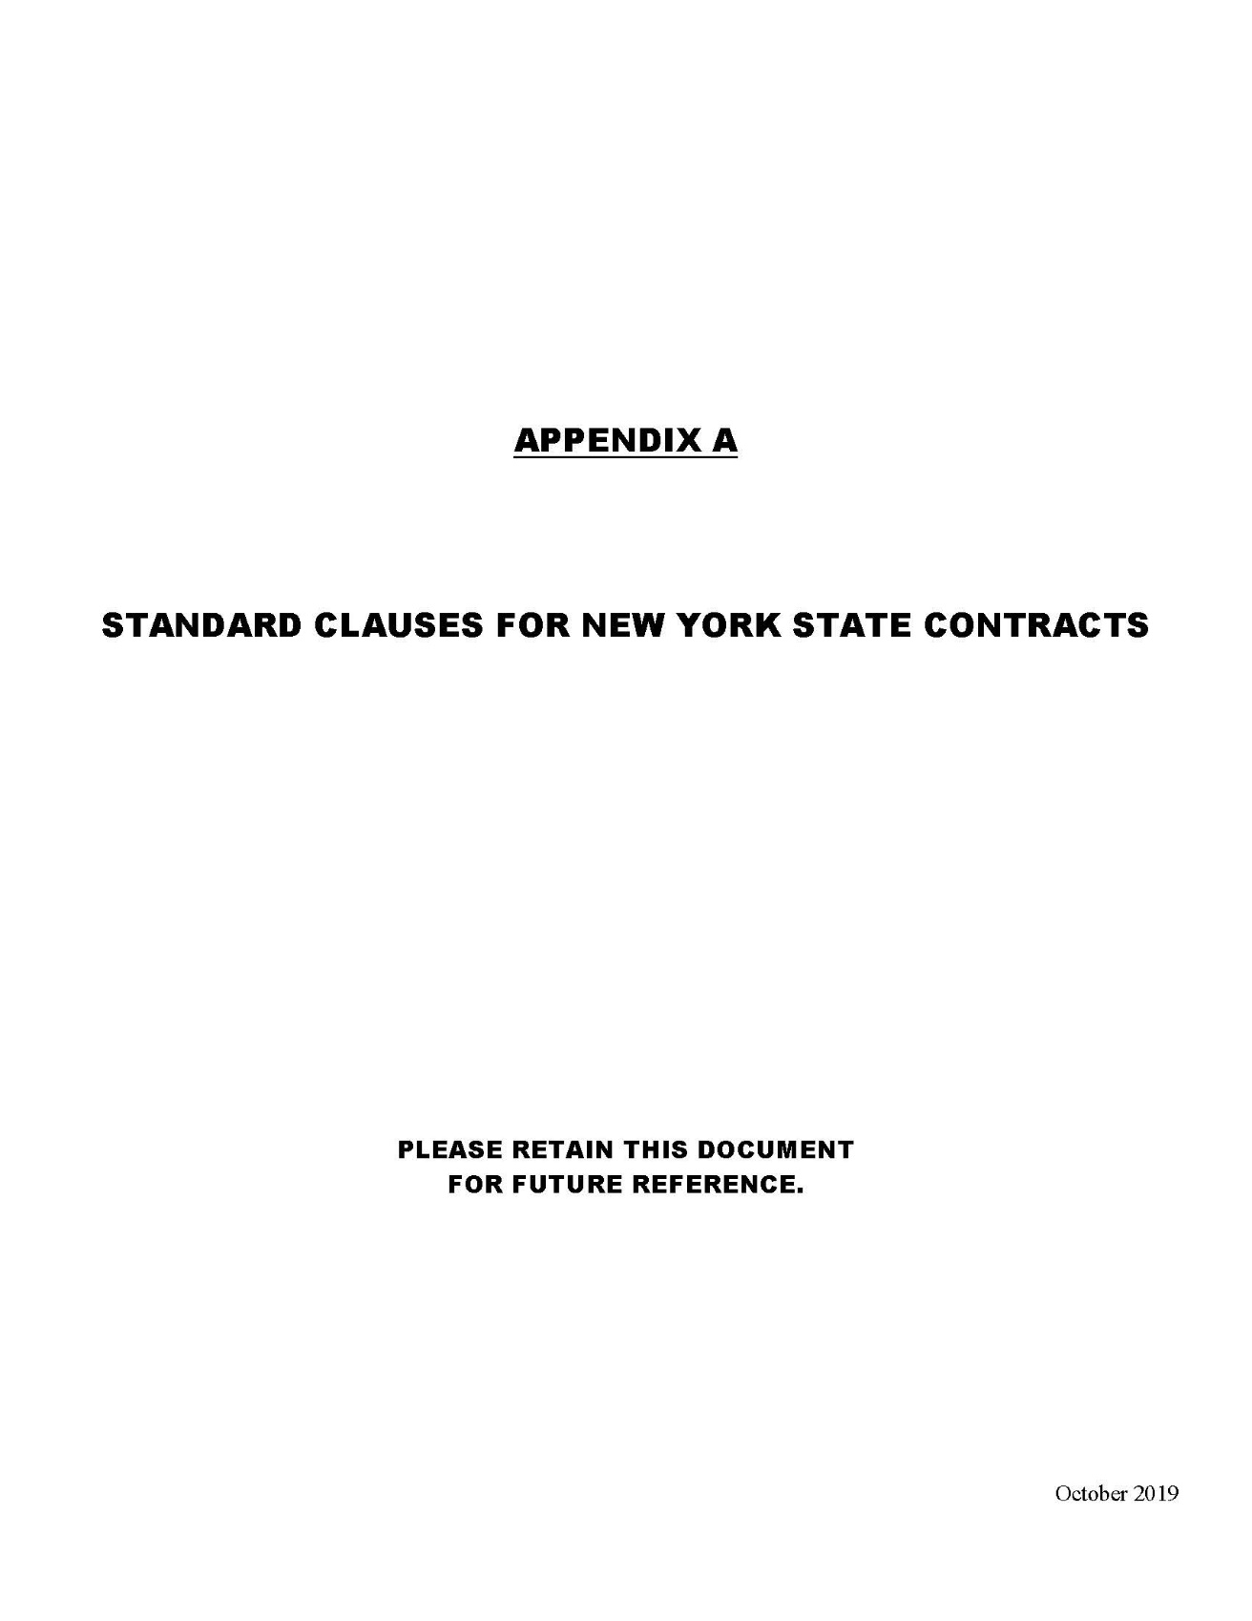
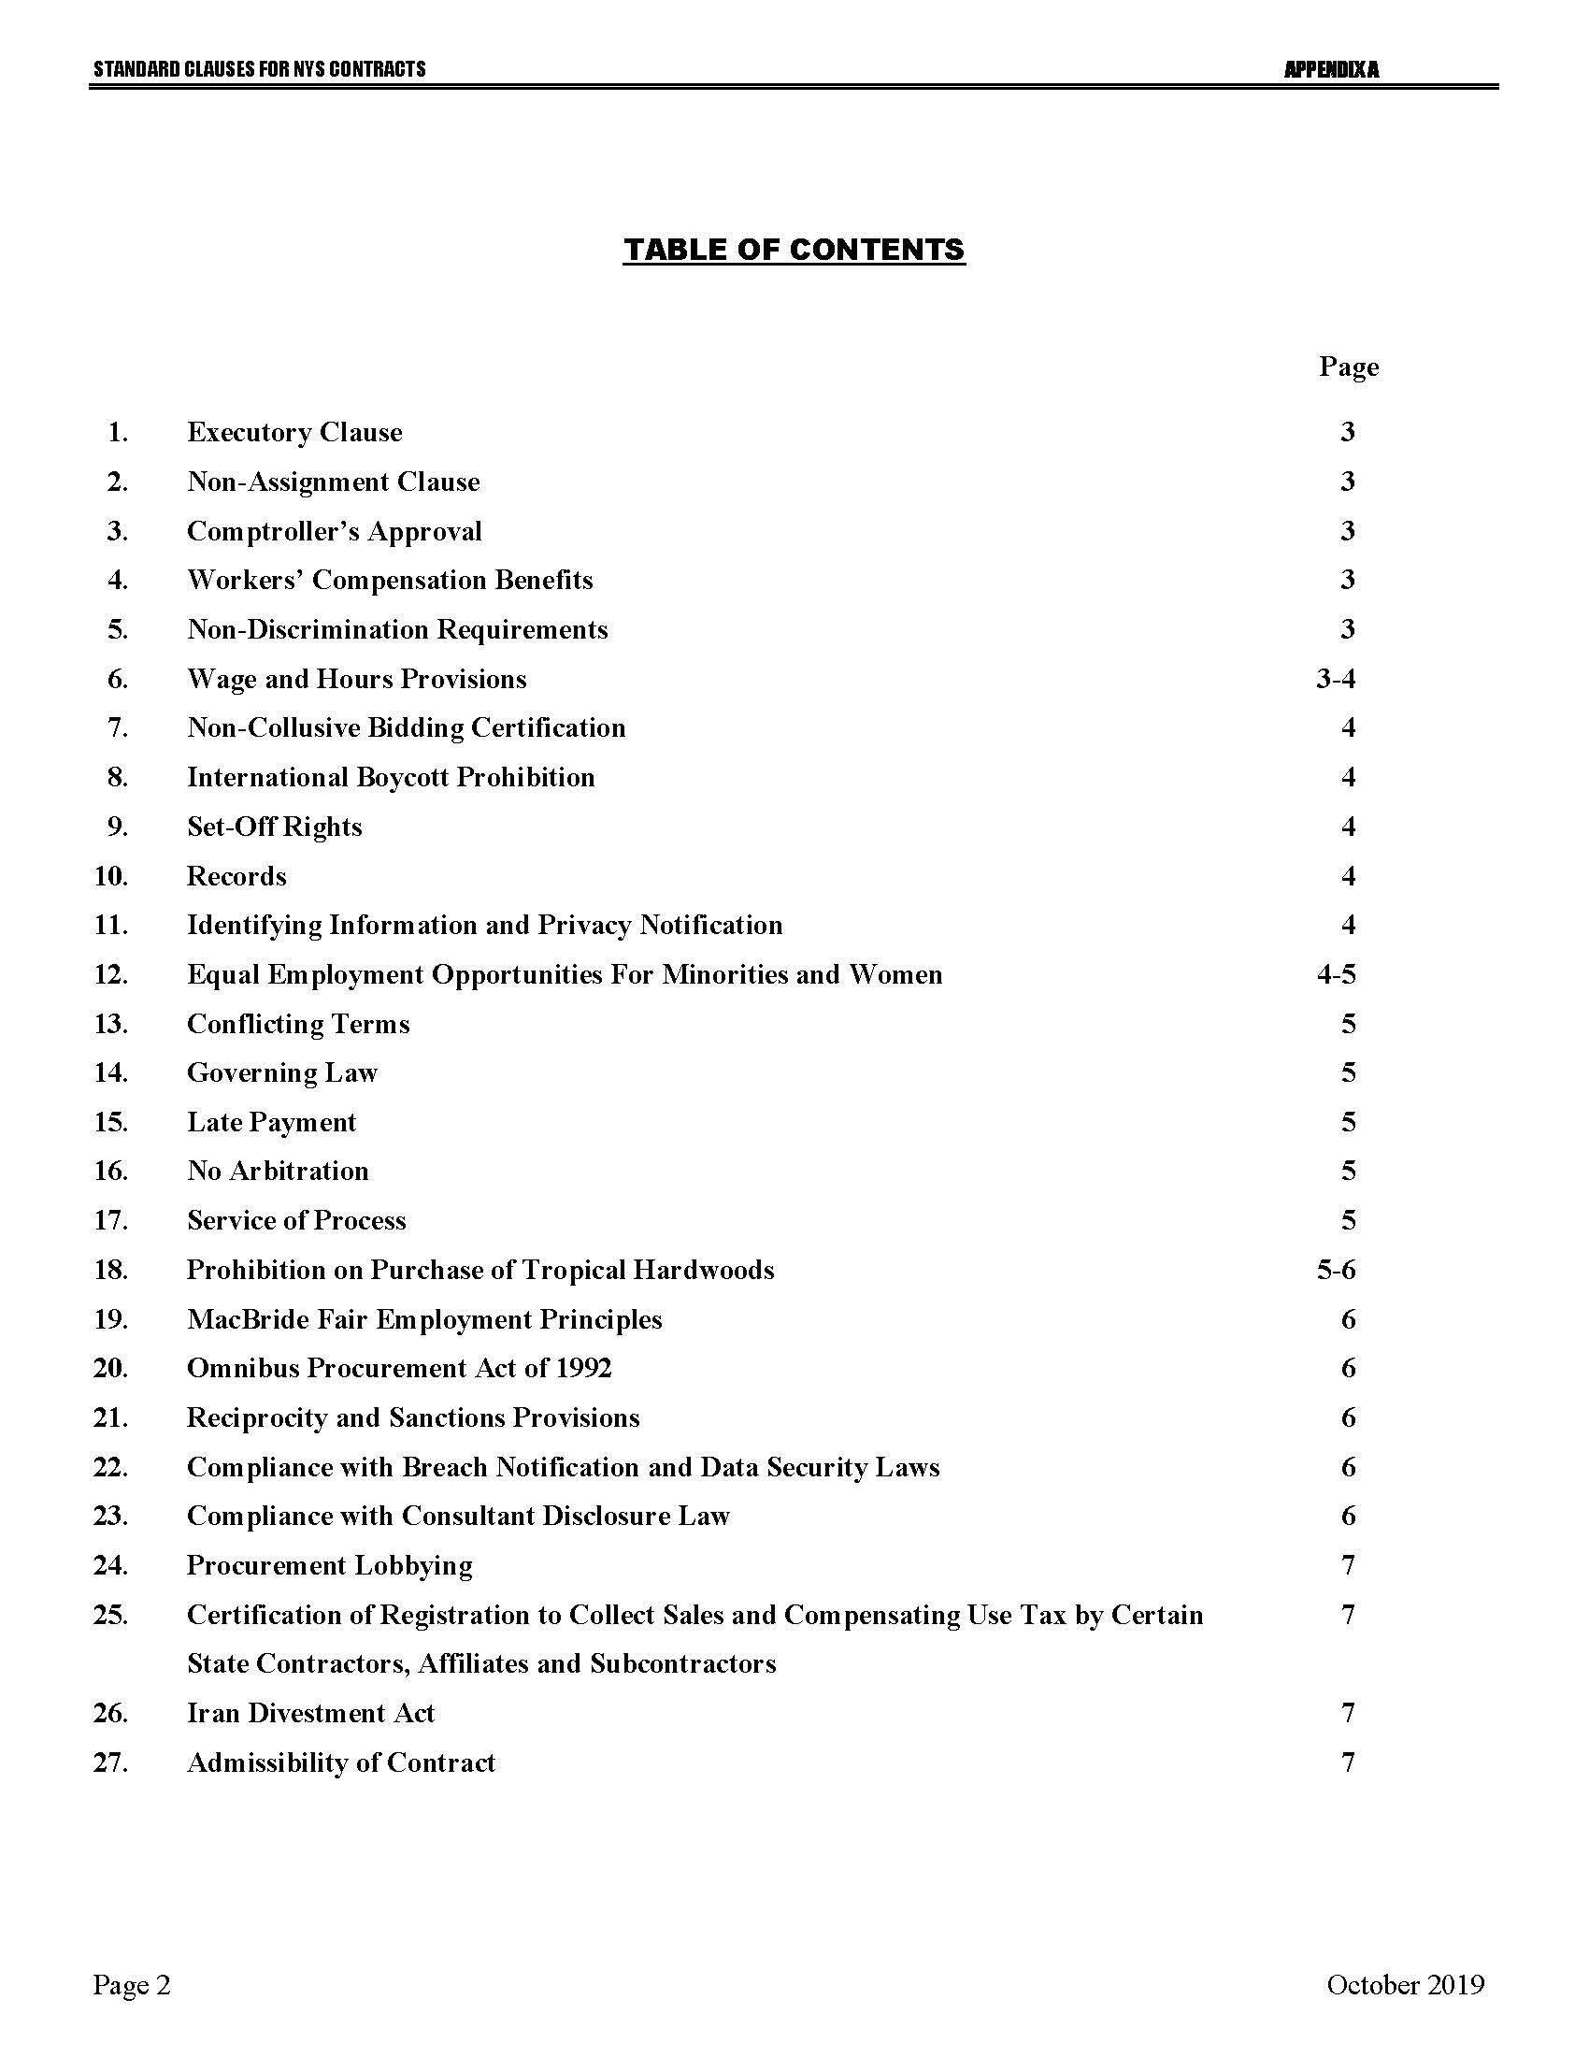

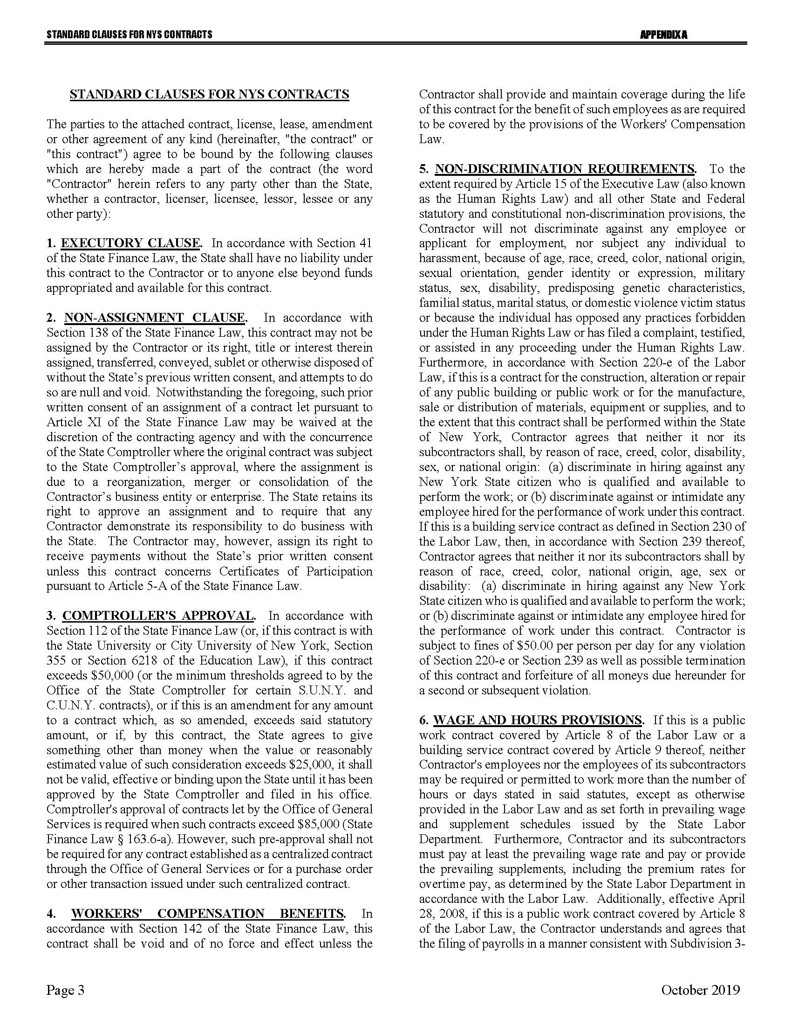
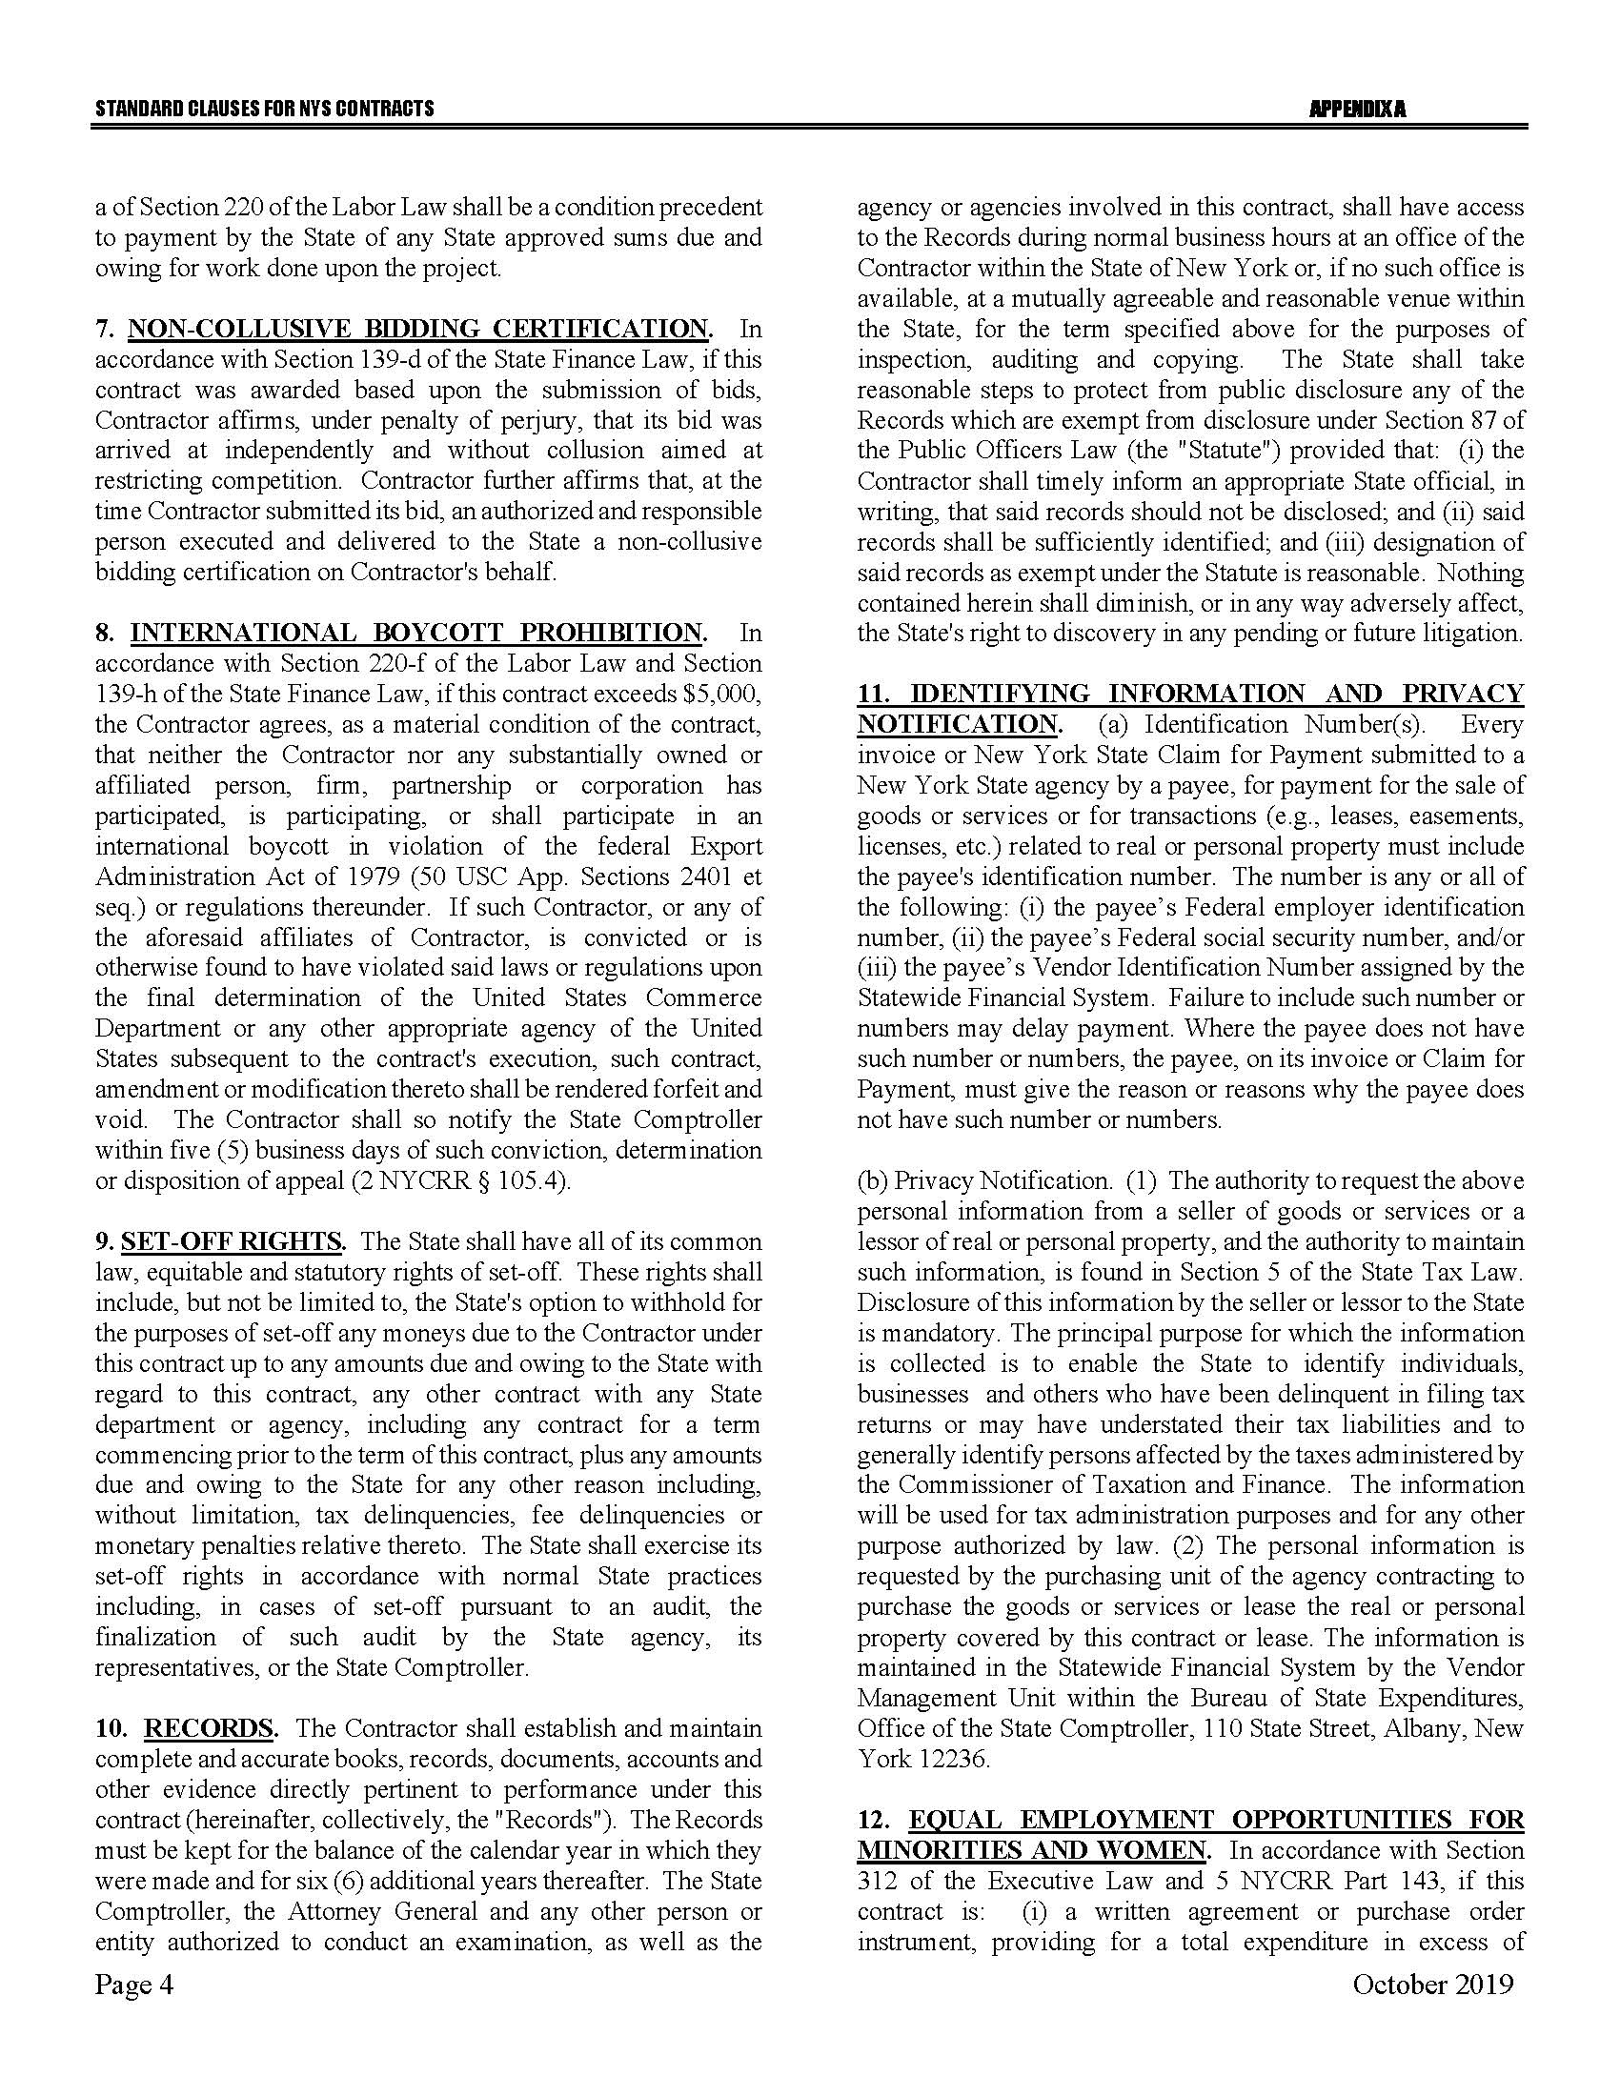

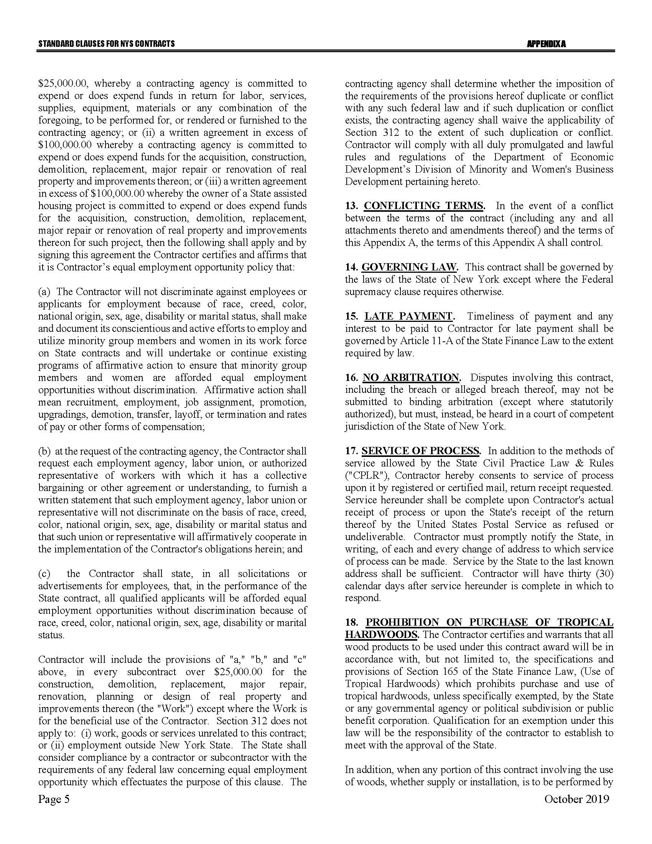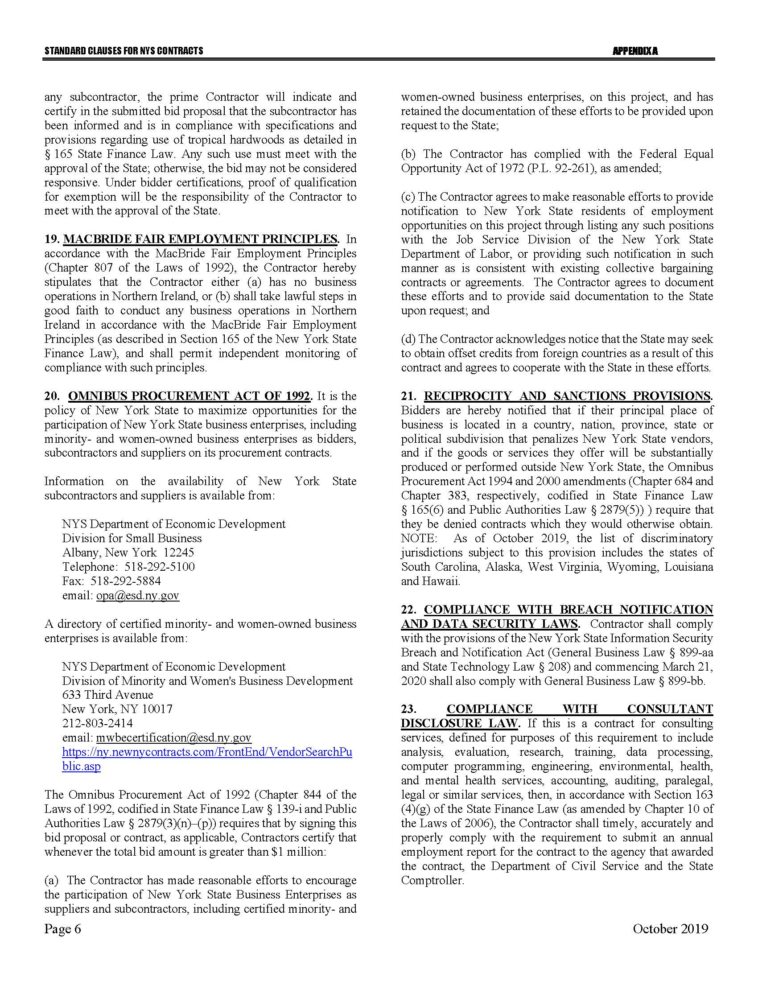
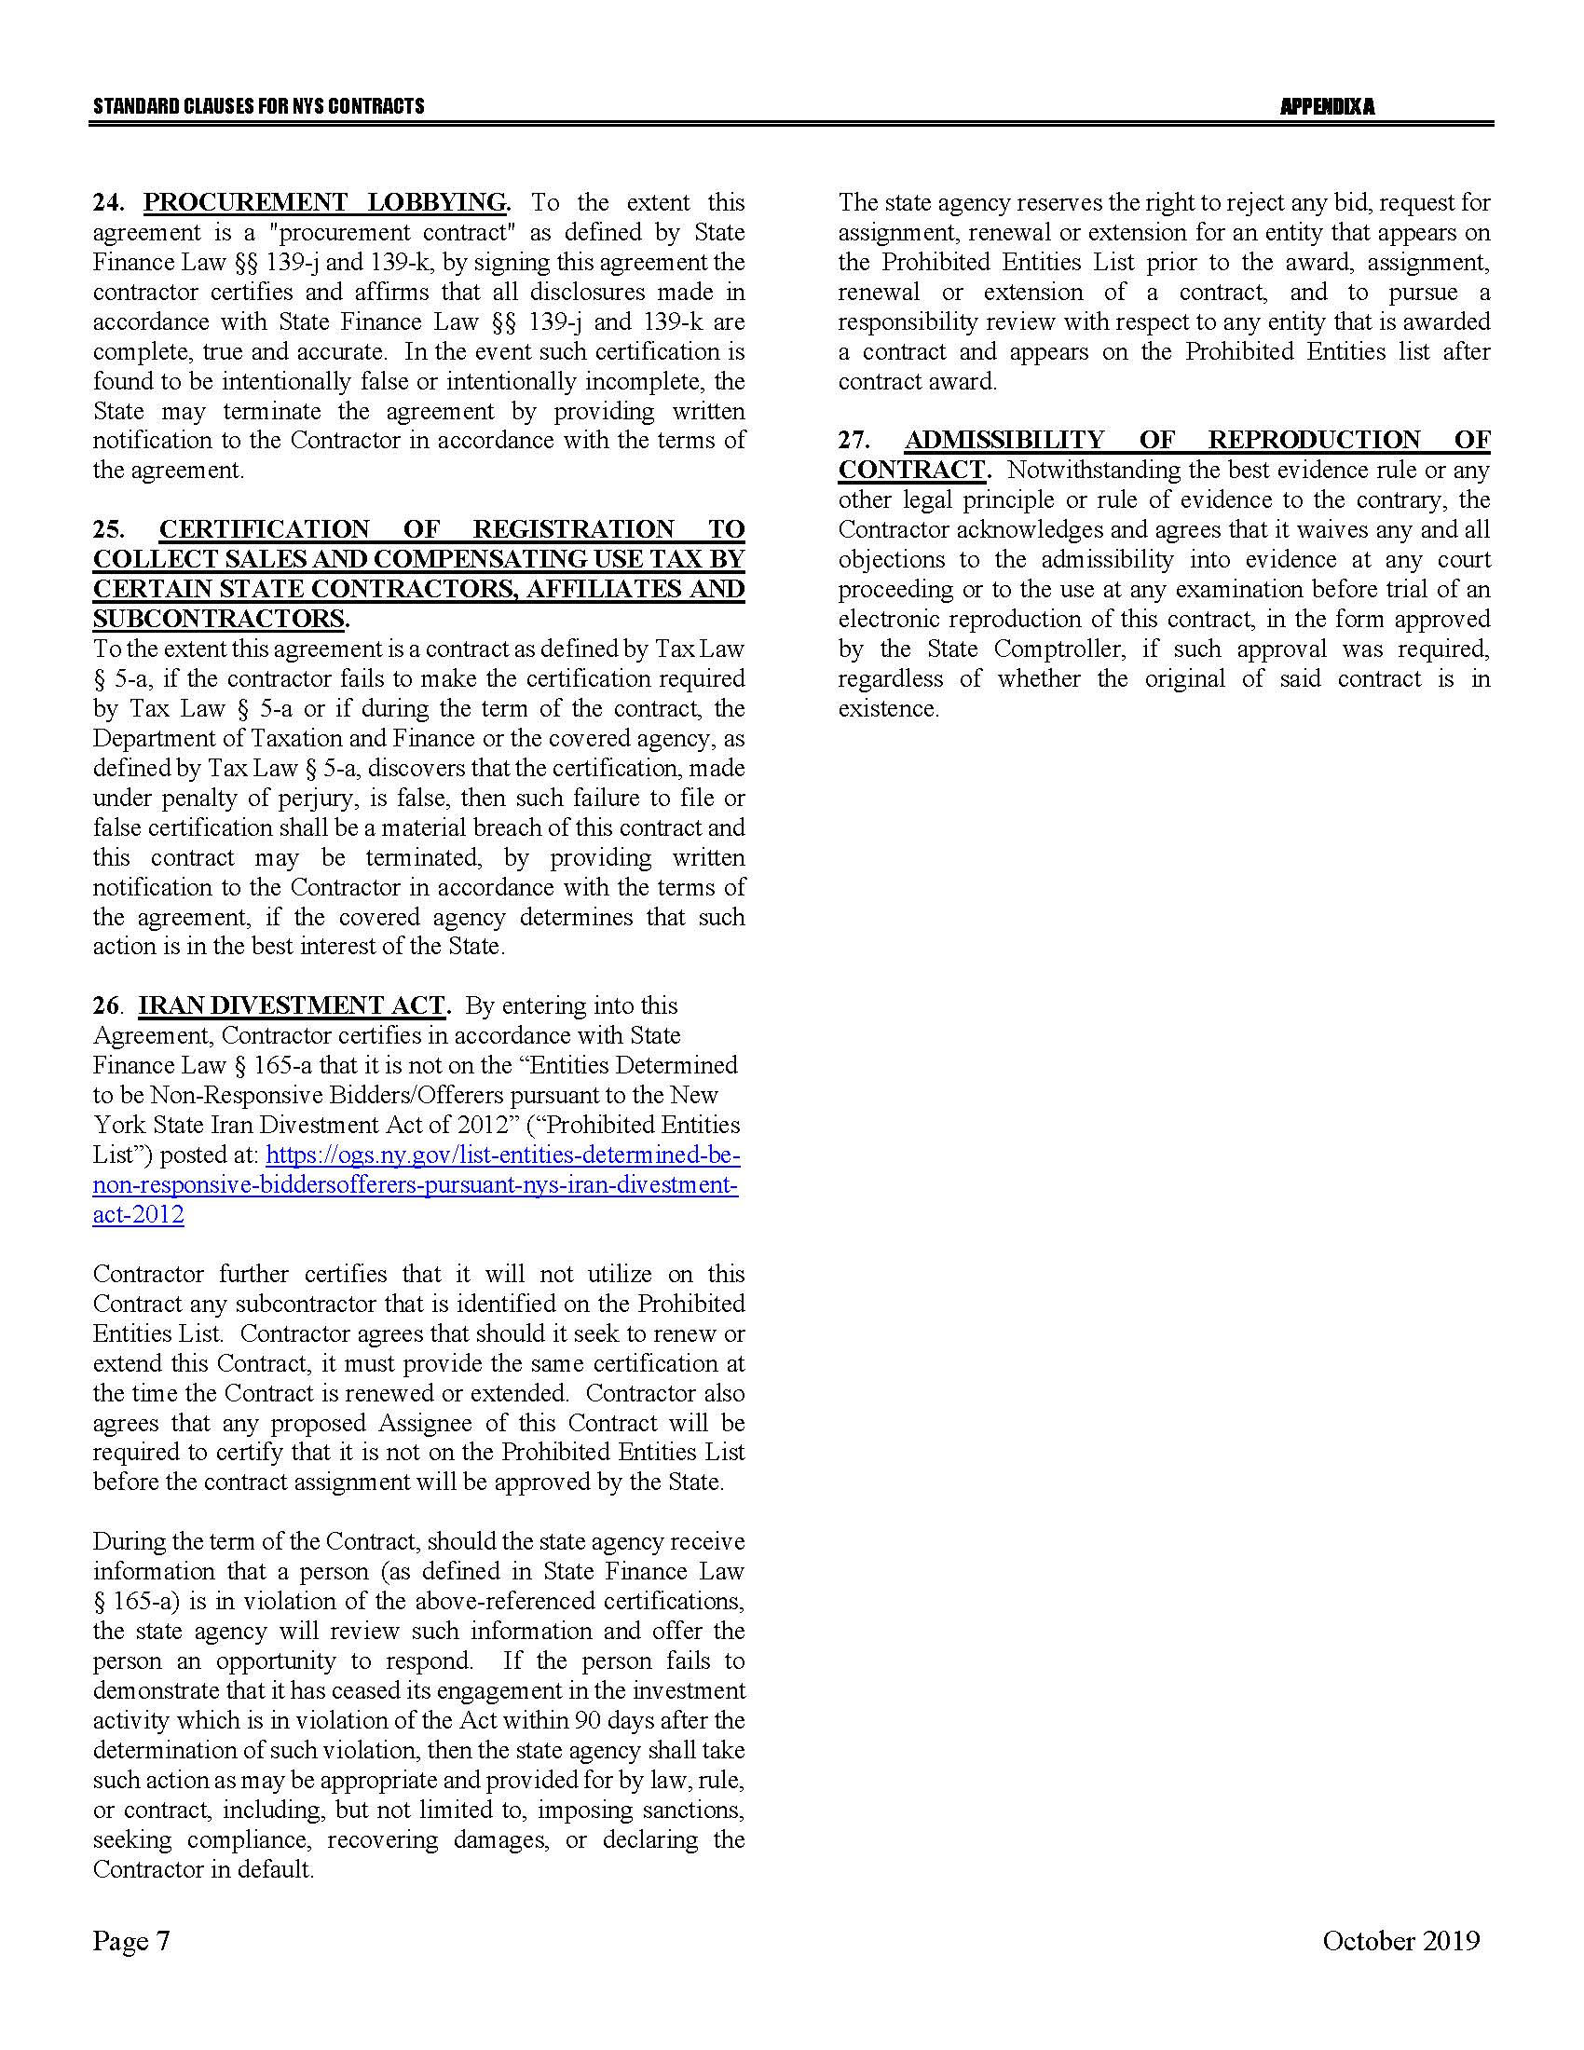

Appendix B – Bid Protest Policy
DTF Protest Procedure
Section 1 Applicability
Section 2 Definitions
Section 3 General Protest Guidelines
Section 4 Protest Procedure
Section 5 Appeal process
Section 1: Applicability
These guidelines set forth the procedure to be utilized when an Interested Party challenges a Contract Award by the New York State Department of Taxation and Finance. The guidelines shall apply to all Contract Awards made by the Department and approved by the New York State Office of the State Comptroller, including bid Solicitations, Sole Source procurements, Single Source procurements, and Emergency procurements.
Section 2: Definitions
- "Contract Award" is a written determination from DTF to an Offeror indicating that the DTF has selected a particular Offeror under the procurement process.
- “DTF” or “Department” means the New York State Department of Taxation and Finance.
- "Emergency" means an urgent and unexpected requirement where health and public safety or the conservation of public resources is at risk (see New York State Finance Law, Section 163.1.b).
- "Interested Party" means a participant in the procurement process and those whose participation in the procurement process has been foreclosed by the actions of the DTF and have suffered harm as a result of the manner in which the procurement was conducted.
- “Offeror” means the entity submitting an offer to DTF.
- "OSC" means the New York State Office of the State Comptroller.
- "Protest" means a written challenge by an Interested Party of a Contract Award that is subject to the approval of OSC.
- “Protesting Party” means an Interested Party who has filed a Protest.
- "Single Source" means a procurement in which, although two or more offerors can supply the required commodities or services, DTF, upon written findings setting forth the material and substantial reasons therefor, awards the contract to one offeror over the other (see New York State Finance Law, Section 163.1.h).
- "Sole Source" means a procurement in which only one offeror is capable of supplying the required commodities or services (see New York State Finance Law, Section 163.1.g).
- “Solicitation” means a document issued by DTF, requesting a response to a procurement need, including an Invitation for Bids, a Request for Proposals, or another written method seeking a bid or Proposal for a specified purpose.
- "Successful Bidder" means the Bidder or offeror whose Bid or Proposal has been selected for Contract Award by DTF.
Section 3: General Protest Guidelines

  - Any Interested Party will be given the opportunity to participate in the protest procedure.
A Protest submitted to DTF must be in writing and must contain specific factual and legal allegations setting forth the basis on which the Protesting Party challenges the Contract Award by DTF. A Protest must include:
- a statement of all legal and/or factual grounds for disagreement with a DTF procurement determination;
- a description of all remedies or relief requested; and
- copies of all applicable supporting documentation.
  - DTF may, at its sole discretion, waive any deadline or requirement set forth in these guidelines, or consider any materials submitted beyond the time periods set forth in these guidelines.
  - Where DTF deems appropriate, DTF may require the Protesting Party, DTF staff involved in the procurement, the Successful Bidder, or any other Interested Party, to address and/or submit further information with respect to additional issues raised by any DTF review of the procurement.
  - Nothing herein shall preclude DTF from obtaining information relevant to the procurement from any other source, as it may deem appropriate.
Section 4: Protest Procedure

  - Any Interested Party may file, by mail or electronic mail, a Protest with the DTF Director of Procurement. The following statement must be clearly and prominently displayed on the envelope or package or header of electronic transmittal: “Bid Protest of DTF Solicitation (Reference Number)” when being submitted in regards to a Solicitation and “Protest of DTF Contract Award (Reference Number)” when being submitted in regards to a contract being entered into on a non-competitive basis.
  - Timing of Protest submission:
- Concerning Errors, Omissions or Prejudice in the Bid Specifications, Requirements or Documents - Protests which concern the drafting of bid specifications must be received by DTF at least ten Business Days before the date set in the Solicitation for receipt of bids. If the date set in the Solicitation for receipt of bids is less than ten Business Days from the date of issue, Protests concerning the specifications must be received by DTF at least 48 hours before the time designated for receipt of bids.
- Concerning Proposed Contract Award - Protests concerning a pending Contract Award must be received within ten Business Days after the notice of Contract Award or five Business Days after receiving a debriefing.
  - The DTF Director of Procurement may summarily deny a Protest that fails to contain specific factual or legal allegations, or where the Protest raises only issues of law that have already been decided by the courts or by the OSC Bureau of Contracts.
  - An Interested Party may file only one Protest with respect to a specific Solicitation.
  - The DTF Director of Procurement shall issue a written determination addressing all issues raised by the Protest, as well as any relevant issues raised by his/her review of the procurement or contract. The determination shall make findings of fact and conclusions of law on any issues in dispute. All participants in the Protest and the Successful Bidder shall be provided a copy of the determination. The determination shall be made part of the procurement record.
Section 5: Appeal Process

  - The protest determination of DTF shall be deemed a final and conclusive agency determination unless a written notice of appeal is received no more than five Business Days after the date the written Protest decision is sent to the Offeror. Such notice of appeal must be filed in writing at the address set forth below:
Chief Financial Officer
New York State Department of Taxation and Finance
Reference: Bid Protest of DTF Solicitation (provide procurement reference number) (or, Protest of DTF Contract Award [Reference Number])
Building 9 W.A. Harriman Campus
Albany, NY 12227
  - The Chief Financial Officer shall review and make a final written determination on all appeals within ten Business Days of the date the Appeal is received. A protest appeal may not introduce new facts or legal allegations unless responding to issues newly raised as a result of the written protest determination.
Section 6: OSC Appeal Process

  - An Interested Party must file an appeal of the Department’s determination of a Protest with the OSC Bureau of Contracts within ten Business Days of receiving DTF’s final written determination on appeal.
  - In its appeal, the Interested Party shall set forth the basis on which it challenges DTF’s protest determination. The Interested Party shall also include, as an exhibit to its appeal, a copy of the initial bid Protest submitted to the Department and the determination of such bid Protest issued by DTF.
The appeal must be in writing and a copy must be delivered to DTF and the Successful Bidder (unless the Successful Bidder is the appealing party in which case a copy of the appeal must be delivered to the original Protesting Party), and any other party that participated in the Protest conducted by DTF.
The appeal must be filed with:
Bureau Director at bidprotests@osc.state.ny.us
or
Bureau of Contracts
New York State Office of the State Comptroller
110 State Street, 11th Floor
Albany, NY 12236

July 2020

[The Remainder of this Page is Intentionally Left Blank]

Exhibit A – Preliminary Base Contract
THIS AGREEMENT is between the New York State Department of Taxation and Finance, located at Building 9, W.A. Harriman State Office Campus, Albany, New York 12227 (hereinafter, the “Department” or the “State” or “DTF”) and [Contractor Name], with a principal place of business located at [Contractor Address] (hereinafter, the “Contractor”). The Department and the Contractor are together referred to herein as the “Parties”.
WHEREAS, the Department issued Invitation for Bids (IFB) 22-201 on May 24, 2023, for National Change of Address (NCOA) and NIXIE Mail Processing Services (together, the “Services”); and
WHEREAS, the Contractor timely submitted a responsive Proposal to provide the Services set forth in the IFB and the Department has determined the Contractor is responsible; and
WHEREAS, the Contractor’s Proposal meets all requirements as outlined in the IFB, has submitted the lowest cost Proposal, and the Contractor was determined capable of providing the required services; and
WHEREAS, the Contractor is prepared to undertake performance of providing the Services to meet the Department’s address update needs as set forth in the IFB and according to the terms of this Agreement.
NOW, THEREFORE, in consideration of the mutual covenants and conditions herein set forth, the Parties hereto agree as follows:
Article I. Definitions
The following terms when used herein shall have the specified meanings:
Agreement (also sometimes referred to herein as “Contract”) – This Contract C400750, which includes all documents identified in Article II. Entirety of Agreement
Attorney General – See IFB 22-201 at Glossary of Terms.
Base Contract – That portion of the Agreement preceding the signatures of the Parties.
Commissioner – See IFB 22-201 at Glossary of Terms.
Contractor – [Add Contractor’s name].

Dispute Resolution – The process set forth in Article X for resolving disputes arising under this Agreement.
Invitation for Bids – See IFB 22-201 at Glossary of Terms.
Material Breach – The failure to perform an obligation that the Contractor is bound to perform under this Agreement which materially impacts the State or is fundamental to the Agreement and the Contractor’s failure to perform defeats its purpose.
OGS-BSC – the New York State Office of General Services, Business Services Center.
OSC – See IFB 22-201 at Glossary of Terms.
Service(s) – All functions required to be performed by the Contractor in accordance with IFB 22-201, and this Agreement, to conduct National Change of Address and NIXIE Mail Processing.
Article II. Entirety of Agreement
This Contract C400750 shall consist of the documents listed below, which are fully incorporated by reference. In the event of a conflict between or among the provisions of the Contract, such conflict shall be resolved by reference to the documents in the order listed with Appendix A having precedence:
Appendix A attached to the IFB, “Standard Clauses for New York State Contracts,” dated October 2019;
Attachment 1 to C400750, DTF-202, “Tax Information Access and Non-Disclosure Agreement,” dated 06/2019, attached hereto ;
Any written amendments to the Agreement agreed to by the Parties and approved, where necessary, by the Attorney General and the Office of the State Comptroller;
Base Contract;
All Amendments and Clarifications to IFB 22-201, including Questions and Answers issued by the State, as follows: [List by Title and/or Date];
IFB 22-201 (including all attachments to the IFB, but excluding Appendix A);
Contractor’s Proposal Clarifications, as follows: [List by Title and/or Date]; and
Contractor’s Proposal, excluding Contractor’s Proposal Clarifications.
Article III. Contractor Responsibilities
In addition to the Contractor’s responsibilities set forth elsewhere in this Agreement, the Contractor shall:
- Provide all services as set forth herein and in IFB 22-201 and the Contractor’s Proposal in response to said IFB.
- Not disclose the data provided by the Department to any other individual or entity except as expressly provided by law. The data provided, while in the custody of the Contractor, must be kept confidential, and the Contractor must take all reasonable and prudent steps to ensure the data is fully protected and secured.
- Pay, at its sole expense, all applicable permits, licenses, tariffs, tolls and fees and give all notices and comply with all federal, State, and local laws, ordinances, rules and regulations of any governmental entity in conjunction with the performance of obligations under the Contract.
- Cooperate with the Department to utilize, where necessary, the Dispute Resolution process to ensure the timely resolution of disputes and technical problems that arise during the term of this Agreement.
- Respond within twenty-four (24) hours (unless such period is extended in writing by the Department because the nature of the issue requires additional time) to any DTF request to provide direction, information, approvals, authorizations, or decisions relating to the Contractor’s performance under this Agreement.
- Continuously provide the qualified and experienced personnel and levels of effort required to provide Services in accordance with all requirements as set out in IFB 22-201 and herein.
- Maintain insurance as required in IFB 22-201 and as set forth in this Agreement.
Article IV. Department Responsibilities
In addition to the Department’s responsibilities set forth elsewhere in this Agreement, the Department shall:
- Make diligent efforts to provide the Contractor with direction, assistance, procedures, and contact persons necessary to perform in accordance with the requirements herein.
- Cooperate with the Contractor to utilize, where necessary, the Dispute Resolution process to facilitate the timely resolution of disputes and technical problems that arise during the term of this Agreement.
- Provide the Contractor with access, as necessary, to its end users and system staff who are committed to providing the business information needed by the Contractor to perform services under this Agreement.
- Be responsible for the performance of its employees and agents.
- Advise the Contractor of the security rules, procedures, and regulations that the Department may from time to time establish for its employees with respect to the Department’s premises, property, records, and data in the Department’s care and custody.
- Send the files for NCOA^{Link} Processing in the manner agreed upon by the Parties.
- Compensate the Contractor for Services appropriately rendered and invoiced, in accordance with the terms set forth herein under Article VI. Fees and Payment.
Article V. Contract Term
The Department will award one (1) Contract to the successful Bidder. The Contract will become valid and effective only upon its approval by both the Attorney General (AG) and the Office of the State Comptroller (OSC). Upon receiving the last such approval, the Contract term will commence and thereafter continue for a period of five (5) years.
This Contract may be renewed or modified only upon agreement of the Parties. Such renewal or modification shall be accomplished through written amendment and may require the approval of the New York State Attorney General and the Office of the State Comptroller.
Article VI. Fees and Payment
All fees and payments shall be in accordance with IFB 22-201 Section 6. Price and Attachment D - Financial Response Form, submitted by the Contractor in response to the IFB, both of which are incorporated in their entirety herein by reference. Total payment under this Agreement shall not exceed [tbd].
Payment will be made only for Services billed by Contractor on invoices which are accepted by the State.
- Electronic Payment
Payment for invoices submitted by the Contractor will only be rendered electronically and in accordance with ordinary State procedures and practices. Contractor shall comply with the State Comptroller’s procedures to authorize electronic payments and acknowledges that Contractor will not receive payment on any invoices submitted under this Agreement if it does not comply with the State Comptroller’s electronic payment procedures. The Commissioner, in his/her sole discretion, may authorize payment by paper check, if specifically requested by the Contractor in advance, due to extenuating and documented circumstances necessitating payment by paper check.
In order to receive payment, Contractor must complete and update, as appropriate, its Vendor Record through the online Vendor Self-Service Portal with the applicable Automated Clearing House (ACH) information (e.g., bank routing number, bank account number, account type) into which the Contractor wants payment deposited. It is the Contractor’s responsibility to access the self-service portal, follow instructions provided there, and accurately supply the required information to set up electronic payments. Contractor must input the required ACH information and not permit the payment type to default to payment by paper check. In addition to inputting the appropriate ACH information in the State Comptroller’s Vendor Record system, the Contractor must also advise DTF in writing of the ACH payment information (bank account location) into which it wants payment remitted for this Agreement. The Vendor Self-Service Portal can be found at https://esupplier.sfs.ny.gov/psp/fscm/SUPPLIER. Contractors requiring assistance with accessing or using the self-service portal should contact the NYS Statewide Financial System (SFS) by e-mail at helpdesk@sfs.ny.gov, or by telephone at (855) 233-8363.
- Properly Submitted Invoices
Payment will be made only upon submission of proper invoices by the Contractor, and in accordance with Article 11-A of New York State Finance Law.
Required Information on properly submitted invoices:
- Vendor name;
- Name of NYS Agency that ordered the goods or services;
- Description of goods or services requesting payment for (may be in narrative or code values format);
- Quantity of goods, property, or services delivered or rendered;
- Amount requested; and
- Purchase order (PO) number, if applicable, as provided by ordering agency.
It is preferred that an invoice also contain the following information:
- NYS Vendor ID number;
- Invoice Date;
- Unique invoice number;
- Payment terms being offered, if other than Net 30; and
- Any other information or substantiating documentation the agency may reasonably require.
All invoices and payments therefor are subject to the State’s acceptance of the Services for which billing is being made.
Submission:
Preferred Method:
Submit invoices through the SFS Vendor Portal. (Note: Do not email or send a paper copy, in addition to submitting an invoice via the SFS Vendor Portal.)
Alternate Method:
Email invoices to the OGS-BSC at: accountspayable@ogs.ny.gov including the invoice number and the name of the agency being billed in the subject field. (Note: Do not send a paper copy, in addition to the electronic invoice.)
OR
Mail invoices to OGS-BSC at the following U.S. postal address:
New York State Department of Taxation and Finance
c/o NYS OGS Business Services Center
1220 Washington Ave, Building 5, 5th Floor
Albany, NY 12226-1900
ARTICLE VII. Secrecy, Confidentiality, Information Breach, and Data Ownership
- New York State and Federal Tax Secrecy Provisions
The various secrecy provisions of the Tax Law (e.g., Tax Law §§ 487, 697(e) and 1825) prohibit independent contractors from disclosing tax information in any manner and provide for misdemeanor prosecution for violations. The secrecy provisions of the Internal Revenue Code (26 USC § 6103) provide for felony prosecution for unauthorized disclosure of Federal tax information in the possession of the Department.
All other information about the Department's operations not covered by the preceding provisions of law must be kept confidential as if it were so covered. Contractor representatives must comply with the administrative procedures enforcing these rules.
The Contractor, all staff members and subcontractors agree to view, access, and use only that information relevant and necessary to provide Services to the State under the Agreement; and to subscribe to the provisions of §§ 73 and 74 of the Public Officers Law.
- Tax Secrecy - Required Forms
The Contractor will have a representative authorized to bind the Contractor execute on behalf of the Contractor the Tax Information Access and Non-Disclosure Agreement form (Attachment 1 hereto) (the “DTF-202 Form”). By signing the DTF-202 Form, the Contractor acknowledges and agrees that it has read, understood, and will comply with its terms. The Contractor will also require each employee performing services under this Agreement and/or entering into any DTF premises to review and execute a DTF-202 Form. The Contractor will provide completed originals to the Department at the address indicated on the form.
- Breach of Confidentiality Provisions
The Contractor, through its employees and agents, may have access to tax secret and other confidential and/or proprietary information and materials of the State and tax secret and other confidential and/or proprietary information and materials of third parties rightfully in the State’s possession (“Confidential Information”). Contractor shall maintain all such information in confidence for the sole and exclusive benefit of the State and shall not use same for any purpose whatsoever other than rendering Services to the State.

Contractor acknowledges that any unauthorized use or disclosure of Confidential Information may cause irreparable damage to the State. If an unauthorized use or disclosure occurs, the Contractor shall, at its expense, take such commercially reasonable steps as are necessary to recover Confidential Information and to prevent its subsequent unauthorized use or dissemination, including availing itself of actions for seizure and injunctive relief. If the Contractor fails to take these steps in a timely and adequate manner, the State may take them at the expense of the Contractor.

The Contractor shall be fully liable for breach of the confidentiality provisions of this Agreement in an amount not to exceed the amount allowed by applicable Federal or New York State law (including any damages construed as incidental, consequential or indirect damages). Liability limitations set forth in this Agreement shall not apply to breaches involving the Contractor’s confidentiality obligations.
- Information Security Breach and Notification Law Requirements
Contractor expressly agrees to comply with the provisions of the State Technology Law § 208 (the "Law") and any future amendments thereto, as applied to any breach of computerized "private information" (as defined in the Law) received, handled, processed, uploaded, or maintained by Contractor on behalf of the Department under this Agreement (hereinafter, the "Department Information") where such breach is attributable to the Contractor or its Services. In the event of a "breach of the security of the system" (as defined by the Law), Contractor shall promptly notify the Department upon discovery or notification of such breach. Such notice to the Department shall be provided by contacting the Department's Information Security Office by email to: ISO.Mail@tax.ny.gov and phone call to the DTF Information Security Office at (518) 898-0749. The Contractor shall promptly commence an investigation, in cooperation with the Department, to determine the scope of the breach and to restore the security of the system. Upon completion of Contractor’s investigation, the Contractor shall promptly notify DTF of the results. If the Department determines that notifications are required to be sent out pursuant to the Law, Contractor shall be responsible for providing such notifications to all required recipients including, in accordance with New York State policy, non-New York State residents whose private information is reasonably believed to have been exposed as a result of the breach, and all costs associated with providing such notices shall be borne by Contractor. It is expressly agreed that Contractor shall be obligated to receive authorization from the Department prior to making any notifications to any individuals, the State Office of Information Technology Services, the Department of State – Division of Consumer Protection, the Attorney General's Office or any consumer reporting agencies concerning a breach of the security of the system, or prior to making any determination whether or not to delay notifications due to law enforcement investigations. The Contractor agrees that the Department shall have final approval over the form, content, mode of transmission, and timing of any notice to be provided concerning a breach of the security of the Department Information. Nothing contained herein shall be interpreted as reducing or altering Contractor's own information security breach obligations under General Business Law § 899-aa.
- Additional Remedies Related to a Security Breach
Contractor shall, in conjunction with the State, reasonably cooperate with any federal or State agencies that may investigate a security breach.
Contractor shall be liable for the costs associated with a security breach that compromises State Data and/or taxpayer data, including but not limited to, remediation cost, fees and expenses including cost of any forensic investigation, replacement or restoration required due to any virus, information security breach or any other incident compromising the availability, privacy, security, integrity or usability of any State Data and/or taxpayer data, and any financial loss suffered by the State and, where applicable, the non-State data subject.
At the State’s option where a security breach involves “private information” (as defined in State Technology Law, Section 208), Contractor shall, at no additional cost to the State:
- Pay the cost of providing required notices to all three credit bureaus;
- Provide affected individuals with identity monitoring services, including credit monitoring, for a period of no less than 36 months;
- Provide affected individuals with identity theft insurance for a period of no less than 36 months; and
Provide identity restoration services to affected individuals who, within 36 months of a security breach, have their identity compromised as a result of a security breach.

- Ownership and Return of State’s Data

The State retains sole ownership in and to all information and data provided or made accessible by the State to the Contractor (“State Data”). The Contractor does not have the right to retain State Data or to use it for any purposes other than to provide the Services.

As required by the IFB, Contractor will destroy or return all State Data and records thereof to the State upon completion of the work hereunder. Promptly after the termination or expiration of the Agreement, the Contractor shall, at no cost to the State, perform the following actions with respect to such State Data: (i) transmit the State Data to the State or its designee(s) in a format that is easily usable by the State or its designee(s) and does not contain any proprietary software or other materials of the Contractor or third parties; (ii) destroy the State Data and any copies, extracts, descriptions, and summaries thereof contained in the Contractor’s records or systems; and (iii) provide the State with a written notarized certification of such destruction executed, under penalty of perjury, by an Officer of the Contractor.

Article VIII. Reserved Rights
In addition to such other rights as allowed under this Agreement, the Department reserves the right to request a copy of Federal Form I-9, Employment Eligibility Verification, for each individual assigned to work at the Department under this Contract, if the Contractor is legally obligated to obtain and retain such Form I-9. The social security number of the employee, if listed on Form I-9, shall be redacted from the form.
Article IX. Performance and Remedies
If it is determined that the Contractor is in breach of any terms or conditions set forth in this Contract, the Department reserves the right to take any action it deems appropriate, at its sole discretion, including but not limited to contract termination or the withholding of payment until such breach is remedied to the Department’s satisfaction. The taking of any such action shall not give rise to any cause of action against the Department for any kind of damages, loss of profits, expenses, or other remuneration of any kind.
Article X. Dispute Resolution
In the event of a dispute, resolution will first be sought through conference between the State and the Contractor. The party initiating the Dispute Resolution process shall notify the other party in writing and set forth the issues for resolution and provide all necessary documentation. The Parties shall review each other’s position and attempt to reach a resolution. Disputes that cannot be resolved by Contractor and DTF staff will be resolved by the Commissioner of DTF, whose decision is final and binding. If the Contractor pursues any legal or equitable remedy outside this Dispute Resolution process, the Contractor shall continue to perform work in accordance with the direction of DTF until such proceedings may be concluded and will continue to be paid in accordance with the Agreement, less any amounts attributable to the dispute. Disputes that go to litigation must be pursued in a court of competent jurisdiction within the State of New York, with venue in Albany County. New York law (without regard to its conflicts of law jurisprudence) will govern the dispute. Nothing in this paragraph shall diminish the State’s right to terminate the Agreement.
ARTICLE XI. Termination
A. Termination for Cause (Material Breach)
In the event of a Material Breach or if the State deems the Contractor’s performance unsatisfactory at any time during the term of this Agreement, the State reserves the right, in its sole discretion, to terminate this Agreement in whole or in part, or to terminate the Contractor’s Services with respect to a specific matter or matters, immediately upon providing written notice to the Contractor.
Such termination shall not give rise to any cause of action against the State for damages, breach of contract, loss of profits, expenses, or other remuneration of any kind. The Contractor shall be fully liable for the State’s damages resulting from any Material Breach, and shall be responsible, without limitation, for all additional costs the State incurs should the State terminate the Agreement due to such a breach. Without limiting the foregoing, this includes the State’s recovery of costs incurred by the State in engaging a new contractor.
Material Breach includes, but is not limited to, the following:
- Significant or repeated failure of Contractor to comply with its obligations under the Agreement.
- Failure of Contractor to maintain the confidentiality of and/or security of State Data, and/or taxpayer data or tax administration policies and procedures provided to it in connection with its performance of this Agreement.
- Failure of Contractor to cooperate fully with the Department, its agents, OSC and/or the AG, to the extent required in connection with performance of this Agreement.
- Failure of Contractor to remain a responsible Contractor consistent with applicable New York State Law, regulations and/or Executive policy.
- A finding that the certification filed by the Contractor in accordance with Section 5-a of the Tax Law was intentionally false or misleading or intentionally incomplete.
- A finding that the certification filed by the Contractor in accordance with Procurement Lobbying law was intentionally false or misleading or intentionally incomplete.
- Contractor’s breach of any warranty or representation under the Agreement, which remains uncured.
If it is subsequently determined for any reason that Contractor was not in Material Breach or that the Contractor’s failure to perform or make progress in performance was due to causes beyond the control and without the fault or negligence of the Contractor, the Department will have the option to allow the Contractor to resume performance under the Agreement without an increase in cost.
In the event of Termination for Cause by the State, Contractor shall be liable for the State’s direct damages resulting from such Material Breach.
B. Termination for Convenience
The State may terminate this Agreement in whole, or in part, without cause, upon 30 days prior written notice to Contractor without penalty or other early termination charges due. This provision should not be understood as waiving the State’s right to terminate the Agreement for cause, but is supplementary to those provisions.
C. Notice of Termination; Cooperation
In the event of termination of the Agreement by the State, the Department will issue a written notice of termination. Except as otherwise provided, where any notice is required to be provided by a party, such notice will be delivered in accordance with Article XIX. P. Notices. The Parties agree to cooperate in a manner to effectuate an orderly termination of the Agreement, and to comply with all disengagement and data sanitization requirements set forth in IFB 22-201 and herein.
Article XII. Continuing Administrative Requirements
A. Vendor Responsibility
General Responsibility
The Contractor shall at all times during the Contract term remain responsible. The Contractor agrees, if requested by the Commissioner, to present evidence of its continuing legal authority to do business in New York State, integrity, experience, ability, prior performance and organizational and financial capacity.
Suspension of Work
The Commissioner, at their sole discretion, reserves the right to suspend any or all activities under this Agreement at any time, when they discover information that calls into question the responsibility of the Contractor. In the event of such suspension, the Contractor will be given written notice outlining the particulars of such suspension. Upon issuance of such notice, the Contractor must comply with the terms of the suspension order. Contract activity may resume at such time as the Commissioner issues a written notice authorizing resumption of performance under the Agreement.
Termination
Upon written notice to the Contractor, and a reasonable opportunity to be heard with appropriate DTF officials, or staff, the Contract may be terminated by the Department the Contractor’s expense where the Contractor is determined by the Commissioner to be non-responsible. In such event, the Commissioner may complete the contractual requirements in any manner they may deem advisable and pursue available legal or equitable remedies for breach.
B. Sales and Compensating Use Tax
Section 5-a of the Tax Law, as amended, effective April 26, 2006, requires certain contractors awarded state contracts for commodities, services and technology valued at more than $100,000 to certify, to the Department, that they are registered to collect New York State and local sales and compensating use taxes. The law applies to contracts where the total amount of such contractors’ sales delivered into New York State are in excess of $300,000 for the four quarterly periods immediately preceding the quarterly period in which the certification is made, and with respect to any affiliates and subcontractors whose sales delivered into New York State exceeded $300,000 for the four quarterly periods immediately preceding the quarterly period in which the certification is made.
This law also imposes upon certain contractors the obligation to certify whether or not the contractor, its affiliates, and its subcontractors are required to register to collect state sales and compensating use taxes and contractors must certify to the Department that each affiliate and Subcontractor exceeding the $300,000 sales threshold referenced above is registered with the Department to collect New York State and local sales and compensating use taxes. The law prohibits the State Comptroller, or other approving agency, from approving a contract awarded to a contractor meeting the registration requirements but who has not registered in accordance with the law.

C. Procurement Lobbying
State Finance Law §§139-j and 139-k impose certain restrictions on communications between a Governmental Entity and an Offerer/Bidder during the procurement process. An Offerer/Bidder is restricted from making contacts during the restricted period to other than designated staff unless it is a contact that is included among certain statutory exceptions set forth in State Finance Law § 139-j(3)(a).
If this Agreement is renewed or amended, Contractor shall be subject to the Procurement Lobbying requirements set forth herein and shall submit such updated Procurement Lobbying forms, as required by the State.

ARTICLE XIII. Participation by Minority and Women-Owned Business Enterprises: Requirements and Procedures
- General Provisions

1. The Department of Taxation and Finance (“Department”) is required to implement the provisions of New York State Executive Law Article 15-A and Parts 140-145 of Title 5 of the New York Codes of Rules and Regulations (“NYCRR”) for all State contracts, as defined therein, with a value (1) in excess of $25,000 for labor, services, equipment, materials, or any combination of the foregoing or (2) in excess of $100,000 for real property renovations and construction.

2. The contractor to the subject contract (the “Contractor” and the “Contract,” respectively) agrees, in addition to any other nondiscrimination provision of the Contract and at no additional cost to the Department, to fully comply and cooperate with the Department in the implementation of New York State Executive Law Article 15-A and the regulations promulgated thereunder. These requirements include equal employment opportunities for minority group members and women (“EEO”) and contracting opportunities for New York State-certified minority and women-owned business enterprises (“MWBEs”). The Contractor’s demonstration of “good faith efforts” pursuant to 5 NYCRR § 142.8 shall be a part of these requirements. These provisions shall be deemed supplementary to, and not in lieu of, the nondiscrimination provisions required by New York State Executive Law Article 15 (the “Human Rights Law”) and other applicable federal, state, and local laws.

- Contract Goals
For purposes of this Contract, the Department hereby establishes an overall goal of 0% percent for MWBE participation, 0% percent for New York State-certified minority-owned business enterprise (“MBE”) participation and 0% percent for New York State-certified women-owned business enterprise (“WBE”) participation (collectively, “MWBE Contract Goals”) based on the current availability of MBEs and WBEs.
- Equal Employment Opportunity (“EEO”)

1. The provisions of Article 15-A of the Executive Law and the rules and regulations promulgated thereunder pertaining to equal employment opportunities for minority group members and women shall apply to the Contract.
2. In performing the Contract, the Contractor shall:
a. Ensure that each contractor and subcontractor performing work on the Contract shall undertake or continue existing EEO programs to ensure that minority group members and women are afforded equal employment opportunities without discrimination because of race, creed, color, national origin, sex, age, disability or marital status. For these purposes, EEO shall apply in the areas of recruitment, employment, job assignment, promotion, upgrading, demotion, transfer, layoff, or termination and rates of pay or other forms of compensation.
b. The Contractor shall submit an EEO policy statement to the Department within seventy-two (72) hours after the date of the notice by the Department to award the Contract to the Contractor.
c. If the Contractor, or any of its subcontractors, does not have an existing EEO policy statement, the Department may require the Contractor or subcontractor to adopt a model statement (see Attachment 3 - Minority and Women-Owned Business Enterprises – Equal Employment Opportunity Policy Statement).
d. The Contractor’s EEO policy statement shall include the following language:
i. The Contractor will not discriminate against any employee or applicant for employment because of race, creed, color, national origin, sex, age, disability, or marital status, will undertake or continue existing EEO programs to ensure that minority group members and women are afforded equal employment opportunities without discrimination, and shall make and document its conscientious and active efforts to employ and utilize minority group members and women in its work force.

ii. The Contractor shall state in all solicitations or advertisements for employees that, in the performance of the contract, all qualified applicants will be afforded equal employment opportunities without discrimination because of race, creed, color, national origin, sex, age, disability or marital status.

iii. The Contractor shall request each employment agency, labor union, or authorized representative of workers with which it has a collective bargaining or other agreement or understanding, to furnish a written statement that such employment agency, labor union, or representative will not discriminate on the basis of race, creed, color, national origin, sex age, disability or marital status and that such union or representative will affirmatively cooperate in the implementation of the Contractor's obligations herein.

iv. The Contractor will include the provisions of Subdivisions (i) through (iii) of this Subsection d and Paragraph “4” of this Section C, which provides for relevant provisions of the Human Rights Law, in every subcontract in such a manner that the requirements of the subdivisions will be binding upon each subcontractor as to work in connection with the Contract.

3. Exhibit C – Workforce Utilization Report

a. The Contractor shall submit a Workforce Utilization Report and shall require each of its subcontractors to submit a Workforce Utilization Report, in such form as shall be required by the Department on a quarterly basis during the term of the Contract.

b. Separate forms shall be completed by the Contractor and any subcontractors.

4. The Contractor shall comply with the provisions of the Human Rights Law, and all other State and Federal statutory and constitutional non-discrimination provisions. The Contractor and its subcontractors shall not discriminate against any employee or applicant for employment because of race, creed (religion), color, sex, national origin, sexual orientation, military status, age, disability, predisposing genetic characteristic, marital status or domestic violence victim status, and shall also follow the requirements of the Human Rights Law with regard to non-discrimination on the basis of prior criminal conviction and prior arrest.

ARTICLE XIV. Participation Opportunities for New York State Certified Service-Disabled Veteran-Owned Businesses
Article 17-B of the New York State Executive Law provides for more meaningful participation in public procurement by certified Service-Disabled Veteran-Owned Businesses (“SDVOBs”), thereby further integrating such businesses into New York State’s economy. The Department of Taxation and Finance recognizes the need to promote the employment of service-disabled veterans and to ensure that certified service-disabled veteran-owned businesses have opportunities for maximum feasible participation in the performance of the Department of Taxation and Finance contracts.
In recognition of the service and sacrifices made by service-disabled veterans and in recognition of their economic activity in doing business in New York State, Bidders/Contractors are strongly encouraged and expected to consider SDVOBs in the fulfillment of the requirements of the Contract. Such participation may be as subcontractors or suppliers, as protégés, or in other partnering or supporting roles.
For purposes of this procurement, the Department of Taxation and Finance conducted a comprehensive search and determined that the Agreement does not offer sufficient opportunities to set specific goals for participation by SDVOBs as subcontractors, service providers, and suppliers to Contractor. Nevertheless, Bidder/Contractor is encouraged to make good faith efforts to promote and assist in the participation of SDVOBs on the Agreement for the provision of services and materials. The directory of New York State Certified SDVOBs can be viewed at: https://ogs.ny.gov/veterans/ Bidder/Contractor is encouraged to contact the Office of General Services’ Division of Service-Disabled Veteran’s Business Development at 518-474-2015 or VeteransDevelopment@ogs.ny.gov to discuss methods of maximizing participation by SDVOBs on the Contract.
ARTICLE XV. Indemnification Provisions
- Indemnification
Contractor shall be fully liable for the actions of its agents, employees, partners or subcontractors and shall fully indemnify, defend and save harmless the Department and its officers, commissioners, employees, representatives, and agents from all suits, actions, damages and costs of every name and description including relating to personal injury and damage to real or personal tangible property caused by any intentional act or negligence of Contractor, its agents, employees, partners or subcontractors, without limitation, provided, however, that the Contractor shall not indemnify to the extent any claim, loss or damage arising hereunder is solely due to the negligent act, failure to act, gross negligence or willful misconduct of the Department.

The State shall give Contractor: (i) prompt written notice of any action, claim or threat of suit, or other suit for which Contractor is required to indemnify the State, (ii) the opportunity to take over, settle or defend such action, claim or suit at Contractor’s sole expense, and (iii) assistance in the defense of any such action, claim or suit at the expense of Contractor. The Contractor agrees to cooperate fully with the Attorney General in the defense of such action. Notwithstanding the foregoing, the State reserves the right to join such action, at its sole expense, if it determines there is an issue involving a significant public interest.

In the event that any action or proceeding at law or in equity is commenced against the State arising out of a claim for death, personal injury or damage to real or personal tangible property caused by an intentional or willful act, or negligence of Contractor, its agents, employees, or partners, which shall arise from or result directly or indirectly from the Services performed under this Agreement, and Contractor is of the opinion that the allegations in such action in whole or in part are not covered by the indemnification and defense provisions set forth in the Agreement, Contractor shall immediately notify the Department and the New York State Office of the Attorney General in writing and shall specify to what extent Contractor believes it is obligated to defend and indemnify under the terms and conditions of the Agreement and to what extent it is not so obligated to defend and indemnify. Contractor shall in such event attempt to secure a continuance to permit the State to appear and defend its interests in cooperation with Contractor, as is appropriate, including any jurisdictional defenses the State may have. In the event of a dispute regarding the defense, the Contractor and the Attorney General shall try to reach an amicable resolution, but the Attorney General shall have the final determination on such matters.
- Indemnification Relating to Infringement
Contractor shall fully indemnify, defend and save harmless the Department, its officers, employees, and agents or subcontractors without monetary limitation from and against any and all losses, liabilities, judgments, damages, awards and costs (including legal fees and expenses), arising out of or related to any claim of, or action for, infringement of a United States Letter Patent, or of any copyright, trademark, trade secret or other third party intellectual property rights in each case to the extent caused by any product or Services provided by Contractor hereunder, without limitation, provided that such claim arises out of any product or Services as supplied by the Contractor, and not out of any modification of the product or Services made by the Department or by someone other than the Contractor at the direction of the State without Contractor’s approval. DTF shall give the Contractor: (i) prompt written notice of any action, claim or threat of infringement suit, or other suit, promptness of which shall be established by the Department upon the furnishing of written notice and verified receipt, (ii) the opportunity to take over, settle or defend such action, claim or suit at the Contractor’s sole expense, and (iii) assistance in the defense of any such action at the expense of the Contractor. Where a dispute or claim arises relative to a real or anticipated infringement, the Department may require the Contractor, at its sole expense, to submit such information and documentation, including formal patent attorney opinions, as the Department shall require. Notwithstanding the foregoing, the State reserves the right to join such action, at its sole expense when it determines there is an issue involving a significant public interest.
In the event that any action at law or equity is commenced against the State arising out of a claim that the Department’s use of the product or Services infringes any patent, copyright, trademark, trade secret, or proprietary right, the Contractor will indemnify the State for any expense due to such claim and will cooperate with the Department and the Attorney General in the defense of that claim. If the Contractor is of the opinion that the allegations in such action in whole or in part are not covered by the indemnification and defense provisions set forth in the Agreement, Contractor shall immediately notify the Department and the New York State Office of the Attorney General in writing and shall specify to what extent the Contractor believes it is obligated to defend and indemnify under the terms and conditions of the Agreement and to what extent it is not so obligated to defend and indemnify. Contractor shall in such event protect the interests of the Department and seek to secure a continuance to permit the Department to appear and defend its interest in cooperation with Contractor, as is appropriate, including any jurisdictional defenses the State may have.

ARTICLE XVI. Force Majeure
Neither party shall be responsible to the other for a delay resulting from its failure to perform if neither the fault nor negligence of the Department or the Contractor, their officers, employees or agents contributed to such delay and the delay is due directly to: acts of God, wars, acts of public enemies, strikes, fire or floods, pandemic, or other similar causes beyond the control of the either party, or for any of the foregoing which affects subcontractors or suppliers and no alternate source of supply is available. In such event, the aggrieved party shall notify the other party, by certified or registered United States mail return receipt requested, facsimile transmission, personal delivery, expedited delivery service, or email of the delay or potential delay and the cause(s) thereof either (a) within ten calendar days after the cause which creates or will create the delay first arose if the aggrieved party could reasonably foresee that a delay could occur by reason thereof, or (b) if the delay is not reasonably foreseeable, within five calendar days after the date the aggrieved party first had reason to believe that a delay could result. The foregoing shall constitute the aggrieved party’s sole remedy or excuse with respect to such delay. In the event performance is suspended or delayed in whole or in part, by reason of any of the aforesaid causes or occurrences and proper notification is given to the other party, any performance so suspended or delayed shall be performed by the aggrieved party at no increased cost, promptly after such disabilities have ceased to exist unless it is determined in the sole discretion of the Department that the delay will significantly impair the value of the Agreement to the Department. In the event of such determination, the Department may immediately terminate the Agreement with written notice.
ARTICLE XVII. Ethics Provisions
- Public Officers Law /Former State Employees
The Contractor shall comply will all applicable requirements of Public Officers Law Sections 73 and 74, the Procurement Lobbying Reform Act of 2005, and other New York State statutes, rules and regulations establishing ethical standards for the conduct of business with New York State. Failure to comply with those provisions may result in termination of the Agreement and/or other civil or criminal proceedings as required by law.
Contractor, and any subcontractors, may hire former DTF employees. However, former employees of DTF may neither appear nor practice before DTF, nor receive compensation for services rendered on a matter before DTF, for a period of two years following their separation from DTF service. In addition, former DTF employees are subject to a “lifetime bar” prohibiting them from appearing before DTF or receiving compensation for services regarding any transaction in which they had personally participated or which was under their active consideration during their tenure with DTF.

- Ethics Requirements
The Contractor and its subcontractors shall not engage any person who is, or has been at any time, in the employ of the State to perform services in violation of the provisions of New York Public Officers Law, other laws applicable to the service of State employees, and the rules, regulations, opinions, guidelines or policies promulgated or issued by the New York State Commission on Ethics and Lobbying in Government (the “NYS Ethics Commission”), or its predecessors or successors (collectively, the “Ethics Requirements”). The Contractor certifies that all its employees and those of its subcontractors who are former employees of the State and who are assigned to perform services under this Contract shall be assigned in accordance with all Ethics Requirements. During the Term of the Agreement, no person who is employed by the Contractor or its subcontractors and who is disqualified from providing services under this Contract pursuant to any Ethics Requirements may share in any net revenues of the Contractor or its subcontractors derived from this Contract. The Contractor shall identify and provide the State with notice of those employees of the Contractor and its subcontractors who are former employees of the State that will be assigned to perform services under this Contract, and make sure that such employees comply with all applicable laws and prohibitions. The State may request that the Contractor provide it with whatever information the State deems appropriate about each such person’s engagement, work cooperatively with the State to solicit advice from the NYS Ethics Commission and, if deemed appropriate by the State, instruct any such person to seek the opinion of the Ethics Commission. The State shall have the right to withdraw or withhold approval of any subcontractor if utilizing such subcontractor for any work performed hereunder would be in conflict with any of the Ethics Requirements. The State shall have the right to terminate this Contract at any time if any work performed hereunder conflicts with any of the Ethics Requirements.
Article XVIII. Insurance
Insurance Requirements are set out in IFB 22-201 at Section 4.5. Insurance. As required by the IFB, the Contractor shall provide the Department with certificates of insurance showing that such insurance coverage or statements regarding the Contractor’s self-insurance prior to the commencement of any work hereunder and as requested by DTF throughout the term of the Agreement.
For avoidance of doubt, by requiring insurance, the Department does not imply that certain coverage and limits will necessarily be adequate to protect against all risk and losses, and such coverage limits shall not be deemed to limit in any manner Contractor’s liability to the Department under this Agreement.
Article XIX. General Terms and Conditions
A. Americans with Disabilities Act
The Contractor’s and subcontractor’s processing and/or operations sites must be in compliance with applicable building codes and the Americans with Disabilities Act.
B. Appendix A
The Contractor has read and agrees to Appendix A (Standard Clauses For New York State Contracts), dated October 2019, which is incorporated as part of the Agreement without revision.
C. Assignment of Rights and Duties
The Contractor may not assign the Agreement except in accordance with Section 138 of the State Finance Law and Appendix A. The State may assign this Agreement to any New York State agency provided that the assignee agrees in writing to be bound by the terms and conditions of this Agreement. The State agrees to provide the Contractor 30 day prior written notice of any such assignment.
D. Authorized Representatives
The following individuals are authorized representatives of the Parties and by signing documents do bind their respective party:
On behalf of the State:

-Commissioner
-Executive Deputy Commissioner
-Chief Financial Officer
-Director, Procurement Services

On behalf of the Contractor:
___[To be provided]___
____________________
____________________

E. Continuity of the Agreement
The terms and conditions of this Agreement shall remain in full force and effect for the term of this Agreement and the Contractor agrees to provide all Services for such term, regardless of any reorganizations, consolidations or mergers to which the Contractor is, or may become, a party.
Notwithstanding the foregoing, Appendix A, Standard Clauses for NYS Contracts; Article VII. Secrecy, Confidentiality, Information Breach, and Data Ownership; Article XV, Indemnification Provisions; and subsection I. of this Article XIX. General Terms and Conditions, Evidence/Litigation Support, shall survive the expiration or termination of this Agreement. Any insurance requirements set forth herein shall survive six months beyond the termination of this Agreement, or longer, as otherwise prescribed in Article XVIII. Insurance of this Agreement.
F. Cooperation with Department, State and/or Federal Investigations
The Contractor must cooperate fully with any investigation conducted by the State or its designee acting on its behalf, including but not limited to, the Inspector General's Office, the Office of Internal Affairs, the New York State Police or any local, state or federal law enforcement agency. If the State determines it necessary to investigate relative to a possible or actual (1) crime, or (2) breach of confidentiality or security, in either case related to the Services provided under this Agreement, Contractor and any subcontractors shall cooperate fully with the State's efforts to investigate. Upon written notification from the State, Contractor and any subcontractors shall make their employees and all relevant records, including personnel records and employee photographs, available to investigators. The Contractor must allow the State to interview Contractor's employees and/or agents on matters related to the Agreement during normal business hours. Contractor representatives may be disallowed from being present when the State determines (at its sole discretion) that such presence would present a potential conflict or impede an investigation. The Contractor shall provide immediate and unrestricted access to the State to all records deemed necessary by the State for the conduct of an investigation. In criminal investigations, an out of state Contractor or out of state subcontractor performing any of the Services, must accept a subpoena served upon one of its New York State branches/offices or the Secretary of State designated for this purpose. Additionally, the Contractor must refer, to the Department’s Office of Internal Affairs, any information indicating there is reasonable cause to believe that any of its employees or third-party servicers might have engaged in fraud or other criminal misconduct in the administration of the Agreement.
G. Cooperation with Third Parties
The Contractor shall cooperate with all persons engaged in performing services for Department, whether or not related to this Agreement, including, without limitation, Department officers and employees and third-parties engaged by the State.
H. Dual Employment Provision
The Contractor shall implement and administer a "dual employment policy" under the Code of Ethics in Government Act. The Contractor will not knowingly or recklessly employ a State employee in the provision of the Services under this Agreement. Further, if the Contractor discovers that an employee is also an employee of the State, the Contractor shall immediately notify the Department and take appropriate action to remove such employee from the provision of Services under this Agreement. The Contractor agrees that all the Contractor’s personnel, whether permanent or temporary, involved in providing Services pursuant to this Agreement shall be required to sign a document at the time of employment attesting that they are not employed by the State.
I. Evidence/Litigation Support
During the term of this Agreement (including extensions and transition periods, if applicable) and for a reasonable time thereafter, the Contractor shall cooperate with any request by the State to provide an affidavit or equivalent document (and supporting testimony to the extent reasonably necessary) to assist the Department in the matter or to establish the accuracy, trustworthiness, authenticity or admissibility, in any administrative or judicial proceeding involving the Department, of any procedures utilized by the Contractor, and any records generated by the Contractor in connection with the Services provided under this Agreement, subject to any right of the Contractor to make a claim to the presiding officer in any administrative or judicial proceeding that such records are privileged. The provisions of this section shall survive the termination or expiration of this Agreement.
J. Extension of Use
The terms and conditions of this Agreement may be extended to any other New York State agency, political subdivision, governmental jurisdiction or other authorized entity, through the use of a formally executed agreement between the Contractor and the state agency, political subdivision, governmental jurisdiction, or other authorized entity, subject to review and approval of the Office of the New York State Attorney General and the Office of the New York State Comptroller, if applicable. New York State reserves the right to negotiate pricing discounts based on any increased volume generated by such extensions.
K. Freedom of Information Law
The Department is an agency of the State of New York and is subject to said State’s Freedom of Information Law (FOIL). The Department shall have no liability to Contractor, nor to anyone else, for its good faith compliance with New York State Law, including providing information in response to a FOIL request.
L. Funding
In accordance with Section 41 of the State Finance Law, the State shall have no liability under this Agreement to the Contractor or to anyone else beyond funds appropriated and available for this Agreement. Accordingly, this Agreement will be performed only as long as the New York State legislature appropriates funds and the Governor allocates such funds to the State. Failure of New York State to enact a timely Budget may result in the State being unable to reimburse the Contractor for Services provided in the new fiscal year. All work approved and accepted by the State will subsequently be reimbursed when the Budget has been signed into law.
M. Governing Law and Venue
This Agreement shall be governed by and construed in accordance with the laws of the State of New York without giving effect to its principles of conflict of laws. Venue must be laid in a court of competent jurisdiction in New York State in Albany County.
N. Independent Contractor
It is understood and agreed that the legal status of the Contractor, its agents, officers and employees under this Agreement is that of an Independent Contractor and in no manner shall they be deemed employees of the Department, and therefore are not entitled to any of the benefits associated with such employment. The Contactor agrees, during the term of this Agreement to maintain at the Contractor's expense those benefits to which its employees would otherwise be entitled by law, including health benefits, and all necessary insurance, including workers’ compensation, disability and unemployment insurance, and to provide the State with certification of such insurance upon request. The Contractor remains responsible for all applicable federal, state and local taxes, and all FICA contributions.
O. Mergers, Acquisitions or Consolidation
In the event of any merger, acquisition, or consolidation involving the Contractor which affects this Agreement, the Contractor agrees to transfer all responsibilities for the performance of this Agreement to the successor entity with the approval of the State, which approval will not be unreasonably withheld.
P. Notices
All notices provided hereunder shall be in writing and transmitted either:
Via certified or registered United States mail, return receipt requested;
By facsimile transmission;
By personal delivery;
By expedited delivery service; or
By e-mail.
Unless otherwise provided herein, such notices shall be addressed to the individuals designated below or to others as the Parties may from time to time designate:
Notices to the Department from the Contractor:

Ms. Amber Alexander
Director, Procurement Services
New York State Department of Taxation and Finance
Office of Budget and Management Analysis
W.A. Harriman Campus
Albany, NY 12227

E-mail: BFS.Contracts@tax.ny.gov
Notices to the Contractor from the Department:
___[To be provided]___
____________________
____________________

Any such notice shall be deemed to have been given either at the time of personal delivery or, in the case of expedited delivery service or certified or registered United States mail, as of the date of first attempted delivery at the address provided herein or in the case of facsimile transmission or e-mail, upon completed transmission.
The Parties may, from time to time, specify any new or different address in the United States as the address for purpose of receiving notice under this Agreement by giving fifteen (15) days written notice. The Parties agree to mutually designate individuals as their respective representatives for the purposes of receiving notices under this Agreement. Additional individuals may be designated in writing by the Parties for purposes of implementation and administration/billing, resolving issues and problems and/or for Dispute Resolution.
Q. Payment Records
The Contractor must maintain adequate records as prescribed by the Department to substantiate all claims for payment and must make those records available in New York State for examination and copying.
R. Pending Litigation
The Contractor shall notify the Department of any pending litigation, regulatory action or commencement of legal or regulatory actions which may have a material adverse impact on the ability of the Contractor to perform Services under this Agreement. Such notification shall be in writing and addressed to the Department’s Director of Procurement.
S. Publicity
Neither the Contractor nor any of its officers, directors, employees, affiliates, agents or subcontractors shall, at any time, during or after termination of this Agreement, make any statement to the press or issue any material for publication through any media of communication bearing on the Services performed or data collected under this Agreement without the prior written approval of the Department.
Neither party grants the other the right to use any of its trademarks, trade names, logos, seals, or other designations, whether in any promotion, publication, or otherwise, without the other party's prior written consent.
T. Required Approvals
This Agreement and any amendments will not be effective until approved by the Office of the New York State Attorney General, and the Office of the New York State Comptroller.
U. Severability
If any term or provision of this Agreement shall be found to be illegal or unenforceable, then, notwithstanding such provision, the remainder of this Agreement shall remain in full force and effect, and such term or provision shall be deemed null and void. In addition, if any provision of this Agreement, for any reason, is declared to be unenforceable, the Parties shall make a reasonable effort to substitute an enforceable provision that, to the maximum extent possible in accordance with applicable law, preserves the original intentions and economic positions of the Parties.
V. Tax Liabilities
All outstanding tax liabilities due to the State of New York from the Contractor, or the Contractor's partners, agents and subcontractors engaged in providing services under this Agreement, other than tax liabilities being contested by any such entity, must be satisfied prior to the execution of this Agreement, or a payment schedule arranged for their speedy satisfaction.
W. Unauthorized Use of Information
The Contractor, its officers, employees, subcontractors, or agents shall not use information, confidential or otherwise, obtained in the course of providing the Services to the State, to obtain benefits, financial or otherwise, for themselves or anyone else. Neither can the Contractor or its officers, employees, subcontractors, or agents use or disclose such information to cause embarrassment or injury to others.
X. Waiver of Breach
No waiver of breach or failure to exercise any option, right, or privilege under the terms of this Agreement or any order on any occasion or occasions shall be construed to be a waiver of the same or any other option, right, or privilege on any other occasion. All waivers must be in writing and a waiver of one provision does not constitute a waiver of any other provision. The failure to act or a delay in acting shall not constitute a waiver of any right or remedy.

[The Remainder of this Page is Intentionally Left Blank]

IN WITNESS WHEREOF, the Parties hereto have executed this Agreement, effective upon the date of OSC approval as indicated below.
In addition to the acceptance of this Agreement, the Department’s and Contractor’s signatures on this page also certify that originals of this signature page will be attached to all other originals of this Agreement.
[Contractor] New York State Department of Taxation and Finance

_________________________________ ___________________________________
Signature Signature

_________________________________ ___________________________________
Print Name Print Name
_________________________________ ___________________________________
Title Title
_________________________________ ___________________________________
Date Date

State of
County of _______ ss:

On this _________ day of __________, 2023, before me personally came ________________, to me known and known to me to be the person who executed the above instrument, who, being duly sworn by me, did depose and state that they are a ______________________[insert title/affiliation] of ___________________________[insert name of Contracting entity], the Contractor, and that they executed the foregoing instrument in the name of the of ________________________________[insert name of Contracting entity], and that they had authority to sign same, and they did duly acknowledge to me that they executed the same as the act and deed of said Contractor for the uses and purposes mentioned therein.

________________________________
Notary Public

___________________________________ ___________________________________
Attorney General Office of the State Comptroller
Attachment 1 to C400750 – DTF-202, Tax Information Access and Non-Disclosure Agreement
This form is available at the NYS Department of Taxation and Finance website:
https://www.tax.ny.gov/pdf/current_forms/misc/dtf202_fill_in.pdf
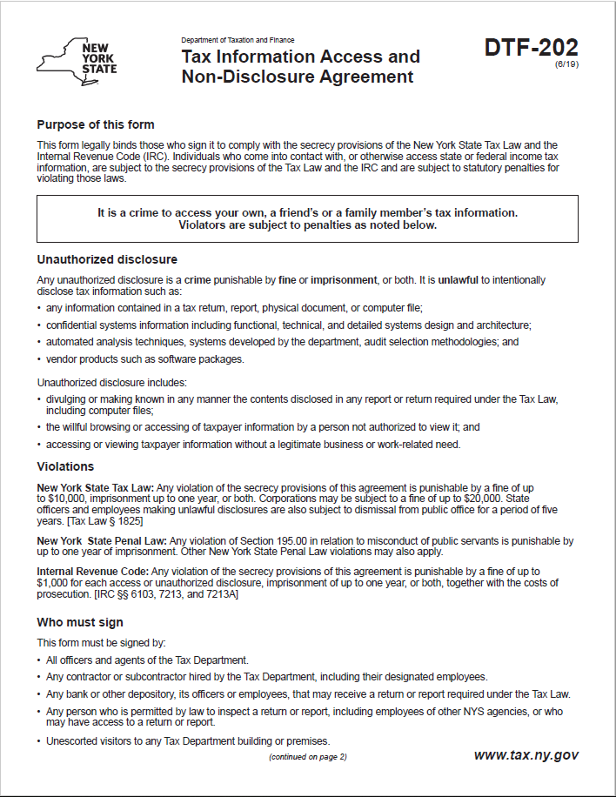
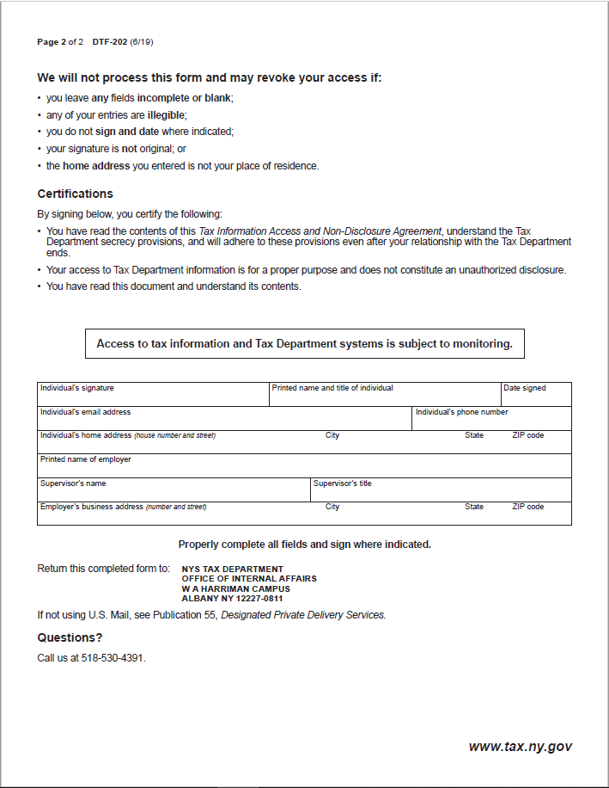

Exhibit B – New York State Office of the State Comptroller Substitute Form W-9
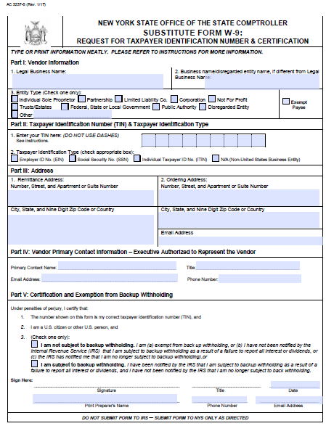
Note: This form is available at the NYS Office of State Comptroller website: https://www.osc.state.ny.us/vendors/forms/ac3237s_fe.pdf

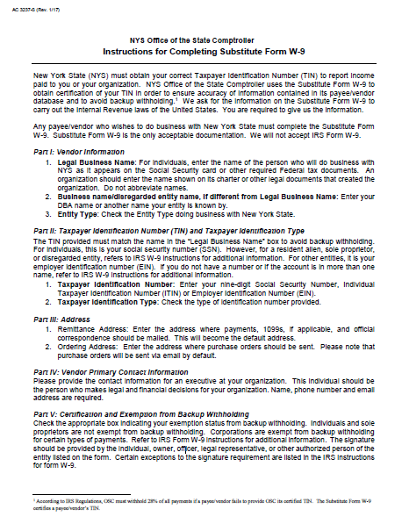

Exhibit C – Workforce Utilization Report

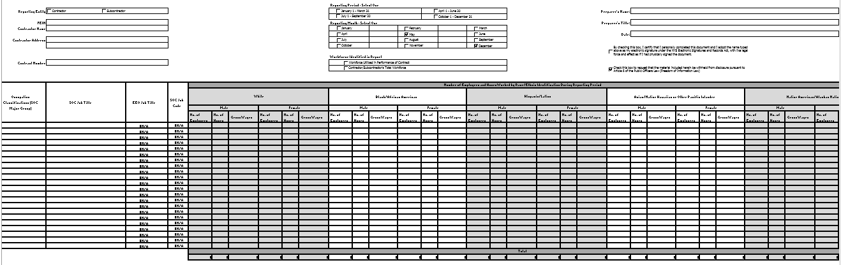
Note: An Excel file of this form will be provided to the Contractor after Contract execution.

Exhibit D – Vendor Responsibility Response Form

Bidder’s Name:

Bidders must complete a Vendor Responsibility Questionnaire. Bidders are invited to file the required Vendor Responsibility Questionnaire online via the OSC New York State VendRep System or may choose to complete and submit a paper questionnaire. To enroll in and use the New York State VendRep System, see the VendRep System instructions available at www.osc.state.ny.us/vendrep. For direct VendRep System user assistance, the OSC Help Desk may be reached at 866-370-4672 or 518-408-4672 or by e-mail at ciohelpdesk@osc.state.ny.us. Bidders opting to file a paper questionnaire can obtain the appropriate questionnaire from the VendRep website at www.osc.state.ny.us/vendrep or may contact one of the Department’s designated contacts.

Please check one of the following:

A Vendor Responsibility Questionnaire has been filed online and has been certified/updated within the last six months.

A Vendor Responsibility Questionnaire is attached to this bid Proposal.

NOTE: If a Vendor Responsibility Questionnaire has been filed online and has not been certified within the last six months, the Bidder must either update/recertify the online questionnaire or submit a new paper Vendor Responsibility Questionnaire.

Exhibit E – Contractor Sales Tax Certification Forms
These forms are available at the NYS Department of Taxation and Finance website:
ST-220-TD: https://www.tax.ny.gov/pdf/current_forms/st/st220td_fill_in.pdf
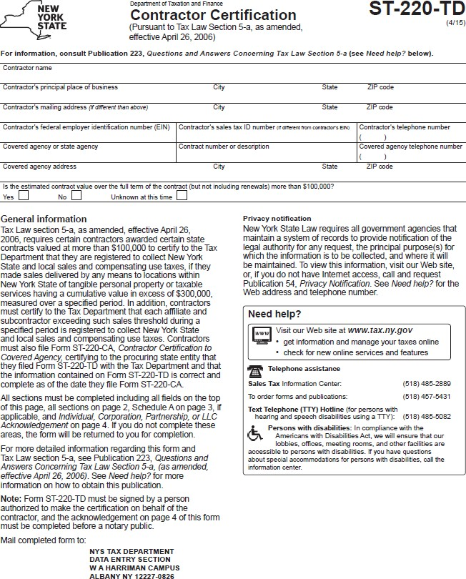
ST-220-CA: https://www.tax.ny.gov/pdf/current_forms/st/st220ca_fill_in.pdf

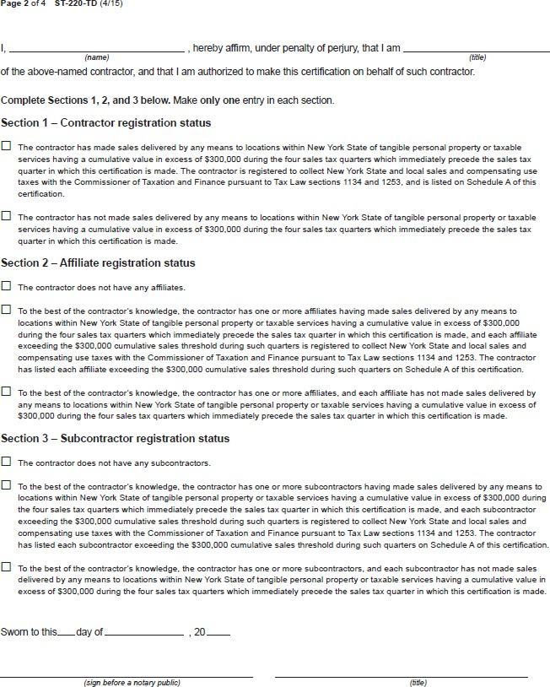

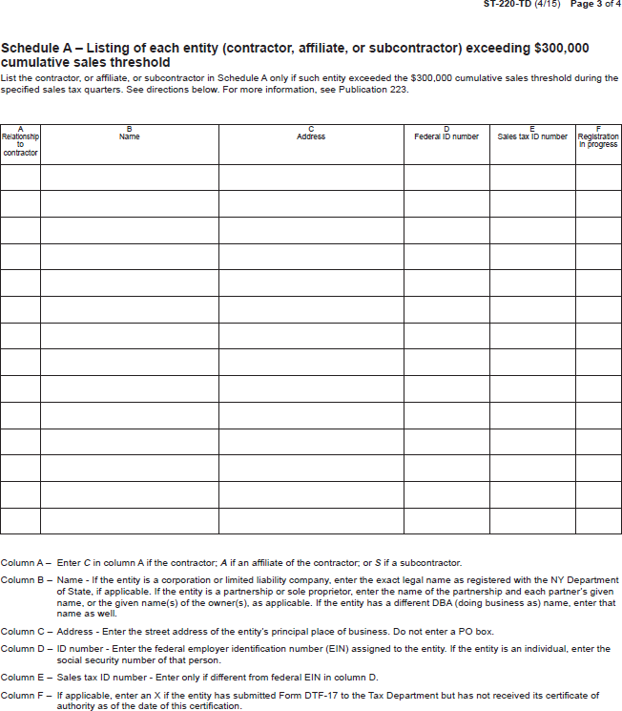

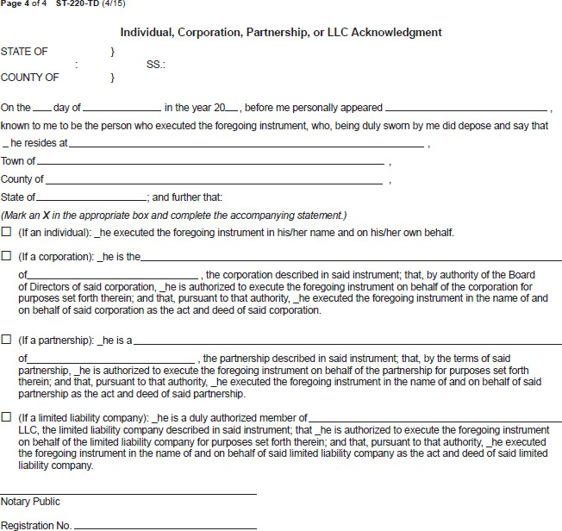

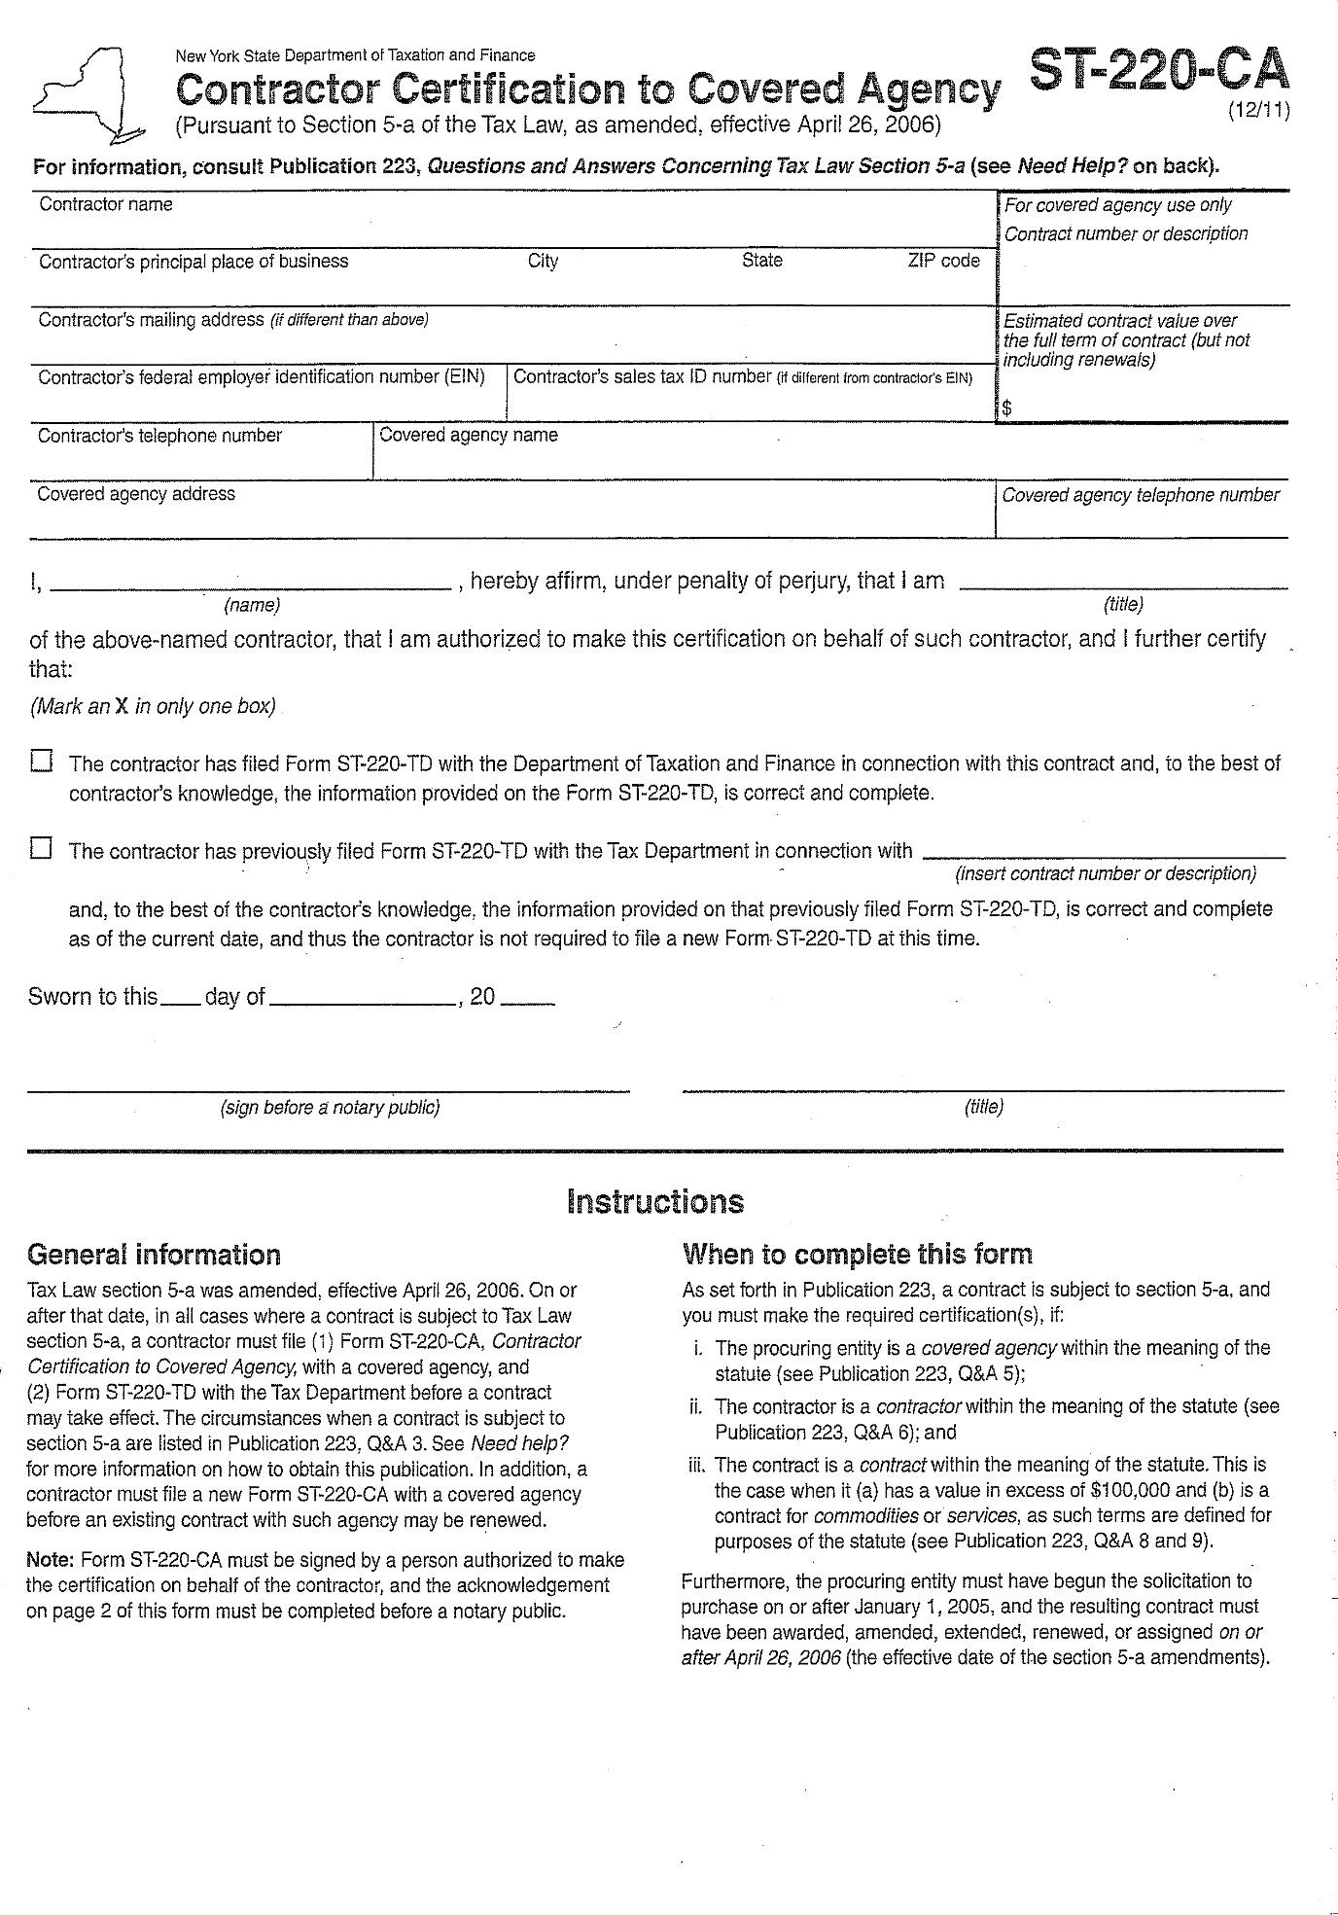

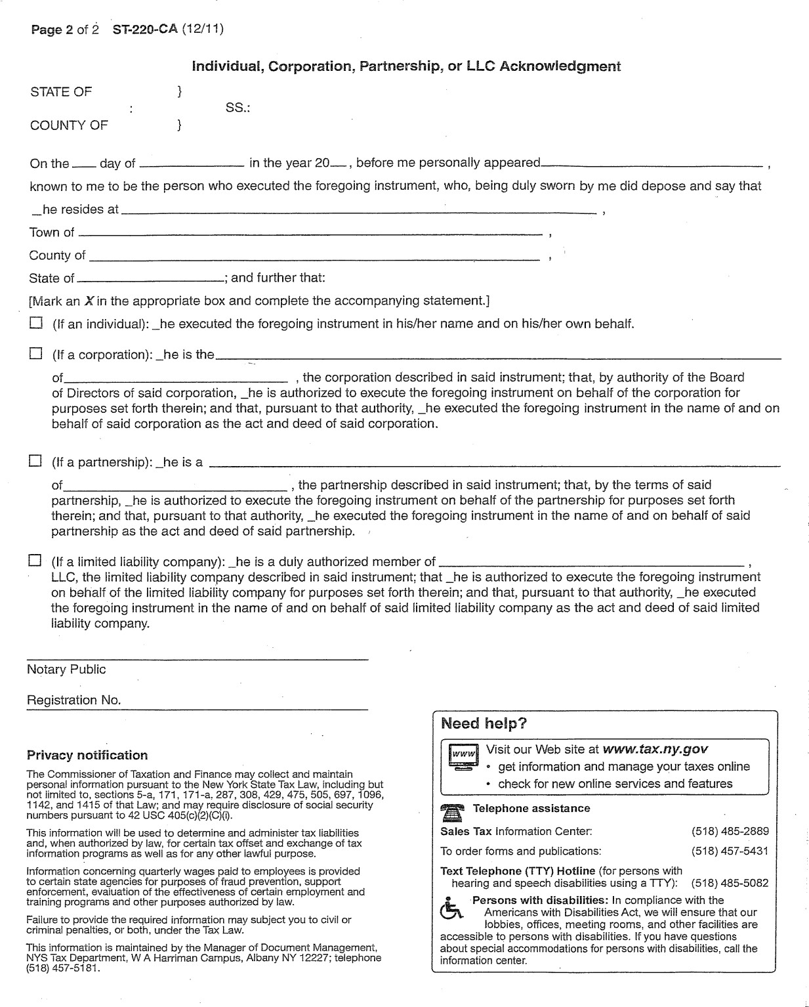

Exhibit 1 – NCOA Outgoing File Layout
Sending format: SHAD.COMMON.COPYLIB.SOURCE(TK0160FD)

*** THIS COPYBOOK IS THE NCOA EXTRACT FILE DESCRIPTION. IT ***
*** BE USED BY TK0160B2 AND TK0170B2. ***
***------------------------------------------------------------***

01 NCOA-REC.
** ========
***------------------------------------------------------------***
** 001 - 050
05 NCOA-FORMATTED-NAME PIC X(50).
***------------------------------------------------------------***
** 051 - 100
05 NCOA-OPTIONAL-ADDRESS
PIC X(50).
***------------------------------------------------------------***
** 101 - 150
05 NCOA-PRIMARY-ADDRESS
PIC X(50).
***------------------------------------------------------------***
** 151 - 178
05 NCOA-CITY PIC X(28).
***------------------------------------------------------------***
** 179 - 180
05 NCOA-STATE PIC X(2).
***------------------------------------------------------------***
** 181 - 185
05 NCOA-ZIP-CODE PIC X(5).
***------------------------------------------------------------***
*** CURRENTLY SPACE FILLED
** 186 - 193
05 NCOA-OPTIONAL-KEYCODE
PIC X(8).
***------------------------------------------------------------***
** 194 - 210
05 NCOA-CLIENT-DATA.
** ================
***------------------------------------------------------------***
** 194 - 207
10 NCOA-MASTER-ID PIC X(14).
***------------------------------------------------------------***
** 208 - 210
10 NCOA-ADR-NMBR PIC X(3).

Exhibit 2 – NCOA Incoming File Layout
NCOA RECORD LAYOUT
DTF – Comes from DTF
REQ – Required
NOT – Not Required

01 NCOA-REC.
** ========
***------------------------------------------------------------***
** 0001 - 0210 ORIGINAL INPUT RECORD
05 NCOA-ORIG-INFO.
** ==============
***------------------------------------------------------------***
** 0001 - 0050
DTF 10 NCOA-ORIG-FORMATTED-NAME
PIC X(50).
***------------------------------------------------------------***
** 0051 - 0100
DTF 10 NCOA-ORIG-OPT-ADR
PIC X(50).
***------------------------------------------------------------***
** 0101 - 0150
DTF 10 NCOA-ORIG-PRIM-ADR
PIC X(50).
***------------------------------------------------------------***
** 0151 - 0178
DTF 10 NCOA-ORIG-CTY PIC X(28).
***------------------------------------------------------------***
** 0179 - 0180
DTF 10 NCOA-ORIG-ST PIC X(2).
***------------------------------------------------------------***
** 0181 - 0185
10 NCOA-ORIG-ZIP-CD
PIC X(5).
***------------------------------------------------------------***
** 0186 - 0193
DTF 10 NCOA-ORIG-OPT-KEYCD
PIC X(8).
***------------------------------------------------------------***
** 0194 - 0210
DTF 10 NCOA-ORIG-CLIENT-DATA.
** =====================
***------------------------------------------------------------***
** 0194 - 0207
DTF 15 NCOA-ORIG-MASTER-ID
PIC X(14).
***------------------------------------------------------------***
** 0208 - 0210
DTF 15 NCOA-ORIG-ADR-NMBR
PIC X(3).
***------------------------------------------------------------***
** 0211 - 0240 APT #, SUITE #, ETC

REQ 05 STD-LINE-1 PIC X(30).
***------------------------------------------------------------***
** 0241 - 0270 MAIN ADDRESS

REQ 05 STD-LINE-2 PIC X(30).
***------------------------------------------------------------***
** 0271 - 0288 CITY ABBREVIATION

REQ 05 STD-CITY-ABBREV PIC X(18).
**
***------------------------------------------------------------***
** 0289 - 0290 STATE ABBREVIATION

REQ 05 STD-STATE PIC X(2).
***------------------------------------------------------------***
** 0291 - 0295 ZIP-5

REQ 05 STD-ZIP5 PIC X(5).
***------------------------------------------------------------***
** 0296 - 0299 ZIP-4

REQ 05 STD-ZIP4 PIC X(4).
***------------------------------------------------------------***
** 0300 - 0303 CARRIER ROUTE

REQ 05 STD-CARRIER-ROUTE PIC X(4).
***------------------------------------------------------------***
** 0304 - 0305 DELIVERY POINT BAR CODE

REQ 05 STD-DELIVERY-POINT PIC X(2).
***------------------------------------------------------------***
** 0306 - 0306 DELIVERY POINT BAR CODE CHECK DIGIT

REQ 05 STD-DELIVERY-CHKDGT PIC X(1).
***------------------------------------------------------------***
** 0307 - 0310 ELOT SEQUENCE NUMBER
- if no value, please send spaces

NOT 05 NCOA-ELOT-NMBR PIC X(4).
***------------------------------------------------------------***
** 0311 - 0311 ELOT SEQUENCE CODE
- if no value, please send spaces

NOT 05 NCOA-ELOT-CODE PIC X(1).

***------------------------------------------------------------***
*** INPUT STANDARDIZATION (CASS) INFORMATION ***
***------------------------------------------------------------***

** 0312 - 0312 DELIVERY POINT VALIDATION STATUS CODE

REQ 05 DPV-STATUS-CODE PIC X(1).

88 CONFIRMED-DELIVERY-PT VALUE 'Y'.
88 SEC-INVALID-PRIM-VALID VALUE 'S'.
88 SEC-MISSING-PRIM-VALID VALUE 'D'.
88 ADR-NOT-VALID-DP-CASS VALUE 'N'.

***------------------------------------------------------------***
** 0313 - 0314 DELIVERY POINT VALIDATION FOOTNOTE

REQ 05 DPV-FOOTNOTE PIC X(2).

88 ADDR-MATCH-DPV VALUE 'BB'.
88 PRIM-MATCH-DPV-NOT-SEC VALUE 'CC'.
88 MILITARY-ADR-DPV-ZIP VALUE 'F1'.
88 GEN-DELV-DPV-ZIP-CONF VALUE 'G1'.
88 PRIM-ADR-NMBR-MISSING VALUE 'M1'.
88 PRIM-ADR-NMBR-INVALID VALUE 'M3'.
88 PR-VAL-HIGHRISE-MISSNG VALUE 'N1'.
88 MISSING-BOX-NMBR VALUE 'P1'.
88 INVALID-BOX-NMBR VALUE 'P3'.
88 ADDR-MATCH-CMRA VALUE 'RR'.
88 ADDR-MATCH-CMRA-NO-PMB VALUE 'R1'.
88 DPV-CONF-UNIQUE-ZIP VALUE 'U1'.

** CMRA = COMMERCIAL MAIL RECEIVING AGENCY

***------------------------------------------------------------***
** 0315 - 0315 DELIVERY POINT VALIDATION CMRA
- if no value, please send spaces

NOT 05 DPV-CMRA PIC X(1).

88 CMRA-YES VALUE 'Y'.
88 CMRA-NO VALUE 'N'.

***------------------------------------------------------------***
** 0316 - 0317 LACS FOOTNOTE
- if no value, please send spaces

NOT 05 LACS-FOOTNOTE PIC X(2).

88 MATCHED-NEW-IN-STD VALUE 'A'.
88 MATCHED-SEC-NA-NR VALUE '09'.
88 MATCHED-UNRES-NR VALUE '14'.
88 MATCHED-SEC-DRP-IN-STD VALUE '92'.
88 LACS-ELIGBL-NO-MATCH VALUE '00'.

***------------------------------------------------------------***
** 0318 - 0318 STD DELIVERABILITY CODE
- if no value, please send spaces

NOT 05 STD-DELIV-CODE PIC X(1).

88 ZIP4-MATCHED-DLVRBL VALUE 'Y'.
88 UNSUITBLE-4-DLVRY VALUE 'N'.

***------------------------------------------------------------***
** 0319 - 0319 CASS ADDRESS TYPE
- if no value, please send spaces

NOT 05 CASS-ADR-TYP PIC X(1).

88 FIRM VALUE 'F'.
88 GENERAL-DELIVERY VALUE 'G'.
88 HI-RISE VALUE 'H'.
88 PO-BOX VALUE 'P'.
88 RURAL-ROUTE-OR-HWY VALUE 'R'.
88 STREET-LEVEL VALUE 'S'.
***------------------------------------------------------------***
** 0320 - 0320 CASS ZIP VERIFIED
- if no value, please send spaces

NOT 05 CASS-ZIP-VRFIED PIC X(1).

88 INPUT-ZIP-VALID VALUE 'Y'.
88 INPUT-ZIP-VALID-INVLD VALUE 'N'.

***------------------------------------------------------------***
** 0321 - 0321 CASS ZIP VERIFIED
- if no value, please send spaces

NOT 05 CASS-ZIP-VERIFIED PIC X(1).

88 INPUT-CZ-VERIFIED VALUE 'Y'.
88 INPUT-CZ-INVALID VALUE 'N'.
***------------------------------------------------------------***
** 0322 - 0322 CASS CITY VERIFIED
- if no value, please send spaces

NOT 05 CASS-CITY-VERIFIED PIC X(1).

88 CASS-CITY-VERIFIED-VALID VALUE 'Y'.
88 CASS-CITY-VERIFIED-INVLD VALUE 'N'.

***------------------------------------------------------------***
** 0323 - 0323 CASS CITY STANDARDIZED
- if no value, please send spaces

NOT 05 CASS-CITY-STDIZD PIC X(1).
88 CASS-CITY-INPUT-CHGD VALUE 'Y'.
88 CASS-CITY-INPUT-NO-CHG VALUE 'N'.

***------------------------------------------------------------***
** 0324 - 0324 CASS MULTI FAMILY DWELLING
- if no value, please send spaces

NOT 05 CASS-MULT-FAM-DWL PIC X(1).
88 HI-RISE-YES VALUE 'Y'.
88 HI-RISE-NO VALUE 'N'.

***------------------------------------------------------------***
** 0325 - 0325 CASS MULTI FAMILY DWELLING WITH SECONDARY
- if no value, please send spaces

NOT 05 CASS-MULT-FAM-DWL-W-SEC PIC X(1).

88 HI-RISE-W-SEC VALUE 'Y'.
88 HI-RISE-SEC-INVALID VALUE 'N'.

***------------------------------------------------------------***
** 0326 - 0326 CASS RR/HC ADDRESS
- if no value, please send spaces

NOT 05 CASS-RR-HV-ADR PIC X(1).

88 RR-OR-HC VALUE 'Y'.
88 NOT-RR-OR-HC VALUE 'N'.

***------------------------------------------------------------***
** 0327 - 0327 CASS RR/HC ADDRESS WITH BOX NUMBER
- if no value, please send spaces

NOT 05 CASS-RR-HV-ADR-W-BOX PIC X(1).

88 RR-OR-HC-W-BOX VALUE 'Y'.
88 RR-OR-HC-WO-BOX VALUE 'N'.

***------------------------------------------------------------***
** 0328 - 0328 ZIP + 4 DEFAULT FLAG
- if no value, please send spaces

NOT 05 CASS-RR-HV-ADR-W-BOX PIC X(1).

88 ZIP4-MATCH-DEFAULT VALUE 'Y'.
88 ZIP4-NOT-DEFAULT-CASS VALUE 'N'.

***------------------------------------------------------------***
** 0329 - 0334 ASSIGNED STATUS OR UNASSIGNED ERROR CODE
- if no value, please send spaces

NOT 05 ASSIGNED-ERROR-CODE PIC X(6).

** 88 STATUS-CODE VALUE 'Y'.
** 88 ERROR-CODE VALUE 'N'.

***------------------------------------------------------------***
** 0335 - 0362 RESERVED
REQ 05 FILLER PIC X(28).
***------------------------------------------------------------***
*** ***
*** NCOALINK NEW ADDRESS ***
*** ***
***------------------------------------------------------------***

** 0363 - 0392 NCOALINK LINE-1 ADDR

REQ 05 NCOALINK-LINE-1 PIC X(30).

***------------------------------------------------------------***

** 0393 - 0422 NCOALINK LINE-2 ADDR

REQ 05 NCOALINK-LINE-2 PIC X(30).

***------------------------------------------------------------***

** 0423 - 0440 NCOALINK NEW CITY

REQ 05 NCOALINK-NEW-CITY PIC X(18).

***------------------------------------------------------------***

** 0441 - 0442 NCOALINK NEW STATE

REQ 05 NCOALINK-NEW-STATE PIC X(2).

***------------------------------------------------------------***

** 0443 - 0447 NCOALINK NEW ZIP

REQ 05 NCOALINK-NEW-ZIP PIC X(5).

***------------------------------------------------------------***

** 0448 - 0451 NCOALINK NEW ZIP+4

REQ 05 NCOALINK-NEW-ZIP4 PIC X(4).

***------------------------------------------------------------***

** 0452 - 0455 NCOALINK NEW CARRIER ROUTE

REQ 05 NCOALINK-NEW-CARRIER-RTE PIC X(4).

***------------------------------------------------------------***

** 0456 - 0457 NCOALINK NEW DELIVERY POINT BAR CODE
- if no value, please send spaces

NOT 05 NCOALINK-NEW-DP-BARCODE PIC X(2).

***------------------------------------------------------------***

** 0458 - 0458 NCOALINK NEW DELIVERY POINT BAR CODE CHK DGT
- if no value, please send spaces
NOT 05 NCOALINK-NEW-DP-BC-CHKDGT PIC X(1).

***------------------------------------------------------------***

** 0459 - 0462 NCOALINK ELOT SEQUENCE NUMBER
- if no value, please send spaces

NOT 05 NCOALINK-ELOT-SEQ-NMBR PIC X(4).

***------------------------------------------------------------***

** 0463 - 0463 NCOALINK ELOT SEQUENCE CODE
- if no value, please send spaces

NOT 05 NCOALINK-ELOT-SEQ-CODE PIC X(1).

***------------------------------------------------------------***
** 0464 - 0464 NCOALINK RECORD TYPE

REQ 05 NCOALINK-REC-TYPE PIC X(1).
***------------------------------------------------------------***

** 0465 - 0476 RESERVED
REQ 05 FILLER PIC X(12).

***------------------------------------------------------------***
*** NCOALINK INFORMATION ***
***------------------------------------------------------------***

** 0477 - 0478 NCOALINK FOOTNOTE

REQ 05 NCOALINK-FOOTNOTE PIC X(2).

** MATCHED - NEW ADDRESS RETURNED
88 ALL-ELEMENT-MATCH VALUE 'A'.
88 NEW-RETD-COA-SEC-DROPPED VALUE '91'.
88 NEW-RETD-INP-SEC-DROPPED VALUE '92'.
** MATCHED - NO NEW ADDRESS RETURNED
88 MATCH-TO-FOREIGN-MOVE VALUE '01'.
88 MATCH-NO-FWD-ADDR VALUE '02'.
88 MATCH-PO-BOX-CLOSED VALUE '03'.
88 MATCH-TO-MULTIPLE-DP VALUE '05'.
88 MATCH-NEW-ADR-NO-CONVERT VALUE '14'.
88 MATCH-BUT-DPV-NO-CONFIRM VALUE '19'.

** 0477 - 0478 NCOALINK FOOTNOTE - continued

** NOT MATCHED - NO NEW ADDRESS RETURNED
88 NO-MATCH-NEW-ADR VALUE '00'.
88 MATCH-FAM-MOVE-NO-SEC VALUE '04'.
88 MATCH-MULT-MI-TEST-FAIL VALUE '06'.
88 MATCH-MULT-GENDER-TEST-FL VALUE '07'.
88 MATCH-MULT-ADR-ELE-FAIL VALUE '08'.
88 MATCH-FAM-HIRISE-SEC-MISS VALUE '09'.
88 MATCH-FAM-RRBOX-MISSING VALUE '10'.
88 MATCH-SURNAME-NOT-FRST VALUE '11'.
88 MATCH-SURNAME-NOT-MI VALUE '12'.
88 MATCH-SURNAME-NOT-GNDR VALUE '13'.
88 INDIV-NAME-NSF-FOR-MATCH VALUE '15'.
88 SEC-ADR-MISSING VALUE '16'.
88 INPUT-NAME-NSF-FOR-MATCH VALUE '17'.
88 FAM-MATCH-TO-GENRL-ADDR VALUE '18'.
88 MATCH-MULT-CONFLCT-ADRS VALUE '20'.
88 NEW-ADR-PEND-DELETION VALUE '66'.

***------------------------------------------------------------***

** 0479 - 0484 NCOALINK MOVE EFFECTIVE DATE
REQ 05 NCOALINK-EFFCTV-DATE PIC X(6).

***------------------------------------------------------------***

** 0485 - 0485 NCOALINK DELIVERABILITY CODE
REQ 05 NCOALINK-DELIV-CODE PIC X(1).

88 DELIVERABLE VALUE 'Y'.
88 UNSUITABLE-FOR-DELIVERY VALUE 'N'.
***------------------------------------------------------------***

** 0486 - 0486 NCOALINK MOVE TYPE
- if no value, please send spaces

NOT 05 NCOALINK-MOVE-TYPE PIC X(1).

88 INDIVIDUAL-MOVE VALUE 'I'.
88 FAMILY-MOVE VALUE 'F'.
88 BUSINESS-MOVE VALUE 'B'.

***------------------------------------------------------------***
** 0487 - 0487 NCOALINK FOREIGN MOVE FLAG
- if no value, please send spaces

NOT 05 NCOALINK-FOREIGN-MOVE PIC X(1).

88 FOREIGN VALUE 'F'.
88 DOMESTIC VALUE ' '.

***------------------------------------------------------------***
** 0488 - 0488 ZIP+4 DEFAULT FLAG
- if no value, please send spaces

NOT 05 ZIP4-DEFAULT-FLAG PIC X(1).
88 MATCH-ZIP4-DEFAULT VALUE 'Y'.
88 ZIP4-NOT-DEFAULT VALUE ' '.

***------------------------------------------------------------***
** 0489 - 0489 DPV STATUS CODE
REQ 05 DPV-STATUS-CODE PIC X(1).

88 CONF-DP-PRI-SEC-BOTH-VALID VALUE 'Y'.
88 SEC-INVALID-PRI-VALID VALUE 'S'.
88 SEC-MISSING-PRI-VALID VALUE 'D'.
88 ADR-NOT-VALID-DP VALUE 'N'.
88 ADR-IS-FALSE-POSITIVE VALUE 'L'.

***------------------------------------------------------------***
** 0490 - 0491 DPV FOOTNOTE
REQ 05 DPV-FOOTNOTE-N PIC X(2).

88 ADDR-MATCH-DPV-N VALUE 'BB'.
88 PRIM-MATCH-DPV-NOT-SEC-N VALUE 'CC'.
88 MILITARY-ADR-DPV-ZIP-N VALUE 'F1'.
88 GEN-DELV-DPV-ZIP-CONF-N VALUE 'G1'.
88 PRIM-ADR-NMBR-MISSING-N VALUE 'M1'.
88 PRIM-ADR-NMBR-INVALID-N VALUE 'M3'.
88 PR-VAL-HIGHRISE-MISSNG-N VALUE 'N1'.
88 MISSING-BOX-NMBR-N VALUE 'P1'.
88 INVALID-BOX-NMBR-N VALUE 'P3'.
88 ADDR-MATCH-CMRA-N VALUE 'RR'.
88 ADDR-MATCH-CMRA-NO-PMB-N VALUE 'R1'.
88 DPV-CONF-UNIQUE-ZIP-N VALUE 'U1'.

***------------------------------------------------------------**
** 0492 - 0492 DELIVERY POINT VALIDATION CMRA
- if no value, please send spaces

NOT 05 DPV-CMRA-NLINK PIC X(1).

88 CMRA-YES-DPV VALUE 'Y'.
88 CMRA-NO-DPV VALUE 'N'.

***------------------------------------------------------------**
** 0493 - 0514 RESERVED
REQ 05 FILLER PIC X(22).
***------------------------------------------------------------***

Attachment 1 – Bidder’s Checklist
Bids should be submitted with the following Attachments (See Note below) in the manner presented in Section 8. Bid Submission.
Do not include any additional information or Attachments that attempt to change and/or conflict with the Terms and Conditions of this IFB. Including any such additional information or attachments may result in the Bid being determined non-responsive and disqualified.

Tab 1: Administrative Requirement Response Forms
 | Cover Letter as specified in Section 9.2.9 including:
 |  | Complete name and address of the bidding entity;
 |  | Federal or Taxpayer Identification Number of the entity;
 |  | Ten-digit Vendor File ID number (if available);
 |  | Affirmation that the Proposal is firm and binding for at least 150 days; and
 |  | Signed by an official authorized to bind the Bidder to its provisions
 | Any Bidder-Proposed Changes to Preliminary Base Contract Terms, if applicable
 | Request for Exemption from Disclosure, if applicable
 | Attachment 1 | - | Bidder’s Checklist showing all items are provided
 | Attachment 3 | - | Minority and Women-Owned Business Enterprises - Equal Employment Opportunity Policy Statement
 | Attachment 4 | - | Staffing Plan
 | Attachment 5 | - | Designation of Prime Contact Response Form
 | Attachment 6 | - | Non-Collusive Bidding Certification
 | Attachment 7 | - | Offerer Disclosure of Prior Non-Responsibility Determinations
 | Attachment 8 | - | Offerer Certification of Compliance with State Finance Law 139-k(5)
 | Attachment 9 | - | Public Officers Law Form
 | Attachment 10 | - | Public Officers Law – Post Employment Restrictions
 | Attachment 11 | - | Encouraging Use of New York State Businesses in Contract Performance
 | Attachment 12 | - | Vendor Assurance of No Conflict of Interest or Detrimental Effect
 | Attachment 13 | - | EO-177 Certification
 | Attachment 14 | - | Sexual Harassment Prevention Certification
 | Attachment 15 | - | EO-16 Certification
 | Exhibit D | - | Vendor Responsibility Response Form
Tab 2: Qualifying Requirements and Mandatory Service Requirements Response Forms
 | Attachment A | - | Qualifying Requirements Response Form
 | Attachment B | - | Bidder Attestation Response Form
 | Attachment C | - | Mandatory Service Requirements Response Form
Tab 3: Financial Response Form
 | Attachment D | - | Financial Response Form

Attachment 2 – Offerer Understanding of, and Compliance with, Procurement Lobbying Guidelines
New York State Finance Law 139-j(6)(b) requires the DTF seek written affirmation from all Offerers as to the Offerer’s understanding of, and agreement to comply, with the DTF procedures relating to permissible contacts during a Government Procurement pursuant to subdivision three of this section.

Procurement Description, Contract or Bid Number:
IFB 22-201 NATIONAL CHANGE OF ADDRESS (NCOA) AND NIXIE MAIL PROCESSING SERVICES
Offerer Name
Offerer Address:
Telephone Number:
Email Address:

Offerer affirms it has read, understands and agrees to comply with the Guidelines of the New York State Department of Taxation and Finance relative to permissible contacts as required by the State Finance Law 139-j(3) and 139-j(6)(b).

By (signature):
Name (please print):
Title (please print):
Date:

Attachment 3 – Minority and Women-Owned Business Enterprises – Equal Employment Opportunity Policy Statement
I, _________________________, the (awardee/contractor) ____________________ agree to adopt the following policies with respect to the project being developed or services rendered at
____________________________________________________________________________
M/WBE

EEO

This organization will and will cause its contractors and subcontractors to take good faith actions to achieve the M/WBE contract participations goals set by the State for that area in which the State-funded project is located, by taking the following steps:

- Actively and affirmatively solicit bids for contracts and subcontracts from qualified State certified MBEs or WBEs, including solicitations to M/WBE contractor associations.

- Request a list of State-certified M/WBEs from AGENCY and solicit bids from them directly.

- Ensure that plans, specifications, request for proposals and other documents used to secure bids will be made available in sufficient time for review by prospective M/WBEs.

- Where feasible, divide the work into smaller portions to enhanced participations by M/WBEs and encourage the formation of joint venture and other partnerships among M/WBE contractors to enhance their participation.

- Document and maintain records of bid solicitation, including those to M/WBEs and the results thereof. Contractor will also maintain records of actions that its subcontractors have taken toward meeting M/WBE contract participation goals.

- Ensure that progress payments to M/WBEs are made on a timely basis so that undue financial hardship is avoided, and that bonding and other credit requirements are waived or appropriate alternatives developed to encourage M/WBE participation.

a. This organization will not discriminate against any employee or applicant for employment because of race, creed, color, national origin, sex, age, disability or marital status, will undertake or continue existing programs of affirmative action to ensure that minority group members are afforded equal employment opportunities without discrimination, and shall make and document its conscientious and active efforts to employ and utilize minority group members and women in its work force on state contracts.

b. This organization shall state in all solicitation or advertisements for employees that in the performance of the State contract all qualified applicants will be afforded equal employment opportunities without discrimination because of race, creed, color, national origin, sex disability or marital status.

c. At the request of the contracting agency, this organization shall request each employment agency, labor union, or authorized representative will not discriminate on the basis of race, creed, color, national origin, sex, age, disability or marital status and that such union or representative will affirmatively cooperate in the implementation of this organizations’ obligations herein.

d. Contractor shall comply with the provisions of the Human Rights Law, all other State and Federal statutory and constitutional non-discrimination provisions. Contractor and subcontractors shall not discriminate against any employee or applicant for employment because of race, creed (religion), color, sex, national origin, sexual orientation, marital status or domestic violence victim status, and shall also follow the requirements of the Human Rights Law with regard to non-discrimination on the basis of prior criminal conviction and prior arrest.

- This organization will include the provisions of sections (a) through (d) of this agreement in every subcontract in such a manner that the requirements of the subdivisions will be binding upon each subcontractor as to work in connection with the State. contract.

Agreed to this _____ day of ___________________, 20____
By (signature) _______________________________________
Print: __________________________________ Title:__________________________________

_________________________________is designated as the Minority Business Enterprise Liaison (Name of Designated Liaison)
responsible for administering the Minority and Women-Owned Business Enterprises- Equal
Employment Opportunity (M/WBE-EEO) program.

M/WBE Contract Goals

________% Minority and Women’s Business Enterprise Participation

________% Minority Business Enterprise Participation

________% Women’s Business Enterprise Participation

____________________________________________
(Authorized Representative)

Title: ________________________________________

Date: ________________________________________

Attachment 4 – Staffing Plan
Instructions on Page 2 of this form

Solicitation No.: | Reporting Entity: | Report includes Contractor’s/Subcontractor’s:  ☐ Work force to be utilized on this contract  ☐ Total work force
Offerer’s Name: |  | ☐ Offerer  ☐ Subcontractor
Offerer’s Address: |  |  | Subcontractor’s name
Enter the total number of employees for each classification in each of the EEO-Job Categories identified
EEO-Job Category | Total Work force | Work force by Gender |  |  | Work force by  Race/Ethnic Identification
 |  | Total  Male  (M) | Total  Female  (F) |  | White |  | Black |  | Hispanic |  | Asian |  | Native American |  | Disabled |  |  | Veteran
 |  |  |  |  | (M) | (F) | (M) | (F) | (M) | (F) | (M) | (F) | (M) | (F) | (M) |  | (F) | (M) | (F)
Officials/ Administrators
Professionals
Technicians
Sales Workers
Office/Clerical
Craft Workers
Laborers
Service Workers
Temporary /Apprentices
Totals

PREPARED BY (Signature): | TELEPHONE NO.:  EMAIL ADDRESS: |  | DATE:
NAME AND TITLE OF PREPARER (Print or Type): |  | Submit completed with bid or proposal M/WBE 101 (Rev 11/08)

General Instructions: All Offerers and each subcontractor identified in the bid or proposal must complete an EEO Staffing Plan (M/WBE 101) and submit it as part of the bid or proposal package. Where the work force to be utilized in the performance of the State contract can be separated out from the contractor’s and/or subcontractor’s total work force, the Offerer shall complete this form only for the anticipated work force to be utilized on the State contract. Where the work force to be utilized in the performance of the State contract cannot be separated out from the contractor’s and/or subcontractor’s total work force, the Offerer shall complete this form for the contractor’s and/or subcontractor’s total work force.
Instructions for completing:
- Enter the Solicitation number that this report applies to along with the name and address of the Offerer.
- Check off the appropriate box to indicate if the Offerer completing the report is the contractor or a subcontractor.
- Check off the appropriate box to indicate work force to be utilized on the contract or the Offerers’ total work force.
- Enter the total work force by EEO job category.
- Break down the anticipated total work force by gender and enter under the heading ‘Work force by Gender’
- Break down the anticipated total work force by race/ethnic identification and enter under the heading ‘Work force by Race/Ethnic Identification’. Contact the OM/WBE Permissible contact(s) for the solicitation if you have any questions.
- Enter information on disabled or veterans included in the anticipated work force under the appropriate headings.
- Enter the name, title, phone number and email address for the person completing the form. Sign and date the form in the designated boxes.
RACE/ETHNIC IDENTIFICATION
Race/ethnic designations as used by the Equal Employment Opportunity Commission do not denote scientific definitions of anthropological origins. For the purposes of this form, an employee may be included in the group to which he or she appears to belong, identifies with, or is regarded in the community as belonging. However, no person should be counted in more than one race/ethnic group. The race/ethnic categories for this survey are:

 |  | WHITE | (Not of Hispanic origin) All persons having origins in any of the original peoples of Europe, North Africa, or the Middle East.
 |  | BLACK | a person, not of Hispanic origin, who has origins in any of the black racial groups of the original peoples of Africa.
 |  | HISPANIC | a person of Mexican, Puerto Rican, Cuban, Central or South American or other Spanish culture or origin, regardless of race.
ASIAN & PACIFIC ISLANDER |  |  | a person having origins in any of the original peoples of the Far East, Southeast Asia, the Indian subcontinent or the Pacific Islands.
NATIVE INDIAN (NATIVE AMERICAN/ ALASKAN NATIVE) |  |  | a person having origins in any of the original peoples of North America, and who maintains cultural identification through tribal affiliation or community recognition.
OTHER CATEGORIES
 |  | DISABLED INDIVIDUAL | any person who: | - has a physical or mental impairment that substantially limits one or more major life activity(ies)
 |  |  |  | - has a record of such an impairment; or
 |  |  |  | - is regarded as having such an impairment.
 |  | VIETNAM ERA VETERAN | a veteran who served at any time between and including January 1, 1963 and May 7, 1975.
 |  | GENDER | Male or Female
 |  |  | M/WBE 101 (Rev 11/08)

Attachment 5 – Designation of Prime Contact Response Form
The Bidder designates the following individual as the prime contact for this Proposal and acknowledges that this individual is authorized to respond on behalf of the Bidder. This designation will last for the entire evaluation process and contract negotiations. Any request for change in the designated contact must be submitted in writing to the issuing officer designated in this IFB and must be accompanied by an updated form.

Bidder Name
Address:
Prime Contact Name:
Title:
Email Address:
Phone Number:
Fax:
Authorized Signature:
Printed Name:
Title:
Date:

Attachment 6 – Non-Collusive Bidding Certification
In accordance with Section 139-d of the State Finance Law:
- By submission of this bid, the Bidder and each person signing on behalf of the Bidder certifies, and in the case of a joint bid, each party thereto certifies as to its own organization, under penalty of perjury, that to the best of their knowledge and belief:
- The prices in this bid have been arrived at independently, without collusion, consultation, communication, or agreement, for the purpose of restricting competition, as to any matter relating to such prices with any other Bidder or with any competitor;
- Unless otherwise required by law, the prices which have been quoted in this bid have not been knowingly disclosed by the Bidder and will not knowingly be disclosed by the Bidder prior to opening, directly or indirectly, to any other Bidder or to any competitor; and
- No attempt has been made or will be made by the Bidder to induce any other person, partnership or corporation to submit or not to submit a bid for the purpose of restricting competition.
- A bid shall not be considered for award nor shall any award be made where (a), (1), (2), and (3) above have not been complied with; provided however, that if in any case the Bidder cannot make the foregoing certification, the Bidder shall so state and shall furnish with the bid a signed statement which sets forth in detail the reasons therefor. Where (a), (1), (2), and (3) above have not been complied with, the bid shall not be considered for award nor shall any award be made unless the head of the purchasing unit of the state, public department or agency to which the bid was made, or his/her designee, determines that such disclosure was not made for the purpose of restricting competition.

The fact that a Bidder has published price lists, rates, or tariffs covering items or services being procured, has informed prospective customers of proposed or pending publication of new or revised price lists for such items, or has sold the same items to other customers at the same prices being bid, does not constitute a disclosure within the meaning stated above.

The Bidder certifies adherence to all conditions in the Non-Collusive Bidding Practices subsection of this IFB.

Bidder Name
Bidder Address:
Authorized Signature:
Name:
Title:

Attachment 7 – Offerer Disclosure of Prior Non-Responsibility Determinations

New York State Finance Law §139-k(2) obligates a Governmental Entity to obtain specific information regarding prior non-responsibility determinations with respect to State Finance Law §139-j. This information must be collected in addition to the information that is separately obtained pursuant to State Finance Law §163(9). In accordance with State Finance Law §139-k, an Offerer must be asked to disclose whether there has been a finding of non-responsibility made within the previous four (4) years by any Governmental Entity due to: (a) a violation of State Finance Law §139-j or (b) the intentional provision of false or incomplete information to a Governmental Entity. The terms “Offerer” and “Governmental Entity” are defined in State Finance Law § 139-k(1). State Finance Law §139-j sets forth detailed requirements about the restrictions on contacts during the procurement process. A violation of State Finance Law §139-j includes, but is not limited to, an impermissible contact during the restricted period (for example, contacting a person or entity other than the designated contact person, when such contact does not fall within one of the exemptions).
As part of its responsibility determination, State Finance Law §139-k(3) mandates consideration of whether an Offerer fails to timely disclose accurate or complete information regarding the above non-responsibility determination. In accordance with State Finance Law, no Procurement Contract shall be awarded to any Offerer that fails to timely disclose accurate or complete information under this section, unless a finding is made that the award of the Procurement Contract to the Offerer is necessary to protect public property or public health safety, and that the Offerer is the only source capable of supplying the required article of procurement within the necessary timeframe. See State Finance Law §§139-j (10)(b) and 139-k(3).

A Governmental Entity must include a disclosure request regarding prior non-responsibility determinations in accordance with State Finance Law §139-k in its solicitation of Proposals or bid documents or specifications or contract documents, as applicable, for procurement contracts. The attached form is to be completed and submitted by the individual or entity seeking to enter into a Procurement Contract. It shall be submitted to the Governmental Entity conducting the Governmental Procurement.
Procurement Description, Contract or Bid Number:
IFB 22-201 NATIONAL CHANGE OF ADDRESS (NCOA) AND NIXIE MAIL PROCESSING SERVICES
Offerer Name
Offerer Address:
Phone Number:
Email Address:
Name and Title of Person Submitting This Form:
- Has any New York State agency or authority made a finding of non-responsibility regarding the Offerer in the last four (4) years? (Please circle):
No Yes
If “Yes” please answer the following questions:
- Was the basis for the finding of the Offerer’s non-responsibility due to a violation of State Finance Law 139-j? (Please circle):
No Yes
- Was the basis for the finding of the Offerer’s non-responsibility due to the intentional provision of false or incomplete information to a Governmental Entity? (Please circle):
No Yes
- If you responded “Yes” to Questions 1, 2 or 3, please provide details regarding the finding of non-responsibility below:
Government Entity:
Date of Finding of Non-responsibility :
Facts Underlying Finding of Non-Responsibility (Add additional pages as necessary):

- Has any New York State agency or authority terminated a procurement contract with the Offerer due to the intentional provision of false or incomplete information? (Please circle):
No Yes
If “Yes” to Question 5, please provide details below:
Government Entity:
Date of Termination or Withholding of Contract :
Basis of Termination or Withholding of Contract:

Offerer certifies that all information provided to the DTF with respect to State Finance Law 139-k is complete, true and accurate.
Authorized Signature:
Name:
Date:

Attachment 8 – Offerer Certification of Compliance with State Finance Law 139-k(5)
New York State Finance Law 139-k(5) requires that every Procurement Contract Award subject to the provisions of State Finance Law 139-k or 139-j shall contain a certification by the Offerer that all information provided to the procuring Government Entity with respect to State Finance Law 139-k is complete, true and accurate.

Offerer Certification
I certify that all information provided to the DTF with respect to State Finance Law 139-k is complete, true and accurate.

Offerer’s Signature:
Date:

Procurement Description, Contract or Bid Number:
IFB 22-201 NATIONAL CHANGE OF ADDRESS (NCOA) AND NIXIE MAIL PROCESSING SERVICES
Name:
Title:
Offerer Name:
Offerer Address:
Email Address:
Phone Number:

Attachment 9 – Public Officers Law Form
Disclosure of business or professional activities by state officers and employees and party officers.

§ 73. Business or professional activities by state officers and employees and party officers.

4. (a) No statewide elected official, state officer or employee, member of the legislature, legislative employee or political party chairman or firm or association of which such person is a member, or corporation, ten per centum or more of the stock of which is owned or controlled directly or indirectly by such person, shall (i) sell any goods or services having a value in excess of twenty-five dollars to any state agency, or (ii) contract for or provide such goods or services with or to any private entity where the power to contract, appoint or retain on behalf of such private entity is exercised, directly or indirectly, by a state agency or officer thereof, unless such goods or services are provided pursuant to an award or contract let after public notice and competitive bidding. This paragraph shall not apply to the publication of resolutions, advertisements or other legal propositions or notices in newspapers designated pursuant to law for such purpose and for which the rates are fixed pursuant to law.

- Is the Bidder a New York State officer, employee, or party officer?
YES ☐ NO ☐

- Are any of the members of Bidder’s firm or corporation, who own or control ten per centum or more of stock, a New York State officer, employee, or party officer?
YES ☐ NO ☐

- Is the proposed subcontractor (if applicable) a New York State officer, employee, or party officer?
YES ☐ NO ☐

Bidder affirms it has read, understands and agrees to comply with the Guidelines of Public Officers Law § 73 (4)(a).

By (signature):
Name:
Title:
Date:

Attachment 10 – Public Officers Law – Post Employment Restrictions
By signing below and submitting a Proposal to this IFB, the signatory certifies, for and on behalf of the Bidder, that:
- He/she has read and understands the provisions applicable to post employment restrictions affecting former State officers and employees, available using the link* below:
- Public Officers Law § 73(8)(a)(i), (the two-year bar); and
- Public Officers Law § 73(8)(a)(ii), (the life-time bar);
- Submission of this Proposal does not violate either provision;
- He/she is familiar with or has made diligent inquiry of, the Bidder's relevant employees, and agents;
- No violation shall occur by entering into a contract or in performance of the contractual services;
- This certification is material to the Proposal; and
- He/she understands that the Department intends to rely on this certification.
The Bidder shall fully disclose to the Department, within its Proposal and on a continuing basis, any circumstances that affect this certification or the Bidder’s ability to comply with the cited laws. Bidders shall address any questions concerning §73(8) of the Public Officers Law to:
New York State
Commission on Ethics and Lobbying in Government
540 Broadway
Albany, NY 12207
Telephone #: (518) 408-3976
By (signature):
Name:
Title:
Date:
*Click on this link: Public Officers Law, Article 4. When the page opens, click on “Laws of New York”. On the next page, select “PBO Public Officers”. When this page opens, select “Article 4 – (60 - 79) POWERS AND DUTIES OF PUBLIC OFFICERS” and see Sections 73 (8-a)(i) and 73 (8-a)(ii).

Attachment 11 – Encouraging Use of New York State Businesses in Contract Performance
New York State businesses have a substantial presence in State contracts and strongly contribute to the economies of the State and nation. In recognition of their economic activity and leadership in doing business in New York State, Bidders for the Contract for commodities, services or technology are strongly encouraged and expected to consider New York State businesses in the fulfillment of the requirements of the Contract. Such partnering may be as subcontractors, suppliers, protégés or other supporting roles.
Bidders need to be aware that all authorized users of the Contract will be strongly encouraged to the maximum extent practical and consistent with legal requirements, to use responsible and responsive New York State businesses in purchasing commodities that are of equal quality and functionality and in utilizing services and technology. Furthermore, Bidders are reminded that they must continue to utilize small, minority and women-owned businesses, consistent with current State law.
Utilizing New York State businesses in State contracts will help create more private sector jobs, rebuild New York’s infrastructure, and maximize economic activity to the mutual benefit of the contractor and its New York State business partners. New York State businesses will promote the contractor’s optimal performance under the Contract, thereby fully benefitting the public-sector programs that are supported by associated procurements.
Public procurements can drive and improve the State’s economic engine through promotion of the use of New York businesses by its contractors. The State therefore expects Bidders to provide maximum assistance to New York businesses in their use of the Contract. The potential participation by all kinds of New York businesses will deliver great value to the State and its taxpayers.
Bidders can demonstrate their commitment to the use of New York State businesses by responding to the question below:
Will New York State Businesses be used in the performance of the Contract resulting from this IFB?
Yes No
If yes, please identify the New York State businesses that will be used and attach identifying information
By (signature):
Name:
Title:
Date:

Attachment 12 – Vendor Assurance of No Conflict of Interest or Detrimental Effect
The Bidder offering to provide services pursuant to this IFB attests that its performance of the services outlined does not and will not create a conflict of interest with, nor position the Bidder to breach, any other contract currently in force with the State of New York.
Furthermore, the Bidder attests that it will not act in any manner that is detrimental to any State project on which the Bidder is rendering services. Specifically, the Bidder attests that:
- The fulfillment of obligations by the Bidder, as proposed in the response, does not violate any existing contract or agreement between the Bidder and the State;
- The fulfillment of obligations by the Bidder, as proposed in the response, does not and will not create any conflict of interest, or perception thereof, with any current role or responsibility that the Bidder has with regard to any existing contract or agreement between the Bidder and the State;
- The fulfillment of obligations by the Bidder, as proposed in the response, does not and will not compromise the Bidder’s ability to carry out its obligations under any existing contract between the Bidder and the State;
- The fulfillment of any other contractual obligations that the Bidder has with the State will not affect or influence its ability to perform under any contract with the State resulting from this solicitation;
- During the negotiation and execution of any contract resulting from this solicitation, the Bidder will not knowingly take any action or make any decision which creates a potential for conflict of interest or might cause a detrimental impact to the State as a whole including, but not limited to, any action or decision to divert resources from one State project to another;
- In fulfilling obligations under each of its State contracts, including any contract which results from this solicitation, the Bidder will act in accordance with the terms of each of its State contracts and will not knowingly take any action or make any decision which might cause a detrimental impact to the State as a whole including, but not limited to, any action or decision to divert resources from one State project to another;
- No former officer or employee of the State who is now employed by the Bidder, nor any former officer or employee of the Bidder who is now employed by the State, has played a role with regard to the administration of this contract procurement in a manner that may violate section 73(8)(a) of the State Ethics Law; and
- The Bidder has not and shall not offer to any employee, member or director of the State any gift, whether in the form of money, service, loan, travel, entertainment, hospitality, thing or promise, or in any other form, under circumstances in which it could reasonably be inferred that the gift was intended to influence said employee, member or director, or could reasonably be expected to influence said employee, member or director, in the performance of the
official duty of said employee, member or director or was intended as a reward for any official action on the part of said employee, member or director.
The Bidder should note that the State recognizes that conflicts may occur in the future because a Bidder may have existing or new relationships. The State will review the nature of any such new relationship and reserves the right to terminate the contract for cause if, in its judgment, a real or potential conflict of interest cannot be cured.
By (Signature): |  |  |  | Name:
 | Date: |  | Title:
This form must be signed by an authorized executive or legal representative.

Attachment 13 – EO 177 Certification
The New York State Human Rights Law, Article 15 of the Executive Law, prohibits discrimination and harassment based on age, race, creed, color, national origin, sex, pregnancy or pregnancy-related conditions, sexual orientation, gender identity, disability, marital status, familial status, domestic violence victim status, prior arrest or conviction record, military status or predisposing genetic characteristics.

The Human Rights Law may also require reasonable accommodation for persons with disabilities and pregnancy-related conditions. A reasonable accommodation is an adjustment to a job or work environment that enables a person with a disability to perform the essential functions of a job in a reasonable manner. The Human Rights Law may also require reasonable accommodation in employment on the basis of Sabbath observance or religious practices.
Generally, the Human Rights Law applies to:
- all employers of four or more people, employment agencies, labor organizations and apprenticeship training programs in all instances of discrimination or harassment;
- employers with fewer than four employees in all cases involving sexual harassment; and,
- any employer of domestic workers in cases involving sexual harassment or harassment based on gender, race, religion or national origin.

In accordance with Executive Order No. 177, the Bidder hereby certifies that it does not have institutional policies or practices that fail to address the harassment and discrimination of individuals on the basis of their age, race, creed, color, national origin, sex, sexual orientation, gender identity, disability, marital status, military status, or other protected status under the Human Rights Law.

Executive Order No. 177 and this certification do not affect institutional policies or practices that are protected by existing law, including but not limited to the First Amendment of the United States Constitution, Article 1, Section 3 of the New York State Constitution, and Section 296(11) of the New York State Human Rights Law.

Contractor :
By (signature):
Name:
Title:
Date:

This form must be signed by an authorized executive or legal representative.

Attachment 14 – Sexual Harassment Prevention Certification
State Finance Law §139-l requires Bidders on state procurements to certify that they have a written policy addressing sexual harassment prevention in the workplace and provide annual sexual harassment training to all its employees and that such policy, at a minimum, meets the requirements of section two hundred one-g of the labor law.
Check one:
☐ | By submission of this Bid, each Bidder and each person signing on behalf of any Bidder certifies, and in the case of a joint bid each party thereto certifies as to its own organization, under penalty of perjury, that the Bidder has and has implemented a written policy addressing sexual harassment prevention in the workplace and provides annual sexual harassment prevention training to all of its employees. Such policy shall, at a minimum, meet the requirements of section two hundred one-g of the labor law.
 | OR
☐ | If the Bidder cannot make the above certification, the Bidder must provide a signed statement with their bid detailing the reasons therefor.

Offerer’s Name:
By (signature):
Name:
Title:
Date:
This form must be signed by an authorized executive or legal representative.

Attachment 15 – EO 16 Certification
Executive Order No. 16 provides that “all Affected State Entities are directed to refrain from entering into any new contract or renewing any existing contract with an entity conducting business operations in Russia.” The complete text of Executive Order No. 16 can be found here.
The Executive Order remains in effect while sanctions imposed by the federal government are in effect. Accordingly, vendors who may be excluded from award because of current business operations in Russia are nevertheless encouraged to respond to solicitations to preserve their contracting opportunities in case the sanctions are lifted during a solicitation or even after award in the case of some solicitations.
As defined in Executive Order No. 16, an “entity conducting business operations in Russia” means an institution or company, wherever located, conducting any commercial activity in Russia or transacting business with the Russian Government or with commercial entities headquartered in Russia or with their principal place of business in Russia in the form of contracting, sales, purchasing, investment, or any business partnership.
Is Vendor an entity conducting business operations in Russia, as defined above? Please answer by checking one of the following boxes:

☐ 1. No, Vendor does not conduct business operations in Russia within the meaning of Executive Order No. 16.

☐ 2.a. Yes, Vendor conducts business operations in Russia within the meaning of Executive Order No. 16 but has taken steps to wind down business operations in Russia or is in the process of winding down business operations in Russia. (Please provide a detailed description of the wind down process and a schedule for completion.)

☐ 2.b. Yes, Vendor conducts business operations in Russia within the meaning of Executive Order No. 16 but only to the extent necessary to provide vital health and safety services within Russia or to comply with federal law, regulations, executive orders, or directives. (Please provide a detailed description of the services being provided or the relevant laws, regulations, etc.)

☐ 3. Yes, Vendor conducts business operations in Russia within the meaning of Executive Order No. 16.
The undersigned certifies under penalties of perjury that they are knowledgeable about the Vendor’s business and operations and that the answer provided herein is true to the best of their knowledge and belief.
Vendor Name:
By (signature):
Name:
Title:
Date:

Attachment A – Qualifying Requirements Response Form
1. In response to Qualifying Requirement 3.1. NCOA/NIXIE Processing License, provide sufficient evidence of the status of your current license issued by the USPS. Use attachment(s) if needed.
Describe:

2. In response to Qualifying Requirement 3.2. Prior Experience, use the forms below to submit information of reference contract(s)
Qualifying Requirement 3.2 Reference
The Bidder must submit the information of one (1) reference contract demonstrating it meets the Qualifying Requirement 3.2. The Bidder must complete and submit this form to provide all information requested herein for demonstrating the required qualifications. The information provided will be verified by the Department.
Bidder Name:
Reference Name:
Contact Person:
Reference Address:
Telephone Number:
Email Address:
Contract Title and/or Contract Number
Contract Term Begin Date (Month/Year):
Contract Term End Date (Month/Year):
Confirm the use of electronic data exchange for the transfer of data: |  | ___ Confirmed
Confirm the volume of files/records involved in NCOA and NIXIE mail processing services consisted of fifteen million (15,000,000) Records or more: |  | ___ Confirmed
Confirm the maximum turnaround time was within ten (10) Business Days (twelve (12) to fourteen (14) calendar days plus holidays) from Contractor receipt of Outgoing File to the contracting agency receipt of Incoming File: |  | ___Confirmed

Qualifying Requirement 3.2 Alternate Reference, if Applicable
(The Bidder may submit the information of a second reference contract that meets the Qualifying Requirement 3.2 as an alternate reference in the event that the primary reference contract does not demonstrate the required experiential qualifications or the reference fails to respond to DTF outreach.)
Reference Name:
Contact Person:
Reference Address:
Telephone Number:
Email Address:
Contract Title and/or Contract Number
Contract Term Begin Date (Month/Year):
Contract Term End Date (Month/Year):
Confirm the use of electronic data exchange for the transfer of data: |  | ___ Confirmed
Confirm the volume of files/records involved in NCOA and NIXIE mail processing services consisted of fifteen million (15,000,000) Records or more: |  | ___ Confirmed
Confirm the maximum turnaround time was within ten (10) Business Days (twelve (12) to fourteen (14) calendar days plus holidays) from Contractor receipt of Outgoing File to the contracting agency receipt of Incoming File: |  | ___Confirmed

Attachment B – Bidder Attestation Response Form

This form is for the Attestation requirement as specified in Section 4.1. Bidder Attestation.

The Bidder’s signature below indicates the Bidder has read, understands and agrees to comply with the requirements and provide the Services as specified in this IFB. The Bidder certifies that all information provided in connection with its Bid is true and accurate.

Bidder’s Name:
Authorized Representative:
Representative’s Signature:
Title:
Date:

Attachment C – Mandatory Service Requirements Response Form
In addition to signing the Bidder Attestation Response Form (Attachment B), the Bidder must provide the following information to demonstrate it meets the Mandatory Service Requirement as specified in Section 4.2.

4.2. Connectivity
The Contractor must supply electronic data file exchange over the internet, to and from the State, using secure protocols acceptable to the State.
Identify the secure file transfer protocol(s) to be used:

[The Remainder of this Page is Intentionally Left Blank]

Attachment D – Financial Response Form
This form is for the financial Proposal requirement as requested in Section 6. Price of IFB 22-201:
All associated costs with the requirements of this IFB must be incorporated into the Bidder’s pricing Proposal. The proposed pricing for each year cannot be increased during the term of the Contract. No other add-on costs will be permitted. The Number of File Records and the Number of Production Runs provided in this Attachment D are estimated numbers. The Department does not guarantee the amount of work to be assigned or the dollar amounts of the Contract awarded.
Contract Year | Aggregate Cost per Thousand Records (A) | Number of File Records  (B) | Number of Production Runs (C) | Subtotal  (A*B*C/1000)
Year 1 | $ | 57,000,000 | 12 | $
Year 2 | $ | 59,000,000 | 12 | $
Year 3 | $ | 61,000,000 | 12 | $
Year 4 | $ | 63,250,000 | 12 | $
Year 5 | $ | 65,500,000 | 12 | $
Total Cost  (Sum of Years 1-5) |  |  |  | $
Attestation
By signature below, the Bidder affirms understanding of, and agreement to comply with, all Provisions of this IFB 22-201.
Bidder’s Name:
Authorized Signature:
Printed Name:
Title:
Date:

Capitalized terms are defined herein. See Glossary of Terms, p. 7 at 1.5

