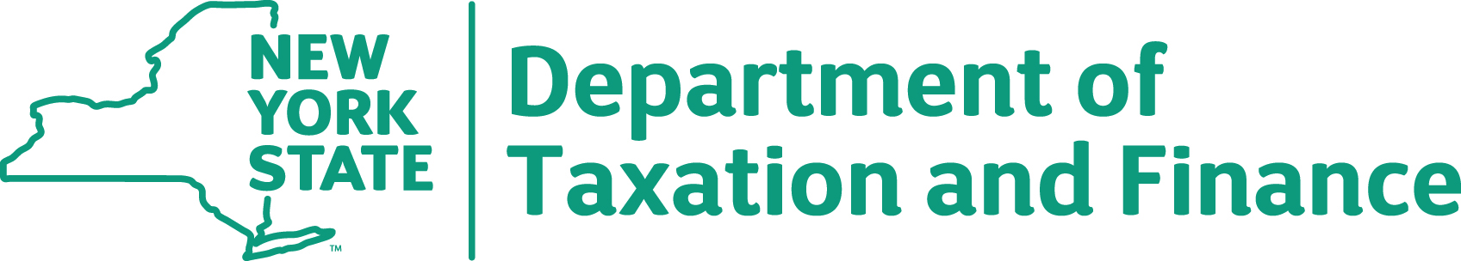

BUREAU OF FISCAL SERVICES
Procurement Unit

REQUEST FOR PROPOSALS (RFP) 16-100 REAL PROPERTY TAX SYSTEM
RESPONSE TO BIDDER QUESTIONS AND ANSWERS

October 4, 2016

To All Bidders:
Additional questions were received by the State post the Question & Answer period deadline. The State is providing the answers to these substantive questions. Please be advised that if there are any questions or concerns, please contact the Department at BFS.Contracts@tax.ny.gov no later than October 5, 2016.

# | RFP Section | RFP Page # | Question | Answer
1 |  |  | Whether companies from Outside USA can apply for this? (like,from India or Canada) | Yes, however vendors must have the legal authority to conduct business in New York State.
2 |  |  | Whether we need to come over there for meetings? | Yes.
3 |  |  | Can we perform the tasks (related to RFP) outside USA? (like, from India or Canada) | No, not all tasks can be performed outside the USA. Development tasks may be performed outside USA, however NO production tasks may be performed outside the continental United States (e.g., testing, conversion, etc.)
4 |  |  | Can we submit the proposals via email????? | No.

