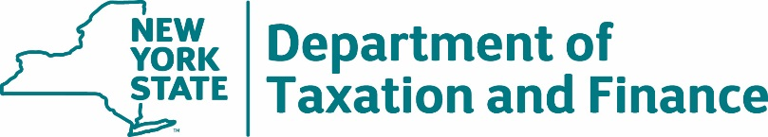

BUREAU OF FISCAL SERVICES
Procurement Unit

April 5, 2024

Request for Proposals (RFP) 23-103
Check 21 Services

Additional Responses to Round Two Bidder Questions and Amendment #3

To All Potential Bidders:
Attached are the Department’s Additional Responses to Round Two Bidder Questions received for the above referenced RFP.
Additionally, the Department is issuing Amendment #3 as clarification to:
- Amend RFP Table 2.3, Requirement 5.1

Corrected pages are attached to this document. All additions are made in blue underlined text (additions) and all deletions are made in red strikethrough text (deletions).

All other requirements and conditions remain as indicated in the RFP.
# | RFP |  | QUESTION | DEPARTMENT RESPONSE
 | SECTION | PG
5 | Table 2.3, Cash Management Requirements  Requirement 5.1 | 47 | Regarding the requirement below, please provide clarification what the Department considers to be “available.” Does the Department intend to sweep out the funds before they are fully collected, creating a negative collected balance position or would the Department only sweep out the collected balance?  “The Contractor must agree that check deposits will be immediately and fully credited to the Department’s/OSC’s bank accounts and available…” | OSC draws available, collected funds.  Domestic check deposits must be immediately and fully "credited" to the State’s bank accounts and available for withdrawal within one business day and must not be debited from the State’s bank accounts while waiting for funds to be received.  Funds will be credited to the State's/agency's account at the time they are received for foreign checks.

TABLE 2.3: CASH MANAGEMENT REQUIREMENTS
# | REQUIREMENT | RESPONSE
 | and account filters.
5. | FUNDS PROCESSING AND AVAILABILITY FOR CHECK DEPOSITS
5.1 | The Contractor must agree that check deposits will be immediately and fully credited to the Department’s/OSC’s bank accounts and available per Table 2.1 (Functional Requirements) for immediate withdrawal within one business day and must not be debited from the Department’s/OSC’s bank accounts while waiting for funds to be received. The Contractor must inform the Department and OSC of any changes that affect individual check end-point and availability schedules. Any changes and/or revised availability schedules must be transmitted to the Department and OSC in a timely manner. | The Bidder must affirm understanding of, and agreement to comply with, this Requirement.
 |  | ☐ | Yes, the Bidder affirms its understanding of, and agreement to comply with, this Requirement.
6. | OSC COLLATERAL
6.1 | Sections 105 and 106 of the New York State Finance Law require financial institutions holding deposits of New York State monies to pledge collateral with OSC to the extent deemed appropriate by OSC. As required by such law, the Bidder must agree to pledge securities as set forth in Section 105 of the State Finance Law or to obtain a surety bond from companies with the highest ratings (issued by nationally recognized statistical rating organizations) to secure the State’s interest in any depository account and any “pass-through” accounts to the extent deemed appropriate by OSC. OSC shall establish and periodically review and adjust, as necessary, the amounts held as collateral. Collateral must be held at the New York State fiscal agent. OSC reserves the right to periodically verify the amount of collateral held. | The Bidder must affirm understanding of, and agreement to comply with, this Requirement.
 |  | ☐ | Yes, the Bidder affirms its understanding of, and agreement to comply with, this Requirement.
END OF TABLE 2.3

