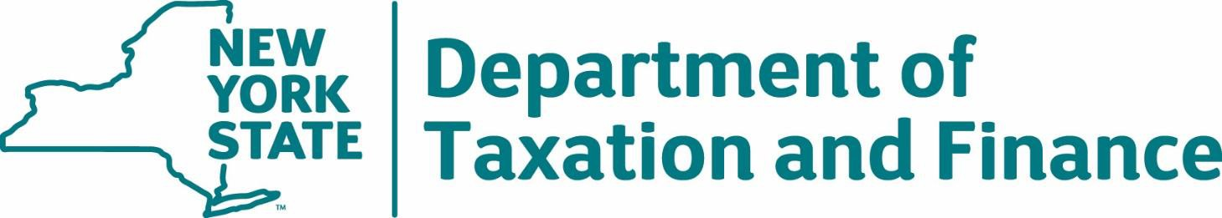
Request for Proposals
23-103
Check 21 Services
Exhibits

Table of Contents
Exhibit A – Glossary 3
Exhibit B – Volumes 7
Exhibit C – Sample Adjustment Data File Format 9
Exhibit D – Peak Dates Calendar 12
Exhibit E – New York State Office of the State Comptroller Substitute Form W-9 13
Exhibit F – Minority and Women-Owned Business Enterprises – Equal Employment Opportunity Policy Statement 15
Exhibit G – Workforce Utilization Report 17
Exhibit H – Contractor Sales Tax Certification Forms 18
Exhibit I – Preliminary Base Contract 24
ARTICLE I. DEFINITIONS 24
ARTICLE II. ENTIRETY OF AGREEMENT 26
ARTICLE III. CONTRACTOR RESPONSIBILITIES 27
ARTICLE IV. DEPARTMENT RESPONSIBILITIES 28
ARTICLE V. AGREEMENT TERM 29
ARTICLE VI. FEES AND PAYMENT 29
ARTICLE VII. TAX SECRECY AND CONFIDENTIALITY 31
ARTICLE VIII. IMPLEMENTATION / TESTING OF PERFORMANCE OF THE SERVICES 34
ARTICLE IX. CONTRACTOR PERFORMANCE MONITORING / REVIEWS 35
ARTICLE X. SERVICES MANAGEMENT 36
ARTICLE XI. SECURITY 37
ARTICLE XII. BUSINESS CONTINUITY / DISASTER RECOVERY / FAIL-SAFE OPERATIONS 38
ARTICLE XIII. REPRESENTATIONS AND WARRANTIES 39
ARTICLE XIV. CHANGE CONTROL PROCEDURE 40
ARTICLE XV. REPORTING 40
ARTICLE XVI. RESERVED RIGHTS 40
ARTICLE XVII. PERFORMANCE DEFICIENCIES, CORRECTIVE ACTION, REMEDIES, AND REIMBURSEMENTS 41
ARTICLE XVIII. DISPUTE RESOLUTION 42
ARTICLE XIX. TERMINATION OR SUSPENSION 43
ARTICLE XX. INDEMNIFICATION AND LIMITATION OF LIABILITY 44
ARTICLE XXI. PARTICIPATION BY MINORITY AND WOMEN-OWNED BUSINESS ENTERPRISES: REQUIREMENTS AND PROCEDURES 47
ARTICLE XXII. PARTICIPATION OPPORTUNITIES FOR NEW YORK STATE SERVICE-DISABLED VETERAN-OWNED BUSINESS ENTERPRISES 49
ARTICLE XXIII. INSURANCE 50
ARTICLE XXIV. CONTRACTOR AND SUBCONTRACTORS 52
ARTICLE XXV. GENERAL TERMS AND CONDITIONS 54
ARTICLE XXVI. CONTINUING ADMINISTRATIVE REQUIREMENTS 60
Exhibit J – Banking Services Schedules 63

Exhibit A – Glossary
Agreement (also referred to as “Contract”) – All documents identified in the Base Contract at Article II, Entirety of Agreement.
Attorney General or AG – The New York State Attorney General or their designee.
Automated Clearing House Network (ACH) – A nationwide electronic funds transfer system governed by the ACH Operating Rules and Guidelines.
Bank Adjustment or Adjustment – Any change to the original amount of the posted transactions, including those changes made due to Dishonorments; debit memos and credit memos (may also include a foreign fund Adjustment). Does not include Non-Conforming Images.
Adjustment Date – The date an Adjustment to a previously processed deposited item posts to the bank account.
Bank Statement(s) – A summary of financial transactions which have occurred over a given period of time.
Banking Day – A weekday (Monday-Friday) that is not a holiday observed by the Federal Reserve System.
Base Contract – That portion of the Agreement preceding the signatures of the Parties.
Bidder – Any qualifying entity submitting a proposal for this procurement.
Business Day – A weekday (Monday-Friday) that is not a holiday designated by the New York State Governor’s Office of Employee Relations.
Certification – A writing issued by DTF to the Contractor verifying that the implementation of the services specified in the writing has been satisfactorily completed.
Change Control Procedure – The procedures set forth in RFP 23-103, Appendix C that must be followed by the Parties to initiate and receive approval to move forward with Changes.
Changes – Additions to, deletions from, enhancements or modifications to the Services, the Requirements for which are set forth in RFP 23-103. All Changes will be initiated by a Change Request submitted pursuant to the Change Control Procedure (Appendix C). Fees may be approved for Changes requested and implemented after Final Certification is achieved and, in DTF’s sole discretion, those Changes occurring prior to Final Certification deriving from unanticipated circumstances on a case-by-case basis (e.g., legislative enactments or program changes requiring addition of new programs, etc.).
Check 21 – The Check Clearing for the 21st Century Act (P.L. 108-100), regulations promulgated thereunder, or any successor legislation including any Operating Circulars from the Federal Reserve Board.
Check Date of Deposit – The date the check was deposited at the bank of first deposit.
Contractor – [successful Bidder’s name to be inserted here]. The selected Bidder resulting from the competitive bid process with respect to this RFP.
Department or DTF – The New York State Department of Taxation and Finance.
Department Data – All Manual Deposit checks and all electronic files containing check images provided by DTF to Contractor for check clearing and payment deposit into Department bank accounts established by the Contractor under this Contract.
Deposit Location – A Department provided tracking number, contained in the ICL file that correlates to a specific Tax Application.
Disaster Recovery Plan – The Contractor’s plan to deal with potential disasters so the effects will be minimized, and the organization will be able to maintain or quickly resume mission critical functions, including providing the Services.
Dishonorments – A bank’s refusal to accept or pay an Original Check or an Electronic Item. For example, a Dishonorment occurs where the payment order is returned unpaid for reasons such as: insufficient funds, account closed and refer to maker.
Electronic Item – An Original Check that has been converted to an electronic image (front and back) of the Original Check, along with the electronic information concerning the check necessary for the Bank to process the check for deposit using electronic check clearing processes and which is transmitted to the Bank.
Fed Funds Rate – The target interest rate set by the Federal Open Market Committee. This target is the rate at which commercial banks borrow and lend their excess reserves to each other overnight.
Final Certification – A written determination by DTF provided to the Contractor notifying the Contractor that the final phase of the initial implementation has successfully completed UAT, and is certified by DTF as ready for production (live data) implementation. When the last phase has been certified, it shall be considered the Final Certification.
Foreign Check in US Funds – An Original Check drawn on any financial institution that is not located in any State (as defined in Regulation CC) in the U.S.A. (including certain designated U.S. Territories that are included as States) which cannot be processed electronically. These will be processed as Manual Deposits under the Agreement.
Foreign Check in Non-US Funds – An Original Check drawn on any financial institution that is not located in any State (as defined in Regulation CC) in the U.S.A. (including certain designated U.S. Territories that are included as States) in currency other than US Dollars which cannot be processed electronically. The Contractor shall not process any Manual Deposits drawn in other than US funds. If any are received by the Contractor in error, they shall be returned to the Department to handle.
Help Desk – The Contractor’s services to provide assistance with payment processing (telephone and electronic, at a minimum).
Image Cash Letter (ICL) – The electronic file containing Electronic Items presented by DTF to the Contractor for the processing of payments in a standardized format.
Implementation Plan – The plan as negotiated between the Contractor and the Department after Contract approval, which defines how the Contractor shall achieve providing the Services.
Maintenance – All modifications to software, documentation, and operating procedures, etc. necessary to ensure satisfactory performance of the Services.
Manual Deposit(s) – The processing of payments (e.g., Original Checks drawn in US funds) which cannot be processed electronically.
Non-Conforming Image (NCI) – Any Electronic Item that does not meet the Check 21 standards and therefore cannot be processed electronically.
Original Check – The first paper check or money order issued with respect to a particular payment transaction.
OSC – The New York State Office of the State Comptroller.
Proposal – The proposal submitted by Bidder in response to RFP 23-103; also referred to as “Bid.”
Remittance – An Electronic Item or Original Check.
Request for Proposals or RFP – The Check 21 Services Request for Proposals 23-103 issued by the Department on January 31, 2024, including all appendices and exhibits contained therein, and any written clarifications or amendments thereto made by DTF.
Requirements – The criteria as set forth in RFP 23-103 that are necessary to perform the Services and achieve Certification for full production.
Services – All functions and work to be performed by the Contractor that are necessary for the Contractor to provide the check processing, depository and related services in accordance with RFP 23-103, and the Agreement, and any as modified through any Change Control Procedure (Appendix C), if applicable.
Sites – Any location where Services are performed by the Contractor or any Subcontractor in connection with the Agreement. Where the RFP or Base Contract uses the term “Contractor’s Sites,” this is inclusive of any Site where the Services are performed by a Subcontractor.
Subcontractor – Any individual or other entity including, but not limited to, a sole proprietorship, partnership, limited liability company, firm or corporation with whom the Contractor or another Subcontractor enters into an agreement to perform all or part of the Contractor’s obligation(s) under the Agreement.
Subsequent Service Provider – The Contractor selected to perform the Services upon the expiration and/or termination of the Agreement. Such provider may or may not be the incumbent.
Tax Application – The name used to identify the form or group of forms as to which accompanying remittances are deposited into one Bank Account that is established and maintained for deposit of the remittances associated with that form or group of forms (Tax Application). For example, there will be one bank account for deposit of remittances for the Tax Application called ‘Corporation Tax.’ That Tax Application will contain the remittances that accompany the following forms: ‘Corporation Tax Returns’ (a group of multiple forms); ‘Corporation Tax Voucher’ (form CT-200-V); and Wireless Communications Surcharge (forms WCS-1 and WCS-2).
Tax Law – The New York State Tax Law.
Tax Secrecy – Refers to requirements imposed by various sections of the Tax Law and the Internal Revenue Code on those who handle confidential tax information (including contractors provided access thereto by virtue of their contractual relationship) to safeguard and protect such information from unauthorized access, use, and disclosure. (See RFP 23-103 at Table 2.6 (Tax Secrecy Requirements) and Agreement at Article VII (Tax Secrecy and Confidentiality).
Testing – The Department’s process to determine whether the Services are performed in accordance with the RFP. This includes systems testing and User Acceptance Testing.
Transition Plan – A proposed plan detailing the requirements for transferring the Services, or components thereof, from the Contractor to the Department and/or a Subsequent Service Provider and the transfer/destruction of all records, files, and data related to the Services upon expiration or termination of the Agreement.
User Acceptance Testing or UAT – The Department's process to determine whether an implementation deliverable performs in accordance with the specifications.

Exhibit B – Volumes

Tax Application Bank Accounts | Electronic Payments | Manual | ICL Transmission  Per Account | Account Maintenance Fee  Per Account | Dishonorments | Adjustment Detail items
Highway Use Tax | 35,163 | 8,953 | 12 | 12 | 104 | 0
Real Estate Transfer Tax | 19,889 | 215 | 12 | 12 | 16 | 16
Corporation Tax  (Return, Voucher, and Wireless Communications Surcharge) | 121,784 | 1,371 | 12 | 12 | 660 | 659
Personal Income Tax and Limited Liability Company | 191,775 | 954 | 12 | 12 | 986 | 986
Sales Tax | 69,149 | 612 | 12 | 12 | 552 | 552
Check to Debit Exchange Account | 5 | 0 | 12 | 12 | 0 | 0
Estate Tax | 1,121 | 26 | 12 | 12 | 7 | 0
Total Estimated Volume Per Fiscal Year | 438,886 | 12,131 | 84 | 84 | 2,325 | 2,216

IMAGE CASH LETTERS (ICL)
The Department anticipates approximately 3,100 file transmissions on an annual basis.

DAILY ACCOUNT BALANCE
Tax Application Bank Accounts |  |  | Average Daily Balance
Highway Use Tax |  |  | $304,370.00
Real Estate Transfer Tax |  |  | $691,710.00
Corporation Tax Return, Voucher, Wireless Communications Surcharge |  |  | $2,613,763.00
Personal Income Tax and Limited Liability Company |  |  | $1,789,103.00
Sales Tax |  |  | $5,008,562.00
Check to Debit Exchange Account (Voucher) |  |  | NA
Estate Tax |  |  | $9,625,825.00
Total Average Daily Balance Across All Accounts |  |  | $20,033,333.00
OVERDRAFT INFORMATION
Tax Application Bank Accounts | Number of Days in Negative Balance | Average Amount Overdrawn
Highway Use Tax | 12 | $45,339
Corporation Tax | 20 | $50,828
Personal Income Tax | 5 | $442,333
Sales Tax | 1 | $198,067
Estate Tax* | 12 | $10,091,789
Real Estate Transfer Tax | 9 | $5,538
* In FY2022-23, an abnormally large overdraft of $109.1M occurred in the Estate Tax account. If this outlier event is omitted, the average overdraft amount would be $1.1M instead of the $10.1M listed in the table.
VOLUME PERIOD
The volumes and accounts information provided in this exhibit are estimates based on the actual volumes from 4/1/2022 to 3/1/2023.

Exhibit C – Sample Adjustment Data File Format

Here are samples of the five (5) acceptable data file formats. The awarded Bidder must use one of these formats for Services pertaining to RFP Table 2.1 (Functional Requirements), Requirement 6.2.

Fixed length text file Dishonorment/Adjustment detail item:

Example:

DDMMYYDDMMYYYY##############################################
DDMMYYDDMMYYYY##############################################
DDMMYYDDMMYYYY##############################################
DDMMYYDDMMYYYY##############################################

• Adjustment Date i.e. Date of Dishonorment
• Check Date of Deposit
• Check Amount
• Check Account Number i.e. issuer’s bank account number
• Check ABA Routing Number
• Check Serial Number i.e. Check Number
• Return Reason Code

CSV file Dishonorment/Adjustment detail item:

Example:

DDMMYY,DDMMYYYY,###############,#########,########## ,##########,##
DDMMYY,DDMMYYYY,###############,#########,########## ,##########,##
DDMMYY,DDMMYYYY,###############,#########,########## ,##########,##
DDMMYY,DDMMYYYY,###############,#########,########## ,##########,##

• Adjustment Date i.e. Date of Dishonorment
• Check Date of Deposit
• Check Amount
• Check Account Number i.e. issuer’s bank account number
• Check ABA Routing Number
• Check Serial Number i.e. Check Number
• Return Reason Code

Spreadsheet Dishonorment/Adjustment detail item:

Example:

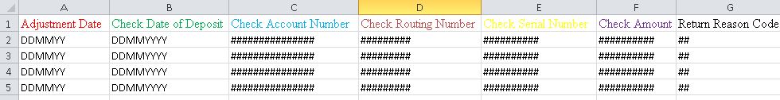

XML Dishonorment/Adjustment detail item:

Example:

<mAdjustmentInfo diffgr:id="mAdjustmentInfo1" msdata:rowOrder="0" diffgr:hasChanges="inserted">
<AdjustmentDate>DDMMYY</AdjustmentDate>
<CheckDepositDate>DDMMYYYY</DepositDate>
<CheckAccountNumber>###############</CheckAccountNumber>
<CheckRoutingNumber>#########</CheckRoutingNumber>
<CheckSerialNumber>##########</CheckSerialNumber>
<CheckAmount>##########</CheckAmount>
<ReturnReasonCode>##</ReturnReason>
</mAdjustmentInfo>
<mAdjustmentInfo diffgr:id="mAdjustmentInfo2" msdata:rowOrder="1" diffgr:hasChanges="inserted">
<AdjustmentDate>DDMMYY</AdjustmentDate>
<CheckDepositDate>DDMMYYYY</DepositDate>
<CheckAccountNumber>###############</CheckAccountNumber>
<CheckRoutingNumber>#########</CheckRoutingNumber>
<CheckSerialNumber>##########</CheckSerialNumber>
<CheckAmount>##########</CheckAmount>
<ReturnReasonCode>##</ReturnReason>
</mAdjustmentInfo>
<mAdjustmentInfo diffgr:id="mAdjustmentInfo3" msdata:rowOrder="2" diffgr:hasChanges="inserted">
<AdjustmentDate>DDMMYY</AdjustmentDate>
<CheckDepositDate>DDMMYYYY</DepositDate>
<CheckAccountNumber>###############</CheckAccountNumber>
<CheckRoutingNumber>#########</CheckRoutingNumber>
<CheckSerialNumber>##########</CheckSerialNumber>
<CheckAmount>##########</CheckAmount>
<ReturnReasonCode>##</ReturnReason>
</mAdjustmentInfo>

JSON Dishonorment/Adjustment detail item:

Example:

[
{
"DISHONORMENT DATE": "01/24/22",
"DEPOSIT DATE": "01/18/2022",
"CHECK SERIAL No.": 9990,
"CHECK ACCT No.": 999999999999,
"CHECK ROUTING No.": 21000322,
"CHECK AMOUNT": 5677,
"RETURN REASON CODE": 01
},
{
"DISHONORMENT DATE": "01/24/22",
"DEPOSIT DATE": "01/20/2022",
"CHECK SERIAL No.": 9991,
"CHECK ACCT No.": 888888888,
"CHECK ROUTING No.": 21000021,
"CHECK AMOUNT": 123,
"RETURN REASON CODE": 01
}
]

Exhibit D – Peak Dates Calendar

CORPORATION TAX
2024 Peak Dates | 2024 Due
March 14 – March 21 | March 15
April 15 – April 22 | April 15
September 16 – September 23 | September 16

SALES TAX
2024 Peak Dates | 2024 Due
March 18 – March 25 | March 20
June 18 – June 25 | June 20
September 19 – September 26 | September 20
December 19 – December 27 | December 20

PERSONAL INCOME TAX
2024 Peak Dates | 2024 Due
March 14 – March 21 | March 15
April 15 – April 22 | April 15
October 14 – October 21 | October 15

Exhibit E – New York State Office of the State Comptroller Substitute Form W-9
This form is available at the NYS Office of the State Comptroller website:
https://www.osc.state.ny.us/vendors/forms/ac3237s_fe.pdf
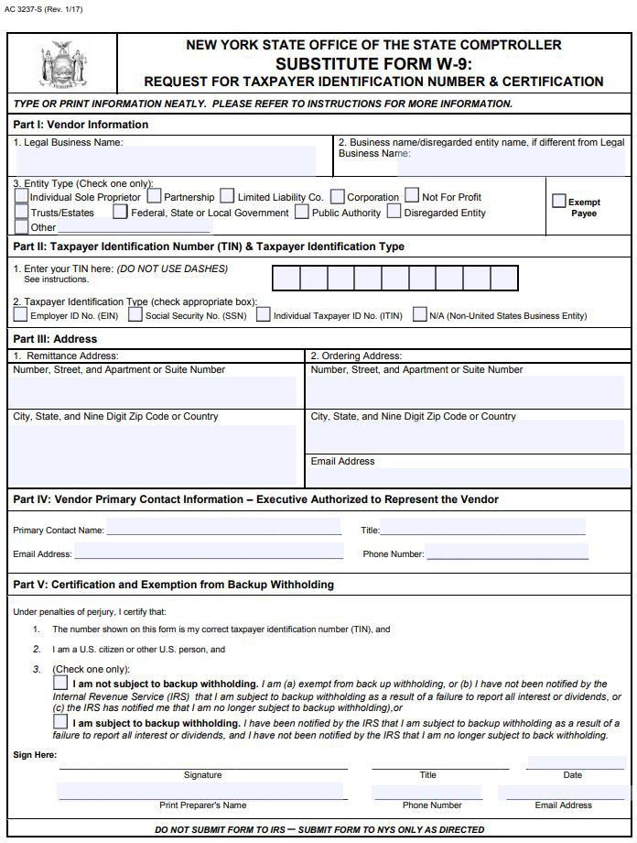

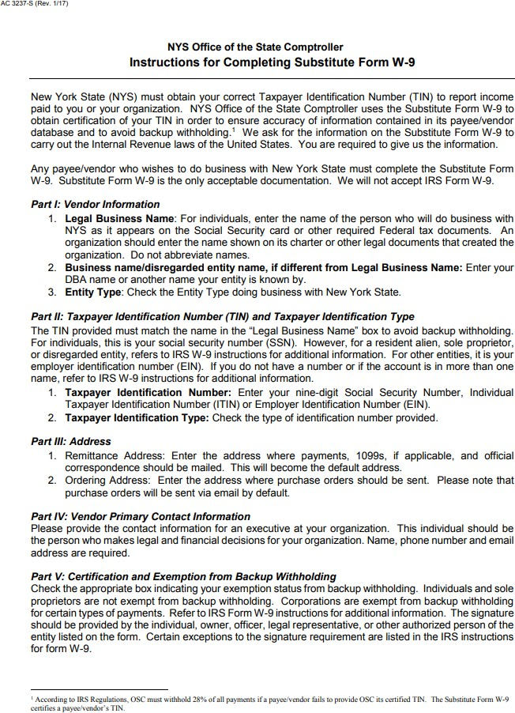

Exhibit F – Minority and Women-Owned Business Enterprises – Equal Employment Opportunity Policy Statement
M/WBE AND EEO POLICY STATEMENT

I, , the (awardee/contractor) agree to adopt the following policies with respect to the project being developed or services rendered at

This organization will and will cause its contractors and subcontractors to take good faith actions to achieve the M/WBE contract participations goals set by the State for that area in which the State-funded project is located, by taking the following steps:
M/WBE

- Actively and affirmatively solicit bids for contracts and subcontracts from qualified State certified MBEs or WBEs, including solicitations to M/WBE contractor associations.
- Request a list of State-certified M/WBEs from AGENCY and solicit bids from them directly.
- Ensure that plans, specifications, request for proposals and other documents used to secure bids will be made available in sufficient time for review by prospective M/WBEs.
- Where feasible, divide the work into smaller portions to enhanced participations by M/WBEs and encourage the formation of joint venture and other partnerships among M/WBE contractors to enhance their participation.
- Document and maintain records of bid solicitation, including those to M/WBEs and the results thereof. Contractor will also maintain records of actions that its subcontractors have taken toward meeting M/WBE contract participation goals.
  - This organization will not discriminate against any employee or applicant for
employment because of race, creed, color, national origin, sex, age, disability or marital status, will undertake or continue existing programs of affirmative action to ensure that minority group members are afforded equal employment opportunities without discrimination, and shall make and document its conscientious and active efforts to employ and utilize minority group members and women in its work force on state contracts.

EEO
  - This organization shall state in all solicitation or advertisements for employees that in the performance of the State contract all qualified applicants will be afforded equal employment opportunities without discrimination because of race, creed, color, national origin, sex disability or marital status.
  - At the request of the contracting agency, this organization shall request each employment agency, labor union, or authorized representative will not discriminate on the basis of race, creed, color, national origin, sex, age, disability or marital status and that such union or representative will affirmatively cooperate in the implementation of this organizations’ obligations herein.
  - Contractor shall comply with the provisions of the Human

- Ensure that progress payments to M/WBEs are made on a timely basis so that undue financial hardship is avoided, and that bonding and other credit requirements are waived or appropriate alternatives developed to encourage M/WBE participation.
Rights Law, all other State and Federal statutory and constitutional non-discrimination provisions. Contractor and subcontractors shall not discriminate against any employee or applicant for employment because of race, creed (religion), color, sex, national origin, sexual orientation, marital status or domestic violence victim status, and shall also follow the requirements of the Human Rights Law with regard to non- discrimination on the basis of prior criminal conviction and prior arrest.
- This organization will include the provisions of sections (a) through (d) of this agreement in every subcontract in such a manner that the requirements of the subdivisions will be binding upon each subcontractor as to work in connection with the State contract.

Agreed to this day of , 2

By

Print: Title:

Minority Business Enterprise Liaison

is designated as the Minority Business Enterprise Liaison
(Name of Designated Liaison)

responsible for administering the Minority and Women-Owned Business Enterprises- Equal Employment Opportunity (M/WBE-EEO) program.

M/WBE Contract Goals

% Minority Business Enterprise Participation

% Women’s Business Enterprise Participation

EEO Contract Goals

% Minority Labor Force Participation

% Female Labor Force Participation

(Authorized Representative)

Title: Date:

Exhibit G – Workforce Utilization Report

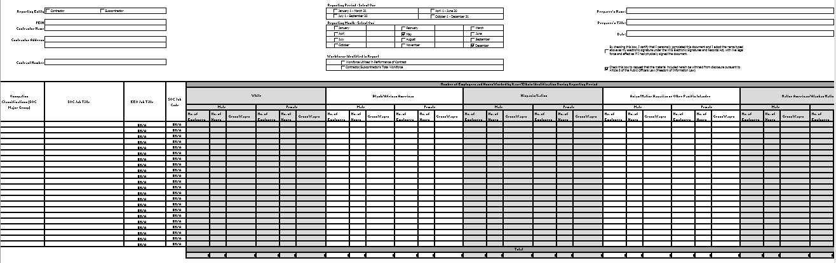
Note: An Excel file of this form will be provided to the Contractor after contract execution.

Exhibit H – Contractor Sales Tax Certification Forms

These forms are available at the NYS Department of Taxation and Finance website: ST-220-TD: https://www.tax.ny.gov/pdf/current_forms/st/st220td_fill_in.pdf
ST-220-CA: https://www.tax.ny.gov/pdf/current_forms/st/st220ca_fill_in.pdf
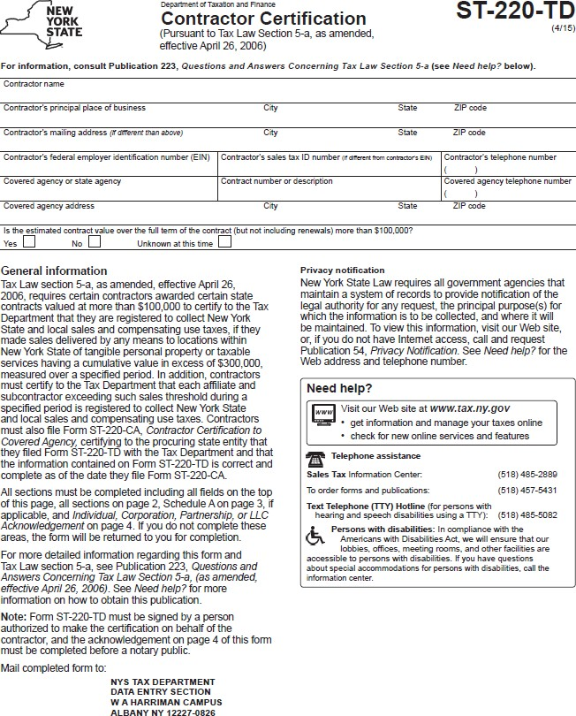

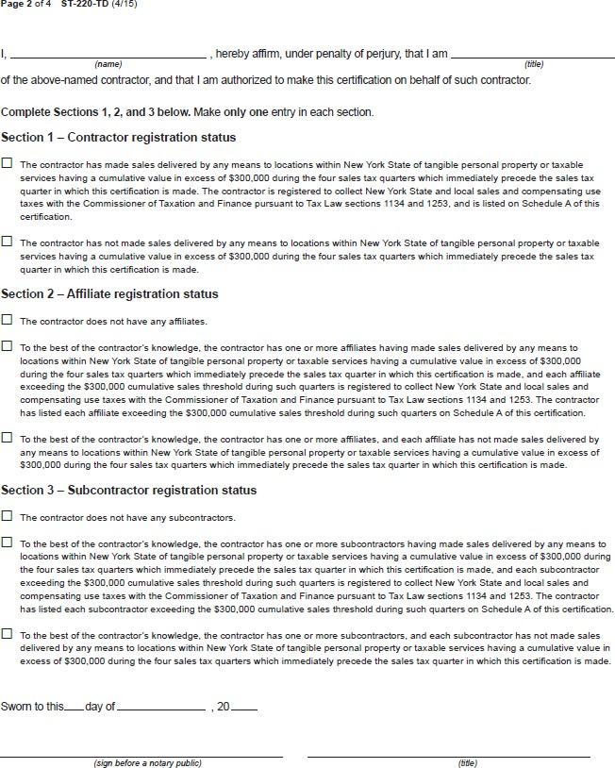

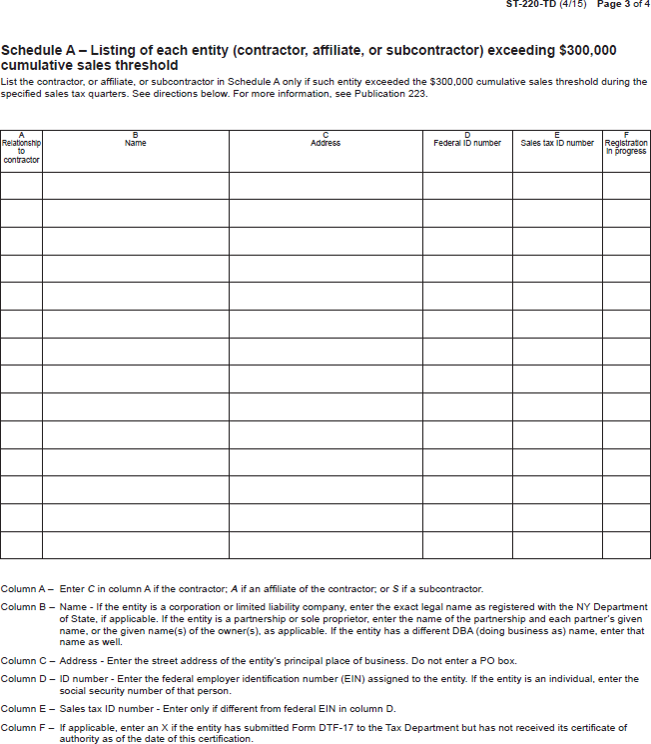

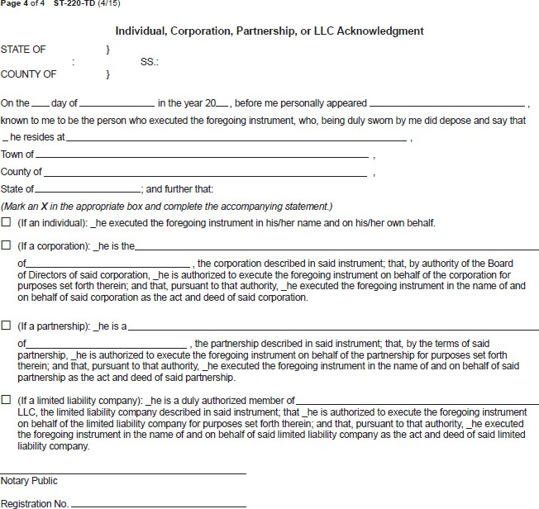

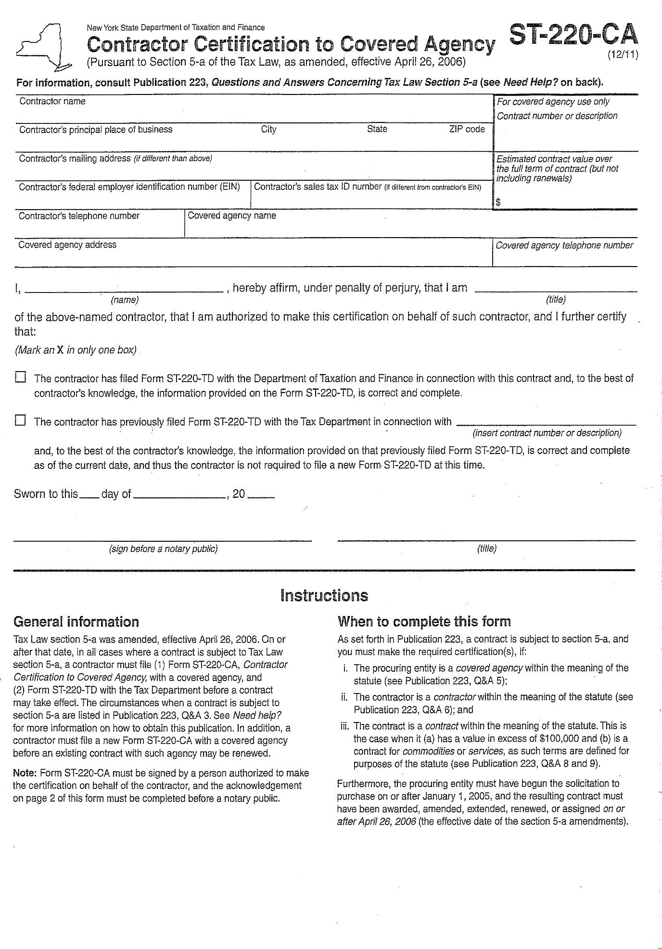

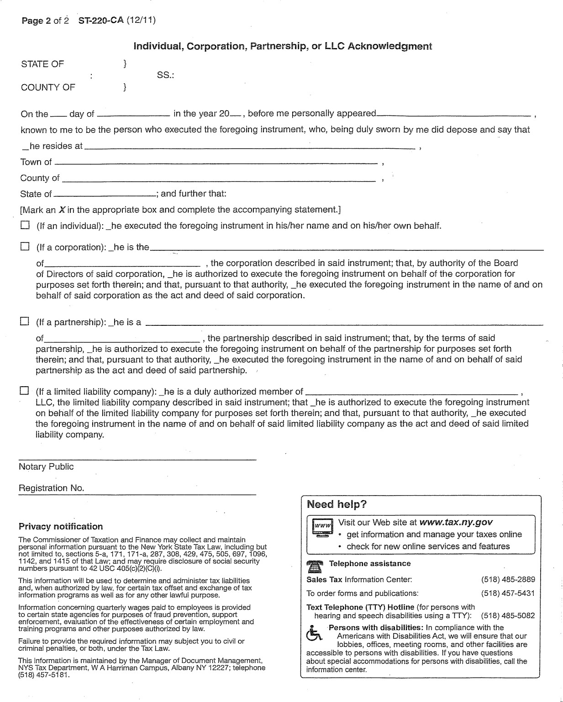

Exhibit I – Preliminary Base Contract
THIS AGREEMENT is by and between the New York State Department of Taxation and Finance, located at Building 9, W.A. Harriman State Office Campus, Albany, New York 12227 (hereinafter, the “Department, “DTF” and/or “State”) and [Contactor Name], with its principal place of business located at [Contractor Address] (hereinafter, the “Contractor” or “Bank”). The Department and the Contractor are collectively referred to as the “Parties.”
WHEREAS, DTF issued Request for Proposals (“RFP”) 23-103 on January 31, 2024, for the acquisition of check processing, depository and related services, as more fully described in RFP 23-103 (“Check 21 Services” or “Services”); and
WHEREAS, the Contractor timely submitted a Proposal to provide the Services set forth in the RFP and the Department has determined the Contractor is responsible; and
WHEREAS, pursuant to Section 6, Proposal Evaluation, of the RFP, the Contractor was determined to have provided the best value Proposal and has been found capable of providing the required Services; and
WHEREAS, the Contractor is prepared to provide the Services according to the terms of this Agreement, and recognizes that Transition of the Services to a Subsequent Service Provider, at the direction of the Department, is a fundamental requisite of such undertaking.
NOW, THEREFORE, in consideration of the mutual covenants and conditions herein set forth, the Parties agree as follows:

ARTICLE I. DEFINITIONS
The following terms when used herein shall have the specified meanings:
Agreement — See RFP 23-103, Exhibit A, Glossary.
Attorney General or AG — See RFP 23-103, Exhibit A, Glossary.
Base Contract — See RFP 23-103, Exhibit A, Glossary.
Business Day — See RFP 23-103, Exhibit A, Glossary.
Certification — See RFP 23-103, Exhibit A, Glossary.
Change Control Procedure — See RFP 23-103, and Article XIV (Change Control Procedure) herein.
Changes — See RFP 23-103, Exhibit A, Glossary.
Check — A written draft drawn on a bank and payable on demand, signed by the maker containing an unconditional promise to pay a sum certain.
Check 21 — See RFP 23-103 Exhibit A, Glossary.
Commissioner — The Commissioner of the New York State Department of Taxation and Finance or their designee.
Contractor — See RFP 23-103, Exhibit A, Glossary.
Corrective Action Plan — An action plan that may or may not (at DTF’s discretion) be provided by DTF to Contractor, along with a Notice of Deficiency (NOD), in the event of a Deficiency in performance of the Services. See Article XVII (Performance Deficiencies, Corrective Action, Remedies and Reimbursements).
Cure Period — The period of time during which Contractor may have the opportunity to cure a Deficiency or a Material Breach, as set forth in a Notice of Deficiency (NOD) issued by the Department.
Deficiency — Any failure by Contractor to meet Requirements in providing the Services pursuant to this Agreement, which may result in the issuance by DTF of a Notice of Deficiency (NOD).
Department or DTF — See RFP 23-103, Exhibit A, Glossary.
Department Data — See RFP 23-103, Exhibit A, Glossary.
Disaster Recovery Plan — See RFP 23-103, Exhibit A, Glossary.
Dispute Resolution — The process set forth in Article XVIII (Dispute Resolution) herein for resolving disputes arising under this Agreement.
Electronic Item — See RFP 23-103, Exhibit A, Glossary.
ICL — See RFP 23-103, Exhibit A, Glossary.
Implementation Plan — See RFP 23-103, Exhibit A, Glossary.
Maintenance — See RFP 23-103, Exhibit A, Glossary.
Manual Deposit — See RFP 23-103, Exhibit A, Glossary.
Material Breach — The failure to perform an obligation that the Contractor is bound to perform under this Agreement which impacts the State or, in the sole judgment of DTF, is fundamental to the Agreement and the Contractor’s failure to perform defeats its purpose.
Nacha — The National Automated Clearing House Association.
Nacha Rules and Guidelines — The Nacha Operating Rules and Guidelines, published and updated at least annually by Nacha, which govern electronic payments transactions processing through the National Automated Clearinghouse.
Notice of Deficiency or NOD — A written notice furnished by the Department to the Contractor which shall set forth performance failure(s) or defects that have been identified which may give rise to DTF withholding of portions of payment and/or a Material Breach of the Agreement if not corrected. The NOD may or may not set forth a Cure Period.
Notice of Suspension — A written notification issued to the Contractor by DTF which notifies the Contractor that DTF is suspending the Agreement, or parts thereof, and sets forth the effective date of the suspension.
Notice of Termination — A written notification issued to the Contractor by DTF which notifies the Contractor that DTF is terminating the Agreement, or parts thereof, and sets forth the effective date of the termination.
Original Check — See RFP 23-103, Exhibit A, Glossary.
OGS-BSC — The New York State Office of General Services, Business Services Center.
OSC — See RFP 23-103, Exhibit A, Glossary.
Proposal — See RFP 23-103, Exhibit A, Glossary.
Reimbursement(s) — A payment made by the Contractor or withheld by the State from payment requested on Contractor’s invoices, to compensate the State or a taxpayer for a loss caused by Contractor Deficiency or error in providing the Services (see Article XVII (Performance Deficiencies, Corrective Action, Remedies and Reimbursements)). Reimbursements neither count towards, nor are they subject to, any limitation of liability agreed to by the Parties herein.
Request for Proposals or RFP — See RFP 23-103, Exhibit A, Glossary.
Requirement(s) — See RFP 23-103, Exhibit A, Glossary.
Services — See RFP 23-103, Exhibit A, Glossary.
Site(s) — See RFP 23-103, Exhibit A, Glossary.
Subcontractor — See RFP 23-103, Exhibit A, Glossary.
Subsequent Service Provider — See RFP 23-103, Exhibit A, Glossary.
Tax Law — See RFP 23-103, Exhibit A, Glossary.
Tax Secrecy — See RFP 23-103, Exhibit A, Glossary.
Transition Plan — See RFP 23-103, Exhibit A, Glossary.
User Acceptance Testing or UAT — See RFP 23-103, Exhibit A, Glossary.

ARTICLE II. ENTIRETY OF AGREEMENT
The entire Agreement shall consist of the documents listed below. Conflicts between these documents will be resolved in the following order of precedence:
- Appendix A to RFP 23-103, “Standard Clauses for New York State Contracts,” dated June 2023.
- Attachment 13 to RFP 23-103, DTF-202, Tax Information Access and Non-Disclosure Agreement, dated June 2019.
- Any written amendments and/or changes to the Agreement agreed to by the Parties and approved, where necessary, by the AG and OSC.
- Base Contract, excluding attachments thereto.
- Any Amendments and clarifications to RFP 23-103, including Questions and Answers issued by DTF, as follows: [List by Title and/or Date].
- RFP 23-103, (including all attachments, exhibits and appendices to the RFP, but excluding Appendix A and Attachment 13).
- Contractor’s Proposal Clarifications, as follows: [List by Title and/or Date].
- Contractor’s Proposal, including Contractor’s completed attachments, but excluding banking services schedules and other standard bank-related materials submitted by Contractor with its Proposal.
- Banking Services Schedules, as negotiated, as follows: [Negotiated Schedules agreed to will be listed here.]

ARTICLE III. CONTRACTOR RESPONSIBILITIES
The Contractor has, by submitting its Proposal, agreed to all mandatory RFP Requirements and to provide all Services as set forth in the RFP, and all are incorporated herein by reference. In addition to the Contractor’s responsibilities set forth elsewhere in this Agreement, the Contractor shall:
- Maintain its status as a state or federally Chartered Bank authorized to do business in New York State and have at least one branch or office with a physical location in New York throughout the life of the Agreement.
- Establish all bank accounts as are required by the State to provide the Services and ensure correct and timely processing of all checks and payment orders in accord with the RFP Requirements.
- Maintain and support products and services which the Contractor provides or performs generally for other customers receiving products or services that are part of the general services provided to DTF under this Agreement. This shall be provided and performed for DTF for no additional compensation, for the duration of the Agreement.
- Accept sole and complete responsibility for the timely accomplishment of all Contractor activities required under this Agreement, including processing of all Electronic Items, ICLs, and Original Checks.
- Maintain accurate records.
- Work in good faith to follow any reasonable recommendations made by DTF regarding the performance of the Services.
- Warrant and affirm that the terms of this Agreement do not violate any contract or agreement to which the Contractor is a party and that Contractor’s other contractual obligations will not adversely influence its performance under this Agreement.
- Accept Departmental oversight and keep DTF informed of any problems encountered in providing the Services.
- Ensure employee, agent, and Subcontractor (if any) compliance with all responsibilities under this Agreement, as applicable.
- Work in good faith with the State and any other party to accommodate any changes in Requirements as outlined in Article XIV (Change Control Procedure).
- Not disclose any Department Data to any other individual or entity except as expressly provided by law, or as necessary to perform the Services. The data provided, while in the custody of the Contractor, must be kept confidential, and the Contractor must take all reasonable and prudent steps to ensure the data is fully protected and secured.
- At the Department’s request, require staff assigned to provide the Services, including Subcontractors (if any), to complete the Department’s Annual Security Awareness Training on the Department’s website.
- Notify DTF of instances of known or suspected breach of confidentiality, fraud, or misconduct in connection with performance of the Agreement, including but not limited to any instance of employee, agent, or Subcontractor discipline or termination(s) related to misconduct in the performance of the Services.
- Continue to evidence financial stability, in accordance with the Financial Stability Requirements of the RFP, throughout the term of the Agreement, including any extensions thereof.
- Pay, at its sole expense, all applicable permits, licenses, tariffs, tolls and fees and give all notices and comply with all federal, state, and local, laws, ordinances, rules and regulations of any governmental entity in conjunction with the performance of obligations under the Agreement.
- Notify the Department in writing whenever non-material deviation from any of the Requirements contained in the Agreement is necessary. Such notification shall specify the reason adherence to a Requirement is not possible and the specific time period(s) during which such adherence is not possible. Written approval from the Department is required to release the Contractor from strict adherence to Requirements and procedures. Material deviations are not permitted and may be considered a Material Breach of this Agreement.
- Maintain insurance as set forth in RFP 23-103 and this Agreement.
- Cooperate with DTF to utilize, where necessary, the Dispute Resolution process outlined in Article XVIII to facilitate the timely resolution of any disputes that arise.
- Promptly designate the appropriate contact person(s) for the Contractor and provide access to appropriate Contractor staff, as necessary, to provide DTF with information and reports concerning the Contractor’s performance of Services under this Agreement.

ARTICLE IV. DEPARTMENT RESPONSIBILITIES
The Department shall:
- Perform all Department-related responsibilities or requirements as set forth herein and in RFP 23-103, including truncating Original Checks, transmitting ICL Files, and presenting Manual Deposits to the Contractor so the Contractor can perform the Services.
- Make diligent efforts to provide the Contractor with the direction, assistance, procedures, and contact persons necessary to perform the Services in accordance with the Requirements contained herein, and in RFP 23-103.
- Oversee the Services provided by the Contractor and make reasonable recommendations regarding the performance of such Services.
- Provide access to DTF and system staff, as necessary, to provide the Contractor the business information needed to perform the Services under this Agreement.
- Be responsible for the performance of Department employees and agents.
- Advise the Contractor of the security rules and procedures that DTF may from time to time establish with respect to DTF’s premises, property, records, and data.
- Use its best efforts to ensure that any reasonable deficiencies identified by the Contractor are corrected expeditiously.
- Cooperate with the Contractor to utilize, where necessary, the Dispute Resolution process outlined in Article XVIII to facilitate the timely resolution of any disputes that arise.

ARTICLE V. AGREEMENT TERM
The initial term of this Agreement is five (5) years. This Agreement requires the approvals of both the New York State Attorney General (“AG”) and the Office of the New York State Comptroller (“OSC”) and will commence and become effective, valid, and binding between the Parties only upon receipt of the approvals of both the AG and OSC. This Agreement may be renewed, upon mutual agreement of the Parties in writing with the approval of OSC, and the AG (if necessary).
This Agreement includes a transition period of up to twelve (12) months beyond the end of the initial term or renewal period, as applicable, to provide for an orderly transition of Services to a Subsequent Service Provider. The use and length of the transition period shall be at the discretion of DTF. Notification of intent to extend the term of the Agreement for twelve (12) months in order to facilitate transition to a Subsequent Service Provider will be provided, in writing, by the Department to the Contractor four (4) months prior to expiration of the initial term or renewal period, as applicable. The Contractor shall cooperate with the Department to develop a detailed Transition Plan upon notice from the Department.

ARTICLE VI. FEES AND PAYMENT
All fees and payments shall be in accordance with Section 3 of RFP 23-103, Financial Requirements, which is incorporated in its entirety herein by reference, and the Contractor’s Cost Proposal, Attachment 22, Cost Proposal Requirements Response Form of RFP 23-103. In addition, the following terms govern.
- Payment Procedures
  - Electronic Payment
Payment for invoices submitted by the Contractor will only be rendered electronically and in accordance with ordinary State procedures and practices. Contractor shall comply with the State Comptroller’s procedures to authorize electronic payments and acknowledges that Contractor will not receive payment on any invoices submitted under this Agreement if it does not comply with the State Comptroller’s electronic payment procedures. The Commissioner, in his/her sole discretion, may authorize payment by paper check, if specifically requested by the Contractor in advance, due to extenuating and documented circumstances necessitating payment by paper check.
In order to receive payment, Contractor must complete and update, as appropriate, its Vendor Record through the online Vendor Self-Service Portal with the applicable Automated Clearing House (ACH) information (e.g., bank routing number, bank account number, account type) into which the Contractor wants payment deposited. It is the Contractor’s responsibility to access the self-service portal, follow instructions provided there, and accurately supply the required information to set up electronic payments. The Contractor must input the required ACH information and not permit the payment type to default to payment by paper check. In addition to inputting the appropriate ACH information in the State Comptroller’s Vendor Record system, the Contractor must also advise DTF in writing of the ACH payment information (bank account location) into which it wants payment remitted for this Agreement. The Vendor Self-Service Portal can be found at https://esupplier.sfs.ny.gov/psp/fscm/SUPPLIER. Contractors requiring assistance with accessing or using the self-service portal should contact the NYS Statewide Financial System (SFS) by e-mail at helpdesk@sfs.ny.gov, or by telephone at (855) 233-8363.
  - Properly Submitted Invoices
Payment will be made only upon submission of proper invoices (see “Properly Submitted Invoices” below) by the Contractor, and in accordance with the provisions of Article 11-A of New York State Finance Law.
Required Information on properly submitted invoices:
    - Contractor's name.
    - Name of NYS Agency to which goods or services related to the invoice were provided.
    - Description of goods or services requesting payment for (may be in narrative or code values format).
    - Quantity of goods, property, or services delivered or rendered.
    - Amount requested.
    - A valid NYS Purchase Order (PO) Number and/or Contract number associated with the invoice.
All invoices and payments therefor are subject to the State’s review, approval, and acceptance of the Services for which billing is being made.
All invoices must be accompanied by an account analysis as described in Article XV.A, Required Financial Statements and Records, and any reasonable additional documentation supporting the invoice, as requested by DTF.
  - Submission
Preferred Method:
Submit invoices through the SFS Vendor Portal. (Note: Do not email or send a paper copy, in addition to submitting an invoice via the SFS Vendor Portal.)
Alternate Method:
Email invoices to the OGS-BSC at: accountspayable@ogs.ny.gov including the invoice number and the name of the agency being billed in the subject field. (Note: Do not send a paper copy in addition to the electronic invoice.)
OR
Mail invoices to OGS-BSC at the following U.S. postal address:
New York State Department of Taxation and Finance
c/o NYS OGS Business Services Center
1220 Washington Ave, Building 5, 5th Floor
Albany, NY 12226-1900
- Payment in the Event of Termination or Suspension (see Article XIX, Termination or Suspension)
In the event of termination of the Agreement, the Contractor shall be compensated for Services not in dispute performed through the date of termination, in the State’s sole discretion.
In the event of suspension, the Contractor shall be compensated for non-suspended Services which are performed in a manner acceptable to the State, in its sole discretion.
- Payment Records
The Contractor must maintain adequate records as prescribed by the State to substantiate all claims for payment and must make those records available in New York State for examination and copying.

ARTICLE VII. TAX SECRECY AND CONFIDENTIALITY

New York State and Federal Tax Secrecy
The various secrecy provisions of the Tax Law (e.g., Tax Law §§ 487, 697(e), and 1825) prohibit independent contractors from disclosing tax information in any manner and provide for misdemeanor prosecution for violations. The secrecy provisions of the Internal Revenue Code (26 USC Sections 6103) provide for felony prosecution for unauthorized disclosure of Federal tax information in the possession of the Department.
All other information about the Department’s tax administration operations not covered by the preceding provisions of law must be kept confidential as if it were so covered. Contractor representatives must comply with the Department’s administrative procedures enforcing these rules.
The Contractor, all Subcontractors, if applicable, and their respective employees and agents of each agree to view, access, and use only that information relevant and necessary to provide Services to the State under the Agreement; and to subscribe to the provisions of §§ 73 and 74 the Public Officers Law.

Tax Secrecy – Required Forms/ Training
Table 2.6 of the RFP (Tax Secrecy Requirements) contains Requirements for the Contractor and all Subcontractors with respect to acknowledging and maintaining the secrecy of confidential tax information, which Requirements are incorporated in their entirety as if fully set forth herein. In addition, the following terms govern: (1) at the Department’s request, DTF may require Contractor and Subcontractor employees to undergo online training about unauthorized access to, and disclosure of, tax information; and (2) Contractor agrees that all Contractor and Subcontractor personnel will observe the Department’s work rules while working on the Department premises and that all Contractor and Subcontractor personnel entering DTF premises will execute the DTF-202, Tax Information Access and Non-Disclosure Agreement (6/19) in their individual capacity as an agent of Contractor.

Breach of Confidentiality
The Contractor, through its employees and agents, may have access to tax secret and other confidential and/or proprietary information and materials of the State and tax secret and other confidential and/or proprietary information and materials of third parties rightfully in the State’s possession (“Confidential Information”). The Contractor shall maintain all Confidential Information in confidence for the sole and exclusive benefit of the State and shall not use same for any purpose whatsoever other than rendering Services to the State.
The Contractor acknowledges that any unauthorized use or disclosure of Confidential Information may cause irreparable damage to the State. If an unauthorized use or disclosure of Confidential Information occurs, the Contractor shall, at its expense, take such commercially reasonable steps as are necessary to recover Confidential Information and to prevent its subsequent unauthorized use or dissemination, including availing itself of actions for seizure and injunctive relief. If the Contractor fails to take these steps in a timely and adequate manner, the State may take them at the expense of the Contractor.
The Contractor shall be fully liable for breach of the confidentiality provisions of this Agreement in an amount not to exceed the amount allowed by applicable Federal or New York State law.

Information Security Breach and Notification
Contractor agrees to comply with the provisions of the State Technology Law § 208 (the "Law") and any future amendments thereto, as applied to any computerized "private information" (as defined in the Law) received, handled, processed, uploaded, or maintained by the Contractor on behalf of the Department under this Agreement (hereinafter, "Department Data "). In the event of a "breach of the security of the system" (as defined in the Law) involving Department Data, the Contractor shall promptly notify the Department upon discovery or notification of such breach. Such notice to the Department shall be provided by contacting the Department's Information Security Office by email to: ISO.Mail@tax.ny.gov. The Contractor shall promptly commence an investigation, in cooperation with the Department, to determine the scope of the breach and to restore the security of the system. Upon completion of the Contractor's investigation, the Contractor shall promptly notify DTF of the results.
If the Department determines that notifications are required to be sent out pursuant to the Law, the Contractor shall be responsible for providing such notifications to all required recipients including, in accordance with New York State policy, non-New York State residents whose private information is reasonably believed to have been exposed as a result of the breach, and all costs associated with providing such notices shall be borne by the Contractor. With respect to Department Data that was breached, the Contractor must consult with and receive authorization from the Department prior to making notifications to any individuals, the State Office of Information Technology Services, the Department of State – Division of Consumer Protection, the Attorney General's Office or any consumer reporting agencies concerning the breach, or prior to making any determination whether or not to delay notifications due to law enforcement investigations. The Contractor agrees that the Department shall have final approval over the form, content, mode of transmission, and timing of any notice to be provided concerning a breach of the security of the Department Data. Nothing contained herein shall be interpreted as reducing or altering Contractor's own information security breach notification obligations under General Business Law § 899-aa.

Additional Remedies Related to a Security Breach
The Contractor shall, in conjunction with the State, cooperate with any federal or State agencies that may investigate a security breach with respect to Department Data.
The Contractor shall be liable for the costs associated with a security breach of Department Data, including but not limited to, remediation cost, fees and expenses including cost of any forensic investigation, replacement or restoration required due to any virus, information security breach or any other incident compromising the availability, privacy, security, integrity or usability of any Department Data and any financial loss suffered by the State and, where applicable, the non-State data subject(s).
At the State’s option, where an information security breach involves “private information” (as defined in State Technology Law § 208), the Contractor shall, at no additional cost to the State:
  - Pay the cost of providing required notices to all three credit bureaus.
  - Provide affected individuals with identity monitoring services, including credit monitoring, for a period of no less than 36 months.
  - Provide affected individuals with identity theft insurance for a period of no less than 36 months.
  - Provide identity restoration services to affected individuals who, within 36 months of a security breach, have their identity compromised as a result of a security breach.
  - Provide call center support to assist affected individuals for a period of no less than 90 days after notice of a security breach has been distributed to all affected individuals.

Ownership / Return of the State Data
The State retains sole ownership and intellectual property rights in and to all information, data, databases, data compilations, reports, charts, graphs, diagrams, or other information provided or made accessible by the State to the Contractor or created by the Contractor pursuant to the Agreement (“State Data”). The Contractor shall not copy or use such State Data except to carry out contracted work under the terms herein and shall not transfer nor display such State Data to any party not involved in the performance of this Agreement. Contractor does not have the right to retain State Data, except to the extent and for the amount of time required by law to keep it for regulatory purposes, or to use it for any purpose other than to provide the Services.
The Contractor must, during the term of the Agreement (including any extensions and/or transition period or disengagement), provide the State with access to any State Data maintained by the Contractor. Contractor must, in accordance with applicable law and the instructions of the State, exercise due care for the protection of State Data and maintain appropriate data integrity safeguards against the deletion or alteration of the State Data.
As required by the RFP, Contractor will destroy or return all State Data and records thereof to the State upon completion of the work hereunder. Promptly after the termination or expiration of the Agreement, and observing all legally required records retention requirements the Contractor may be subject to, the Contractor shall, at no cost to the State, perform the following actions with respect to such State Data: (i) transmit the State Data to the State or its designee(s) in a format that is easily usable by the State or its designee(s) and does not contain any proprietary software or other materials of Contractor or third parties; (ii) destroy the State Data and any copies, extracts, descriptions, and summaries thereof contained in the Contractor’s records or systems; and (iii) provide the State with a written notarized certification of such destruction executed, under penalty of perjury, by an Officer of the Contractor.

ARTICLE VIII. IMPLEMENTATION / TESTING OF PERFORMANCE OF THE SERVICES
Table 2.2, Section 15 of RFP 23-103 (Implementation and Change Controls) sets forth Requirements concerning the Implementation Plan to be provided by the Contractor, which Requirements are incorporated herein in their entirety by reference thereto. In addition, the following terms pertain to the Implementation Plan and Testing of the Contractor’s plan and provision of the Services.
- The Contractor shall carry out and perform the Implementation Plan in a timely and efficient manner. The dates set forth in the Implementation Plan as agreed to by the Parties may be modified only by mutual written agreement between the Parties. DTF, in its sole discretion, shall determine the number of implementation tests to be performed, the performance measures which demonstrate successful implementation of the Services, the length of User Acceptance Testing (UAT), and the means of Testing acceptable performance and delivery of the Services.
- The Contractor may make recommendations to DTF regarding compliance Testing and performance measures, length of UAT, and the means of Testing the Services, but DTF shall have final responsibility for determining such criteria and final say concerning when to issue a Certification that the Services are ready for production.
- The Contractor shall notify DTF when the Services to be provided are ready for UAT, which shall begin no later than the date set forth in the Implementation Plan for such Testing, unless otherwise agreed to by DTF for good cause shown.
- DTF shall have a defined number of days, set forth in the Implementation Plan, from receipt of such notification to test the Services for compliance with the Requirements.
- DTF shall provide Contractor, after the end of the test period, either a Certification or a Notice of Deficiency (“NOD”), as applicable.
- Upon receipt of a NOD, the Contractor shall diligently proceed to correct all Deficiencies and thereafter notify the Department when the Services are again ready for UAT.
- This process shall continue until DTF delivers to the Contractor a Certification for production or determines that the Contractor is incapable of achieving such Certification, which will be considered a Material Breach.

ARTICLE IX. CONTRACTOR PERFORMANCE MONITORING / REVIEWS
By submitting a Proposal in response to the RFP, the Contractor has agreed to comply with all mandatory Requirements for providing and performing the Services as set forth in RFP 23-103, and the same are incorporated herein in their entirety by reference. Performance monitoring reviews will be conducted by the State to determine the Contractor’s compliance with the Requirements. The Agreement sets forth a notice process and several remedies that may be imposed for non-compliance. See Article XVII, Performance Deficiencies, Corrective Action, Remedies, and Reimbursements.
Requirements and performance measures (e.g., turnaround times for, and content of, ICL file transmission receipt acknowledgements, funds availability timeframes, timeframes for transaction reporting, etc.) are set forth in the RFP and based upon statutory requirements and State rules, regulations, policies and procedures. Future mandated Changes that alter processing systems may necessitate that Requirements and performance measures be adjusted accordingly and/or result in the creation of new Requirements. All Changes, including those mandated by legislative enactments, are to be proposed, evaluated and implemented in accordance with the Change Control Procedure set forth in RFP 23-103 Appendix C.

Evaluating Contractor Performance
Performance monitoring reviews shall be conducted by the Department or its agent or other governmental agencies to evaluate Contractor compliance with the Requirements. Performance monitoring reviews will ascertain, in part, whether:
  - The processing complies with the Requirements.
  - Automated processing and deposit systems necessary to comply with Requirements in providing the Services are implemented and maintained.
  - Appropriate controls are implemented and maintained in order to ensure complete and accurate processing, as required.
  - Security measures are implemented and maintained, as required.
  - Disaster Recovery, Fail Safe Operations and Business Continuity capability are maintained consistent with the Requirements.
  - Complete and accurate documentation is maintained consistent with Requirements.

Performance Monitoring
Performance monitoring reviews not requiring access to Contractor Sites may be ongoing throughout the Agreement, at the Department's discretion. Performance monitoring requiring access to Contractor Sites may be requested and conducted upon reasonable advance notice to the Contractor at any point in time for a reasonable duration and frequency as determined by the Department. All performance reviews requiring access to Contractor Sites shall be undertaken in conformance with the Contractor's or Subcontractor’s reasonable security procedures in place at the Site(s). Any such review will minimize, to the greatest extent possible, any disruption to the Site's on-going business operations.

Cooperation with DTF / Oversight Agency Review
The Contractor and any Subcontractor must cooperate fully with DTF, or its designee(s), for all performance monitoring. Cooperation includes, but is not limited to, providing DTF access to Site employees, provision of all necessary documents in a timely manner as determined by DTF, and, if necessary, provision of adequate working space and support for the conduct of such performance reviews at no cost to the Department.
In addition to reviews conducted by DTF or its designee(s), the Contractor and any Subcontractor must cooperate fully with the Office of the State Comptroller (OSC), or its designee(s), or any other appropriate State oversight entity, for all aspects of performance reviews. During the conduct of performance monitoring review, the Department may identify the need for certain documentation. After written notification by the Department, Contractor shall provide all such requested documentation within the time frames specified by the Department. Failure to cooperate with performance monitoring reviews may result in the imposition of Reimbursements, and may constitute a Material Breach of the Agreement.
The Contractor shall, at the Department's request, cooperate in support of performance monitoring of Subcontractors’ or third-party services supporting the provision of the Services.

ARTICLE X. SERVICES MANAGEMENT

Site Resources
Notice of any proposed change (from what is set out in Contractor’s Proposal) of geographic Site locations, specific information concerning the Contractor’s Site locations and information security requirements with respect to performance of Check 21 Services at the Site locations identified in the Proposal are contained at RFP Table 2.2, Requirements 1.1 and 1.2 (Service Location(s)), RFP Table 2.2, Requirement 2.4 (Internal Controls and Security for Physical Assets and Data), and RFP Table 2.2, Requirement 16.2 (Disaster Recovery Site Locations). All of these requirements are incorporated herein by reference thereto as if fully set forth herein.
If, during the term of the Agreement, or any extensions thereto, the Contractor proposes to change the geographical location of any Site identified in its Proposal, including with respect to the Site(s) used for provision of Disaster Recovery services, in addition to providing DTF timely notice as required for a Site change (see RFP Table 2.2, Requirement 1.2), Contractor must provide with its notice all of the information requested in RFP Table 2.2, Response Requirement 1.1 as it relates to the proposed new Site(s) and provide the information requested in the Response Requirement for RFP Table 2.2, Requirement 2.4 as relates to the proposed new Sites. Based on the information provided, the Department shall have the right to disagree with any change in Site location(s) if the Department determines that such change would adversely affect provisions of the Services. In such event, the Parties will cooperate to come to a mutually acceptable solution, addressing DTF’s objection(s) to the proposed new Site. In addition to the foregoing, all Contractor Sites must comply with applicable building codes, regulations and laws and kept so at the Contractor’s or the Subcontractor’s expense.

Staff Resources
  - Management and Key Staff
The Contractor shall provide key executives, managers, and other key personnel ("Key Staff”) resources to support the delivery of the Services in accordance with the Requirements.
  - Removal of Management and Staff
The Department reserves the right to require the removal of any Contractor Staff assigned to the provision of the Services under the Agreement, for work related cause upon written notification to the Contractor. Such notification shall set forth the reasons for the request for removal. Once an employee is removed, the Contractor shall promptly provide an equivalent substitution.
  - Personnel Changes by Contractor
The Contractor shall notify the Department of planned Key Staff personnel changes (including, but not limited to terminations and reassignments) of Key Staff responsible for the provision of the Services. Such notification must be received by the Department at least thirty (30) days prior to the effective date of the change when feasible, or else as soon as possible once the change is known.
If the Contractor makes a personnel change involving Key Staff and the Department believes the result of such change will cause degradation of the Services performed by the Contractor, then the Department may pursue the Dispute Resolution process (as described in Article XVIII (Dispute Resolution) of this Agreement) regarding such change.

Equipment
The Contractor shall acquire, provide and maintain all equipment needed to perform the Services in accordance with the Requirements. The Contractor shall pay all installation, recurring, and other charges relating to the installation and use of communications lines in connection with providing the Services.

ARTICLE XI. SECURITY
There are a number of physical and data security Requirements set forth throughout the RFP which are incorporated fully herein by reference thereto. In addition, the following standards apply to the Services performed in connection with the Agreement.

System Security and Data Access System
The Contractor agrees to provide and maintain an automated system security and data access system to restrict and monitor access to Confidential Information and Department Data to persons involved in providing the Services.

Physical Security
The Contractor agrees to maintain sufficient physical security measures to ensure that all appropriate and necessary precautions are taken to prevent unauthorized access to the designated processing Sites and those locations are appropriately restricted and/or monitored for the safety and security of Confidential Information and Department Data and assets. The Department reserves the right to initiate a performance review if warranted by the findings of the physical security inspection.

Data Security
In the event that any data is lost or destroyed because of any act or omission of the Contractor or any non-compliance with the obligations of this Agreement, then Contractor, at its own expense, shall reconstruct such data as soon as feasible. The Contractor shall reimburse the Department for any costs incurred by the Department in correcting, recreating, restoring or reprocessing such data or in providing assistance therewith.
The Contractor must maintain the data for the period of time required by the Department unless a longer period is required by applicable law or regulation. Any such statutory or regulatory retention requirement(s) shall be demonstrated by the Contractor to the Department upon request. The Contractor must exercise due care for the protection of the data and maintain appropriate data integrity safeguards against the deletion or alteration of the data.

ARTICLE XII. BUSINESS CONTINUITY / DISASTER RECOVERY / FAIL-SAFE OPERATIONS
RFP 23-103 requires the Contractor have in place a comprehensive Business Continuity/Disaster Recovery/Fail-Safe Operations Plan (“Disaster Recovery Plan”) at Table 2.2, Section 16, which is incorporated herein in its entirety by reference.
In addition, to the extent the Contractor or Subcontractor (if any) updates the Disaster Recovery Plan as may be needed to reflect technological, system, or other changes, the Contractor must notify the Department that there have been updates to the Disaster Recovery Plan and provide the Department or its designee with updated relevant information, as appropriate or requested.

Failure to Implement Disaster Recovery Plans
If the Contractor fails to timely and effectively implement the Disaster Recovery Plan necessary to recover the Services under this Agreement, then it shall be liable for damages and Reimbursements caused thereby.

Disaster Event Notification
The Contractor shall as soon as possible, but no later than twenty-four (24) hours after the occurrence of an event requiring activation of the Disaster Recovery Plan, inform the Department that the Disaster Recovery Plan has been activated. At that time, the Contractor shall provide the Department with a description of the nature and extent of the disaster, an assessment of the impact on all Services provided pursuant to the Agreement and a description of the specific recovery actions with their associated timeframes which have been or will be taken as part of the Disaster Recovery Plan. The Contractor will provide appropriate periodic updates of the recovery process as required by the Department.

Fail Safe Operations
The Contractor must safeguard the operating environment used for providing the Services in the event of the Contractor’s business termination, bankruptcy, or any other business restructuring affecting the operating environment. Safeguards must include, but not be limited to, allowing for reconstruction of the operating environment at another Site and specifically preserving source code changes, as well as key system components and documentation.

ARTICLE XIII. REPRESENTATIONS AND WARRANTIES

Rights and Authority
The Contractor represents and warrants that (1) at all times it shall have all rights, authorizations and licenses necessary for the Contractor to provide the Services; and (2) each of the Contractor’s employees and agents assigned to perform the Services under this Agreement has the proper skills, training and background (core competencies) so as to be able to perform the Services in a competent and professional manner.

Proprietary Software
The Contractor represents and warrants full ownership, clear title free of all liens, and/or that the Contractor has obtained all necessary rights to use any proprietary software and related documentation required by the Contractor to perform the Services set forth in this Agreement.

Third-Party Licensed Software and Licensed Documentation
If the Contractor is the licensee or sub-licensee of third-party licensed software that it or the Department will use in connection with the Services performed under the Agreement, then the Contractor represents and warrants that:
  - Such license or sub-license has not expired.
  - Such license or sub-license allows the Department to use, execute, copy, display and distribute such software and documentation, for at least as long as the Contractor performs the Services under the Agreement.

Virus Free
The Contractor represents and warrants that it shall employ industry standard measures to prevent incorporation of known viruses or worms or other devices capable of halting operations, copying, erasing or altering data or programs with respect to any Services provided. If it is discovered that proprietary software used in performing the Services contains a virus, worm or device, then the Contractor shall take appropriate measures at its sole expense, to remove such virus, worm or device and assist the Department, if necessary, with the restoration of data and/or software that has been damaged as a result of such virus, worm or device.

No Disabling Code
The Contractor represents and warrants that proprietary software, if any, shall not contain disabling code planted by Contractor and/or a Subcontractor that will activate upon a predetermined date or that can be remotely activated by Contractor and/or a Subcontractor without the Department’s prior written consent.
The representations and warranties specified in this Article shall be in addition to the those made by the Contractor elsewhere in this Agreement.

ARTICLE XIV. CHANGE CONTROL PROCEDURE
The Parties agree that any requisite Changes must be addressed quickly and efficiently. All Changes must be initiated by a Change Request submitted pursuant to the Change Control Procedure as set forth in RFP 23-103, Appendix C.
Upon receipt from DTF of written approval of the Change Control, such Change Control will be deemed part of this Agreement, and the Parties will perform in accordance with such Change Control. Neither DTF nor the Contractor shall have any obligation to proceed with the performance of any Change Control until receipt of appropriate approval from DTF of the applicable Change Control.
DTF may request that the Contractor propose or prepare specifications for contemplated Changes (through the Change Control Procedure). However, the State is under no obligation to have the Contractor develop and implement the Changes and reserves the right to develop and implement any program Changes internally or to obtain Changes from a third party. Prior written authorization of DTF is required prior to Contractor performing any Changes.

ARTICLE XV. REPORTING

Required Financial Statements and Records
The Contractor shall provide an account analysis in report form for each account maintained by the Contractor for each month on behalf of the Department pursuant to this Agreement. Such report shall specify, at a minimum, the average ledger balance, average uncollected funds, itemization of the number of and fee per transaction(s), the applicable earnings rate as specified by OSC. This account analysis shall be transmitted within thirty (30) Business Days following the end of the Contractor’s reporting period to the Department and the Office of New York State Comptroller.

Corrective Reporting
Where any of the reports are found to require correction after being transmitted, Contractor shall as soon as reasonably possible (consistent with its obligations to securities agencies and stock exchanges) notify the Department of any such corrections and transmit a revised report in its entirety with the corrected data.

Other Financial and Administrative Reports
The Department may request the submission of additional financial and administrative reports, on either a routine or an ad hoc basis, and the Contractor agrees to provide such additional reports as may be reasonably requested by the Department.

ARTICLE XVI. RESERVED RIGHTS
In addition to its other rights under this Agreement, the Department reserves the following rights:
  - To request a copy of Federal Form I-9, Employment Eligibility Verification, for each individual assigned to work under this Agreement, if the Contractor is so legally obligated to obtain and retain such Form I-9. The social security number of the employee, if listed on Form I-9, shall be redacted from the form.
  - In the State’s sole discretion, to allow extra time for the delivery of a deliverable, without waiver of, or prejudice to any of its rights.
  - To terminate the Agreement should the Contractor not cooperate with a State investigation. This includes, but is not limited to, not providing appropriate access to Contractor personnel or agents and records relating to performance of the Agreement.
  - To terminate the Agreement if the Contractor does not resolve a conflict of interest to the State’s satisfaction.
  - To send its officers and/or employees or agents into the office locations and Sites of the Contractor and any Subcontractor for inspection of the facilities and operations provided for performance of any Services. On the basis of such inspection, where the Contractor/Subcontractor is found to be non-compliant with Agreement safeguards, the Contractor/Subcontractor shall promptly take action to remedy such non-compliance. Such determination shall be made at the sole discretion of DTF.
  - To negotiate mutually acceptable modifications throughout the term of this Agreement.

ARTICLE XVII. PERFORMANCE DEFICIENCIES, CORRECTIVE ACTION, REMEDIES, AND REIMBURSEMENTS
By submission of its Proposal, the Contractor has agreed to comply with all Requirements for providing the Services as set forth in RFP 23-103. Payments for development and implementation of the Services will be made to the Contractor as provided in the RFP Table 3.1, Cost Proposal Requirements and Response. Fees for ongoing provision of Services in production will be made based on properly submitted invoices and satisfactory performance of the Services by the Contractor. Performance reviews will be conducted by the State to determine the Contractor’s compliance with the Requirements. The following sets out the process and terms that will govern, in the event of performance deficiencies.

Notice of Deficiency/Corrective Action/Retention of Payments
If DTF determines that Contractor is deficient in any aspect of timely processing of checks or other provision of the Services, including but not limited to, implementation of the processes/Services, then DTF may email a Notice of Deficiency (NOD) to Contractor informing Contractor of the Deficiency (hereafter used to refer to both the singular and the plural, i.e., Deficiency or Deficiencies) and requiring it be cured within a set timeframe. DTF may, but is not required to, provide the Contractor with a Corrective Action Plan (CAP) outlining steps to be taken to cure the Deficiency.
If the Deficiency is not resolved within the timeframe set by DTF in the NOD, DTF may email a Second Notice of Deficiency (Second NOD) to the Contractor. The Contractor shall have ten (10) Business Days from issuance of a Second NOD to correct the Deficiency and notify DTF of such correction. If, after expiration of the ten (10) Business Day Cure Period provided by a Second NOD, the Deficiency still exists, then DTF will retain 10% of amount(s) invoiced by Contractor until the Deficiency is rectified. If the Deficiency is rectified within a period of time not to exceed 6 months from issuance of the initial NOD, then DTF will pay the retained amounts over to Contractor. If the Deficiency is rectified within a time period satisfactory to the State, which period may be extended at the State’s sole discretion, then the State shall pay over to the Contractor the withheld amount(s). If, however, the Deficiency is not satisfactorily cured by the Contractor, the State will retain the withheld amounts and may also pursue all other available remedies.

Reimbursements
When the Contractor’s Deficiency results from any of the issues listed below, then with respect to such Deficiency, DTF will not provide any Cure Periods to the Contractor, and the Contractor agrees to Reimbursements, as follows:
  - If the Contractor fails to implement and keep a debit block on the account(s) as required by the RFP and as a result the State incurs a loss, then the Contractor shall reimburse DTF for that loss.
  - If the Contractor fails to timely credit DTF for any deposit(s) received by the agreed upon cut-off times, then the Contractor shall reimburse DTF for any loss incurred by DTF (e.g., lost interest) as a result of the Contractor’s failure.
  - If the Contractor makes an error (e.g., processes a duplicative presentment) that results in a bank charge being assessed against a taxpayer, then upon verification of that bank charge by the State, the Contractor shall reimburse the taxpayer for the bank charge incurred as a result of the Contractor’s error.
  - If the Contractor fails to timely implement the Disaster Recovery Plan necessary to recover the Services, then the Contractor shall Reimburse for any losses or damages caused thereby.

Cover and Substitute Services
If Contractor failures to perform the Services and/or meet the Requirements result in the Department’s normal business operations being materially interrupted, then the State will be entitled to immediately seek out and obtain cover, e.g., substitute Services, at Contractor’s expense from a third party until Contractor’s failure has been cured. The Contractor will not be paid for the Services affected by the performance failure if substitute Services must be performed by a third-party or the State must pay any additional costs for substitute Services.

Other Remedies
The remedies set forth above are not exclusive. In addition to them, and other legal remedies available to it, the State may retain from amounts otherwise payable to Contractor such money as may be necessary to satisfy any claim for damages or Reimbursements the State may have against Contractor.
The State also retains the right to terminate the Agreement. Such termination will not give rise to any cause of action against the State for any kind of damages, loss of profits, or other remuneration of any kind.

ARTICLE XVIII. DISPUTE RESOLUTION
In the event of a dispute, resolution will first be sought through conference between the State and the Contractor. The party initiating the Dispute Resolution process will notify the other party in writing and set forth the issues for resolution and provide all necessary documentation. The Parties shall review each other’s position and attempt to reach a resolution. Unresolved disputes will be resolved by the Commissioner of DTF, or his/her designee, whose decision is final and binding. During this period all Services will be performed. If the Contractor pursues any legal or equitable remedy outside this resolution process, the Contractor shall continue to perform work in accordance with the direction of DTF until such proceedings may be finally concluded and will continue to be paid in accordance with the Agreement, less any amounts attributable to the dispute. Disputes between the Parties that cannot be resolved through this process that go to litigation must be pursued in a court of competent jurisdiction of the State of New York. New York law will govern the dispute and venue must be laid in Albany County, New York. Nothing in this paragraph shall diminish the State’s right to terminate the Agreement.

ARTICLE XIX. TERMINATION OR SUSPENSION

Termination or Suspension for Cause (Material Breach)
In the event of a Material Breach or if the State deems the Contractor’s performance unsatisfactory at any time during the term of this Agreement, the State may terminate or suspend this Agreement, in whole or in part, or terminate or suspend the Contractor’s performance of Services with respect to a specific matter or matters, immediately upon providing written notice to the Contractor.
Examples of Material Breach include, but are not limited to, the following:
  - Failure of Contractor to maintain financial stability as set forth under the Agreement, such that the State cannot reasonably expect the Contractor to satisfactorily perform its obligations through the term of this Agreement and which are of a material nature and directly and negatively impact the Services. The Contractor may be provided with an opportunity to demonstrate that it has restored its financial stability and has obtained sufficient resources to continue to perform through the term of this Agreement.
  - Significant or repeated failure of Contractor to perform its obligations under the Agreement.
  - Failure of Contractor to maintain the confidentiality and/or security of Confidential Information, as required by this Agreement, including, but not limited to, taxpayer data or tax administration policies and procedures and/or failure to safeguard any other State Data that is compromised via information security breach.
  - Failure of Contractor to activate the Disaster Recovery Plan within a reasonable period of time, as determined by the State, in the event a disaster/ disruption event occurs.
  - Failure of Contractor to remain a responsible Contractor consistent with applicable New York State law, regulations and/ or policy.
  - A finding that the certification filed by the Contractor in accordance with Procurement Lobbying was intentionally false or intentionally incomplete.
  - A finding that the information filed by the Contractor in accordance with the requirements for Vendor Responsibility is incomplete, untrue, or inaccurate.
  - Failure of Contractor to maintain Vendor Responsibility substantially similar to, or superior to, its status as of the execution of this Agreement.
  - A finding that the certification filed by the Contractor in accordance with Section 5-a of the Tax Law was not timely filed, was intentionally false, or intentionally incomplete.
  - Failure of the Contractor to cooperate fully with DTF, or its designee(s), during reviews conducted in connection with the Services.
If it is subsequently determined for any reason that there was not a Material Breach or that the Contractor's failure to perform or make progress in performance was due to causes beyond the control and without the fault or negligence of the Contractor, the State will have the option to treat the Termination or Suspension for Cause to have been issued hereunder as a Termination or Suspension for Convenience or to allow the Contractor to resume performance under the Agreement without an increase in cost.
In the event of Termination or Suspension for Cause, the Contractor shall be liable for the State’s direct damages resulting from such Material Breach, subject to the limitations and exclusions contained in Article XX (Indemnification and Limitation of Liability).

Termination or Suspension for Convenience
The State may terminate or suspend this Agreement, in whole or in part, or terminate or suspend the Services with respect to a specific matter or matters, without cause, upon thirty (30) days written notice provided to the Contractor and without penalty or other early termination charges.

Notice of Termination or Suspension
In the event of termination or suspension by the State, a Notice of Termination or a Notice of Suspension will be issued to the Contractor.

Delivery of Notices
Except as otherwise provided, where any notice is required to be provided by the State to Contractor, such notice will be delivered in accordance with Article XXV.O, General Terms and Conditions, Notices.

ARTICLE XX. INDEMNIFICATION AND LIMITATION OF LIABILITY

Indemnification
The Contractor shall be liable for the actions of its agents, employees, partners, or Subcontractors and shall fully indemnify, defend, and save harmless the Department, and its officers, commissioners, employees, representatives, and agents, from all suits, actions, damages, and costs of every name and description including relating to personal injury and damage to real or personal tangible property caused by any intentional act or negligence of the Contractor, its agents, employees, partners, or Subcontractors, without limitation, provided, however, that the Contractor shall not indemnify for that portion of any claim, loss, or damage arising hereunder due to the negligent act or failure to act of the Department.
DTF shall give Contractor: (i) prompt written notice of any action, claim or threat of suit, or other suit for which Contractor is required to indemnify DTF, (ii) the opportunity to take over, settle or defend such action, claim or suit at Contractor’s sole expense, and (iii) assistance in the defense of any such action, claim or suit at the expense of Contractor. The Contractor agrees to cooperate fully with the Attorney General in the defense of such action. Notwithstanding the foregoing, the State reserves the right to join such action, at its sole expense, if it determines there is an issue involving a significant public interest.
In the event that any action or proceeding at law or in equity is commenced against the State arising the out of a claim for death, personal injury or damage to real or personal tangible property caused by an intentional or willful act, or negligence of Contractor, its agents, employees, or partners, which shall arise from or result directly or indirectly from the Services performed under this Agreement, and Contractor is of the opinion that the allegations in such action in whole or in part are not covered by the indemnification and defense provisions set forth in the Agreement, Contractor shall immediately notify the Department and the New York State Office of the Attorney General in writing and shall specify to what extent Contractor believes it is obligated to defend and indemnify under the terms and conditions of the Agreement and to what extent it is not so obligated to defend and indemnify. Contractor shall in such event attempt to secure a continuance to permit the State to appear and defend its interests in cooperation with Contractor, as is appropriate, including asserting any jurisdictional defenses the State may have. In the event of a dispute regarding the defense, the Contractor and the Attorney General shall try to reach an amicable resolution, but the Attorney General shall have the final determination on such matters.

Indemnification Relating to Infringement
Contractor shall fully indemnify, defend and save harmless the State, its officers, employees, agents and subcontractors, without monetary limitation, from and against any and all losses, liabilities, judgments, damages, awards and costs (including legal fees and expenses), arising out of or related to any claim of, or action for, infringement of a United States Letter Patent, or of any copyright, trademark, trade secret or other third party intellectual property rights in each case to the extent caused by any product or Services provided by the Contractor hereunder,; provided that such claim arises out of any product of Services as supplied by the Contractor, and not out of any modification of the product or Services made by the State (or by someone other than the Contractor at the direction of the State without the Contractor’s approval). The State shall give the Contractor: (i) prompt written notice of any action, claim or threat of infringement suit, or other suit, promptness of which shall be established by the State upon the furnishing of written notice and verified receipt, (ii) the opportunity to take over, settle or defend such action, claim or suit at the Contractor’s sole expense, and (iii) assistance in the defense of any such action at the expense of the Contractor. Where a dispute or claim arises relative to a real or anticipated infringement, the State may require the Contractor, at Contractor’s sole expense, to submit such information and documentation, including formal patent attorney opinions, as the State shall require. Notwithstanding the foregoing, the State reserves the right to join such action, at its sole expense when it determines there is an issue involving a significant public interest.
In the event that any action at law or equity is commenced against the State arising out of a claim that the Department’s use of the product or Services infringes any patent, copyright, trademark, trade secret, or proprietary right, the Contractor will indemnify the State for any expense due to such claim and will cooperate with the Department and the Attorney General in the defense of that claim. If the Contractor is of the opinion that the allegations in such action in whole or in part are not covered by the indemnification and defense provisions set forth in the Agreement, Contractor shall immediately notify the Department and the New York State Office of the Attorney General in writing and shall specify to what extent the Contractor believes it is obligated to defend and indemnify under the terms and conditions of the Agreement and to what extent it is not so obligated to defend and indemnify. The Contractor shall in such event protect the interests of the Department and seek to secure a continuance to permit the Department to appear and defend its interest in cooperation with the Contractor, as is appropriate, including asserting any jurisdictional defenses the State may have.

Limitation of Liability
Except as otherwise provided in this Agreement, and as set forth in the Indemnification and Indemnification Relating to Infringement paragraphs above, the limit of liability shall be as follows:
- Contractor’s liability for any claim, loss or liability arising out of, or connected with the Services, and whether based upon default, or other liability such as breach of contract, warranty, negligence, misrepresentation or otherwise, shall in no case exceed direct damages in the amount of One Million Dollars ($1,000,000); provided, however, that such dollar limitation shall not apply to direct damages resulting from Contractor's(i) willful, malicious, intentional misconduct, (ii) intentional tortious conduct, or (iii) gross negligence.
- In the event of termination of the Agreement, the State will not be liable for damages, loss of profits, expenses, specific performance, or remuneration for future performance of any kind.
NOTWITHSTANDING THE FOREGOING, CONTRACTOR REMAINS LIABLE WITHOUT MONETARY LIMITATION, FOR DIRECT DAMAGES FOR PERSONAL INJURY, DEATH OR DAMAGE TO REAL PROPERTY OR TANGIBLE PERSONAL PROPERTY OR INTELLECTUAL PROPERTY ATTRIBUTABLE TO THE NEGLIGENCE OR OTHER TORT OF CONTRACTOR, ITS OFFICERS, EMPLOYEES OR AGENTS.

Force Majeure
Neither party shall be responsible to the other for a delay resulting from its failure to perform if neither the fault nor negligence of the Department or the Contractor, their officers, employees or agents contributed to such delay and the delay is due directly to: acts of God, wars, acts of public enemies, strikes, fire or floods, or other similar causes beyond the control of the either party, or for any of the foregoing which affects Subcontractors or suppliers and no alternate source of supply is available. In such event, the aggrieved party shall notify the other party, by certified or registered United States mail return receipt requested, facsimile transmission, personal delivery, expedited delivery service, or email of the delay or potential delay and the cause(s) thereof either (a) within ten (10) calendar days after the cause which creates or will create the delay first arose if the aggrieved party could reasonably foresee that a delay could occur by reason thereof, or (b) if the delay is not reasonably foreseeable, within five calendar days after the date the aggrieved party first had reason to believe that a delay could result. The foregoing shall constitute the aggrieved party’s sole remedy or excuse with respect to such delay. In the event performance is suspended or delayed in whole or in part, by reason of any of the aforesaid causes or occurrences and proper notification is given to the other party, any performance so suspended or delayed shall be performed by the aggrieved party at no increased cost, promptly after such disabilities have ceased to exist unless it is determined in the sole discretion of the Department that the delay will significantly impair the value of the Agreement to the Department. In the event of such determination, the Department may immediately terminate the Agreement with written notice.

ARTICLE XXI. PARTICIPATION BY MINORITY AND WOMEN-OWNED BUSINESS ENTERPRISES: REQUIREMENTS AND PROCEDURES
- General Provisions
  - The Department is required to implement the provisions of New York State Executive Law Article 15-A and Parts 140-145 of Title 5 of the New York Codes, Rules and Regulations (“NYCRR”) for all State contracts, as defined therein, with a value (1) in excess of $25,000 for labor, services, equipment, materials, or any combination of the foregoing or (2) in excess of $100,000 for real property renovations and construction.
  - The contractor to the subject contract (the “Contractor” and the “Contract,” respectively) agrees, in addition to any other nondiscrimination provision of the Contract and at no additional cost to the Department, to fully comply and cooperate with the Department in the implementation of New York State Executive Law Article 15-A and the regulations promulgated thereunder. These requirements include equal employment opportunities for minority group members and women (“EEO”) and contracting opportunities for New York State-certified minority and women-owned business enterprises (“MWBEs”). The Contractor’s demonstration of “good faith efforts” pursuant to 5 NYCRR § 142.8 shall be a part of these requirements. These provisions shall be deemed supplementary to, and not in lieu of, the nondiscrimination provisions required by New York State Executive Law Article 15 (the “Human Rights Law”) and other applicable federal, state, and local laws.
- Contract Goals
For purposes of this Contract, the Department hereby establishes an overall goal of 0% percent for MWBE participation, 0% percent for New York State-certified minority-owned business enterprise (“MBE”) participation and 0% percent for New York State-certified women-owned business enterprise (“WBE”) participation (collectively, “MWBE Contract Goals”) based on the current availability of MBEs and WBEs.
- Equal Employment Opportunity (“EEO”)
  - The provisions of Article 15-A of the Executive Law and the rules and regulations promulgated thereunder pertaining to equal employment opportunities for minority group members and women shall apply to the Contract.
  - In performing the Contract, the Contractor shall:
        - Ensure that each contractor and subcontractor performing work on the Contract shall undertake or continue existing EEO programs to ensure that minority group members and women are afforded equal employment opportunities without discrimination because of race, creed, color, national origin, sex, age, disability or marital status. For these purposes, EEO shall apply in the areas of recruitment, employment, job assignment, promotion, upgrading, demotion, transfer, layoff, or termination and rates of pay or other forms of compensation.
        - The Contractor shall submit an EEO policy statement to the Department within seventy-two (72) hours after the date of the notice by the Department to award the Contract to the Contractor.
        - If the Contractor, or any of its subcontractors, does not have an existing EEO policy statement, the Department may require the Contractor or subcontractor to adopt a model statement (see RFP 23-103, Exhibit F, Minority and Women-Owned Business Enterprises - Equal Employment Opportunity Policy Statement).
        - The Contractor’s EEO policy statement shall include the following language:
- The Contractor will not discriminate against any employee or applicant for employment because of race, creed, color, national origin, sex, age, disability, or marital status, will undertake or continue existing EEO programs to ensure that minority group members and women are afforded equal employment opportunities without discrimination, and shall make and document its conscientious and active efforts to employ and utilize minority group members and women in its work force.
- The Contractor shall state in all solicitations or advertisements for employees that, in the performance of the Contract, all qualified applicants will be afforded equal employment opportunities without discrimination because of race, creed, color, national origin, sex, age, disability or marital status.
- The Contractor shall request each employment agency, labor union, or authorized representative of workers with which it has a collective bargaining or other agreement or understanding, to furnish a written statement that such employment agency, labor union, or representative will not discriminate on the basis of race, creed, color, national origin, sex, age, disability or marital status and that such union or representative will affirmatively cooperate in the implementation of the Contractor's obligations herein.
- The Contractor will include the provisions of Subdivisions (i) through (iii) of this Subsection (d) and Paragraph 5 of this Section C, which provides for relevant provisions of the Human Rights Law, in every subcontract in such a manner that the requirements of the subdivisions will be binding upon each subcontractor as to work in connection with the Contract.
  - Staffing Plan (see RFP 23-103, Attachment 20)
To ensure compliance with this section, the Contractor shall submit a staffing plan to document the composition of the proposed workforce to be utilized in the performance of the Contract by the specified categories listed, including ethnic background, gender, and Federal occupational categories. The Contractor shall complete the staffing plan form and submit it as part of their bid or proposal or within a reasonable time, as directed by the Department.
  - Workforce Utilization Report (see RFP Exhibit G)
        - The Contractor shall submit a Workforce Utilization Report and shall require each of its subcontractors to submit a Workforce Utilization Report, in such form as shall be required by the Department on a quarterly basis during the term of the Contract.
        - Separate forms shall be completed by the Contractor and any subcontractors.
  - The Contractor shall comply with the provisions of the Human Rights Law, and all other State and Federal statutory and constitutional non-discrimination provisions. The Contractor and its subcontractors shall not discriminate against any employee or applicant for employment because of race, creed (religion), color, sex, national origin, sexual orientation, military status, age, disability, predisposing genetic characteristic, marital status or domestic violence victim status, and shall also follow the requirements of the Human Rights Law with regard to non-discrimination on the basis of prior criminal conviction and prior arrest.

ARTICLE XXII. PARTICIPATION OPPORTUNITIES FOR NEW YORK STATE SERVICE-DISABLED VETERAN-OWNED BUSINESS ENTERPRISES
Article 3 of the New York State Veterans’ Services Law provides for more meaningful participation in public procurement by certified Service-Disabled Veteran-Owned Businesses (“SDVOBs”), thereby further integrating such businesses into New York State’s economy. The Department of Taxation and Finance recognizes the need to promote the employment of service-disabled veterans and to ensure that certified service-disabled veteran-owned businesses have opportunities for maximum feasible participation in the performance of the contracts.
In recognition of the service and sacrifices made by service-disabled veterans and in recognition of their economic activity in doing business in New York State, Bidders/Contractors are strongly encouraged and expected to consider SDVOBs in the fulfillment of the requirements of the Department of Taxation and Finance contracts. Such participation may be as subcontractors or suppliers, as protégés, or in other partnering or supporting roles.
For purposes of this procurement, the Department conducted a comprehensive search and determined that the Contract does not offer sufficient opportunities to set specific goals for participation by SDVOBs as subcontractors, service providers, and suppliers to Contractor. Nevertheless, Bidder/Contractor is encouraged to make good faith efforts to promote and assist in the participation of SDVOBs on the Contract for the provision of services and materials. The directory of New York State Certified SDVOBs can be viewed at: https://ogs.ny.gov/veterans/
Bidder/Contractor is encouraged to contact the Office of General Services’ Division of Service-Disabled Veteran’s Business Development at 518-474-2015 or VeteransDevelopment@ogs.ny.gov to discuss methods of maximizing participation by SDVOBs on the Contract.

ARTICLE XXIII. INSURANCE
The Contractor is required to provide proof of Workers’ Compensation and Disability Insurance as set forth in RFP 23-103 at Table 2.4 (Insurance Requirements), which requirements are incorporated herein in their entirety by reference. The Contractor shall also provide the Department with certificates of insurance showing such insurance coverage or statements regarding the Contractor’s self-insurance (if any) prior to the commencement of any work hereunder and as requested by DTF throughout the term of the Agreement. The Contractor shall procure, at its sole cost and expense, insurance as set forth below, and provide proof of compliance with all requirements of this section.
For avoidance of doubt, by requiring insurance, DTF does not imply that certain coverage and limits will necessarily be adequate to protect against all risk and losses, and such coverage limits shall not be deemed to limit in any manner Contractor’s liability to the Department under this Agreement.
- General Terms
During the term of the Agreement, the Contractor shall maintain in force, at its sole cost and expense policies of insurance as set forth below. Policies shall be written by companies licensed or authorized by the New York State Department of Financial Services (NYSDFS) to issue insurance in the State of New York and that have an A.M. Best Company rating of “A-,” Class “VII” or better. If, during the term of a policy, the carrier’s A.M. Best rating falls below “A-,” Class “VII,” the insurance must be replaced, on or before the renewal date of the policy, with an insurer licensed or authorized by the NYSDFS to issue insurance in the state of New York and rated at least “A-,“ Class “VII” in the most recently published Best’s Insurance Report.
Acceptance and/or approval by the State of such evidence of policies or self-insurance does not, and shall not be construed to, relieve the Contractor of any obligations, responsibilities, or liabilities in connection with performance under this Agreement. The Contractor shall not take any action, or fail to take any action, that would suspend or invalidate any of the insurance coverages during the term of this Agreement.
All policies of insurance shall comply with the following:
- Policy Forms. Except as otherwise specifically provided herein, or agreed to in writing by the Department, all policies of insurance shall be written on an occurrence basis.
- Certificates of Insurance/Notices. The Contractor shall provide DTF with Certificates of Insurance (COI), in a form satisfactory to DTF (an ACORD certificate), or other acceptable proof of coverage at the request of the Department, but in all events prior to commencement of Services under the Agreement, and thereafter, within thirty (30) days after renewal or within three (3) Business Days of a request from DTF therefor.
Unless otherwise agreed to herein, each COI should reference the Agreement number and name the People of the State of New York, the New York State Department of Taxation and Finance, Procurement Services, Building 9, W.A. Harriman State Office Campus, Albany, NY 12227, and their officers, agents, and employees as the certificate holders or Additional Insureds. The certificates shall be signed by an authorized representative of the referenced insurance carriers and COI or other proof of coverage for self-insurance should also indicate the applicable deductibles/self-insured retentions for each listed policy. Deductibles or self-insured retentions above $100,000.00 are subject to approval from the State. Such approval shall not be unreasonably withheld, conditioned or delayed. The Contractor shall be solely responsible for all claim expenses and loss payments in connection with the deductibles or self-insured retentions.
Coverage policies should be written to include the requirements for notice of cancellation contained in the New York State Insurance Law. The Contractor should provide DTF with a copy of any written notice of cancellation or non-renewal along with proof of replacement coverage that complies with the requirements set forth in this Article within ten (10) Business Days of the Contractor’s receipt of such notice.
Policies Not Requested – DTF has not requested that the Contractor submit copies of their entire insurance policies. If an entire insurance policy is submitted but not requested, DTF shall not be obligated to review and shall not be chargeable with knowledge of its contents. In addition, submission of an entire insurance policy not requested by DTF does not constitute proof of compliance with the insurance requirements and does not discharge the Contractor from submitting the requested insurance documents.
- Primary Coverage. Insurance policies covering risks under this Agreement will provide that the coverage be primary and non-contributory to other insurance available to the People of the State of New York, the New York State Department of Taxation and Finance, and their officers, agents, and employees. Any other insurance maintained by the People of the State of New York, the New York State Department of Taxation and Finance, and their officers, agents, and employees, shall be in excess of and shall not contribute with the Contractor’s insurance, regardless of any “Other Insurance” clause.
- Breach for Lack of Proof of Coverage. The term of this Agreement shall not commence if the coverage provisions and policy limits provided by the Contractor do not comply with requirements or proof of compliance is not provided to DTF. The failure to comply with the insurance provisions set forth herein at any time during the term of the Agreement may be considered a breach of the terms of the Agreement and shall allow DTF to pursue all remedies available under the Agreement or at law or in equity, except that the State shall not procure insurance and seek reimbursement from the Contractor.
- Subcontractors. Prior to the commencement of any work by a Subcontractor, the Contractor shall require such Subcontractor to procure policies of insurance, as may be applicable, and require a Subcontractor to maintain the same in effect during the term of any work performed by that Subcontractor, and the Contractor will provide proof of such coverage to the Department upon request.
- Waiver of Subrogation. The Contractor shall cause to be included in each of its policies, and each policy of a Subcontractor covering risks in performance of this Agreement, a waiver of the insurer’s right to recovery or subrogation against the People of the State of New York, the New York State Department of Taxation and Finance, and their officers, agents, and employees. A Waiver of Subrogation Endorsement evidencing such coverage(s) should be provided to the State within three (3) days of request.
- Tail. Unless otherwise agreed, if at any time during the term of the Agreement, the Contractor work under this Agreement is performed at more than one location, the policy shall contain an endorsement providing that the aggregate limit in the policy shall apply separately to each location where work is performed. The same provision will be included in any agreement related to extending self-insurance coverage protection to DTF.
- Insurance Coverage Specifics
Consistent with Contractor’s Proposal in response to the RFP Requirements, and as agreed to by the Parties, the Contractor and any Subcontractor, as applicable, shall, at their own expense, obtain and maintain in full force and effect during the term of the Agreement (including any renewal, extension, or transition periods), insurance coverage as set forth below:
[To be negotiated and inserted]

ARTICLE XXIV. CONTRACTOR AND SUBCONTRACTORS
- Contractor
The Contractor is acting as the prime Contractor under this Agreement and shall be:
- Responsible for, and liable to, the Department for performing in accordance with this Agreement. The Contractor shall not in any way be relieved of any financial, programmatic or service responsibility under this Agreement by its agreement with any Subcontractor or by the Department’s approval of such an agreement with a Subcontractor.
- Responsible for supervising the work of its Subcontractors performing any Services under this Agreement consistent with industry standards applicable to such work.
- As fully responsible for the acts and omissions of its Subcontractors and employees as it is for acts and omissions of its own employees and agents.
- Responsible for payment of all Subcontractors and suppliers engaged by or through the Contractor in performance of this Agreement.
- Subcontractors
The Contractor may arrange for some of its responsibilities under this Agreement to be subcontracted to qualified, responsible Subcontractors, subject to the approval of DTF. If the Contractor determines to subcontract a portion of the Services, the Subcontractor(s) must be clearly identified and the nature and extent of its involvement in and/or proposed performance under this Agreement must be fully explained by the Contractor to DTF.
The Department reserves the right to reject any proposed Subcontractor, assignee or supplier for bona fide business reasons, which may include, but are not limited to: that the proposed Subcontractor is on the Department of Labor’s list of companies with which New York State cannot do business; or the Department determines that the proposed Subcontractor is not qualified; or unsatisfactory contract performance or service has been previously provided by such proposed Subcontractor.
All subcontracts shall be in writing and contain provisions, which are functionally identical to, and consistent with, the provisions of this Agreement including, but not limited to:
- That the work performed by the Subcontractor must be in accordance with the terms of the Agreement including, but not limited to, Appendix A, Standard Clauses for New York State Contracts (dated June 2023), and RFP 23-103, Check 21 Services Requirements.
- That Subcontractor shall comply with the provisions of section 5-a of the Tax Law and all Tax Secrecy and confidentiality provisions.
- That nothing contained in such subcontract shall impair the rights of the Department.
- That nothing contained herein or in such subcontract shall create any contractual relation between any Subcontractor and the Department.
- That the Subcontractor shall maintain all records with respect to work performed under the Subcontractor in the same manner as required of the Contractor.
- That the Department shall have the same authority to review the records of all Subcontractors as it does those of the Contractor.
DTF reserves the right to review and approve or reject any subcontract, as well as any amendment to said subcontract(s), and this right shall not make DTF or the State a party to any subcontract or create any right, claim, or interest in the Subcontractor or proposed Subcontractor against DTF.
DTF reserves the right, at any time during the term of the Agreement, to (1) request and be provided with a copy of the written subcontract between the Contractor and Subcontractor and (2) to verify that the written subcontract is in compliance with all the provisions of this Section and any subcontract provisions contained in this Agreement.
The Contractor shall give DTF immediate written notice of the initiation of any legal action or suit which relates in any way to the subcontract with the Subcontractor or which may affect the performance of the Contractor’s duties under the Agreement. Any subcontract shall not relieve the Contractor in any way of any responsibility, duty, and/or obligation of the Agreement.
If at any time during the performance of this Agreement total compensation to a Subcontractor exceeds or is expected to exceed one hundred thousand dollars ($100,000), that Subcontractor shall be required to submit and certify a Vendor Responsibility Questionnaire as required in RFP 23-103, Section 4.2.11.

ARTICLE XXV. GENERAL TERMS AND CONDITIONS

Americans with Disabilities Act
The Contractor's and the Subcontractor’s operations Sites must be in compliance with applicable building codes and the Americans with Disabilities Act.

Appendix A
The Contractor has read and agrees to Appendix A, Standard Clauses for New York State Contracts (dated June 2023), which is incorporated as part of the Agreement without revision.

Assignment of Rights and Duties
The Contractor may not assign the Agreement except in accordance with Section 138 of the State Finance Law and Appendix A, Standard Clauses for New York State Contracts (dated June 2023). The State may assign this Agreement to any New York State Agency provided that the assignee agrees in writing to be bound by the terms and conditions of this Agreement. The State agrees to provide the Contractor thirty (30) days’ prior written notice of any such assignment.

Authorized Representatives
The following individuals are authorized representatives of the Parties and by signing documents do bind their respective party:
- On behalf of the Department:
    - Commissioner or Acting Commissioner
    - Executive Deputy Commissioner
    - Chief Financial Officer
    - Director, Procurement Services
- On behalf of the Contractor:
    - [To be provided]

No Conflict of Interest (Contractor & Subcontractors)
- The Contractor has provided a form (Attachment 17 to RFP 23-103, Vendor Assurance of No Conflict of Interest or Detrimental Effect), signed by an authorized executive or legal representative attesting that the Contractor’s performance of the Services does not and will not create a conflict of interest with, nor position the Contractor to breach any other contract currently in force with the State of New York, that the Contractor will not act in any manner that is detrimental to any State project on which the Contractor is rendering services.
- The Contractor hereby reaffirms the attestations made in its Proposal and covenants and represents that there is and shall be no actual or potential conflict of interest that could prevent the Contractor’s satisfactory or ethical performance of duties required to be performed pursuant to the terms of this Agreement. The Contractor shall have a duty to notify DTF immediately of any actual or potential conflicts of interest.
- In conjunction with any subcontract under this Agreement, the Contractor shall obtain and deliver to DTF, prior to entering into a subcontract, a Vendor Assurance of No Conflict of Interest or Detrimental Effect form, signed by an authorized executive or legal representative of the Subcontractor. The Contractor shall also require in any subcontracting agreement that the Subcontractor, in conjunction with any further subcontracting agreement, obtain and deliver to DTF a signed and completed Vendor Assurance of No Conflict of Interest or Detrimental Effect form for each of its Subcontractors prior to entering into a subcontract.
- DTF and the Contractor recognize that conflicts may occur in the future because the Contractor may have existing, or establish new, relationships. The State will review the nature of any relationship and reserves the right to terminate this Agreement for any reason, or for cause, if, in the judgment of the State, a real or potential conflict of interest cannot be cured.

Ethics Provisions
- Public Officers Law/Former State Employees
The Contractor shall subscribe to and comply with all applicable requirements of Public Officers Law Sections 73 and 74, the Procurement Lobbying Reform Act of 2005, and other New York State statutes, rules, and regulations establishing ethical standards for the conduct of business with New York State. Failure to comply with those provisions may result in termination of the Agreement and/or other civil or criminal proceedings as required by law.

The Contractor, and any Subcontractors, may hire former DTF employees. However, former employees of DTF may neither appear nor practice before DTF, nor receive compensation for services rendered on a matter before DTF, for a period of two years following their separation from DTF service. In addition, former DTF employees are subject to a “lifetime bar” from appearing before DTF or receiving compensation for services regarding any transaction in which they personally participated or which was under their active consideration during their tenure with DTF.
- Ethics Requirements
The Contractor and its Subcontractors shall not engage any person who is, or has been at any time, in the employ of the State to perform services in violation of the provisions of New York Public Officers Law, other laws applicable to the service of State employees, and the rules, regulations, opinions, guidelines or policies promulgated or issued by the New York State Commission on Ethics and Lobbying in Government, or its predecessors, or successors (collectively, the “Ethics Requirements”). The Contractor certifies that all its employees and those of its Subcontractors who are former employees of the State and who are assigned to perform Services under this Contract shall be assigned in accordance with all Ethics Requirements. During the Agreement term, no person who is employed by the Contractor or its Subcontractors and who is disqualified from providing Services under this Contract pursuant to any Ethics Requirements may share in any net revenues of the Contractor or its Subcontractors derived from this Contract. The Contractor shall identify and provide the State with notice of those employees of the Contractor and its Subcontractors who are former employees of the State that will be assigned to perform Services under this Contract, and make sure that such employees comply with all applicable laws and prohibitions. The State may request that the Contractor provide it with whatever information the State deems appropriate about each such person’s engagement, work cooperatively with the State to solicit advice from the New York State Commission on Ethics and Lobbying in Government and, if deemed appropriate by the State, instruct any such person to seek the opinion of the New York State Commission on Ethics and Lobbying in Government. The State shall have the right to withdraw or withhold approval of any Subcontractor if utilizing such Subcontractor for any work performed hereunder would be in conflict with any of the Ethics Requirements. The State shall have the right to terminate this Contract at any time if any work performed hereunder is in conflict with any of the Ethics Requirements.

Continuity of the Agreement
The terms and conditions of this Agreement shall remain in full force and effect for the term of this Agreement and the Contractor agrees to provide all Services for such term, regardless of any reorganizations, consolidations, or mergers to which the Contractor is, or may become, a party.
Notwithstanding, the following provisions shall survive the expiration or termination of this Agreement: Appendix A, Standard Clauses for NYS Contracts (dated June 2023); Article VII (Tax Secrecy and Confidentiality); Article XX (Indemnification and Limitation of Liability), Section I of Article XXV (General Terms and Conditions, Evidence/Litigation Support); and all insurance requirements set forth herein which shall survive six months beyond the termination of this Agreement, or longer, as otherwise prescribed in Article XXIII (Insurance) of this Agreement.

Dual Employment Provision
Contractor shall implement and administer a "dual employment policy" under the Code of Ethics in Government Act. Contractor will not knowingly or recklessly employ a State employee in the provision of the Services under this Agreement. Further, if Contractor discovers that an employee is also an employee of the State, Contractor shall immediately notify the Department and take appropriate action to remove such employee from the provision of Services under this Agreement. The Contractor agrees that all of Contractor’s personnel, whether permanent or temporary, involved in providing Services pursuant to this Agreement, shall be required to sign a document at the time of employment attesting that they are not employed by the State.

Evidence/Litigation Support
During the term of this Agreement (including extensions and transition period, as applicable) and for a reasonable time thereafter, Contractor shall cooperate with any request by the Department to provide an affidavit or equivalent document (and supporting testimony to the extent reasonably necessary) to establish the accuracy, trustworthiness, authenticity or admissibility, in any administrative or judicial proceeding involving the Department, of any systems and procedures utilized by Contractor, and any records generated by Contractor in connection with the Services provided under this Agreement, subject to any right of Contractor to make a claim to the presiding officer in any administrative or judicial proceeding that a record is privileged. The provisions of this Section shall survive the termination or expiration of this Agreement.

Extension of Use
The terms and conditions of this Agreement may be extended to any other New York State agency, political subdivision, governmental jurisdiction or other authorized entity, through the use of a formally executed agreement between the Contractor and the state agency, political subdivision, governmental jurisdiction, or other authorized entity, subject to review and approval of the Office of the New York State Attorney General and the Office of the New York State Comptroller, if applicable. New York State reserves the right to negotiate pricing discounts based on any increased volume generated by such extensions.

Funding
In accordance with Section 41 of the State Finance Law, the State shall have no liability under this Agreement to the Contractor or to anyone else beyond funds appropriated and available for this Agreement. Accordingly, this Agreement will be performed only as long as the New York State legislature appropriates funds and the Governor allocates funds to the Department. Failure of New York State to enact a timely Budget may result in the Department being unable to reimburse the Contractor for Services provided in the new fiscal year. All work approved and accepted by the Department will subsequently be reimbursed when the Budget has been signed into law.

Governing Law and Venue
This Agreement shall be governed by and construed in accordance with the laws of the State of New York, without giving effect to its principles of conflict of laws. Venue must be laid in a court of competent jurisdiction in the State of New York.

Independent Contractor
The legal status of the Contractor, its agents, officers, and employees under this Agreement is that of an independent Contractor. In no regard shall they be deemed employees of the Department, and they are therefore not entitled to any of the benefits associated with such employment. Contactor agrees, during the term of the Agreement, to maintain at Contractor's expense those benefits to which its employees would otherwise be entitled by law, including health benefits, and all necessary insurance, including workers’ compensation, disability and unemployment insurance, and to provide the Department with certification of such insurance upon request. The Contractor remains responsible for all applicable federal, state and local taxes, and all FICA contributions.

Mergers, Acquisitions or Consolidation
In the event of any merger, acquisition, or consolidation involving the Contractor which affects this Agreement, the Contractor agrees to transfer all responsibilities for the performance of this Agreement to the successor entity with the approval of the Department, which approval will not be unreasonably withheld.

Notices
Except for notifications of Information Security Breaches to be provided to the DTF Information Security Office per the requirements of Section D of Article VII hereof (which sets forth its own contact information and breach notification requirements), all notices to be provided hereunder shall be in writing and transmitted through one of the following methods:
  - Via certified or registered United States mail, return receipt requested.
  - By facsimile transmission.
  - By personal delivery.
  - By expedited delivery service
  - By email.
Unless otherwise provided herein, such notices shall be addressed to the individuals designated below or to others as the Parties may from time to time designate in writing:
Notices to the Department from the Contractor:
Director, Procurement Services
New York State Department of Taxation and Finance Office of Budget and Management Analysis
W.A. Harriman Campus
Albany, NY 12227
Email: BFS.Contracts@tax.ny.gov
Notices to the Contractor from the Department:
[To be provided]
Any such notice shall be deemed to have been given either at the time of personal delivery or, in the case of expedited delivery service or certified or registered United States mail, as of the date of first attempted delivery at the address provided herein or in the case of facsimile transmission or email, upon completed transmission.
The Parties may, from time to time, specify any new or different address in the United States as the address for purpose of receiving notice under this Agreement by giving fifteen (15) days written notice. The Parties agree to mutually designate individuals as their respective representatives for the purposes of receiving notices under this Agreement. Additional individuals may be designated in writing by the Parties for purposes of implementation and administration/billing, resolving issues and problems and/or for Dispute Resolution.

Payment Records
The Contractor must maintain adequate records as prescribed by the Department to substantiate all claims for payment and must make those records available in New York State for examination and copying.

Pending Litigation
Contractor shall notify the Department of any pending litigation or pending regulatory action or the commencement of legal or regulatory actions which may have a material adverse impact on the ability of the Contractor or any Subcontractor to perform Services under this Agreement. Such notification shall be in writing and directed to the Department’s Director of Procurement.

Publicity
Neither the Contractor nor any of its officers, directors, employees, affiliates, agents or Subcontractors shall, at any time, during or after termination of this Agreement, make any statement to the press or issue any material for publication through any media of communication bearing on the Services performed or data collected under this Agreement without the prior written approval of the Department.
Neither party grants the other the right to use any of its trademarks, trade names, logos, seals, or other designations, whether in any promotion, publication, or otherwise, without the other party's prior written consent.

Required Approvals
This Agreement and any amendments will not be effective until approved by the Department, the Office of the New York State Attorney General, and the Office of the New York State Comptroller.

Severability
If any term or provision of this Agreement shall be found to be illegal or unenforceable, then, notwithstanding such provision, the remainder of this Agreement shall remain in full force and effect, and such term or provision shall be deemed null and void. In addition, if any provision of this Agreement, for any reason, is declared to be unenforceable, the Parties shall make a reasonable effort to substitute an enforceable provision that, to the maximum extent possible in accordance with applicable law, preserves the original intentions and economic positions of the Parties.

Tax Liabilities
All outstanding tax liabilities due to the State of New York from the Contractor, or Contractor's partners, agents and Subcontractors engaged in providing Services under this Agreement, other than tax liabilities being contested by any such entity, must be satisfied prior to the execution of this Agreement, or a payment schedule arranged for their speedy satisfaction.

Unauthorized Use of Information
Contractor, its officers, employees, Subcontractors, or agents shall not use information, confidential or otherwise, obtained in the course of providing the Services to the State, to obtain benefits, financial or otherwise, for themselves or anyone else. Neither can Contractor nor its officers, employees, Subcontractors, or agents use or disclose such information to cause embarrassment or injury to others.

Waiver of Breach
No waiver of breach or failure to exercise any option, right, or privilege under the terms of this Agreement or any order on any occasion or occasions shall be construed to be a waiver of the same or any other option, right, or privilege on any other occasion. All waivers must be in writing and a waiver of one provision does not constitute a waiver of any other provision. The failure to act or a delay in acting shall not constitute a waiver of any right or remedy.

ARTICLE XXVI. CONTINUING ADMINISTRATIVE REQUIREMENTS

Vendor Responsibility
- General Responsibility
The Contractor shall at all times during the Agreement term remain responsible. The Contractor agrees, if requested by the Commissioner of Taxation and Finance, or their designee, to present evidence of its continuing legal authority to do business in New York State, integrity, experience, ability, prior performance, and organizational and financial capacity.
- Suspension of Work (for Non-Responsibility)
The Commissioner, or their designee, in their sole discretion, reserves the right to suspend any or all activities under this Agreement, at any time, when they discover information that calls into question the responsibility of the Contractor. In the event of such suspension, the Contractor will be given written notice outlining the particulars of such suspension. Upon issuance of such notice, the Contractor must comply with the terms of the suspension order. Contract activity may resume at such time as the Commissioner, or their designee, issues a written notice authorizing resumption of performance under the Agreement.
- Termination (for Non-Responsibility)
Upon written notice to the Contractor, and a reasonable opportunity to be heard with appropriate Department officials or staff, the Agreement may be terminated by the Commissioner, or their designee, at the Contractor’s expense where the Contractor is determined by the Commissioner, or their designee, to be non-responsible. In such event, the Commissioner, or their designee, may complete the contractual requirements in any manner they may deem advisable and pursue available legal or equitable remedies for breach.

Sales and Compensating Use Tax
The Contractor shall comply with all documentation requirements of Section 5-a of the Tax Law, as set forth in RFP 23-103 at Section 4.2.16, Sales and Compensating Use Tax Documentation, which is incorporated in its entirety herein by reference.

Procurement Lobbying
If this Agreement is renewed or amended, Contractor shall be subject to the Procurement Lobbying requirements set forth in RFP 23-103 and shall submit such updated Procurement Lobbying forms as are required by the Department.

Financial Stability
The Contractor is required by the RFP to be financially stable for the duration of the Agreement. See RFP 23-103 at Table 2.5 (Financial Stability Requirements), setting forth Requirements which are fully incorporated herein by reference. To ensure uninterrupted Services, the financial stability of the Contractor and any Subcontractor performing substantial Services hereunder shall be a material condition of this Agreement. The Department reserves the right to terminate the Agreement if the Contractor’s or a Subcontractor’s financial stability is determined by the Department to be at risk.

[Remainder of Page Intentionally Left Blank]
IN WITNESS WHEREOF, the Parties hereto have executed this Agreement, effective upon the date of OSC approval as indicated below.
In addition to the acceptance of this Agreement, the Department’s and Contractor’s signatures on this page also certify that originals of this signature page will be attached to all other originals of this Agreement.
 | [CONTRACTOR] |  |  |  | New York State Department of Taxation and Finance
 | Signature |  |  |  | Signature
 | Print Name |  |  |  | Print Name
 | Title |  |  |  | Title
 | Date |  |  |  | Date
CORPORATE ACKNOWLEDGEMENT
STATE OF }
} SS.:
COUNTY OF }
On the day of in the year 202__ , before me personally appeared , known to me to be the person who executed the foregoing instrument, who, acknowledged to me that they maintain an office at , and further that they are the _________________________ of ____________________________________________ , the corporation described in foregoing instrument; that, by authority of the Board of Directors of the corporation they are authorized to execute the foregoing instrument on behalf of the corporation for purposes set forth therein; and that, pursuant to that authority, they executed the foregoing instrument in the name of and on behalf of the corporation as the act and deed of the corporation.
Notary Public
 | Attorney General |  |  |  |  |  | Office of the State Comptroller

Exhibit J – Banking Services Schedules
    - Schedule 1 -- ACH Debit Protection– Electronic Payment Authorization Services
    - Schedule 2 -- Electronic and Manual Items Processing Services Schedule

Schedule 1
ACH DEBIT PROTECTION– ELECTRONIC PAYMENT AUTHORIZATION SERVICES
Nothing contained herein shall be construed to vary the terms of RFP 23-103 and/or the Base Contract.
The State and the Bank agree to the terms and conditions below:
- Protected Account.
The State shall designate one or more of its accounts at the Bank with respect to which Bank shall provide the Automated Clearing House (“ACH”) protection services. Each such account shall hereinafter be referred to as a "Protected Account."
- ACH Protection Services.
With respect to each Protected Account, the Bank shall provide the State with the ability to immediately trigger one of the following protections, as selected by the State:
  - The ability of the State to reject all ACH debit entries; or
  - The ability of the State to reject all ACH debit entries except those that meet the criteria specified by the State.
The Bank shall provide to the State, as prescribed by the State a rejected entries report for every transaction on any day that has activity. Entries are any monetary or non-monetary debit or credit origination submitted pursuant to Nacha Operating Rules and Guidelines.
The State shall:
- Provide the information requested by the Bank regarding the ACH protection service being selected for each Protected Account in such format as prescribed by the Bank; and
- Indicate the effective date or dates for the ACH protection service.
- Subsequent Instructions.
Following the initial delivery of Set-Up Instructions to the Bank in accordance with Section 4 below, the State may deliver to the Bank additional subsequent instructions ("Subsequent Instructions"):
- In writing on a data sheet form, signed by one or more State Administrator or
- Electronically through a secure or encrypted computer-to-computer transmission.
The Bank shall have a reasonable time to implement any Subsequent Instructions received. The State shall designate in the Set-Up Instructions the method it intends to use to deliver Subsequent Instructions to the Bank.
- Genuineness of Instructions.
The State confirms that it has in place sufficient internal safeguards to prevent fraudulent Set-Up Instructions and/or Subsequent Instructions (collectively, "Instructions") from being generated.
- Return of ACH Debit Entries.
The Bank shall return to the originating financial institution ACH debit entries in accordance with the Instructions (using an ACH return code that indicates the entry is unauthorized) within the time period allowed by the applicable Nacha ACH Operating Rules and Guidelines, as in effect from time to time.
- State Information.
The State understands and acknowledges that, in order for the Bank to perform the Services hereunder, the State must provide all required information, including, the Instructions, in a timely manner, and such information must be accurate and complete. In the event that any such information is not timely, accurate and/or complete, the Bank may be unable to reject an entry in accordance with the Instructions, this Schedule or any related documents. The parties shall mutually agree in advance as to what constitutes “timely manner.”
7. Account Documentation.
The State will execute and deliver to the Bank such account documentation (e.g., State Authorization Form) as the parties deem necessary. The State agrees promptly to notify the Bank of any changes to any information presented in such documentation.

Schedule 2
ELECTRONIC AND MANUAL ITEM(S) PROCESSING SERVICES SCHEDULE
Nothing contained herein shall be construed to vary the terms of RFP 23-103 and/or the Base Contract.

The State and the Bank agree to the terms and conditions below:
- DEFINITIONS.
Definitions of terms for purposes of this Schedule 2 are as follows:
  - "Bank" shall mean the Contractor awarded the Contract under RFP- 23-103.
  - “MICR” shall mean magnetic ink character recognition.
  - “Original Check” shall mean the first paper check issued with respect to a particular payment transaction.
  - “Electronic Item(s)” shall mean an Original Check that has been converted to an electronic image (front and back) of the Original Check, along with the electronic information concerning the check necessary for the Bank to process the check for deposit using electronic check clearing processes and which is transmitted to the Bank via ICL File transmission.
  - “Image Cash Letter (ICL) File” shall mean the electronic file containing Electronic Items presented by DTF to the Contractor for the processing of payments in a standardized format.
  - “Manual Deposit” shall mean the processing of payments (e.g., Original Checks) which cannot be processed electronically.
  - “Manual Items” shall mean Original Checks presented by DTF to the Contractor for deposit and payment processing because they cannot be cleared electronically (e.g., Non-Conforming Images, or Foreign Checks).
  - “Truncate” or “Truncation” shall mean to remove an Original Check from the forward collection and payment process and send to the Contractor, in lieu of such Original Check, electronic information relating to the Original Check (data taken from the MICR line of the Original Check; and an electronic image of the Original Check).
  - “Electronic and Manual Item(s) Processing Services” shall mean the banking services to be provided pursuant to this Schedule whereby: (1) with respect to Electronic Item(s), the State will create ICL Files of Electronic Items (check data and image files) from Original Checks, to be transmitted to the Contractor for deposit and collection; and (2) with respect to Manual Item(s), the State will deliver Original Checks to the Contractor for deposit and collection. Electronic and Manual Items Processing Services are together referred to in this Schedule 2 as “the Check Processing Services.”
  - “Service Instruction(s)” shall mean any requirements or instruction by the State that covers any of the Check Processing Services being provided.
  - “Substitute Check” has the meaning given by Check 21.
- ACCOUNT DOCUMENTATION.
The State will execute and deliver to the Bank such account documentation (e.g., State Authorization Form) as the parties deem necessary. The State agrees promptly to notify the Bank of any changes to any information presented in such documentation.
- THE STATE'S RECORDS AND MEDIA.
Prior to the implementation of the Check Processing Service(s), the State agrees to provide to the Bank all records and data processing media necessary to perform the Check Processing Service(s). The records will be legible, correct, complete, and in the format specified in RFP 23-103, and any Service Instructions provided by the State or agreed to by the parties. Checks presented as Electronic Items will be MICR encoded according to agreed specifications. The Bank, in consultation with the State, will determine the adequacy of the information and the format in which it is submitted.
- Designated Accounts.
The State shall designate one or more deposit accounts at the Bank (collectively, the "Account") with respect to which the Check Processing Services shall apply. The number and title of each Account and any special instructions are set forth in Set-Up Instructions completed between the parties as may be amended in writing, signed by the parties, from time to time. Each new account shall be designated in a new Set-up Instruction. In order for the Bank to perform the Check Processing Services hereunder, the State must provide all information required by the Bank, and such information must be accurate and complete. In the event that any such information is not timely, accurate or complete, the Bank may be unable to process an Electronic or Manual Item.
- Responsibilities of the State.
A. The State shall truncate those one or more Original Checks that the State has received for payment or deposit and which the State has selected for truncation. The State shall create ICL Files containing such truncated Original Checks (collectively, "Electronic Items") and shall transmit such ICL Files to the Bank. Original Checks which cannot be deposited as Electronic Items (e.g., Foreign Checks or truncated checks resulting in Non-Conforming Images) shall be presented by the State to the Contractor for Manual Deposit.
B. After truncation of an Original Check, the State shall safeguard the Electronic Items and Original Checks identified in any ICL File previously sent to the Bank in order to assure that such Original Checks and Electronic Items: (i) shall not be submitted for deposit with the Bank or any other financial institution, unless necessary, which shall be a determination made by the State in its sole discretion, but such discretion shall not be unreasonably exercised, and the State will provide notice of such exercise of discretion to the Bank, and (ii) shall not be transferred for value to any other person or other entity, and (iii) will be responsible for complying with image forwarding requirements under the Check Clearing for the 21st Century Act (Public Law 108-100).
C. The State shall retain and securely store all Original Checks truncated for a minimum period of 30 calendar days, after which time the State may destroy such Original Checks; the State agrees that such retention and destruction shall be carried out in a reasonable manner. The State may maintain copies of ICL Files or Electronic Items.
D. The State shall not knowingly truncate nor create an ICL File under this Agreement for:
(i). Any Foreign Checks, drafts or other items drawn on any financial institution that is not located in any State (as defined in Regulation CC) in the U.S.A. (including certain designated U.S. Territories that are included as States),
(ii). Any automated clearing house (ACH) entry subject to the rules of the National Automated Clearing House Association (the "Rules"),
(iii). Any Substitute Check created by the Bank or any other person or other entity except as provided for redeposit of a returned check or returned Electronic Item,
(iv). U.S. savings bonds, and
(v). Other items that are not eligible for check image collection and presentment under applicable law.
E. For all purposes under this Schedule 2, any other agreements with the Bank relating to the Account, and the application of applicable law to the Check Processing Services provided hereunder, an Electronic Item shall be deemed to be a "check" and/or an "item" as such terms are used and defined in the Uniform Commercial Code, the Expedited Funds Availability Act, Regulation CC and Regulation J of the Federal Reserve Board and other applicable check law and rules to the same extent that the Original Check is a check and/or an item.
F. The State agrees to pay the Bank for the amount of any claims for Adjustments reasonably accepted by the Bank, for any Manual Items or Electronic Items which the Bank has previously credited to the State’s account. Such amounts will be charged as adjustments to the State’s account. Such payment will be in accord with the Agreement and the pricing set forth in the Contractor’s Proposal submitted in response to RFP 23-103.
- Services; Responsibilities of Bank.
A. The Bank shall accept for deposit at the Bank's designated location(s) all Manual Items and ICL Files containing Electronic Items transmitted by the State, which are acceptable as agreed to by the parties or otherwise qualify based on criteria selected by the parties from time to time. The Bank shall process such Electronic Items, either as electronic image exchange items or as Substitute Checks, for forward collection and presentment for payment by the paying bank, subject to applicable laws and regulations and clearinghouse rules. ICL Files will be deemed received by the Bank when the State has received an electronic acknowledgement file from the Bank, as required by RFP 23-103.
B. Electronic Items received by Bank before Bank's cut-off time, as mutually agreed to by the parties, but not inconsistent with the provisions of the RFP, and/or the Proposal when applicable, shall be posted to the State's Account for settlement that Banking Day. Manual Items are processed as set forth in RFP 23-103. The Bank will make a deposit to the Account available for withdrawal as prescribed in RFP 23-103.
7. Security Procedures.
A. When an ICL File is transmitted to the Bank, its authenticity will be confirmed by the State prior to transmission pursuant to the security procedure mutually agreed upon by the State and the Bank. The State agrees that the security procedures selected are reasonable for the State.
B. The State shall at all times maintain safeguards and security procedures to prevent unauthorized or fraudulent Set-Up Instructions and fraudulent or unauthorized ICL Files or Electronic Items. The State shall establish procedures that ensure deposits are made only by those employees authorized to do so.
C. Security or operational procedures for the detection of State errors in creating any Electronic Item or ICL File are not provided by the Bank.

