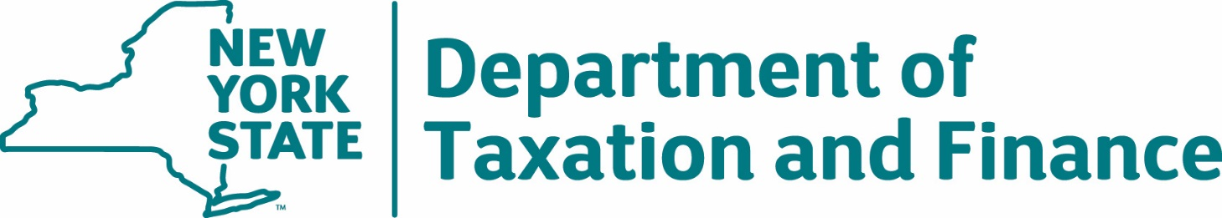

Request for Proposals
23-103
Check 21 Services

Appendices
Table of Contents

Appendix A – Standard Clauses for New York State Contracts 3
Appendix B – Bid Protest Policy 10
Appendix C – Change Control Procedure 13

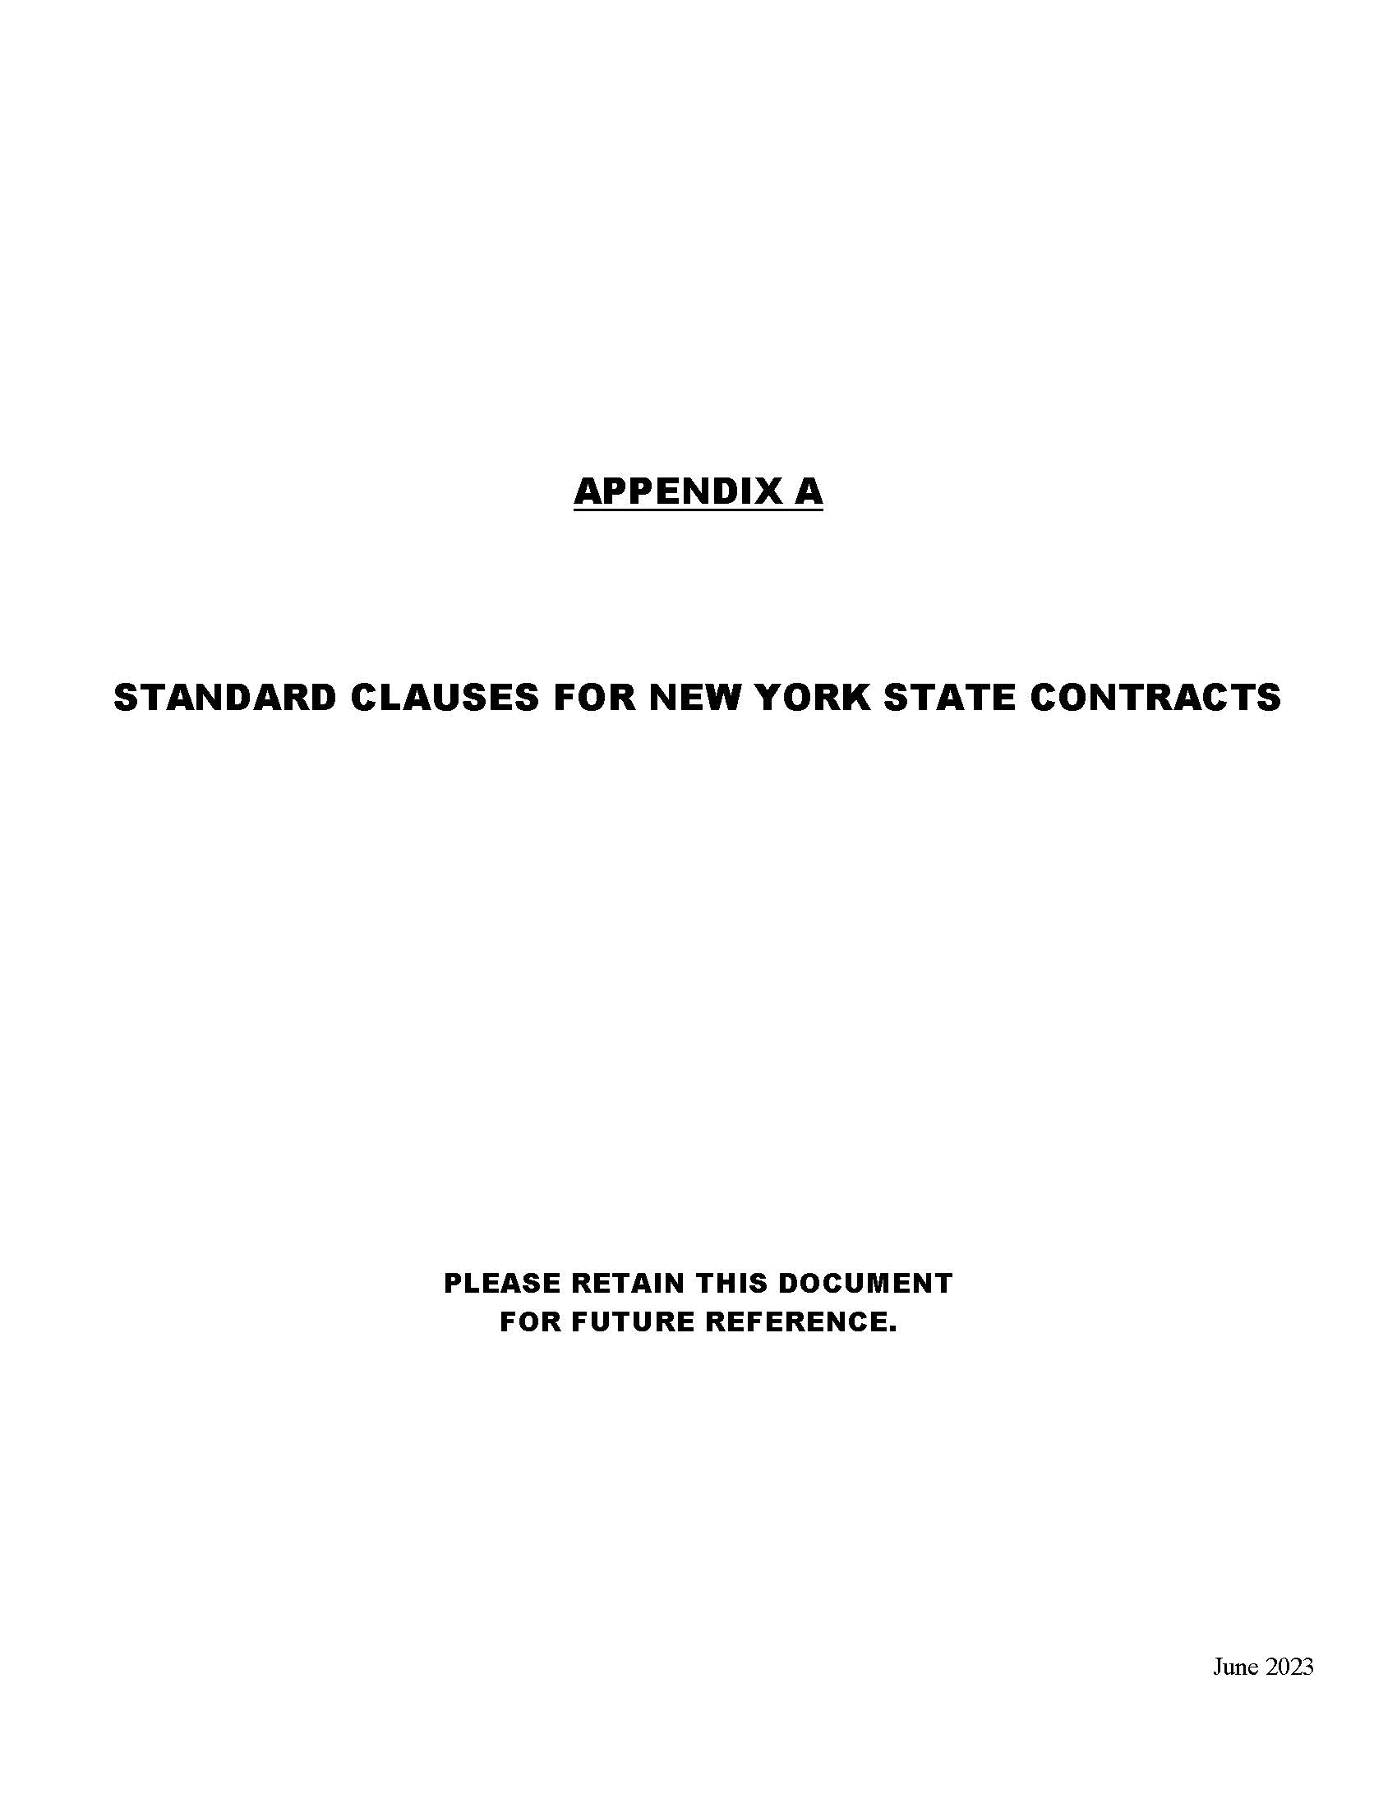
Appendix A – Standard Clauses for New York State Contracts
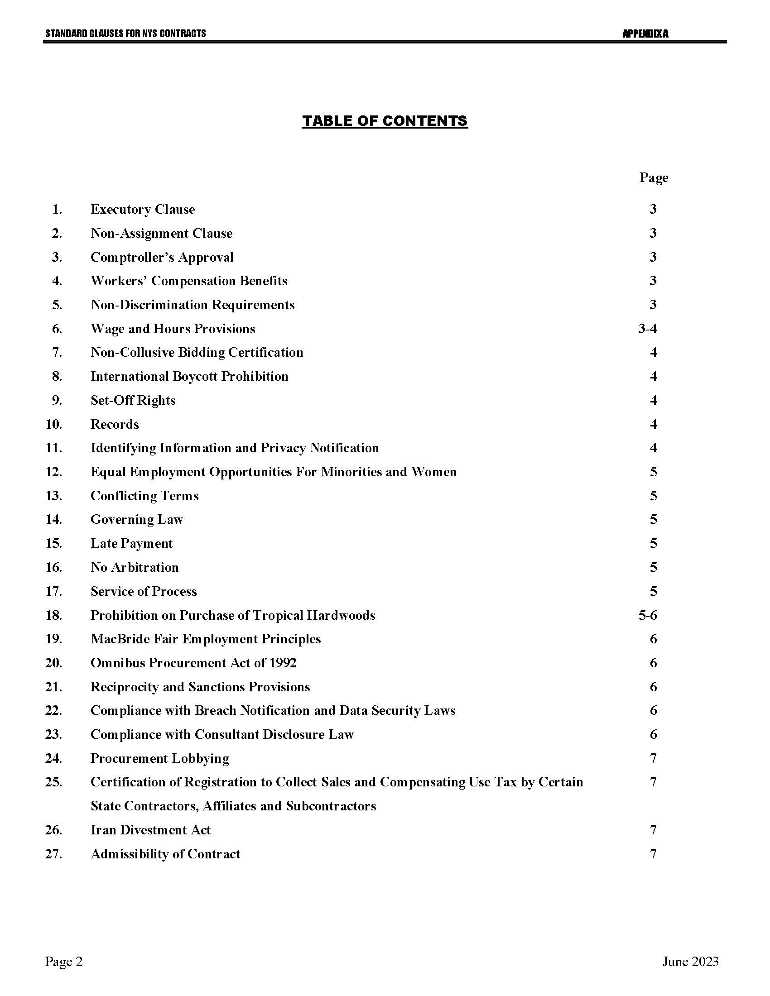
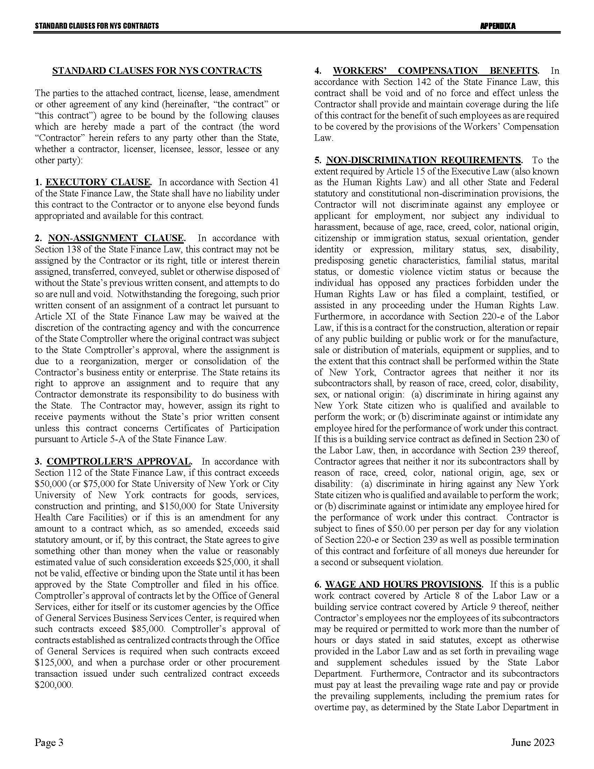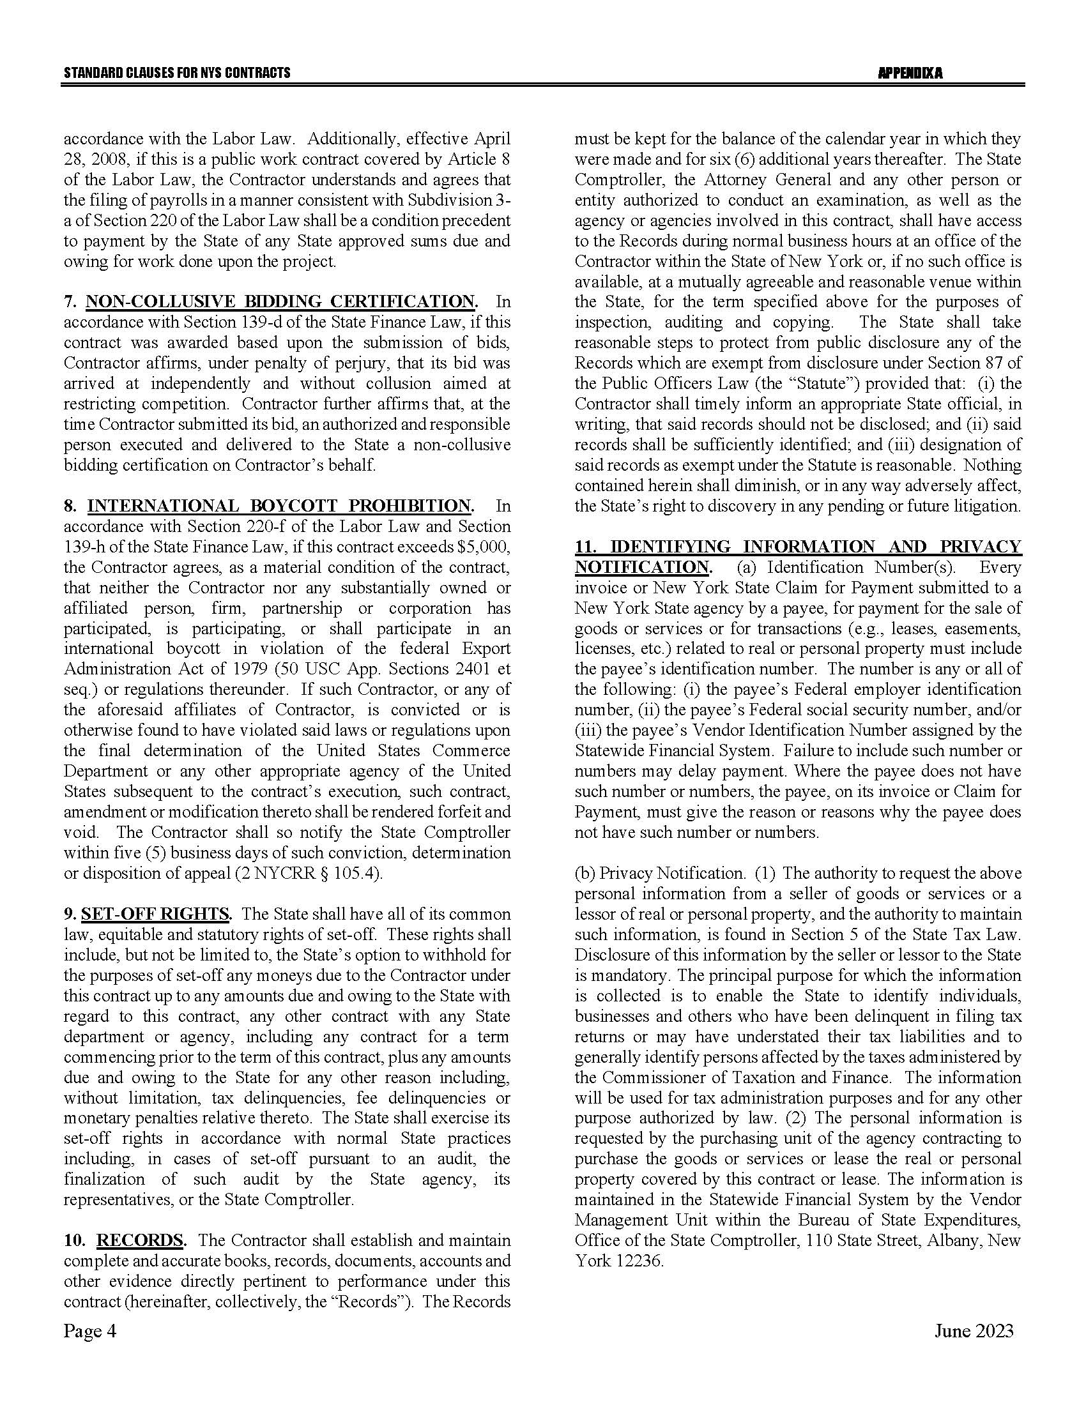
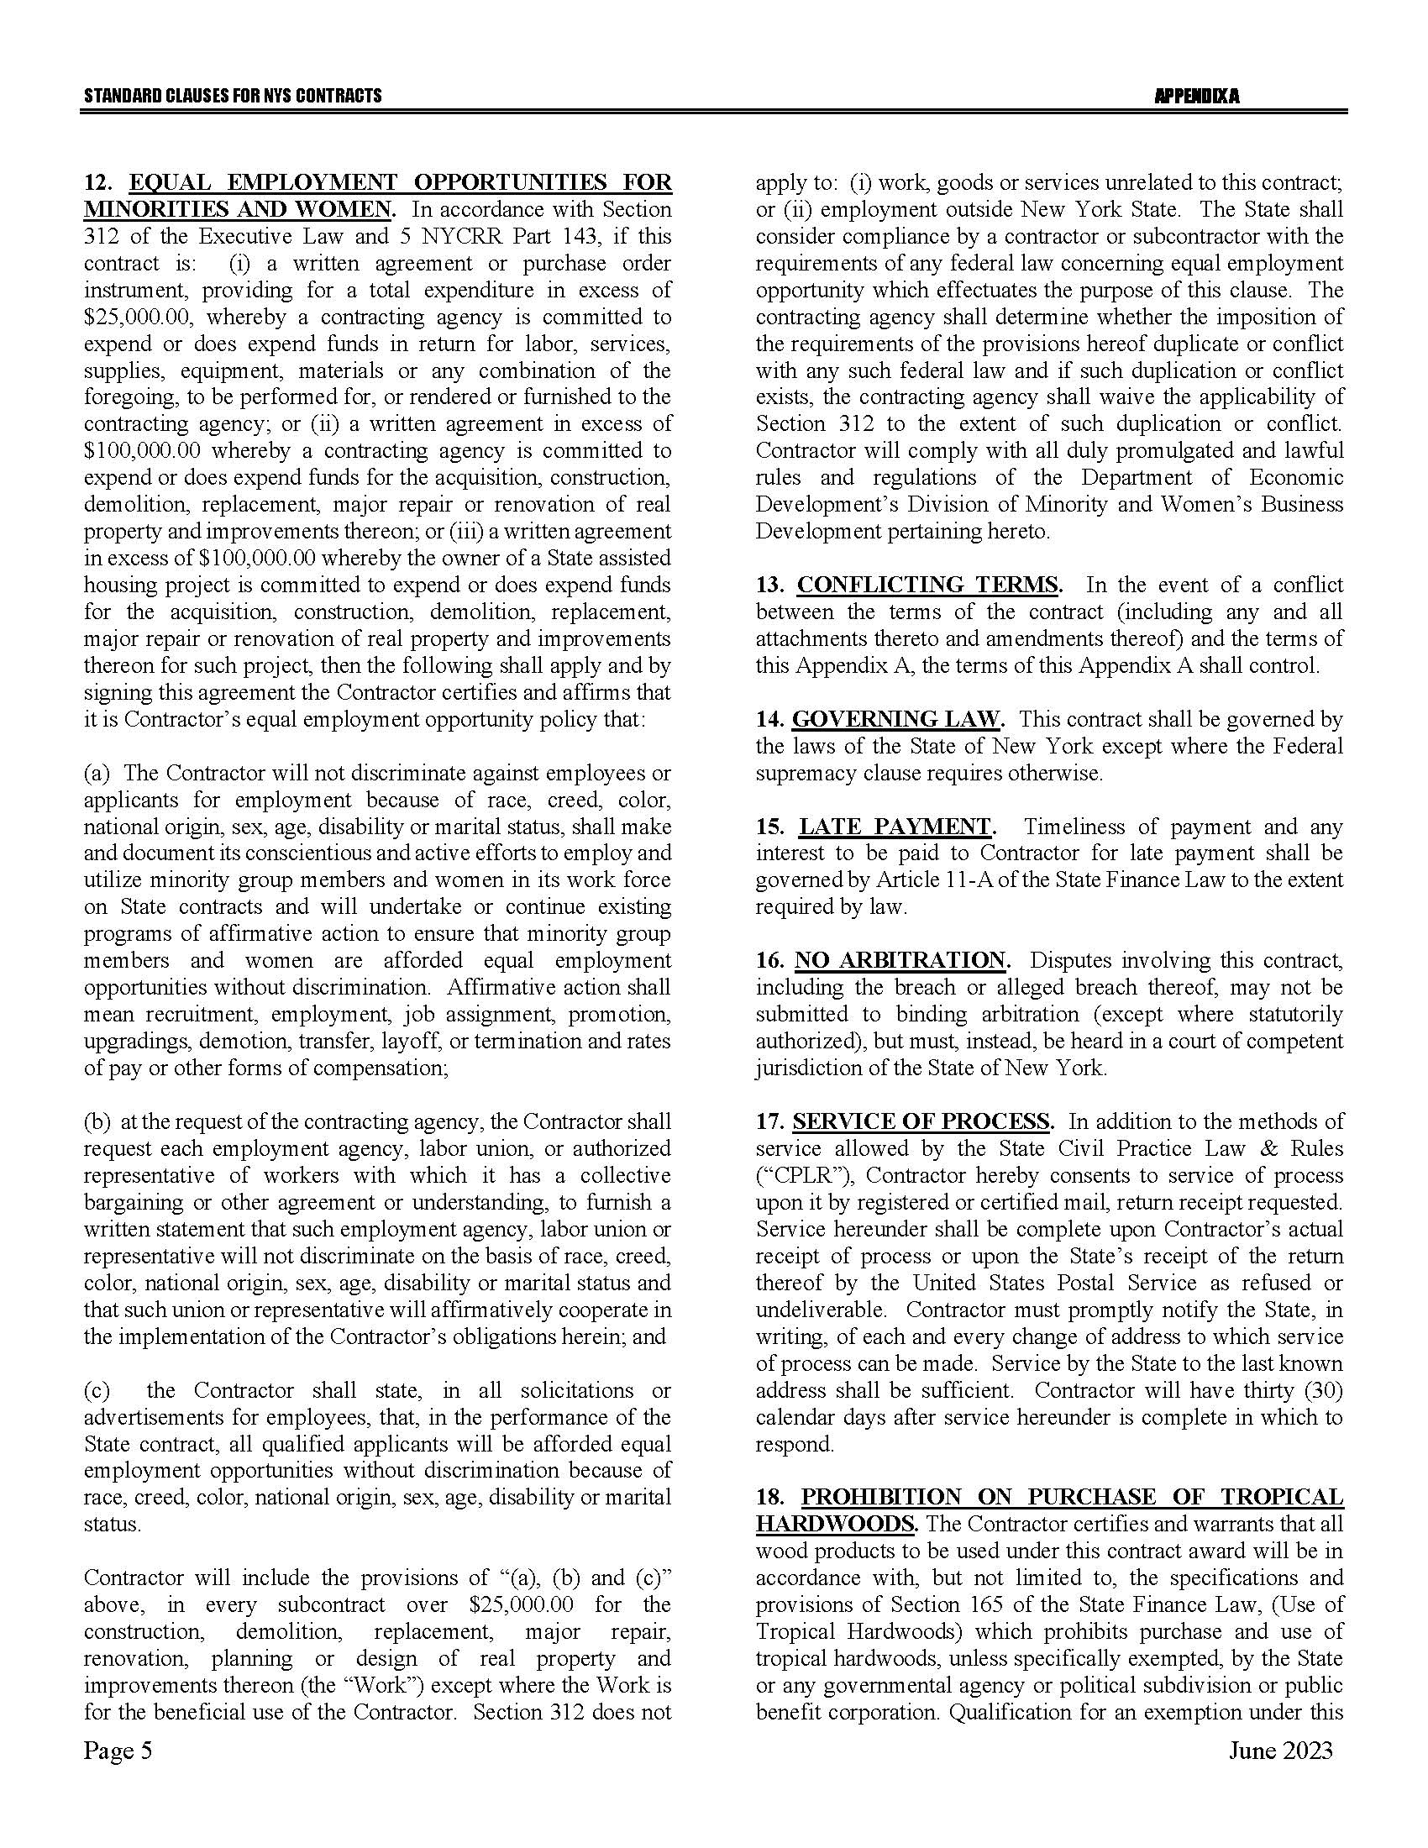
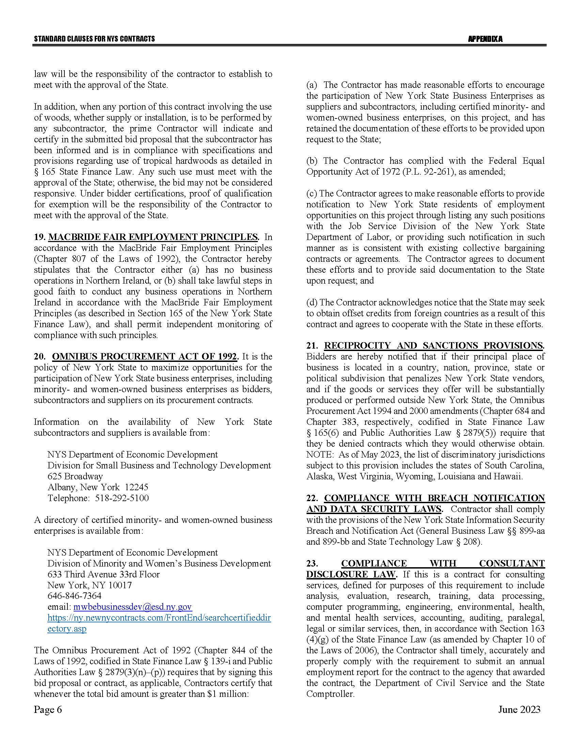
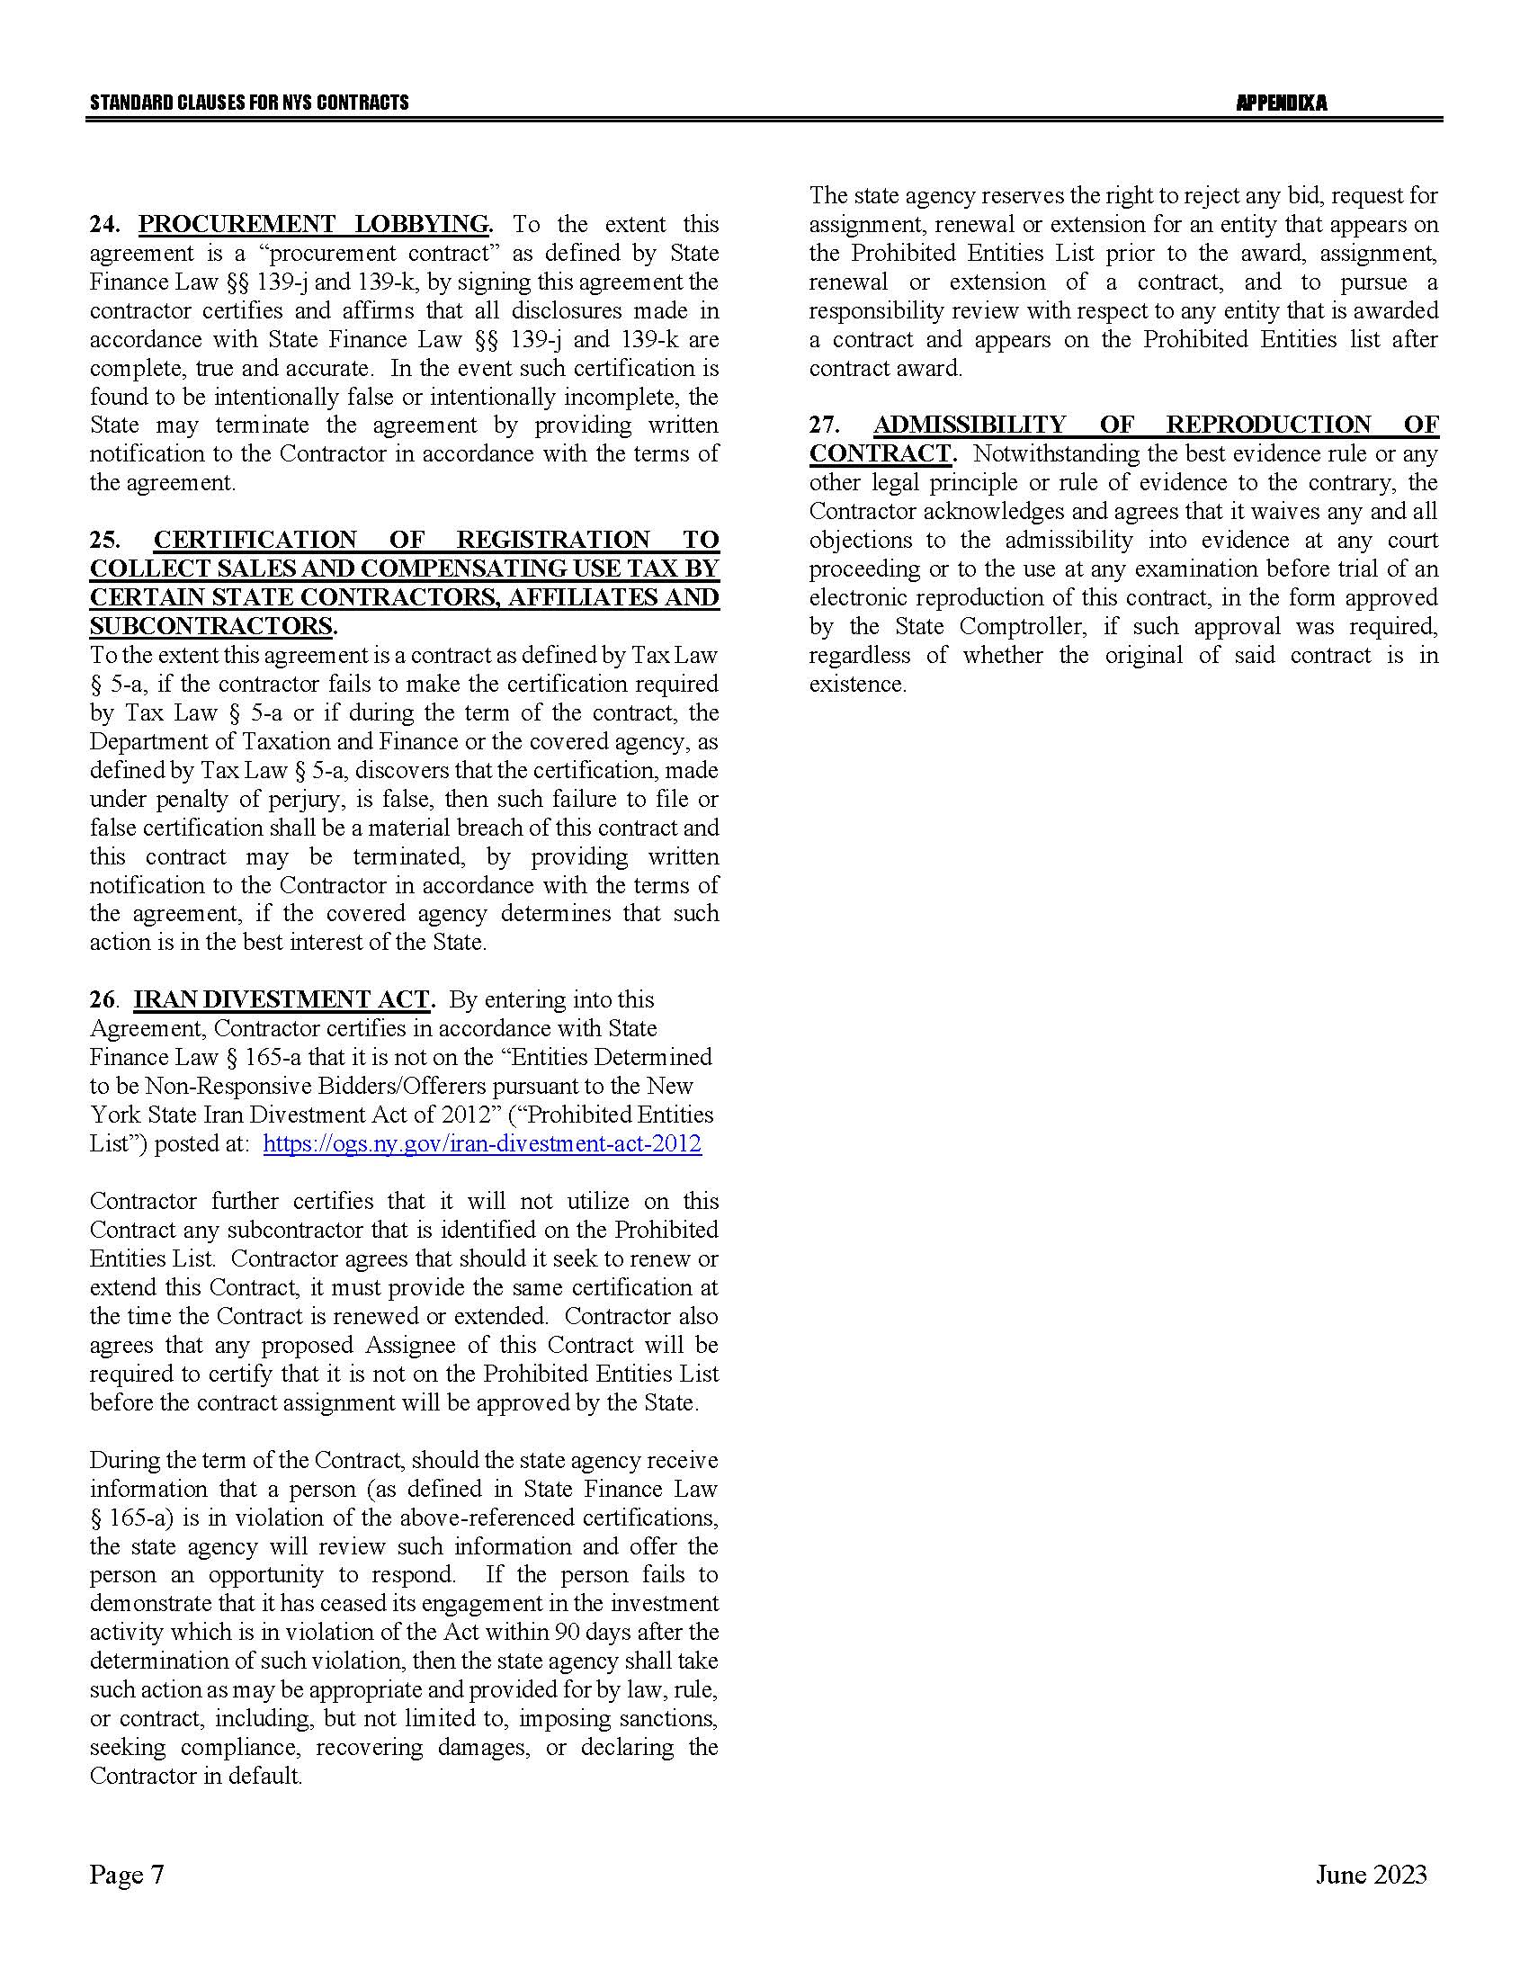

Appendix B – Bid Protest Policy
DTF Protest Procedure
Section 1 Applicability
Section 2 Definitions
Section 3 General Protest Guidelines
Section 4 Protest Procedure
Section 5 Appeal process
Section 1: Applicability
These guidelines set forth the procedure to be utilized when an Interested Party challenges a Contract Award by the New York State Department of Taxation and Finance. The guidelines shall apply to all Contract Awards made by the Department and approved by the New York State Office of the State Comptroller, including bid Solicitations, Sole Source procurements, Single Source procurements, and Emergency procurements.
Section 2: Definitions
- "Contract Award" is a written determination from DTF to an Offeror indicating that the DTF has selected a particular Offeror under the procurement process.
- “DTF” or “Department” means the New York State Department of Taxation and Finance.
- "Emergency" means an urgent and unexpected requirement where health and public safety or the conservation of public resources is at risk (see New York State Finance Law, Section 163.1.b).
- "Interested Party" means a participant in the procurement process and those whose participation in the procurement process has been foreclosed by the actions of the DTF and have suffered harm as a result of the manner in which the procurement was conducted.
- “Offeror” means the entity submitting an offer to DTF.
- "OSC" means the New York State Office of the State Comptroller.
- "Protest" means a written challenge by an Interested Party of a Contract Award that is subject to the approval of OSC.
- “Protesting Party” means an Interested Party who has filed a Protest.
- "Single Source" means a procurement in which, although two or more offerors can supply the required commodities or services, DTF, upon written findings setting forth the material and substantial reasons therefor, awards the contract to one offeror over the other (see New York State Finance Law, Section 163.1.h).
- "Sole Source" means a procurement in which only one offeror is capable of supplying the required commodities or services (see New York State Finance Law, Section 163.1.g).
- “Solicitation” means a document issued by DTF, requesting a response to a procurement need, including an Invitation for Bids, a Request for Proposals, or another written method seeking a bid or proposal for a specified purpose.
- "Successful Bidder" means the bidder or offeror whose bid or proposal has been selected for Contract Award by DTF.

Section 3: General Protest Guidelines

  - Any Interested Party will be given the opportunity to participate in the Protest procedure.
A Protest submitted to DTF must be in writing and must contain specific factual and legal allegations setting forth the basis on which the Protesting Party challenges the Contract Award by DTF. A Protest must include:
- a statement of all legal and/or factual grounds for disagreement with a DTF procurement determination;
- a description of all remedies or relief requested; and
- copies of all applicable supporting documentation.
  - DTF may, at its sole discretion, waive any deadline or requirement set forth in these guidelines, or consider any materials submitted beyond the time periods set forth in these guidelines.
  - Where DTF deems appropriate, DTF may require the Protesting Party, DTF staff involved in the procurement, the Successful Bidder, or any other Interested Party, to address and/or submit further information with respect to additional issues raised by any DTF review of the procurement.
  - Nothing herein shall preclude DTF from obtaining information relevant to the procurement from any other source, as it may deem appropriate.
Section 4: Protest Procedure

  - Any Interested Party may file, by mail or electronic mail, a Protest with the DTF Director of Procurement. The following statement must be clearly and prominently displayed on the envelope or package or header of electronic transmittal: “Bid Protest of DTF Solicitation (Reference Number)” when being submitted regarding a Solicitation and “Protest of DTF Contract Award (Reference Number)” when being submitted regarding a contract being entered into on a non-competitive basis.
  - Timing of Protest submission:
- Concerning Errors, Omissions or Prejudice in the Bid Specifications, Requirements or Documents - Protests which concern the drafting of bid specifications must be received by DTF at least ten business days before the date set in the Solicitation for receipt of bids. If the date set in the Solicitation for receipt of bids is less than ten business days from the date of issue, Protests concerning the specifications must be received by DTF at least 48 hours before the time designated for receipt of bids.
- Concerning Proposed Contract Award - Protests concerning a pending Contract Award must be received within ten business days after the notice of Contract Award or five business days after receiving a debriefing.
  - The DTF Director of Procurement may summarily deny a Protest that fails to contain specific factual or legal allegations, or where the Protest raises only issues of law that have already been decided by the courts or by the OSC Bureau of Contracts.
  - An Interested Party may file only one Protest with respect to a specific Solicitation.
  - The DTF Director of Procurement shall issue a written determination addressing all issues raised by the Protest, as well as any relevant issues raised by his/her review of the procurement or contract. The determination shall make findings of fact and conclusions of law on any issues in dispute. All participants in the Protest and the Successful Bidder shall be provided a copy of the determination. The determination shall be made part of the procurement record.
Section 5: Appeal Process

  - The Protest determination of DTF shall be deemed a final and conclusive agency determination unless a written notice of appeal is received no more than five business days after the date the written Protest decision is sent to the Offeror. Such notice of appeal must be filed in writing at the address set forth below:
Chief Financial Officer
New York State Department of Taxation and Finance
Reference: Bid Protest of DTF Solicitation (provide procurement reference number) (or, Protest of DTF Contract Award [Reference Number])
Building 9 W.A. Harriman Campus
Albany, NY 12227
  - The Chief Financial Officer shall review and make a final written determination on all appeals within ten business days of the date the Appeal is received. A Protest appeal may not introduce new facts or legal allegations unless responding to issues newly raised as a result of the written Protest determination.
Section 6: OSC Appeal Process

  - An Interested Party must file an appeal of the Department’s determination of a Protest with the OSC Bureau of Contracts within ten business days of receiving DTF’s final written determination on appeal.
  - In its appeal, the Interested Party shall set forth the basis on which it challenges DTF’s Protest determination. The Interested Party shall also include, as an exhibit to its appeal, a copy of the initial bid Protest submitted to the Department and the determination of such bid Protest issued by DTF.
The appeal must be in writing and a copy must be delivered to DTF and the Successful Bidder (unless the Successful Bidder is the appealing party in which case a copy of the appeal must be delivered to the original Protesting Party), and any other party that participated in the Protest conducted by DTF.
The appeal must be filed with:
Bureau Director at bidprotests@osc.ny.gov
or
Bureau of Contracts
New York State Office of the State Comptroller
110 State Street, 11th Floor
Albany, NY 12236

January 2024

Appendix C – Change Control Procedure
Change Request  (“CR”) | When a Change is contemplated, the appropriate DTF program area contact will discuss same with the Contractor. If DTF agrees with the proposed Change(s), DTF prepares a CR (see Change Request form, p.14).
Analysis of Implementation Alternatives | Upon receipt of the CR from DTF, the Contractor may discuss with DTF Program any revisions to the suggested implementation approach, prior to providing the Contractor’s Change Analysis, and Program may engage additional DTF staff as appropriate.
Change Analysis (“CA”) | The Contractor completes the CA (see Change Analysis form, p.15), and submits it, along with any additional documentation required to support the CA, to the Department.
Proposed Fees | One-time development: Total project manager, business analyst, programmer, and tester costs for the Change(s), calculated based on the hours necessary to effectuate the Change(s) utilizing the titles and rates provided in the Contractor’s Cost Proposal in response to RFP 23-103.  Other: The following fees, as negotiated between DTF and the Contractor, may be added to arrive at a final price to effectuate the Change(s), and will require justification from the Contractor. No add-on costs will be allowed.  - Transaction fees or flat fees:  - Proposed new transaction fee(s)  - Any flat one-time or recurring fee  - Changes to existing transaction fees:  - Current transaction fee for relevant transaction or report  - Proposed change to current fee  - Travel: Travel-related expenses shall be reimbursed in accordance with the NYS Office of State Comptroller guidelines.
Negotiation | After DTF and Contractor negotiate and document technical details, including justification of number of hours, and costs:  - DTF Change Control Manager and DTF Program Area Manager sign-off  - Copy of approved CR and CA provided to the Program Area and the Change Control Manager.
Notification | The Department notifies the Contractor in writing of final approval, including a copy of the approved CR and CA.
Development/ Implementation | Upon approval of the Change Control, development and implementation commences in accordance with an accepted methodology.  PRIOR TO IMPLEMENTATION, the Contractor updates all related documentation.
Administrative Documentation | CR, CA, and all related documents become a part of the official Contract documentation.
Payment | Changes must be accepted by the Department, in writing, before invoices can be rendered. The Department’s acceptance may be conditioned upon demonstration of successful completion of UAT and/ or Production implementation (as deemed necessary, in the Department’s sole discretion) of the Change(s). Payment will be made only after Department acceptance of the Change and Contractor’s submission of a proper invoice.

NEW YORK STATE DEPARTMENT OF TAXATION AND FINANCE
CHANGE REQUEST
Change Category:  ☐ Legislative  ☐ Enhancement  ☐ Fee |  | Contract #:  Change Control #:  Tax Type:  Fiscal Year:  Change Control Title: |  |  |  | Priority:  ☐ High  ☐ Medium  ☐ Low
Change Type: | ☐ Existing Return  ☐ New Method of Filing Option  ☐ Annual Cycle  ☐ New Return or Form |  | ☐ New Method of Data Delivery  ☐ Legislative Changes  ☐ New Report or Report Change  ☐ Other:
I. Description of Process:
System(s)/Plan(s) Affected:
II. Description of Change Requested:
III. Why Needed:
IV. Suggested Implementation Approach:
V. Required Implementation Date: / / |  |  |  | VI. Date Change Analysis Due: / /
VII. Attachments:
VIII. Approvals/Contacts
A. DTF Change Control Manager:
Signature: |  |  |  |  | Signature Date: / /
Office: |  |  |  |  | Phone: ( ) -
B. DTF Program Area Manager:
Signature: |  |  |  |  | Signature Date: / /
Office: |  |  |  |  | Phone: ( ) -
Contact Person: |  |  |  |  | Phone: ( ) -

NEW YORK STATE DEPARTMENT OF TAXATION AND FINANCE
CHANGE ANALYSIS
Change Environment:  ☐ Legislative  ☐ Enhancement  ☐ Fee | Contract #:  Change Control #:  Tax Type:  Fiscal Year:  Change Control Title: |  |  |  |  | Priority:  ☐ High  ☐ Medium  ☐ Low
I. Recommended Implementation Approach:
II. Development/Implementation Timeframes:
III. Impacts on Other Systems/Plans:
IV. Resource Requirements:
V. Additional information required for enhancement; attach the following required information:
☐ Design Specifications |  | ☐ Schedule of Deliverables |  |  | ☐ Workflow
VI. Proposed Fees (Attach additional documentation, if necessary):
One-time Development:
Task breakdown:
- Project Manager: |  |  |  | hours
- Business Analyst: |  |  |  | hours
- Programmer: |  |  |  | hours
- Tester: |  |  |  | hours
- Total Hours: |  |  |  | hours
Other:
VII. Approvals/Contacts
A. Contractor Change Control Representative:
Signature: |  |  |  |  | Signature Date: / /
Office: |  |  |  |  | Phone: ( ) -
B. DTF Change Control Manager:
Signature: |  |  |  |  | Signature Date: / /
Office: |  |  |  |  | Phone: ( ) -
C. DTF Program Area Manager Approval:
Signature: |  |  |  |  | Signature Date: / /
Office: |  |  |  |  | Phone: ( ) -

