Request for Proposals
23-100
Program Administration and Investment Management Services for the New York State Secure Choice Savings Program

Appendices

Table of Contents

APPENDIX A
Standard Clauses for New York State Contracts 3
APPENDIX B
Bid Protest Policy 10
APPENDIX C
RFP Glossary 13

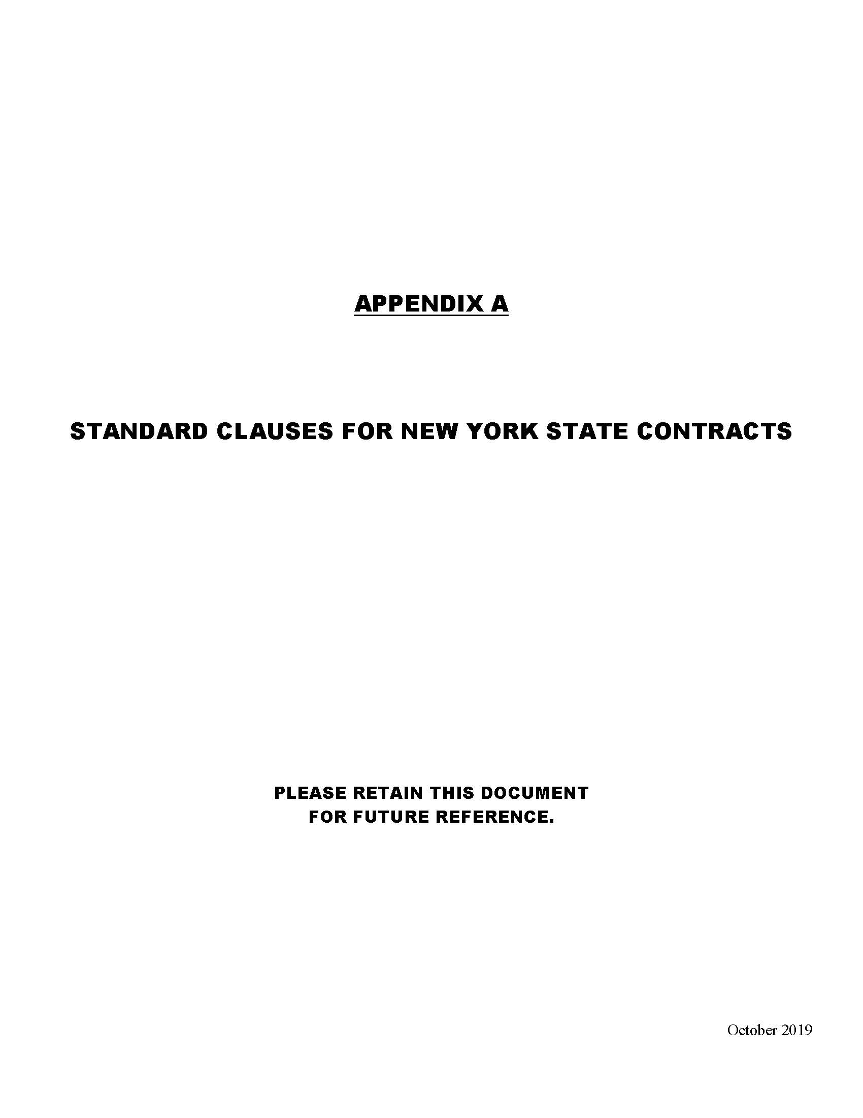
APPENDIX A

Standard Clauses for New York State Contracts
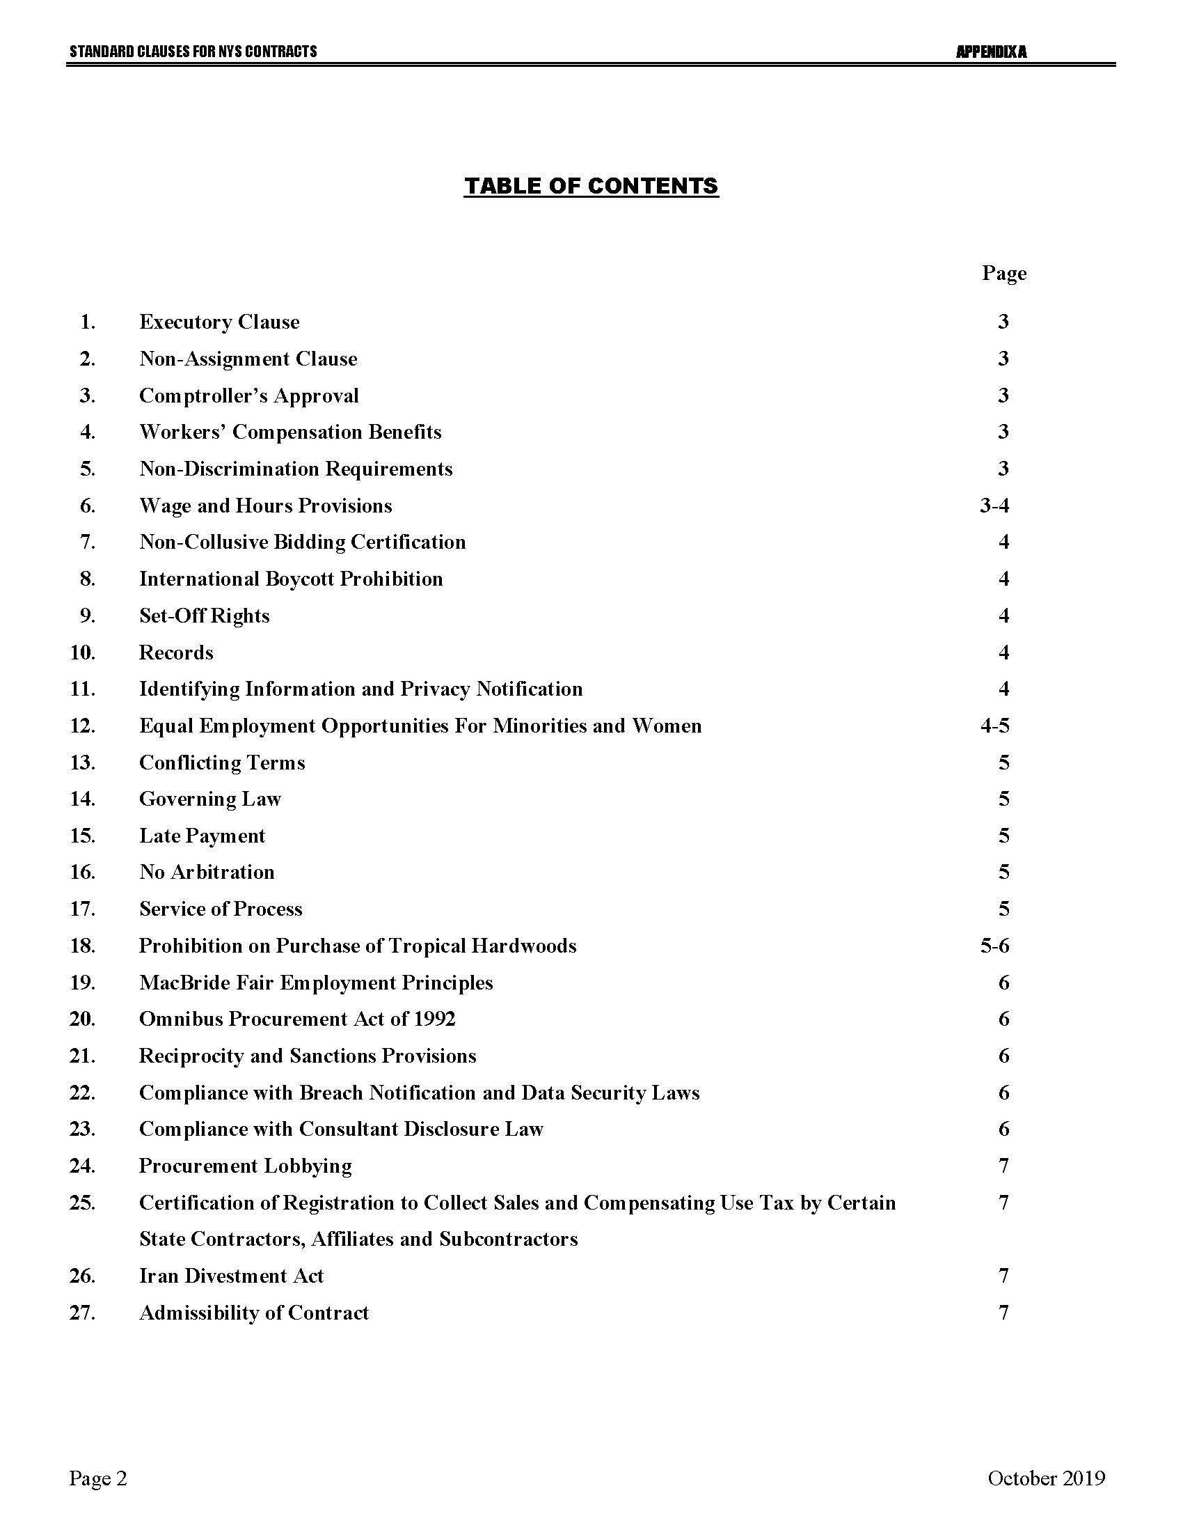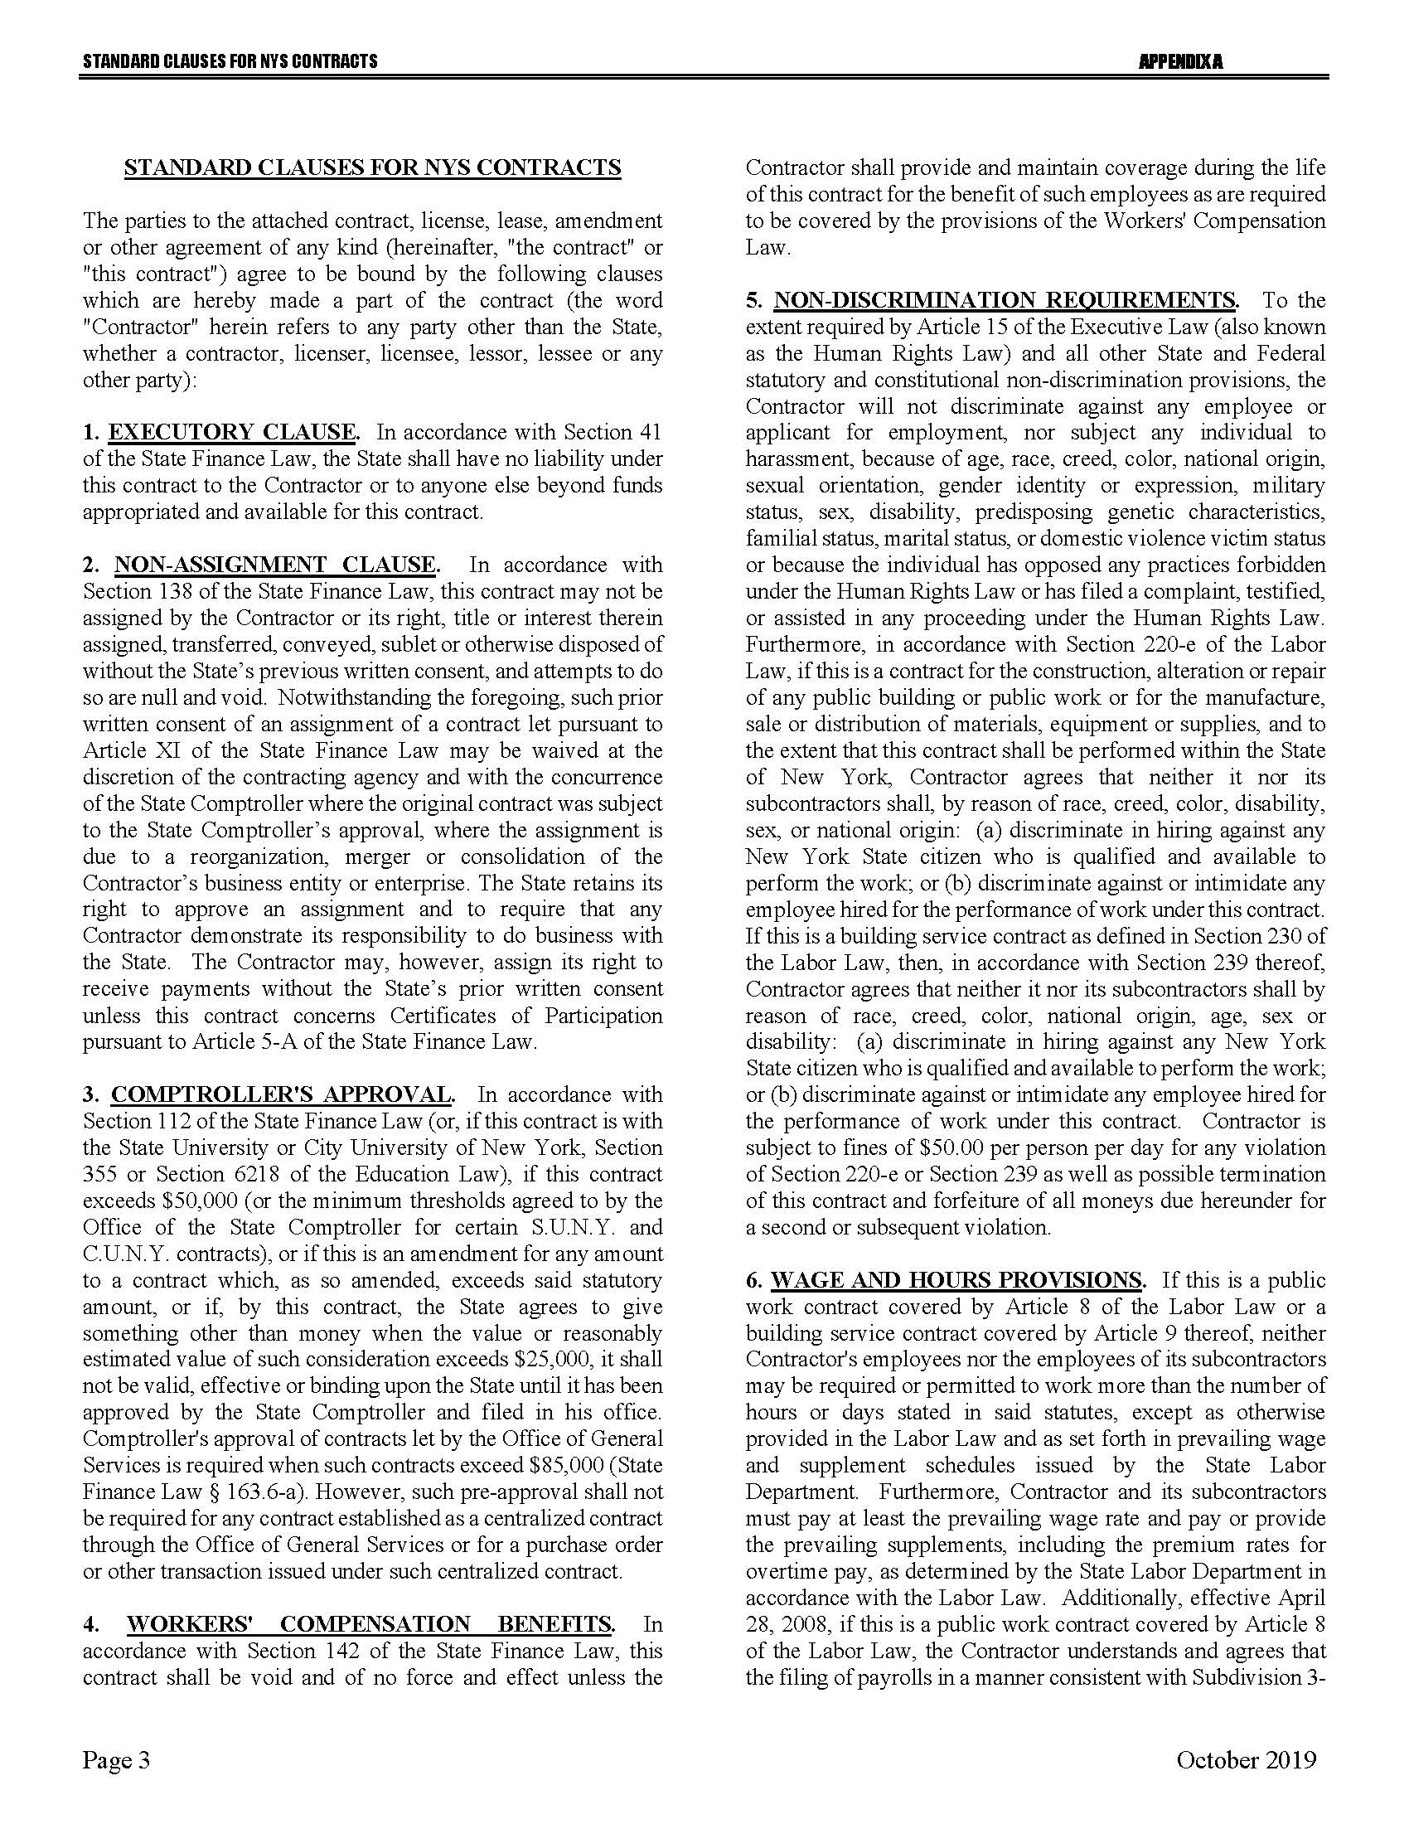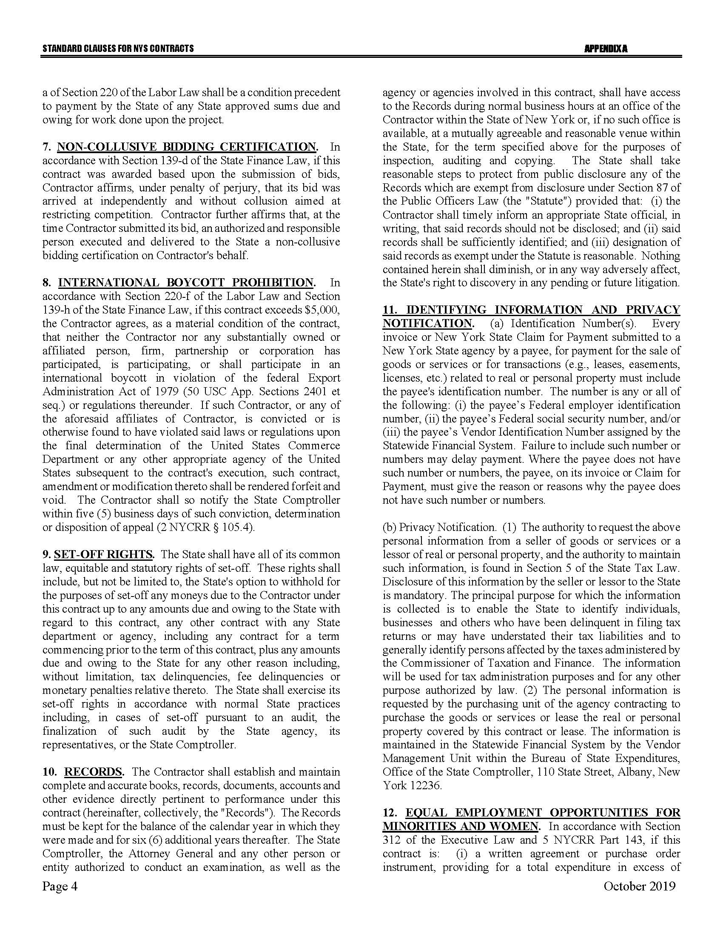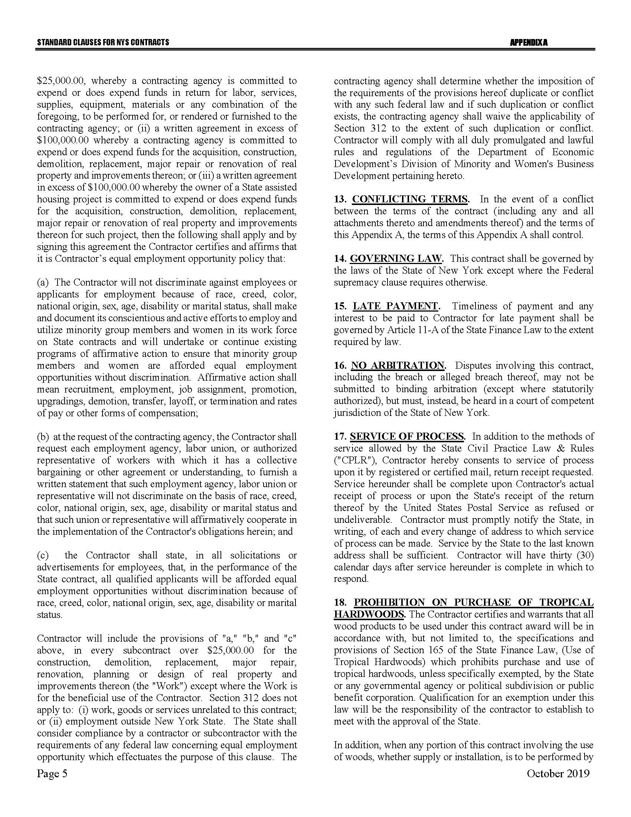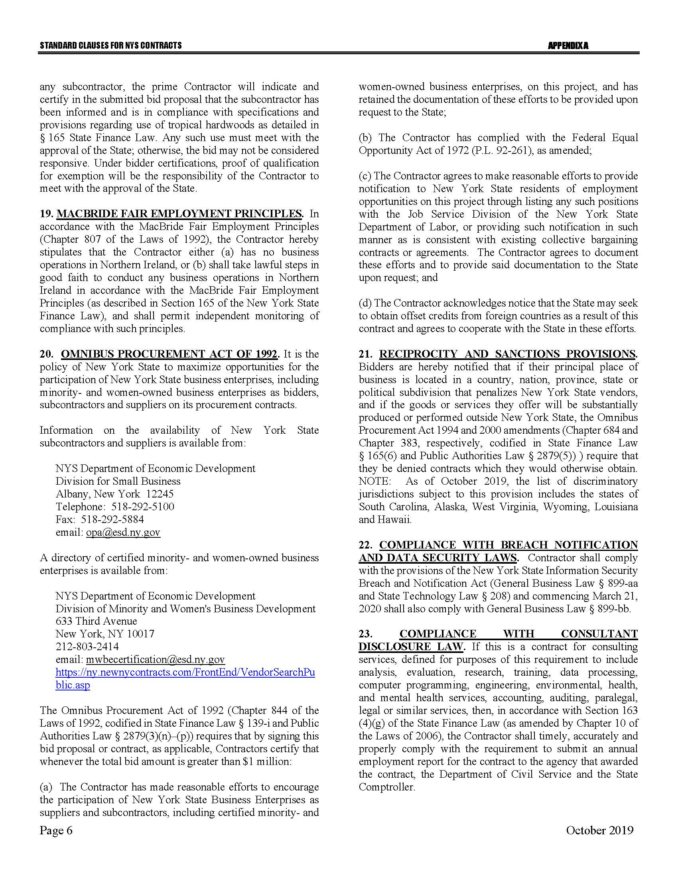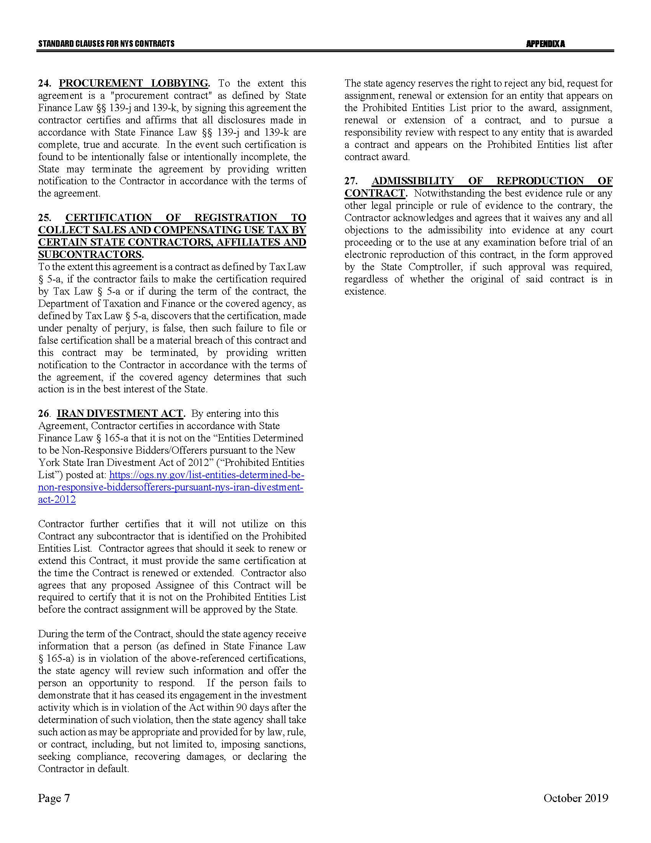

APPENDIX B

Bid Protest Policy

DTF Protest Procedure
Section 1 Applicability
Section 2 Definitions
Section 3 General Protest Guidelines
Section 4 Protest Procedure
Section 5 Appeal process
Section 1: Applicability
These guidelines set forth the procedure to be utilized when an Interested Party challenges a Contract Award by the New York State Department of Taxation and Finance. The guidelines shall apply to all Contract Awards made by the Department and approved by the New York State Office of the State Comptroller, including bid Solicitations, Sole Source procurements, Single Source procurements, and Emergency procurements.
Section 2: Definitions
- "Contract Award" is a written determination from DTF to an Offeror indicating that the DTF has selected a particular Offeror under the procurement process.
- “DTF” or “Department” means the New York State Department of Taxation and Finance.
- "Emergency" means an urgent and unexpected requirement where health and public safety or the conservation of public resources is at risk (see New York State Finance Law, Section 163.1.b).
- "Interested Party" means a participant in the procurement process and those whose participation in the procurement process has been foreclosed by the actions of the DTF and have suffered harm as a result of the manner in which the procurement was conducted.
- “Offeror” means the entity submitting an offer to DTF.
- "OSC" means the New York State Office of the State Comptroller.
- "Protest" means a written challenge by an Interested Party of a Contract Award that is subject to the approval of OSC.
- “Protesting Party” means an Interested Party who has filed a Protest.
- "Single Source" means a procurement in which, although two or more offerors can supply the required commodities or services, DTF, upon written findings setting forth the material and substantial reasons therefor, awards the contract to one offeror over the other (see New York State Finance Law, Section 163.1.h).
- "Sole Source" means a procurement in which only one offeror is capable of supplying the required commodities or services (see New York State Finance Law, Section 163.1.g).
- “Solicitation” means a document issued by DTF, requesting a response to a procurement need, including an Invitation for Bids, a Request for Proposals, or another written method seeking a bid or proposal for a specified purpose.
- "Successful Bidder" means the bidder or offeror whose bid or proposal has been selected for Contract Award by DTF.
Section 3: General Protest Guidelines

  - Any Interested Party will be given the opportunity to participate in the protest procedure.
A Protest submitted to DTF must be in writing and must contain specific factual and legal allegations setting forth the basis on which the Protesting Party challenges the Contract Award by DTF. A Protest must include:
- a statement of all legal and/or factual grounds for disagreement with a DTF procurement determination;
- a description of all remedies or relief requested; and
- copies of all applicable supporting documentation.
  - DTF may, at its sole discretion, waive any deadline or requirement set forth in these guidelines, or consider any materials submitted beyond the time periods set forth in these guidelines.
  - Where DTF deems appropriate, DTF may require the Protesting Party, DTF staff involved in the procurement, the Successful Bidder, or any other Interested Party, to address and/or submit further information with respect to additional issues raised by any DTF review of the procurement.
  - Nothing herein shall preclude DTF from obtaining information relevant to the procurement from any other source, as it may deem appropriate.
Section 4: Protest Procedure

  - Any Interested Party may file, by mail or electronic mail, a Protest with the DTF Director of Procurement. The following statement must be clearly and prominently displayed on the envelope or package or header of electronic transmittal: “Bid Protest of DTF Solicitation (Reference Number)” when being submitted in regards to a Solicitation and “Protest of DTF Contract Award (Reference Number)” when being submitted in regards to a contract being entered into on a non-competitive basis.
  - Timing of Protest submission:
- Concerning Errors, Omissions or Prejudice in the Bid Specifications, Requirements or Documents - Protests which concern the drafting of bid specifications must be received by DTF at least ten business days before the date set in the Solicitation for receipt of bids. If the date set in the Solicitation for receipt of bids is less than ten business days from the date of issue, Protests concerning the specifications must be received by DTF at least 48 hours before the time designated for receipt of bids.
- Concerning Proposed Contract Award - Protests concerning a pending Contract Award must be received within ten business days after the notice of Contract Award or five business days after receiving a debriefing.
  - The DTF Director of Procurement may summarily deny a Protest that fails to contain specific factual or legal allegations, or where the Protest raises only issues of law that have already been decided by the courts or by the OSC Bureau of Contracts.
  - An Interested Party may file only one Protest with respect to a specific Solicitation.
  - The DTF Director of Procurement shall issue a written determination addressing all issues raised by the Protest, as well as any relevant issues raised by his/her review of the procurement or contract. The determination shall make findings of fact and conclusions of law on any issues in dispute. All participants in the Protest and the Successful Bidder shall be provided a copy of the determination. The determination shall be made part of the procurement record.
Section 5: Appeal Process

  - The protest determination of DTF shall be deemed a final and conclusive agency determination unless a written notice of appeal is received no more than five business days after the date the written Protest decision is sent to the Offeror. Such notice of appeal must be filed in writing at the address set forth below:
Chief Financial Officer
New York State Department of Taxation and Finance
Reference: Bid Protest of DTF Solicitation (provide procurement reference number) (or, Protest of DTF Contract Award [Reference Number])
Building 9 W.A. Harriman Campus
Albany, NY 12227
  - The Chief Financial Officer shall review and make a final written determination on all appeals within ten business days of the date the Appeal is received. A protest appeal may not introduce new facts or legal allegations unless responding to issues newly raised as a result of the written protest determination.
Section 6: OSC Appeal Process

  - An Interested Party must file an appeal of the Department’s determination of a Protest with the OSC Bureau of Contracts within ten business days of receiving DTF’s final written determination on appeal.
  - In its appeal, the Interested Party shall set forth the basis on which it challenges DTF’s protest determination. The Interested Party shall also include, as an exhibit to its appeal, a copy of the initial bid Protest submitted to the Department and the determination of such bid Protest issued by DTF.
The appeal must be in writing and a copy must be delivered to DTF and the Successful Bidder (unless the Successful Bidder is the appealing party in which case a copy of the appeal must be delivered to the original Protesting Party), and any other party that participated in the Protest conducted by DTF.
The appeal must be filed with:
Bureau Director at bidprotests@osc.state.ny.us
or
Bureau of Contracts
New York State Office of the State Comptroller
110 State Street, 11th Floor
Albany, NY 12236

July 2020

APPENDIX C

RFP Glossary

Account | An individual retirement account under Sections 408(a), 408(b), or 408A of the Code established under the Program. Each Account shall be held in custodial accounts meeting the requirements of Sections 408 and 408A of the Code, or any other applicable federal law requirements.
Account Owner | The Employee for whose benefit the Account has been established.
Act | Article 43 of the New York State General Business Law.
ACH | Electronic transfer of funds including payroll deposits between financial institutions.
Agreement (also referred to as “Contract”) | Each Contract entered into as a result of RFP 23-100. Each Agreement will be identified by a specific State-assigned Contract number when known. Each Agreement will be made up of the RFP and all documents identified therein at the Article titled “Entirety of Agreement.”
Applicable Law | Article 43 of the NYS General Business Law and all applicable laws, regulations, judgments, decrees, injunctions, writs and orders of an appropriate court, tribunal or Governmental Authority and rules, regulations, orders, licenses and permits of any Governmental Authority or Regulatory Body, including without limitation, all IRA Requirements, and all proposed and existing regulations, and Securities Exchange Commission (“SEC”) requirements applicable to the Parties or the Program. Any references to federal or state statutes or regulations or other rules of a Governmental Authority or a Regulatory Body shall be deemed to include a reference to any amendments thereof and any successor provisions thereto.
Attorney General (AG) | The Attorney General of the State of New York, or their designee.
Base Contract | That portion of the Agreement preceding the signatures of the parties.
Beneficiary | The person or persons entitled to receive all or a portion of the Account in the event of the Account Owner’s death.
Bidder/Offerer | An entity submitting a Proposal or Bid in response to this RFP.
Board | The New York Secure Choice Savings Program Board established under Article 43 of the New York State General Business Law.
Census Bureau | U.S. Census Bureau.
Commissioner | The Commissioner of the New York State Department of Taxation and Finance, or their designee
Comptroller (OSC) | The New York State Office of the State Comptroller, or their designee.
Contractor | A Contractor to whom a contract is awarded as a result of RFP 23-100.
CONUS | The Continental United States.
Default Contribution Rate | The contribution rate at which payroll deductions will be made, equal to 3% of Employee Wages, for Employees who do not opt out or otherwise designate a contribution rate.
Department (DTF) | The New York State Department of Taxation and Finance.
Direct Transfer | Electronic movement from one Roth IRA account to another Roth IRA account involving two Roth IRA custodians. The Account Owner does not touch the money and does not experience a taxable event.
EFT | Electronic funds transfer.
Employee | Any individual who is eighteen years of age or older, who is employed by an Employer, and who earned Wages working for an Employer in New York state during a calendar year.
Employer | A person or entity engaged in a business, industry, profession, trade, or other enterprise in New York State, whether for profit or not for profit, that (i) has at all times during the previous calendar year employed at least 10 employees in the State, (ii) has been in business at least two years, and (iii) has not offered a qualified retirement plan, including, but not limited to, a plan qualified under sections 401(a), 401(k), 403(a), 403(b), 408(k), 408(p) or 457(b) of the Internal Revenue Code of 1986 in the preceding two years.
Enrollee | Any Employee who is enrolled in the Program.
Governmental Authority | Any federal, state, local, municipal or other governmental department, commission, district, board, bureau, agency, regulatory body, court, tribunal or other instrumentality (or any officer or representative thereof) with competent jurisdiction.
Human Rights Law | Article 15 of the New York State Executive Law.
Informational Materials | All Employer and Employee Informational Materials described in Section 1309 of the Act and which are also referred to in the RFP at Section 2.1.4.1.
Investment Management Services or IM Services | Services that one or more Investment Management Services Contractor will be responsible for, including but not limited to, provision of a default option of a target retirement date fund, growth fund, growth and income fund, and a conservative principal protection fund.
IM Services Contractor(s) | Contractor(s) engaged to provide Investment Management Services as a result of RFP 23-100.
IPS | The Investment Policy Statement designed to provide a framework within which to manage and monitor the investments of the New York State Secure Choice Savings Program.
IRA (or Roth IRA) | For the purposes of this RFP, IRA means a Roth IRA (individual retirement account).
IRA Custodial Agreement | Documents describing the IRA, including tax benefits, contribution and distribution rules, and any other information pertinent to understanding the benefits and considerations of opening and maintaining an IRA.
IRA Disclosure Statement | The IRS Model 5305-RA contractual agreement that describes the Roth IRA’s terms and conditions and meets the requirements of Section 408A of the Code.
IRS | Internal Revenue Service.
Open Architecture Platform | Describes the Program's ability to offer investment funds from multiple Investment Management Services Contractors.
Participating Employer | An Employer that facilitates access to the Program's payroll deduction IRA for its Employees.
Payroll Deduction Roth IRA | An arrangement by which a Participating Employer facilitates access for Enrollees to remit payroll deduction contributions to the Program.
Pew | The Pew Charitable Trusts.
Program | The New York State Secure Choice Savings Program.
Program Administration Services or PA Services | Services that a Program Administration Services Contractor will be responsible for, including administration and compliance, recordkeeping, customer service, and marketing and outreach.
PA Services Contractor(s) | Contractor(s) engaged to provide Program Administration Services as a result of RFP 23-100.
Program Disclosure Statement | Document containing Program rules, including any amendments and supplements that may be necessary, and material information necessary for participants to participate in the Program. This must be included in all Enrollee information packets.
Program Forms | Required forms to facilitate necessary transactions or changes to IRAs and/or participation in the Program.
Program Records | All Account records, Program Informational Materials and other materials, Account Owner and Beneficiary lists, logos, slogans, trademarks, copyrighted materials and website content and marketing specific to the Program.
Proposal or Bid | The response submitted by a Bidder to the Department’s RFP 23-100, Program Administration and Investment Management Services for the New York State Secure Choice Savings Program.
Regulatory Body | The SEC and any other State or federal entity or association that regulates the activities of the Contractor(s) and any Subcontractor(s).
Request for Proposals (RFP) | This solicitation documents used by the Department to procure Program Administration Services or Investment Management Services for the Program where factors, in addition to cost, are considered and weighted to award the Contract using a “best value” standard as defined in State Finance Law.
Responsible Bidder | A Bidder that is determined to have financial and organizational capacity, legal authority, satisfactory previous performance, skill, judgment and integrity, and that is found to be competent, reliable and experienced, as determined by the Department. For purposes of being deemed responsible, a Bidder must also be determined to be in compliance with Sections 139-j and 139-k of the State Finance Law relative to restrictions on contacts during the procurement process and disclosure of contacts and prior findings of non-responsibility under these statutes.
Rollover | Movement of funds from one Roth IRA account to another Roth IRA whereby the account owner is responsible for taking the distribution and depositing the funds to a new retirement account.
SEC | U.S. Securities and Exchange Commission.
Services | All functions required to be performed by a Contractor in accordance with RFP 23-100, and the Agreement, to provide New York State Secure Choice Program Administration or Investment Management Services.
State | The State of New York.
Subcontractor | Any individual (not an employee of the Contractor) or other legal entity including but not limited to sole proprietor, partnership, limited liability company, firm or corporation, engaged by the Contractor to perform a portion of the Contractor’s obligations under the Agreement.
Subsequent Service Provider | A Contractor selected to perform the services upon the expiration and/or termination of an Agreement. Such provider may or may not be the incumbent service provider.
SUSB | Statistics of U.S. Businesses.
Target Retirement Date Option | An option that is a mutual fund that is part of a target date series that shifts investor asset allocation over time based upon a target retirement date.
Wages | Any compensation within the meaning of section 219(f)(1) of the Internal Revenue Code that is received by an Enrollee from a Participating Employer during the calendar year.

